Programme: Master of Business Administration
Module: Marketing Management
Module code: LCMB7024

Marketing Environment Analysis
Student Name: Bansari Ramesh Bhai Sheth
Student ID : 2545069
Personal mail ID: shethbansari23@gmail.com

Table of Contents
1.0 Task 1: Marketing Environment Analysis 3
1.1 Two external marketing environment actors influencing its transition toward lower-carbon products 3
2.0 Task 2: Strategic Growth and Competitive Positioning 8
2.1 Recommendation of a strategic growth approach for the company using the Ansoff Matrix 8
2.2 Way the organisation can achieve competitive advantage while transitioning to a lower-carbon business model 10
3.0 Task 3: Critical Reflection on AI Usage 13
3.1 Tool Disclosure 13
3.2 Critical Evaluation of AI Output 13
3.3 Contribution Analysis 13
3.4 Ethical & Professional Reflection 14
References 15

1.0 Task 1: Marketing Environment Analysis

1.1 Two external marketing environment actors influencing its transition toward lower-carbon products
Natural Environment Actor
The natural environment is the most significant external marketing environment actor impacting Codelco's transition towards lower carbon products, as climate change, water scarcity and rising demand for sustainably sourced critical minerals are altering customer expectations and competitive landscape. Kotler et al. (2024) states that the natural environment has become a more important factor in the decision-making process of marketers because organisations have to reduce the negative impact on the environment and earn value for customers (Kotler et al., 2024). Copper is vital for electric vehicles (EVs), renewable energy systems and electricity transmission, making environmental sustainability a strategic marketing issue for Codelco, the world's largest copper producer (Codelco, 2025a).
The main environmental risk that affects Codelco's marketing is the emission of greenhouse gases. Mining is responsible for about 4-7% of global GHG emissions and the world's 12,000 largest companies, many of which are industrial customers and investors, generate around 25% of emissions from the mining industry. As a response, Codelco has set its GHG Scope 1 and 2 emission reduction target to 70% by 2030, over 2019, and its ambition to become a net zero emitter by 2050 (Codelco, 2025b). The global demand for copper in energy transition technologies will rise from around 20 million tonnes in 2020 to around 30 million tonnes by 2040, continuing to strengthen the market demand for copper sustainably produced, with low carbon footprint as part of Codelco's decarbonisation strategy.
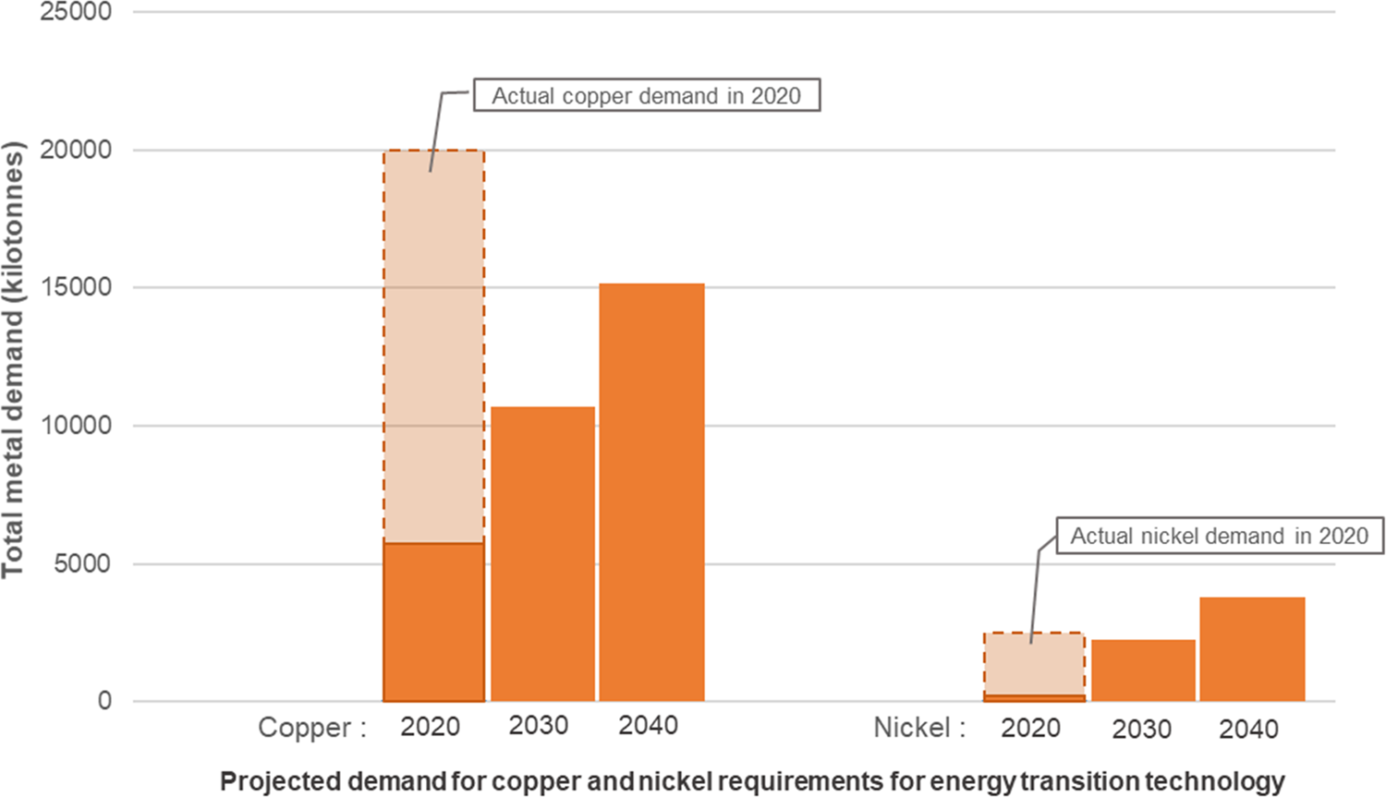
Fig 1: Requirements for energy and transition technology
Source: (Cox et al., 2025)
The second major natural environmental stress is water shortages. Codelco's activity is concentrated in the north area of Chile, and especially in the Atacama Desert, which is one of the driest regions in the world, with operational continuity being under threat due to the long periods of drought and freshwater scarcity. Environmental groups are increasingly seeking mining companies to conserve freshwater, and to avoid harming sensitive ecosystems. As a result, Codelco has set ambitious environmental goals, such as lowering the unit freshwater consumption of the sulphide plants in water-stressed basins by 60% by 2030, and by less than 10% for the most water-stressed basins by 2035 (Codelco, 2025c). In support of those goals, the company is building a new, significant desalination plant to be used to provide water for Northern Operations, to be ready for industrial water supply in 2026, as well as expanded mine-water recirculation and recycling systems. These programs help to lower the risk of operations and enhance Codelco's environmental footprint among its customers who value responsibly sourced minerals.
The natural setting is also propelling technological advances that bolster Codelco's market position. The company has already installed over 250 electric buses, which currently make up the largest fleet of electric transport in Chile's mining industry, and signed long-term power purchase agreements, which will generate an 85% renewable electricity matrix by 2026, with plans to reach 100% renewable electricity supply by 2030. Additionally, Codelco is testing electric haul truck technologies that can cut vehicles emissions by 60-70% and implementing energy-efficient mineral processing technologies that can lead to up to an 80% saving in processing energy consumption (Codelco, 2026a). These investments illustrate the fact that environmental pressures are not only compliance requirements but also differentiators of products.
Political Actor
A second important external marketing environment actor affecting Codelco's transition towards lower carbon products is political forces, as environmental legislation, government ownership and international climate policy directly affects the company's strategic priorities. In contrast to private mining companies, Codelco has 100% government ownership, and its sustainability plan resonates strongly with the country's climate goals and industrial policy (Codelco, 2026b). Political decisions thus have consequences beyond compliance, for investment decisions, access to financing and the company's competitiveness in increasingly demanding international markets for minerals from responsible sources.
Chile has made ambitious climate policies, which demand heavy emission reductions in the mining sector. As part of the nation's Long-Term Climate Strategy, Chile seeks to become carbon-neutral by 2050, with plans to lower emissions from industrial and mining activities by 70% and increase renewable electricity generation and embrace zero emission mining fleets in the coming decades. In October 2025, the Chilean Government signed the Mining Decarbonisation Agreement with the Chilean Mining Council, the Ministry of Mining, the Ministry of Energy and the Ministry of Economy and Environment, with the objective of speeding up the implementation of the Agreement (Deloitte, 2026). Chile's policy and regulatory framework for decarbonisation will enable Codelco to benefit from the increasing demand for sustainable mining and the low-carbon copper, with the global mining market expected to grow at a 6.3% CAGR from USD 2.16 trillion in 2026 to USD 2.76 trillion by 2030.
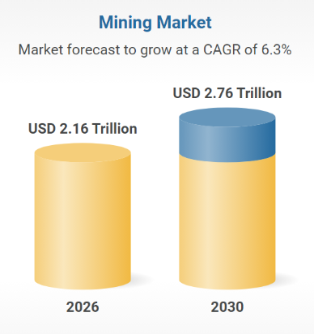
Fig 2: Mining Market
Source: (Research and Markets, 2026)
Codelco's decarbonisation investments are also directly assisted by government policy, both financially and in terms of strategic control. In 2024, Codelco launched its inaugural climate financing programme valued at US$ 532 million, of which the financing will be used to implement decarbonisation projects such as renewable electricity, emissions reduction and sustainable mining technologies (ICMM, 2026). The company is politically supported and backed more strongly than other private businesses, with its longer-term sustainability investments, which may not yield financial benefits for many decades.
International market access is also affected by the political developments. Increasingly stringent environmental reporting standards and sustainable procurement policies throughout Europe, North America and Asia are putting governments under pressure to choose suppliers that can prove they are low carbon producers. This opportunity was seized by Chile with the adoption of its National Critical Minerals Strategy, which was adopted in January 2026, where copper production in a responsible way is considered a strategic export for the electrification of the world and the expansion of renewable energy (IEA, 2026a). The strategy recognizes the increasing international competition for these critical minerals with ethical and sustainable production, and aims to consolidate the Chilean's role as a trustworthy supplier. It means that Codelco's environmental performance is becoming more and more an obligation and an asset in international B2B markets.
Political forces also bring a number of strategic risks, however, despite these benefits. Environmental permitting and shifting government priorities, as well as mining royalty changes, can cause delays for expansion project, higher compliance expenses and uncertainty about long-term capital investment. Codelco is a government owned company and therefore could have more political influence in its investment decisions, than a private competitor (IEA, 2026b).

2.0 Task 2: Strategic Growth and Competitive Positioning

2.1 Recommendation of a strategic growth approach for the company using the Ansoff Matrix
Market Penetration (Existing Products – Existing Markets)
Market penetration involves selling more of existing copper products in existing markets. Codelco already has a solid global footprint, as in 2025, it is scheduled to produce 1.44 million tonnes of copper and to generate revenue of US$16.99 billion and an EBITDA of US$6.67 billion. However, the global copper market is expected to expand from 26.29 MT in 2025 to 33.27 MT till 2031 at 4.01% CAGR, meaning that besides market penetration it is crucial for Codelco to be able to differentiate its products by offering low-carbon copper. So, to sustain long-term competitive advantage in a rapidly low-carbon world, it is unlikely that the only way to boost sales of conventional copper will be sufficient (IEA, 2026c).
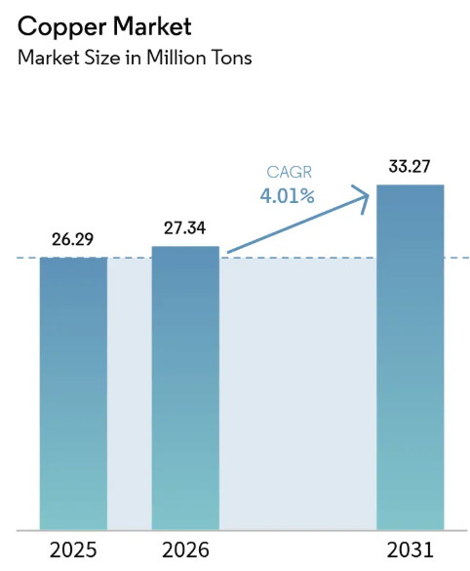
Fig 3: Global Copper Market
Source: (Mordor Intelligence, 2026)
Market Development (Existing Products – New Markets)
Market development is the marketing of current product into new geographic or industrial markets. The global demand for copper is continuing to rise as investment in EV, renewable energy and power grids are rising. But Codelco is already able to export to the key markets of Asia, Europe and North America, which restricts the potential for significant expansion (McKinsey & Company, 2026). Furthermore, geographies are not enough for long-term growth because international buyers are more interested in investing in low-carbon, responsibly sourced copper than in the regular products, which are no longer attractive.
Product Development (New Products – Existing Markets)
The greatest opportunity is product development, as it will supply new low-carbon copper products to current industrial customers. In 2025, Codelco pledged to decrease the intensity of its Scope 3 emissions by 25% by 2030; acquired more than 250 electric buses; and progressed its renewable electricity projects toward a 100% renewable electricity target by 2030. Over 450 proposals for sustainability innovations have been received by the company, and 20 projects are being put into practice (Microsoft, 2026). All these programs allow Codelco to distinguish its copper product by certifying its environmental performance, while satisfying customers who are increasingly demanding more sustainable minerals.
Diversification (New Products – New Markets)
Diversification is a strategy where new industries and new products are entered. Codelco has advanced the first steps with its lithium project, SQM, which will lead to a net income in 2025 of US$2.423 billion. But it's a big investment that needs to be done, and the company is already investing in structural mining projects at a rate of $5.07 billion a year (Mining.com, 2026). It would be financially and operationally risky to enter into new markets, which would be a less desirable short-term option than strengthening its core copper operation.
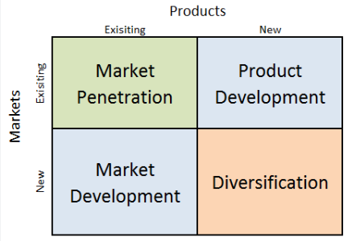
Fig 4: Ansoff Matrix
Source: (Dudovskiy, 2023)
Recommendation of Strategic Growth Approach
Product Development is the best strategy for growth for Codelco, according to the analysis of the Ansoff Matrix. The company's ability to produce certified low carbon copper, produce with renewable energy and provide traceable sustainable products allows it to cater to the current worldwide client base and meet the growing ESG demands (OECD, 2026). This approach will help to differentiate from the competition, optimize the relationship with customers and pave the way for the company to take advantage of the demand for low-carbon critical minerals that have lower risk than diversification.

2.2 Way the organisation can achieve competitive advantage while transitioning to a lower-carbon business model
Codelco's differentiation strategy in the market would be to focus on responsible and low-carbon copper production and not only on production volume, giving the company a competitive edge in the long-term. The company can leverage its significant efforts in sustainable supply chain management by marketing certified copper products that customers can be confident of being environmental friendly (Reuters, 2026a). Codelco copper production, between 90,000 and 170,000 tonnes monthly from 2022 to January 2026, points to a need to differentiate with the help of the Copper Mark certified copper products based on low carbon and ESG standards. For its part, the El Teniente Division also acquired The Copper Mark and The Molybdenum Mark for 2026, further enhancing Codelco's credibility as a responsible supplier and enhancing the availability of verified sustainable minerals for global customers (Reuters, 2026b).
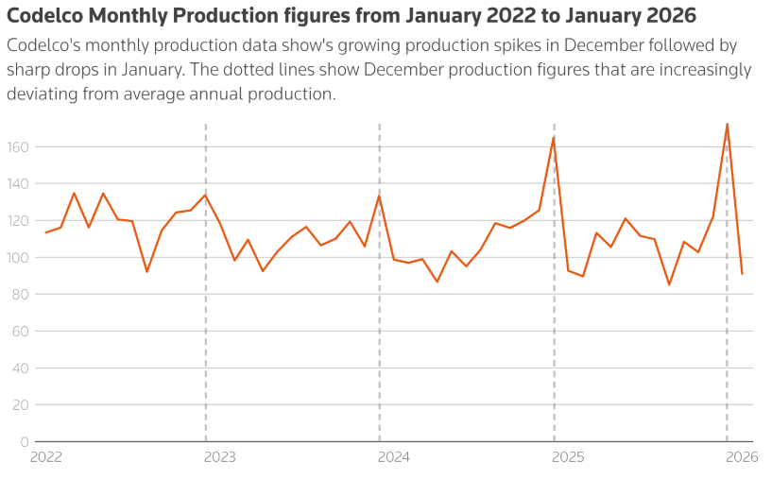
Fig 5: Codelco Monthly Production
Source: (Reuters, 2026c)
The company's sustainability measurement and transparency leadership is another source of advantage. In 2025, Codelco was the first mining company in Chile to measure its blue water footprint and customers are now able to see how much freshwater is used to produce each tonne of copper. This enhances product traceability, mitigates consumer worries about water scarcity in mining and acts as a water saving tool (S&P Global Commodity Insights, 2026). The company also released its first Climate Change Report in the same year, where it made climate risks and progress towards emissions management and decarbonisation transparent for investors and industrial buyers. This transparency improves corporate reputation and contributes to better long-term customer relations in markets where ESG reporting is becoming increasingly a part of the procurement process.
Innovation partnerships further consolidate Codelco's competitiveness. The company recently signed an 18-month strategic partnership agreement in March 2026 with Microsoft to incorporate artificial intelligence, advanced analytics, automation and cybersecurity into mining operations (The Copper Mark, 2026). The partnership is primarily centered on autonomous systems, AI-driven decision making and operational optimisation, with the aim of increasing productivity whilst minimising energy consumption and operational risk. Comparable to many other companies, Codelco is embracing digitalization earlier than others, offering more than just environmental benefits to production, but also competitive advantages by reducing production costs, increasing operational reliability and accelerating sustainable mining practices (Chile, Ministry of Economy, 2026).
Lastly, Codelco has the opportunity of consolidating its market with circular economy projects and ESG leadership. In 2025, the company launched its first 100% recycled supply model for the mining industry, which has reduced the carbon footprint of this input by 53%, and, in 2026, extended it to other divisions, with annual emissions reduced by 40,000 tonnes of CO₂. Furthermore, Codelco led the Chilean mining industry in the Merco ESG 2025 ranking for the 11th time in a row, with 61,342 surveys from its stakeholders and 71 objective ESG indicators (Chile, Ministry of Mining, 2025). These accomplishments help to increase customer confidence, improve the company's environmental value chain relationship, and make Codelco more competitive than other miners by leaning on the transition to a lower carbon business model (UNFCCC, 2025).

3.0 Task 3: Critical Reflection on AI Usage

3.1 Tool Disclosure
This report was developed with the support of Artificial Intelligence (AI) tools, such as ChatGPT and Microsoft Copilot, which helped brainstorm ideas, enhance academic writing, restructure sentences and summarise publicly available information about Codelco's sustainability efforts. Machine learning was also used to select relevant marketing frameworks that facilitate the organisation of the report, such as the marketing environment model and the Ansoff Matrix. The AI-generated content was, however, only used as a secondary guide, and the analysis, critical evaluation, interpretation of evidence and report writing were carried out independently by the author. AI has been used with permission in compliance with the university's AI usage policy and policy on academic honesty.

3.2 Critical Evaluation of AI Output
All information generated by the AI tools was carefully reviewed and vetted before it was used in the report, though the tools were helpful with summarising content and offering writing assistance. Facts, statistics and company-specific information were cross-referenced with the latest Codelco sustainability reports, annual reports, government publications, industry reports and academic sources, to ensure accuracy and reliability. The AI generated information was verified for any statements that were unsupported, outdated information or inconsistencies were either omitted or sourced from reliable and trusted information. Checking data across several sources was another helpful way to detect potential inaccuracies in AI-generated output or conceptual flaws in the overview, making the final report accurate, current, and backed up by data instead of relying on the AI-generated version to the extent that it could be.

3.3 Contribution Analysis
AI was mainly used to produce the initial ideas, suggest a logical structure for the report and help to improve the language throughout the report. It also helped in pinpointing crucial marketing concepts and the possible sources that could be explored. The critical analysis, selection of evidence, interpretation of the marketing environment of Codelco, evaluation of the strategic alternatives of growth through the use of the Ansoff Matrix and conclusions were, however, produced by the author of this report, and were based on academic literature and verified company data. The inclusion of theory and the current evidence from the industry, comparisons and recommendations are, as a result, those of the author and do not necessarily reflect AI analysis.

3.4 Ethical & Professional Reflection
Marketing analysis is another area where AI can play a crucial role, providing benefits such as increased efficiency, aid in summarizing information, and helping to organize information. Its application also brings with it ethical and professional implications, such as the potential for misinformation, biased results, plagiarism and dependency on generated content. While AI-driven data can significantly inform marketing choices, it shouldn't replace human judgment or context, as these elements may be missing from the output. So it is crucial to use AI in a responsible way, and not as a replacement for independent analysis (World Bank, 2025). Transparency regarding the use of AI, verifying information from reliable sources, and fostering critical thinking and analysis in marketing are crucial to uphold academic honesty and professional standards in marketing analysis.

References
Chile, Ministry of Economy (2026) National Critical Minerals Strategy. Available at: https://www.economia.gob.cl
Chile, Ministry of Mining (2025) Mining Decarbonisation Agreement. Available at: https://www.minmineria.cl
Codelco (2025a) Annual Report 2024. Available at: https://www.codelco.com
Codelco (2025b) Climate Change Report 2025. Available at: https://www.codelco.com
Codelco (2025c) Sustainability Reports. Available at: https://www.codelco.com/sustainability
Codelco (2026a) 2025 Financial Results. Available at: https://www.codelco.com
Codelco (2026b) Investor Relations: Financial and Operational Information. Available at: https://www.codelco.com
Cox, B., Innis, S., Kunz, N.C. and Steen, J. (2025) ‘The mining industry as a net beneficiary of a global tax on carbon emissions’, Communications Earth & Environment, 3, Article 17. Available at: https://www.nature.com/articles/s43247-022-00346-4
Deloitte (2026) Tracking the Trends 2026: Mining and Metals. Available at: https://www.deloitte.com/global/en/Industries/mining-metals.html
Dudovskiy, J. (2023) Apple Ansoff Matrix. Research Methodology. Available at: https://research-methodology.net/apple-ansoff-matrix-2/
International Council on Mining and Metals (ICMM) (2026) Climate Change. Available at: https://www.icmm.com/en-gb/climate-change
International Energy Agency (IEA) (2026a) Global Critical Minerals Outlook 2026. Available at: https://www.iea.org/reports/global-critical-minerals-outlook-2026
International Energy Agency (IEA) (2026b) National Critical Minerals Strategy: Chile. Available at: https://www.iea.org
International Energy Agency (IEA) (2026c) Critical Minerals. Available at: https://www.iea.org/topics/critical-minerals
Kotler, P., Armstrong, G., Harris, L.C. and He, H. (2024) Principles of Marketing. 19th edn. Harlow: Pearson.
McKinsey & Company (2026) The Net-Zero Transition in Metals and Mining. Available at: https://www.mckinsey.com/industries/metals-and-mining
Microsoft (2026) Microsoft News: AI and Mining Innovation. Available at: https://news.microsoft.com
Mining.com (2026) Latest Copper and Codelco News. Available at: https://www.mining.com
Mordor Intelligence (2026) Copper Market Size & Share Analysis – Growth Trends and Forecast (2026–2031). Available at: https://www.mordorintelligence.com/industry-reports/copper-market
OECD (2026) Critical Minerals. Available at: https://www.oecd.org/en/topics/critical-minerals.html
Research and Markets (2026) Mining Market Size, Competitors, Trends & Forecast to 2030. Available at: https://www.researchandmarkets.com/report/mining
Reuters (2026a) Codelco and Microsoft Sign AI Partnership for Mining Operations. Available at: https://www.reuters.com
Reuters (2026b) Codelco Revises Production Outlook amid Project Challenges. Available at: https://www.reuters.com
Reuters (2026c) ‘Codelco monthly output dives, sowing doubts about validity of end-2025 production spike’, Reuters, 17 March. Available at: https://www.reuters.com/world/americas/codelco-monthly-output-dives-sowing-doubts-about-validity-end-2025-production-2026-03-17/
S&P Global Commodity Insights (2026) Metals and Mining. Available at: https://www.spglobal.com/commodityinsights/en/commodities/metals
The Copper Mark (2026) The Copper Mark Standard. Available at: https://coppermark.org
United Nations Framework Convention on Climate Change (UNFCCC) (2025) The Paris Agreement. Available at: https://unfccc.int/process-and-meetings/the-paris-agreement/the-paris-agreement
World Bank (2025) Climate-Smart Mining Initiative. Available at: https://www.worldbank.org/en/topic/extractiveindustries/brief/climate-smart-mining-minerals-for-climate-action

