A presentation on Academic and Employability Skills

Slide 2
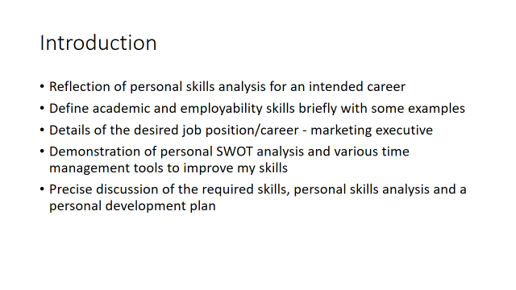
Note 2
Introduction
This part of the module of ‘Academic and employability skills’ contain an individual presentation on the reflection of personal skills analysis for an intended career. Firstly, this portion of the module defines academic and employability skills briefly with some examples and details of the job position/career that I have chosen - marketing executive. Also, this part contains a demonstration of my reasons to choose this career through personal SWOT analysis and various time management tools that I can use to improve my skills or satisfy the responsibilities as a marketing executive. Also, this includes a precise discussion of the required skills for this career along with their usage, what skills I have and what skills I do not have with proper reason, and a personal development plan for improving desired skills.
Slide 3
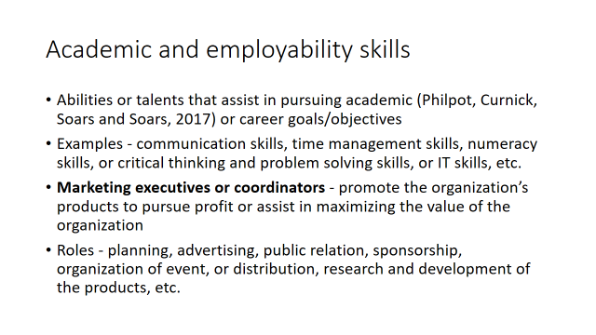Note 3
Academic and employability skills
Academic and employability skills include those abilities or talents of an individual that assist in achieving or pursuing academic or career goals or objectives with appropriate or effective performance (Philpot, Curnick, Soars and Soars, 2017). Thus, these skills vary over the levels or different responsibilities of different academic and career objectives where most of the common skills are communication skills, time management skills, numeracy skills, or critical thinking and problem-solving skills, or IT skills, etc. Like other academic and career positions, marketing executives or coordinators who are responsible to promote the organization’s products to pursue profit or assist in maximizing the value of the organization playing roles in diverse areas like planning, advertising, public relation, sponsorship, event organization, or distribution, research and development of the products, etc. As I intend to be a marketing executive of an organization in the future, I need to achieve diverse skills or capabilities as par the responsibilities of this position like building a strong relationship with customers to promote the brand which requires effective communication and presentation skills (Job profiles | Prospects.ac.uk, 2021) or creating contents/writing marketing copy requires to have literacy, designing, or innovative skills and so on.
Slide 4
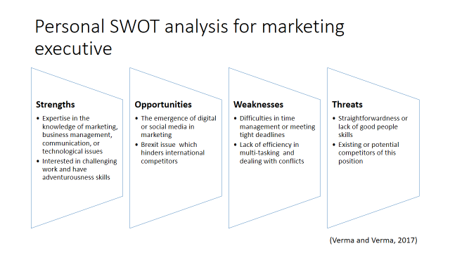
Note 4
Numerous underlying reasons acted towards choosing this job position which can be described with a personal SWOT analysis as follows:
Profound academic knowledge or understanding of the areas like marketing, business management, communication, or technological issues strengthen or motivate to choose this job position. Also, eagerness to take challenges due to adventurousness skills along with other supportive skills like commercial skills, designing skills, openness, and creative skills enhanced the chances of success in this career. Also, some changes in the marketing industry like the use of digital or social marketing tools (Twitter or Facebook, etc.) create opportunities for me to go for this position with expertise in IT and social media skills (Romanov, Drozdova and Romanova, 2018). Also, the Brexit issue restrict the executives of the EU to compete in the UK which creates the opportunity to compete with fewer people. Whereas, some weaknesses will create challenges in satisfying the responsibilities of this position like difficulties in time management or meeting tight deadlines, lack of efficiency in multi-tasking, and dealing with conflicts.
Table: Personal SWOT analysis for marketing executive
Strengths  - Expertise in the knowledge of marketing, business management, communication, or technological issues  - Interested in challenging work and have adventurousness skills | Opportunities  - The emergence of digital or social media in marketing  - Brexit issue which hinders international competitors
Weaknesses  - Difficulties in time management or meeting tight deadlines  - Lack of efficiency in (Verma and Verma, 2017) multi-tasking and dealing with conflicts | Threats  - Straightforwardness or lack of good people skills  - Existing or potential competitors of this position
Also, personality traits like straightforwardness or lack of good people skills create threats as the marketing industry operates holding customers as the central position and what customers say, is always right but which is not true indeed. Existing executives and potential candidates also create some threats with better skills and knowledge for this job position.
Slide 5
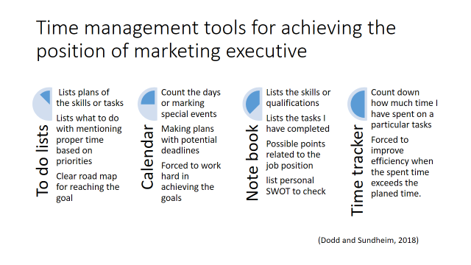
Note 5
Time management tools for achieving intended career
There are several time management tools to coordinate the assigned or targeted tasks in time. Some of the major time management tools are – the to-do list, calendar, or notebook, or time tracker, etc. The usage of these time management tools in pursuing the job position of a marketing executive is discussed below:
Although all of the time management tools work for ensuring the completion or achievement of goals in time through allowing evaluation of performance and make necessary corrections. Specifically, the to-do list will assist me in listing plans of the skills or tasks that I need to achieve or complete to be qualified for being hired as a marketing executive. This tool permitted me to lists what to do with mentioning proper time on priorities which provide me a clear road map for reaching the goal. Whereas, a calendar will assist me to count the days or marking special events, and making plans with potential deadlines which pushed or forced me to work hard in achieving the goals. also, keeping notebooks will help me (Dodd and Sundheim, 2018) to lists the skills or qualifications, what tasks I have completed, or possible points related to the job position along with listing personal SWOT to check what to do and how to improve. Also, a time tracker will help to count down how much time I have spent on a particular task and forced me to improve efficiency when the spent time exceeds the planned time.
Slide 6
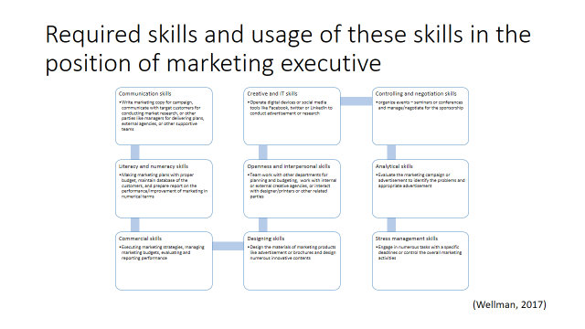
Note 6
Required skills and usage of these skills in intended career
Working as a marketing executive, required to develop numerous skills like communication skills both verbal and written as I will need to write marketing copy for the campaign, communicate with target customers for conducting market research, or other parties like managers for delivering plans, external agencies, or other support teams (Wellman, 2017). Also, this job position requires me to have literacy and numeracy skills as I need to assists in making marketing plans with a proper budget, maintain a database of the customers, and prepare a report on the performance/improvement of marketing in numerical terms.Also, the intended career of marketing executives required to have some commercial skills including skills in sales and marketing, leadership, and team working as I will be responsible for executing marketing strategies, managing marketing budgets, evaluating and reporting performance, etc. Whereas designing skills is also necessary as I need to design the materials of marketing products like advertisement or brochures and design numerous innovative contents to promote the brand. Also, openness and interpersonal skills like group work needed to be developed as I will need to engage in teamwork with other departments like sales for planning and budgeting, work with internal or external creative agencies, or interact with designer/printers or other related parties to satisfy the responsibilities. Creative and IT skills will also be necessary as I will be required to operate digital devices or social media tools like Facebook, Twitter, or LinkedIn to conduct advertisement or research as part of digital marketing along with creating content like videos or blogs, etc. Also, I have to develop controlling and negotiation skills to organize events – seminars or conferences to promote new products and manage/negotiate for the sponsorship to support the brand promotion (Job profiles | Prospects.ac.uk, 2021). Analytical skills are also important as I need to evaluate the marketing campaign or advertisement to identify the problems and appropriate advertisement for ensuring effective marketing along with arranging effective distribution of these marketing materials. Along with these skills, I need to develop stress management skills as I will be required to engage in numerous tasks with specific deadlines or control the overall marketing activities along with engaging other external parties in planning which may create challenges and stress, hamper the performance and failure in achieving organizational goals along with personal/professional development.
Slide 7
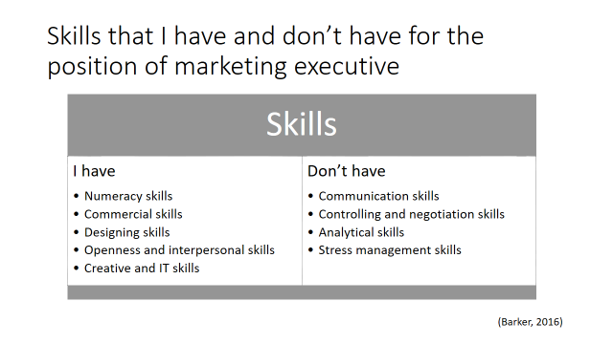
Note 7
Skills that I have and don’t have
As discussed earlier, the intended job position of marketing executive required to have some skills and qualifications. After careful evaluation, I have realized that I have some of these skills or abilities like literacy and numeracy skills as I have proved my expertise in reading and writing during completing the academic studies and also I can describe or analyse information in a numerical term using numerous mathematical/statistical tools (Barker, 2016). Also, I have possessed commercial skills as I have thorough knowledge in marketing and business management while I also have interpersonal skills as I have worked in numerous teams completing my academic tasks an also have profound in operating digital devices and media like Facebook or Twitter which enhance the creative and IT skills for satisfying the job roles. Along with these improved skills, I have will face some challenges or difficulties to be hired as a marketing executive due to the lack of some skills like effective communication or presentation skills as I have faced difficulties in making interaction with people, failed in presenting speech attractive way, or engaging audiences in the conversation. Also, I cannot manage conflicts or unusual situations and identify others point of interest or negotiate in a better term which shrinkage the controlling and negotiation skills. While difficulties in analytical skills due to lack of detailed evaluation or related information to (Wellman, 2017) understand situation and failure in stress management reduce the success or chances to satisfy the job position of marketing executive.
Slide 8
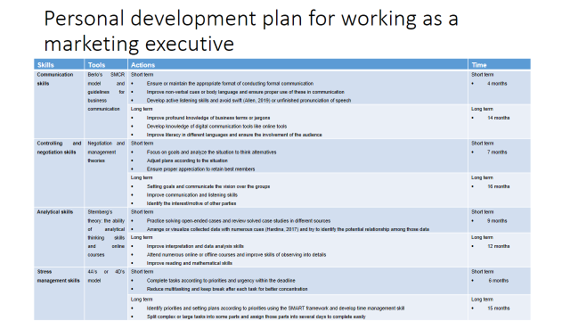
Note 8
Table: Personal development plan for working as a marketing executive
Skills | Tools | Actions | Time
Communication skills | Berlo’s SMCR model and guidelines for business communication | Short term  - Ensure or maintain the appropriate format of conducting formal communication  - Improve non-verbal cues or body language and ensure proper use of these in communication  - Develop active listening skills and avoid swift (Allen, 2019) or unfinished pronunciation of speech | Short term  - 4 months
Communication skills | Berlo’s SMCR model and guidelines for business communication | Long term  - Improve profound knowledge of business terms or jargons  - Develop knowledge of digital communication tools like online tools  - Improve literacy in different languages and ensure the involvement of the audience | Long term  - 14 months
Controlling and negotiation skills | Negotiation and management theories | Short term  - Focus on goals and analyse the situation to think alternatives  - Adjust plans according to the situation  - Ensure proper appreciation to retain best members | Short term  - 7 months
Controlling and negotiation skills | Negotiation and management theories | Long term  - Setting goals and communicate the vision over the groups  - Improve communication and listening skills  - Identify the interest/motive of other parties | Long term  - 16 months
Analytical skills | Sternberg’s theory: the ability of analytical thinking skills and online courses | Short term  - Practice solving open-ended cases and review solved case studies in different sources  - Arrange or visualize collected data with numerous cues and try (Hardina, 2017) to identify the potential relationship among those data  - Practice numerous brain games and try to learn new things regularly | Short term  - 9 months
Analytical skills |  | Long term  - Improve interpretation and data analysis skills  - Attend numerous online or offline courses and improve skills of observing into details  - Improve reading and mathematical skills | Long term  - 12 months
Stress management skills | 4A’s or 4D’s model | Short term  - Complete tasks according to priorities and urgency within the deadline  - Remove unnecessary tasks and delegate less important tasks to others  - Reduce multitasking and keep break after each task for better concentration | Short term  - 6 months
Stress management skills | 4A’s or 4D’s model | Long term  - Identify priorities and setting plans according to priorities using the SMART framework  - Develop time management skills  - Split complex or large tasks into some parts and assign those parts into several days to complete easily | Long term  - 15 months

Slide 9
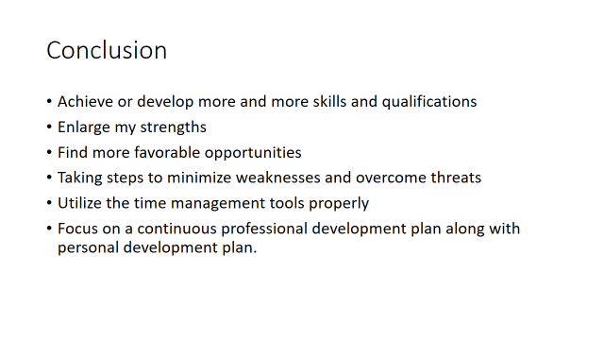
Note 9
Conclusion
For satisfying the responsibilities of the desired career better, I should achieve or develop more and more skills and qualifications related to the requirement. Also, I should improve or enlarge my strengths and find more favourable opportunities from external sources along with taking steps to minimize weaknesses and overcome threats. Also, I should utilize the time management tools properly to reduce inefficiency and focus on a continuous professional development plan along with a feasible personal development plan.

Reference
Allen, A., 2019. Time Management and Personal Development. Thorogood Publishing.
Barker, B., 2016. Employability skills: Maintaining relevance in marketing education. The Marketing Review, 14(1), pp.29-48.
Dodd, P. and Sundheim, D., 2018. The 25 Best Time Management Tools and Techniques.
Hardina, D., 2017. Analytical skills for community organization practice. New York: Columbia University Press.
Prospects.ac.uk. 2021. Job profiles | Prospects.ac.uk. [online] Available at: <https://www.prospects.ac.uk/job-profiles> [Accessed 4 August 2021].
Philpot, S., Curnick, L., Soars, L. and Soars, J., 2017. Academic skills. Oxford: Oxford University Press.
Romanov, E., Drozdova, T. and Romanova, E., 2018. SWOT-analysis: strategy of the organization to the strategy of personal growth. Perspectives of science and education, 36(6), pp.246-253.
Verma, S. and Verma, S., 2017. "Swot Analysis for Career Planning ." Artha - Journal of Social Sciences, 6(2), p.73.
Wellman, N., 2017. The employability attributes required of new marketing graduates. Marketing Intelligence & Planning, 28(7), pp.908-930.

