
Module Assignment Submission
Student Name: | Kevin richards
Student Number: | 2515044
Module No: | BMSK 2012
Module Title: | Enterprise and intrapreneurship
Statement of Confirmation of Authenticity
By the act of making this submission, the student declares that this is the work of the student named above. The work has not, in whole or in part, been knowingly presented elsewhere for assessment, or where assessment has been built on a previous assessment, this has been identified. Where materials have been used from other sources it has been properly acknowledged. If this statement is untrue, the student acknowledges that an assessment offence has been committed.
Attention is drawn to the plagiarism and unfair practice policies of both the University and of ILM.

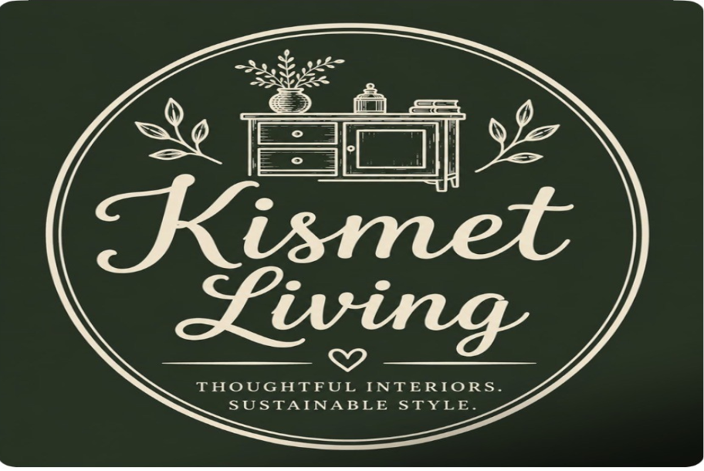
Kismet living
kevin and Claire richards
Partnership
Pontlliw,
Swansea
Partnership
kismetliving@outlook.com

Table of contents
Contents
1.Executive summary 5
2. Introduction and business identity 8
3. Personal suitability and smart objectives 10
SMART Objectives – Year One 11
4.1 Target Market and Market Size 12
4.2 PESTLE Analysis 13
Political 13
Economic 14
Social 14
Technological 14
Legal 14
Environmental 15
4.3 SWOT 15
4.4 COMPETITOR ANALYSIS 16
4.5 Unique selling point 18
5. Marketing and pricing strategy 18
5.1 Marketing objectives 20
5.2 7ps marketing mix 21
6. Operations 23
Risk Management and Self-Reflection 24
7.Financial information 25
7.1 First-year (12month) forecast 26
7.2 Break-even and capacity 28
8.Conclusion 29
References 30
Appendix A Customer Testimonials (2019-2020) 31
Appendix B House Clearance Pricing and Service 31
Pricing Justification 31
Restoration Strategy 32
Appendix C Evidence of commercial success 32
1. Authorised Annie Sloan Stockist 32
2. BBC Filming 33
3. Ticketed Customer Events 33
Appendix D- Case study-compassionate house clearance and customer care. 33
Appendix E – Property Renovation and Interior Styling Experience 34
Appendix F Marketing material 39
Appendix G 41
Industry - relevant CV summary 41
PROFILE 41
KEY LEADERSHIP & MANAGEMENT STRENGTHS 41
RELEVANT EXPERIENCE 42
FULL‑TIME CARER 43
MILITARY SERVICE 43
EDUCATION 44
ADDITIONAL INFORMATION 44

1.Executive summary
Kismet Living is a partnership that provides house clearances, property maintenance, and business and Airbnb styling services across Southwest Wales. The business targets homeowners, business owners, landlords, estate agents, and Airbnb hosts who need practical property improvements, professional styling, or complete property preparation before selling or renting.
Swansea has a population of approximately 238,500 (ONS,2023) creating a large potential customer base for Kismet Living’s Airbnb styling and house clearance services Environmental Protection Act 1990. Southwest Wales also provides a sizeable market, with around 21,000 registered businesses operating across Swansea, Neath Port Talbot, Carmarthenshire, and Pembrokeshire. The region is dominated by small and micro businesses, creating opportunities to work with estate agents, landlords, holiday-let owners, property investors, and local trades. As tourism and the private rental sector continue to grow, demand for property presentation, home staging, house clearance, and sustainable furniture reuse is expected to remain strong (Stats Wales).
The growth in short-term holiday accommodation across Wales has increased demand for professional property presentation, creating opportunities for Airbnb styling businesses (Visit Wales, ONS, Air DNA or Business Wales).
The business offers a complete service that combines practical property maintenance with interior styling. This makes it different from many competitors, who usually specialise in only one area. Customers can use one trusted company to manage the whole project, from clearing a property and conducting repairs to creating an attractive, guest-ready space. The business will operate from home; this will mean reduced fixed costs and financial risk during the first year. However, limited storage could restrict the quantity of furniture retained for restoration and resale. This will be managed by carefully selecting higher-value items, selling stock quickly online and using temporary storage only when financially justified.
Kismet Living is well placed to succeed because of the combined experience of both partners. I have over 30 years' experience in property maintenance, more than 15 years in house clearances and military leadership experience, providing strong organisational and practical skills. Claire brings experience in interior styling, business management, and customer service, as well as an extensive collection of vintage furnishings and styling accessories. This significantly reduces start-up costs, as the business already owns many of the resources needed to create high-quality interiors.
The estimated start-up costs are around £3100 covering insurance, marketing, branding, and specialist equipment. Most project materials will be purchased by clients, reducing financial risk and improving cash flow. The business aims to establish a strong local reputation, build long-term relationships with estate agents and Airbnb/business owners, and achieve profitability within its first year through repeat business and customer recommendations. According to Welsh Airbnb data, thousands of short-term rental properties operate across Southwest Wales, particularly in Pembrokeshire, Swansea, and Carmarthenshire. This provides a significant target market for Airbnb styling and business property improvement services.
In May 2022 there were 21,718 listings on Airbnb in Wales, up from 13,800 in 2018 (Beven foundation 2022)

Previous business experience demonstrated that relying solely on retail premises created significant overheads and contributed to burnout. The proposed business therefore adopts a low-overhead home-based model with diversified income streams, allowing greater flexibility and resilience."
Operating from home reduces fixed costs and lowers financial risk during the initial stages of the business. Although this limits storage space and may restrict future expansion, the lower overheads improve cash flow and provide greater flexibility while the business establishes its customer base.
Evidence from earlier business provides a solid foundation for Kismet Living. Customer reviews consistently praised the quality of service, welcoming atmosphere, product knowledge, and value for money, demonstrating an established reputation for delivering elevated levels of customer satisfaction.
By offering multiple services, the business is less dependent on a single income stream and more resilient to changes in demand. If one service slows, income can still be generated through house clearances, home staging, property preparation, furniture restoration, and maintenance.
Business planning literature also highlights the importance of developing flexible business models that can adapt to changing customer needs and market conditions. Osterwalder and Pigneur (2010) suggest that organisations creating multiple complementary value streams are better placed to respond to changes in demand while maintaining long-term resilience.
“The financial forecast indicates that Kismet Living is on track to make a profit in its first year, supported by low start-up costs, multiple income streams and careful cost management.”
The business model has been developed using lessons learned from previous commercial experience rather than assumptions alone. Although operating from home limits storage capacity and the business will initially depend on two partners, lower overheads and diversified income streams reduce financial risk and improve flexibility. This balanced approach provides a stronger foundation for sustainable growth than relying on a single service or operating from expensive retail premises.

2. Introduction and business identity
Kismet Living is a partnership between myself, Kevin Richards, and my wife, Claire Richards. Based in Swansea, Southwest Wales, we provide a range of property services including house clearances, property maintenance, home staging, Airbnb styling, and interior presentation for both residential and commercial clients.
The business has been created to provide customers with a complete property improvement service. Whether preparing a property for sale, conducting repairs and maintenance, clearing a home after bereavement or relocation, or styling an Airbnb or business premises to appeal to guests and customers, our aim is to deliver a dependable, professional, and practical service tailored to each client’s needs.
Our target customers include homeowners, landlords, estate agents, property investors, Airbnb, and holiday let owners, housing associations, and small businesses across Southwest Wales. Working from a home base allows us to keep our overheads low while offering a flexible, responsive, and competitively priced service.
The business will operate as a partnership because it allows us to combine our different skills and share responsibility for running the business. Claire and Kevin will register for self-assessment, keep accurate business records, and understand tax responsibilities (GOV.UK,2026a; GOV.UK,2026b).
As a partnership, we each bring different skills to the business. I will focus on house clearances, property maintenance, quotations, customer visits, and the day-to-day running of the business. “House clearance provides immediate income while also supplying quality furniture and homeware that can be restored and resold. This creates multiple revenue streams from a single job, reduces waste through reuse, and supports the business’s sustainability objectives” Claire will lead on the creative side, including home staging, interior styling, furniture sourcing, marketing, administration, and customer communication.
Rather than offering separate services, Kismet Living provides an all-in-one solution to help clients improve, prepare, and present their properties to a high standard. We want to build a strong reputation for professionalism, reliability, diligence and excellent customer service. We also aim to promote sustainability by reusing quality furniture and household items wherever possible, helping to reduce waste while providing value for our customers.
“Experience gained from operating Kismet Vintage Coffee & Curiosities demonstrated that maintaining retail premises created substantial fixed overheads and placed significant demands on time, staffing and day-to-day operations. This experience informed the development of Kismet Living, which adopts a lower overhead, home -based business model with multiple complementary income streams. By reducing costs while diversifying revenue through property preparation, house clearance, furniture restoration, interior styling and online sales, the business is designed to provide greater flexibility, financial resilience and long-term sustainability.
The table below outlines Kismet Living's circular business model, showing how each stage adds value and creates multiple income streams from a single project. This approach supports sustainability while maximising the commercial potential of each property clearance.

Stage | Activity | Value created
1 | Property clearance. | Identify reusable furniture and homeware.
2 | Furniture assessment. | Assess quality, condition, and resale potential.
3 | Restore/refresh. | Clean, repair or restore suitable items.
4 | Home staging & styling. | Use restored furniture to stage homes and holiday lets.
5 | Sell furniture online. | Sell quality items through Etsy, eBay, Facebook marketplace, and other platforms.
6 | Generate income. | Create revenue from services and furniture sales.
7 | Create new property opportunities. | Build long-term relationships leading to repeat work, referrals, and additional projects.

Overall, this process demonstrates how Kismet Living combines sustainable practices with value creation. By restoring, reusing, and styling furniture, the business generates additional income while creating opportunities for future projects and long-term customer relationships.
Instead of simply clearing a property, Kismet Living creates value at every stage by restoring furniture, improving property presentation, and generating several income streams from a single project. This reduces waste, keeps overheads low and allows the business to respond to changing customer needs. However, the success of this model depends on accurately identifying furniture with resale potential and managing projects efficiently. When managed effectively, it provides a competitive advantage that many local businesses do not currently offer, demonstrating innovation, opportunity recognition, and sustainable entrepreneurship.
Porter (1985) argues that businesses achieve competitive advantage by offering customers a distinctive value proposition that competitors find difficult to replicate. Kismet Living's combination of property clearances, furniture restoration, home styling, and sustainable reuse creates a unique service offering within the local market.
Evidence of previous commercial success is provided in appendix C.

3. Personal suitability and smart objectives
I have the knowledge, skills and experience needed to establish and manage Kismet Living successfully. Over the past 30 years I have built experience in property maintenance, alongside more than 15 years working in house clearances. During this time, I have developed practical trade skills, strong problem-solving abilities, organisational skills, and the confidence to collaborate with a wide range of customers while consistently delivering a high standard of service. This practical experience reduces many of the risks normally associated with starting a new business because many of the services offered have already been successfully delivered in previous ventures.
My military background has also developed my leadership, teamwork, communication, and decision-making skills. Although business differs from the military, these transferable skills provide a solid foundation for managing projects, leading people and working under pressure.
A key strength of the business is the partnership between myself and my wife, Claire. We previously owned and managed Kismet Vintage, combining my experience in house clearances, maintenance, and operations with Claire's expertise in interior styling, marketing, and customer service. Evidence of previous success and experience is provided in appendix C with further examples of renovation and styling projects in appendix E. Although the business model has changed, the experience gained provides a sturdy foundation for Kismet Living and reduces many of the challenges faced by first-time business owners.
Our combined skills allow Kismet Living to offer a complete property preparation service, giving customers the convenience of using one business rather than several contractors. However, delivering multiple services will require careful planning to maintain quality as the business grows.
I am also studying the Level 4 Applied Leadership and Management qualification to strengthen my knowledge of leadership, business planning, and management. This demonstrates my commitment to continuous learning and improving the business.
Overall, I believe our experience, complementary skills and commitment to excellent customer service place Kismet Living in a strong position to build a successful and sustainable business.

SMART OBJECTIVES– Year One
- Achieve a turnover of £60,000.
- Maintain an average 5-star customer review rating.
- Build partnerships with five local estate agents.
- Secure at least 60 paying customers or projects during the first year, increasing to eight paid projects per month by Month 9.
The projected Year 1 turnover of £60,000 has been deliberately set at a realistic level rather than an optimistic target. The forecast is based on previous trading experience, existing industry knowledge and a gradual return to business following a three-year break. Although the business has historically generated significantly higher revenues, this projection reflects a cautious approach that allows the partners to rebuild the business sustainably while maintaining low overheads and a healthy work-life balance. If demand exceeds expectations, the business has the capacity to increase turnover by expanding restoration work, property styling and online furniture sales without the immediate need for commercial premises.
These objectives are realistic, measurable, and based on previous business experience, providing clear targets to monitor the business's performance during its first year.

A copy of our CVs is included in the appendix to provide further evidence of our experience and qualifications.

4. Market Analysis, PESTLE, SWOT, competitors, and USP

4.1 Target Market and Market Size
Market research shows there is a strong tourism and self-catering market in Wales. In 2024, visitors made 7.61 million overnight trips to Wales and spent approximately £2.24 billion. Around 16% of these trips involved self-catering accommodation, representing approximately 1.22 million stays. Swansea alone attracts around 4.63 million visitors each year, increasing demand for quality holiday accommodation and creating opportunities for Airbnb owners to invest in professional property presentation.
There is also evidence that accommodation owners are investing in improving their properties. A Welsh Government survey found that 38% of tourism businesses had invested or planned to invest during 2025, with 81% aiming to improve the quality of their existing accommodation. Airbnb also reports that professional photography can increase earnings by an average of 21%, highlighting the importance of effective property presentation.
Swansea generated approximately £696 million through tourism in 2025, supporting the area as a suitable location for Kismet Living. Although demand may fluctuate because of seasonal tourism or changes to short-term letting regulations, offering house clearances, property maintenance and home staging alongside Airbnb styling reduces reliance on one market and creates a more resilient business model.
If approximately 1.22 million overnight trips involved self-catering accommodation, this demonstrates significant demand within the wider Welsh market. However, Kismet Living will initially focus on Swansea, Carmarthenshire, Neath Port Talbot, and Pembrokeshire. Securing only 60 projects during the first year would represent an exceedingly small share of the property and tourism market, making the target achievable.
Marketing research also supports the importance of building long-term customer relationships rather than focusing solely on individual sales. Kotler and Keller (2022) state that creating customer value, trust and satisfaction encourage repeat business and positive word-of-mouth recommendations, Existing digital audience, and market evidence.
Kismet Living benefits from an established Instagram account inherited from the previous Kismet Vintage business. At the time of analysis, the account had 3,120 followers despite having been inactive following the closure of the former premises. This indicates that the business retained significant brand recognition and customer interest.
Instagram audience data shows that 80.7% of followers are women, with the largest age groups being 35–44 years at 32%, 45–54 years at 26%, and 55–64 years at 14.8%. In total, 72.8% of the audience is aged between 35 and 64. This closely reflects the intended customer profile for Kismet Living, which includes homeowners, landlords, property sellers and customers interested in interiors, vintage furniture, restoration, and sustainable reuse.
The audience is also geographically relevant. A total of 93.7% of followers are based in the United Kingdom, while Swansea represents the largest individual city at 17.4%. Other local areas include Llanelli, Dunvant, Morriston and Bishopston. This demonstrates that the business already has an established audience within its intended operating area of Swansea and Southwest Wales.
During the most recent 30-day period, the account recorded 807 content views. Of these, 62.7% came from non-followers, suggesting that the content continues to reach potential new customers beyond the existing audience. Instagram data also shows that followers are most active between 6pm and 9pm, which can inform future posting and promotional decisions.
Overall, this evidence reduces the marketing risk associated with launching Kismet Living because the business is not beginning without an audience. It already possesses an established social-media platform, local brand awareness and a clearly identifiable target market. Which form a key part of Kismet Living's marketing strategy.

4.2 PESTLE Analysis
A PESTLE analysis examines the external factors that may influence the success of Kismet Living. Understanding these factors helps identify opportunities while reducing potential risks.

Political
Government support through Business Wales and local enterprise schemes can help new businesses establish and grow. Waste disposal legislation also affects the house clearance side of the business, requiring compliance with legal waste management procedures.
Welsh self-catering properties must meet occupancy requirements to qualify for non-domestic rates, encouraging owners to maintain ambitious standards and maximise bookings. While these regulations increase pressure on property owners, they also create opportunities for businesses that improve property presentation and guest appeal.

Economic
The rising cost of living may reduce customer spending, but demand for house clearances and property preparation remains stable because these services are often linked to bereavement, relocation, or property sales. Flexible pricing, free quotations, and multiple income streams should help the business remain competitive during changing economic conditions.

Social
Customers increasingly expect reliable businesses that provide high-quality accommodation and excellent customer service. Claire's interior styling experience, combined with our practical maintenance and house clearance background, provides a competitive advantage. However, maintaining this reputation will depend on consistently delivering ambitious standards and encouraging positive customer reviews.

Technological
Most customers now search online before choosing a business. A professional website, Google Business Profile and social media will help attract customers and build trust. Although digital marketing requires ongoing time and effort, it provides a cost-effective way of reaching a wider audience compared with traditional advertising.

Legal
The business must comply with health and safety legislation, waste disposal regulations, GDPR and tax requirements. We will register the partnership with HMRC, maintain accurate records, and operate under a partnership agreement.
House clearances will be conducted under a Natural Resources Wales Waste Carrier Licence, while risk assessments, COSHH guidance and safe working practices will help protect staff and customers. Appropriate insurance and compliance with the Consumer Rights Act 2015 will further reduce business risk.
Although legal compliance increases operating costs, it protects the business, builds customer confidence and reduces the likelihood of fines or legal disputes.

Environmental
Many customers prefer businesses that recycle and reduce waste. Reusing, restoring, and donating suitable furniture reduces landfill while supporting the business's sustainability objectives.
Sustainability also creates a competitive advantage by appealing to environmentally conscious customers while generating additional income from restored furniture.

4.3 SWOT

This SWOT analysis looks at the main strengths, weaknesses, opportunities, and threats affecting Kismet Living. It helps identify what the business does well and the areas that may need more planning.
STRENGTHS | WEAKNESSESS
Combines house clearance, maintenance, furniture sourcing, and styling in one service. | New business with limited brand awareness.
Around 15 years of house-clearance experience and 30 years of home-maintenance experience. | The business depends heavily on myself and Claire.
Claire has experience styling homes and our former vintage coffee shop. | Storage, vehicles, tools, and materials may create extra costs.
Military experience provides strong planning, reliability, and organisation. | We do not currently have formal interior-design qualifications.
Proven experience creating and styling successful vintage retail, hospitality, and residential interiors. | Some projects may require upfront costs.

Opportunities | Threats
Growth in Airbnb and holiday accommodation in Southwest Wales. | Competition from designers, house-clearance firms and Airbnb management companies.
 | Rising fuel, disposal, and material costs
  Owners may need help improving property photographs and guest appeal.
The business could collaborate with landlords, estate agents, and holiday-let owners. | Changes to tourism demand and short-term-let regulations.
Restored furniture could be sold online as another income stream. | Poor reviews or accidental property damage could harm the business.
The sustainable reuse of furniture could attract environmentally aware customers. | Seasonal demand may affect the number of projects available.

Overall, Kismet Living has strong practical experience and a unique range of services. However, the business will need to manage costs, competition, and changing regulations to grow successfully.

4.4 COMPETITOR ANALYSIS
Kismet Living will compete with interior designers, home-staging companies, and Airbnb management services across Southwest Wales. The Staging House Wales is a close direct competitor, offering home staging, vacant-property staging, presentation guides and serviced-accommodation styling across Swansea and South Wales. Its strengths are specialist staging knowledge and a focus on improving property photographs, but it does not appear to combine staging with house clearance, maintenance, and full Airbnb preparation. SA1 Interiors offers styling and interior design, while Stay Gower and N&N Stays provide Airbnb management, cleaning, and maintenance.
Kismet Living differs by combining house clearance, minor maintenance, furniture sourcing, and property styling in one service, so customers avoid using several companies. One-off packages will also suit owners who need property preparation without ongoing management fees.
Our strengths combine Claire’s interior styling experience with my house clearance, maintenance, and military planning background, allowing us to offer Airbnb owners in Southwest Wales a practical, affordable, and reliable service.
Competition is high; therefore, the business will differentiate itself through over 15 years of house clearance experience, 30 years of home maintenance experience, Claire's interior design knowledge, and competitive pricing. We will also encourage customer referrals and positive online reviews. Analysing competitors provides an understanding of the current market and helps identify opportunities for Kismet Living to stand out. By comparing services, strengths, and weaknesses, we can develop strategies that provide customers with greater value and a clear competitive advantage.
While some competitors specialise in only one service, this can require customers to coordinate several contractors, increasing both cost and inconvenience. By integrating house clearances, property maintenance, and styling into one business, Kismet Living provides a more efficient solution while creating several income streams from a single project. However, offering multiple services also requires effective planning and time management to maintain consistent quality. The competitors reviewed do not advertise the same combination of house clearance, maintenance, furniture restoration, and property styling.
The competitor analysis table compares Kismet Living with other businesses offering house clearances, home staging, furniture sales and property preparation services. It highlights the strengths and weaknesses of each competitor and helps identify how Kismet Living can stand out through its combined services, experience, sustainable reuse, and personalised customer approach.

Competitor | Their strength | Weakness | Our advantage
The staging house Wales. | Specialist staging. | No house clearance. | We provide both.
Stay Gower. | Full management. | Ongoing fees. | One-off packages.
SA1interiors. | Interior design. | No maintenance. | Complete property preparation.
This comparison shows that no local competitor offers the same combination of house clearance, maintenance, and Airbnb styling. This gives Kismet Living a clear competitive advantage.
"Although competitors specialise in individual services, they may have greater brand recognition and larger marketing budgets. Kismet Living will compete by offering a more personalised service and combining several services into one package."

4.5 Unique selling point
Kismet Living offers more than property clearance or interior styling. The business combines house clearances, furniture restoration, home staging, and property presentation into one integrated service.
Our key strength is identifying opportunities that others may overlook. During property clearances, we select quality furniture and homeware that can be restored, reused, or sold, creating added value while reducing waste. We also help homeowners, landlords, and holiday-let owners improve their properties through practical maintenance, interior styling, and furniture sourcing.
With over 30 years of experience in property maintenance, and over 15 years of house clearances and furniture experience, and interior styling, we can see the potential in both properties and their contents. This allows us to maximise value for our customers while providing a sustainable, flexible, and cost-effective service that few local competitors can offer.
“Kismet living doesn’t simply clear properties or sell furniture; it identifies hidden potential in homes, furniture and spaces creating value where others see very little”.
An example of a compassionate house clearance is provided in Appendix D

5. Marketing and pricing strategy
A clear marketing and pricing strategy is important to help Kismet Living attract customers build a strong reputation and generate sustainable income. The business will use a mix of digital marketing, networking, and competitive pricing to promote its range of services while reflecting the quality, experience and value offered to customers. Our pricing is based on previous jobs rather than research.
Examples of the proposed branding and marketing materials can be found in Appendix F
Rather than relying on one income stream, kismet living generates income through several complementary services.
Kismet Living’s prices are designed to remain competitive while reflecting the quality, experience, and value of the service. Quotations will be flexible and based on each customer’s needs and the amount of work required.

Service | Typical price | Reasoning
House clearances | From £300-£2500 | Based on property size, volume of contents and complexity of the clearance.
Property Preparation | Quotation | Tailored to each client's requirements and the work involved.
Home Staging | From £250 | Improves property presentation, helping properties sell or let more quickly.
Airbnb Styling | £650-1500 | Complete furnishing and styling packages tailored to holiday let properties.
Furniture Restoration | £40–£500+ | Price depends on the size, condition, and complexity of the restoration.
Vintage Furniture Sales | Variable | Profit generated from carefully sourced, restored, and resold vintage furniture.

Overall, the pricing structure supports a range of income streams while remaining fair and competitive within the local market. Offering flexible pricing enables Kismet Living to meet different customer needs, maximise profitability and support the long-term sustainability of the business.
Diversifying income reduces business risk. House clearances create opportunities to source furniture, which can then be restored and resold online or incorporated into interior projects.
Pricing has been determined using previous trading experience rather than competitor estimates. Over many years of trading, typical house clearance projects generated between £800 and £2,500, depending on property size, accessibility, and the volume of contents. This pricing reflects labour, transport, disposal costs, waste carrier compliance, and the commercial value created through the ethical resale and restoration of suitable furniture and household items. Using historic trading data provides a realistic, evidence-based pricing strategy that demonstrates commercial viability and supports the financial forecasts within this business plan.
PLEASE SEE APPENDIX B FOR A MORE DETAILED PRICING.

5.1 Marketing objectives
These marketing objectives will help Kismet Living build awareness, attract customers and develop a strong local reputation during its first year.
The pricing strategy has been developed to ensure services remain competitive while reflecting the value, quality and experience offered by Kismet Living. Prices are flexible where appropriate, allowing quotations to be tailored to each client's individual requirements and the scope of work involved.

OBJECTIVES | SMART ANALYSIS
Brand awareness | Reach 2,000 combined followers across Facebook and Instagram within the first 12 months by posting regular content, completed projects, before-and-after transformations, and vintage sourcing videos.
Customer enquires | Generate at least 20 customer enquiries per month by Month 6 through social media, Google Business Profile, referrals, estate agents, and local networking.
Sales and conversion’s | Secure at least eight paid projects or house clearances per month by Month 9, alongside additional income from furniture and vintage sales.
Business reputation | Gain 30 Google reviews with an average rating of at least 4.8 stars within the first year by providing excellent customer service and requesting feedback after every completed project.

Overall, the pricing structure supports a range of income streams while remaining fair and competitive within the local market. Offering flexible pricing enables Kismet Living to meet different customer needs, maximise profitability and support the long-term sustainability of the business.
Marketing will focus on social media, referrals, estate agents, and Google Business Profile. Before-and-after projects and sustainable furniture reuse will help build trust and attract customers.

5.2 7PS marketing mix

The 7Ps Marketing Mix explains how Kismet Living will market its services and meet customer needs. It outlines the key elements that will help attract customers, deliver quality services, and build a successful business.

7PS | Application to kismet living
Product | House clearances, Home staging, Airbnb styling, Interior styling, Furniture sourcing, Furniture restoration, Property Preparation, Handyman services, and the sale of carefully selected vintage furniture and homeware.
Price | Competitive, bespoke quotations based on individual customer requirements. Fixed prices for smaller services and transparent written quotations for larger projects.
Place | Home-based business operating throughout Swansea and Southwest Wales, with restored furniture and homeware sold nationwide through online platforms.
Promotion | Facebook, Instagram, Google Business Profile, Etsy, eBay, Vinted, partnerships with estate agents and holiday-let owners, together with customer recommendations and referrals.
People | Kevin manages house clearances, logistics, property maintenance, and customer relationships. Claire leads interior styling, home staging, furniture sourcing, restoration, marketing, and creative direction.
Process | Customer enquiry → Free consultation → Site visit (where required) → Written quotation → Booking → Completion of clearance, maintenance, or styling work → Furniture restoration (where required) → Customer sign-off → Follow-up and review request.
Physical Evidence | Professional branding, branded vehicle, before-and-after photographs, website, social media portfolio, customer reviews, uniforms, and professionally completed projects.

Overall, the 7Ps Marketing Mix supports Kismet Living's aim of providing high-quality property services while building customer trust and encouraging repeat business. Each element contributes to creating a professional and customer-focused business.
Marketing will focus on building trust through storytelling, highlighting completed projects, sharing before and after transformation and highlighting sustainable reuse. The business will rely heavily on referrals, social media, estate agents, and an established reputation rather than expensive advertising.
Previous customer testimonial’s provide evidence of the partners reliability, customer care and ability to deliver a high-quality service see Appendix A.

6. Operations
The operational plan explains how Kismet Living will deliver its services on a day-to-day basis. It outlines how the business will operate efficiently, meet customer needs, and ensure work is completed safely, legally and to a high standard.

Area | Plan
Locations and premises | Home-based business operating throughout Swansea and Southwest Wales. All customer visits by appointment.
Equipment | Van, trailer, hand tools, ladders, PPE, lifting equipment, decorating equipment, cleaning supplies, photography equipment, laptop, and mobile phone.
Suppliers | Local builders' merchants, paint suppliers, hardware stores, cleaning suppliers, furniture restoration materials, and trusted local trade professionals where specialist work is required.
Process | 1.Customer enquiry → 2. Initial discussion →3. Site visit (if required) →4. Written quotation →5. Booking →  6. Completion of work →7. Customer sign-off → 8. Invoice → 9. Follow-up and Google review.
Workflow journey | 1.customer enquiry 2. Initial discussion 3. site visit (if required) 4. written quotation 5. booking 6. completion of works 7.Customer sign-off 8. Invoice 9. follow-up & Google review.  See below for additional info.
Health & Safety | Risk assessments, manual handling procedures, PPE, safe use of equipment, safe waste disposal, vehicle safety checks and compliance with relevant health and safety legislation.
Legal Compliance | Waste Carrier Licence, Public Liability Insurance, GDPR compliance, Health & Safety legislation, consumer protection legislation, and HMRC registration.
Contingency | Emergency fund, flexible scheduling, trusted subcontractors where appropriate, equipment maintenance programme and alternative suppliers for key materials.
People / Owner Suitability | Kevin will lead house clearances, maintenance work, restoration, quotations, and operational management. Claire will lead interior styling, home staging, sourcing, marketing, administration, and customer communications. Together we provide both practical expertise and creative property presentation.
Risk Management | The main operational risks include manual handling injuries, working at height, use of power tools, transporting furniture, road travel, waste disposal, customer property damage, and delays caused by weather or supplier availability. These risks will be managed through appropriate insurance, risk assessments, training, safe systems of work, suitable PPE, and regular equipment maintenance.
Quality Control | All completed work will be checked against the agreed quotation before customer sign-off to ensure ambitious standards and customer satisfaction. Follow-up communication will encourage customer feedback, repeat business and referrals.
Capacity | Initially operate as a two-person partnership, completing 2–4 smaller projects or 1–2 larger property projects each week depending on size and complexity.

Mapping the customer journey demonstrates how Kismet Living delivers a consistent, professional service from initial enquiry through to project completion and aftercare. Each stage is designed to build trust, maintain clear communication and maximise customer satisfaction. This structured approach also encourages repeat business, referrals, and positive online reviews, supporting long-term business growth.
The workflow journey demonstrates how each project can create more than one source of income. By restoring, reusing, and reselling suitable furniture, Kismet Living can maximise the value of each job while reducing waste and supporting long-term profitability.
On balance, the operational plan demonstrates that Kismet Living has clear processes, appropriate resources, and effective risk management in place. This provides a solid foundation for delivering a reliable, professional service while supporting future business growth.

Risk Management and Self-Reflection
One of the main risks identified by the partners is not a lack of business opportunities, but the possibility of expanding too quickly. Previous experience showed that Kismet could successfully develop opportunities across retail, hospitality, house clearances, events, and furniture restoration. However, this growth also increased overheads, operational pressures, and workload, eventually making the business difficult to manage.
The partners recognise that their ability to identify opportunities is a major strength, but it can also become a weakness if growth is not controlled. Kismet Living has therefore been designed with clear operational limits. These include restricting the number of house clearances completed each week, remaining home-based for as long as practical and avoiding expansion that could reduce service quality or negatively affect work-life balance.
With more than fifteen years of practical business experience, the partners are confident in their ability to attract customers and build strong relationships. However, they understand that long-term success will depend on controlled and sustainable growth rather than continually increasing the size of the business.
The main lesson from previous experience is that business growth should not come at the expense of personal wellbeing, family life or customer service. Success within Kismet Living will therefore be measured through profitability, customer satisfaction, and the ability to maintain a manageable and balanced business model.

7.Financial information
The start-up costs identify the estimated investment required to establish Kismet Living. The budget covers the equipment, facilities and resources needed to launch the business and begin trading professionally.

Item | Estimated cost
Restoration tools and equipment | £800
Marketing and branding | £500
Waste carrier licence (upper tier NRW) | £184
Public liability insurance | £300
Vendoo | £16.99
Website & domain | £150-£250
Workshop set – up and equipment | £1000
The estimated start-up cost of £3,100 provides the resources required to establish Kismet Living. Careful financial planning and contingency funding will help the business operate successfully from the outset. The estimated start-up requirement is approximately £3,100, including a small contingency for unexpected costs.

7.1 First-year (12month) forecast
The first-year financial forecast estimates the expected income and expenditure for Kismet Living during its first 12 months of trading. It provides a realistic projection of the business's financial performance and demonstrates how the business aims to achieve profitability while maintaining positive cash flow.

Cashflow (£) | Pre-start | M1 | M2 | M3 | M4 | M5 | M6 | M7 | M8 | M9 | M10 | M11 | M12
Cash in Bank | £1000 | £1956 | £3526 | £4816 | £7805 | £10885 | £15295 | £13365 | £19085 | £23965 | £28044 | £33366 | £36986
Company Income
Cash sales | £2900 | £3500 | £3200 | £4800 | £5000 | £6500 | £7000 | £7500 | £7800 | £8000 | £8000 | £6000 | £4000
Credit sales collected
Loan / Owner investment
Total income | £3900 | £3500 | £3200 | £4800 | £5000 | £6500 | £7000 | £7500 | £7800 | £8000 | £8000 | £6000 | £4000
Total available (Bank plus income) |  | £5456 | 6676 | £9616 | £12805 | £17385 |  | £20865 | £26885 | £31965 | £36044 | £39366 | £40980
Company Outgoings
Van tax. |  | £31.50 | £31.50 | £31.50 | £31.50 | £31.50 | £31.50 | £31.50 | £31.50 | £31.50 | £31.50 | £31.50 | £31.50
Diesel. |  | £80 | £40 | £50 | £60 | £30 | £40 | £60 | £50 | £50 | £50 | £70 | £50
Cross list (vendoo). | £27.99 | £27.99 | £27.99 | £27.99 | £27.99 | £27.99 | £27.99 | £27.99 | £27.99 | £27.99 | £27.99 | £27.99 | £27.99
Van repairs/MOT. |  | £42 | £42 | £42 | £42 | £42 | £42 | £42 | £42 | £42 | £500 | £42 | £42
Tools. |  | £50 | £30 | £0 | £100 | £300 | £100 | £0 | £0 | £0 | £0 | £0 | £0
Van insurance | £40.06 | £40.06 | £40.06 | £40.06 | £40.06 | £40.06 | £40.06 | £40.06 | £40.06 | £40.06 | £40.06 | £40.06 | £40.06
website and domain. | £150 | £80 | £40 | £40 | £40 | £40 | £40 | £40 | £40 | £200 | £200 | £40 | £40
Accountant. |  | £50 | £50 | £50 | £50 | £50 | £50 | £50 | £100 | £300 | £!00 | £100 | £100
printer ink/stationary. | £30 | 0 | £30 | £0 | £0 | £0 | £30 | £0 | £60 | £0 | £0 | £0 | £0
vehicle breakdown. | £28.73 | £28.73 | £28.73 | £28.73 | £28.73 | £28.73 | £28.73 | £28.73 | £28.73 | £28.73 | £28.73 | £28.73 | £28.73
public liability. | £300 | £0 | £0 | £0 | £0 | £0 | £0 | £0 | £0 | £200 | £0 | £0 | £0
waste carrier licence. | £184 | £0 | £0 | £0 | £0 | £0 | £0 | £0 | £0 | £0 | £0 | £0 | £0
workshop set-up. | £1000 | £0 | £0 | £0 | £0 | £0 | £0 | £0 | £0 | £1000 | £0 | £0 | £0
marketing and branding. | £500 | £0 | £0 | £0 | £0 | £0 | £0 | £0 | £0 | £500 | £0 | £0 | £0
Owner drawings. |  | 15000 | £1500 | 1500 | £1500 | £1500 | £1500 | £1500 | 2500 | £1500 | 1500 | £2000 | £2000
Total paid out | £2210 | £1930 | £1860 | £1810 | £1920 | £2090 | £1930 | £1780 | £2920 | £3920 | £2678 | £2380 | £2360
Final balance | £1956 | £3526 | £4816 | £7805 | £10885 | £15295 | £13365 | £19085 | £23965 | £28044 | £33366 | £36986 | £38619

Overall, the first-year forecast indicates that Kismet Living has the potential to become a financially sustainable business through multiple income streams and careful cost management. Although actual performance may vary, the forecast provides a realistic foundation for planning future growth and investment.

7.2 Break-even and capacity
The break-even and capacity analysis estimates the level of sales needed for Kismet Living to cover its costs and operate profitably. It also identifies the number of projects the business can realistically complete each month while maintaining ambitious standards of service.
Measure | Estimated
Average house clearance value | £1000
Average furniture sale | £120
Average styling project | £650
Estimated monthly fixed costs | £1800
Break-even turnover | Approximately £3000 per month
Comfortable monthly turnover | £5000-£9000
maximum realistic capacity | Around eight house clearances, plus 4 styling projects also furniture restoration work and online sales each month

Based on estimated fixed costs of £1,800 per month and an average gross profit margin of approximately 60%, Kismet Living would need around £3,000 in monthly sales to break even. This calculation is: £1,800 ÷ 0.60 = £3,000.
- Tools
- Fuel
- Insurance
- Marketing
- Vehicle repairs/mot/tax
- Accountant
- Consumables
- Vehicle breakdown
- Website and domain
A break-even point of approximately £3,000 per month means Kismet Living needs around £3,000 in monthly sales to cover its fixed costs. This is achievable through approximately three average house clearances each month, with any additional income from furniture sales and styling services contributing towards profit.
The figures represent the maximum workload Kismet Living could complete during a busy month. However, work is likely to vary throughout the year, with some months being quieter or involving fewer, lower-value projects. This flexibility has been considered when planning the business's finances.
The break-even analysis shows that Kismet Living has the potential to become profitable at a realistic level of monthly sales. Careful planning and managing workload effectively will allow the business to maintain quality while supporting sustainable growth.

8.Conclusion
This business plan demonstrates that Kismet Living has a realistic and achievable business model with opportunities for future growth. By combining house clearances, property services, furniture restoration and interior styling, the business offers a unique and sustainable service. Careful planning, effective marketing, and sound economic management will provide a solid foundation for building a successful and profitable business.
Previous commercial experience significantly reduces the risk associated with starting Kismet Living. The business model has been developed using lessons learned from running a successful furniture, coffee shop and house-clearance business, allowing proven approaches to be adapted while avoiding previous challenges such as high premises costs.

References
Airbnb. (n.d.). Professional photography. https://www.airbnb.com/
Air DNA. (2025). AirDNA market data and analytics. https://www.airdna.co/
Bevan Foundation. (2022). Tourism and Airbnb in Wales. https://www.bevanfoundation.org/
Business Wales. (2026). Non-domestic rates for self-catering properties in Wales. https://businesswales.gov.wales/
Consumer Rights Act 2015, c. 15. https://www.legislation.gov.uk/ukpga/2015/15/contents
Environmental Protection Act 1990, c. 43. https://www.legislation.gov.uk/ukpga/1990/43/contents
Information Commissioner’s Office. (n.d.). Guide to UK GDPR. https://ico.org.uk/for-organisations/uk-gdpr-guidance-and-resources/
Kotler, P., & Keller, K. L. (2022). Marketing management (16th ed.). Pearson.
Office for National Statistics. (2025). Travel and tourism statistics. https://www.ons.gov.uk/
Office for National Statistics. (2023, January 19). How life has changed in Swansea: Census 2021. https://www.ons.gov.uk/visualisations/censusareachanges/W06000011/
Osterwalder, A., & Pigneur, Y. (2010). Business model generation: A handbook for visionaries, game changers, and challengers. John Wiley & Sons.
Porter, M. E. (1985). Competitive advantage: Creating and sustaining superior performance. Free Press.
Stats Wales. (2026). Business demography by area and year. https://statswales.gov.wales/
Swansea Council. (2026). Tourism research and statistics. https://www.swansea.gov.uk/
Visit Wales. (2025). Tourism industry statistics. https://www.visitwales.com/
Welsh Government. (2025). Tourism barometer: February wave 2025. https://www.gov.wales/
Welsh Government. (2026). Visitor levy in Wales. https://www.gov.wales/

Appendix A Customer Testimonials (2019-2020)
Customer feedback from the previous Kismet Vintage business demonstrates consistently important levels of customer satisfaction, repeat custom and positive word-of-mouth recommendations. This provides evidence that the founders have successfully built and managed a customer-focused business previously.
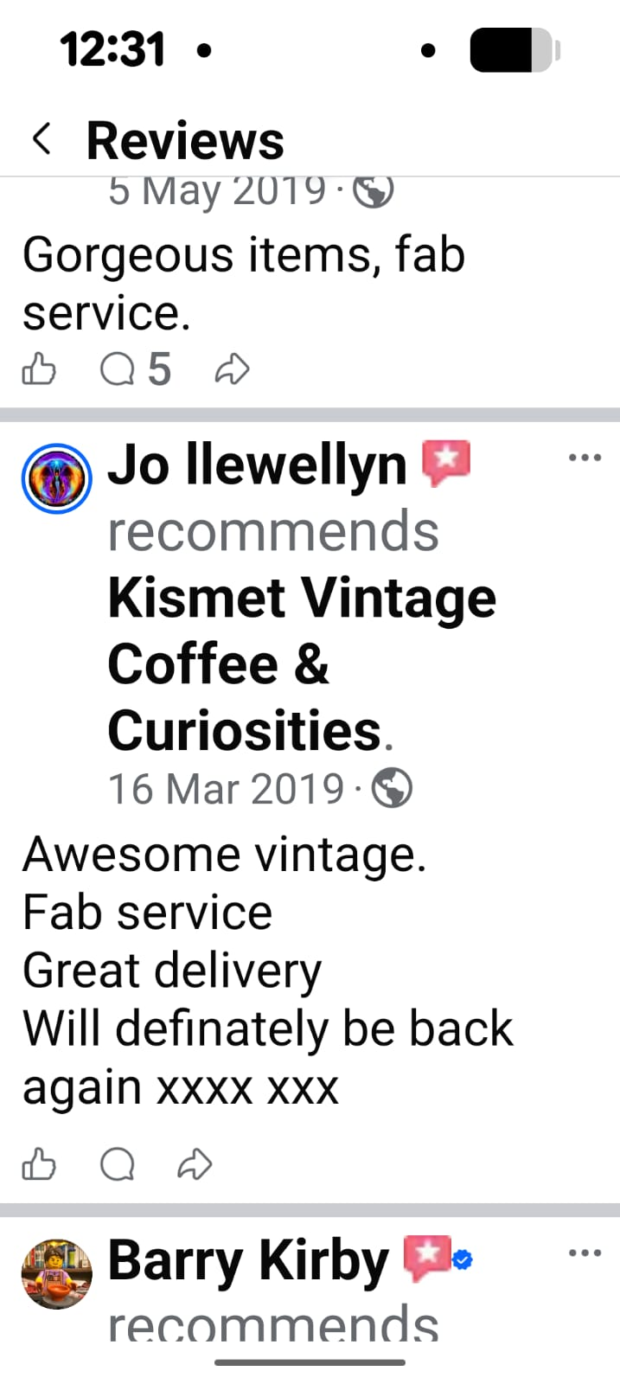
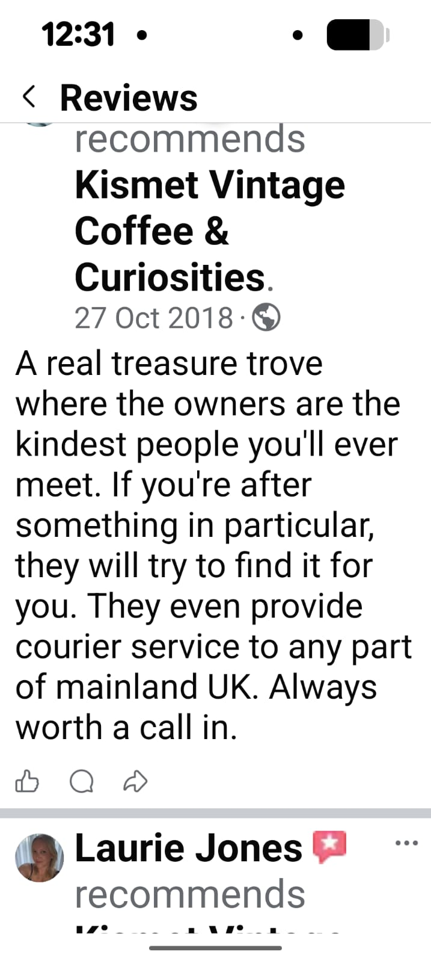

Appendix B House Clearance Pricing and Service
Our house clearance service supports executors of estates and families moving relatives into residential care. Most projects involve long-occupied three-bedroom homes with substantial amounts of furniture and personal belongings.
Based on previous trading, the average clearance fee was £1,000-£1500. Most jobs were completed in one day by a team of four and typically required around four - six van loads. The service included clearing the entire property, including lofts, garages, sheds, and gardens, with optional services such as garden maintenance, carpet removal, pressure washing and property preparation available at an additional cost.

Pricing Justification
The average charge of £1,000-£1500 reflected the scale of work rather than the property size. Earlier in the business, clearances were priced from around £500, but experience showed this did not cover the labour, transport, disposal costs, and time involved. Pricing was therefore increased to reflect the actual cost of delivering a professional, dependable, and compassionate service while maintaining a sustainable business.
Based on previous trading, the average house clearance fee was approximately £1,500. Prices will be reviewed regularly to reflect changes in inflation, disposal costs, fuel prices, and labour rates, ensuring quotations remain competitive and commercially viable.

Restoration Strategy
One of Kismet Living's key strengths is identifying furniture with resale potential during the initial property assessment. Before providing a quotation, each property is assessed to estimate labour requirements and the quality, condition and resale value of any furniture or household contents.
Where valuable furniture is identified, the resale value can offset part of the clearance costs, creating an additional income stream. This allows the business to offer competitive pricing while reducing waste through restoration and reuse.
With over 15 years' experience in the vintage furniture and interiors industry, Kismet Living can identify furniture worth restoring, including G-Plan, McIntosh, Nathan, solid oak furniture, Welsh dressers, farmhouse tables, and quality sideboards. These items remain in demand and offer strong resale potential.
Furniture is inspected for structural condition, wear, and damage. Wherever possible, original finishes are preserved through cleaning, minor repairs, and refinishing, with painting only used when restoration is not practical.
In contrast, many mass-produced reproduction pieces from the 1980s and 1990s have lower resale value. Assessing each item carefully ensures time and resources are focused on furniture that provides the best commercial return while supporting a sustainable, circular business model.

Appendix C Evidence of commercial success

1. Authorised Annie Sloan Stockist
Becoming an authorised Annie Sloan Chalk Paint® stockist was a significant achievement for the previous business. The application process was competitive and required the business to meet the brand's standards before being accepted. Specialist training was then completed to develop product knowledge and application techniques. This strengthened the business's reputation, improved customer confidence, and created additional income through paint sales, workshops, and furniture restoration.

2. BBC Filming
The previous business was selected by the BBC for filming, demonstrating its strong reputation and credibility. Rather than simply allowing the filming to take place, the opportunity was used to organise a ticket-only "Strictly Come Dancing" themed event. The event sold out, creating additional income while increasing customer engagement and promoting the business.

3. Ticketed Customer Events
The business regularly organised themed customer events that attracted strong attendance and sold out. These events generated extra income, encouraged repeat customers, and strengthened relationships with the local community.

Appendix D- Case study-compassionate house clearance and customer care.
While working in our previous vintage furniture shop and coffee shop, two ladies visited from England and commented on how unique the business was. During conversation, they asked where we sourced our furniture. I explained that, alongside purchasing items directly from customers, we also carried out house clearances. I told them that what made us different from many traditional clearance companies was that we always tried to restore, reuse and rehome as many belongings as possible because we believed that items which had been cared for throughout someone's lifetime deserved the opportunity to continue being appreciated rather than simply being thrown away.
One of the ladies then explained that she had travelled to Swansea following the death of her mother, who had lived in the same house in Mumbles for over fifty years. She admitted she felt completely overwhelmed and did not know where to begin clearing the property before it could be sold. She asked whether we would visit the house and advise her.
Following a site visit, we agreed a quotation and arranged a clearance date for the following week. As the customer needed to return home to England before the work could begin, she trusted us to manage the entire process. We liaised directly with the estate agent to collect and return the keys, allowing the property to be cleared without causing the family any additional stress.
The clearance was completed in one day by a team of four people and included the house, garden and outbuildings. Throughout the project, we carefully identified and separated any personal or sentimental belongings that we believed the family may wish to keep. Rather than simply removing everything, we took the time to ensure that important memories were preserved.
Among the items discovered was a small braid of the customer's mother's hair, carefully wrapped and kept from when she was sixteen years old. Alongside family photographs, documents and other personal possessions, it was placed safely into a box for the family. Once the clearance had been completed, we contacted the customer to let her know that we had retained several personal effects. A few months later, when she returned to Swansea, she collected the box and expressed her gratitude that these irreplaceable memories had been preserved.
This experience demonstrates that Kismet Living provides far more than a house clearance service. Every property represents a lifetime of memories, and we believe customers deserve empathy, dignity, and respect throughout what is often one of the most difficult periods of their lives. By combining compassion with professionalism, careful project management, and sustainable reuse wherever possible, Kismet Living aims to deliver a service that builds trust, generates recommendations, and provides genuine value to customers.

Appendix E – Property Renovation and Interior Styling Experience
The proposed Kismet Living business is supported by more than three decades of practical experience renovating and improving residential and commercial properties.
Examples of previous experience include:
Renovating numerous family homes over the past 30 years.
Renovating rental properties to improve presentation, functionality, and value. Transforming commercial premises, including the complete renovation and development of Kismet Vintage Coffee & Curiosities. Designing interiors that combine practicality, sustainability, and character.
Restoring original features wherever possible while introducing sympathetic modern improvements.
Assisting family and friends with decorating, styling, and preparing homes for sale.
Advising on room layouts, colour schemes, furniture placement, and presentation to maximise buyer appeal.
Restoring furniture specifically to complement renovated interiors.
Creating attractive, welcoming spaces on realistic budgets through careful sourcing and upcycling.
Relevance to Kismet Living
This extensive practical experience directly supports the services offered by Kismet Living, particularly property preparation, home staging, interior styling, and furniture restoration. Having successfully completed similar projects over many years, the partners possess the practical knowledge, creativity and problem-solving skills required to deliver high-quality results for future clients.

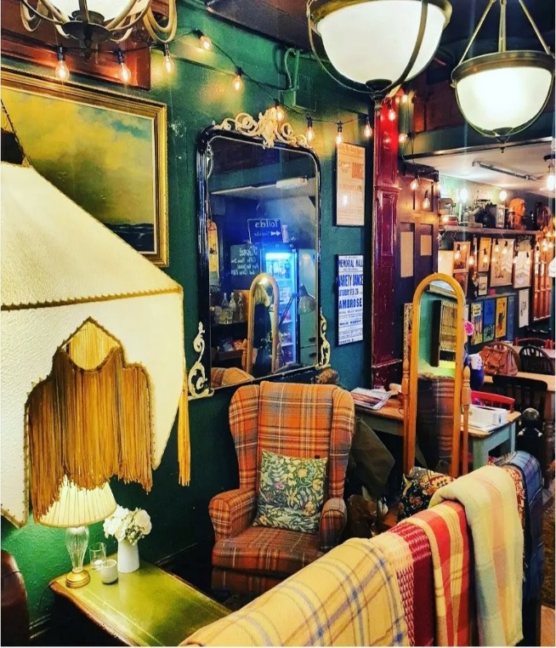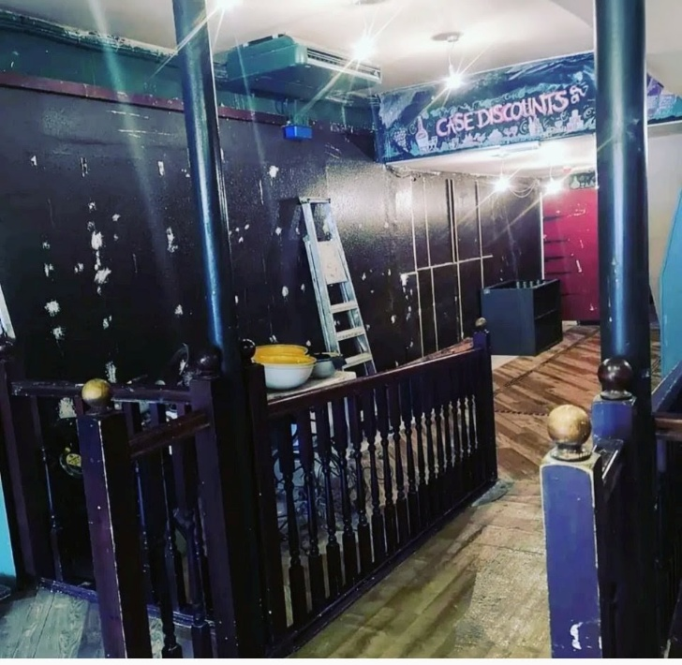

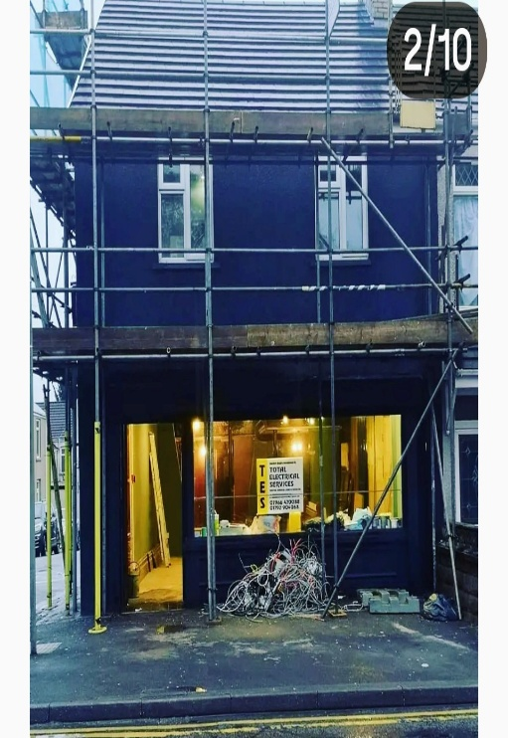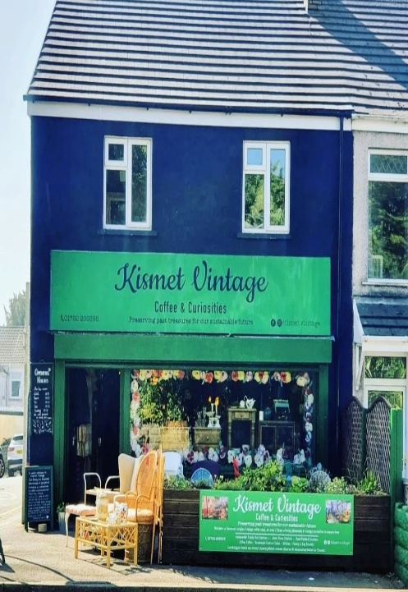
Kismet Vintage Coffee & Curiosities transformed a vacant retail unit into an award-winning destination that combined vintage retail, café services, furniture restoration, community events, and property styling. The business demonstrates practical experience in interior transformation, visual merchandising and creating commercially successful customer environments.
The premises itself reflected exactly that for which Kismet stood. It was an end-of-terrace building that had previously been a wine shop and, many years before that, a greengrocer. When we took it on, the upstairs had never been used commercially. We invested in completely renovating it, including replastering, new flooring and replacement windows, transforming it into additional customer spaces including a kitchen room, library, and clothing room. In total, the business grew to occupy 11 individual rooms, each with its own atmosphere and purpose. Rather than simply filling a shop with stock, we created a destination where customers wanted to explore, spend time and return.
Case Study 1 – Furniture Restoration
Project: Traditional Pine Wardrobe Restoration
Background A solid farmhouse pine wardrobe was completely restored to create a high-quality piece for a nursery. The wardrobe originally had significant sentimental value, having been owned by the family for many years.
Work Completed
Fully dismantled into individual sections.
Removed doors, drawers and fittings.
Stripped and sanded all surfaces.
Filled imperfections and prepared the timber.
Applied primer and furniture paint.
Cleaned and refitted original hardware.
Installed new handles where required.
Reassembled and quality checked.
Outcome The wardrobe was transformed into a contemporary heirloom piece that will continue to be used by the next generation, demonstrating the sustainability and craftsmanship that underpin Kismet Living.

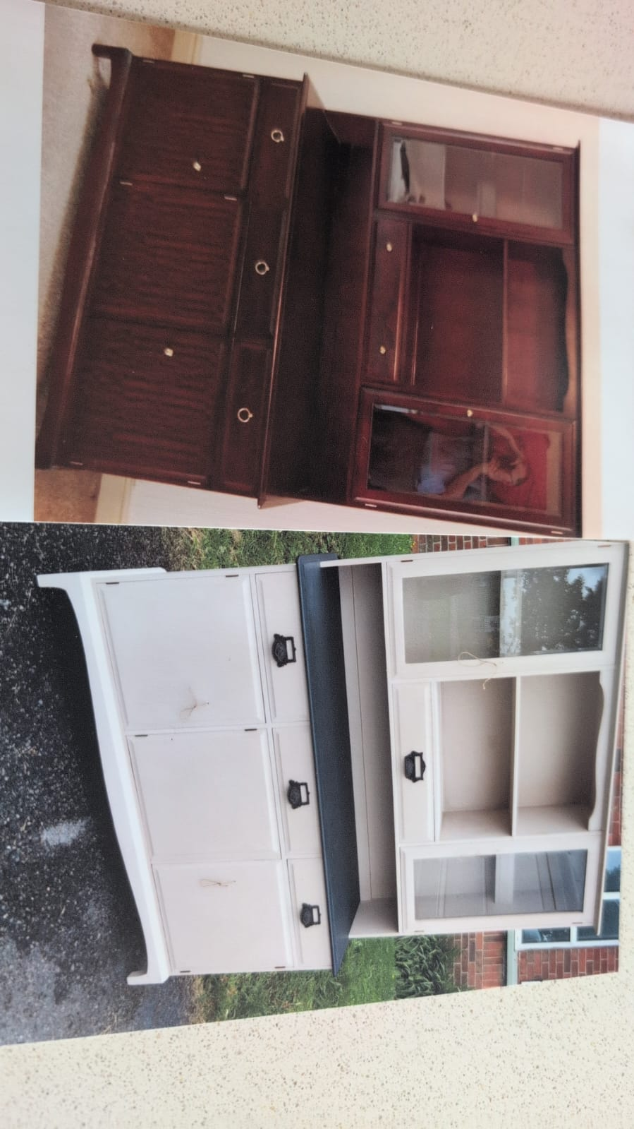

Before a stag wall unit, outdated.
Brought up to date with a Pale grey Matt finish, a slate effect surface and updated pull handles.

Case Study 2 – Furniture Transformation
Project: Farmhouse Dining Table
Client Requirement Create a statement dining table to complement a modern country home with eclectic styling.
Work Completed
Removed previous finish.
Sanded and prepared the timber.
Applied a rich dark wood stain to the tabletop.
Painted the base in a deep burgundy heritage colour.
Protected with a durable furniture finish.
Outcome The completed table became a unique centrepiece tailored to the client's interior, illustrating how existing furniture can be transformed instead of replaced.

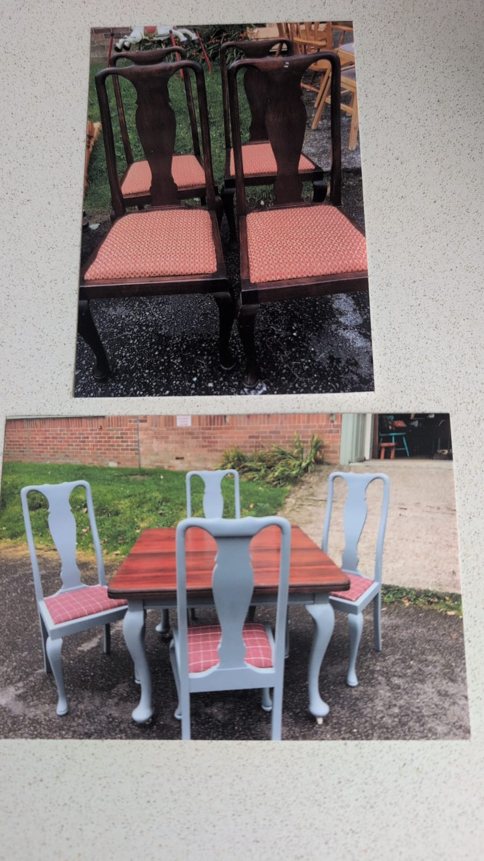

The customer’s own dining set originally belonged to their grandparents. The chairs were painted grey to suit the customer’s décor and the seats were recovered in modern burgundy tartan. The tabletop was stripped and resealed, while the base was painted to match the chairs.

Appendix F Marketing Material

Contains examples of the proposed marketing materials that will be used to promote Kismet Living and create a consistent, professional brand identity across all customer touchpoints. The materials demonstrate how the business intends to communicate its services, values and professionalism through both traditional and digital marketing. Together, these examples support the marketing strategy outlined within the business plan and illustrate how Kismet Living will attract, engage and retain customers while presenting a recognisable and trustworthy brand.

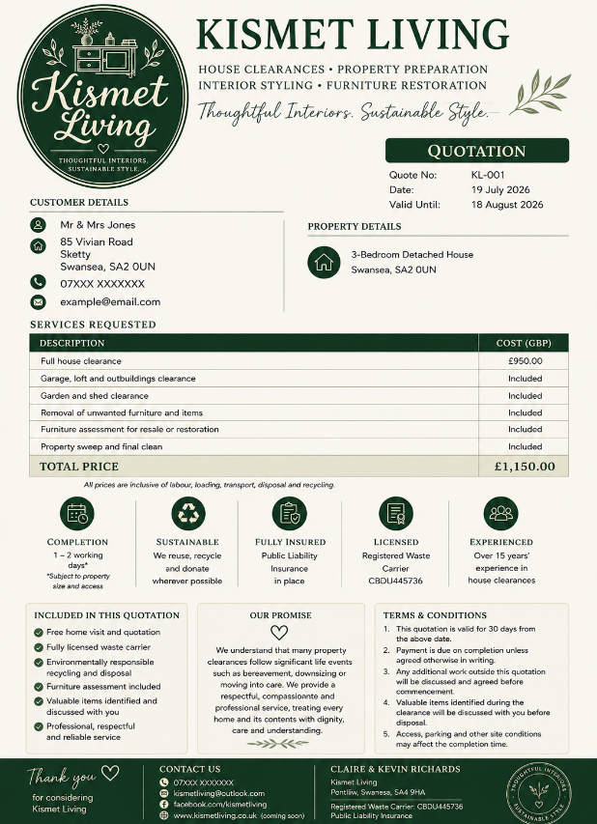

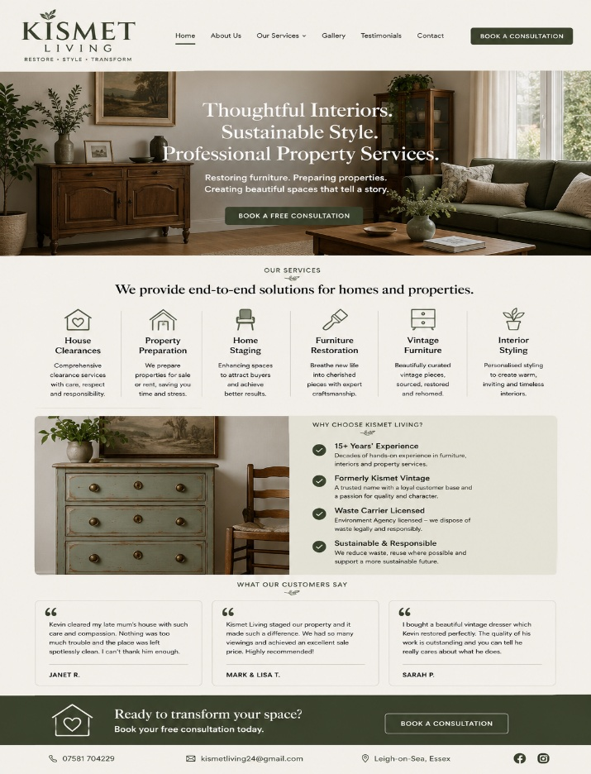

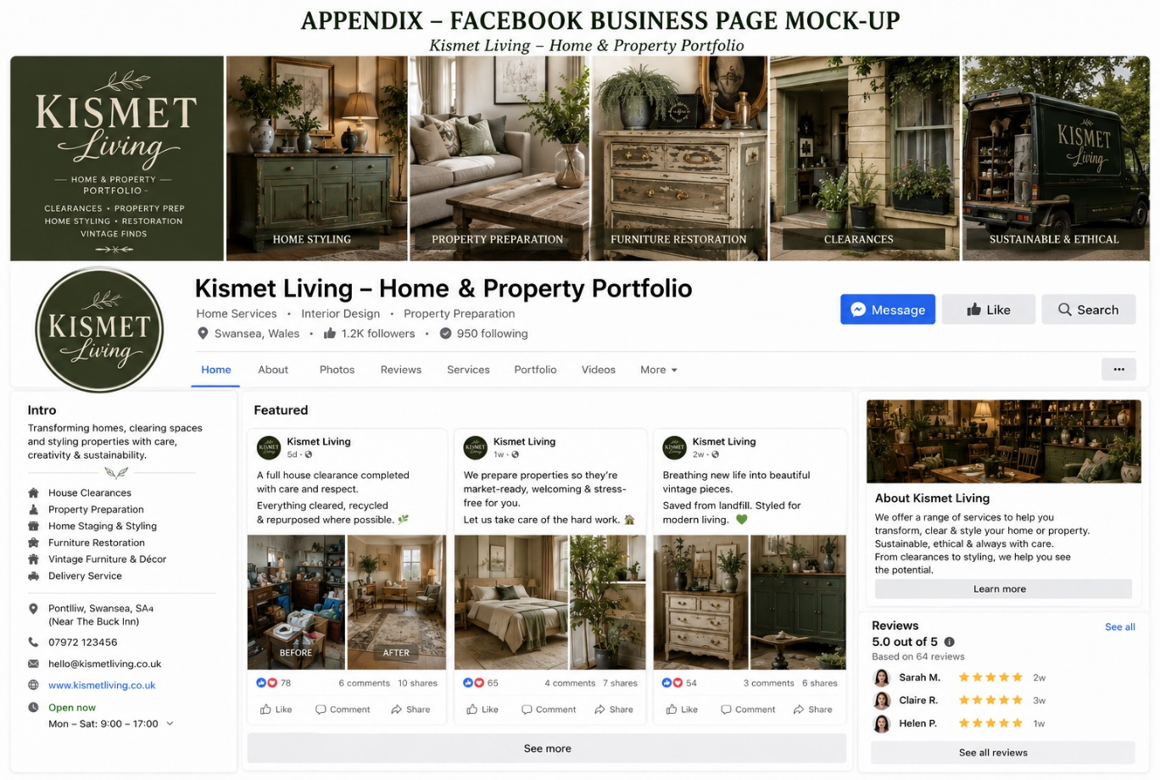

Appendix G

Industry - relevant CV summary

KEVIN MARK RICHARDS
Glanlliw uchaf, Pontlliw, SA4 9HA
Phone: 07597 177 890
Email: kevinrichards5337@gmail.com

PROFILE
A resilient, disciplined and experienced leader with a strong background in operations, team management, project management, and practical problem-solving. A former British Army soldier with over 30 years' experience in property renovation and maintenance, 15 years managing a professional house-clearance business, and experience running a large vintage furniture warehouse and a successful coffee shop employing eight staff. Skilled in business management, customer service, property presentation, furniture restoration, and sustainable reuse, with a proven ability to lead teams, manage projects and build strong client relationships. Currently studying Applied Leadership & Management (Level 4) to further develop strategic leadership and management skills.

KEY LEADERSHIP & MANAGEMENT STRENGTHS
• Team leadership & supervision
• Staff training, scheduling & communication
• Strategic and independent decision‑making
• Project & operational management
• Business ownership & monetary responsibility
• Experience managing large premises (30,000 sq. ft warehouse)
• Customer‑facing communication & conflict resolution
• Adaptability, resilience & problem‑solving

RELEVANT EXPERIENCE
2011–2023
Co-owner & Partner – Vintage Furniture Business (Self-Employed)
• Co-owned and operated a successful vintage furniture warehouse and coffee shop, specialising in furniture sourcing, restoration, sustainable reuse, interior styling and customer service.
• Managed sourcing, restoration, coordination, pricing, and customer service.
• Oversaw large‑scale operations including a 30,000 sq. ft warehouse selling second‑hand furniture.
• Managed budgeting, negotiation, and business strategy.
• Strengthened leadership, organization, and operational planning skills.
- Owner & Partner – Vintage Coffee Shop
2020 – 2023
• Co‑owned a popular vintage‑themed coffee shop employing eight staff.
• Responsible for scheduling, staff management, training, and customer environment.
• Overseen budgeting, ordering, and compliance.
• Demonstrated strong people‑management and team leadership.
- Owner & Partner – House Clearance Business
2011 – 2023
- Ran a professional house‑clearance service specializing in deceased estates.
- Collaborated closely with solicitors and estate agents.
- Organized planning, waste management, valuations, and resale operations.
- Demonstrated professionalism, sensitivity, and organizational leadership.
- Smallholding & Land Management
- 2021 – Present
- Routine livestock care: horses, sheep, goats, dogs, poultry.
- Responsible for fencing, land management, repairs, and machinery operation.
- Demonstrates long‑term planning, independence, and responsibility.
- Property Renovation – Self‑Employed.
2003 – Present
- managed renovation projects from planning to completion.
- Skills include carpentry, painting, tiling, maintenance, and tool use.
- Strong practical problem‑solving and project management abilities.
- Keith Chugg House Clearances – Clearance & Labour Assistant
- 2007 – 2009
- Juliana Butchers – Butcher’s Assistant
- 2006 – 2007
- Roger Thomas Butchers – Butcher’s Assistant
2002 – 2005
- Asda Supermarket – Customer Assistant
1999 – 2004
- Delivery Driver
1998 – 1999
- Brook Night Security – Security Officer
1997 – 1998

FULL‑TIME CARER
2010 – 2015
Provided full‑time care for ill wife while raising four children. This period demonstrates resilience, responsibility, emotional strength, organization, and the ability to manage multiple demands under pressure.

MILITARY SERVICE
Infantry Soldier – Royal Welch Fusiliers
Royal engineers.
British Army | 1991 – 1997
• Deployments to Northern Ireland, Canada, and Bosnia.
• Strong discipline, teamwork, and leadership under pressure.
• Experience in operational planning, communication, and high‑stress decision‑making.
Army Qualifications:
• 81mm Mortar Course – 1993
• Team Medic Course – 1995
• Combat Engineering Course – 1996
Key achievements
• Managed a 30,000 sq. ft furniture warehouse.
• Successfully employed and supervised a team of eight staff.
• Built and managed three successful businesses over 12 years.
• Developed long-term relationships with estate agents and solicitors.

EDUCATION
Applied Leadership & Management (Level 4) (Currently Studying)
University of Wales Trinity Saint David (UWTSD)
Expected completion: 2027.
Applied Leadership & Management (Current Study)

ADDITIONAL INFORMATION
• Full UK driving license
• Effective communication and people skills
• Dependable, physically fit, and initiative-taking
• References available on request

