

UNIVERSITY OF WALES TRINITY SAINT DAVID

BACHELOR OF SCIENCE (HONOURS)

POLICING AND CRIMINOLOGY

2020-2021

POLICING OF YOUTH OFFENDING: HOW DO POLICE REDUCE AND PREVENT OFFENDING OF THE YOUNG PEOPLE WITHIN THE CARMARTHENSHIRE AREA.

ELAN WILLIAMS

1802224

WORD COUNT: 8748

POLICING OF YOUTH OFFENDING: HOW DO POLICE REDUCE AND PREVENT OFFENDING OF THE YOUNG PEOPLE WITHIN THE CARMARTHENSHIRE AREA.

Coronavirus (COVID 19) Impact
In light of the continuing impact of the global pandemic, it is important to include a statement at the start of my dissertation which outlines the effects that COVID-19 has had on the research that I have undertaken towards your undergraduate degree.

The University of Wales Trinity Saint David recognises that the COVID-19 pandemic, and consequent closures of our campus (18th March 2020) and national and international lockdowns, has directly or indirectly impacted the work of many of our undergraduate researchers. Although the campus had periods of re-opening in 2020 and 2021, some research will have been disrupted and some personal circumstances difficult to manage. Teaching was arranged via suitable meeting software and documents shared electronically. All research data collection was designed to utilise digital data collection.

The inclusion of this statement is to facilitate the reader’s awareness, both now and in the future, that the pandemic may have had an effect on the scope, direction and presentation of the research.

The academic standards and quality threshold for the award remains unchanged. I wish to reassure readers that this statement is not evidencing a lack of original research or quality.
Declaration:
This work has not previously been accepted in substance for any degree and is not being concurrently submitted in candidature for any degree.
Signed:  Date: 03/05/2021
STATEMENT 1
This dissertation is being submitted in partial fulfilment of the requirements for the degree of BA.
Signed: Date: 03/05/2021
STATEMENT 2
This dissertation is the result of my own independent work/investigation except where otherwise stated. Other sources are acknowledged in the Reference Section.
Signed: Date: 03/05/2021
STATEMENT 3
I hereby give consent for my dissertation, if accepted, to be available for photocopying and for interlibrary loan, and for the title and summary to be made available to outside organisations.
Signed: Date: 03/05/2021

STATEMENT 4
I hereby give you consent for my dissertation, if accepted, to be available on the university’s IT system to those who have consent to use the system.
Signed: Date: 03/05/2021

TABLE OF CONTENTS

Chapter: | Title: | Page Number
Acknowledgements |  | 8
CHAPTER 1 | Introduction | 10
CHAPTER 2 | Literature Review | 14
2.1 | The present research of statistics in England and Wales | 14
2.2 | Present research of young people and offending in Wales | 16
2.3 | Youth Offending in Dyfed Powys Police force area | 18
2.4 | Safeguarding the young offender | 19
2.5 | Adverse Childhood Experiences and offending | 21
2.6 | Adverse Childhood Experiences – Wales | 22
2.7 | Social and psychological findings on young person’s offending behaviour | 24
CHAPTER 3 | Methodology | 27
3.1 | Selection Research Method | 27
3.2 | Organisation of Study | 29
3.3 | Ethical Considerations | 30
3.4 | Interview Process | 30
3.5 | Interview Reflection | 31
3.6 | Barriers and Limitations | 32
CHAPTER 4 | Findings | 34
4.1 | Findings illustrated within the graph  (Appendix C) | 35
4.2 | Community Impact | 35
4.3 | Safeguarding and Adverse Childhood Experiences | 37
4.4 | Community engagement | 38
CHAPTER 5 | Conclusion and Recommendation | 40
5.1 | Conclusion | 41
5.2 | Recommendations | 42
REFERENCE LIST |  | 44
APPENDICIES |  | 53
 | Appendix A: Interview: Different organisations in Carmarthenshire Area | 54
 | Appendix B: Online Survey | 61
 | Appendix C: Graphs from online survey | 65
 | Appendix D: Ethics Form | 71

ACKNOWLEDGEMENTS

Firstly, I would like to thank and show appreciation to the academic director of studies Bronwen Williams for her guidance and support over the last three years and during my final year whilst working on my dissertation. Also, a huge thank you to Senior lecturer and project tutor, Mike Durke for all his time and support during my studies. I would also like to thank and show appreciation to those who have participated in the study. I am very appreciative of everyone’s time, effort and patience whilst being interviewed and completing the questionnaire. Finally, I would like to thank my mother, family and friends for all the support and motivation to drive me forward to reach my goal.

CHAPTER 1

INTRODUCTION

1.Introduction

The aim is to investigate how Dyfed Powys Police engage on a multi-agency level to reduce young people from offending and what policies and procedures are in place to support young people specifically in the Carmarthenshire area from offending and re-offending.

This chapter will deliver clear aims and objectives which will support and assist in the particular field of research. In doing so, it will enable the examination of the root causes whilst providing opportunity to explore what is required to achieve the specific details which refer back to the main subject research field.

Primarily, the aim is to solve the research problem, to do that, evidence should be undertaken to ensure it has been solved correctly. Secondly, the main aim and focus is to determine how the police reduce and prevent offending. Thirdly, further research will be required surrounding the young person themselves along with any external factors, which may result in delinquent behaviour and ultimately offending and criminality.

The use of positivist philosophy will be used to write the research proposal as the work is factual and the information will be credible and reliable. Looking at the previous research that has been done on my chosen topic. The Youth Justice Board (2015) are the form creator by Crime and Disorder Act 1998 to ‘monitor and lead’ the Youth Justice System in England and Wales. The Youth Justice System is in place to ‘prevent offending by children and young people’. Evidence shows that procedures are in place supporting young people regarding offending but isn’t very effective as the statistics of ‘21,700 children were cautioned or sentenced’ in Wales dating April 2018 to March 2019 states Youth Justice Board/Ministry of Justice (2020 pg2) and ‘19,000 children were cautioned or sentenced’ between April 2019 and March 2020 says Youth Justice Board/Ministry of Justice (2021 pg2). Other research shows that the Youth Offending Teams work alongside multi agencies to deliver the right and most suitable approach to young people. They would intervene if a young person ‘gets in trouble with the police or is arrested, charged with a crime and has to go to court and convicted of a crime and given a sentence’ states Government UK (2020).

With working alongside other multi agencies, the youth justice services are a group of individuals who liaise and support with young people who are identified as at risk of offending or reoffending. The young person will have a strong, supportive relationship with their mentors and the people within the organisation. It is shown that the relationship between the police and the youth justice service is very important as they give an example of great leadership and group work which becomes a positive influence for young people. The Youth Offending teams work alongside the ‘police, the local authority, probation and health’ sector in today’s society which gives the young offenders the best approach and receive positive support but on the other hand, there are still high statistics regarding crime in today’s communities says the Youth Justice Board (2015, p.7). Evidence show a ‘reduction in the number of children and young people in the youth justice system’ and ‘reduction in public spending on youth justice system’ as research show from the Youth Offending Teams.

As a result of this, latest figures show 75% has ‘fallen since 2003/2004’ and how figures are reducing but on the other hand there isn’t any recent data collected to show how many crimes have been committed. To the public, these figures have decreased and gives a positive outlook for what the figures are in 2020. In 2009/2010, the Youth Offending Team received a total of ‘£372m for that annual year’, but in 2013/2014 it dropped to ‘302m’ which is a reduction of 19%. These figures show that the Youth Offending Team doesn’t receive adequate funding in order to provide the best support for young people, in comparison to previous years. This raises the question of; is this the reason why figures of offending and reoffending are high due to youth offending teams not being able to support them to their best ability through crime prevention intervention strategies.

This was researched by the Youth Justice Board (2015) who’s also sponsored by The Ministry of Justice. The details of their findings are shared as National statistics making them available for analysis by the public to keep them informed on what happens in regards to the prevention of offending and re-offending amongst young people in today’s society.

These figures show high crime rates and the research question supports the enquiry into how specifically do the police reduce and prevent young people from offending on a multi-agency level.

CHAPTER 2

LITERATURE REVIEW

2. Literature Review

Detailed examination into the definition of a young offender is paramount to ensure accurate understanding for this thesis. The Youth Justice Legal Centre (2018) identifies young offenders as ‘children aged 10-17 can be arrested by the police and charged for committing a criminal offence’. Whereas United Nations (2020) identifies youth as individuals amongst the ‘ages of 15 and 24 years’. The Youth Justice Board/Ministry of Justice (2019 pg2) recognises youths as ‘children aged 10-17 in the system’. Contrastingly, the NSPCC (2020) detects a child as a ‘person who is aged under 18’. Existing research fails to agree on a specific age category when defining children and young people in reference to offending. Royal College of Nursing (2021) also describes a ‘child as under 18 years of age’, whilst offering further explanation that ‘once a child is 18 years of age they are legally an adult’.

2.1 The present research of statistics in England and Wales
The research conducted by the Youth Justice Board/Ministry of Justice (2019 pg6) seeks to identify young people who commit crime in the UK. Statistics in the year ending March 2018 reveal there were more than ‘65,800 arrests of children aged 10-17 years old by police in England and Wales’. It later mentions that is has ‘decreased by 78% over the last ten years’ however, with a ‘decrease of 8% in the last year’. However, it remains that evidently the prevention and reduction of offending in young people continues as the figures reveal that ‘11,000 youth cautions were given to children in England and Wales’.
Inevitably, crime will continue to be committed; however, discovering the root cause will assist long term in regards to prevention and reduction of these figures. In addition, the research shows that young people had an opportunity to change and improve their offending behaviour in an attempt to prevent re-offending. Additionally, they voice that it had decreased ‘91% compared’ to ten years ago and lowered to ‘19% in the last year’. This finding was unexpected; it suggests that the figures indicate significant improvements over the previous decade. There are several possible explanations for this result, for example, the issuing of a warning and educating young people about the danger of crime, this truly can have a positive effect. An important matter emerging from these findings is that police give young people an opportunity to understand that their choices have consequences by using alternative disposal methods.

Youth Justice Board/ Ministry of Justice (2019, pg11) identifies that there were around ‘14,000 first time entrants (FTE) to the Youth Justice System’. This finding has implications for a number of young people who require help and support to divert them from re-offending. The amount of FTE’s which have been lowered to ‘86% since the year ending March 2008’ and a ‘14% fall since the year ending March 2017’. This suggests that the Youth Justice Board are not receiving the volume of referrals from the police and other agencies. This data must be interpreted with caution, as controversially this does not reflect the current recorded figures produced by the police. Figures still show that over ‘65,800 arrests of children’ were made by the police in England and Wales states Youth Justice Board/Ministry of Justice (2019 pg6). There are several possible explanations for this result, a reduction in repeated offending by young people; alternatively, those open to Youth Offending Services continue to reoffend. Undeniably, this leaves opportunity to investigate further in regards to prevention strategies, which currently exist. It may be the case that they are ineffective in examining the root causes, which ultimately result in young people offending and re-offending.

In contrast to earlier findings, Youth Justice Board/ Ministry of Justice UK (2021 pg2) explains that ‘19,000 children were cautioned or sentenced’ between April 2019 to March 2020. As a result of that, it appears that figures have ‘fallen by 82% over the last ten years’ and a ‘12% fall in the last year’. Statistic of ‘11,100 first time entrants to the YJS’ with another ‘12% fall since the year ending December 2018’. Statistics contradict data from 2019 as there are more FTE now than was previously identified. Research to date has tended to focus on the number of FTE, a key problem with this is that these figures fail to identify the root cause of offending. Until now, little importance has been given to identify the reasons behind the decrease in figures.

Detailed examination by Watkins et al (2018) states that young people ‘might lack formal legal capacity’. This view is central to the author’s findings when discussing educating young people, as they do not understand the complexities of the law. The issue of ‘capacity’ referred to by Watkins has recently grown in importance; do young people have the capacity to understand the consequences of their actions? If not, this can lead to a life of criminality unbeknown to them.

2.2 Present research of young people and offending in Wales
The Care Council for Wales (2017 pg1) explains that the secure estate is in place for;
adults with care and support needs in prison, approved premises and bail accommodation, and children with care and support needs in youth detention accommodation, prison, approved premises or bail accommodation’

Gyateng et al (2013 pg3) finds that a positive approach for the secure estate and having a ‘positive relationships between young people and staff played a key role in the management of the young people’s behaviour and the understanding of their needs’.

According to the Howard League for Penal Reform (2009 pg4) figures reveal that from January 2009 ‘144 Welsh children’ were present in a secure estate. The confirmed total admitted to the secure estate is ‘161 children’. The analysis of the January 2009 figures represents the amount of young people in both Wales and England. Further research and analysis of the findings show that ‘118 children were in Young Offender Institutions’ and the ‘remaining 26’ of those young people were assigned to training centres and protected children’s homes. These inconsistencies in revealing the true figures predominantly in Wales, young people led the researcher to believe that this appears to be an issue within Wales rather than the United Kingdom.

In Wales, the Youth Justice Board (2014 pg4) implies that ‘All Wales Youth Offending Strategy and Delivery Plan’ has delivered a structure of work for the Youth Justice Policy in Wales from 2004. Their aim is to ‘work effectively together to prevent offending by young people in Wales’. The research has focused on encouragement through prevention and education from the Youth Offending Strategy and Youth Justice Board (YJB). As explained in the research, there are strategies in place from Youth Justice Board and Welsh Government to ensure they provide the outcomes given to children and young offenders. The outcomes allow young people to participate and gain ‘high quality prevention, treatment and support’. It has been demonstrated that this will support children and young offenders through ‘multi-agency partnership’. This view is supported by including the development of provisions and meeting the young person’s vulnerability needs. However, there is inconsistency with this argument, young people are ‘recognised as being made vulnerable by contact with the criminal justice system and are safeguarded from harm’. Alternatively, another outcome would be to ensure that young people who need support can be ‘diverted into services’ which will allow them to develop as individuals. Furthermore, and most importantly, ‘sentencing children and young people to custody is a last resort’. Additionally, the Youth Justice Board (2014 pg5) state that ‘young people are children first, offenders second’. The Youth Justice Board (2014 pg4) agree with the statement of Children and Young People’s Centre for Justice (2016) on how they are portrayed to ensure young people are dealt with as ‘children first’ and then treated like an ‘offender second’. This allows them to deal with the young people’s well-being as well as exploring the root cause.

Youth Justice Board (2009 pg7) express their objectives from the 2004 All Wales Youth Offending Strategy. Their aim is to ‘identify children and young people at risk of offending’. This is a strategy for young people to ensure that there is a prevention for offending and is securely in place. It was also their aim to work with other ‘partnerships’ and work together to ‘re-engage and divert them from offending behaviour’.
This method, from comparing the data has worked in Wales as shown in the Youth Justice Board (2009 pg7) study. It implies that the number of ‘first-time entrants’ in the Youth Justice System in Wales had ‘fallen by 14.14% between 2005/06 and 2007/08’. Results and data from the study shows that they had targeted successfully those who were ‘most at risk of offending’. It states that they had ‘supported 11 youth inclusion and support programmes’ and ‘9 youth inclusion projects’. Welsh Government (2013 pg14) explains the implementation plan for ‘Youth engagement and progression framework’ that is focusing on ‘reducing the number of young people aged 11 to 25’ who are ‘not in education, employment or training (NEET)’. This framework supports young people to be suitable around their ‘needs’ and concerns. Moving forward, to improve the approach to support young people they are suggesting to improve ‘outcomes for 17-18 years olds’, promote reduction of ‘16-year-old who are NEET in some areas’ as there is still ‘large variations’. Certifying that ‘all young people’ are supported through ‘education and training’ and supporting improved ‘engagement and progression’ for young people and ‘contributing to higher achievements’. In addition, these programmes have maintained and supported the Youth Justice Board and Assembly Government over the last decade. They bring out positive support with the ‘Youth Justice Service, Children and Young People’s Partnerships and Community Safety Partnership’ to avoid young people from being an FTE of the Youth Justice System. With regards to partner agencies working together as a prevention of crime strategy, to support
young people, it states that in 2007/2008 there was a scheme in place that ‘worked with over 8,000 young people at risk of entering the criminal justice system’.

2.3 Youth Offending in Dyfed Powys Police force area
Dyfed Powys Police and Crime Commissioner (2020 pg2-4) explain that their priorities and aim is to maintain safe communities, look after the vulnerable, protect society from danger but to also connect with communities. Dyfed Powys Police has invested their time into crime prevention to try and ‘prevent crime, decrease harm and reduce demand through problem solving’ as a whole.

Dyfed Powys Police and Dafydd Llewelyn, Crime Commissioner (2019) in their objectives state that there is importance to the ‘role of youth workers’ which encourage a way ‘in preventing young people becoming involved in crime’. A project, namely, ‘Fearless’ established to ‘tackle the criminal exploitation of young people’ was founded by Crimestoppers specifically for young people. They aim to work together with ‘youth workers from public and charity sector’ but also with support from ‘the council for Wales Voluntary Youth Services’ to divert and speak to young people about crime. This agency encourages young people to raise concern and talk about crime as well as give them the tools to report.

Observer Reporter (2017) found that, positively, across Dyfed Powys that ‘£180,000 for four youth offending and prevention services’ has been made available. This will give opportunity to express and progress a better service. In doing so, this will enable the required funds to boost the service provided to young people living within Dyfed Powys. Through research, it is evident that Dyfed Powys Police and Dafydd Llewelyn aims to support young people who come to the attention of authorities. However, it is important to delve further to see where this funding has supported services, how it aims to safeguard vulnerable children within the community and what this entails for the young person receiving the service.

2.4 Safeguarding the young offender

News coverage is often full of headlines and stories on Young People Offending. However, The Children and Young People’s Centre for Justice (2016) wrote an article with a big, bold heading of ‘Positive Youth Justice: Children First, Offenders Second’. The article shows ‘focus and promotes a positive, principled, progressive and practical approach to the treatment of children in the Youth Justice System’. To analyse the phrase, their aim is clear; their objective primarily is to safeguard young people through wellbeing strategies. Furthermore, to look for the root cause of why they commit crime whilst safeguarding remains a priority. This highlights the importance of giving opportunity to gather enough information about the individual as a whole to allow the young person to voice their perspective and reasoning behind offending.

This article further examines the fact the crime committed could be down to many factors from childhood experiences and has affected the individual later on in their lives.
Supporting the Children and Young People’s Centre for Justice (2016) writer of article ‘Positive Youth Justice: Children First, Offenders Second’ in regarding of ‘progressive and practical approach’ one suggestion highlighted by Jeremy Wright is the impact that joining a youth group in the local community can have on a young person. Through engagement with others, this will develop the child/ young person’s communication skills and enhance their mental, emotional, social and physical wellbeing. The press release from the Government UK (2019) shows that Jeremy Wright, the Secretary of State for Digital, Culture, Media and Sport voiced that ‘youth groups teach important life skills, build friendships and help expand young people’s horizons’. This statement supports why youth groups are an integral part of the community, they have a positive influence on young people through engagement with peers.
Department for Education (2019 pg5) expresses that ‘peer and family relationships’ as well as the ‘wider school and neighbourhood environment’ have the ‘strongest links to children and young people’s wellbeing’. However, despite the negative engagement which the author identifies such as being ‘bullied, parent relationships’ the positive ‘peer relationships and school engagement’ can support positive welfare which out ways the negatives long term.

2.5 Adverse Childhood Experiences and offending:
Adverse Childhood Experiences (ACE’s) is a major factor in young people of today’s society. Centers for Disease Control and Prevention (2019 pg7) indicates that ACE’s covers ‘childhood of 0-17 years old’ who experience ‘violence, abuse or neglect; witnessing violence in the home; and having a family member attempt or die by suicide’. It can also include young people’s family home atmosphere as it can be a danger for them. The ‘safety, stability and bonding’, suggests young people growing up in a household with ‘misuses of substances or mental health issues’. Disturbing and traumatic occurrences in childhood can be ‘emotionally painful or distressing’ and can have a life changing effect on an individual. A history of disturbing and traumatic experiences from the home environment can ‘shape a child’s response’. Especially crime. Does this imply a gap in the early identification and response of multi-agency services who work with children effected by ACE’s? As previously referred to by Watkins, it might be that they are not educated on what is right and wrong. Ultimately, this begins from a young age within the family home. An important issue which continues to emerge is why young people commit crime, further research is likely to reduce offending. Likewise, should external and internal factors not be explored in the reasons why a young person commits an offence the root cause will be left unidentified which means it will remain to be a concern and not reduce the level of re-offending.
It is shown by Centers for Disease Control and Prevention (2019 pg11) that ‘relationships with caring adults who are positive role models can prevent ACEs’. As a result, having ‘mentoring and after-school programs’ and youth groups outside of school environment are ways where young people can ‘connect youth to other caring adults and activities’. This will help young people to enhance their qualities and opportunities by ‘skill development, academic success and future schooling and employment’. They will also get the opportunity to ‘strengthen their behavioural, leadership and academic skills’. To enhance a young person’s qualifications, a program named ‘After School Matters’ helps all young people. The program covers a broad range of area such as ‘academic support, mentoring, positive youth development, art, sports and recreation, apprenticeships, workforce development programs, and programs for opportunity youth and homeless youth’ states the Youth Government (2014).

2.6 Adverse Childhood Experiences – Wales
Public Health Wales (2015) states that Adverse Childhood Experiences (ACEs) in Wales is an occurring experience which happens during childhood that ‘directly harm a child’ or can be an ‘affect of the environment in which they live in’ for example, ‘growing up’ within a ‘domestic violence’ home setting. Statistics show that ACEs is exposed to children in Wales and is categorised in different groups. Examples of ACEs which are affecting young people is ‘verbal abuse’ with a percentage of ‘23%’, ‘physical abuse’ with a percentage of ‘17%’ and ‘sexual abuse’ a percentage of ‘10%’. Statistics show that ACE’s can have an effect later on in life with adult’s mental health and well-being. The study of these statistics is showing high in the different ACE categories; Parental separation equates to ‘20%’ of adults who are affected, domestic violence with ‘16%’, mental illness with ‘14%’, alcohol abuse with ‘14%’, drug use with ‘5%’ and incarceration with ‘5%’. The data indicates that there is strong evidence of children identifying ACE’s not receiving support who will be directly affected in the future.

It is possible to hypothesis that if someone who suffers from ACEs were supported adequately at a young age then in turn, this would lead to the prevention and reduction in the high levels of criminality seen within today’s society. It may be the case that from the evidence if those in ‘incarceration’ for a lifetime were identified sooner it would have reduced the current high figures ‘by 65%’. People who were involved in ‘violence victimisation’ were addressed too then figures would be reduced ‘by 57% in the past year’. The research says that if ‘violence perpetration’ was addressed, results in figures would be reduced ‘by 60%’. Another factor is preventing ‘unintended teen pregnancy’ with figures showing if it would be successful it would reduce ‘by 41%’. Findings in the present study are consistent with the findings of the Youth Justice Board and Watkins et al that early support to those who are affected by ACEs will in the end prevent and reduce crime rates. However, this is if the Child is treated as a child first and offender secondly.

ACEs Wales (2021) reveal a predicted financial costing to Wales of ‘£2.2 billion a year’. This funding is distributed to departments that need to support people directly affected by ACE’s. Data shows that ‘nearly half of all adults in Wales have experienced at least one ACE as a child’ and also ‘one in ten have experienced four or more ACEs’. These figures show that further research is required to identify the effectiveness of early intervention to prevent ACEs from having a detrimental effect on an individual’s future.

Jacobs (2020) titles her article ‘Police need ACE training to better understand impact of child violence’. It explains that educating the Police is required to ‘tackle an increase in child to parent violence’. Evidence has shown that there was ‘515 incidents of CCVAB (Childhood Challenging Violent Aggressive Behaviour)’ which has increased every month ‘between March and July 2019’. A coloration was found between ‘parental reporting’ which exposed that just over one fifth ‘153 out of 515 children’ who were involved in CCVAB incidents during the period of ‘March 2019 and January 2020’ had ‘special educational needs and disabilities’ (SENDS). From the data, ’52 had autism’, ’28 had attention deficit hyperactivity disorder’ and ’73 had mental health conditions’. Future research should concentrate on police incidents and reports of CCVAB and whether recorded as crimes against young people when they become violent despite there being underlying behavioural/ health factors to take in to consideration.

An important finding was the research of Farinu (2021) on the ‘EAT programme’ which means Early Prevention Together. This is a new ‘police-led initiative in Wales’ and establishes a ‘multi-agency approach’ to challenge offending behaviour by ‘identifying and supporting people’ who have suffered from ACEs. Although Jacobs raises controversy it is apparent that Police are receiving training, constables would have experienced first-hand the impact of ACE’s when responding to incidents. Supporting this, Public Health Wales (2020) speaks about the;

‘Early Action Together’ programme that is ‘supporting the police, prison and probation services to work collaboratively with multi-agencies (e.g social services, schools, housing, third sector etc) across Wales’.

This programme can
‘identify vulnerable people, intervene early and keep them out of criminal justice system, break the generation cycle of crime and ultimately improve their lives’.
This programme is mainly to be carried out to ‘frontline police and criminal justice staff’ as it will give them awareness, ability and assurance to ‘offer support to vulnerable people’ who have had an unfortune experience during their lives. It shows that ‘90% of demand on police is complex welfare, public safety and vulnerability issues’ and as a result of this programme it supports other services and organisations on how to deal with the vulnerable and hopefully ‘reduce the impact of ACEs’.

2.7 Social and Psychological findings on young person’s offending behaviour
The Howard League for Penal Reform (2009 pg4-5) show that ‘29% of boys and 44% of girls in prison custody had been in care’, ‘one in three girls and one in 20 boys reported being sexually abused’. ’81% of boys and 76% of girls in custody had been excluded from school’. Undoubtedly, traumatic childhood experiences are evidently having an impact on a young person which is having a direct impact on delinquent behaviour after being victim to a horrific crime. The study examines further the children in custody who are ‘vulnerable and challenging’. They also have ‘chaotic family backgrounds and histories of neglect and abuse’. Examination of the research conducted raises questions of why a young person results in offending. Additionally, it aims to prove the reasons behind the child’s offending behaviour and suggests that many children who offend are slipping through the system due to not taking these circumstances in to consideration and applying support to the young person across different aspects of their lifestyle. This in turn, may influence them or push them unknowingly towards delinquent behaviour and ultimately offending. The research suggests that without this break in the chain the child will not be able to understand the consequences of behaviour. Consideration of external factors in the child’s offending behaviour requires investigation. Inevitably, examination of the above would enable enforcement of good behaviour through other aspects of the young person’s life. This highlights a gap in the research – Is the root cause of why young people offend examined thoroughly by the Police and Youth Justice System?

CHAPTER 3

METHODOLOGY

3.Methodology
Primary data will be collected from different organisations to build and support the secondary data and will be collected through questionnaires and informal interviews. The correct research methods will enhance the findings and gather information to help with the work. This will enable the participants to express their knowledge and opinion on how we deal with young people with the hope to find the gap in the thesis.

3.1 Selection Research Method
The secondary research literature included journals, books, internet and academic text. The internet searches for appropriate resources such as Youth Justice Board which support the work to analyse up to date statistics and data.

The use of Positivism and interpretivism will be used to approach the findings in the research. Despite that positivism approach finds verifiable data rather than interpretivism does not guarantee the verifiable data. As a result of using reliable sources for responses to the interviews and questionnaires it finalises that the data collected will be true to fact. Positivism is a part of the research onion under research philosophy. The positivism approach relates to the ‘viewpoint that the researcher needs to concentrate on facts’ says Crowther and Lancaster (2008).

The information which was gathered was from two different types of research. First being quantitative. The key essentials to a quantitative research are it enables to ‘capture patterns that would not be obvious’ as it is factual. It also ‘makes predictions’ because the quantitative work is surrounded with figures and data and enables us to predict the end result when it either decreases or increases for example. It ‘test whether our theories about the world stand up to empirical scrutiny’. This allows to analyse the work and to look further into it, states Tolmie et al (2011 pg5). Collis and Hussey (2012 pg5) explained quantitative type of research allows the data to be collected as ‘statistical methods to analyse the data’. This brings in-depth analysis to the thesis. This has provided understanding through research from the internet showing factual and statistical figures which has delivered a positive outcome to conduct the work.

The alternative is qualitative data ‘with intention of using non-numerical methods to analysing the research data’ states Collis and Hussey (2012 pg5). Qualitative research method was used in order to research, collect, evaluate and analyse important research which supports the thesis. It was vital that the data which had been carried out was relevant and of good quality. Without that, it would not have been possible to include it.

Grbich (2012 pg2) expresses the data analysis in the qualitative research method. As the researcher, the information that has been gathered on what the research question looks for and with regards to primary data it could result in channelling information targeting directly the answers the researcher requires. Social media platform was used to upload the questionnaire to find out information about the public’s opinion. This could result in a negative effect as it could be directed at the local participants instead of having a broader response from the wider community. It could also be a negative effect if there are any higher-class participants responding to the questionnaire and don’t have knowledge of local and broader issues within communities. In view of the above, having designed the survey in a way to accommodate all.

As a result of the research topic being about young people and the link with crime and offending, it was important that a reasonable approach was taken to ensure the sensitivity of the matter was taken into consideration when approaching different individuals within an organisation and not to cause offence or stigmatise the work being carried out.

3.2 Organisation of Study
Research on what groups were available to young people in the Carmarthenshire area was undertaken. An initial search on the Carmarthenshire County Council (CCC) website and Ceredigion County Council website showed several services accessible to young people living in the area. Furthermore, individual analysis of websites such as the Youth Service, Youth Justice Preventions Service and Dyfed Powys Police provided an in depth understanding of services applicable to the research. Within these sites, there was information available in regards to specific individuals within these organisations, including names and contact details. However, on further inspection it appeared that some of the information had expired for a considerable time and was likely to be out of date. Safari search tool was utilised to gain further information in regards to these services as well as cross-reference with local social media pages of the organisations.

Finally, once in possession of correct information, contact was made with seven separate individuals/ organisations with capability of assisting. From this, one responded within two days stating that they would be willing to participate in an interview. Therefore, a date and time was arranged to conduct the meeting via telephone, as meeting in person was not a possibility under the current restrictions of coronavirus in Wales. Further responses were received within the following days and majority requested that the interview questions would be sent to them via email and that they would complete and respond at a suitable time. Individuals within the local community also stated a willingness to participate in the research as they had heard locally of the work in which was being carried. Contact was made to seven organisations via text message and email rather than a telephone conversation. One organisation in particular were reluctant to discuss offending behaviour and a link that may be present between their organisation and the young people they provide support to in the community. They did not believe that the information that they would provide would be of any relevance. However, they asked for the questions and responded appropriately on the basis that the information provided would be confidential.

3.3 Ethical Considerations
Gray (2014 pg4) explains that ‘ethics’ is ‘a set of moral principles or norms that are used to guide moral choices of behaviour and relationship with others’. Furthermore, he explains this in his table of ethical stances that the ethical principles ‘should never be broken. Breaking these principles is both morally wrong and damaging to social research’ however, accept that these ‘duties are bound to particular countries, communities, professional groups and clients’. Therefore, it will be responsibility of the researcher to carry this out and ensure it is successful. As a part of the ethical principles, it mentions that is important to ‘avoid harm to participants’, ‘ensure informed consent of participants’, ‘respect the privacy of participants’ and ‘avoid the use of deception’. These principles have been conducted in this thesis to ensure that it is correctly approached and followed to protect the confidentiality of the individuals and organisations. Additionally, to ensure that participants will not feel ‘embarrassed, ridiculed, belittled, mental distress, anxious, stress and negative emotional reactions’ particular attention will need to be considered in regards to the wording and the environment of the interview. In addition to this, it is important that the participants are aware that their ‘participation in the study is voluntary’ and ‘that responding to all questions is voluntary’. This will enable them to take it upon themselves to carry out responses to the research questions. To correspond to interaction with conformation that ‘access to the data once it is collected’ will be made confidential and destroyed after use and will not be shared with a third party. During the process, they are able to ‘withdraw at any time’.

3.4 Interview Process
To participate in an interview the planning and process had to be made thoroughly to commence with a strong opening question which would prompt discussion with the participant. Firstly, a briefing of the questions will determine what will be discussed to inform them the aim of the thesis. This will enable them to be aware of the topics which will be discussed during the interview. In order to decide the appropriate style of questioning, research was conducted on interview methods. Moeller et al (2018) expresses that ‘formal interviews and questionnaires’ are ‘possible bias’. They also suggest that using informal interview techniques would decrease the chances of a bias discussion to occur. The use of open and closed questions was used allowing them to voice their opinions. This will also decrease the chances of a bias discussion. Informal interview was a preferred method for the questions as a part of the discussion to support the thesis.

As a result of the Coronavirus, restrictions to face-to-face interviews were unable to take place. Consequently, location for the interviews to take part did not require consideration as it was all undertaken online via email. Nevertheless, professionalism was still important as the representation as interviewer would have a reflection on the University. It was significant that prior, during and after the interview that all discussions and correspondence was conducted in a courteous, efficient and a polite manner.

3.5 Interview Reflection
In comparison, the telephone interview presented itself to be a less effective and efficient method, rather than email. The telephone interview was planned and arranged at a specific date and time, allowing the direct response from the participant to be documented immediately during discussion. This also reduced the number of responses and correspondence from one organisation via email. On reflection, the main method of interviewing via email allowed the interviewee to interoperate the questions as they wished and where little response was given. This was a missed opportunity to prompt for answers or ask for further explanation.

Conducting of the interviews allowed the opportunity to establish relationships with different organisations who have vast knowledge and experience in their role within their own organisation. Having evaluated all interviews it was clear that there were varied responses in terms of enthusiasm of their position and role to make change. Those passionate about the subject matter and making change had taken adequate time to complete the responses and this passion could be felt on reading. Alternatively, shorter, informal responses were received from some individuals and this showed that they had little or no knowledge of the current situation and experiences that young people face. They also showed little remorse for the offending behaviour and how this could be addressed to protect the young person. This raises an important question of the responsibilities of organisations within the community and the importance of working together to prevent offending and re-offending.

3.6 Barriers and Limitations
This process of interviewing was filled with dismay due to the limitations and restrictions of the Coronavirus pandemic. The preferred method of communication with numerous agencies would have been to have face-to-face contact through a pre-arranged meeting to understand the particular organisations views and opinions around the subject matter. However, after careful consideration, research was required in order to find and establish the specific person within an organisation to speak and discuss the subject matter. Contact details obtained were predominantly through online resources, this process proved time consuming and frustrating, however, predominantly the details appeared to be incomplete or incorrect. The lack of response from several organisations may perhaps be due to inaccurate or no updated contact information, the unwillingness of the organisation to help and finally, the lack of understanding of the request. Alternatively, due to the number of employees within organisations currently home working, the information and requests submitted have not reached or distributed to the correct department.
Participants at first were reluctant to voice their honest opinions. However, they were reassured that the research obtained from those participating would remain anonymous. This raises the question, do these organisations have adequate support from Senior Management Teams in terms of identifying pitfalls within their own organisation and expressing their views on what does and does not work? This resulted in short responses from some organisations who did not look beyond their organisational strategies and procedures in order to give their views. Nevertheless, other individuals were pleased and grateful of the opportunity to assist, expressing views of the importance of research in this subject field. It was evident in responses from these organisations willing to share as well as give experiences and opinions on the subject matter to evaluate and identify further strategies to better support the young people living within the community or area. This included specific barriers and limitations within their own organisation.

CHAPTER 4

FINDINGS

4.1 Findings illustrated within graph (Appendix C)
Whilst interviewing and distributing a survey out online to the public. This has enabled a variety of respondents to undertake the survey from communities in Carmarthenshire area. This will improve the findings as it gives opinions and statistics from a wide area when analysing. For reference, there were 100 respondents who participated in the survey. Data from all respondents was effective as each organisation had a different role and personal opinions on how the police reduce and prevent crime. Furthermore, the survey gave the publics opinion on the work that the police do and the other seven organisations were explaining how their work also supports the police and multi agencies.

4.2 Community impact
Referring to question 1 as there were 27 respondents aged 10-17 years old. This gives a fair knowledge from young people who are categorised as ‘youth’ which also supports The Youth Board/ Ministry of Justice (2019 pg2) on their definition of a child and young person.

Youth Justice Board/ Ministry of Justice (2021 pg2) show that figures of 10-17-year olds who were cautioned or sentenced and figures of first-time entrants to the YJS have decreased from previous years. Question 3 of the survey contradicts this as there is a high statistic of 27% stating that young people should be educated about the law. This suggests that young people aren’t educated on the consequences of committing crime and result in still doing so.

Watkins et al (2018) view that young people have a deficiency of knowledge around ‘formal legal capacity’. It is important to address the situation and to educate young people. It is significant that young people are supported in the environment where they are present most. As answered by parents, individuals and young people, they believe that educating young people about the law is essential as question 4 supports this. Being educated about the law in a school was the favourable answer with a figure of 97% and likewise with education in college with a figure of 53%. On the other hand, a member of Carmarthenshire County Council believes that is it not essential to divert young people from offending as it ‘should always start at home from a young age’. This would result in leaving selected children and also young people provide for themselves due to being categorized as ACEs with remaining young people receive support from home.

Local communities have a huge impact on young people as Department for Education (2019 pg5) states about the ‘neighbourhood environment’ having ‘strongest links to children and young people’s wellbeing’. To support the young people, it is important that they have somewhere to go such as community groups. Question 5 states that 66% weren’t aware of what youth clubs are available in their local communities and the other 34% who were aware of the facilities in their local area for young people. This implies that young people aren’t engaging with the community and surroundings which could result in the increase of crime. Furthermore, community groups can give everyone a sense of identity or a belonging which also in turn educates young people to respect the community but also those who live within it.
A controversial data from question 9 had 60% of respondents feel that youth crime is a problem in their local area where 60% of others didn’t think so. Despite that the Youth Offending Strategy and Youth Justice Board are to support young offenders but it is important that the individuals have a safe place in their communities that they can focus on.
Question 6 had 53% respondents who suggests that the most common club that their child or the young person as the responder would attend is sports club (football, rugby, tennis etc). A comment box was presented to express other suggestions which were church and youth theatre clubs.
Whilst interviewing a police officer (Appendix A, Q3), ‘young farmers’ club was the suggested place where they attend but sports clubs should take priority as they have the most attendance of young people. This suggests that police officers aren’t targeting the right places.

4.3 Safeguarding and Adverse Childhood Experiences
Safeguarding young people is equally important as safeguarding young offenders. The aim of The Children and Young People’s Centre for Justice (2016) is to safeguard their wellbeing and to look deeper into the root cause of their motive to commit crime. As Adverse Childhood Experiences (ACEs) is a considerable feature in a young person’s life it is important to support them when needed. A household environment can have a negative, long lasting effect on young people which can result in them committing crimes. Question 8 with 94% of respondents believing that children and young people are influenced by peers when committing crime and 4% did not believe that young people aren’t influenced by peers. When asking Carmarthenshire County Council about their additional work which is being undertaken to reduce and prevent young people from offending their response was ‘we can only give advice to help these young people’. This does not support young people’s emotional or mental wellbeing. Question 11 expresses that participants felt that domestic abuse, witnessing violence, neglect, substance misuse and mental health issues were the common answers with 70-80% selecting those as the reason why a child may commit crime with parental separation and family member attempt or die by suicide with figures around 50-60%. After interviewing a police officer (Appendix A, question 2) who expressed that ACE’s is a ‘huge baring on young people’s actions and behaviour’ but some other influential factors being ‘generation cycle, poverty and deprivation’. Since COVID 19, Dyfed Powys Police (DPP) have a ‘Vulnerability Hub’ to offer within the police HQ and as a result of this ‘child on parent abuse has become more apparent’. An individual from the Youth Service in Ceredigion, voiced that from personal experience, the root causes of young people offending was ‘family who were already committing crime, lack of support at home, rural areas where there are no activities or clubs and poverty’. The Youth drop-in Centre in Carmarthen states that young people ‘who offends in general usually are young people with limited support at home turn to crime to fill that gap’. Efficient, effective focus should be made to look after the vulnerable. To enable offending rates in young people, the Youth Service believes that working with ‘the family, foster carers, LAC and many more’ with other agencies similar to ‘TAF, Tim Teulu, Social Services, LAC team, Youth Justice, Mentor’s, Police, Child Protection worker and Inclusion Team’ to support and ‘provide valuable information’ to the vulnerable. Additionally, supporting Centre’s for Disease Control and Prevention (2019 pg7) as ACEs cover young people who are suffering and in need of help and support. Furthermore, to support this, local community councillor states that ‘county councillors have undertaken engagement within schools to identify opportunities and challenges that face young people’ as well as the school community police officer whose role is to ‘focus on early intervention and prevention with young people’ and ‘safeguard pupils first’. Additionally, the school police officer is at the premises ‘regularly’ to engage with young people to ‘give advice when needed’. This gives young people the awareness of crime and its consequences.

4.4 Community engagement
Supporting Centre’s for Disease Control and Prevention (2019 pg11) believe that being involved in youth groups outside school environment has a positive effect on young people by being involved with ‘other caring adults’ and could ‘benefit them for the future’.

The local community councillor states that working closely with local sports clubs and organisations to deliver ‘opportunities for young people’ need to consist of ‘constructive and positive activities’. They are investing in ‘play equipment’ and ‘secured free community use of MUGA and playing field’ for young people in a new Primary School. Youth drop-in Centre in Carmarthenshire area is a ‘safe place for young people to meet and interact with generic, universal youth club type activities’. This organisation enables young people to ‘learn new skills’ which will be of benefit. It is also important that the police have engagement with youth clubs and groups as ‘communication is key to having engagement with children and young people’ says an interviewed police officer. Officers attend clubs which involve young people to inform them of ‘dangers associated with crime and ASB’.

After interviewing a football coach in the local area, any confrontational circumstances that would occur would be ‘dealt with in confidence to help the children’. Many young people who are involved with a sports club, suggests that having police engagement gains their trust and enhances their knowledge of the law. This will enhance the crime rates to be reduced. The instructor states that ‘the police have a role to play in supporting clubs’ as they need to be ‘aware of any dangers that the children may be in’. This will enable the coaches in the local area to be familiar and informed about the issues occurred and will be able to ‘alert the correct people’ when in need.

CHAPTER 5

CONCLUSION
AND RECOMMENDATIONS

5. Conclusion and Recommendations

5.1 Conclusion

In conclusion to the findings of; how do police reduce and prevent offending of the young people within the Carmarthenshire area, the main findings have reflected that youth crime offending statistics are high. However, there are organizations available to support and divert vulnerable young people away from criminal conduct to prevent re-offending.

Through research, ACEs has a detrimental effect on a child’s behavior from a young age. This can lead and result in delinquent behavior and offending. In order to prevent, it is paramount that multi agencies and organizations continue a positive working relationship whilst sharing valuable information. This will allow the early identification to those at risk of offending, allowing at the earliest opportunity in the child’s development stages for intervention to take place. This can be achieved through regular meetings and discussions between agencies to discuss external factors of behavior and to provide support to not only the young person but the family as a whole. Through direct analysis of research conducted, multiple agencies are undertaking considerable amount of work to divert young people from crime such as interventions with youth teams, regular engagement, community groups, local funded projects, vulnerable groups, youth individual and group engagement as well as school engagement. The liaison between agencies partnered with early identification procedures will undoubtedly assist in protecting future generations through educating of the impact that crime has on the individual and community.

5.2 Recommendations

- Firstly, evidence concludes that there is ample awareness to the available multi agencies and accessible organizations established that can support children and young people. This allowing young people to feel safe and secure within that environment.

- Research has proven that education is a key factor for young people in educating the consequences of crime. In particular, the personal and social education framework within the already established school curriculum. This certifying that programs such as School Beat which is funded by Welsh Government and the four Welsh Police forces requires continued financial support to maximize the positive impact that the police can have on young people for the future.

- It is critical that parents are educated of the law to enable them to guide their child. For instance, police officers could attend parents evening at the school to share information which may affect their child as they develop through adolescence. In the same way, police officers could give talks in young persons’ clubs or groups which will benefit them.

- As demonstrated in the findings to encourage and divert from criminal behavior the impact that the local and county council can have on a young people is important. Therefore, they can attend social places in the public area to engage with young people to seek opinions and views on what facilities can be brought to the community. In turn, this will hopefully reduce crime as they have a place to go and will prompt them to show respect for property and people living within the area.

- Lastly, however a central theme in the thesis is the impact of ACEs. Young people’s wellbeing are imperative and strategies to identify vulnerability is vital. The evidence suggests that this will enable the young person to seek help and support and will enable early intervention away from criminal behavior. It is apparent that to provide guidance to the young people, all information should be shared between multi agencies to surround the family dynamics with a support network to encourage positive citizenship. Hence, it should be funded to the greatest capacity as commonly, the majority of young people are affected by ACEs. Based on the findings support should be available and accessible to all.

REFERENCE LIST

ACEs Wales . (2021). INFOGRAPHIC HIGHLIGHTS THE HEALTH AND FINANCIAL COSTS OF ADVERSE CHILDHOOD EXPERIENCES TO WALES.Available: https://www.aceawarewales.com/blog/2021/2/8/eng. Last accessed 10th March 2021 .

Care Council for Wales . (2017). Getting in on the Act . Available: https://socialcare.wales/cms_assets/hub-downloads/Secure_Estate_Resource_Guide_January_17.pdf. Last accessed 29th January 2021.

Centers for Disease Control and Prevention . (2019 ). Preventing Adverse Childhood Experiences (ACEs). Available: https://www.cdc.gov/violenceprevention/pdf/preventingACES.pdf. Last accessed 1st February 2021 .

Children and Young People's Centre for Justice . (2016). Positive Youth Justice: Children First, Offenders Second. Available: https://www.cycj.org.uk/event/positive-youth-justice-children-first-offenders-second/. Last accessed 28th January 2021 .

Collis, J , Hussey, R (2013). Business Research:A Practical Guide for Undergraduate and Postgraduate Students. London: Macmillan International Higher Education. pg 1-376.

Crime Prosecution Service . (2017). Youth offending teams: making the difference for children and young people, victims and communities. Available: https://www.cps.gov.uk/crime-info/youth-crime. Last accessed 22nd January 2021.

Crowther, D and Lancaster, G (2008). Research Methods: A Concise Introduction to Research in Management and Business . 2nd ed. Oxfordshire: Routledge. 1-304.

Department for Education . (2019 ). State of the Nation 2019: Children and Young People’s Wellbeing. Available: https://assets.publishing.service.gov.uk/government/uploads/system/uploads/attachment_data/file/906693/State_of_the_Nation_2019_young_people_children_wellbeing.pdf. Last accessed 25th March 2021 .

Dyfed Powys Police and Crime Commissioner . (2019 ). Commissioner highlights value of youth work in tackling crime. Available: http://www.dyfedpowys-pcc.org.uk/en/news/press-releases/commissioner-highlights-value-of-youth-work-in-tackling-crime/. Last accessed 3rd February 2021 .

Dyfed Powys Police and Crime Commissioner. (2020). Crime Prevention .Available: https://democracy.carmarthenshire.gov.wales/documents/s38737/Report.pdf. Last accessed 3rd February 2021 .
Farinu, M . (2021 ). Early Action Together (EAT). Available: https://justiceinnovation.org/project/early-action-together-eat. Last accessed 12th March 2021 .

Gray, D . (2014). Chapter 4: Research Ethics . Available: https://www.academia.edu/5017998/Chapter_4_Research_Ethics. Last accessed 24 of February 2021.

Grbich, C (2012). Qualitative Data Analysis. London : SAGE Publications. 1-344 .

Government UK . (2019 ). Thousands to benefit from multi-million pound boost to youth organisations. Available: https://www.gov.uk/government/news/thousands-to-benefit-from-multi-million-pound-boost-to-youth-organisations. Last accessed 28th January 2021.

Government UK . (2020 ). Youth offending teams . Available: https://www.gov.uk/youth-offending-team. Last accessed 7th April 2021 .

Gyateng, T , Moretti, A, May, T and Turnbull, P. (2013 ). Young People and the Secure Estate: Needs and Interventions. Available: https://assets.publishing.service.gov.uk/government/uploads/system/uploads/attachment_data/file/395999/young-people-secure-estate.pdf. Last accessed 29th January 2021 .

Jacobs, N. (2020). POLICE NEED ACE TRAINING TO BETTER UNDERSTAND IMPACT OF CHILD VIOLENCE, STUDY SAYS. Available: https://www.cypnow.co.uk/news/article/police-need-ace-training-to-better-understand-impact-of-child-violence-study-says. Last accessed 12th March 2021 .

Merriam-Webster . (2021). Legal Definition of youthful offender .Available: https://www.merriam-webster.com/legal/youthful%20offender. Last accessed 30th January 2021.

Moeller, G, Mescher, M , More, T and Shafer, E. (2018 ). The Informal Interview as a Technique for Recreation Research. Available: https://www.tandfonline.com/doi/abs/10.1080/00222216.1980.11969436. Last accessed 24th February 2021.

NSPCC. (2020). Children and the Law - Definitions of a child. Available: https://learning.nspcc.org.uk/child-protection-system/children-the-law#article-top. Last accessed 29th January 2021.

Observer Reporter. (2017). 0 Post a comment Commissioner commits total of £180,000 for four youth offending and prevention services. Available: https://www.tenby-today.co.uk/article.cfm?id=111436&headline=Commissioner%20commits%20total%20of%20£180,000%20for%20four%20youth%20offending%20and%20prevention%20services§ionIs=news&searchyear=201. Last accessed 3rd February 2021.

Public Health Wales . (2015 ). Adverse Childhood Experiences (ACEs) in Wales. Available: http://www2.nphs.wales.nhs.uk:8080/PRIDDocs.nsf/7c21215d6d0c613e80256f490030c05a/00c40b58ce773d5e80257f3700390f65/$FILE/ACE%20Infograph%20FINAL%20(E).pdf. Last accessed 11th March 2021 .

Public Health Wales . (2020 ). Early Action Together . Available: https://phw.nhs.wales/services-and-teams/early-action-together/. Last accessed 12th March 2021 .

Royal College of Nursing . (2021 ). Children and young people’s nursing is underpinned by beliefs that are based upon the nature of the child or young person and their status and rights within society.. Available: https://www.rcn.org.uk/clinical-topics/children-and-young-people. Last accessed 29th January 2021 .

The Howard League for Penal Reform (2009) ‘Youth justice in Wales’. Thinking beyond the prison bars. Available: https://www.google.com/url?sa=t&rct=j&q=&esrc=s&source=web&cd=&ved=2ahUKEwjAqov5sqvuAhWPQRUIHbKxAyoQFjAPegQIERAC&url=https%3A%2F%2Fwww.bl.uk%2Fbritishlibrary%2F~%2Fmedia%2Fbl%2Fglobal%2Fsocial-welfare%2Fpdfs%2Fnon-secure%2Fy%2Fo%2Fu%2Fyouth-justice-in-wales-thinking-beyond-the-prison-bars.pdf&usg=AOvVaw22kFYuQtWIE1qP6hfHI5oV Last accessed 28th January 2021.

Tolmie, A, Muijs, D and McAteer, E (2011 ). Quantitative Methods In Educational And Social Research Using Spss. London: McGraw-Hill Education (UK). 1-571.

United Nations . (2020 ). Youth. . Available: https://www.un.org/en/sections/issues-depth/youth-0/. Last accessed 29th January 2021 .

Watkins, D, Law, L & Barwick, J . (2018 ). Exploring children's understanding of law in their everyday lives. Available: https://www.researchgate.net/publication/324202356_Exploring_children%27s_understanding_of_law_in_their_everyday_lives. Last accessed 1st February 2021 .

Welsh Government . (2013). Youth engagement and progression framework. Available: https://gov.wales/sites/default/files/publications/2018-02/executive-summary.pdf. Last accessed 14th April 2021 .

Youth Government . (2014). Afterschool Programs. Available: https://youth.gov/youth-topics/afterschool-programs. Last accessed 2nd February 2021 .

Youth Justice Board . (2009). Prevention of First Time Offending . Available: https://dera.ioe.ac.uk/9616/13/fileDownload.asp_file=All+Wales+Youth+Offending+Strategy+-+Delivery+Plan+2009-11_Redacted.pdf. Last accessed 1st February 2021 .

Youth Justice Board . (2014 ). Welsh Government/Youth Justice Board joint strategy to improve services for young people from Wales at risk of becoming involved in, or in, the youth justice system. Available: https://assets.publishing.service.gov.uk/government/uploads/system/uploads/attachment_data/file/374572/Youth_Justice_Strategy_English.PDF. Last accessed 30th January 2021 .

Youth Justice Board / Ministry of Justice. (2019 ). Youth Justice Statistics 2017/18 - England and Wales. Available: https://assets.publishing.service.gov.uk/government/uploads/system/uploads/attachment_data/file/774866/youth_justice_statistics_bulletin_2017_2018.pdf. Last accessed 26th January 2021.

Youth Justice Board / Ministry of Justice. (2020). Youth Justice Statistics . Available: https://assets.publishing.service.gov.uk/government/uploads/system/uploads/attachment_data/file/862078/youth-justice-statistics-bulletin-march-2019.pdf. Last accessed 7th April 2021.

Youth Justice Board / Ministry of Justice. (2021 ). Youth Justice Statistics 2019/20. Available: https://assets.publishing.service.gov.uk/government/uploads/system/uploads/attachment_data/file/956621/youth-justice-statistics-2019-2020.pdf. Last accessed 24th March 2021 .

Youth Justice Legal Centre . (2018). Age. Available: https://yjlc.uk/age-2/. Last accessed 29th January 2021 .

APPENDICES

APPENDIX A
INTERVIEW:
DIFFERENT ORGANISATIONS IN CARMARTHENSHIRE AREA

At start of all emails the below was included to ensure that every person knew that their data and information was confidential and safe and that their responses were voluntary:

I’d like to take the opportunity to thank you once again for assisting in my research for my dissertation, for your information, all data and information will be anonymous, that it will be destroyed after use, will not be shared with a third party.

Thank you very much once again,
Elan.

Questions were asked to different people of the community and local area and were relevant, appropriate and well-structured to enable best results when the individual was answering.

Questions to a Police Officer:

- What, in your opinion, is an essential asset to policing on educating children and young people on Crime and the Law?
- Are there any specific factors through your role in policing, which you have identified as a root cause or a direct link to children and young people offending?
- What types of children and young people groups or clubs are Neighbourhood Policing Teams currently engaging with to protect and safeguard the youth in our communities?
- What other agencies/ support services do Dyfed Powys Police work with to reduce offending rates in young people?
- How can children and young people report their concerns to police?
- Looking towards the future, is there any additional work currently being undertaken by Dyfed Powys Police to reduce and prevent children and young people from offending?

Questions to a Local Community Councillor:
- As a local community councillor, do you think that Youth Crime/ Anti-Social Behaviour is a problem in this area?
- Are there any hot-spot areas where Young people are gathering and engaging in criminal activity/ behaviour, which have been identified by the community?
- What is currently in place in the local community to divert young people from delinquent behaviour, such as community clubs and groups?
- What further can be done by the local community council to improve facilities available to children and young people?
- Do you as the community council engage with children and young people to view their opinions of what is required locally in terms of facilities, clubs and groups? If so, How?
- If you were to become aware of issues locally which required police involvement, how would you go about reporting?
- Do the community council have regular engagement with police and or Neighbourhood Policing Teams?

Questions to a high placed Carmarthenshire County Council individual:
- In regards to your communications and engagements with partner agencies and the public, do you think that Youth Crime is a problem in the Carmarthenshire area?
- What, in your opinion, is an essential asset for your organisation in diverting children and young people from offending?
- What is currently in place in the local community to divert young people from delinquent behaviour, such as community clubs and groups?
- What types of children and young people groups or clubs are your organisation currently engaging with to protect and safeguard the youth in our communities?
- Does your organisation engage with children and young people to view their opinions of what is required locally in terms of facilities, clubs and groups? If so, How?
- What other agencies/ support services do your organisation work with to reduce offending rates in young people?
- How can children and young people report their concerns to your organisation?
- Does your organisation have regular engagement with police and or Neighbourhood Policing Teams?
- Looking towards the future, is there any additional work currently being undertaken by your organisation to reduce and prevent children and young people from offending?

Questions to an individual from the Youth Service:
1.What county to you work in?
2.What age categories do you work with?
3. What types of services do you provide to the children and young people in the area that you work?
4.What types of children and young people groups or clubs are your organisation currently engaging with to protect and safeguard the youth in our communities?
5.Does your organisation engage with children and young people to view their opinions of what is required locally in terms of facilities, clubs and groups? If so, How?
6. What, in your opinion, is an essential asset to the Youth Service on educating children and young people on Crime and the Law?
7. Are there any specific factors through your role in the Youth Service, which you have identified as a root cause or a direct link to children and young people offending?
8. What other agencies/ support services does your organisation work with to reduce offending rates in young people?
9.Does your organisation have regular engagement with police and or Neighbourhood Policing Teams?
10.If you were to become aware of issues locally through your work, which required police involvement, how would you go about reporting?
11.Do the police have regular engagement with the young people that you work with? If so, what impact does this have on the young person?
12.Looking towards the future, is there any additional work currently being undertaken by your organisation to reduce and prevent children and young people from offending?

Questions to a School Community Police Officer:
1.What county do you work in?
2.What age categories do you work with?
3.What is your role?
4.What specifically do you do in educational establishments?
5.What types of services do you provide to the children and young people in the area that you work?
6.Are there any specific factors through your role in policing, which you have identified as a root cause or a direct link to children and young people offending?
7.In your role, what types of children and young people services are you currently engaging with to protect and safeguard the youth in our communities?
8.How can children and young people report their concerns to police?

Questions to a Football Coach in the Local Area:
- Do you as a coach feel that you would be prepared in dealing with a problem or difficult situation if a young person was to approach you in confidence?
- If so, how would you support the young person to solve the issue?
- Do you feel that the police have a role in supporting youth clubs/groups in order to look after a child or young person’s well-being?

Questions to a Youth Centre in Carmarthen – DR MZ Youth Centre:
- What types of services do you provide to the children and young people in the area that you work?
- 2.In your role, do you think it is essential to educate children and young people on Crime and the Law?
- 3. Are there any specific factors through your role in the Youth Club, which you might have identified as a root cause or a direct link to children and young people offending?
- 4.Does your organisation have regular engagement with police and or Neighbourhood Policing Teams?
- 5.Do the police have regular engagement with the young people that you work with? If so, what impact does this have on the young person?
- 6. Looking towards the future, is there any additional work/projects currently being undertaken by your organisation to support children and young people living in the area.

APPENDIX B
ONLINE SURVEY

Policing of Youth Offending:

This survey was voluntary and when clicking on the link to fill out the survey that’s when they consented to participate in answering the questions.

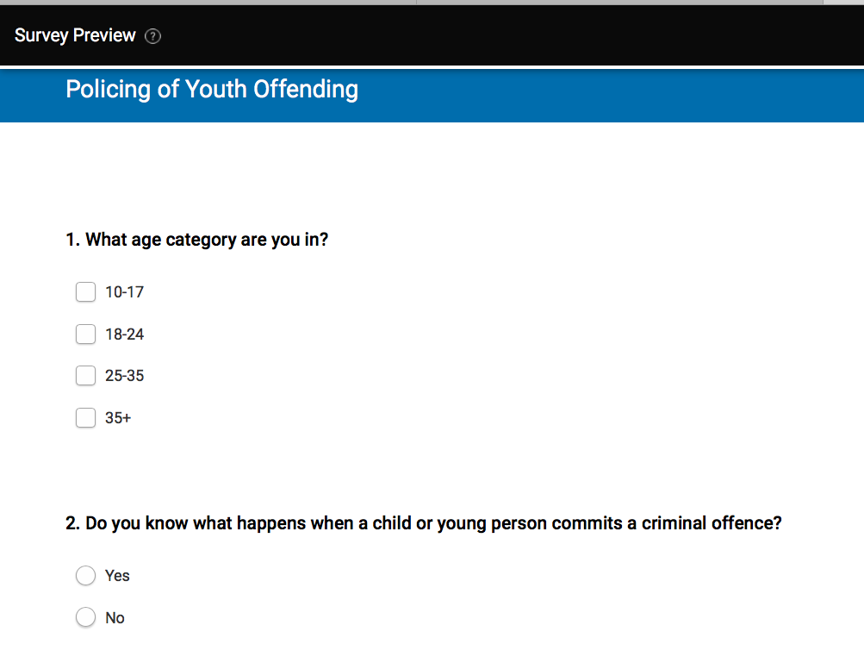

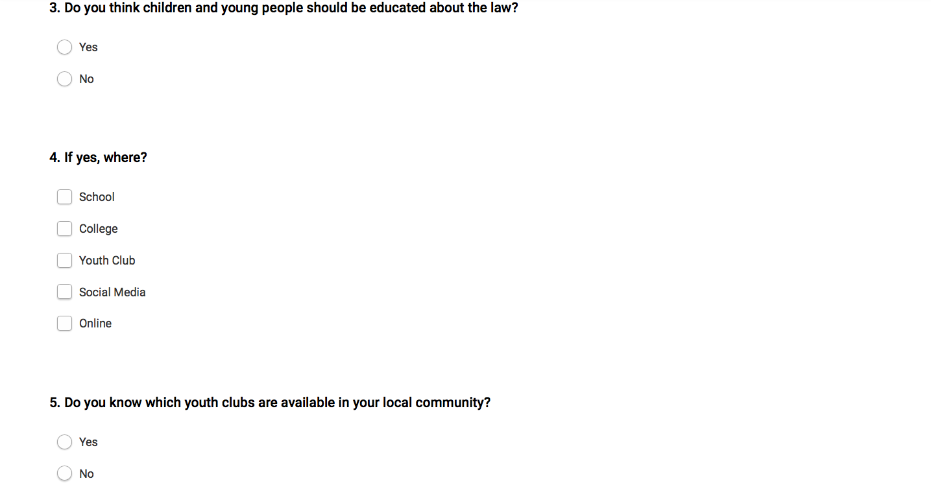

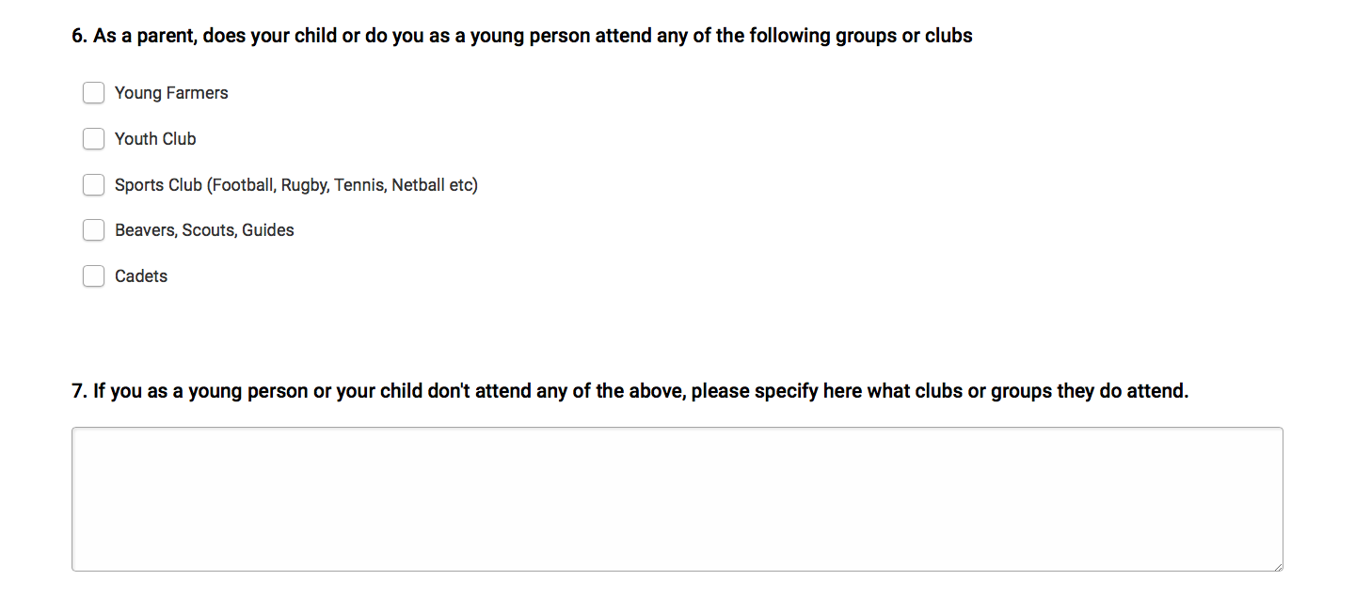

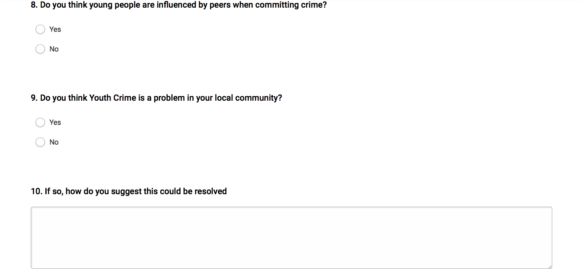

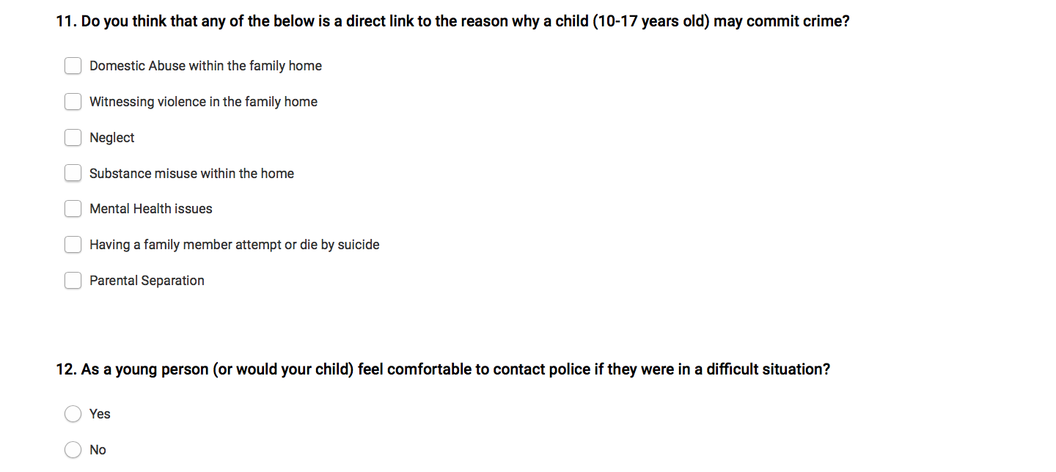

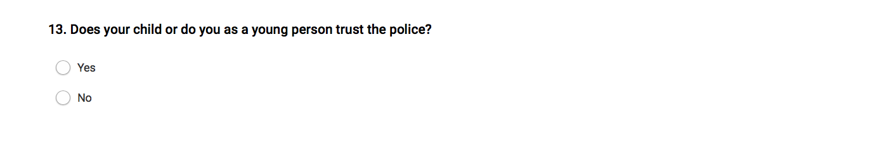
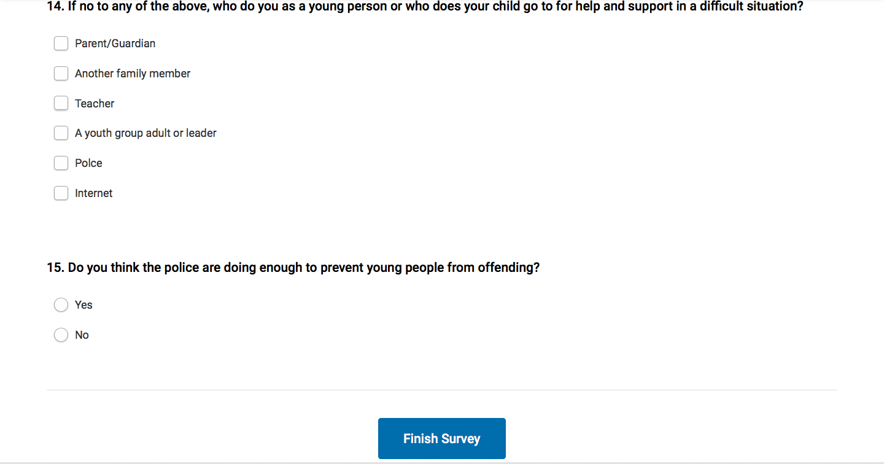

APPENDIX C:
GRAPHS FROM ONLINE SURVEY

APPENDIX D:
ETHICS FORM

APPLICATION FOR ETHICAL APPROVAL

In order for research to result in benefit and minimise risk of harm, it must be conducted ethically. A researcher may not be covered by the University’s insurance if ethical approval has not been obtained prior to commencement.

The University follows the OECD Frascati manual definition of research activity: “creative work undertaken on a systematic basis in order to increase the stock of knowledge, including knowledge of man, culture and society, and the use of this stock of knowledge to devise new applications”. As such this covers activities undertaken by members of staff, postgraduate research students, and both taught postgraduate and undergraduate students working on dissertations/projects.

The individual undertaking the research activity is known as the “principal researcher”.

Ethical approval is not required for routine audits, performance reviews, quality assurance studies, testing within normal educational requirements, and literary or artistic criticism.

Please read the notes for guidance before completing ALL sections of the form.

This form must be completed and approved prior to undertaking any research activity. Please see Checklist for details of process for different categories of application.

Delete the Guidance Notes at the end of the form BEFORE submitting your application

SECTION A: About You (Principal Researcher)
Full Name: |  | Elan Williams
Tick all boxes which apply: |  | Member of staff: | ☐ | Honorary research fellow: | ☐
Undergraduate Student | ☒ | Taught Postgraduate Student | ☐ | Postgraduate Research Student | ☐

Institute/Academic Discipline/Centre: | Business School
Campus: | Swansea
E-mail address: | 1802224@uwtsd.ac.uk
Contact Telephone Number: | 07989996631
For students:
Student Number: | 1802224
Programme of Study: | Policing and Criminology
Director of Studies/Supervisor: | Bronwen Williams / Caroline Jawad

SECTION B: Approval for Research Activity
Has the research activity received approval in principle?  (please check the Guidance Notes as to the appropriate approval process for different levels of research by different categories of individual) |  | YES | ☒ | NO | ☐
 |  |  |  | Date
If Yes, please indicate source of approval (and date where known): Approval in principle must be obtained from the relevant source prior to seeking ethical approval | Research Degrees Committee |  | ☒ | 22/11/2020
 | Institute Research Committee |  | ☐
 | Other (write in) |  | ☐

SECTION C: Internal and External Ethical Guidance Materials
Please list the core ethical guidance documents that have been referred to during the completion of this form (including any discipline-specific codes of research ethics, and also any specific ethical guidance relating to the proposed methodology). Please tick to confirm that your research proposal adheres to these codes and guidelines.
UWTSD Research Ethics & Integrity Code of Practice | ☒
UWTSD Research Data Management Policy | ☒
 | ☐

SECTION D: External Collaborative Research Activity
Does the research activity involve collaborators outside of the University? |  | YES | ☐ | NO | ☒
If Yes, please provide the name of the external organisation and name and contact details for the main contact person and confirmation this person has consented to their personal data being shared.as part of this collaboration.
Institution
Contact person name
Contact person e-mail address

Has this individual consented to sharing their details on this form? |  | YES | ☐ | NO |  |  | ☒
Are you in receipt of a KESS scholarship? |  | YES | ☐ | NO |  |  | ☒
Is your research externally funded |  | YES | ☐ | NO |  |  | ☒
Are you specifically employed to undertake this research in either a paid or voluntary capacity? | Voluntary | YES | ☒ | NO |  | ☐
 | Employed | YES | ☐ | NO |  | ☒
Is the research being undertaken within an existing UWTSD Athrofa Professional Learning Partnership (APLP) | If YES then the permission question below does not need to be answered. | YES | ☐ | NO |  |  | ☒
Permission to undertake the research has been provided by the partner organisation | (If YES attach copy)  If NO the application cannot continue | YES | ☐ | NO |  |  | ☒

Where research activity is carried out in collaboration with an external organisation
Does this organisation have its own ethics approval system? | YES | ☐ | NO | ☒
If Yes, please attach a copy of any final approval (or interim approval) from the organisation

SECTION E: Details of Research Activity
Indicative title: | Policing of Youth Offending: How do police reduce and prevent offending of the young people within the Carmarthenshire area.
Proposed start date: | November 2020 | Proposed end date: | May 2021
Introduction to the Research (maximum 300 words)
Ensure that you write for a Non-Specialist Audience when outlining your response to the three points below:
- Purpose of Research Activity
- Proposed Research Question
- Aims of Research Activity
- Objectives of Research Activity
Demonstrate, briefly, how Existing Research has informed the proposed activity and explain
- What the research activity will add to the body of knowledge
- How it addresses an area of importance.
Purpose of Research Activity

- Aim: Investigate how Dyfed Powys Police engage on a multi-agency level.
- Objective: Explore what current agencies Dyfed Powys Police liaise with in regards to children and young people.
2. Aim: In what way do Dyfed Powys Police reduce young people from offending.
2. Objective: What existing policies and procedures are in place to reduce children and young people from offending. Additionally, what, if any arrangements are being implemented for future engagement.
3. Aim: Discover how Dyfed Powys Police prevent young people specifically in Carmarthenshire area from offending
3. Objective: Review current strategies in place to deter and prevent young people from offending in Carmarthenshire area.

Proposed methods (maximum 600 words)
Provide a brief summary of all the methods that may be used in the research activity, making it clear what specific techniques may be used. If methods other than those listed in this section are deemed appropriate later, additional ethical approval for those methods will be needed.
Online Questionnaire and interviews.

Location of research activity
Identify all locations where research activity will take place.
Dyfed Powys Police - Carmarthen Police Officers

Different organisations within the Carmarthenshire area which are involved with young people.
Research activity outside of the UK
If research activity will take place overseas, you are responsible for ensuring that local ethical considerations are complied with and that the relevant permissions are sought. Specify any local guidelines (e.g. from local professional associations/learned societies/universities) that exist and whether these involve any ethical stipulations beyond those usual in the UK (provide details of any licenses or permissions required). Also specify whether there are any specific ethical issues raised by the local context in which the research activity is taking place, for example, particular cultural and/or legal sensitivities or vulnerabilities of participants.
Use of documentation not in the public domain: Are any documents NOT publicly available? | NO | ☒
 | YES | ☐
If Yes, please provide details here of how you will gain access to specific documentation that is not in the public domain and that this is in accordance with prevailing data protection law of the country in question and England and Wales.

(this box should expand as you type)
SECTION F: Scope of Research Activity
Will the research activity include: | YES | NO
Use of a questionnaire or similar research instrument? | ☒ | ☐
Use of interviews? | ☒ | ☐
Use of diaries? | ☐ | ☒
Participant observation with their knowledge? | ☒ | ☐
Participant observation without their knowledge? | ☐ | ☒
Use of video or audio recording? | ☐ | ☒
Access to personal or confidential information without the participants’ specific consent? | ☐ | ☒
Administration of any questions, test stimuli, presentation that may be experienced as physically, mentally or emotionally harmful / offensive? | ☐ | ☒
Performance of any acts which may cause embarrassment or affect self-esteem? | ☐ | ☒
Investigation of participants involved in illegal activities? | ☐ | ☒
Use of procedures that involve deception? | ☐ | ☒
Administration of any substance, agent or placebo? | ☐ | ☒
Working with live vertebrate animals? | ☐ | ☒
Other primary data collection methods, please explain in this box  For example, ‘focus groups’. Please indicate the type of data collection method(s) in this box and tick the accompany box. | ☐ | ☒
Details of any other primary data collection method:  (this box should expand as you type) | ☐ | ☒
If NO to every question, then the research activity is (ethically) low risk and may be exempt from some of the following sections (please refer to Guidance Notes).

If YES to any question, then no research activity should be undertaken until full ethical approval has been obtained.

SECTION G: Intended Participants
Who are the intended participants: | YES | NO
Students or staff at the University? | ☐ | ☒
Adults (over the age of 18 and competent to give consent)? | ☒ | ☐
Vulnerable adults? | ☐ | ☒
Children and Young People under the age of 18? (Consent from Parent, Carer or Guardian will be required) | ☐ | ☒
Prisoners? | ☐ | ☒
Young offenders? | ☐ | ☒
Those who could be considered to have a particularly dependent relationship with the investigator or a gatekeeper? | ☐ | ☒
People engaged in illegal activities? | ☐ | ☒
Others (please identify specifically any group who may be unable to give consent) please indicate here and tick the appropriate box. | ☐ | ☒
Other – please indicate here:  (this box should expand as you type) | ☐ | ☒

Participant numbers and source
Provide an estimate of the expected number of participants. How will you identify participants and how will they be recruited?
How many participants are expected? | 100 participants and around 7 interviews will be undertaken.  Participants will be anonymous.

Information for participants: | YES | NO | N/A
Will you describe the main research procedures to participants in advance, so that they are informed about what to expect? | ☒ | ☐ | ☐
Will you tell participants that their participation is voluntary? | ☒ | ☐ | ☐
Will you obtain written consent for participation? | ☒ | ☐ | ☐
Will you explain to participants that refusal to participate in the research will not affect their treatment or education (if relevant)? | ☐ | ☐ | ☒
If the research is observational, will you ask participants for their consent to being observed? | ☐ | ☐ | ☒
Will you tell participants that they may withdraw from the research at any time and for any reason? | ☒ | ☐ | ☐
With questionnaires, will you give participants the option of omitting questions they do not want to answer? | ☒ | ☐ | ☐
Will you tell participants that their data will be treated with full confidentiality and that, if published, it will not be identifiable as theirs? | ☒ | ☐ | ☐
Will you debrief participants at the end of their participation, in a way appropriate to the type of research undertaken? | ☒ | ☐ | ☐
If NO to any of above questions, please give an explanation
(this box should expand as you type)

Information for participants: | YES | NO | N/A
Will participants be paid? | ☐ | ☒ | ☐
Is specialist electrical or other equipment to be used with participants? | ☐ | ☒ | ☐
Are there any financial or other interests to the investigator or University arising from this study? | ☐ | ☒ | ☐
Will the research activity involve deliberately misleading participants in any way, or the partial or full concealment of the specific study aims? | ☐ | ☒ | ☐
If YES to any question, please provide full details
(this box should expand as you type)

SECTION H: Anticipated Risks

Outline any anticipated risks that may adversely affect any of the participants, the researchers and/or the University, and the steps that will be taken to address them.

If you have completed a full risk assessment (for example as required by a laboratory, or external research collaborator) you may append that to this form.
Full risk assessment completed and appended? | Yes | ☐
Full risk assessment completed and appended? | No | ☒
Risks to participants
For example: emotional distress, transfer of personal data, sensitive information.

Sensitive information could be an issue but participants can withdraw at any time and will be made aware of that.
If research activity may include sensitive, embarrassing or upsetting topics (e.g. sexual activity, drug use) or issues likely to disclose information requiring further action (e.g. criminal activity), give details of the procedures to deal with these issues, including any support/advice (e.g. helpline numbers) to be offered to participants. Note that where applicable, consent procedures should make it clear that if something potentially or actually illegal is discovered in the course of a project, it may need to be disclosed to the proper authorities
Research activity might include some information regarding criminal activity as I interview police officers and their knowledge and experience may be sensitive or upsetting. To deal with this, victim support organisation has a helpline with a phone number 08081689111.

(this box should expand as you type)
Risks to investigator
For example: personal safety, physical harm, emotional distress.

Each participants will be treated in a professional manner.
University/institutional risks
For example: adverse publicity, data protection
High standards by UWTSD will be upheld always to ensure professional manner.

Disclosure and Barring Service
If the research activity involves children or vulnerable adults, a Disclosure and Barring Service (DBS) certificate must be obtained before any contact with such participants. | YES | NO | N/A
Does your research require you to hold a current DBS Certificate? | ☐ | ☒ | ☐

SECTION I: Feedback, Consent and Confidentiality
Feedback
What de-briefing and feedback will be provided to participants, how will this be done and when?
The feedback will be given to the participant if it wishes to receive it after completion of the research activity.

Informed consent
Describe the arrangements to inform potential participants, before providing consent, of what is involved in participating. Describe the arrangements for participants to provide full consent before data collection begins. If gaining consent in this way is inappropriate, explain how consent will be obtained and recorded in accordance with prevailing data protection legislation.
I will ensure that the participant will receive a written form which will ask for consent to participate in this research project. Regarding the online survey, participants are consenting by opening the tab to fill the questionnaire itself as it is voluntary.

Confidentiality / Anonymity
Set out how anonymity of participants and confidentiality will be ensured in any outputs. If anonymity is not being offered, explain why this is the case.
Confidentiality and anonymity will be available for all participants doing the online survey as I will not need to know their personal details just their opinions on the subject matter. Regarding the interview, the participant will have a choice whether or not to reveal their name or keep anonymous. Either of these choices will not make a difference as it is only the information and knowledge which will be important.

SECTION J: Data Protection and Storage
In completing this section refer to the University’s Research Data Management Policy and the extensive resources on the University’s Research Data Management web pages (http://uwtsd.ac.uk/library/research-data-management/).
Does the research activity involve personal data (as defined by the General Data Protection Regulation 2016 “GDPR” and the Data Protection Act 2018 “DPA”)? | YES | NO
“Personal data” means any information relating to an identified or identifiable natural person (‘data subject’). An identifiable natural person is one who can be identified, directly or indirectly, in particular by reference to an identifier such as a name, an identification number, location data, an online identifier or to one or more factors specific to the physical, physiological, genetic, mental, economic, cultural or social identity of that natural person. |  | ☒
If YES, provide a description of the data and explain why this data needs to be collected:
Does it involve special category data (as defined by the GDPR)? | YES | NO
“Special category data” means sensitive personal data consisting of information as to the data subjects’ –  (a) racial or ethnic origin,  (b) political opinions,  (c ) religious beliefs or other beliefs of a similar nature,  (d) membership of a trade union (within the meaning of the Trade Union and Labour Relations (Consolidation) Act 1992),  (e) physical or mental health or condition,  (f) sexual life,  (g) genetics,  (h) biometric data (as used for ID purposes), | ☐ | ☒
If YES, provide a description of the special category data and explain why this data needs to be collected:
(this box should expand as you type)
Will the research activity involve storing personal data and/or special category data on one of the following: | YES | NO
Manual files (i.e. in paper form)? | ☐ | ☒
University computers? | ☐ | ☒
Private company computers? | ☐ | ☒
Home or other personal computers? | ☒ | ☐
Laptop computers/ CDs/ Portable disk-drives/ memory sticks? | ☒ | ☐
“Cloud” storage or websites? | ☒ | ☐
Other – specify: | ☐ | ☒
For all stored data, explain the measures in place to ensure the security of the data collected, data confidentiality, including details of password protection, encryption, anonymisation and pseudonymisation:
1.Technical measures will be in place to prevent any unauthorised access. I will only have access to the data collected until the research project is handed in to the course holder. Passwords will be on my personal laptop which will ensure that nobody will be able to get any information from. Strong passwords will be key for this. Strong passwords will include long words which will make the password stronger, also lower and upper case will be used to make it stronger.

2. Only myself and the supervisor which is the course leader who will have access to the data at all times.

All Data Storage
Will the research activity involve any of the following activities: | YES | NO
Electronic transfer of data in any form? | ☐ | ☒
Sharing of data with others at the University? | ☐ | ☒
Sharing of data with other organisations? | ☐ | ☒
Export of data outside the European Union or importing of data from outside the UK? | ☐ | ☒
Use of personal addresses, postcodes, faxes, emails or telephone numbers? | ☐ | ☒
Publication of data that might allow identification of individuals? | ☐ | ☒
Use of data management system? | ☐ | ☒
Data archiving? | ☐ | ☒
If YES to any question, please provide full details, explaining how this will be conducted in accordance with the GDPR and DPA (and/or any international equivalent):
List all who will have access to the data generated by the research activity:
Myself, course leader and the marker of the research project.
List who will have control of, and act as custodian(s) for, data generated by the research activity:
Myself.

Give details of data storage arrangements, including security measures in place to protect the data, where data will be stored, how long for, and in what form. Will data be archived – if so how and if not why not.
Security measures will be in place to protect data and how it is stored. The research data will be stored on my computer and the Cloud storage to ensure double safety procedures in case of any data loss or corruption. It is only myself who has access to this. Strong passwords are used to enter the computer which will ensure that nobody has access under no circumstances. All data which will be collected from participants will of course be voluntary and will have given their consent before starting. To ensure their safety and data collection is safe, the research will be on the computer with a strong password also. All data which will be collected and stored will be kept safe until completion of the project and will be deleted immediately.

Please indicate if your data will be stored in the UWTSD Research Data Repository (see https://researchdata.uwtsd.ac.uk/ ). If so please explain. (Most relevant to academic staff)
(this box should expand as you type)
Confirm that you have read the UWTSD guidance on data management (see https://www.uwtsd.ac.uk/library/research-data-management/) | YES | ☒
 | NO | ☐
Confirm that you are aware that you need to keep all data until after your research has completed or the end of your funding | YES | ☒
 | NO | ☐

SECTION K: Declaration
The information which I have provided is correct and complete to the best of my knowledge. I have attempted to identify any risks and issues related to the research activity and acknowledge my obligations and the rights of the participants.

In submitting this application I hereby confirm that I undertake to ensure that the above named research activity will meet the University’s Research Ethics and Integrity Code of Practice which is published on the website: https://www.uwtsd.ac.uk/research/research-ethics/
Signature of applicant: |  | Date:  22/11/2020

For STUDENT Submissions:
Director of Studies/Supervisor: | Bronwen Williams / Caroline Jawad | Date: 22/11/2020
Signature: |  | Date: 22/11/2020

For STAFF Submissions:
Academic Director/ Assistant Dean: |  | Date:
Signature: |  | Date:

Checklist: Please complete the checklist below to ensure that you have completed the form according to the guidelines and attached any required documentation:
☒ | I have read the guidance notes supplied before completing the form.
☒ | I have completed ALL RELEVANT sections of the form in full.
☒ | I confirm that the research activity has received approval in principle
☐ | I have attached a copy of final/interim approval from external organisation (where appropriate)
☒ | I have attached a full risk assessment (and have NOT completed Section H of this form) (where appropriate) ONLY TICK IF YOU HAVE ATTACHED A FULL RISK ASSESSMENT
☒ | I understand that it is my responsibility to ensure that the above named research activity will meet the University’s Research Ethics and Integrity Code of Practice.
☒ | I understand that before commencing data collection all documents aimed at respondents (including information sheets, consent forms, questionnaires, interview schedules etc.) must be confirmed by the DoS/Supervisor, module tutor or Academic Director.
☒ | I have deleted the guidance notes before submitting the PG2 for consideration

RESEARCH STUDENTS AND STAFF ONLY
All communications relating to this application during its processing must be in writing and emailed to pgresearch@uwtsd.ac.uk , with the title ‘Ethical Approval’ followed by your name.
You will be informed of the outcome of your claim by email; therefore it is important that you check your University and personal email accounts regularly.

STUDENTS ON UNDERGRADUATE OR TAUGHT MASTERS PROGRAMMES should submit this form (and receive the outcome) via systems explained to you by the supervisor/module leader.

This form is available electronically from the Academic Office web pages: https://www.uwtsd.ac.uk/academic-office/appendices-and-forms/

Application Process

All staff research projects and all research students must submit the Ethical Approval Form to the University Research Ethics Committee via the Academic Office (pgresearch@uwtsd.ac.uk). Staff research directly in relation to personal study for taught undergraduate or Masters programmes should be submitted via the Institute procedures explained below.

Taught masters and taught undergraduate research Ethical Approval Forms are considered within Institutes. Institutes will provide details of the specific processes for this. Where the Ethical issues within any single ethical application are of particular concern the Institute will refer these to the University Research Ethics Committee. Any student activity that involves the collection of primary data needs to undergo Ethical approval, this includes assignment work as well as dissertations.

Notes for guidance in completion of this form

Section A: About You
Please complete all relevant sections

Section B: Approval for research activity
Research proposals must be approved in principle before applying for Ethical Approval. The proposal approval only becomes final when the ethical approval is received.

The process for proposal approval varies according the individual and programme of study:
- Research students, by application on form PG1 to the Research Degrees Committee
- Taught students by review of research proposal within Institutes (Institutes provide specific details of these processes)
- Staff, by agreement by the Academic Director/Assistant Dean

Section C: External Ethical Guidance materials
Many discipline areas are required to operate with the discipline specific codes of research ethics (for example health, psychology, education etc.), any such codes must be listed and you must tick to confirm that you have consulted with these.

Section D: External Collaborative Research Activity
Provide details of the external collaborative partners, where appropriate you might want to submit a copy of the external collaboration agreement with the Ethical Approval Form. If the partner requires the research to be subject to its own internal Ethical approval process then please provide details of that process and a copy of any final (or interim) approvals received from the organisation.

Section E: Details of Research Activity
Remember that the individuals reviewing this Ethical Approval Form may not have seen your research proposal, and also may not be experts in the specific area of your research. The information provided should therefore be jargon free and clearly stated.
Indicative Title: please use the same title as used on the research proposal.
Purpose: the Ethical approval process will want to ensure that the methods you propose are adequate and appropriate to address the research aims and objectives. Excessive additional data collection can be seen as unethical.
Proposed Methods: the Ethical approval process seeks to ensure that you understand the methods that are intended, and that the implementation of those methods will be appropriate and without unnecessary impact on respondents. This section must explain how the methods described will lead to the collection of necessary and sufficient data, but not excessive data. Please be specific.
Location: this needs to mention geographical location and also local situation (for example, within Local Authority Offices in Cardiff, using a private room but close to other individuals). If you are collecting data within an organisational setting then you need to explain the permissions that you have obtained to do this.
Research Activity outside of the UK: please complete this section in detail, and note any guidance you have received. Also describe your own familiarity (or not) with the location that you will be utilising.

Section F: Scope of Research Activity
Please tick ALL of the research activities that might be undertaken. If any additional types of activity are intended then please add an extra box and describe these.
If you have answered no to all questions in F then sections G and J do not need to be completed. Section H should be considered, and may be completed. Signatures are still required in section K.

Section G: Intended Participants
Please tick all categories that might apply.
Numbers & Source: if you are using a series of different methods or research activities please list numbers for each stage/phase. Be clear about how you will find respondents. Will you use intermediaries, and if so how? How will you ensure compliance with your sampling strategy?
Information for participants: all participants should be appropriately informed about the research, what is expected of them and what will happen to the information that they provide. The Ethical review process does not ask to see this documentation, but requires this to be reviewed and approved by the Director of Studies in the case of research students, the supervisor/module tutor in relation to students on taught programmes and the Academic Director/Assistant Dean in relation to staff research.

Section H: Anticipate Risks
All research carries some level of risk. The answers you provide to questions in this section will be reviewed to ensure that you have an appropriate understanding of the type of risks involved and how you can mitigate against these risks. If you have completed a full risk assessment, as required for example for laboratory work, field work, clinical tests, diving operations, or by a collaborative partner, you may append that to this form. In that case, please tick the box indicating this has been provided. You will not then be required to complete Section H.
Risk to participants Think very carefully about how your actions/questions/discussions might affect the people you are involving as participants. You might identify the risk as small but it would still be a risk. Many types of question have the potential to make respondents less content with their life / job; you need to recognise and try to ameliorate any such effects
If these are business owners, time with you may reduce profit.
In some locations physical risk is very real to both participants and yourself, please consider this.
Risk to you, the researcher Think about where you will meet people, if there are any dangers involved in the location. If you are meeting people as individuals think about using a public place. In general do not visit people in their own homes or remote locations. If you are talking to individuals about certain issues think about how their responses might affect you emotionally. What about the risk of collecting insufficient data?
Risk to the University When undertaking your research, you are acting as a member of the University (student or staff). Professionalism is important, so it is important to be well organised and well prepared. Punctuality, clarity etc. are all part of this. What will you do to ensure this? You must ensure you do not harm the good name of the University in any way and do nothing to undermine the reputation of the research it conducts and sponsors. Upholding high standards of conduct and integrity are vital in this regard. You must also conduct the research in such a way to minimise the potential for claims of negligence made against the University, its researchers and any collaborating individual or organisation. In this respect you should always comply with ethical, legal and professional frameworks, obligations and standards as required by statutory and regulatory authorities, as well as the university’s Research Integrity and Ethics Code of Practice. Research misconduct in this respect can take many forms, including:
- fabrication: making up results or other outputs (eg, artefacts) and presenting them as if they were real
- falsification: manipulating research processes or changing or omitting data without good cause
- plagiarism: using other people’s material without giving proper credit
- failure to meet ethical, legal and professional obligations: for example failure to declare competing interests; misrepresentation of involvement or authorship; misrepresentation of interests; breach of confidentiality; lack of informed consent; misuse of personal data; and abuse of research subjects or material
- improper dealing with allegations of misconduct: failing to address possible infringements such as attempts to cover up misconduct and reprisals against whistle-blowers

Adverse Outcomes. Think carefully about the possibilities, and cover here

Section I: Feedback, Consent and Confidentiality
Feedback to participants: outline your approach. Will interview transcripts be shared with respondents to check accuracy? Will summaries of questionnaire analysis be made available to respondents in some way? Will an overview report be provided? How and when?
Informed consent: Draft letter / e-mail / or heading (or footer) section of questionnaire must be approved by DoS/supervisor (if research student), supervisor/module tutor if taught student, or Academic Director / Assistant Dean if a member of staff.
Confidentiality/Anonymity. Explain clearly how you will ensure confidentiality and anonymity.

Section J: Data Protection and Storage
Before completing this section it is necessary to read the University’s Research Data Management information. The questions that follow are designed to ensure compliance with the Data Protection Act as well as established research protocols.

Many research activities will involve electronic transfer of data and use of data management systems in the summarisation and analysis of data. You will need to explain these in relation to compliance with the Data Protection Act.
Think carefully about who will have access to your data, this will include supervisors and examiners. Also that a thesis will be made available via the University library and the British Library system. If you are seeking an access bar for a period of time after completion then mention it here. If you will provide a copy of your findings, or intend to give a presentation, to a facilitating/ supporting/accessing organisation then explain that in this section. But also think about the general principle of data sharing, as explained in the Research Data Management information.
In terms of storage of data please ensure security, and also mitigate against loss of data.

Section K: Declaration
Ensure the appropriate countersignatures have been provided
Look carefully at the checklist and ensure that you comply with and tick all that are relevant to your research.

