University of Wales Trinity Saint David
Wales Institute of Science & Art



Material Selection Report
Engineering Design and Materials (ACHA4001)

Name: Evan Craig
Student ID: 2012643
Date: 02/2022
Contents
1 Introduction 2
2 Material Properties 3
3 Material Selection 4
3.1 Steel 4
3.2 Aluminium 4
3.3 Aluminium-Silicon Alloy 4
4 Manufacturing Process 6
5 Conclusion 8
6 References 9

Introduction

The Aims of this report are to discuss a multitude of materials before a final material is selected, with the reasoning behind choice. Finally, the manufacturing processes a piston could undertake will be looked at and considered before a conclusion at the end of the report.
This report will consider the working environment of a piston from a 6-cylinder turbocharged 4 stroke petrol engine. This engine will be a high-performance engine seeking power over reliability.

Material Properties

When you look at a lifespan of a piston it is usually quite brutal with the piston living in harsh conditions. You have extreme amounts of heat and pressure for possibly hundreds of thousands of miles, meaning you will need a material that is able to cope with thousands of heat cycles without any cracking or weakening of the material.
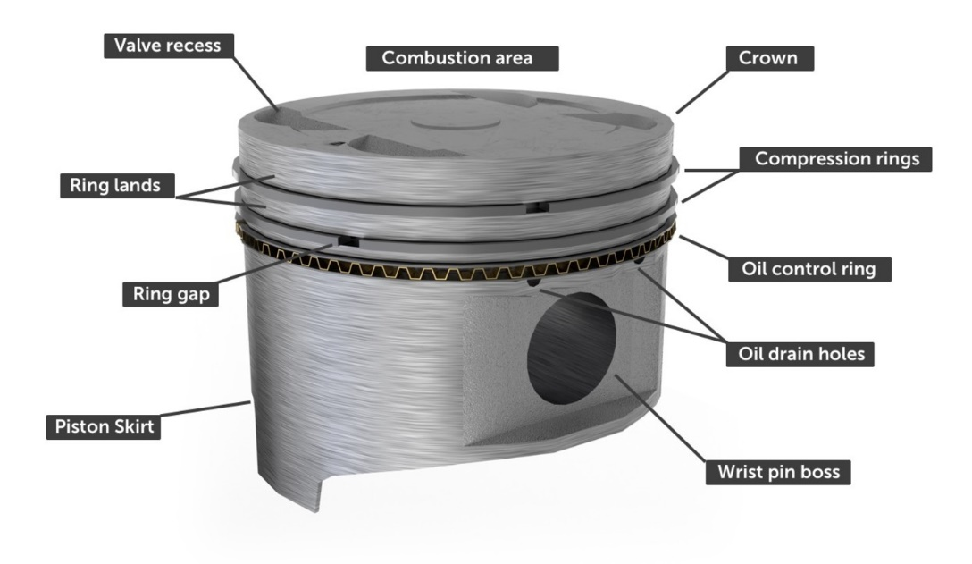

Figure 1 - A Diagram of a Piston (How A Car Works, n.d.)

Figure 1 is a ladled diagram of a basic piston, as you can see there is a great deal of parts to a piston. The most important in terms of the material properties would be the crown and the skirt, the former being the area of the piston where the most heat and force is at its greatest. According to MAHLE (2016, p. 4) the gas temperatures in the combustion area can easily reach over 2,300°C however, the crown of the piston will only ever get heated to around 200 - 400°C and the skirt around 120-180°C.
The piston will also have about 6.0-13.0 MPa or 870-1885 PSI of pressure acting on it each power stroke, the lower end of the scale being for naturally aspirated engines and the top end for turbocharged engines. (MAHLE, 2016 p.4)
With these figures in consideration a material with a low density and low coefficient of thermal expansion would definitely be a high contender. The selected material would also have to have a wear resistance that is optimal for a long use application as it will be going in a road car. This means that the material will also need to be extremely strong as it will be facing high temperatures and pressures on an almost daily basis.
Taking into consideration that the engine this piston will be in will have high horsepower you can expect the pressures to be over 13.0 MPa, this depends on how many pounds of boost the engine is running at. For this engine we will take 15.0 MPa as the maximum amount of cylinder pressure.

Material Selection

Steel
One of the most common materials used in the past, mainly when Internal combustion engines were in the starting phases, was steel it is still used today in some applications, this is due to the properties of a steel piston with the main one being that steel is much stronger than aluminium and can handle higher cylinder pressures which is definitely a benefit to diesel engine applications. Steel pistons can also be more reliable as they expand and cool down at the same time as a cast iron engine block would, this helps with the emissions of the engine because the seal of the pistons rings remains better for longer. One of the biggest downsides for steel pistons is the increased weight this results in more frictional drag which in a low torque engine such as a petrol engine is sub-optimal. (Baechtel, 2018)

Aluminium
Today you would find the current most popular material used is Aluminium alloys, this is due to the fact that Aluminium has a low density (Smallman & Ngan, 2007, p.474) which helps reduce the moving mass of the piston possibly extending the life of the piston. But it also has a high thermal conductivity which is needed in this application because it could experience thousands of heat cycles in its lifetime, this thermal conductivity can also help with cooling as a lot of the heat can be transferred to the oil being used to lubricate it which is another massive benefit to using aluminium alloys as mentioned by the European Aluminium Association (2011).

Aluminium-Silicon Alloy
A Hypereutectic Aluminium alloy will be used for this piston, more specifically A390 Aluminium-Silicon (Al-Si). To see main reasons for the choosing of this material you have to look at the many properties it has to offer, including but not limited to: Exemplary corrosion and wear resistance, low density with high specific strength, and most importantly it has a low coefficient of thermal expansion. The different properties of Aluminium-Silicon alloys can employ its alloying elements of Copper, Nickle, Magnesium, Titanium, Zinc, Manganese and Iron to help emphasise their effects. (Ahmed. et al, 2016 p.2).
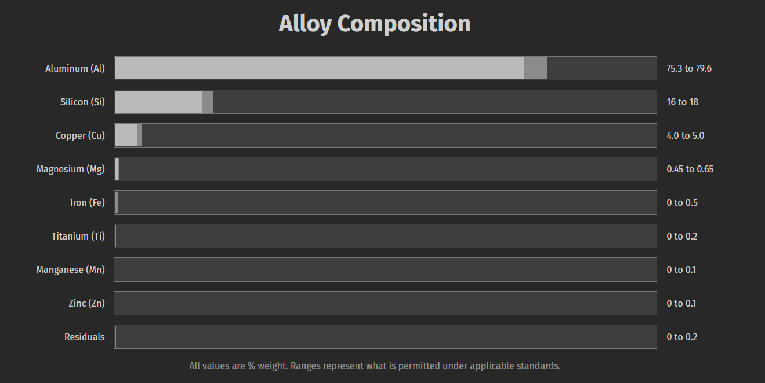
The alloy composition of A390 Aluminium can be seen below in Figure 2.
Figure 2 - A390 Aluminium Alloy Composition (MakeItFrom.com, n.d.)

This alloy composition is quite effective for pistons and offers all the desired aspect a piston would require, these alloying materials such as copper can help to increase the thermal efficiency of the alloy which will certainly help with the heat exchange to the engine oil. Furthermore, Brunel University London (2018) said that magnesium has a small benefit which could be of use to the consumer market, it can dampen the vibrations and the noise produced by the piston giving the user a more enjoyable ride.
Another small benefit an Aluminium-Silicon alloy piston is the superior thermal conductivity of the alloy can reduce the amount of coolant required by the engine. (Smallman & Ngan, 2007, p.475). Not only is this better for the consumer this could also help the environment as Antifreeze can have massive detrimental effects if not recycled properly.

Manufacturing Process

A390 Aluminium has 16-18% Casting is a method of metallurgy which involves the pouring of molten metal into a mould where it is left to solidify becoming the shape of the mould it is in. It’s a great method to use if you want to keep your manufacturing costs low without sacrificing durability. Casting is a very tried and tested method being around for thousands of years, but it does have some downside’s to forging. (Shewmon, n.d.)
Table 1 - General Properties of Cast Metals (Taylor, 1985, p.335)
 | Aluminium Alloys
Ultimate Tensile Strength (ksi) | 17 – 45
Elastic modulus (psi x 10^-6) | 10
Brinell scale | 40 – 125*
Endurance ratio (EL/UTS) | 0.30
Elongation, per cent | 0 – 12
Specific gravity | 2.6 – 2.9
Heat conductivity (cal/cm °C hr) | 0.26 – 0.40
Coefficient of thermal expansion °F x 10^6 | 12.1 – 13.8
Relative machineability | Excellent
*500-kg ball
Forging is another method of manufacturing which instead of using molten metal it uses extremely hot metal and applies a great amount of pressure onto it while being in a die of the piston to achieve the desired shape. (Shewmon, n.d.) Forging does have some advantages over casting for example, Forged pistons are more durable than their cast counterparts, because the forging process produces a better grain flow that has been shown to produce higher tensile strength because it produces uniform grain structure which in turn would increase the directional strength of the alloy. (Rithjin, 2019) & (CFS Forge, 2017)
Table 2 - Table 1 - General Properties of Wrought Metals (Taylor, 1985, p.334)
 | Aluminium Alloys
Ultimate Tensile Strength (ksi) | 15 – 77
Elastic modulus (psi x 10^-6) | 10 – 11
Brinell scale | 23 – 135*
Endurance ratio (EL/UTS) | 0.35 – 0.50
Elongation, per cent | 1 – 30
Specific gravity | 2.2 – 3.0
Heat conductivity (cal/cm °C hr) | 0.37 – 0.53
Coefficient of thermal expansion °F x 10^6 | 12.7 – 13.3
Relative machineability | Excellent
*500-kg ball
If you look at both above tables, you will see the differences between cast and forged aluminium alloys you will see just how the different manufacturing processes can affect the material. The main one is the ultimate tensile strength as the forged aluminium alloy can be much stronger as previously mentioned.

After the piston has been Cast/Forged it can have a coating applied to the combustion area of the crown and the skirt. These coating can help with the longevity of the piston; the skirt coating can also function as a lubricant contributing to an increase in durability. One of the coatings that can be applied to the crown is known as nickel ceramic composite coatings, this type of coating has been found by Funatani et al. (1994) to have a slight improvement on fuel economy and a reduction in emissions. The use of the nickel ceramic composite coating of the skirts of a piston can help to reduce the friction and in turn reduce the temperature of the cylinder walls with the study finding the amount of scoring on the cylinder bore to decrease therefore increasing the durability and life span of an engine.

Conclusion
In this report, the material properties of a piston were investigated and discussed before a final material was chosen. The selection of this material was also discussed before an evaluation of the many manufacturing processes of a piston was undertaken. The conclusion of this report is as follows.
The living conditions of a piston do require a strong material with characteristics suitable for the required role. As mentioned in the material properties section of this report steel and un-alloyed aluminium were looked at before an Aluminium-Silicon alloy was decided on, A390 Aluminium, due to it many beneficial properties which were talked about in the material selection segment of the report. Finally, the manufacturing process chosen for the piston would be forging as it offers a higher ultimate tensile strength which is optimal for a piston.
Therefore, the aims of this report were met in full and a piston for a 6-cylinder turbocharged 4 stroke petrol engine, would be made from A390 Aluminium alloy and forged to achieve the desired result of high power.

References
How A Car Works (n.d.) Pistons. Available at: https://www.howacarworks.com/pistons (Accessed 23rd February 2022).
MAHLE (2016) Pistons and Engine Testing. 2nd edition. Stuttgart: Springer.
European Aluminium Association (2011) The Aluminium Automotive Manual. Available at: https://www.european-aluminium.eu/media/1570/aam-applications-power-train-1-pistons.pdf (Accessed 24th February 2022).
Smallman, R. and Ngan, A.H.W. (2007) Physical Metallurgy and Advanced Materials. 7th edn. Oxford: Elsevier
Baechtel, J (2018) Behind the Scenes: Diamond's STEEL Piston Technology. Available at: http://blog.diamondracing.net/behind-the-scenes-diamonds-steel-piston-technology-#:~:text=Steel%20pistons%20are%20significantly%20stronger,advantages%20attributed%20to%20steel%20pistons. (Accessed 24th February 2022).
Ahmed, A. et al. (2016) ‘Mechanical Properties, Material and Design of the Automobile Piston: An Ample Review’, Indian Journal of Science and Technology, 9(36), pp.2-3. DOI: 10.17485/ijst/2016/v9i36/102155.
MakeItFrom.com (n.d.) A390.0-F Cast Aluminium. Available at: https://www.makeitfrom.com/material-properties/A390.0-F-Cast-Aluminum. (Accessed 25th February 2022).
Brunel University London (2018) Lightweight products are the goal for new magnesium piston. Available at: https://www.brunel.ac.uk/news-and-events/news/articles/Lightweight-products-are-the-goal-for-new-magnesium-piston#:~:text=Nyberg%20added%3A%20%E2%80%9CMagnesium%20is%20recognised,comfortable%20operation%20for%20the%20consumers.%E2%80%9D (Accessed 25th February 2022).
Shewmon, P.G (n.d.) Casting. Available at: https://www.britannica.com/science/metallurgy/Casting (Accessed 26th February 2022).
Rithjin, M (2019) Wiseco's Near-Net Piston Forging Process Explained. http://blog.wiseco.com/wisecos-near-net-piston-forging-process-explained#:~:text=When%20pistons%20are%20forged%2C%20a,part%20yielding%20higher%20tensile%20strength (Accessed 26th February 2022).
CFS Forge (2017) How Does Steel Forging Increase Strength? Available at: https://www.steelforging.org/how-does-steel-forging-increase-strength/#:~:text=Forging%20produces%20predictable%20and%20uniform,uniformity%20and%20Increased%20Structural%20Strength (Accessed 26th February 2022).
Taylor, C.F. (1985) The Internal-Combustion Engine in Theory and Practice. Revised. edn. Massachusetts: The Massachusetts Institute of Technology Press.
Funatani, K et al. (1994) Improved engine performance via use of nickel ceramic composite coatings (NCC coat). Available at: https://www.osti.gov/biblio/91291-improved-engine-performance-via-use-nickel-ceramic-composite-coatings-ncc-coat (Accessed 27th February 2022).

