Nikolay Balkanski
by Nikolay Balkanski

BSc Cloud Computing
Academic Employability and Skills

Table of Contents
Introduction(1) 1
Brief overview of myself 2
Screen shot of power point presentation and key points 3
Skill evaluations(2) 4
Skill require for successful (HE) and employability 5
Conduct of self-evaluation 6
Action plan (3)……………………………………………………………………………………………………………………………………7
Short term and long term goal…………………………………………………………………………………………………….8
Action plan for academic and personal professional skill………………………………………………………….9
Looking after your data(4)…………………………………………………………………………………………………….10
Time management and organisation(5)………………………………………………………………………………………11
Conclusion(6)………………………………………………………………………………………………………………………………12
Appendences(7)………………………………………………………………………………………………………………………….13

Section1: introduction
IN today's world of relentless competition for constant innovation and striving for a more efficient use of all available resources. It is entering an era where devices are interconnected and intelligent.
The world Today without computer technology it’s impossible.

Section 2: Quick brief of Myself
My name is Nikolay Balkanski, I am 42 years old from Bulgaria, recently living in UK. I am BSc cloud computing student in University of Wales Saint David. I am a positive man who always is ready to help. I am hard working individual who work flexible shifts and long hours, which gives me ability to succeed in my work.
My strength is working well whit peers, people from different nationalities and putting myself forward to face new challenges. I am very good delegator and in the last few years in London I developed my communication skills, problem solving and team working abilities.
I have not been into education since 2005 when I obtain of 3 years full time University as Aircraft Engineering. I have a full English driving qualification and English certificates required for my current job. In my spare time, aside from work as a HGV driver in London, like to spend time socialising whit close friends and family. I have special interest in motorcycling and build up them whit my highly mechanical skills, and also I’d like to swim in my free time. As a student in Computer System Engineering would give me an in depth study of the relationship between society and computers. I am hard working, responsible, ambitious, enthusiastic but most of all friendly, sociable and highly motivated.



. HGV and LGV driver, working experience in the last 25 years.


. effective technical and mechanical skills
And team working skills.

.Computing skills



.swimming in free time
What evaluation skills and key point I have been learn
From power point presentation.
I first worked on the PowerPoint program when I made my presentation. For me, the program was new and everything I learned from it was new and interesting, like adding photos to write text to adjust and shape. The PowerPoint program is great and allows you to create great presentations in the future.
F4 duplicate it is real time saver, using F4 can safe a lots of time when duplicate
CTR C – copy
CTR V – paste
Insert pictures, design structure of pictures, insert shapes, lines, colors. Etc.
This power point is absolutely Magical !

Section 3: Skill evaluation
Self- regulation - Is a set of individual goals, self-control, adaptability, conscientiousness, trustworthiness, and innovation are skills need to show progress towards achieving them, employability reflects critically on your strength, Learning opportunities and strategies to meet personal needs and achieves goals.
Collaboration/Team work – What is really important to learn team work to show respect to other in the also can share credit for good ideas, team value of the skills you have, accept various role, share of the work within a group, respond positively to any ideas, opinions all this is a good examples of collaboration or Team work skills.
Initiative – opportunities for learning, demonstrates a willingness to take risks it is really important that skill for employee to demonstrate initiative and interest in deal it whit new task whit positive attitudes, use common sense for specific task
Problem solving – Problem solving is one of the most important skill we need for successful Employability.
Researching skills – Defining and solving problems often requires you to do some researches, this may be a simple Google search or more Etc.
All those learning study and employability skills of students in computing education is key points for success.

For (HE), graduate and employment is a key success for students create and developing skills in specific topic in the University and to achieve a goal an Employment. (HE) assesses employability skills of student and after the graduation you will be easily find your working career and prosperity and to become a stronger candidate on the job market. Why preparation for the job market is so important, the university teach students the skill they will need in the future. The employment market will continue to be very challenging. (HE) learning was recommend for an enhance key skills for success employment. Weakness of the employee, they actually not taking a criticism well, impatient, lazy, easily bored, procrastination.

Section 4:
“Short-term goals are more immediate goals you set for yourself to achieve your larger, long-term
Goals. You can think of short-term goals as milestones or stepping stones. Short-term goals usually exist in short time frame, anywhere from days or month to one or two years”. Or something to do in your neat future.
L
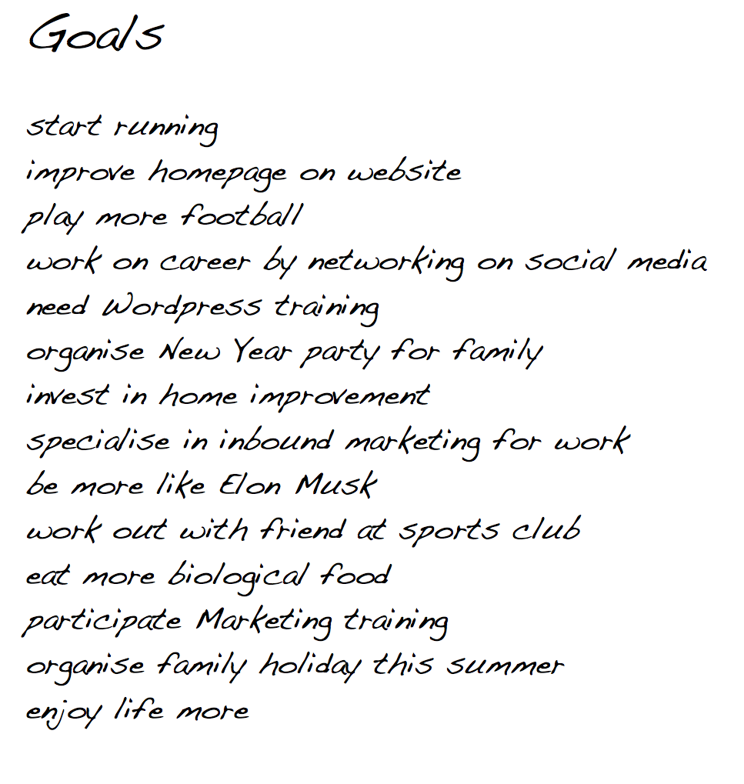
Long term goal is a something further in our future. It’s need a planning and time. Especially when they enter their working place and continue challenging developing during their working life. The points listed above are addressed in the activities. The skills and goals developed by employee and activity are in the working schedule. Students are encouraged to developed skills by the (HE)to link extend beyond higher education in all activities and are looking forward to a job. New graduate should be face up and challenging to contribute explicitly their own goal, and continue developed their own skills on a work place as a short - term and long term goals.

 Creating Backup Plan
Creating a backup plan in place is one of the good strategy to prevent most type of disasters, including hacking or attacking. Creating a new backup plan for your DATA protect is just to take few quick steps:
- Utilize three different backups for essential data.
- Verify your backups to make sure they are capturing all essential files.
- Test own restores frequently to make sure DATA can be retrieved.
- Sleep better at night knowing your DATA is safe.
The worst disaster scenario for your DATA can be / DoS, Datacenter destruction, Data sabotage/
1 DoS is attack, the hacker or attacker can take control of groupe computers as a victims systems known as ‘Zombies’ or call it slaves by spreading different kind of malware. This collection of slaves is known as a botnet. Now, the hacker can take down a cloud server by pushing the slaves in the botnet to send fake traffic which factoring of data or applications or other resources in cloud unavailable to legitimate users.

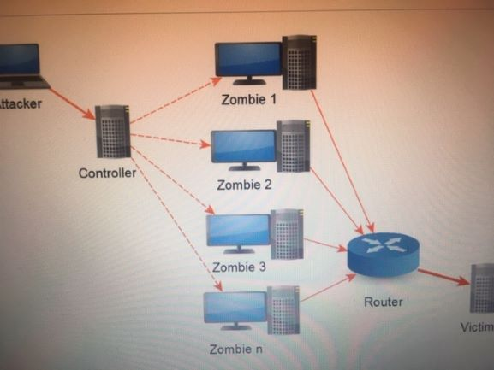

1. Data center destruction, is one of the firs worst disaster scenario that a modern technologies face up hackers or attacker. Is a disaster that destroy part of all its data center and all of the servers and disks inside it, so date centers need of high level of security. The line, restoring Data after “Data center destruction” requires having offsite copies of Data available, as well as a plan for moving that data quickly to wherever it needs to go following the disaster in order to keep you running.
1. Data sabotage, is the second type of Data disaster that might befall your Data or Business is one which someone such as a deliberately sabotages data, or employee might insert inaccurate or bogus Data into your databases, for example, in order to lower data quality and make the Data unusable for you.
It might even insert encrypted code or ransom encryption into your data in an effort to spread malware to your system.
The critical step in preparing of this type of disaster, is to ensure that you have backup copies of your Data that go back far enough in time to allow you to recover.
Most people and companies that days doesn’t know how disastrous data loss can be, despite this, they still consider the threat is almost zero. Loosing big part of your Data or files seems unlikely, but not having a backup plan is still extremely dangerous. Whit no backups, you are not only vulnerable to viruses and hackers, you must also consider the possibility of negligence, DoS, Datacenter destruction and Data sabotage. These situations can cause problems even if you have backup strategy. Whit out it they could very spell doom for you. That’s why a risk you shouldn’t take it because will cost a lots to restore important Data for you or your business. The cost of restore devices of hacking or data lost is a huge amount of Money, from my point of view this absolutely disaster.

Time management and organization:
Time management is the process of organizing and planning how to divide your time between specific activities. Good time management enable you to work smarter not harder so you get more done in less time, even time is tight and pressures are high. By taking the time to arrange your priorities, you can give yourself the best chance of staying on track and organized during the exams period, which in turn can help reduce stress levels, something that can be difference between success and failure at University. Whit exams approaching, you should be thinking about how to get better at time management and organized your days, so you can strike the right balance between home, work and University life. So I can give you some examples of time management:
- What you need have to do
- Making or Create life schedule
- Be flexible and up to date
- Avoid procrastination and distraction
All those examples and key points are good part of time management which can give you a success.

Section5: Conclusion
Rapid development and changes in information technology today. Computer are an integral part of your lives, however useful they may be, and are so harmful. Harmful to our eyes and overall your health. However, whit computers, we can get a lots of knowledge, skills and to be prepared for the job market IT professionals. Knowledge, skills and extensive information through the internet abot the world and everything around us that we could not find elsewhere as fast and in many cases for free. To learn every day and develop new skills for better employability. Students must keep themselves updated whit the changes so they can prosper in their career. That’s why we should not stop doing it professionals as well as the business. It will help us to be successful, creative and realized in our lives. Satisfied whit ourselves and useful to others and the world we live in. Zhang, X., Chen, H., Wang, W.& Ordones de Pablos, P.(2016) What is the role of IT innovation?

Modern material production and other areas of activity are increasingly in need of information services, processing a huge amount of information. A universal technical tool for processing any information is a computer, which plays the role of an amplifier of the intellectual capabilities of man and society as a whole, and communication tools using computers serve to communicate and transmit information. The emergence and development of computers is a necessary component of the process of computerization of society.
Skill evaluation we need in IT to be up to date whit new technology
Indian Journal of Industrial Relations
Vol. 49, No. 3, Special Issue on Skill Development (January 2014), pp. 401-408

The collection of techniques, skills, methods and processes used in the production of goods or services.

In conclusion, goal setting is done in our everyday life. The moment one choses to get out the bed a face up the world, goal have been met. Short term goal setting has become important in day to day function. Goal setting help someone get from where they are to where they want to be. Some goals are tougher to obtain, than other. Chamberline, J (2011). Who put the ‘ART’ in ‘SMART’ Goal? Management service, 55 (3), 22-27. Retrieved from.

While it may seem like there is nothing you can do about stress at work, University and home, There is a steps you can take to relieve the pressure and regain control. It may seem there is nothing you can do about stress. The bills won’t stop coming, there will never be more hours in the day, and your work and Family responsibility will always be demanding. But you have a lot more control than you might think. Stress management is all about taking charge, of your life style, thoughts, emotions and the way you deal whit problems. No matter how stressful your life seems, there is a steps you can take to relieve the pressure and regain control:

- Identify the source of stress in your life:
  - Learn to say ‘NO’.
  - Avoid people who stress you up.
  - Take control of your environment.
  - Be willing to compromise.
  - Create a balanced schedule.
- Get moving.

When you are stressed, the last think you probably feel like doing is getting up exercising . But physical activity is a huge stress reliever. By reducing stress level from yourself you probably will enhance your productivity.
There is nothing more calming down than spending quality time whit another human being who make you feel safe and understood.
Keeping mind that people you talk to do not have to be able fix your stress.
Set aside leisure time, include rest and relaxation in your daily schedule do not allow other obligations take over. This is your time to take a break from responsibility and recharge the batteries.
Poor time management can cause a lot of stress. When you are stretched too thin and running behind, it is hard to stay calm and focused.

HOBBIES STRESS RELIEF

ACTIVITIES AND SPORT STRESS RELIEF

Before start doing this report and conclusion about skill evaluation, short time goal, long time goal and stress relief I have not been ask myself what evaluations I have, I have short time goal, how to relief and reduce stress and what activities you can take, because as involve in our daily work, family and University bases it is difficult to realize the level of stress. So thank you very much on this’ REPORT’
Just learned me how to deal whit all those kind of things. My long time GOAL is to finished and Graduate successfully BSc Cloud computing in University of Wales Saint David.

Section 6: Appendices,

Skills Evaluations:

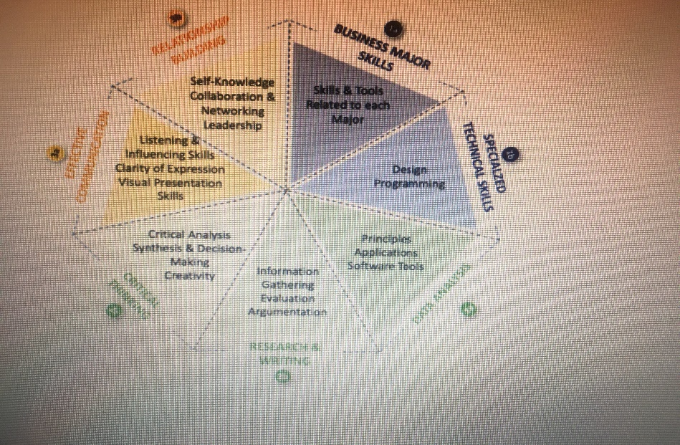

Cryptowall:
- Quick brief what is a Cryptowall.
  - Cryptowall is a classified as malware known as a Ransomware that is virus who get access on your computer and encrypt your important files in 128 bits or 256 bits encryption that means after encryption you don’t have access to you, files if you want to decrypt the files need to pay Ransome money and will decrypt your files.
  - Some of the version on Windows 10 pro there is option lock bits which prevent unauthorized encryption of unauthorized access, but not on Windows 10 home version.
- The attack is a simply yet effective use of the macro functionality within a Microsoft Word document. The payload performs a number of dropping task that eventually lead to a Cryptowall infection. That’s why is very important back up on your files or project all the time how I mentioned before data protection.

