
Software Solutions for Business (ACCA4026)
Component 1- Coursework: Portfolio

Ayaan Jabbar (2509359)

Table of Contents
Task 1 E-Commerce Website Builders/Software Solutions 2
Task 2 Mind-Map Of Contemporary Software Applications 3
2.1 Mind Mapping and Its Benefits in Business Operations 3
2.2 Mind Map Artefact 4
Task 3: Office Applications for Creating, Storing, Presenting and Analysing Information 6
3.1 Office Software Solutions for Business Operations 6
Microsoft Word 6
Microsoft Excel 6
PowerPoint 7
Microsoft Access 8
Comparison and Business Suitability 8
Task 3.2: Practical Testing of Office Application Features 9
Task 4 Communication and Collaboration Applications 13
4.1 Analysis of Microsoft Teams and Google Docs 13
Microsoft Teams as a Communication Application 13
Google Docs as an Online Collaboration Application 14
Comparison and Business Suitability 15
Task 4.2 Practical Testing 15
Microsoft Teams Meeting Feature 15
Google Docs Commenting Feature 17
Reference List 20

Task 1 E-Commerce Website Builders/Software Solutions
Web-based e-commerce website builders are software applications used by businesses to build websites without creating the whole website through coding. The website builder typically integrates all components such as website design, management of products, payments, and inventory among others. This is particularly valuable for small and medium-sized enterprises because digital platforms can help them reach customers beyond their local area and develop additional sales channels [1]. Two widely used examples are Shopify and Wix.
Shopify is an e-commerce platform that is intended for use by companies selling products or services online. It provides product catalogues, checkout, payments, orders, inventory and sales reports functionality. Businesses can also connect their Shopify store to multiple sales channels, allowing products to be sold through different online platforms while being controlled from one system [2]. This increases efficiency since it eliminates the need for the employees to manage each sales channel individually. It also allows Shopify to monitor stock levels from various locations like stores or even warehouses.
Another advantage of Shopify is its flexibility. With Shopify, you can start with an entry-level online store, which you can enhance with the addition of more products, more stores, and more applications. This means that it is a good fit for a firm that expects to grow. But with all the charges associated with using the platform, such as subscription, it can be quite costly.
Wix is an all-purpose website creator that also offers e-commerce capabilities via Wix Stores. The visual drag-and-drop editor lets the user place various website elements including text and images in the desired location. This can come in handy for a small company that lacks dedicated web developers. Wix Stores provides product pages, inventory management, customer checkout and different payment options [3]. Businesses can additionally customise the look of their website and mix an online store with other Wix services.
The key strength of Wix lies in how easy it is to use and the freedom of design. For instance, a self-employed photographer can make a professional-looking website that will be used for selling his or her services and photos from the portfolio. Nevertheless, Wix might get complicated to use in case there are many products in the store and their variety is huge.
In general, both platforms can help in conducting business online however, the two options will suit different scenarios. It is clear that Wix would be the perfect fit for a small and service-based or local business where the main aim is to have a good-looking website with simple selling capabilities. On the other hand, Shopify would be ideal for a product-based business and one that will handle many orders, sell via multiple channels or maintain inventory in different locations.

Task 2 Mind-Map Of Contemporary Software Applications

2.1 Mind Mapping and Its Benefits in Business Operations
A mind map is a technique for organising information around a central theme visually. The main theme is positioned at the centre of the map, while other branches connect it to other themes and sub-themes. Other elements such as keywords, colours, symbols, and pictures may also be used to assist with distinguishing the information presented. This approach enables one to see the relationship among the various ideas rather than reading information sequentially. Research has found that mind maps can support the organisation and representation of knowledge [4].
The technique of mind mapping can be employed in brainstorming sessions in business firms. The employees can start by having a problem or an objective in the middle and adding thoughts to it without having to evaluate or prioritise them at once. For instance, when a company is developing a new product, branches such as those of clients, expenses, marketing, designs, and risks can be created and each of the employees can come up with ideas regarding each of the branches.
Another advantage of mind mapping is the better planning of projects. The project manager may split the project into different areas like tasks, people, deadlines, and risks. Mind mapping has been suggested as one of the tools that may contribute to project management in terms of project purpose, people, problems, and customer requirements [5]. Visual representation of these aspects will assist the manager to identify any missing actions prior to undertaking any activity. It is important to note that while a mind map can serve as an aid in a project management process, it is not a replacement for a detailed project schedule.
Mind maps could also help in solving problems and making decisions. In a business, they could put their problem, say reduced sales, at the centre of the map and develop branches indicating the likely reasons. These include price, competitors, product quality, marketing, etc. The team would then make suggestions on how to solve the problem and its effects. Research indicates that mind mapping can support creativity by helping people develop and connect different ideas [6]. Before making a final decision managers still need evidence such as customer feedback and sales data.
The other advantage includes communication. Good mind mapping enables the presentation of information relating to a broad topic in one page. This will enable the employees to be able to see how various activities or applications are related. Crowding of the map with long sentences makes it difficult for comprehension.
In general, mind mapping can be useful for brainstorming, planning, communication and problem solving. The primary advantage of mind maps is that they help to visualise connections between concepts. The usefulness of mind mapping depends upon having a clear focus of discussion and an organised structure of branches.

2.2 Mind Map Artefact
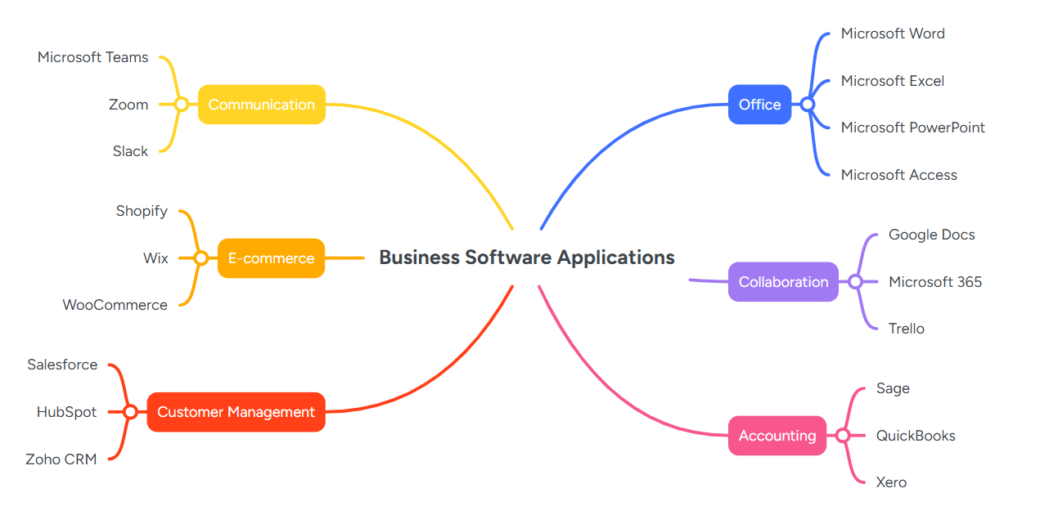
Figure 1: Mind map of contemporary software applications used to support business operations
Figure 1 classifies modern business software into six major categories. It shows that organisations use various software for document creation, communication, collaboration, sales, financial management, and customer relations. The branches help to get a clear idea of the functionality of each software category and the role played by various types of software in business operations.

Task 3: Office Applications for Creating, Storing, Presenting and Analysing Information

3.1 Office Software Solutions for Business Operations
Office software aids companies in creating documents, communicating information, calculating numbers, and organising information systematically. Microsoft Word, Excel, PowerPoint, and Access serve varying functions, but they also exchange information among themselves. Choosing the right application may increase efficiency and correctness, while choosing the wrong application would only result in extra work.

Microsoft Word
Microsoft Word is a document preparation software that is used to create various text-based documents. The software is usually employed by firms for composing letters, reports, policies, minutes of meetings, invoices, and manuals for employees. The formatting functions in Microsoft Word enable the user to regulate fonts, headings, layout of pages, tables, and pictures. The function of styles is to maintain consistent headings in a lengthy report.
Word has collaboration tools as well. The “Track Changes” tool keeps track of the insertions, deletions, and formatting done, thus giving the option to either accept or reject the changes made. Comments can be added to specific areas without modifying the document. Mail Merge can combine one main document with a recipient list to produce personalised letters, emails, envelopes or labels [7]. For example, without entering every name and address manually a company could generate 200 customer letters.
The major advantages of Word are its user-friendly interface, the ease of formatting and its ability to support common document formats used in businesses. The document can be saved in PDF format as well. But Word is not as useful for complex numerical analysis since such processes can be more efficiently handled by Excel. Additionally, formatting can vary depending on the program used for opening a file, and sometimes even when using a different version.

Microsoft Excel
Microsoft Excel is a spreadsheet program that allows data storage, calculation, analysis and presentation of numerical data. It has worksheets made up of rows and columns where each single box on the sheet is referred to as a cell. Organisations use Excel for budgeting, keeping sales data, scheduling employees, inventory control, tracking expenditure and performance measurement.
Formulas and functions form some of the strengths of Microsoft Excel. Simple formulas may be used for addition, subtraction, and calculating percentages while formulas like SUM, AVERAGE and IF will help to make decisions and carry out calculations automatically. An example of an IF formula is one that can check the sales results obtained by an employee and if it meets a certain value it can show "Target Achieved."
PivotTables are another important feature. They can calculate, summarise and analyse worksheet data, allowing users to identify comparisons, patterns and trends [8]. PivotTables can be used for instance by a retailer to do comparison of the total sales made in relation to products, regions, and months. Using the filters will enable the manager to look at one region without altering the actual data.
Excel is able to save time, increase calculation accuracy, and make evidence-based decisions. At the same time, wrong formulas or incomplete information can distort results. It is also possible that a large spreadsheet will be hard to manage when different employees work on separate copies of it. Therefore, Excel is good for calculations and not very big sets of information, while a database is better suited for the rest.

PowerPoint
Microsoft PowerPoint is a program that uses slides to communicate ideas through a series of slides. In businesses, Microsoft PowerPoint is used for training purposes, marketing proposals, meeting presentations, conference presentations among others. The slides contain text, images, graphics, tables, charts and audio or video clips. The Theme and Slide Master tools help organisations use common colors and fonts across their presentations.
Presenter view enables the speaker to see the slide, the upcoming content, and the notes while the audience just sees the presentation. Another way of using PowerPoint is through Microsoft Teams. PowerPoint Live allows a presenter to view slides, notes, meeting participants, reactions and chat within one screen [9]. While continuing to deliver the material this can help the presenter respond to the audience.
The advantage of using PowerPoint is that it is able to make things easy to understand through visualising what one says verbally. For instance, when giving a presentation on quarterly performance as a manager, instead of going through a list of all sales, one can simply use a graph.
But the use of PowerPoint presentations cannot ensure that communication is effective. PowerPoints that have a lot of texts, distracting transitions, and/or animations will lower the audience's level of concentration. Further, the speaker himself might become too dependent on the PowerPoint presentation, rather than speaking about the topic. PowerPoint must assist the speaker and not take the place of his knowledge.

Microsoft Access
Microsoft Access is an application for database management system which is relational. This system enables a company to record connected data in different tables rather than recording the same data several times in a single spreadsheet. A table comprises records and fields whereas relationships link tables through identical identifiers. For instance, a relationship between customer and order tables can be created via Customer ID.
Access databases contain four important objects tables store information, queries retrieve selected information, forms allow records to be entered or updated, and reports display information in a suitable layout [10]. The query may reveal customers that made orders in a certain month. The data-entry form will serve to give employees an easier way to deal with the table rather than using the table directly. The reports can summarise the sales by regions and generate a list of customers.
One advantage of using Access is better control of structured and associated data. Validation rules will prevent wrong entries, while associations may help maintain consistency among tables. Using Access would be better for the organisation when searching and updating connected data on a regular basis. For instance, a car rental firm can have customer, car, and bookings tables separately.
Access needs more expertise in databases than Word or Excel. If the tables and their relationships are designed incorrectly, there will be redundancy or incorrect information. Also, Access is not the ideal application when compared to a database installed on the server for a big organisation that has a lot of users accessing it at once.

Comparison and Business Suitability
These uses cannot be interchanged but complement each other. Word is best suited for creating formal documents, Excel can be used for analysis and computations, PowerPoint for presentation purposes and Access for managing relational databases. For instance, an organisation may decide to keep its customer and order information in Access, analyse its sales information using Excel, summarise its findings using Word and finally use PowerPoint to present its key findings.
The ultimate decision should be based on the data and the target audience. Excel may prove inadequate in storing the data as the data becomes larger, while using Access to create a basic report would make the process unnecessarily complex. Hence, businesses ought to use the application that fits the purpose rather than relying on the software that is familiar to their employees.

Task 3.2: Practical Testing of Office Application Features
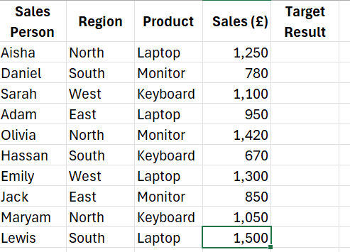
Figure 2: Fictional sales data prepared for testing the Excel IF function
Figure 2 illustrates the fictitious data set of sales used to validate the IF function in Excel. This worksheet includes sales personnel, regions, product sold, and total sales value. A sales target of £1,000 was chosen such that the formula could automatically classify the performance of the employees.
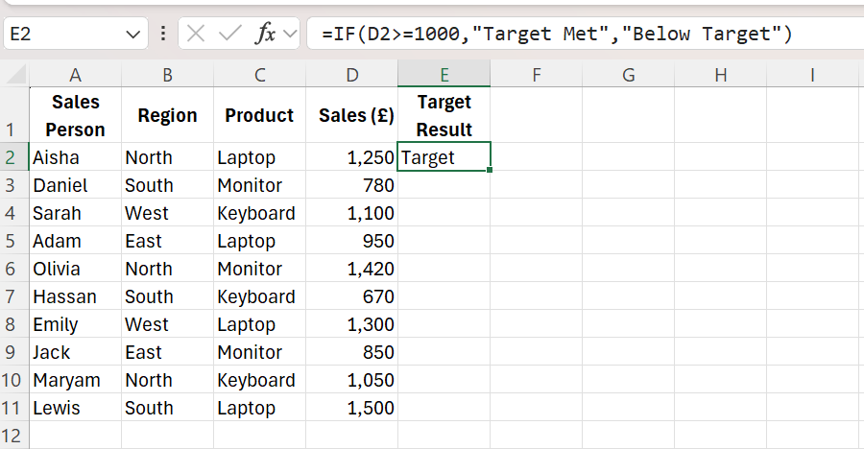
Figure 3: IF formula entered to compare sales against the £1,000 target
In Figure 3, you will see the use of IF formula in cell E2. The IF formula checks if the value in D2 is more than or equal to 1,000. In case the result is true, Excel writes “Target met.” Otherwise, it writes “Below target.”
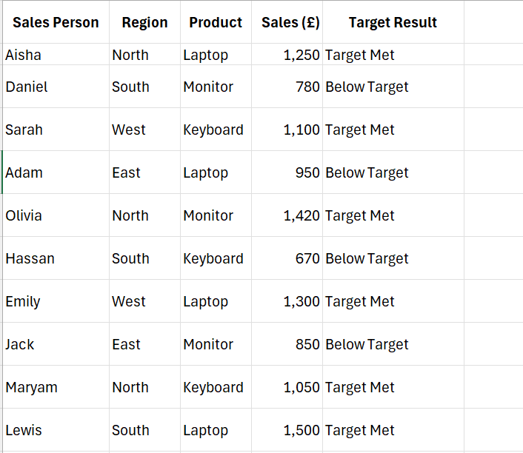
Figure 4: Completed IF function results for all sales records
Figure 4 shows the output after copying the formula down the Target Result column. Staff whose sales were £1,000 or above were categorised as “Target Met” while others who scored less were categorised as “Below Target.” A sales manager could easily identify the performance of employees using this function without having to manually verify every value.

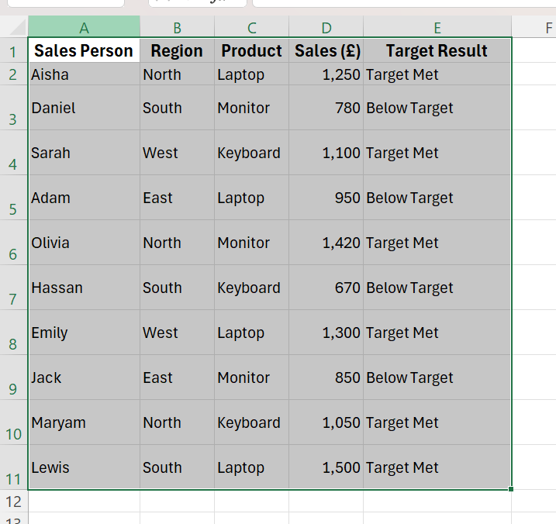
Figure 5: Sales dataset selected for PivotTable analysis
Figure 5 illustrates the entire dataset of sales data chosen before the creation of the PivotTable. Headings were included since Excel takes them as fields. The entire range has been chosen to include all records in the analysis.

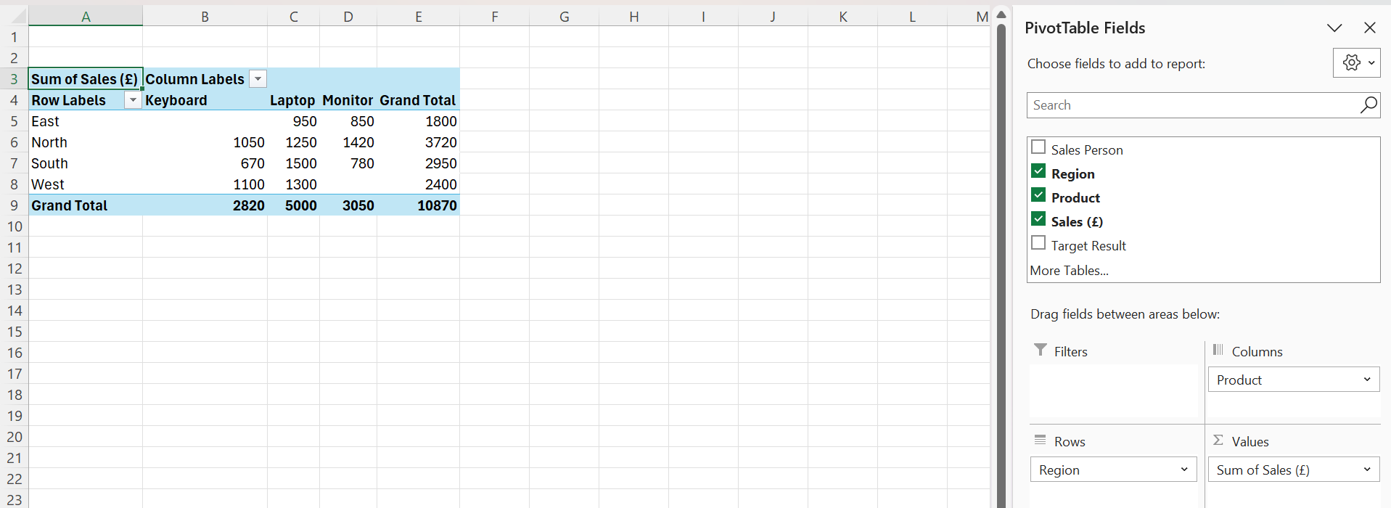
Figure 6: Configuration of the PivotTable fields
Figure 6 displays the manner in which the Pivot Table fields were arranged. The field Region was inserted in the Rows section, while the field Product was inserted in Columns and the field Sales in Values. This particular arrangement was chosen for comparing the value of product sales in four regions.

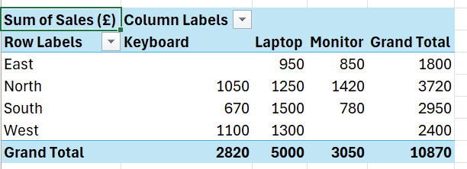
Figure 7: Completed PivotTable comparing product sales by region
Figure 7 gives the final output of the PivotTable. The data reveal that the North region contributed the highest total sales at £3,720, and the East region gave the lowest total sales at £1,800. Meanwhile, laptops provided the highest total sales from the product point of view at £5,000. Such information might be useful to a sales manager in making further decisions.
From the practical experience, it is clear that pivot tables can take sales records from individual entries and transform them into a summary table without needing a separate formula for each category, which renders the tool very useful in situations where managers have to analyse large volumes of business data. Accuracy of the results, however, is dependent on the quality of the initial input data.

Task 4 Communication and Collaboration Applications

4.1 Analysis of Microsoft Teams and Google Docs
Modern day organisations rely on digital collaboration and communication apps that facilitate communication among employees working in different places. Communication apps are used mainly for sending messages and conversing, while collaboration apps help users make contributions to collaborative work. There are similarities between the functionality of Microsoft Teams and Google Docs; however, their roles are different.

Microsoft Teams as a Communication Application
Microsoft Teams is an online collaboration tool which allows instant messaging, group chats, voice and video calling and file sharing. An organisation can create different teams for each department and channels for particular topics or projects. Microsoft explains that channels are dedicated areas that organise conversations according to a particular topic, project or discipline [11]. For instance, a business can set up a Marketing department with specific channels for social media, ads, and consumer insights.
Chat is faster for communication compared to e-mail in case employees need an immediate reply. Video conferences help remote workers to communicate face to face, display their screen and make presentations. Moreover, conferences may minimise travelling needs in case of employees or clients located in other places. Academic research has recognised that digital collaboration technologies can influence important team communication and collaboration processes [12].
One advantage of Teams is that many communication options exist within the same platform. The user is able to switch between a discussion through the written word, to a visual discussion while sharing documents without having to leave the platform. Its compatibility with Microsoft 365 makes it a good choice for companies already using Word, Excel, PowerPoint, Outlook, and SharePoint.
Nonetheless, Teams can also lead to information overload. There might be messages, meeting requests, and notifications being sent from multiple sources, thus making it hard to distinguish which pieces of information matter. Unorganised channels and teams can also make people store their messages or files in the wrong places. Online meetings can also suffer from poor connectivity issues, faulty microphones, and lack of employee confidence using the software.
It becomes clear that Teams works best when there are certain ground rules put into place in an organisation. Channel names need to be clear, notifications should not be used unnecessarily, and sensitive information should only be communicated to approved individuals.

Google Docs as an Online Collaboration Application
Google Docs is a cloud-based word processing program which enables several people to collaborate on a document. A document owner can grant another individual access to the document where he will be allowed to see, comment on or modify the document. Modifications can be done by employees at the same time hence reducing the need to send documents through emails.

Some of the collaboration tools that Google Docs has are comments, Suggesting mode, and version history. Using comments, an individual can raise a question or comment beside the relevant section. Suggesting mode shows the modification suggestions that have been made without deleting the existing wording. Google confirms that users can comment, make suggestions, inspect version history and accept or reject proposed edits [13].
For instance, in case of a firm that is preparing a project proposal, several workers may work on the same Google document together. One worker in the finance department may verify the cost estimates, a manager may verify the language used, while another worker may provide evidence. This helps the firm avoid having various attachments that may have names like “Proposal Final” and “Proposal Final Updated,” among others.
The productivity of workers can be increased by Google Docs by making real-time editing possible. Research into Google-mediated collaborative writing also demonstrates that web-based collaboration tools can support teamwork and the joint development of written work [14]. The automatic saving feature further reduces the possibility of losing recent changes.
Nonetheless, Google Docs has its own demerits. In order for collaboration features to be effective in Google Docs, there must be reliable access to the internet although offline mode is possible depending on how it is set up. The problem that could arise from this is the accidental exposure and manipulation of the file by any other person besides the one intended if the correct permission setting is not done. Moreover, overly complicated formatting could be difficult when transferring the document into a different format for word processing purposes.
This could be solved through assigning of correct permissions to the user, where access will be limited to certain persons only, with employees editing particular sections only.

Comparison and Business Suitability
Teams works better than Google Docs in situations that require conversation and collaboration of employees. However, Google Docs is intended to work with writing collaborative documents.
The tools can be used in combination with each other. The employee can first have a meeting via Teams to discuss some idea and then write the proposal via Google Docs. The former tool will give an opportunity to communicate verbally, and the latter will provide the record of the work.
The selection is ultimately based on the business process. The application of Teams will be more suitable in case of consistent communication among departments and quick communication. Google Docs will be the better tool if the employees have to work on drafting, commenting and approval of the same document. Neither of the two applications is effective without any additional measures.

Task 4.2 Practical Testing

Microsoft Teams Meeting Feature
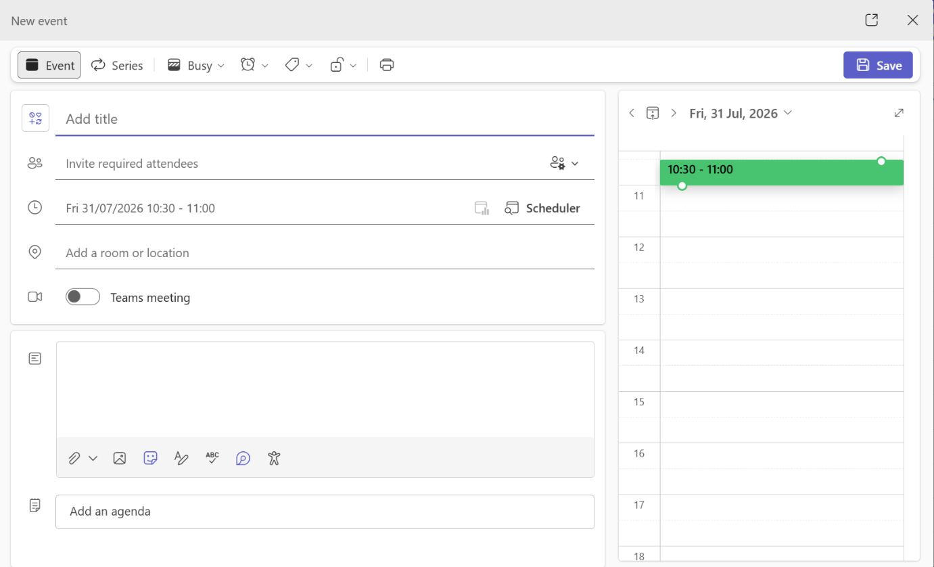

Figure 8: Opening the new meeting form in Microsoft Teams
Figure 8 depicts the meeting form that has been created via the Microsoft Teams calendar. The new feature enables the employee to schedule the online business meeting by providing the purpose, date, time, and participants of the meeting.
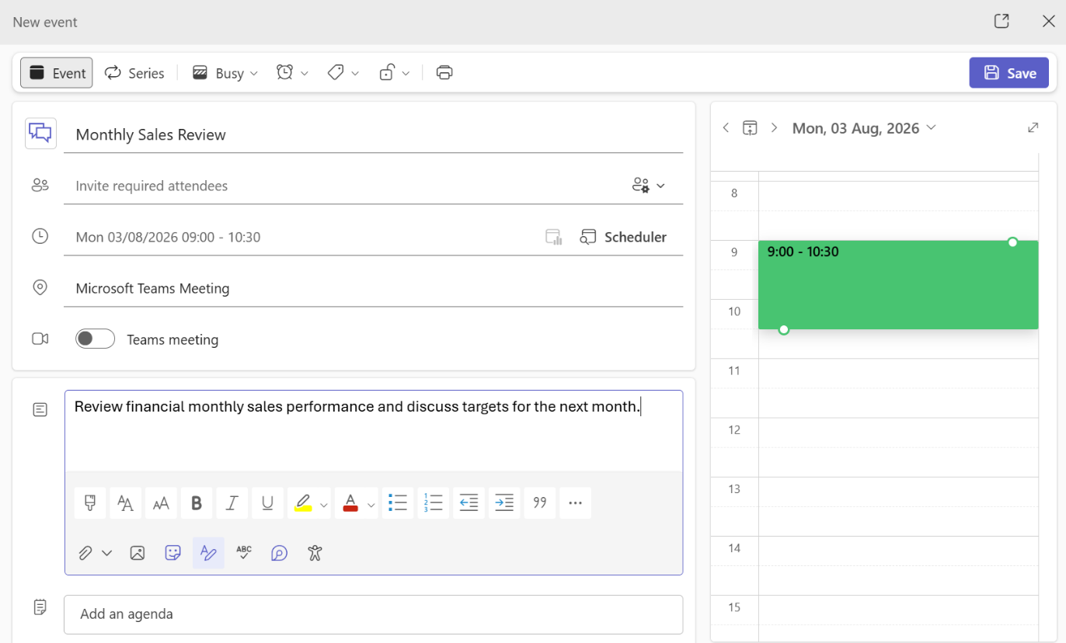
Figure 9: Fictional business meeting details entered in Teams
The information that was filled in regarding the fictional monthly sales meeting is illustrated in Figure 9. A suitable name, date, time and description was indicated to ensure that the attendees understood the objective of the meeting. This may assist the organisation in coordinating communication remotely.
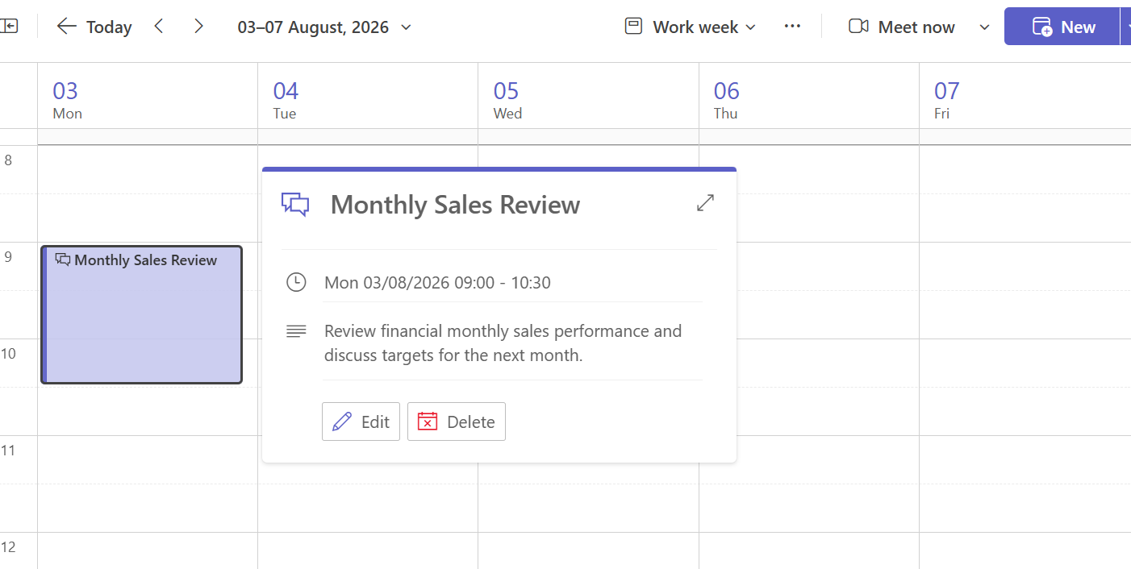
Figure 10: Microsoft Teams meeting successfully scheduled
Figure 10 confirms that the meeting was successfully added to the Teams calendar. The saved event provides one location for the meeting details and joining information. This feature could help remote or hybrid employees attend meetings without travelling to the same workplace.
This practical test demonstrated that Microsoft Teams can be used to schedule and organise online business communication. The feature combines the meeting purpose, date, time and joining information in one event. This could save time and help employees plan their availability. However, successful communication still depends on participants receiving the invitation, having a suitable device and maintaining a reliable internet connection.

Google Docs Commenting Feature
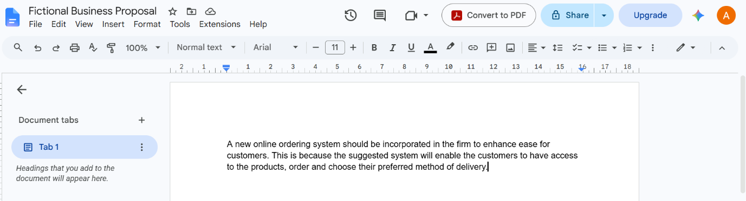
Figure 11: Fictional business document created in Google Doc
Figure 11 shows the fictional business proposal created to test Google Docs commenting feature. The document suggests introducing an online ordering service. No genuine company or customer information was used during the practical activity.
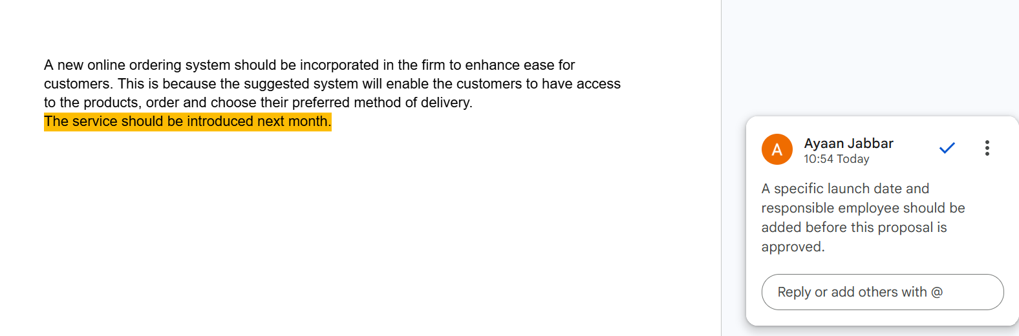

Figure 12: Feedback added using the Google Docs commenting feature
Figure 12 is an example of comments that have been attached to one particular sentence in the document. This comment asks for the clarification on the date of the launch and the need for someone to be assigned with the responsibility. This will help the other employee understand clearly the suggested change.

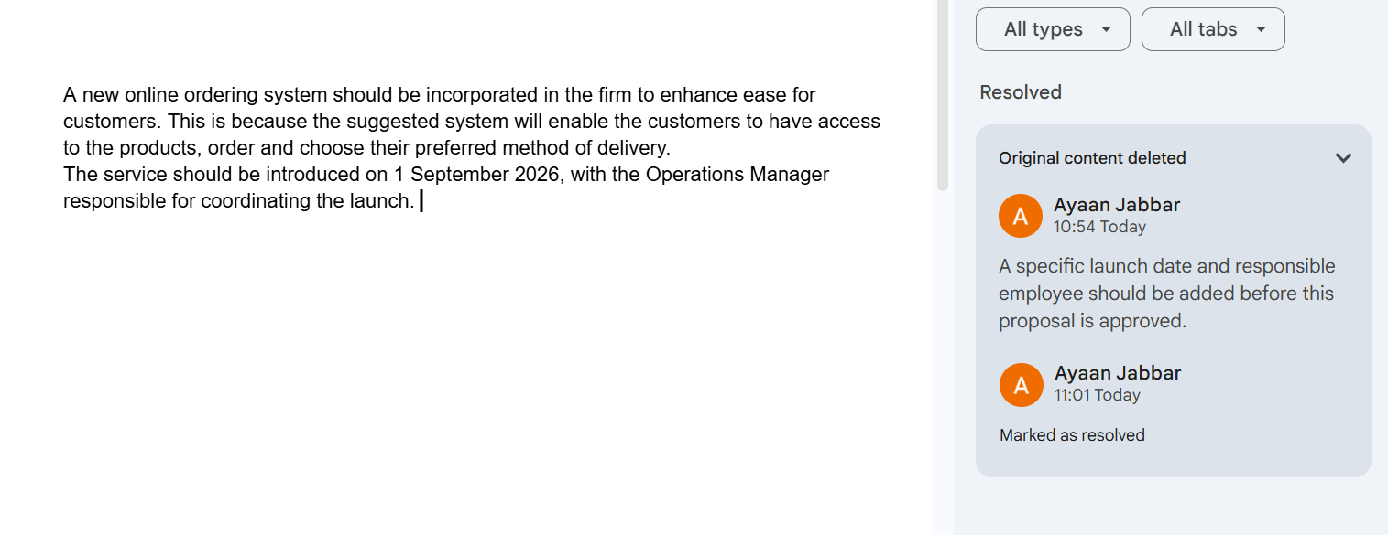
Figure 13: Document updated after responding to the Google Docs comment
Figure 13 shows the amended sentence after the feedback was considered. A specific implementation date and responsible role were added before the comment was resolved. This demonstrates how comments can support review, accountability and collaborative improvement without placing feedback inside the main document.
From this test, it was shown that feedback using Google Docs comments can be tied to a certain word, sentence or part of the document. Employees will be able to give feedback on changes without changing the work of someone else, and the closed comment will serve as an indication that the feedback was attended to. This may simplify collaborative work with documents and prevent long email threads. Nevertheless, employees require certain permissions, and sensitive information may become public.

Reference List
[1] OECD, The Digital Transformation of SMEs. Paris, France: OECD Publishing, 2021. [Online]. Available: https://doi.org/10.1787/bdb9256a-en. [Accessed: Jul. 31, 2026].
[2] Shopify, “Sales channels,” Shopify Help Center. [Online]. Available: https://help.shopify.com/en/manual/online-sales-channels. [Accessed: Jul. 31, 2026].
[3] Wix, “About Wix Stores,” Wix Help Center. [Online]. Available: https://support.wix.com/en/article/wix-stores-about-wix-stores. [Accessed: Jul. 31, 2026].
[4] C. Kefalis, K. Drigas and A. Skianis, “A systematic review of mind maps, STEM education and artificial intelligence,” Computers, vol. 14, no. 6, Art. no. 204, 2025. [Online]. Available: https://doi.org/10.3390/computers14060204. [Accessed: Jul. 31, 2026].
[5] M. A. Wickramasinghe, A. Widanapathirana, O. Kuruppu, I. Liyanage and P. Karunathilake, “Adding value to projects using mind maps,” PM World Journal, vol. 4, no. 8, pp. 1–13, 2015. [Online]. Available: https://journals.sagepub.com/doi/10.1177/2394964315602412. [Accessed: Jul. 31, 2026].
[6] Y. Dong, S. Zhu and W. Li, “Promoting sustainable creativity: An empirical study on the application of mind mapping tools in graphic design education,” Sustainability, vol. 13, no. 10, Art. no. 5373, 2021. [Online]. Available: https://doi.org/10.3390/su13105373. [Accessed: Jul. 31, 2026].
[7] Microsoft, “Use mail merge for bulk email, letters, labels, and envelopes,” Microsoft Support. [Online]. Available: https://support.microsoft.com/en-us/word/use-mail-merge-for-bulk-email-letters-labels-and-envelopes. [Accessed: Jul. 31, 2026].
[8] Microsoft, “Create a PivotTable to analyse worksheet data,” Microsoft Support. [Online]. Available: https://support.microsoft.com/en-us/excel/get-started/create-a-pivottable-to-analyze-worksheet-data. [Accessed: Jul. 31, 2026].
[9] Microsoft, “Present from PowerPoint Live in Microsoft Teams,” Microsoft Support. [Online]. Available: https://support.microsoft.com/en-us/powerpoint/present-from-powerpoint-live-in-microsoft-teams. [Accessed: Jul. 31, 2026].
[10] Microsoft, “Learn the structure of an Access database,” Microsoft Support. [Online]. Available: https://support.microsoft.com/en-us/access/learn-the-structure-of-an-access-database. [Accessed: Jul. 31, 2026]
[11] Microsoft, “Overview of teams and channels in Microsoft Teams,” Microsoft Learn, Mar. 13, 2025. [Online]. Available: https://learn.microsoft.com/en-us/microsoftteams/teams-channels-overview. [Accessed: Jul. 31, 2026].
[12] J. N. Lane, E. S. Shaughnessy, M. A. M. Prewett and M. J. I. Salas, “Teams in the digital workplace: Technology’s role for communication, collaboration, and performance,” Small Group Research, vol. 55, no. 1, 2024. [Online]. Available: https://doi.org/10.1177/10464964231200015. [Accessed: Jul. 31, 2026].
[13] Google, “Collaborate with real-time editing,” Google Workspace. [Online]. Available: https://workspace.google.com/resources/real-time-editing/. [Accessed: Jul. 31, 2026].
[14] M. H. Neumann and T. J. Kopcha, “Collaborative writing and text quality in Google Docs,” Language Learning & Technology, vol. 23, no. 2, pp. 22–42, 2019. [Online]. Available: https://www.lltjournal.org/item/10125-44681/. [Accessed: Jul. 31, 2026].

