Student name: | Gabriel Phillips | Student ID number: | 2209168
Programme: | School of Engineering Portfolio
Module: | Stress Analysis and Dynamics
Module code: | ACMA5010 | Contribution to Overall Module Assessment (%): | 50%
Lecturer: | Rob Goodson | Internal Verifier: | Kelvin Lake
Assignment Title: | Analysis and Simulation of a Centrifugal Clutch | Word count (or equivalent): | 2500
Submission deadline: | 11/11/24 | Return date of provisional marks & written feedback: | 20 Working days after the submission date
Submission method: | All written assessments, where practical and possible, must be submitted via Turnitin unless otherwise instructed by the Lecturer. (Please DO NOT put this assessment specification into Turnitin or it will match many similarities with other students’ submissions.)  Alternative submission method (if applicable):  Late submission of the assessment will result in a late penalty mark.  Work which is submitted up to 1 week late will be capped at 40% for the first attempt and will be awarded a mark of 0% for re-assessment. Late submission penalties may be lifted only if there is an approved extenuating circumstances claim.  Work submitted more than 1 week late will be considered as a non-submission and will not be marked. The work may be considered as a submission for reassessment if offered by an Examining Board or if there is an approved extenuating circumstances claim.
2024 | Academic honesty is required. In the main body of your submission you must give credit to authors on whose research and ideas your work is based. Append to your submission a reference list that indicates the books, articles, etc. that you have used, cited or quoted in order to complete this assessment.

Stress Analysis and Dynamics Assignment

  - Author: Gabriel Phillips
  - Date: 11/11/2024

Contents
Table of Figures 4
Task A 5
Introduction 5
The Historical Development of Centrifugal Clutches 6
Modern Applications 6
Materials 7
Pros and Cons 8
Pros 8
Cons 8
Electromagnetic Clutches 8
Conclusion 9
Task B 10
1 10
2 11
3 12
4 12
5 13
6 14
7 15
8 16
Word Count: 2503 + Written Work 17
References 17

Table of Figures
Figure 1 - Centrifugal Clutch Design (Extrudesign, 2024) 4
Figure 2 - Centrifugal Clutch internals with radial movement design. 5
Figure 3 - Centrifugal Clutch internals with linear movement design. 5
Figure 4 - Patent for Centrifugal Clutch coupled with an electric motor (Fogarty, 1898) 5
Figure 5 - Armstrong Siddeley 17 hp 5
Figure 6 - Centrifugal Clutch on a Go Kart drivetrain. 6
Figure 7 - Centrifugal Clutch with high friction material on the drum and shoes. (Mechanical Engineering, 2018) 7
Figure 8 - FANUC M710 applying sealant to a car on an assembly line. 8
Table 1 - 450-700 RPM vs Torque 13
Table 2 - 450-6000 RPM vs Torque 13
Table 3 - RPM vs Torque with reference to varying coefficients of friction 14

Task A

Introduction
A clutch is a mechanism that enables the transfer of torque and power from an engine/motor to various components (Gearbox Specialists Bournemouth, 2020), such as the wheels of a car (through the differentials) or the drive system of a chainsaw. Clutches are designed to disconnect the power source from the driven components when needed which prevents shock loading of the power train (BLM Automatic Clutch, 2019), ensuring safety, reliability, or improved efficiency as they allow mechanisms like gearboxes.
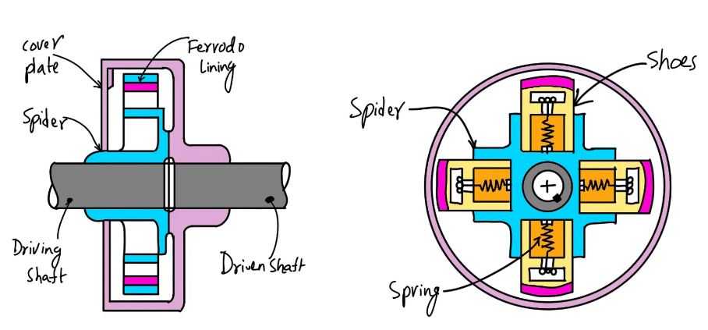
The internal component of a centrifugal clutch is essentially fly weights attached to a driveshaft via a spring. When in motion the driveshaft creates a centrifugal force that overcomes the force of the springs loading to a point when it contacts the inside diameter of a drum, the drum will have clearance of the shoes when not in motion. As the driveshaft accelerates, the shoes are pushed outward and contact the drum, the shoes movements are restricted to radial/linear movement depending on design.
Figure 1 - Centrifugal Clutch Design (Extrudesign, 2024)
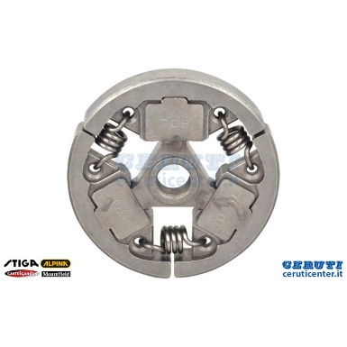
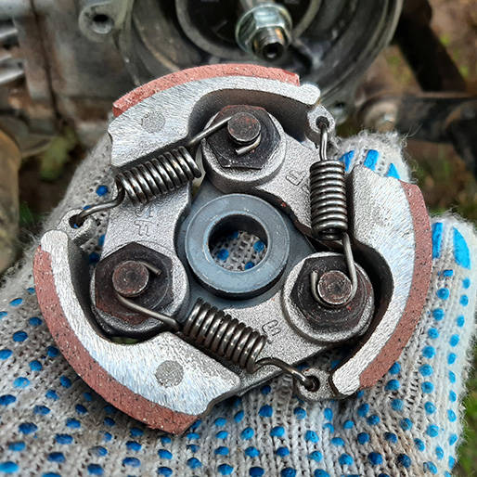
A centrifugal clutch typically features multiple shoes, with at least two to prevent imbalance. The shoes have a surface that contacts the inner diameter of the drum. This surface is coated with a material designed to maximise friction while minimising wear. This friction enables the transfer of torque to the drum and, in turn, to the driven shaft. Centrifugal clutches will also have a component known as a spider is the contact point between the driveshaft and the shoes as well as acting as a guide on linear clutches and house the pins for the rotation points on radial clutches as shown in figure 2 and 3.
Figure 2 - Centrifugal Clutch internals with radial movement design.
Figure 3 - Centrifugal Clutch internals with linear movement design.

The Historical Development of Centrifugal Clutches
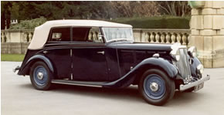
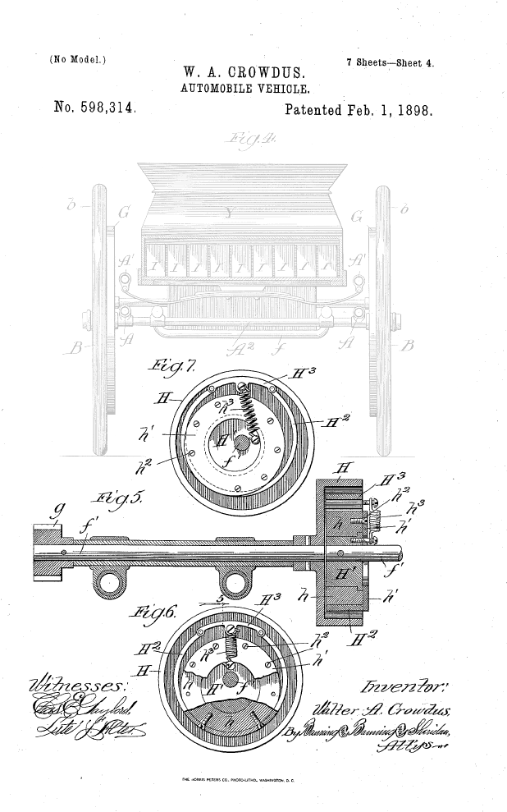
The original invention of the centrifugal clutch is said to be mid-19th century with the uses of them in locomotives, however data from that period is hard to come across, with the earliest findings from my research being a patent for an electric vehicle in 1898 shown in figure 4. From there they progressed into small vehicles such as motorbikes in the 1920s (MotoDealers UK, 2023). It further progressed into larger vehicles such as cars, an example of this is Armstrong Siddeley 17hp which was installed with a "Newton" automatic (centrifugal) clutch from 1936. The cars were not known for their power or torque, but praised for their quality and reliability (Siddeley, 1936).
Figure 4 - Patent for Centrifugal Clutch coupled with an electric motor (Fogarty, 1898)
Later into the 1950s clutches developed into more heavy-duty machines such as hydraulic dredgers which were responsible for moving large volumes of earth on the St. Lawrence Seaway. The clutches were paired with diesel engines and pumps allowing continuous smooth operation, the clutches would allow the automatic disengagement of the pumps without turning off the engine, prolonging the life of the engines by reducing the repeated restarts. The clutch also allowed slippage from large blockages, making the clutch multifunctional and ideal for the given task. (BLM Automatic Clutch, 2023)
Figure 5 - Armstrong Siddeley 17 hp

Modern Applications
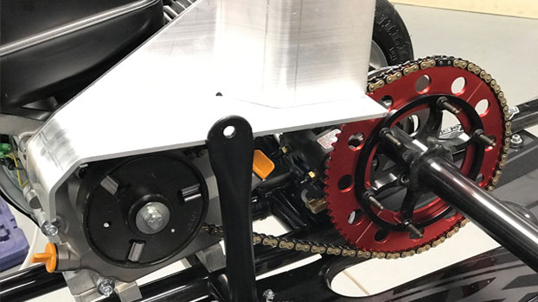
These days centrifugal clutches are used in go-karts, minibikes, chainsaws, lawnmowers and so on. They are used in these products due to their simplicity, dependability and low maintenance requirements (The Engineers Post, 2023). Due to their ability to automatically engage and disengage based on RPM, centrifugal clutches facilitate a smooth start (Lancereal, 2019). This characteristic explains why vehicles like go-karts accelerate gradually as RPMs increase. Unlike modern sports cars, which can deliver an immediate surge of torque when the accelerator is pressed, go-karts with centrifugal clutches lack the instantaneous power. The controlled engagement prevents sudden acceleration, but torque builds as rpm increases as shown in task B of the assignment. In some niche cases centrifugal clutches can still be used for heavy duty applications, with BLM Automatic Clutch claiming to have custom centrifugal clutches that are capable of handling 800hp (BLM Automatic Clutch, 2023).
Figure 6 - Centrifugal Clutch on a Go Kart drivetrain.

Materials
There are several different components to a centrifugal clutch and depending on the components the material needs to meet a certain set of characteristics. Breaking down the components helps clarify their roles, making it easier to understand their individual functions within the system.

Friction plate
The role of the friction plate is to provide as much frictional force as possible when rubbing against the drum, characteristics that are needed and a good resistance to heat, wear resistance and a high friction coefficient. Materials that meet these requirements include:
- Ceramics
- Composites (ceramic, sintered metallic or resin based (CompositesWorld, n.d.))
- Carbon Based Materials
- Organic Compounds (Motion Drives and Controls, n.d.)

Shoe and Spider
The shoe and spider components of a centrifugal clutch are generally made from high-strength metals due to their need to resist high temperatures and significant centrifugal forces without deforming. These parts must have minimal friction to allow controlled movement as the shoes extend to the drum. They also experience cyclic loading as the clutch accelerates and decelerates, which can make materials like aluminium less suitable. Suitable materials include:
- Steel (Service Steel, 2024)
- Cast Iron (Motion Drives and Controls, n.d.)
- Titanium – This material offers strong properties but can be considered excessive for the application and challenging to machine.

Spring

The springs in a centrifugal clutch experience cyclic loading, so the material must have the ability to deform repeatedly without surpassing the elastic limit, ensuring it does not enter the plastic deformation phase. Additionally, it should possess high heat resistance to maintain its performance under the temperature fluctuations generated during operation. Suitable materials include:
- High Carbon Steels
- Stainless Steel
- Nickel Alloys (Airedale Springs, 2024)

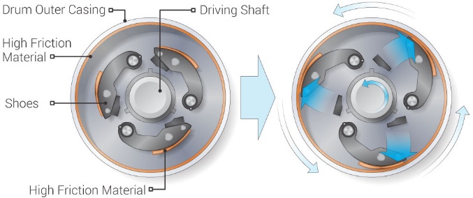
Drum
The drum will be an amalgamation of the materials used for the spider/shoe and the friction plate. This is because the drum's inner diameter is often coated with a material that has a high friction coefficient, which helps to further reduce wear. To summarise a suitable steel or cast-iron casing with a ceramic coating on the internal diameter is one of the suitable solutions for the material characteristics of a drum.
Figure 7 - Centrifugal Clutch with high friction material on the drum and shoes. (Mechanical Engineering, 2018)

Pros and Cons

Pros
Their simple design leads to low manufacturing costs and easy maintenance. Automatic engagement allows operation without manual input, making vehicles such as go-karts easier to drive than manual cars. The soft start feature significantly reduces shock loading, extending drivetrain life. Additionally, automatic disengagement serves as a valuable safety measure in tools like chainsaws. Overall, their versatility makes them suitable for various modern applications, as demonstrated in related sections.

Cons
The automated design of centrifugal clutches results in less control compared to manual clutches, which can deliver near-instant torque. This highlights another drawback: performance is tied to engine RPM, with torque increasing only as RPM rises, limiting effectiveness at variable speeds. Mechanical wear and tear are standard issues with mechanical systems, and the friction-based design can lead to excessive heat buildup. Although some centrifugal clutches can handle high horsepower as demonstrated in modern applications, they are generally less efficient than other clutch types for managing higher torque levels.

Electromagnetic Clutches
Electromagnetic clutches have been used since the late 1950s (Ogura Clutch, n.d.). They operate using electromagnets that generate a magnetic field when a DC voltage is applied. A magnetic material, known as the armature, is attached to the desired rotating component and moves to engage the friction surface, initiating clutch rotation. When the DC current is switched off, the magnetic field weakens, allowing the armature to retract and disengaging the clutch instantly, similar to turning off a light switch (KEB America, 2023).

Clutches are essential in modern automation for their ability to engage and disengage instantly. When integrated with censored motors that can detect rotor positions, or high precision servos, multiple clutches enable precise multi-axis movement, such as in robotic arms on assembly lines. A notable example is when robotic arms apply sealant to car chassis, working with high precision and speed across several axes to perform repetitive tasks efficiently. (Fanuc America Corporation, 2024) The potential for robotics is limitless, and the future is exciting, with tasks like loading dishwashers, wiping kitchen countertops, and putting away laundry possibly being handled by robotic arms. These advancements will make everyday chores easier and more efficient. As technology progresses, robots could become more integrated into home life, bringing greater convenience and flexibility to daily routines.
Figure 8 - FANUC M710 applying sealant to a car on an assembly line.

Conclusion
Centrifugal clutches still play an important role in mechanical applications, particularly in simple systems like small engines. Their easy-to-understand design makes them ideal for learning the fundamentals of clutch operation. In my experience, while designing a 3D-printed RC car drivetrain, I’ve faced difficulties with a basic drivetrain setup, which connects a spur gear directly to a locked differential through a long shaft. Despite attempts to reduce torque through flexible materials like Ninjaflex and TPU, I continue to encounter issues such as stripped gears and broken shafts. A centrifugal clutch could offer a solution with its mechanical soft start application, transferring power more evenly and minimizing strain on the materials, although heat buildup may be a challenge due to the nature of 3D printing materials.

Task B

1
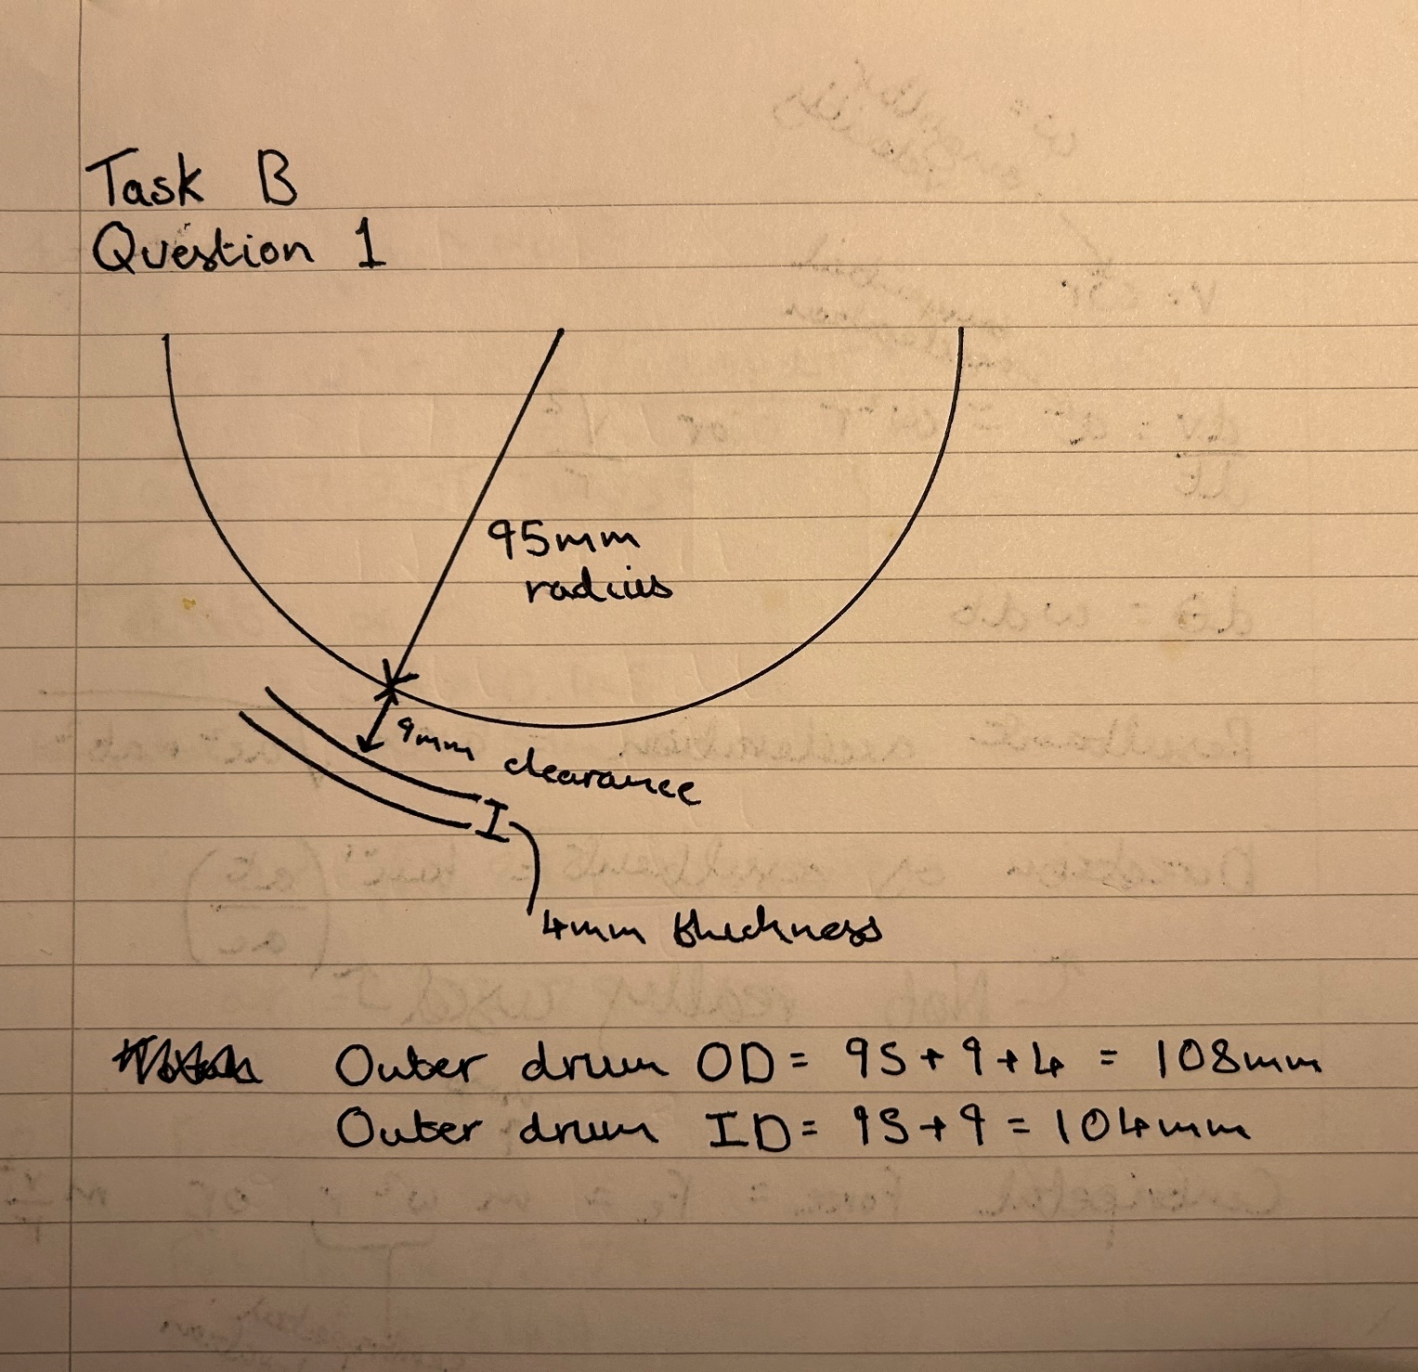

2
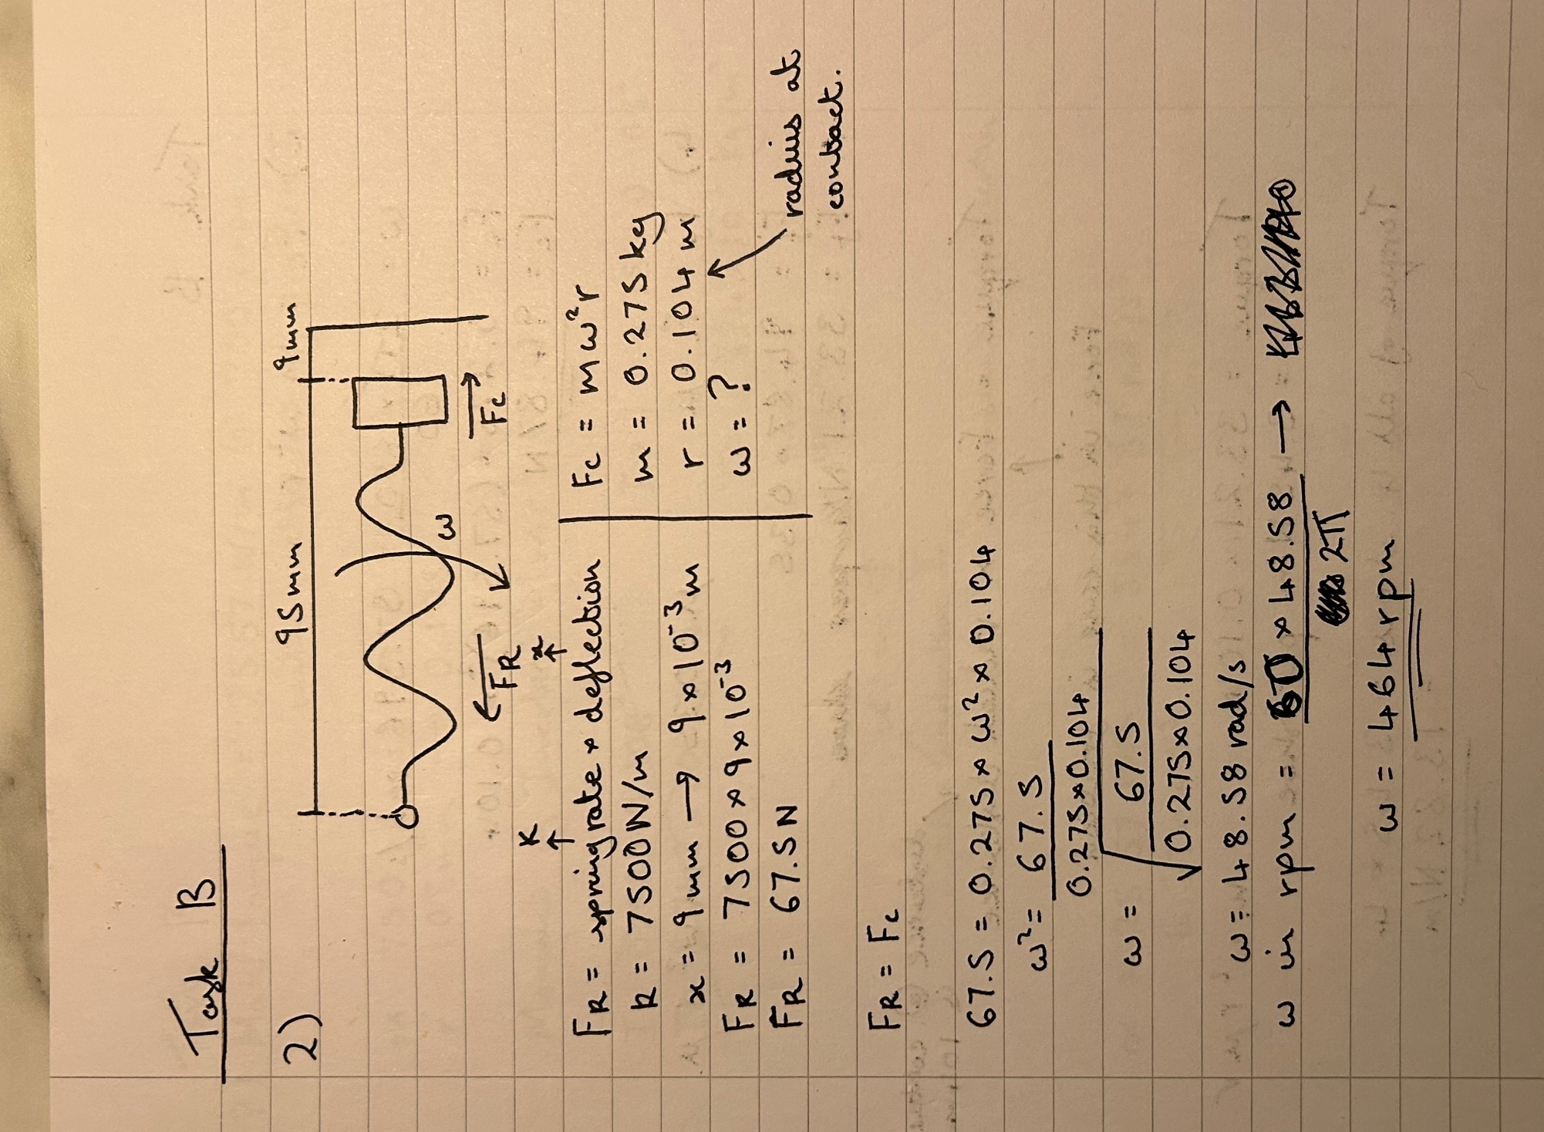

3
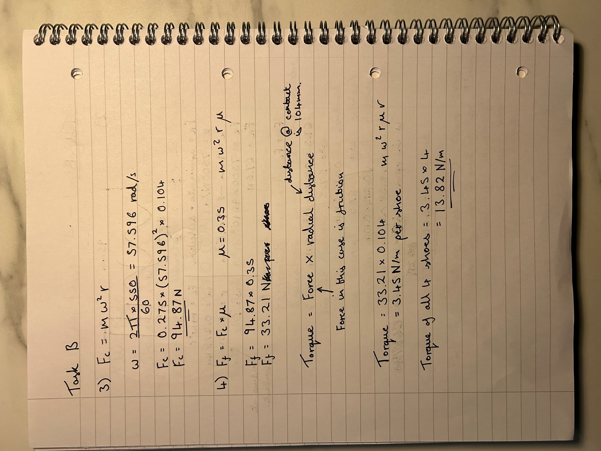

4

5

Table 1 - 450-700 RPM vs Torque
Although subtle, the torque increase with rising RPM is quadratic, not linear, which becomes evident at higher RPMs, a graph to 6000 rpm shows a better illustration of the curve. Below the engagement speed of 464 RPM, torque output would be zero as the clutch remains disengaged. This illustrates the relationship between RPM and torque, emphasizing how torque ramps up significantly after engagement, following a non-linear curve.

Table 2 - 450-6000 RPM vs Torque

6

Table 3 - RPM vs Torque with reference to varying coefficients of friction
The coefficient of friction representation of the parasitic losses in a system due to heat, sound, or other forms of energy dissipation. The higher the coefficient of friction, the greater the torque produced as there is less energy dissipation. When the coefficient of friction is 0.3, it implies that 30% of the applied force contributes to frictional effects, resulting in 70% of the force being lost as parasitic effects. When the coefficient of friction increased to 0.4, 40% of the applied force is contributing to friction, so 60% is lost. Max Torque is 25.57N/m at 700 RPM with coefficient of friction of 0.4.

7
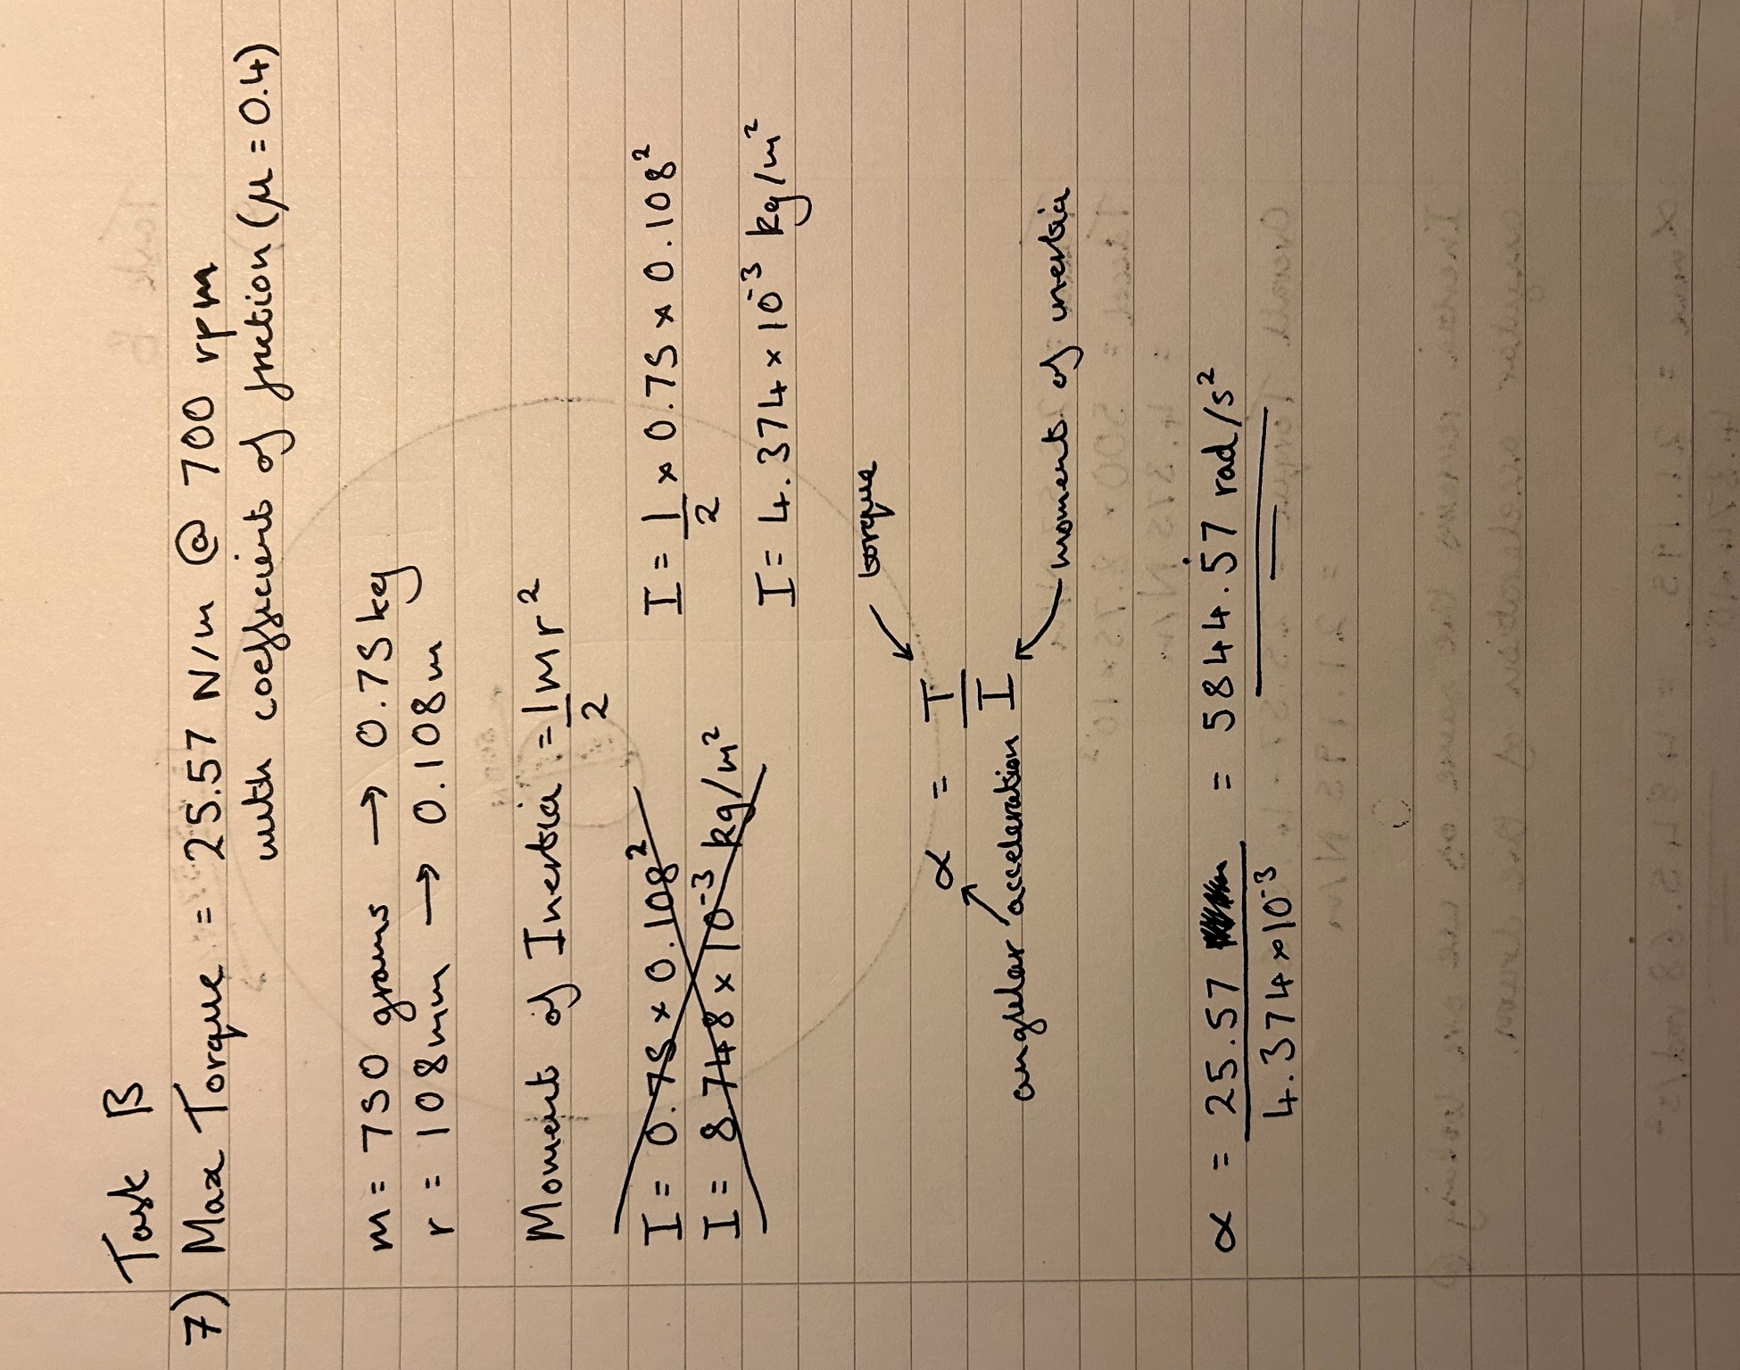

8
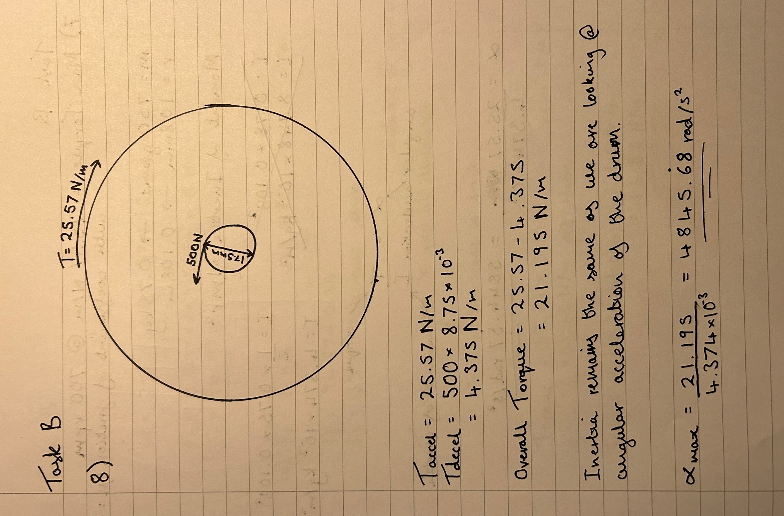

Word Count: 2503 + Written Work

References
BLM Automatic Clutch. (2019). The how and why of centrifugal clutches. Available at: https://www.centrifugalclutches.com/blog/the-how-and-why-of-centrifugal-clutches/ [Accessed 10 Nov. 2024].
BLM Automatic Clutch. (2023). Heavy-duty centrifugal clutches: A BLM case history. Available at: https://www.centrifugalclutches.com/blog/heavy-duty-centrifugal-clutches-a-blm-case-history/ [Accessed 10 Nov. 2024].
Extrudesign. (2024). Different types of clutches. Available at: https://extrudesign.com/different-types-of-clutches/?utm_content=cmp-true [Accessed 9 Nov. 2024].
Fogarty, T. (1898). Centrifugal clutch, U.S. Patent 598314. Available at: https://patents.google.com/patent/US598314 [Accessed 10 Nov. 2024].
Gearbox Specialists Bournemouth. (2020). The importance of the clutch in motor vehicles – from the point of view of a clutch specialist. Available at: https://www.gearboxspecialistsbournemouth.co.uk/the-importance-of-the-clutch-in-motor-vehicles-from-the-point-of-view-of-a-clutch-specialist [Accessed 9 Nov. 2024].
Lancereal. (2019). Centrifugal clutch explained – An engineer’s guide to a centrifugal clutch. Available at: https://www.lancereal.com/centrifugal-clutch-explained/ [Accessed 10 Nov. 2024].
MotoDealers UK. (2023). Types of motorcycle clutches. Available at: https://motodealers.co.uk/riders-article/types-of-motorcycle-clutches [Accessed 10 Nov. 2024].
Siddeley. (1936). 17 hp. Siddeley motor car. Available at: https://web.archive.org/web/20110716070138/http://www.siddeley.com/info_17hp.html [Accessed 10 Nov. 2024].
The Engineers Post. (2023). Centrifugal clutch: Definition, parts, working principle, advantages & disadvantages. Available at: https://www.theengineerspost.com/centrifugal-clutch/ [Accessed 10 Nov. 2024].
CompositesWorld. (n.d.). High-temperature resins. Available at: https://www.compositesworld.com/topics/hi-temp-resins#:~:text=High%2Dtemperature%20resins%20are%20specialized,environments%20without%20compromising%20structural%20integrity [Accessed 10 Nov. 2024].
Motion Drives and Controls. (n.d.). Friction clutches: Applications and advantages. Available at: https://www.motiondrivesandcontrols.co.uk/blog/friction-clutches-applications-and-advantages#:~:text=allowing%20power%20transfer.-,Material%20Requirements,and%20heat%20generated%20during%20operation [Accessed 10 Nov. 2024].
Service Steel. (2024). How strong is steel? Available at: https://www.servicesteel.org/resources/how-strong-is-steel [Accessed 10 Nov. 2024].
Airedale Springs. (2024). Choosing the best materials for springs. Available at: https://www.airedalesprings.co.uk/blog/choosing-the-best-materials-for-springs/#0 [Accessed 10 Nov. 2024].
Mechanical Engineering. (2018). Centrifugal clutch: Parts, working principle, and applications. Available at: https://mechanical-engineering.com/centrifugal-clutch/ [Accessed 10 Nov. 2024].
Ogura Clutch. (n.d.). About Ogura Clutch. Available at: https://ogura-clutch.com/about.php#:~:text=Eight%20decades%20of%20excellence.,the%20demand%20of%20these%20markets [Accessed 10 Nov. 2024].
KEB America. (2023). How Centrifugal Clutches Work. Available at: https://www.youtube.com/watch?v=OztP3uFlUlI [Accessed 10 Nov. 2024].
Fanuc America Corporation. (2024). Video Title. Available at: https://www.youtube.com/watch?v=SVPf7-7hMvo [Accessed 10 Nov. 2024].

