Managing Enterprise in the 21st Century
MODULE CODE: BMSW 4006

Lecturer: Vasilios Tavlaridis

Student’s:
- Izabela Galeru - 2107607
- Cristian Dumitru – 2108821
- Andreea Vlasceanu - 2108084

Table of Content
Contents
Introduction 3
Executive Summary 3
Company Review 3
Product and Service 3
Market Audit 4
Competitor Analysis 4
SWOT Analysis 5
PESTLE Analysis 6
Target Market 7
Marketing Plan 7
Selling Plan 8
Management Team 9
Financial Plan 9
Cash-flow Statement 9
Income Statement 10
Conclusion 10
Reference 11
Appendix 1: Financial Statement 13
Appendix 2: Cash-flow Statement 14
Appendix 3: Income Statement 15

Introduction
This Business plan aims to explore various important aspects of managing the enterprise in the 21st century. At present managing, an enterprise is becoming very complex. Many issues need to consider. Firstly, a business overview and the nature of products and services of Pet Shop will be discussed. Secondly, the market audit and target market will be explained. Then marketing plan and the management team will be explored. And finally, a financial plan will be explained.

Executive Summary
A new pet retail business model will be presented in this report. The initial launch of this company will take place in London. We will talk about a few crucial elements, such as products, services, marketing plans, market audits and financial plans. This strategy is anticipated to be effective.

Company Review
Pet Shop is the name of the business. In the USA and the UK, the pet industry is hugely popular. Having a pet is seen as a sign of status. There are more than 34 million pets in the UK. However, a recent study indicates that roughly 17 million families in the UK have pets. The company will first make its debut in London. It will thereafter be brought to further cities. Customers and businesses will both be able to buy pets from the store. Clients can place orders online.

Product and Service
The business will offer the customers four types of services. Firstly, they will offer healthy pets for the customers. Secondly, they will offer pet hotels. Thirdly, they will offer grooming services. And finally, they will provide a pet training facility. These services will help to differentiate itself from its competitors (Suckling et al, 2020). The shop will focus on long-term customer relationships. For this reason, the shop will highly focus on customer satisfaction.

Market Audit

Competitor Analysis
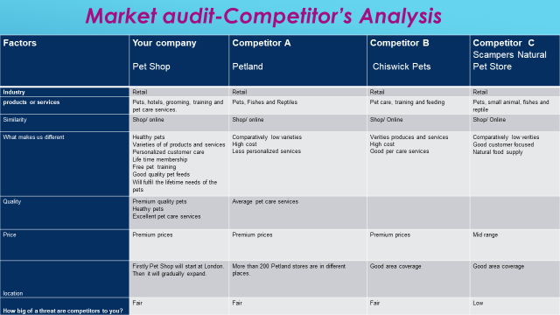
Figure 1: Competitor Analysis of Pet Shop (Sripipatthanakul & Chana, 2021)
Here three main competitors have been described. These competitors are Petland, Chiswick pets and Scamper pet store. All the pet retail offers almost similar products and services. But Pet Shop will provide some extra advantages for the customers (Phadermrod, 2019). For example, they will provide healthy and cheerful pets. Customers will be offered varieties of pets. Customers will get personalized services. Good quality pet foods will also be provided. They will also provide lifetime pet needs.
Pet Shop will differentiate its services in many ways including free pet training facility, and lifetime fulfilment of the need of the pets. On the other hand, Petland has differentiated itself by providing high prices, quality services and low verities. Chiswick Pet has differentiated itself with verities products and services, high cost and excellent personal care services. Besides, Scampers Natural Pet Store has differentiated itself with low verities, and a customer-focused orientation (White, 2022). They also provide natural foods for their pets. Thus, all these companies have differentiated their services. All the competitors offer their pets both from physical shops and online. But they are not efficient to provide excellent services (Sripipatthanakul & Chana, 2021). But Pet Shop’s main lacking is capital. As a new business, there is a shortage of capital. The business believes that it can be able to differentiate itself through excellent services. This analysis shows that Pet Shop has some advantages against the three competitors.

SWOT Analysis

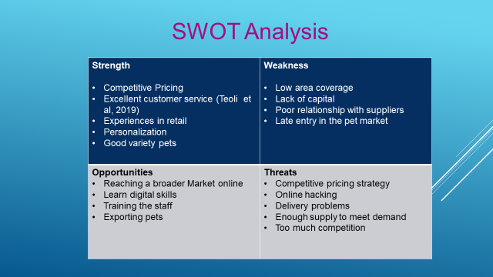
Figure 2: SWOT Analysis of Pet Shop (Elwin et al, 2020)
SWOT analysis shows that Pet Shop has several strengths and weaknesses compared to its competitors. The strengths of the business include competitive pricing, excellent customer service, varieties of pets and personalized services. This shop is committed to providing excellent customer service (Samejima, Shimizu, Akiyoshi, & Komoda, 2006). The shop has also experience in the retail business. This will help to make them efficient. On the other hand, customers will be provided personalized services and will be offered a good variety of pets.
Weaknesses include low area coverage, lack of capital, and poor relationship with suppliers and late entry into this market. At first, the shop will launch in a few cities in the UK. For this reason, low area coverage is a serious problem (Elwin et al, 2020). Another important weakness is a shortage of capital. The shop will not get any first mover advantage. Opportunities include digital skills, exporting and a large market. The shop can easily attract a huge number of customers using digital media. Pets can be exported to foreign countries. Digital skills can be used to grow the business. But the shop has some serious threats. Threats include delivery problems, online hacking and too much competition. The delivery problem can ruin the reputation of the shop. Facing too much competition is another great threat for the shop (Team, 2020).

PESTLE Analysis
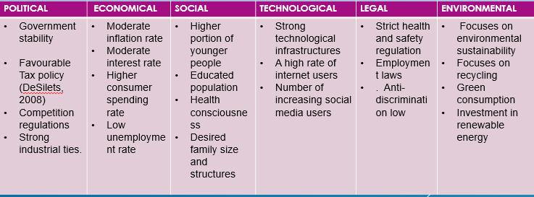
Figure 3: PESTLE Analysis of Pet Shop (Perera, 2017)
PESTLE analysis consists of six types of factors including political, economic, social, technological, legal, and environmental factors. The political environment shows government stability, favorable tax policy, competition regulations and strong industrial ties. The economic environment shows a moderate inflation rate, moderate interest rate, higher consumer expending rate and low employment rate.
The social environment shows an educated population, a higher portion of younger people and health consciousness, an educated population and desired family size and structures (Perera, 2017). The technological environment shows strong technological infrastructures and increasing social media users. The legal environment shows strict health and safety laws, anti-discrimination laws and employment laws. Finally environmental shows sustainability, recycling, green consumption, and investment in renewable energy.

Target Market
The target market is the selected group of customers of a particular business. Targeting comes after segmentation. Targeting is important for the Pet Shop. It will allow the shop to attract high-quality leads. Targeting helps to increase customer loyalty. It also helps to improve customer relations. Targeting also improves communication. Targeting is used to serve the customer preciously. PetSmart's main target is children under 18 (Jepson, 2015). Families without children, on the other hand, have also been targeted as potential customers by the business, and all pet-loving people (Roberts, 2022).

Marketing Plan
The 4P’s of Pet Shop are stated here.
Promoting the marketing policy of the company means initiating a series of practical actions and at the same time making efforts to achieve them. These practical actions are carried out as a correct whole which is represented by the marketing mix.
The marketing mix is a continuation of the market strategy, after defining the strategic objectives, the enterprise must develop detailed strategies on price, product, distribution and communication, these strategies being derived from the market strategy.
By the marketing-mix concept we can therefore understand the orientation of the marketing activity of the enterprise, according to the internal resources and the market conditions, by combining in a unitary, coherent whole, in the form of programmers, the elements of product, price, distribution and communication policy (TWIN, 2022).

Product: Pet Shop will provide consumers with four different kinds of goods and services, including hotels, pets, grooming, and training. They will provide quality services to the customers. Customers will be given lifetime membership cards. They will maintain a good relationship with the customers.
Price: The goods and services offered by Pet Shop will be expensive. The reason for this is that the clients will receive high-quality goods and services (Loganbill, 2019). Pet Shop believes that customers do not bother about the price if they get quality services. For this reason, they will charge a premium price.
Distribution: Fresh, healthy pets will be available in every store. Customers will have access to home delivery services. In London, 15 distribution centers will be used to deliver their products. Customers can order online. Multiple payment options will be available for the customers.
Promotion: Pet Shop will prioritize online marketing and word-of-mouth advertising. We will post positive customer testimonials on social media. Pet Shop will always relate to the customers through social media. The main reason for using digital marketing is that digital marketing is very cost-effective and efficient.
The extended marketing mix of the shop includes people, place, and process.
People: People are the workforce of a business organization. Pet Shop has a skilled workforce to run the shop. The management of the shop is committed to developing a good workforce. It is because the quality of service of a business organization depends on the workforce.
Process: Process is a way of operating a business. Pet Shop is designed to provide service using both offline and online channels. Customers can order and pay from their homes.
Physical Evidence: Physical evidence includes all the tangible aspects of a business organization (Sramkowski, 2021).
Pet Shop will use various shelves to keep pets. Customers will provide a handwritten greeting card after purchasing pets (WOLF, 2020).

Selling Plan
Selling is one of the most important tasks of every business organization. The shop will focus on relationship-based selling. The salesperson will be provided special training to manage selling activities. Pet Shop is dedicated to giving its customers healthy, brand-new pets. All visitors will get a warm welcome. Long-term relationships are maintained with the customers by the salespeople (Vesvijak, 2004). Customers will be provided with all pet-related services for life.

Management Team
A qualified individual is needed by Pet Shop to oversee all the stores. Each staff will receive specialized training on how to manage animals and assist customers. The Pet Shop will adhere to this hierarchy. The management hierarchy shows that the owner of the business will be top of the hierarchy (Dominici, 2009). The entire country will be divided into different regions. In each region, there will be three management fields. They are marketing, operation, and finance. The owners of the business will coordinate all the regions. The marketing manager will perform all the marketing and selling activities. The operation manager will manage all the operating activities and the finance manager will prepare various statements and financial requirements. Thus, the owners or president will coordinate all the functions.

Financial Plan
At the beginning year, the total assets will be £30,000. In the second year, it will be £67,428. Then it will increase to £106,766. And in the fourth year, total assets will be £154,556. At the beginning year shown in Appendix 1, cash receivables from sales and other receivables are zero. But inventory is £5,000. Though the initial assets are not in a high amount, the shop will be able to increase its assets by making a continuous investment. The total liability of the business will be equal to the fourth-year projection of the assets. First-year, total liability will be £15,000 but the initial net worth is £15000. Next year the total net worth and liability will increase to £67,428. Then it will increase to £106,766. And in the fourth year, the total liability and net worth will be £154,556.

Cash-flow Statement
From appendix 2, the cash-flow statement shows that at the beginning month, Pet Shop has a beginning cash balance of £15,000. In this month, cash received from sales is £4,100. On the other hand, account payable merchandise is zero. And a net cash balance is £9,354. In the next month, the net cash balance will decrease to £6,961. It is because that at the beginning period, sales become low. In the third month, the net hand cash will be £6833. From Appendix 2, it is found that the net cash balance is continuously increasing as the sales are increasing proportionately. Thus, at the tenth of the month, net cash will be £14,226. And thus, it will increase in the future. So, it can be concluded that the shop will be undoubtedly profitable. Both net cash balance and assets will increase gradually.

Income Statement
According to appendix 3, the income statement shows that Pet Shop’s first year’s net income will be £9.234. At the beginning year, the total sales will be £113,118. In the next year, this will increase by £146,333. And in the 3rd year, this will increase to £1,75,204. The gross profit for the 1st three consecutive years will be respectively £75,789, £48,290, and £117,187. Thus, the gross profit will increase by 33% in the beginning year, 33% in the second year and 33% in the third year. The income statement also shows that the cost of goods sold will be £37,329 in the beginning year, £48290 in the second year and £57,817 in the final year. In the second year, it will increase by 8% and the net income will be £30,553. And then net income will increase to £43,214. This amount is 25% increasing. And thus, the amount of profit will increase day to day.

Conclusion
This report aims to explore various important aspects of a pet shop. In this report, firstly, a business overview of a pet shop has been introduced. Secondly, the products and services of the pet shop have been explained. Thirdly, the target market and market audit have been explained. Then a marketing plan has been executed for the shop. After that management team of the shop and financial plan have been concluded. This report suggests that the business will be profitable. Tough the business will face extreme competition; it can differentiate their services.

Reference
DeSilets, L.D., (2008). SWOT is useful in your tool kit. The Journal of Continuing Education in Nursing, 39(5), pp.196-197.
Dominici, G., (2009). From marketing mix to e-marketing mix: a literature overview and classification. International journal of business and management, 4(9), pp.17-24.
Elwin, A., Green, J. and D’Cruze, N., (2020). On the record: An analysis of exotic pet licences in the UK. Animals, 10(12), p.2373.
Jepson, L., (2015). Inspecting pet shops. In Practice, 37(7), pp.333-346.
Loganbill, K.R., (2009). Y Bar H Outpost & Pet: Marketing Plan (Doctoral dissertation, University of Kansas).
Perera, R. (2017). The PESTLE Analysis. In R. Perera, The PESTLE Analysis (pp. 2-21).
Phadermrod, B., Crowder, R. M. and Wills, G. B. (2019) ‘Importance-Performance Analysis based SWOT analysis’, international journal of information management. Kidlington: Elsevier Ltd, 44, pp. 194–203. doi: 10.1016/j.ijinfomgt.2016.03.009.
Roberts, R. (2022). Pet Industry Trends, Growth & Statistics in 2022 and Beyond: Unleashing Your Ecommerce Pet Marketing Strategies. Retrieved from https://commonthreadco.com/blogs/coachs-corner/pet-industry-trends-growth-ecommerce-marketing
Samejima, M., Shimizu, Y., Akiyoshi, M., & Komoda, N. (2006). SWOT analysis
support tool for verification of business strategy. In IEEE international
conference on computational cybernetics (pp. 1–4).
Siripipatthanakul, S. and Chana, P., (2021). Service Marketing Mix (7Ps) and Patient Satisfaction in Clinics: A Review Article. International of Trend in Scientific Research and Development, 5 (5), pp.842-850.
Sramkowski, L. (2021). From 4Ps to 7Ps: Towards an Integrated Marketing Mix. Retrieved from https://www.exportplanning.com/en/magazine/article/2021/03/03/from-4ps-to-7ps-towards-an-integrated-marketing-mix/

Suckling, J., Druckman, A., Moore, C.D. and Driscoll, D., (2020). The environmental impact of rearing crickets for live pet food in the UK, and implications of a transition to a hybrid business model combining production for live pet food with production for human consumption. The International Journal of Life Cycle Assessment, 25(9), pp.1693-1709.
Teoli, D., Sanvictores, T., & An., J. (2021). SWOT Analysis. Retrieved from https://www.ncbi.nlm.nih.gov/books/NBK537302/
TWIN, A. (2022). The 4 Ps of Marketing. Retrieved from https://www.investopedia.com/terms/f/four-ps.asp
Team, M. S. (2020). Pets at Home SWOT Analysis, Competitors & USP. Retrieved from https://www.mbaskool.com/brandguide/lifestyle-and-retail/9316-pets-at-home.html
Vesvijak, Y., (2004). Online pet supplies: www. doggie. com.
White, C. (2022). What's a Competitive Analysis & How Do You Conduct One? Retrieved from https://blog.hubspot.com/marketing/competitive-analysis-kit
WOLF, A. (2020). Marketing Strategy for Pet Shops. Retrieved from https://www.thebalancecareers.com/marketing-strategy-for-pet-shops-2660624

Appendix 1: Financial Statement
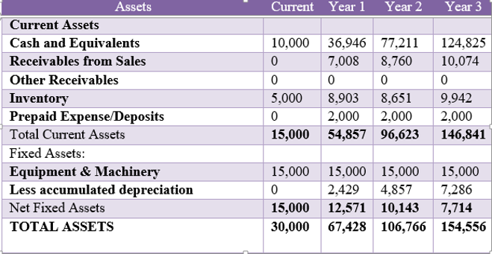

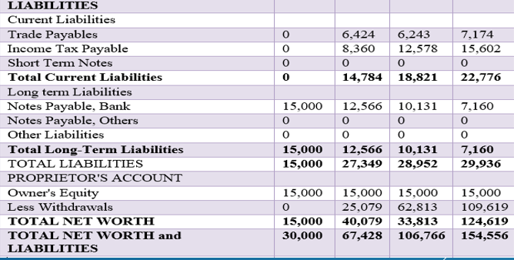

Appendix 2: Cash-flow Statement
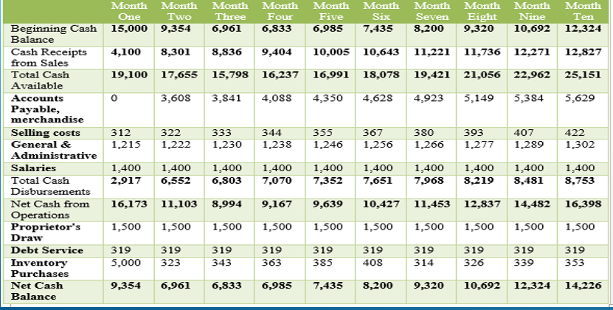

Appendix 3: Income Statement


