BA International Hotel Management

Food & Beverage Operations

Module: BMIH4002

Shila Laskar

Assignment 2 Menu Engineering (Practical Task)

Table of Contents
1. Brief Writing 3
2. Menu 5
References 7

1. Brief Writing
The elegant menu at "Vita Bella", a hotel chain of Hotel Trinity, takes diners on an Italian Gourmet Journey by combining traditional dishes with cutting-edge techniques. This restaurant caters to individuals with a penchant for traditional Italian fare as well as those with a more exploratory taste who are looking for a modern take on familiar flavours.
People who can enjoy authentic Italian cuisine for its fresh ingredients and careful preparation are the intended customers. Moreover, Bravi et al. (2020) and Vizzoto et al. (2021) point out that the restaurant appeals to ecologically concerned customers by addressing their worries about food waste. It also attracts a youthful, global clientele with an emphasis on ethical consumption and fine dining.
Food waste is a serious problem, and the meal has been carefully crafted with it in mind (see Filimonau et al., 2021). Dishes like "Bruschetta" and "Insalata Caprese" are cooked using fresh, locally sourced tomatoes and mozzarella, allowing for little waste and assuring optimal flavour. The "Antipasto platter" is adaptable, customizable, and produced to order, all of which eliminate waste by cutting down on overproduction.
The major meals of "Vita Bella," such the "Pollo al Marsala" and the "Vitello al parmigiano," are made according to classic recipes that are at the essence of Italian cuisine. The restaurant's intention to highlight the breadth of Italy's cheese-making legacy and the variety of its vegetable preparations is reflected in the presence of dishes like "Quattro Formaggi" and "Melanzane alla parmigiana" on the menu.
Traditional desserts like "Tiramisu" and "Cannoli" aren't only good menu options since they cut down on food waste, but they're also delicious. Products with a longer shelf life and several uses, such as mascarpone, chocolate chips, and ricotta, can reduce waste by making the most of limited supplies.
Italian and regional wines were chosen for the restaurant's wine list because of their compatibility with the dishes on the menu. These wines were selected to complement the depth and complexity of the food served.
In conclusion, "Vita Bella" is committed to both providing an authentic Italian dining experience and responding to contemporary concerns about environmental preservation and resource conservation. The restaurant is proof that old-school ethics and cutting-edge care can coexist in perfect harmony to provide a mindful but decadent meal.

2. Menu
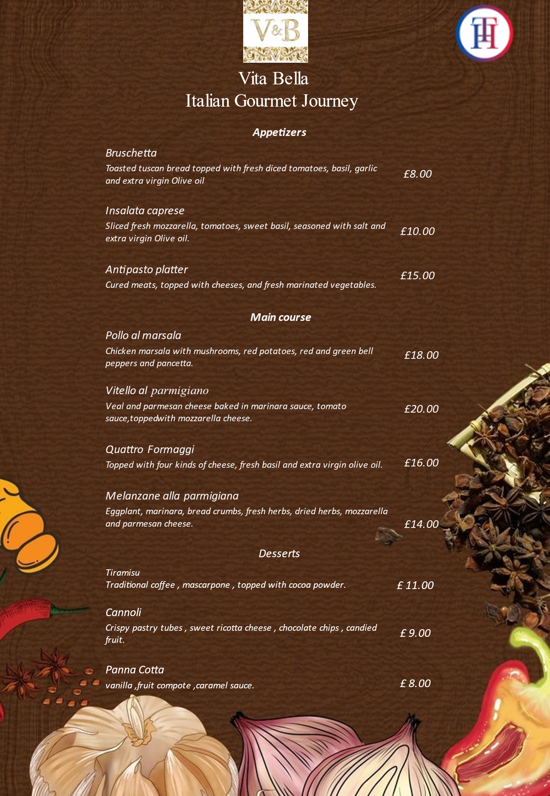
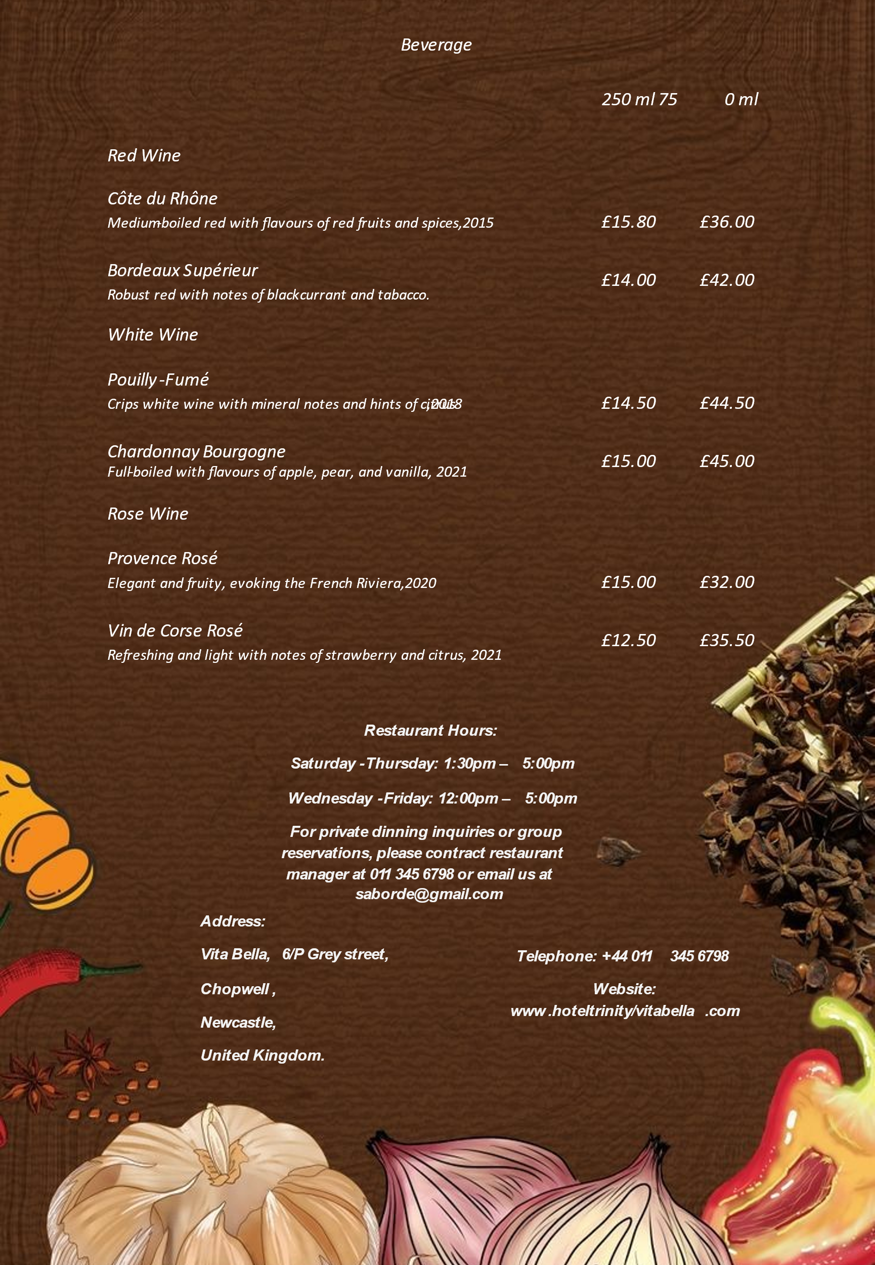

References
Bravi, L. et al. (2020) ‘Factors affecting household food waste among young consumers and actions to prevent it. A comparison among UK, Spain and Italy’, Resources, Conservation and Recycling, 153.
Civera, C. et al. (2020) ‘Paradoxes and strategies in social enterprises’ dual logics enactment: A csQCA between Italy and the United Kingdom’, Journal of Business Research, 115, pp. 334–347.
Filimonau, V., Nghiem, V. N. and Wang, L. E. (2021) ‘Food waste management in ethnic food restaurants’, International Journal of Hospitality Management, 92.
Tassinari, A. and Maccarrone, V. (2020) ‘Riders on the storm: Workplace solidarity among gig economy couriers in Italy and the UK’, Work, employment and society, 34, pp. 35–54.
Vizzoto, F. et al. (2021) ‘Plate waste in foodservice outlets: Revealing customer profiles and their support for potentially contentious measures to reduce it in Italy’, Resources, Conservation and Recycling, 174.

