Question 1: From the MESSAGE, MEDIUM, CONTEXT research strand lectures, choose a theme, movement, or selection of artists or designers that relate to your practice or interests, and construct a 2,500-word essay. Critically assess primary themes, key writers, and relevant practitioners.

The evolution of female body image in art and photography and how it’s changed and impacted societies views

Nerys Thomas- 1802221
Year 2 BA Hons illustration
1501 words
Tutor- louise Burston

The topic of female bodies have always been an obsession in art. Many artists have used it as a muse or medium in which to study and explore their creativity, only being able to draw what was presented to them at the time which was the real bodies of real woman whether alive, or morbidly dead, using dissection as a means of learning, however, the ever extending period of time in which female bodies have been the focus of great artists, mixed with the evolution of the art world and the way woman are viewed by society, would lead us to believe that vast representation and inclusion is an ever growing trend yet, many woman are still being left out of art, feeling excluded and under represented as societies standards still play a huge roll in what we paint, consume and see when once, the roles were switched and fine art of the time was the biggest societal influence. This switch in dynamics has forced people to believe that if they deviate from the ideal and what’s socially acceptable, their work would be viewed negatively and for many, that can be off putting, pushing painters and illustrators away from the traction that the body positivity movement has made. Its very evident that over the centuries, what is deemed beautiful and acceptable for the way a woman looks has changed, from the plump bodices of the Greeks, to voluptuous curves of the renaissance, the full figures of the 1800 to the more modern standards of boyish figures in the 1920s, tiny waists of the 1990s to large breasts, flat stomachs and big bums of the 21s century.
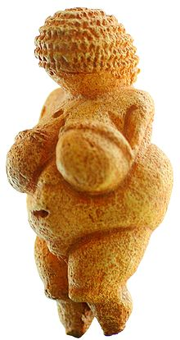
One of the first ever representations of the female form found in history was a 4.4” stone figurine called the Venus of Willendorf, found in1908 but dates back to 25,000 BC. The figure is thought to be a Stone Age good luck totum of a fertility goddess with its exaggerated features indicating link. It is also thought that the figure was an overly fetishised version of woman, made by men for the appreciation of men. This is the earliest form of beauty standards and objectification found in history although, at the time of creation, this body type wouldn’t have been achievable. More evidence to back this up is a BC era text, the Book of Isaiah mentioned fatness as ‘a way to freedom’. “The LORD of hosts will arouse a scourge against him . . . His staff will be over the sea and He will lift it up . . . so it will be in that day, that his burden will be removed from your shoulders and his yoke from your neck, and the yoke will be broken because of fatness.”
Venus of Willendorf- 25,000BC, Creator unknown

Even with the ever growing gap between modern day and Paleolithic times, this figure and the way her body is represented is almost worlds apart from the standard being pushed on impressionable woman of the 21st century. In current day, the body of the Venus of Willendorf would be viewed negitivly and classed as morbidly obese with woman of plus size bodies being shamed and looked down apon. This exposes how the artists depiction of the female body that we see popular in the art world at that time, does so because it corresponds to the societal standard of beauty at that time in hirstory. This can be further explained as these “body types” are the product of the culture and values that were popular at the time, which are reflected in the art because that was art’s purpose back then.
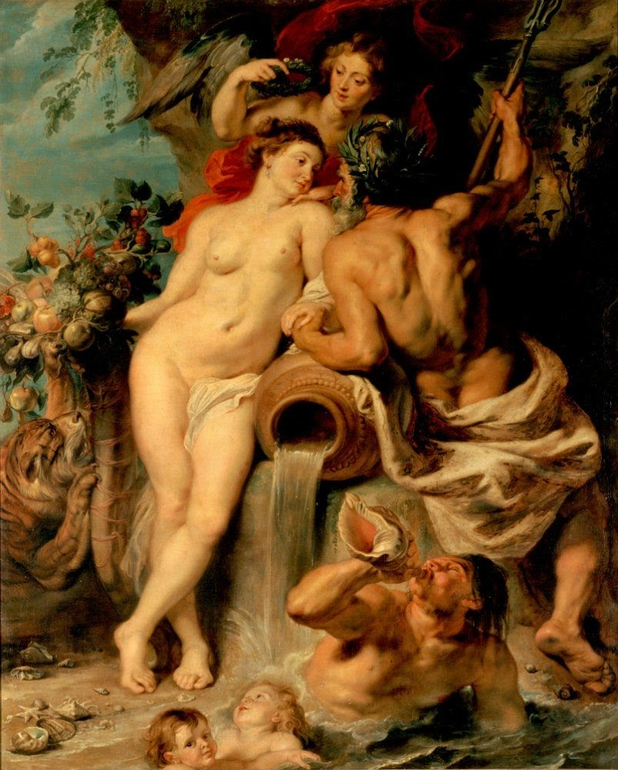
Another great representation of polar opposite beauty standards is the renaissance movement of the 14th century. It was quoted as being a “fervent period of European culture, artistic, political and economic rebirth following the Middle Ages” says History.com. It is credited with bridging the gap between middle age and modern day art with its more detailed and studied human form compared to the more cartoon paintings of earlier years. The “type” of woman’s bodies that were often depicted in paintings were always soft, chubby and rounder. These ideals are thought to be heavily based on the ideals of Grecian times, being called a period or “comeback” of Greek culture that influenced art and literature and architecture. When it came to renaissance art though, the painters of the time took a classical aproach of painting not necessarily the way woman looked back then but their own ideals. But why was a bigger body seen as an ideal?

In the renaissance, a bigger body meant wealth as the working class did hard manual layber and couldn’t afford to consume loads of food thus staying lean where as, rich women could stay inside and do nothing which led the first group to look stronger and tougher, and the richer, softer and plumper. It sent off a message that the woman as wealthy and healthy. Another reason is they were seen as more fertile. Fertility was one of the leading standards of beauty as best said by Culturacolectiva.com- “most of the art created at this time in history was created by men, and men came up with their ideas of beauty based on what they wanted from a partner: money and child-bearing hips.” They also said, “if you think about it, modern-day beauty standards for women aren’t that different these days. Having narrow hips or a more muscular build is still considered unattractive by many, and even “un-feminine.” Which backs up my argument that art over the centuries has played role in socitial beauty standards. Even thousands of years later, we are still impacted by some of the primitive thoughts about a woman’s role and perpous in life, wit the ideas that we must be rounder, softer and our only role is to be pretty and fertile.
The Union of Earth and Water, Peter Paul Rubens. (1617)

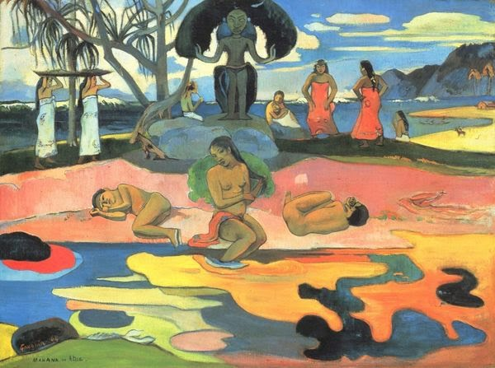
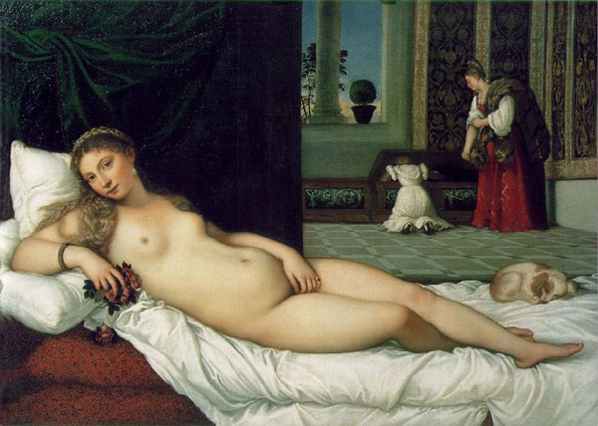
One of the most iconic paintings of the renaissance that highlights my points is The Venus Of Urbino which is an oil painting completed in 1534 by the popular Italian painting of the time, Titian. It depicts a curvasiois and healthily plump nude young lady, identified with the goddess Venus, casually laying on a bed in a sensually explicit manner of the time. She is thought to be a depiction of the prefect renaissance woman as the painting was a gift to the duke of Urbinos wife. The Uffizi Gallery Museum of Florence is quoted in saying “the painting represents the allegory of marriage and was a “teaching” model to Giulia Varano, the young wife of eroticism, fidelity and motherhood.” Thus backing up my point that the way a woman’s body was ‘supposed to look’ meant motherhood and fertility was the forefront of ideals. In simple terms, the painting was made as a way of reminding woman that their role in a marriage was being obliged to forfil their husbands desires.
The Venus Of Urbino, Titian, 1534

The problem of objectification is highlighted further when looking into woman of colour in art and how they’re depicted. They are often the centre of exoticisation and racism and have their bodies presented in overtly sexual ways. A good example of this is seen in post-expressionist, Gauguin’s work. A lot of people veiw his work as just painted depictions of his travels, but fail to research furtherinto them, finding out that the girls painted could have been as young as thirteen, completely nude with over sexualised assets. This shows how the artist deemed them exotic in an almost fetished way. Some of these ideas still carry on today with subtle everyday racism and woman of colour being a goal as if they’re not normal or a trophy. I feel that art such as Gauguins allowed people to think that the way they saw people of colour was okay as art was the modern media of the day and it impacted society in a negative way, instead of it creating a bridge between cultures, it was more something to gawk at as people of colour were not understood as well by the consumers of the work.
Paul Gauguin
Mahana No Atua (Day of the God), 1894

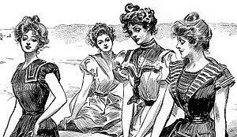
After the Renaissance, a large period of time passed before woman’s body ideals started to change again and they changed drastically. No more was a plump, bigger figure in, but a trend called “pin-up” was in that completely reshaped the way woman were expected and wanted to look. The idea of the Pin Up girl was that she was the perfect woman, embracing her sexuality in an innocent and cheesy way. She was based on an ideology that biologically couldn’t exist as she had big breasts, a ‘wasp’ waist and large hips, though it was still popular for girls to look soft and round, the trend towards a thinner ideal was beginning. It is thought that the first ever pinup created was Charles Gibson’s 1887 Gibson girl. She was based on what was referred to the “new woman.” A sensual and indioendant female with impossible proportions, thought to be a ‘fragile lady’ and ‘volumptuous woman’ at the same time. The Gibson girl movement took off and woman started corseting their bodies to the extreme to try and get a classic hourglass shape so heavily desired. Never before had a media influenced a society so much to the point where even at modern day, woman still desire a tiny waist hourglass figure. In many ways, the Gibson girl was used as another means to over sexualise woman to a standard they couldn’t achieve created by men, for men to enjoy.
Gibson girls At The Beach- unknown date but thought to be 1890

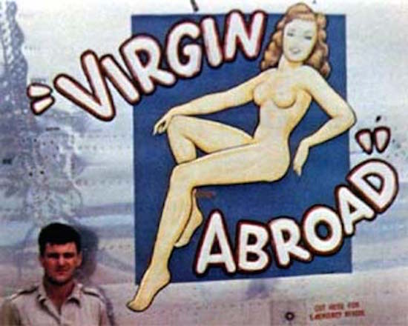
The time when Gibson girls really took and evolved into the more popularly known ‘Pin Up’ girl was the 1940s where woman gained more independence and the ability to express themselves more through helping with the war effort, though the trend played more towards men’s desires as during the pop culture boom, it was popular for the modern gentleman to get the girls tattooed on them or carry around a photo or print as a reminder of what they had at home especially when in the second world war, female contact was rare and it was a simple way to boost moral. Another popular way men used the pin up model was by painting them on the noses of their aircrafts as they not only were praised for their sexuality but seen as good luck charms, almost patriots for the fighting men. In many ways, it captivated the male audience as the pin ups could be dipicted in anyway they wanted as the idea of a woman being openly sexual was a no go, and sex was still deemed a sacred thing so having a girl who expressed their sexuality openinly was exciting and almost naughty. They could be sweet, innocent, homely woman that fit in with the role woman played in society at that time, or they could be outside of Reality, being aliens or vampires, really playing to the ideals that men of the time desired of fetishised. In my opinion, pin up girls are the retro equivalent to playboy bunny’s in many ways and the sensuality and desire still carries on to the modern day.

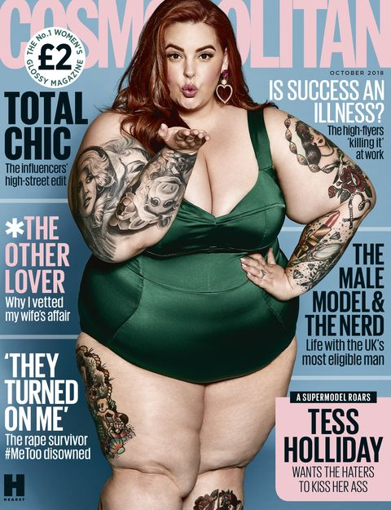
As for modern day art, we have distanced ourselves from traditional media and now lean more towards digital and photography and as for the the way woman are being represented, a lot has changed from the ideals of a plump, fertile body of the renaissance to the extreme, thin hour glasses of the pin up girls of the 40s/50s and every defining art movement and preferred female body shape inbetween. It’s no longer the case of one ideal fits all when it comes to woman being represented in art and photography even though the reminance of the preferred thinnger figure is still there from the super thin super models of the 90s and the photoshop queens of the 2000s. The pressure for woman to look a certain way is defibabtly still a prominent problem that many deal with but now a new and way more enlightening movement has been created. The Body Positive Movement. The term really took off in 2012 when the hashtag #effyourbeautystandards came out, created by plus size model Tess Holliday who in 2018 became the first size 26 model to feature on the cover of popular fashion magazine Cosmopolitan. Holliday is quoted saying “It’s all about accepting yourself the way you are, If you want to work towards a better you in whatever regards… do it. But you’re okay just the way you are today."

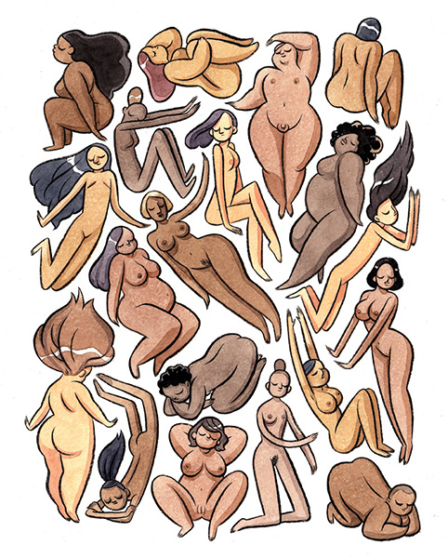
As art is no longer the main form of media and communication as we now live in the age of the internet and smart phones, it’s more difficult to talk about how it influences people but there are still many artists who greatly Inspire me and share their art online on platforms such as Instagram to inspire others. One being a Lady named Kelly Bastow. She created a series of ink and water colour paintings in a collage of cartoon yet inclusive male and female bodies. Some are fat, skinny, have stretch marks, surgery scars, are transgender and have body hair. The aim was to cover a huge variety of people. In an interview she said her goal is “To connect with my viewers. I want to make people feel calm and at ease when they look at my artwork. I want to make people feel better about themselves.” Which is what many ‘bo-po’ artists of the day also aim to do. They aim to fight the stigma of imperfection that so often is being shoved down impressionable young girls throats and teach others that diversity is an amazing thing.
Kelly Bastow, Unnamed art
In conclusion, the evolution of the female body in art and photography has greatly impacted societies expectations for woman over the years as art was the main form of communication and many artists painted what they wanted to see when it came to woman and how they expressed their sexuality. Many famous pieces of art sent out a message to woman on how they were expected to look as a woman’s role in society up until recently has been to submit to a man and forfil their desires. Even though the ideal body has dreastically changed over the years from a plump and bigger figure to an impossibly thin yet curvaceous sex symbol, the underlying message to woman is to fit into a box in which society has created which is why the Body Positive movement and the artists around the world partacking in the advocacy of acceptance is such an amazing and important turn in the right direction for art and photography. It teaches woman of all ages that no matter what society expects of them, what they are is always enough and if they choose to change themselves, they must do it only for themselves as what other people want and expect of them is completely irrelevant and being happy and feeling good about themselves and their bodies is what’s most important.

Bibliography for references and research
https://www.khanacademy.org/humanities/prehistoric-art/paleolithic-art/a/venus-of-willendorf
https://theboar.org/2019/04/evolution-female-body-art/
https://www.scienceofpeople.com/beauty-standards/
https://www.google.co.uk/amp/s/amp.cnn.com/cnn/2018/03/07/health/body-image-history-of-beauty-explainer-intl/index.html
https://www.google.co.uk/amp/s/www.dailymail.co.uk/femail/article-4404338/amp/The-retro-pin-girls-WWII-troops-pulses-racing.html
https://www.visituffizi.org/artworks/venus-of-urbino-by-titian/
https://en.m.wikipedia.org/wiki/Pin-up_model
https://www.health.com/mind-body/plus-size-model-tess-hollidays-inspiring-message-its-all-about-accepting-yourself
https://www.google.co.uk/amp/s/www.history.com/.amp/topics/renaissance/renaissance
https://www.google.co.uk/amp/s/www.artsy.net/article/artsy-editorial-art-divided-gauguins-legacy/amp
https://www.google.co.uk/amp/s/culturacolectiva.com/art/the-body-in-renaissance-art/amp

