

Detached Dwelling Construction Portfolio


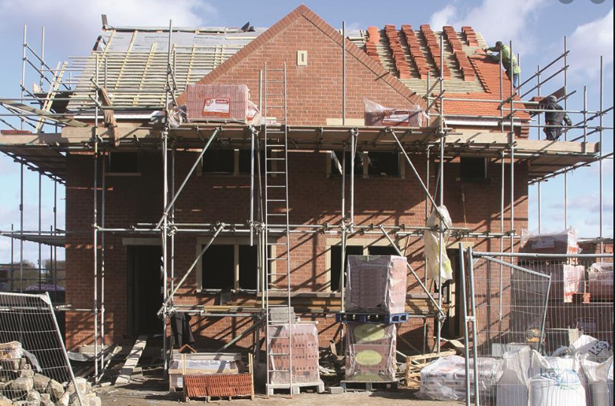

Matthew Riddler (1904663)- 1904663@student.uwtsd.ac.uk
Contents
Introduction

Construction Details
- External Walls
- Ground floor
- First Floor
- Openings
- Eaves & Roof

Conclusion

Appendices

References

Introduction
As a civil engineer for Trinity St David’s construction. I have received planning consent to build a luxury detached domestic dwelling in an upcoming sought-after rural location on the outskirts of Swansea. The location of the development is on a Greenfield site. Initial site investigation has concluded that the site consists of firm subsoil with a low clay content & is well above the water table therefore, standard pad foundations will be sufficient for the development. The domestic dwelling consists of a ground floor, first floor & second floor. The aim of this assignment is to provide technical solutions & designs for the construction phase of the development.
Architectural drawings have been developed in receipt of planning permission & are highlighted below:
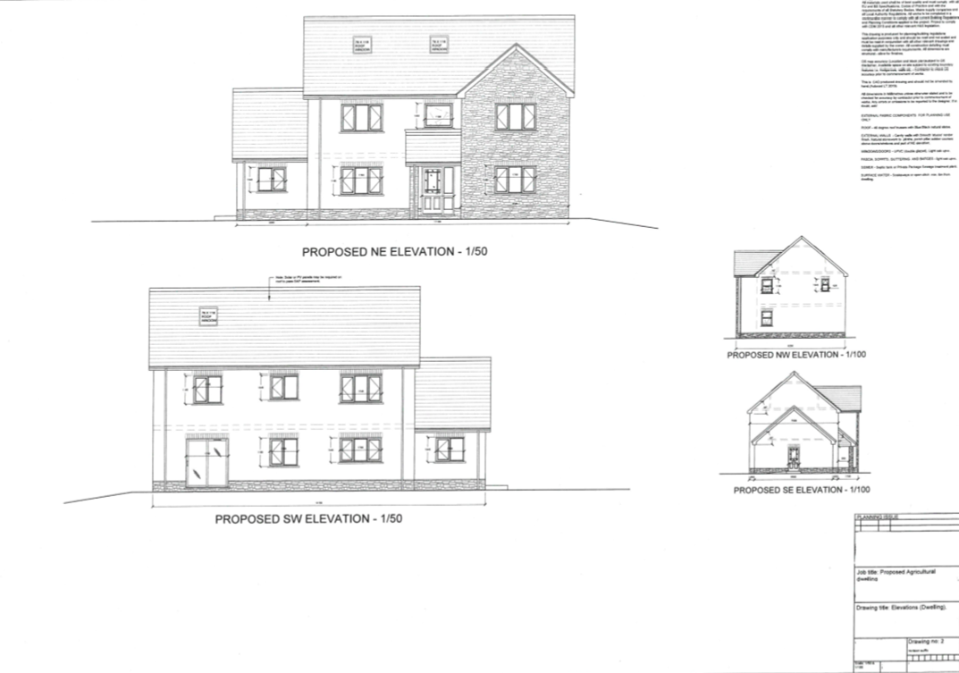
Figure 1- Development with proposed exterior elevations
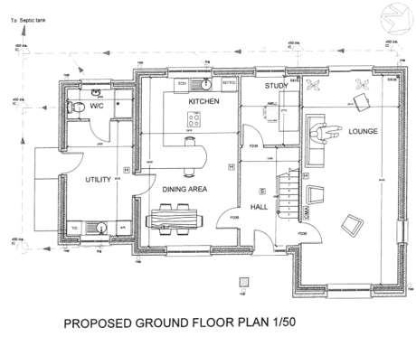
Figure 2- Proposed ground floor plan

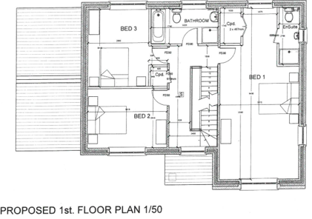
Figure 3- Proposed 1st floor plan

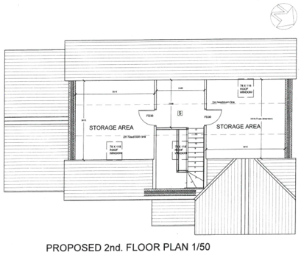
Figure 4- Proposed 2nd floor plan

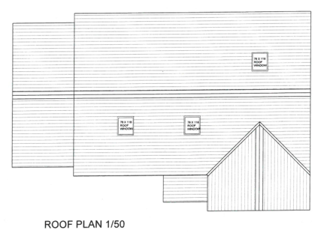
Figure 5- Proposed roof plan

Construction Details
External Walls
The development build is a standard cavity wall construction, Outer & internal layers are both block material, with a smooth external render. All plinths, soldier courses & openings are to be made with natural sandstone.
The purpose of the double skin wall is for weather protection, noise retention & thermal insulation as shown in Appendix 1. The inner & outer walls will be connected with wall ties to increase strength & building stability, all wall ties will comply with BS-1243:1978, & will meet the requirements of Building Regulations Part B
Kingspan phenolic foam sheet insulation will be used within the cavity wall & will comply with BS-5618:1985.
Appendix 2. Shows a cross section of the cavity wall with partial fill cavity insulation, cavity width can vary & is usually a maximum of 100mm but 50mm is generally a minimum.

Ground Floor
The ground floor of the development will consist of a suspended timber floor as shown in Appendix 3 & Appendix. 4. Providing adequate ventilation is used a suspended floor is favourable as it promotes air flow & prevents rising damp & dry rot entering the dwelling which could easily occur if the floor was constructed directly on to the ground. In order to comply with Building Regulations document A, all timber flooring work will comply with the following standards:
- BS EN 1195-1-1:2004+A2:2014:2019- UK National Annex design of timber structures.
- Eurocode 5- Span tables for solid timber floors, ceilings & roofs for dwellings 4th edition (2014).
- BS 8103-3:2009- Structural design of low-rise buildings. Code of practice for timber floors & roofs for housing.
- PD 6693-1:2009- Recommendations for the design of timber structures.

First Floor
The first floor of the development will be constructed with solid wood timber joists as shown in Appendix 5. This is a much more favourable material compared to other solutions such as steel as wood has much better thermal properties, also the cavity created between the joists will provide an optimal area for insulation such as Rockwool insulation. Joist hangers will be used to tie in the wooden joists & masonry as shown in Appendix 6., & these will comply with BS EN 845-1, & meet the requirements of the Building regulations Part E. Herring bone struts & restraint straps will be used for added strength & to connect the singular joists together.
Openings
As the dwelling is a cavity wall construction, the chosen lintel type will be a lightweight steel cavity lintel as shown in Appendix 7. Lintel & bearing work will comply with BS 5977-1:1981. In order to minimise thermal bridging, the lintel must be insulated correctly as shown in Appendix 8.

Sills & Jambs
The dwelling will consist of light oak wood effect uPVC windows & external doors with double glazed sealed units. The windows & doors will comply with BS EN 7412:2007. The double-glazed units will comply with BS EN 1279 & will meet the requirements of Building Regulations part L. Masonry sills will be used for the windows. Aluminium flashing will be used across the span of the drainage cavity as shown in Appendix 9.

Roof & Eaves
The roof structure for the dwelling will be trussed rafters at a 40⁰ pitch, the covering will be natural slate & closed eaves. Closed eaves are more favourable as they create more space & provide better fixing capabilities for joists & masonry. The construction design for the closed eaves are shown in Appendix 10. & will comply with BS EN 612: 1996 & will meet the requirements of Building Regulations part C.
As the second floor will be used as a habitable loft area a queen post roof truss design will be constructed as shown in Appendix 11. All trusses will comply with BS 5268-3: 2006. British spruce timber battens & counter battens will be used & will comply with BS 5534:2014+A2:2018.
The impact of weathering has been taken into consideration, in particular driving rain. Figures 6 & 7 below highlight the annual driving rain index for the United Kingdom. As the development is in Swansea area the potential driving rain impact has been deemed as ‘severe’
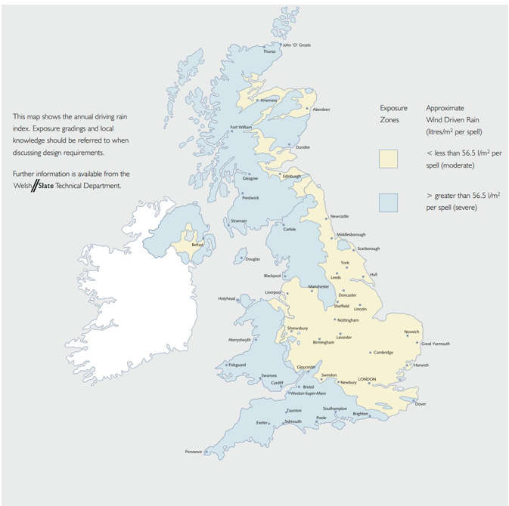
Figure 6- Annual driving rain index for the United Kingdom
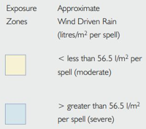
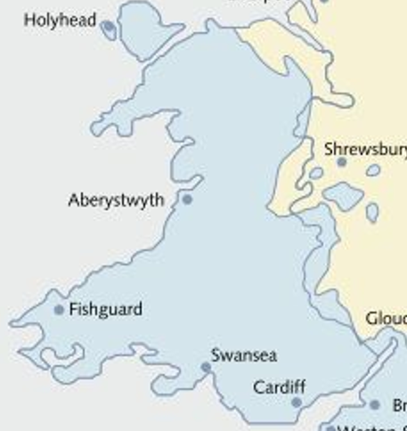
Figure 7- Annual driving rain index for Wales
With this considered & the pitch of the roof at 40⁰, a minimum lap of 80mm will be used as per figure 8 below.

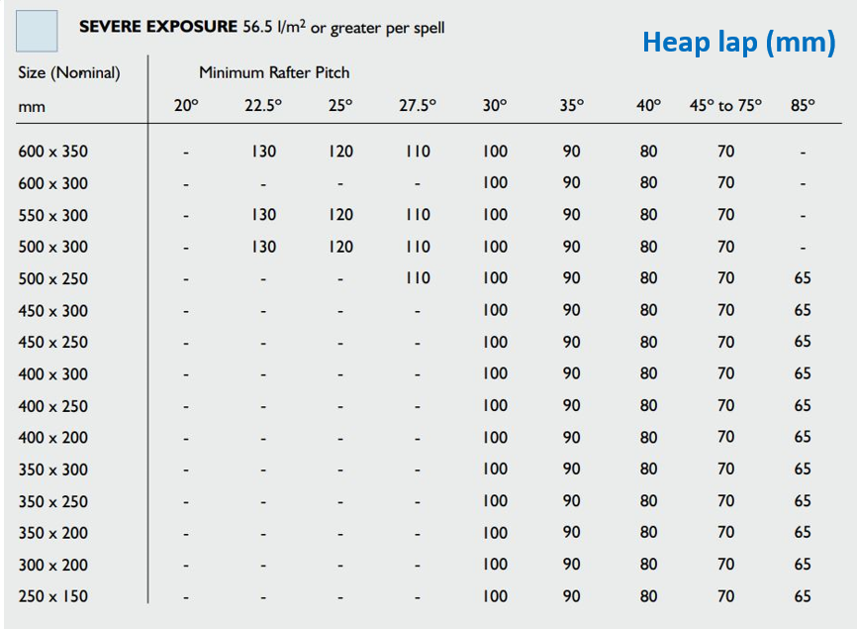
Figure 8- Minimum lap requirements for severe driving rain exposure.

Due to the 40⁰ pitch of the roof, natural slate will be used to cover the roof, as shown in Figure 9 below, & will comply with BS 5534:2015.
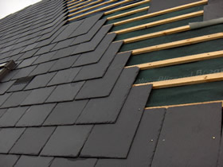
Figure 9- A typical slate roof covering.
Appendix 12. Shows the roof cover design in relation to the trusses. A minimum gutter width of 100mm will be used as per BS 5534:2014+A2:2018. Gang nail plates, Truss clips & restraint straps will be used to fix the relevant components of the roof as shown in Appendix 13. All roof fixings will comply with the above standard.

Conclusion
In conclusion, this case study has provided technical solutions for the relative construction methods required for the domestic dwelling. Sufficient external wall designs, each separate floor design, openings & all elements of roof construction have been produced to comply with appropriate British Standards & Building Regulations. Obtaining appropriate information to produce these designs has been relatively easy to obtain through internet-based research & desktop analysis & taught academia.
One part of the case study that could have provided easier solutions & delayed the detailed design, was not having the availability of CAD to use for construction methods. Though sketch drawings were sufficient & provided the necessary details, CAD would have improved the efficiency of the case study & would have been presented better in the overall document.

Appendices
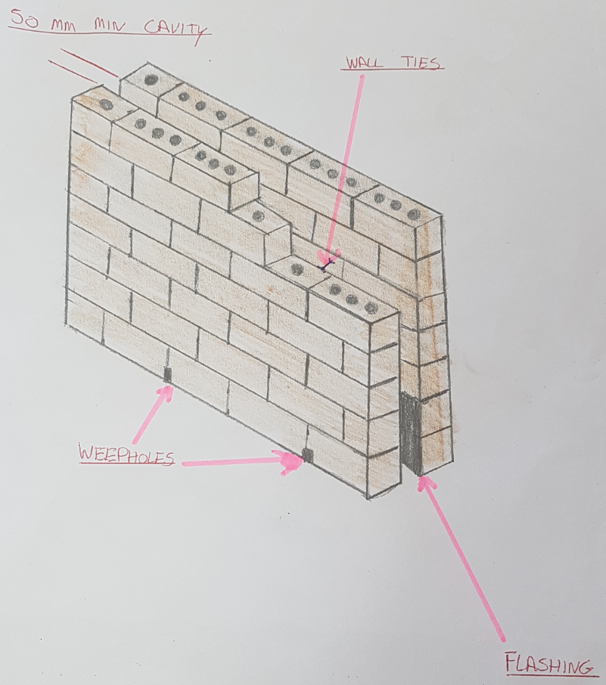
Appendix 1.

Appendix 2.
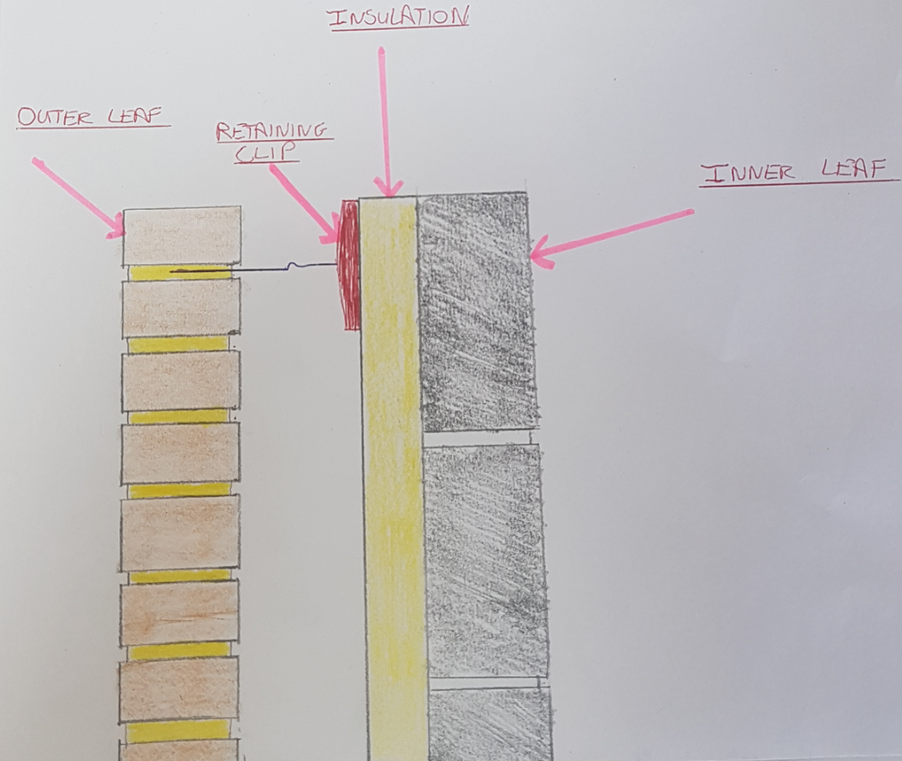

Appendix 3.
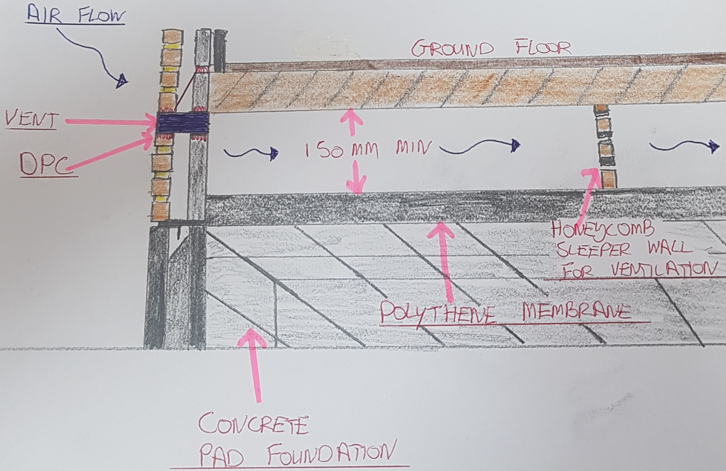

Appendix 4.
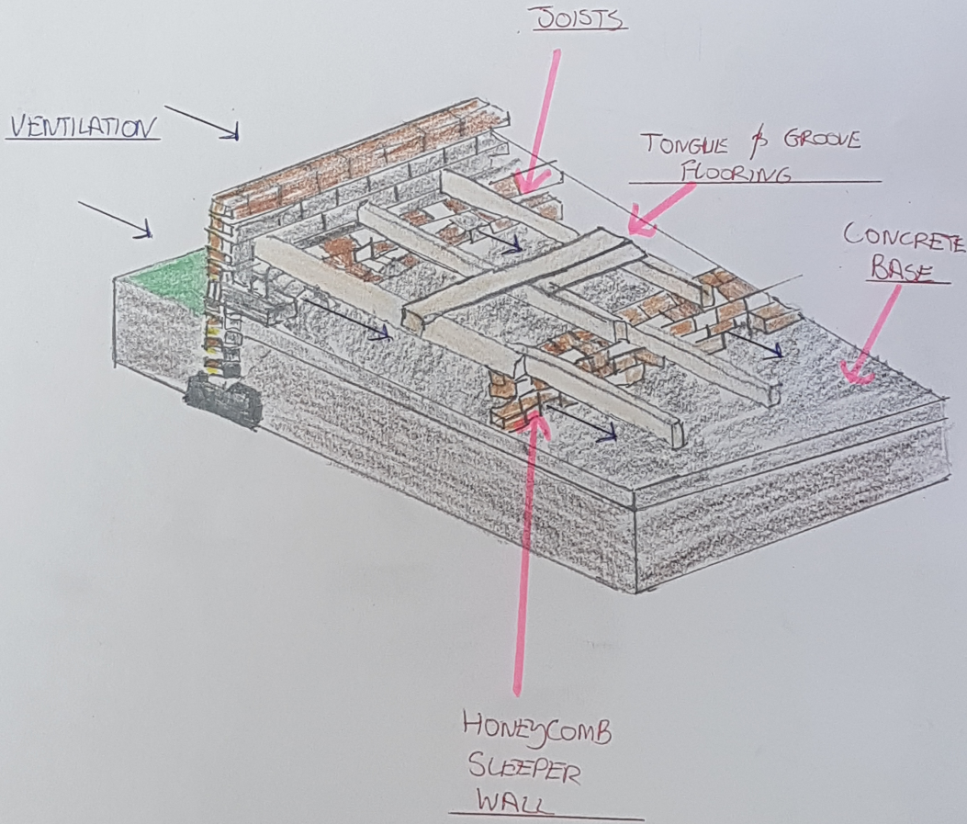

Appendix 5.

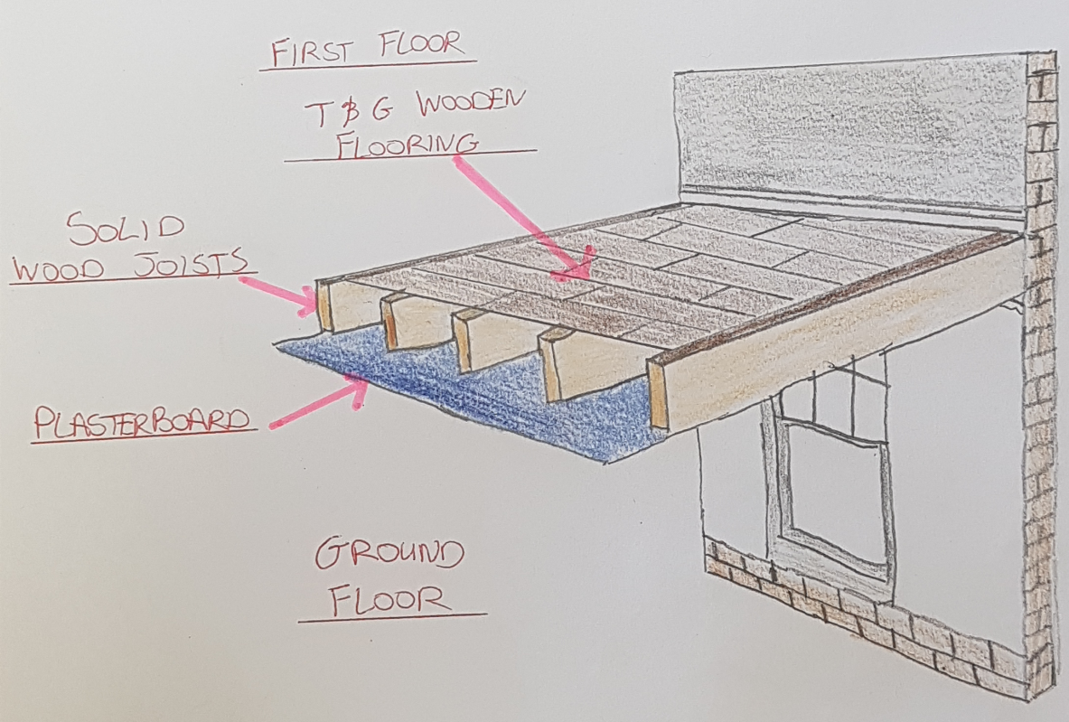

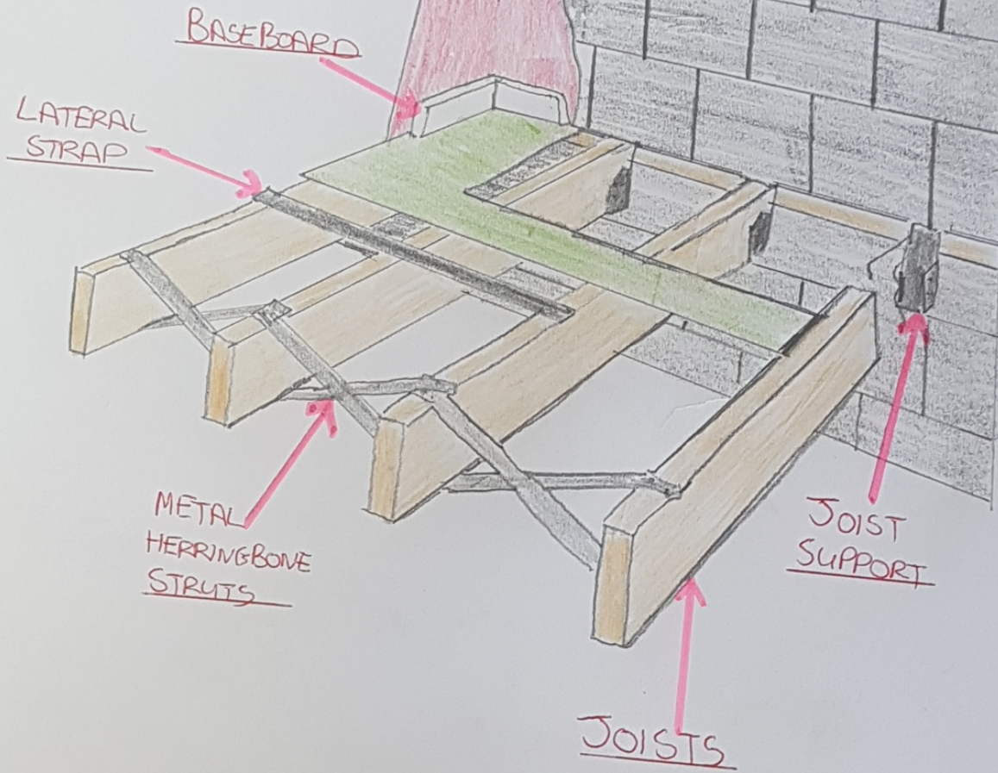
Appendix 6.

Appendix 7.
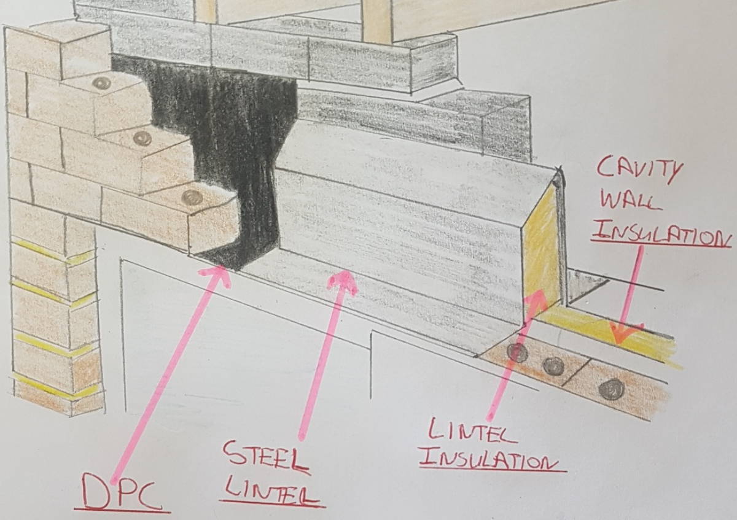

Appendix 8.
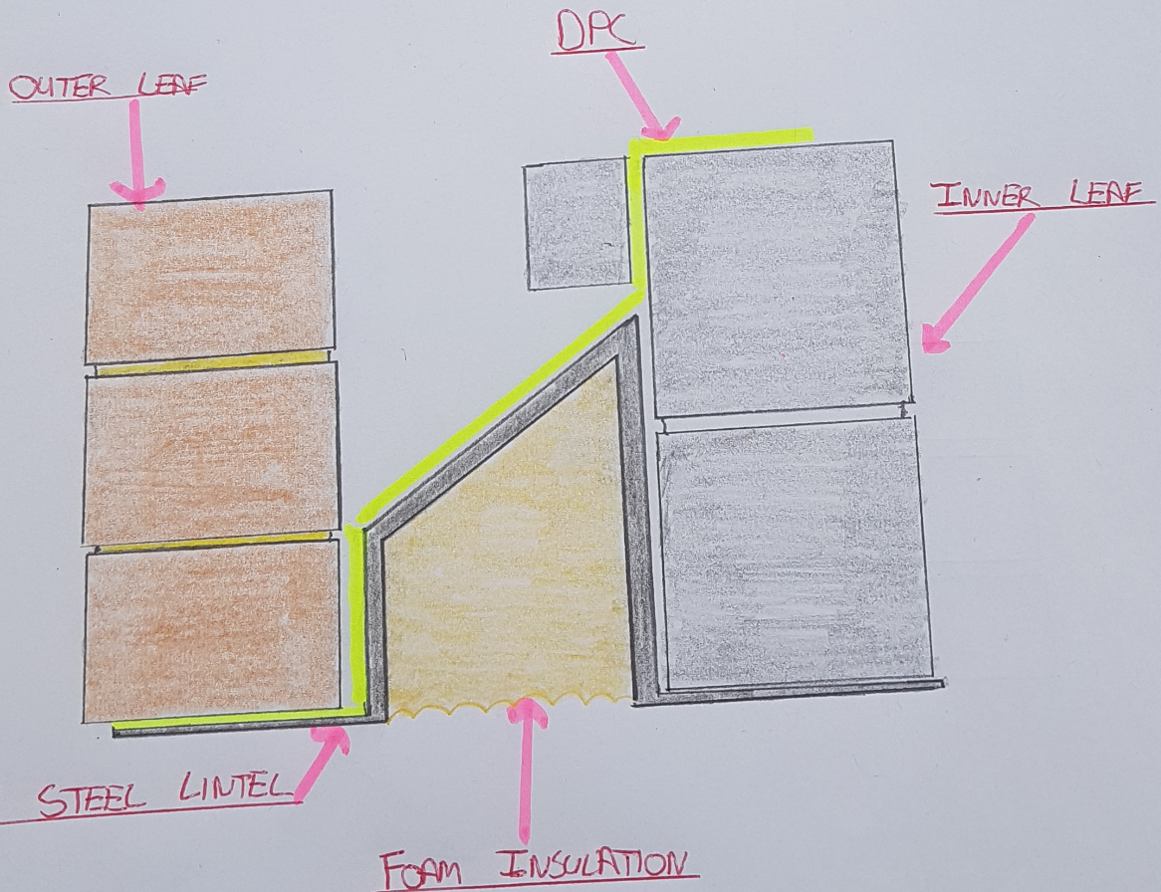

Appendix 9.
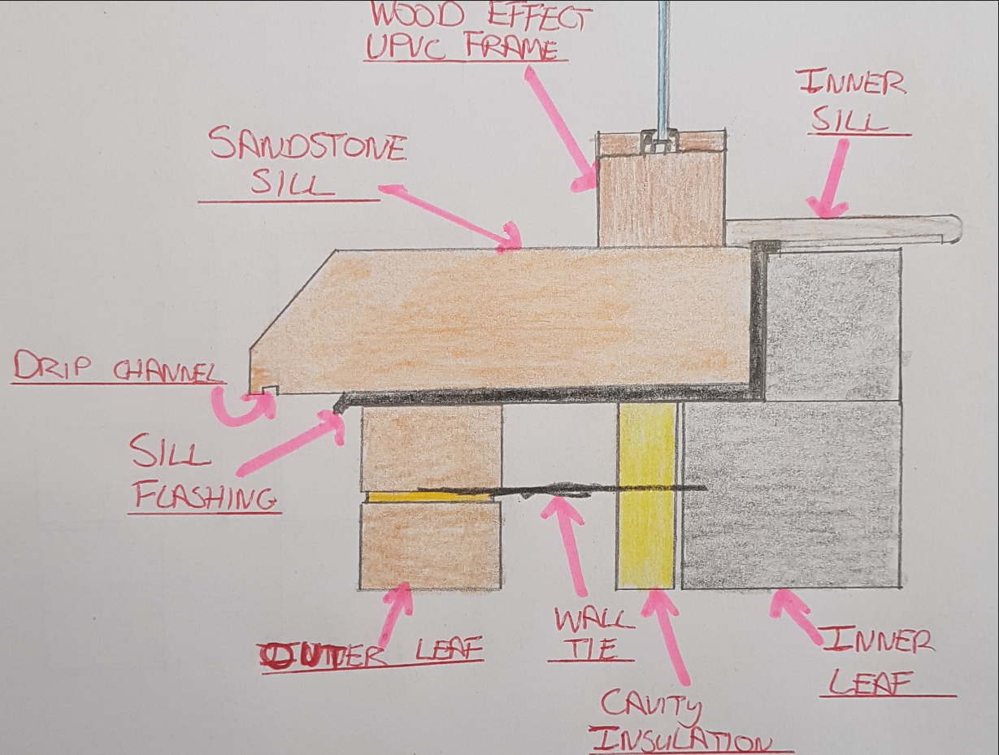

Appendix 10.
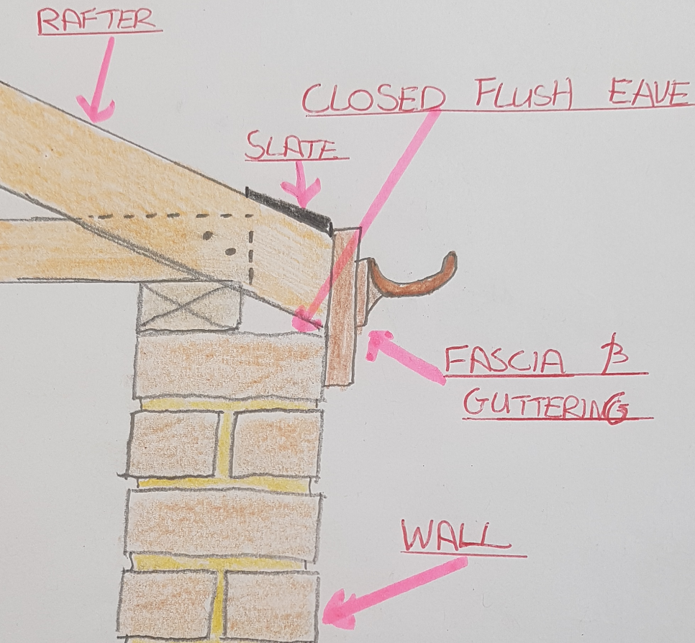

Appendix 11.
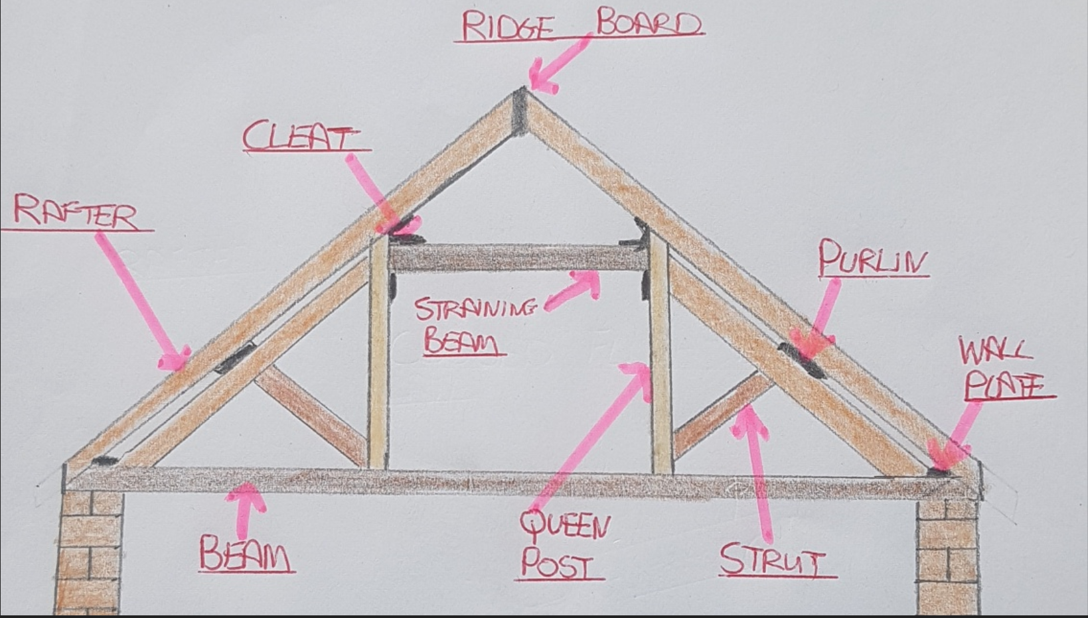

Appendix 12.
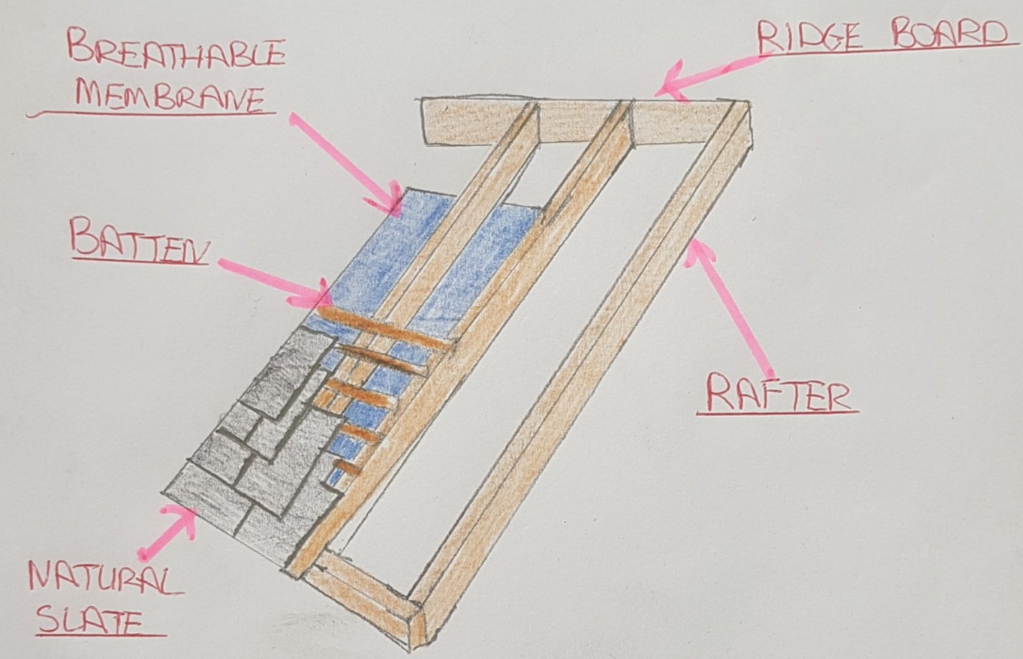
NOTE: INSUALTION IS NOT SHOWN IN THE DRAWING TO PROVIDE EASIER VISIBILITY OF COMPONENTS

Appendix 13.
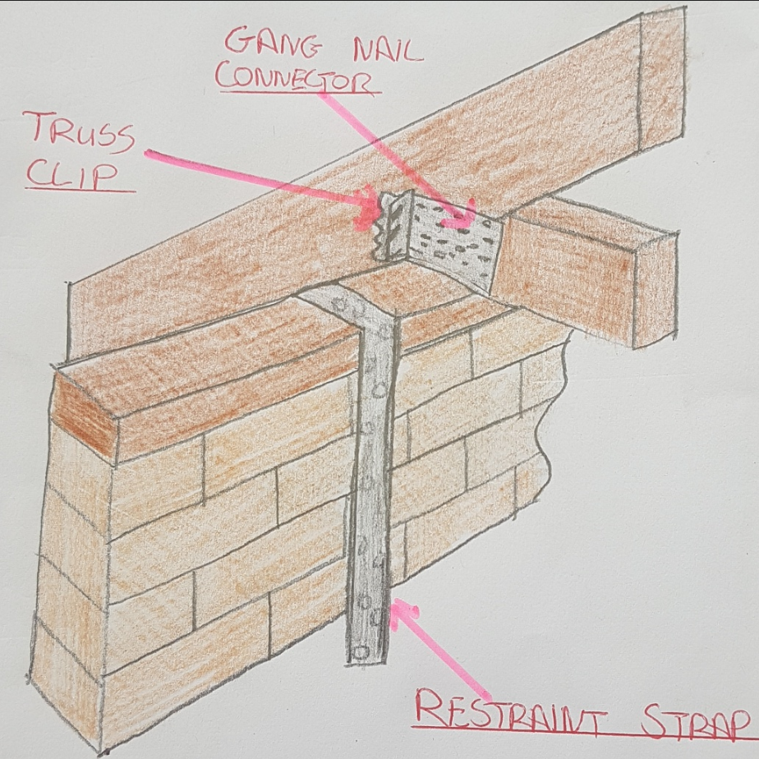

References
BS-1243:1978- British standard for metal ties for cavity walls.
Available on: https://shop.bsigroup.com/

BS-5618:1985- British standard for thermal insulation of cavity walls
Available on: https://www.techstreet.com/standards

BS EN 1195-1-1:2004+A2:2014:2019- UK National Annex design of timber structures.
Available on: https://www.ihsti.com/CIS

Eurocode 5- Span tables for solid timber floors, ceilings & roofs for dwellings 4th edition (2014).
Available on: www.thenbs.com

BS 8103-3:2009- Structural design of low-rise buildings. Code of practice for timber floors & roofs for housing.
Available on: www.thebuildingregulations.org.uk

PD 6693-1:2009- Recommendations for the design of timber structures.
Available on: www.hanson-plywood.co.uk

BS EN 845-1 – British Standard for hanger brackets & tension straps.
Available on: www.tecties.co.uk

BS 5977-1:1981- Specification for lintels & assessment of load
Available on: www.azobuild.com

BS EN 7412:2007- Specification for windows & door sets made from uPVC
Available on: www.cpni.gov.uk

BS EN 1279. British standard for insulated glass units.
Available on: www.pilkington.com

BS EN 612: 1996. – Classification for eaves, gutters & rainwater downpipes
Available on: www.doi.org

BS 5268-3: 2006. – British standard for structural use of timber
Available on: www.timber-frame-suppliers.co.uk

BS 5534:2014+A2:2018. - British Standard for Slating, tiling & pitched roofs
Available on: www.roofbase.com

