The opportunity to be able to attend a work placement was suspended due to the Covid-19 Pandemic. To be able to complete research a telephone interview was conducted on the 8th April 2020 at 11AM. Within this document is a portfolio of evidence regarding a key, mythological and ethical issues which were faced whilst completing research.
Ethical Section
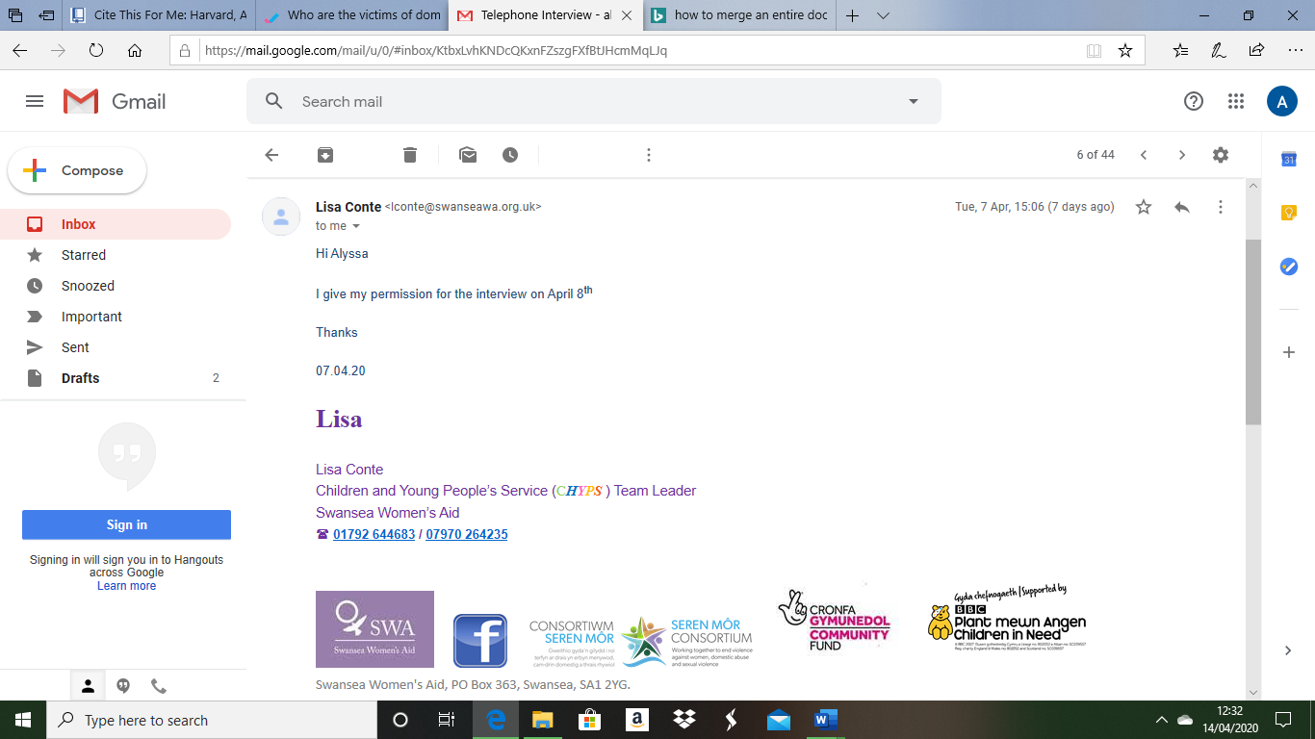

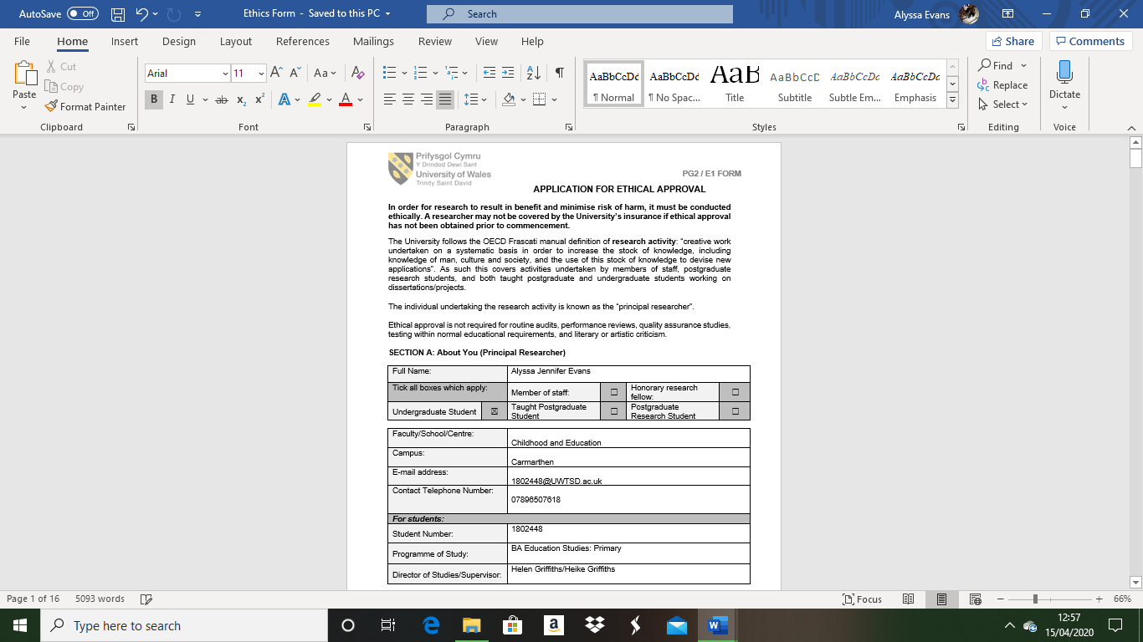
Ethics Form
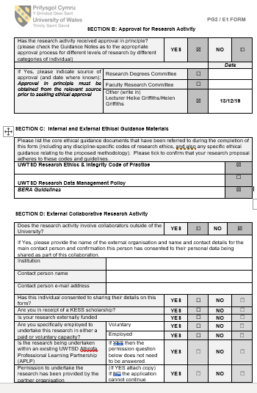

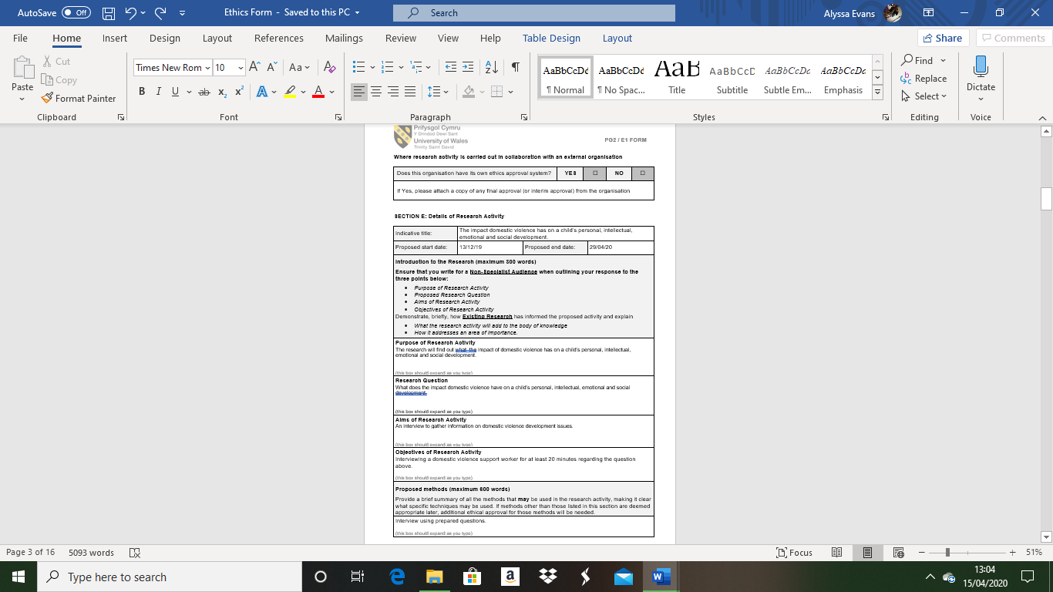

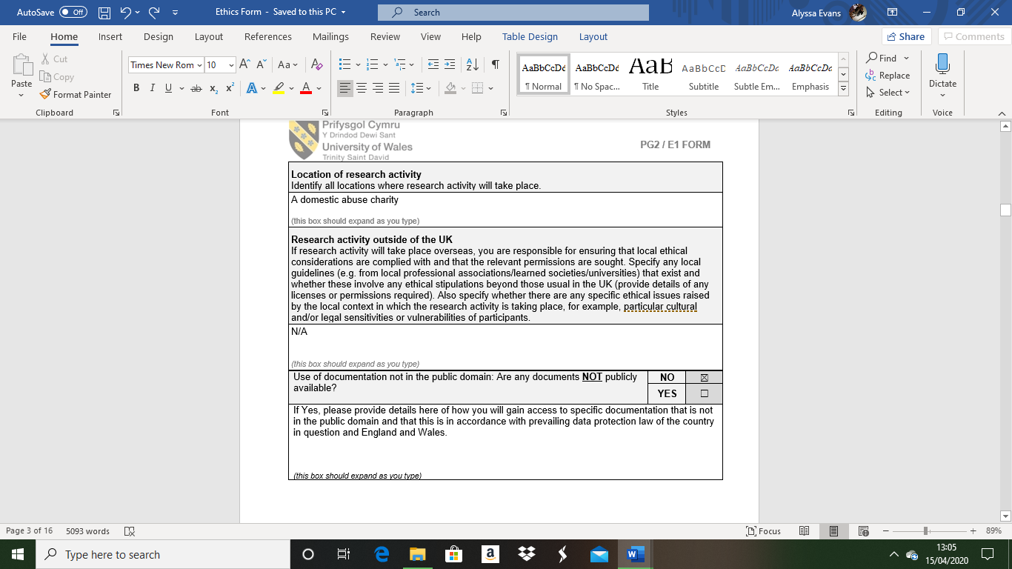

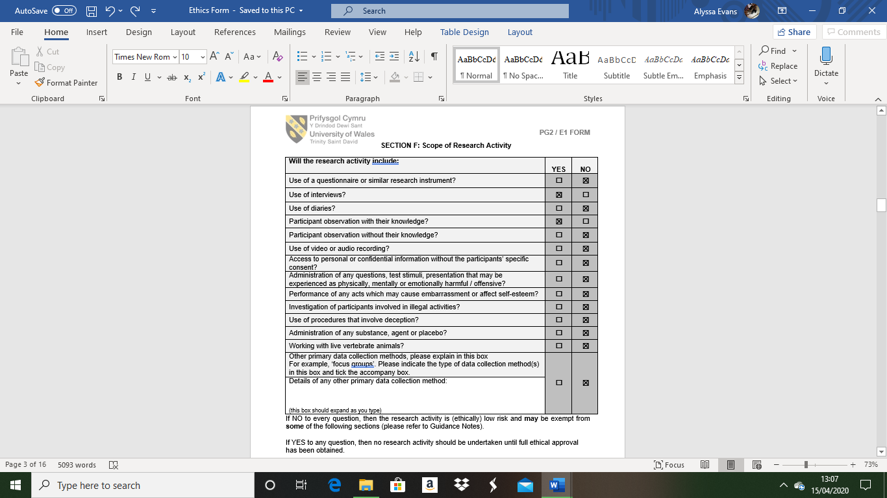

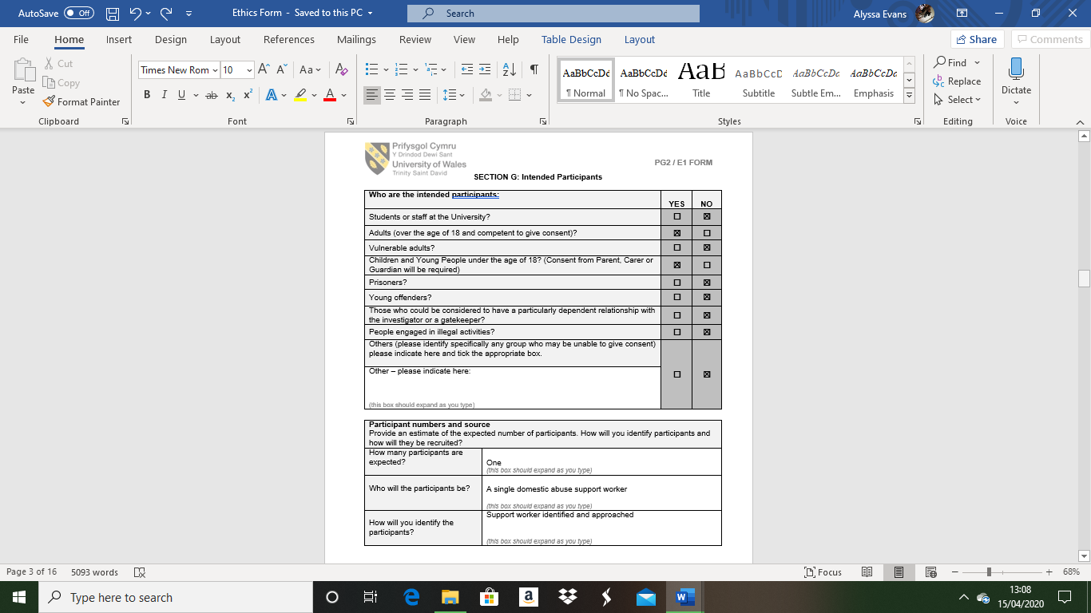

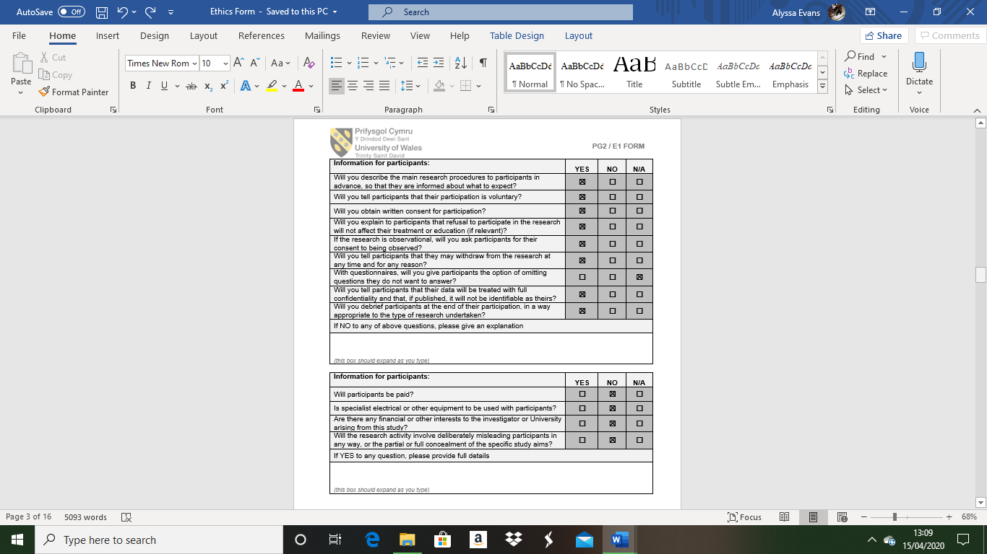

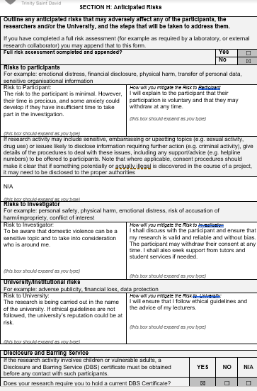

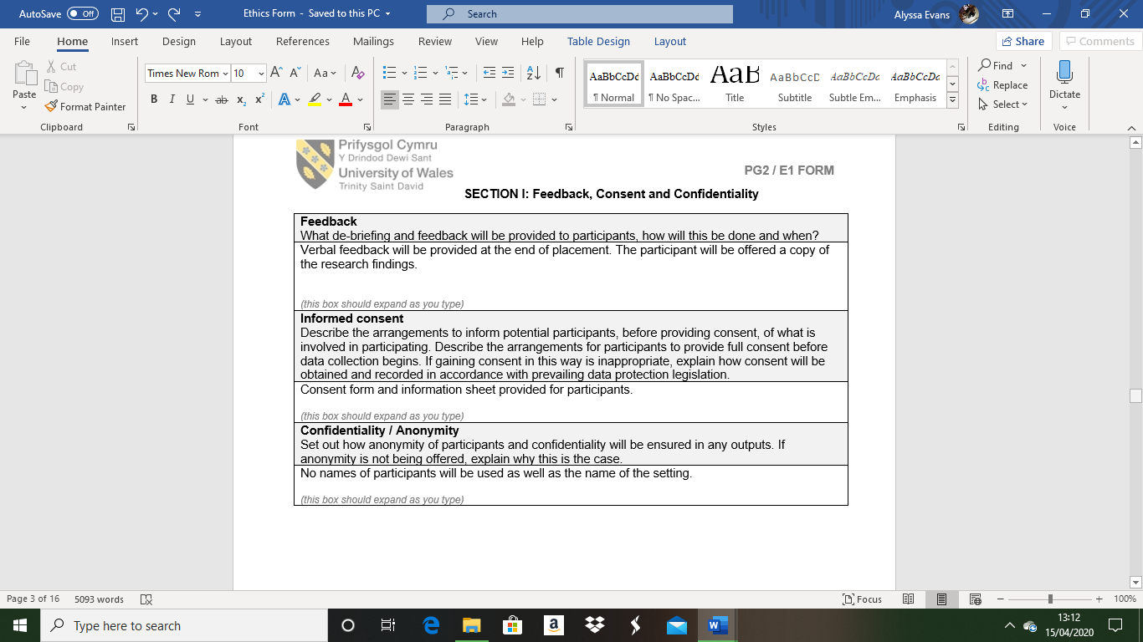

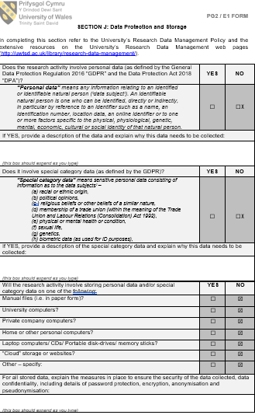

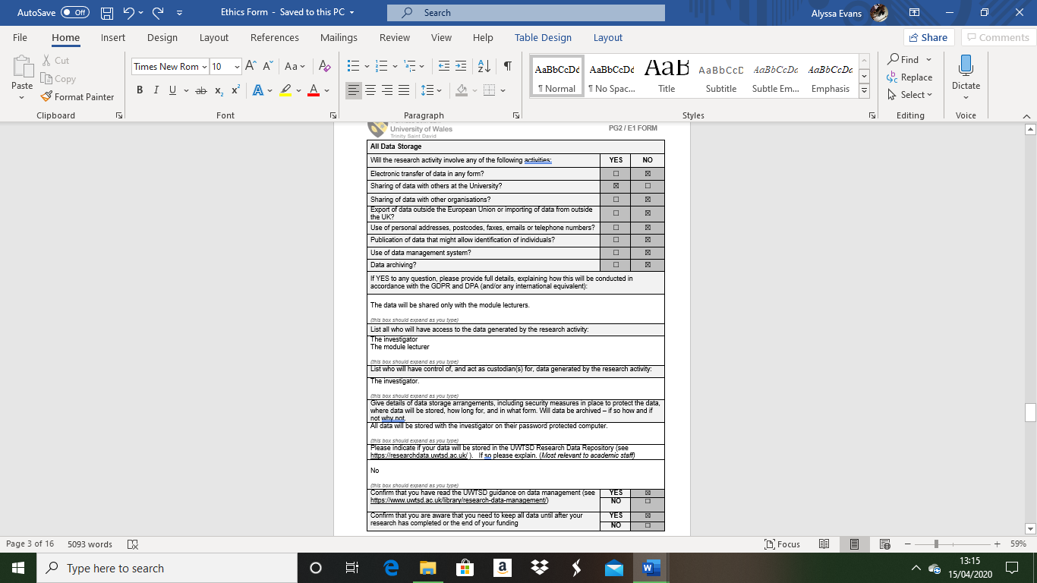

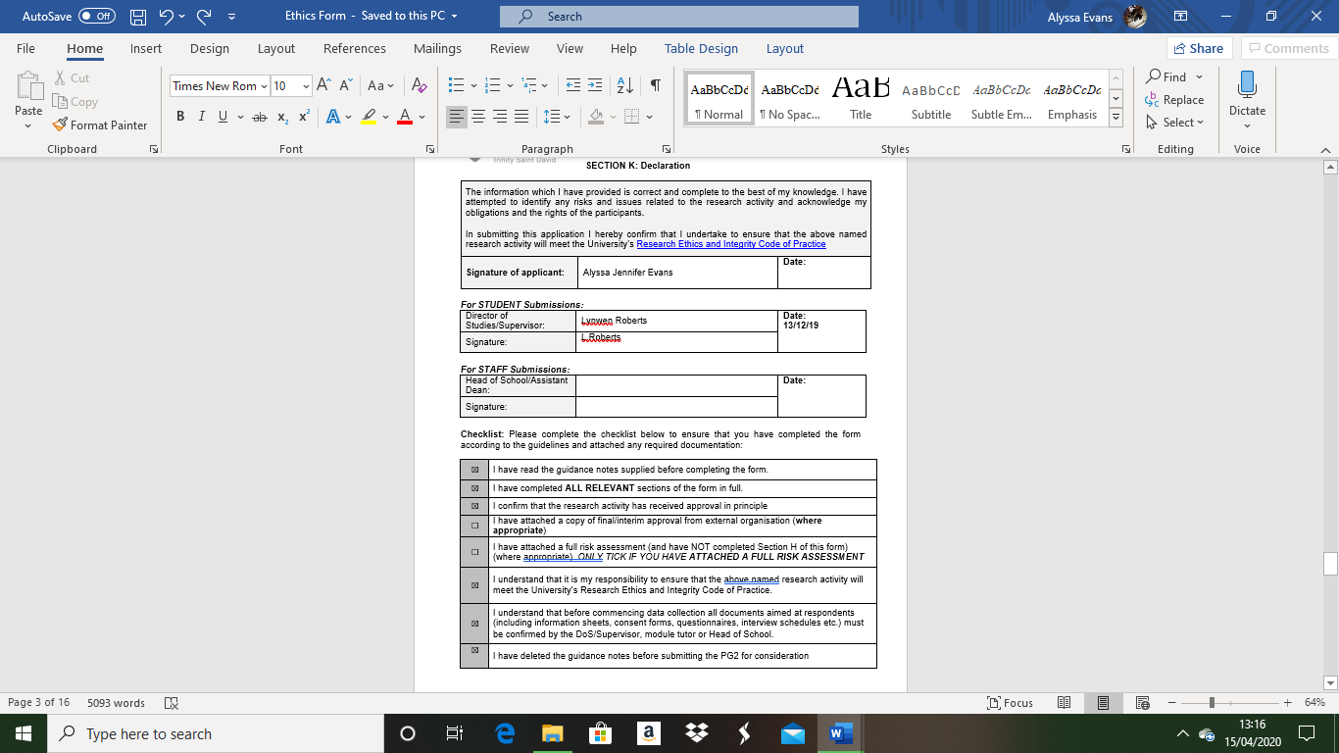

 | PARTICIPANT INFORMATION SHEET
FFURFLEN GANIATÂD CYFRANOGIAD | PARTICIPANT INFORMATION SHEET
Dear Participant:
My name is Alyssa Evans and I am studying in the School of Childhood and Education.
I would like to invite you to participate in my research project. This project will study domestic violence and aims to find out how domestic violence impacts on a child’s personal, intellectual, emotional and social well-being.

All interview questions will be kept strictly confidential to the researchers involved and at NO time will individual interview answers be released to the general public. Your participation in this study is completely voluntary so you can withdraw from the interview at any stage.

Our interview should take about 20 minutes to complete, but there is no time constraint. There are also no right or wrong answers. Attached to this letter is a consent form. We understand that your time is at a premium, but your opinions are very valuable to us.

After careful and precise analysis of the data obtained from this interview I will be happy to provide you with a copy of the findings at your request. The results of this interview will hopefully enhance my understanding of the impact of domestic violence on children and will be stored on my password protected computer. The results of the research will be fed back to my lecturers at UWTSD and an external examiner.

We thank you in advance for your time and participation. If any questions do arise, feel free to contact me at your convenience.
ENW A CHYFEIRIAD YR YMCHWILYDD | NAME & ADDRESS OF RESEARCHER  Alyssa Jennifer Evans  UWTSD College Road Carmarthen SA31 3EP  Email: 1802448@UWTSD.ac.uk

FFURFLEN GANIATÂD CYFRANOGIAD | PARTICIPATION CONSENT FORM
Teitl Y Prosiect: / Project Title: The impact domestic violence has on a child’s development.
Enw'r Ymchwilydd / Name of Researcher: Alyssa Evans

1 | Cadarnhaf fy mod wedi darllen a deall y daflen wybodaeth dyddiedig 13/12/19 ar gyfer yr astudiaeth uchod. Rwyf wedi cael y cyfle i ystyried y wybodaeth, gofyn cwestiynau, ac rwyf wedi cael ateb boddhaol i’r rhain. |  | I confirm that I have read and understand the information sheet dated 13/12/19 for the above study. I have had the opportunity to consider the information, ask questions and have had these answered satisfactorily.
2 | Deallaf fy mod yn cymryd rhan o’m gwirfodd a bod croeso i mi dynnu’n ôl ar unrhyw adeg, heb roi rheswm. |  | I understand that my participation is voluntary and that I am free to withdraw at any time, without giving any reason.
3 | Deallaf y gellir defnyddio unrhyw wybodaeth a roddir gennyf mewn adroddiadau, erthyglau neu gyflwyniadau gan y tîm ymchwil. |  | I understand that any information given by me may be used in future reports, articles or presentations by the research team.
4 | Deallaf na fydd fy enw’n ymddangos mewn unrhyw adroddiadau, erthyglau neu gyflwyniadau. |  | I understand that my name will not appear in any reports, articles or presentations.
5 | Cytunaf i gymryd rhan yn yr astudiaeth uchod. |  | I agree to take part in the above study.
Enw’r Cyfranogwr Name of Participant |  | Lisa Conte |  | Llofnodwyd  Signature  See Above
Ymchwilydd  Researcher |  | Alyssa Evans |  | Llofnodwyd  Signature  A.Evans

Cewch wrthod cymryd rhan yn yr astudiaeth hon. Cewch ddod â’ch cyfranogiad yn yr astudiaeth hon i ben unrhyw bryd. Os penderfynwch barhau’n ddienw, bydd sicrhau hynny’n flaenoriaeth a chymerir pob cam ymarferol i guddio pwy ydych. Os yw’n well gennych fod yn anhysbys, ni fydd unrhyw wybodaeth yn eich enwi ar dapiau sain na thrawsgrifiadau o’r cyfweliad hwn nac o unrhyw un arall. Ni fydd neb yn clywed unrhyw dapiau sain nac yn gweld unrhyw drawsgrifiadau heb eich cydsyniad o flaen llaw. Bydd deunyddiau a grëir yn sgil y cyfweliad hwn neu unrhyw gyfweliad arall yn aros yn gyfrinachol. | You may decline to participate in this study. You may end your participation in this study at any time. If you decide to remain anonymous, maintaining your anonymity will be a priority and every practical precaution will be taken to disguise your identity. If you prefer anonymity, there will not be any identifying information on audiotapes or transcripts of this or any interview. No-one will hear any audiotapes or see any transcripts without your prior consent. All materials generated from this or any interview will remain confidential.
Ar ôl llenwi’r ffurflen, dychwelwch hi yn yr amlen a ddarperir (lle bo’n berthnasol). Rhoddir un copi i’r cyfranogwr a chedwir y gwreiddiol yn ffeil y tîm ymchwilio yn: | When completed please return in the envelope provided (if applicable). One copy will be given to the participant and the original to be kept on the file of the research team at:
ENW A CHYFEIRIAD YR YMCHWILYDD | NAME & ADDRESS OF RESEARCHER  Alyssa Jennifer Evans  UWTSD College Rad Carmarthen.  SA31 3EP.  Email: 1802448@UWTSD.ac.uk

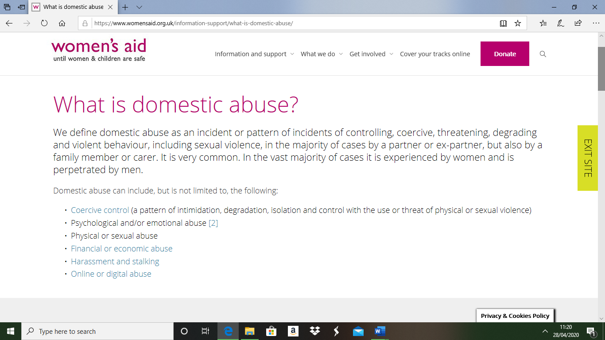
(Womens Aid.org.uk)
Annotation of What Is Domestic Abuse From Women’s Aid
Definition of domestic abuse – no longer referred to as domestic violence due to the range of abuse there is, not just physical for instance, emotional sexual and mental.
Specifies both genders can be affected as well as children within the household. As well as specifying that anyone within and in a past intimate relationship can be affected.
Shows advancement of abuse – for example from face to face abuse to online or digital such as stalking and harassment.
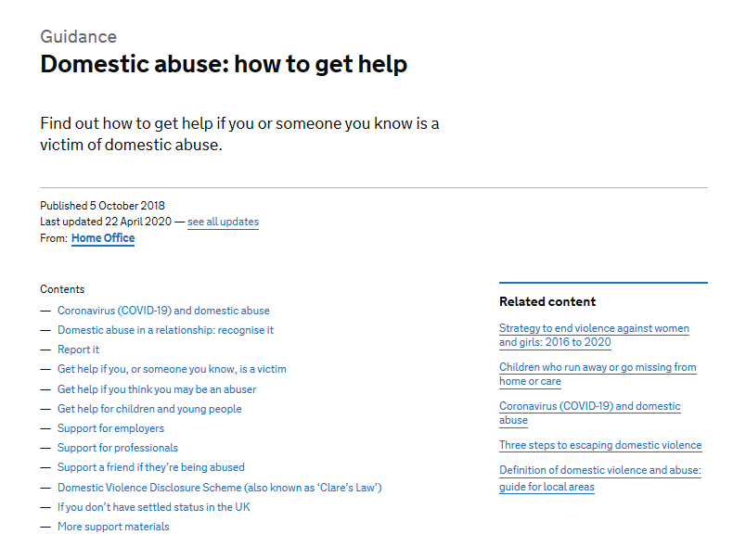
Relevant to research due to the range of examples given and who domestic abuse can happen to, will give insight into all types of abuse that are still unknown or taboo.
(Gov.uk)
Annotation of Gov.uk Domestic abuse page
This page was created 22nd April 2020 I order to support people in lockdown and quarantine due to the current pandemic who my be trapped in a domestic abuse situation.
As it stands, according to Gabby Bertin, writer at the telegraph newspaper, over 20 women have been murdered due to domestic abuse whilst in lockdown, whether children have witnessed is currently unknown (Bertin,2020).
Relevant to research due to current events, many other links towards helpful pages and policies and shows the severity of the amount of cases that may be happening currently.

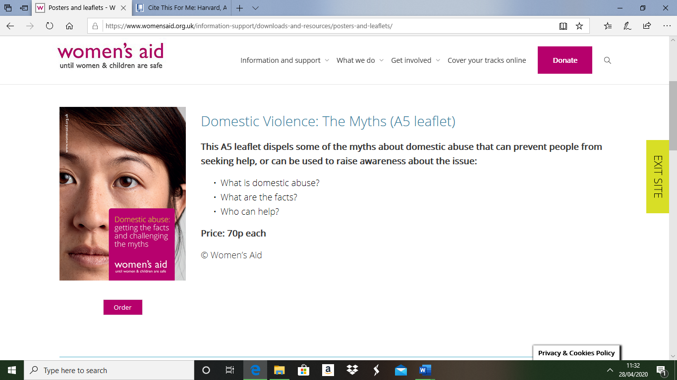
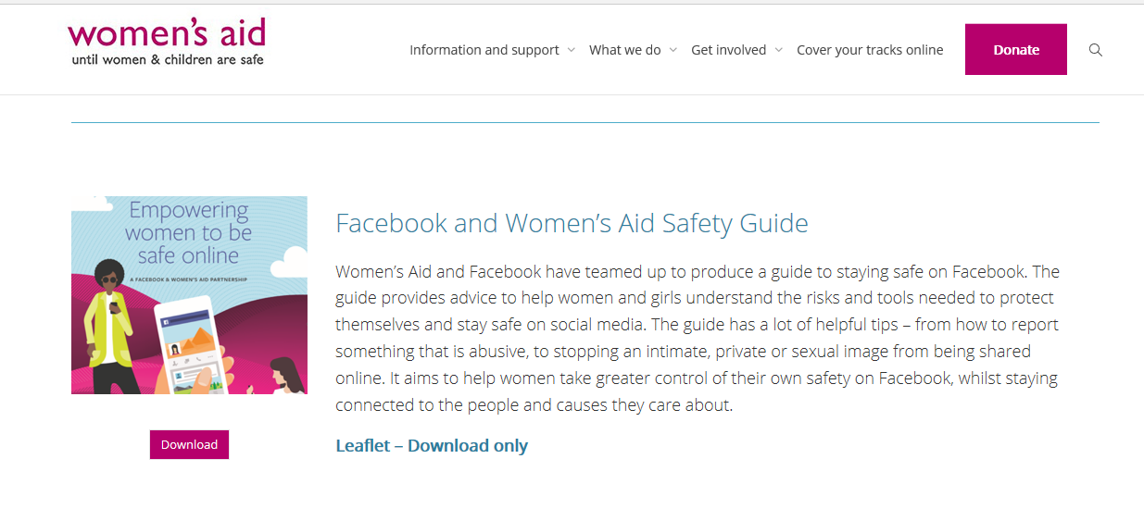
(WomensAid.org.uk)
Annotations of Women’s Aid Leaflets
These were put into place in order to give women options about their situations as well as fundraising at the same time e.g. the 70 pence charge for the leaflet.
The first leaflet includes information of all sorts regarding definitions, range of abuse such as physical, financial and digital s well as networks to intervene and support, for instance the victim wants to flee abuse because there is a child involved, the victim does not want to add issues onto their child or lessen the issues that are already present by getting in touch with the correct companies such as Hafan Cymru or Woman’s aid.
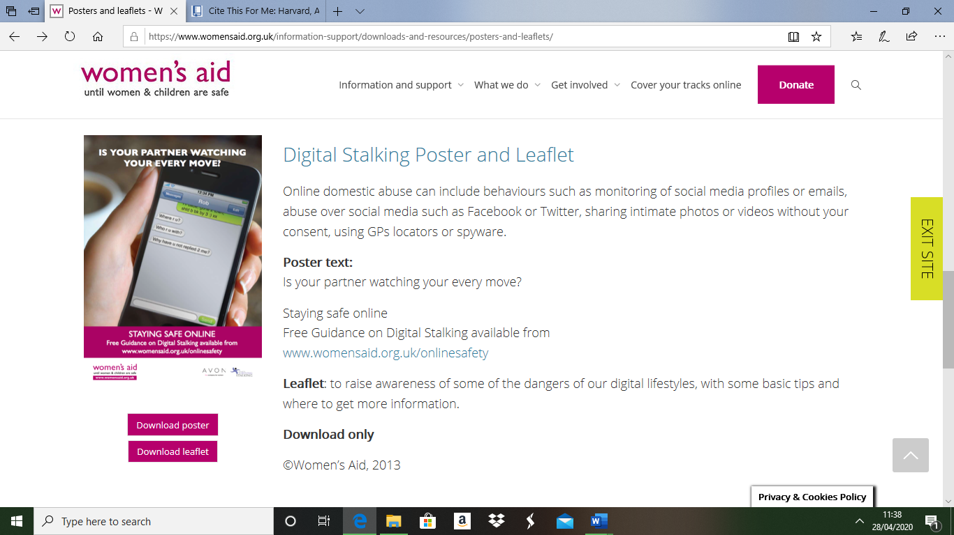
Relevant more to the victim than research however facts and information on prevention and intervention such as anonymous calls and social service referrals can be found within them.

(WomensAid.org.uk)
Annotation of Digital Stalking Leaflet
A modern style of abuse becoming more popular (womensaid.org.uk).
Domestic abuse can include cyber abuse and stalking, more common in ex-partners.
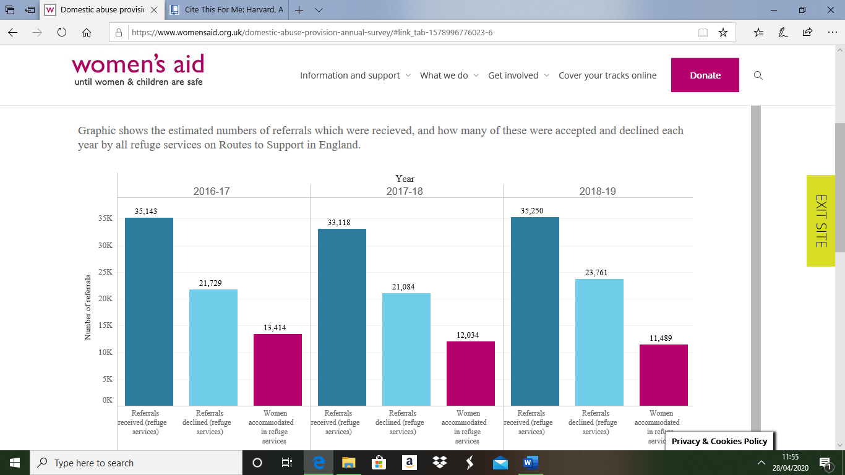
Relevant due to increasing cases and use of modern technological devices.
(Womansaid.org.uk)
Annotation of Statistics of Annual Survey
This is visual proof of how many victims are currently being in a domestic abuse household but are not being able to or perhaps wanting to receive help that they need.
Referrals made to woman’s aid in 2017-2018 are decreased whereas in 2018-2019 they are higher than ever, and the victims taken out of abuse lowers as each year passes showing that perpetrators know what they are doing and victims are indeed vulnerable are unaware that social services will support and not take a child away unless harm or possible harm occurs.
Relevant to research because of the severity of cases that are currently taking place within the United Kingdom as figures rise so will children’s positive and healthy development statistics decrease.
All these Women’s aid website pages, posters, statistics and leaflet briefings are of paramount importance to complete this research project because Women’s aid is the base of all of it, for instance the interview that has been conducted took place from Women’s aid and all the relevant information needed is available.
Topic Based Information
To Begin the topic-based information, theorists were looked into at detail, below are Lenore Walkers cycle of abuse diagram (1970s’), Erik Erickson’s psychosocial development diagram (1950) and John Bowlby’s attachment theory diagram (1951) these three theorists stood out beyond others because of the depth and relatability information of the key issue of how does domestic abuse impact on a child’s development, be it physical, social, intellectual or emotional and these theories are all unique and varied.
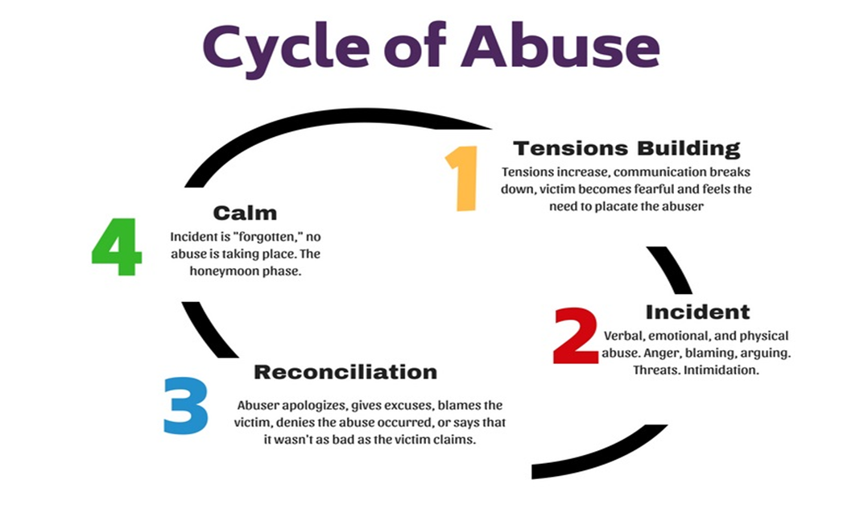
Lenore Walkers Cycle Of Abuse Diagram 1970s’
(JPHMPdirect.com)
Annotations of Walkers Cycle Of Abuse Diagram
Lenore Walker 1980s believes this cycle is the case for all people in a domestic abuse situation
This diagram is crucial in the issue being researched, for instance it can be relatable to victims and their children who have witnessed abuse within the family home.
Four stages all pinpoint the abuser/perpetrator as the main subject, the abuser knows their actions and is continuing to repeat the same patterns until the victim intervenes.
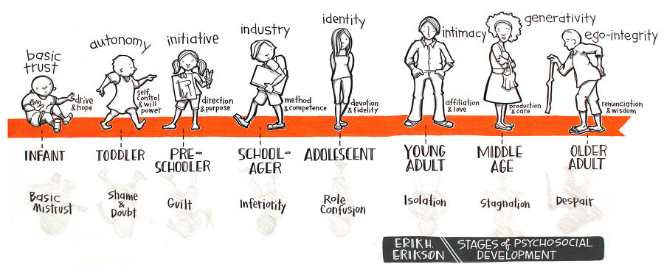
EriK Ericksons Diagram Of Psychosocial Development 1950

(Quizlet.com)
Annotations Of Erikson’s Psychosocial Development
This theory states that there are two options in each part of the life-stages and whatever is played out from birth will follow through to adolescence and adulthood
In terms of domestic abuse, it is more than likely that a child in the middle of the situation will experience the negative impact in each of their life-stages unless intervention is put into place rapidly, for instance, bad behaviour, emotional issues, anger issues, late development milestones such as potty training and speech and mental illness. (Mooney,2006).
Relevant to research due to the connections of childhood trauma such as domestic abuse witnessing to a repetitive adulthood, e.g. becoming a victim or perpetrator.
John Bowlby’s’ Attachment Theory Diagram
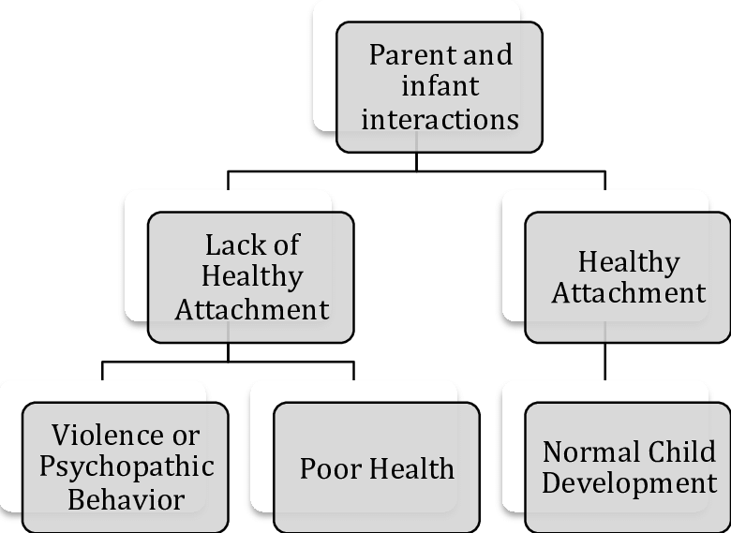

(Researchgate.net)
Annotations Of Bowlby’s Attachment Theory 1951
Bowlby – Theorist in Briton in the 1950s. studied implicating factors of a healthy and toxic childhood to grow into a healthy or negative adulthood.
This theory is based on the caregiver or parents of the child and how their actions will impact on their child’s life and development.
If the child doesn’t receive the amount of attention and care they require It will impact badly on well-being of all aspects within that child.
However, Bowlby believes that if a child has a behavioural issue its due to neglect or bad parenting which is now understood as false as there are lots of different factor which cause behavioural or learning difficulties such as illness from childhood, autism and ADHD (Holmes,1993).
Relevant to research because of the key issue, Bowlby’s theory connects the key issue together with reliable evidence and relevant queries.
Topic Based Information also covers policies and the effects on children which was the key issue question.
Every Child Matters

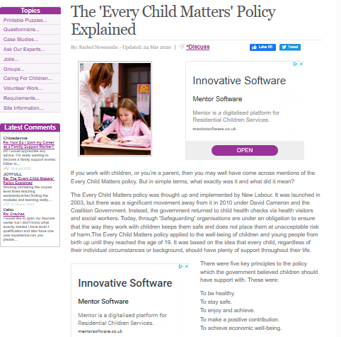
(Newcombe,2020)
Annotation of Every Child Matters (2003).
Brought into place due to the notorious death of Victoria Climbie and updated due to the tragic death of baby P.
Applies to everyone who works with children closely such as teachers and paediatric nurses and doctors or in the same setting such as social workers and health visitors. Every child matters 2003 teaches practitioners to look out for signs of neglect or abuse.
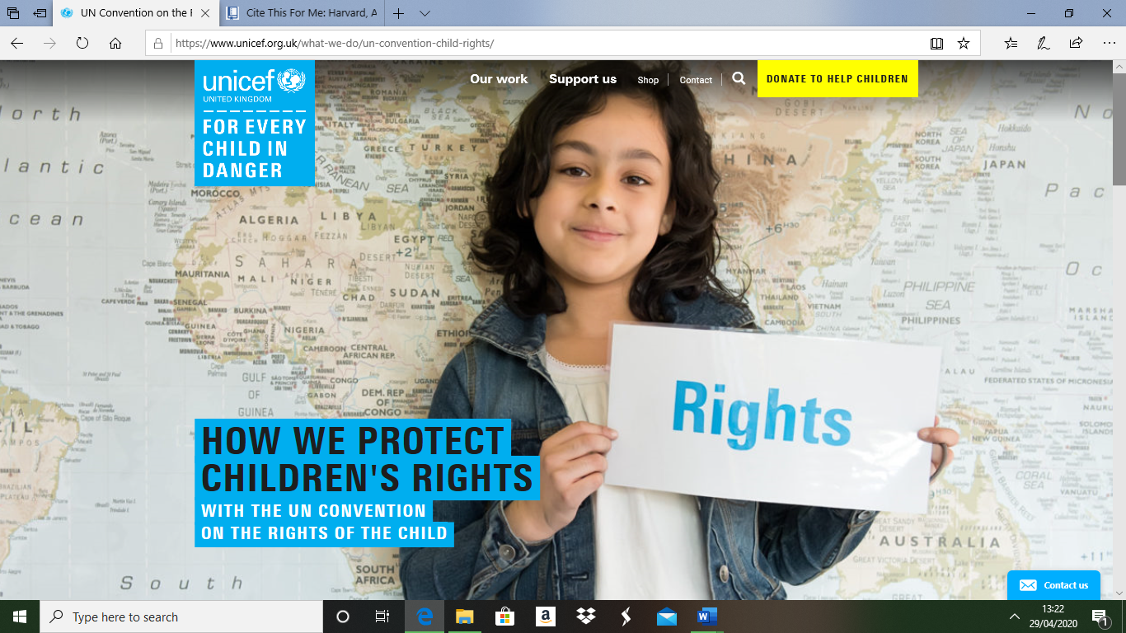
Five key aspects of childhood, health, safety, enjoyment and achievement, contributions, economic well-being.

(unicef.org.uk)
Annotation of the UNCRC
54 articles on the rights of a child.
All people under the age of 18 are classed as children (Alderson,2008).
All children are entitled to rights.
Domestic abuse is damaging to young and older children and impacts on their personality and behaviours (unicef.org.uk).

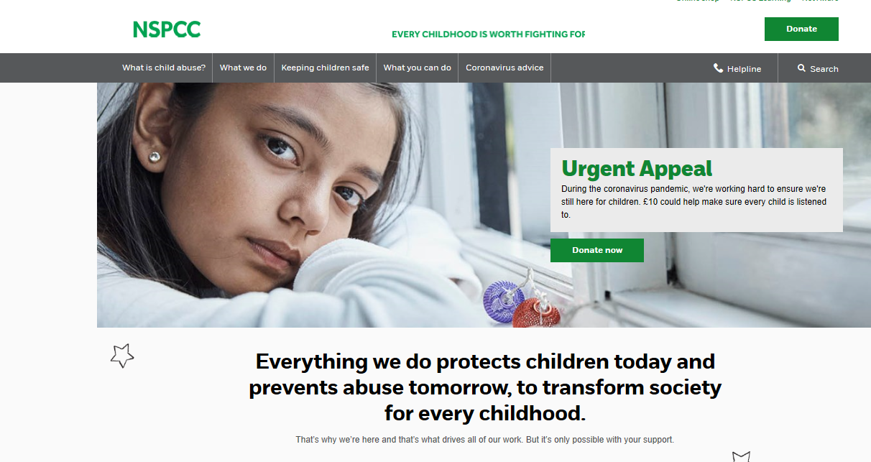
(NSPCC.org.uk)
Annotation of the NSPCC
The NSPCC webpage states the laws of domestic abuse. This page safeguards all children from harm or possible harm.
The NSPCC state that domestic abuse and making a child witness the abuse is an offence as part of the serious crime act, 2015. (NSPC.org.uk).
This offence can lead to up to 5 years imprisonment, a fine or both.

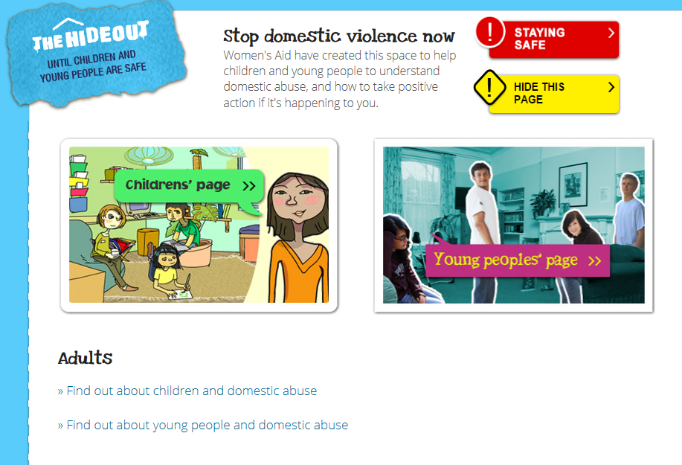
(Thehideout.org.uk)
Annotations of The Hideout
The hideout was created by women’s aid in order to get in touch with children in a domestic abuse household, this webpage is seen as a safety net for children and young people to express their feelings, play games and receive support from the relevant people such as workers at women’s aid.
The hideout is also put in place to show the effects of domestic abuse on their children to intervene and encourage fleeing the situation for the child and their safety and best interest.

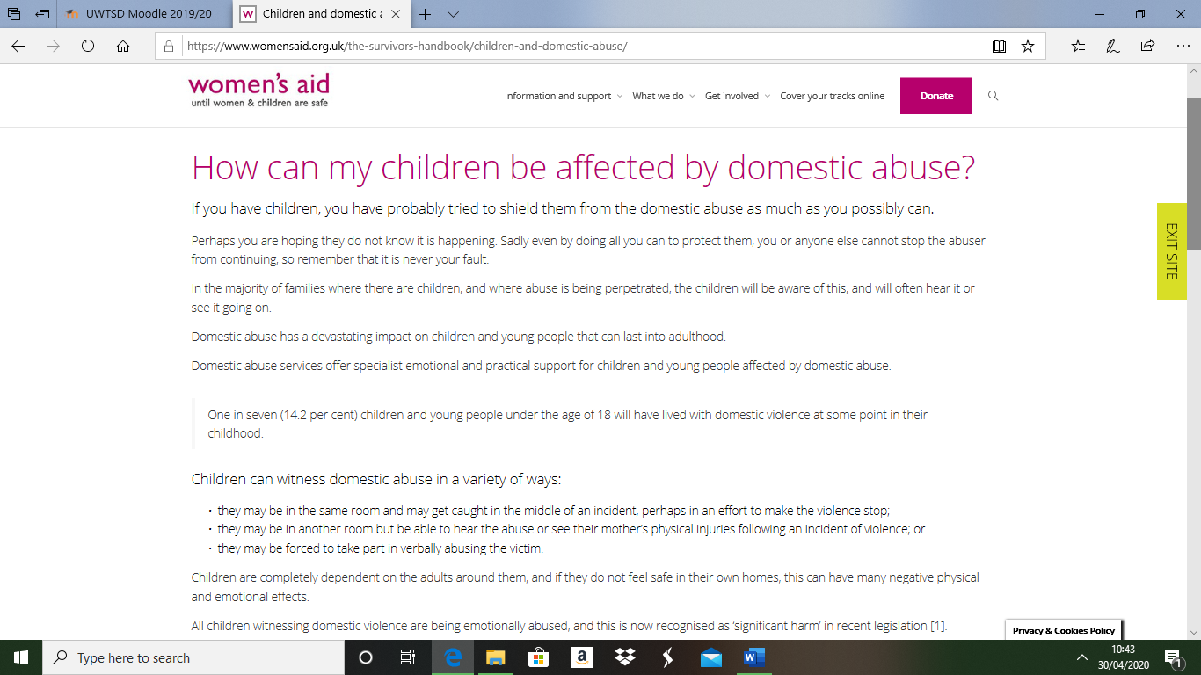
(Womensaid.org.uk)
Annotation of how children may be affected by domestic abuse
On this page of women’s aid.org.uk the network has added statistics about how many children are caught up in a household abuse situation and one in seven is very common, worrying and shocking.
The page states that a child is completely dependent on parents and can be emotionally abused by witnessing and possibly being made to take part in the abuse leading to social service referrals and safety plans such as he possible removement from the family home.

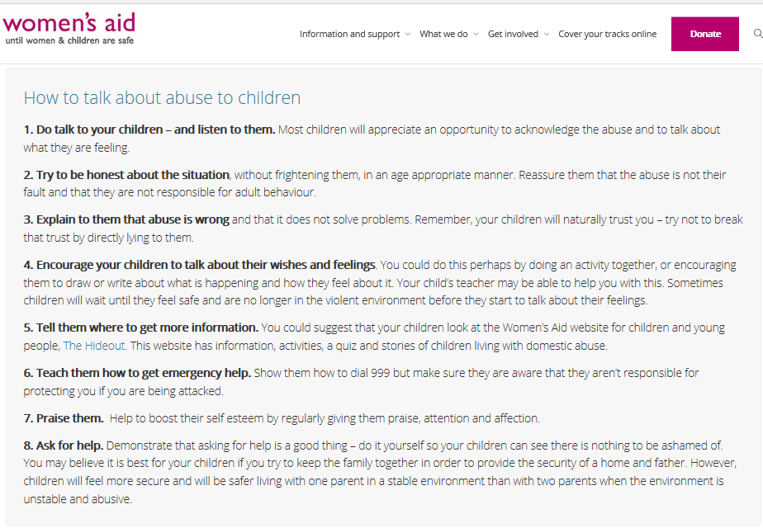
(Womensaid.org.uk)
Annotations on how to help your child/children during abuse
This page on the woman’s aid website explains to domestic abuse victims on how to make a safety plan out of fear. It is a very necessary plan to make due to the severity of this topic.
Children are being encouraged to talk and support the victim, hopefully speaking to the correct authority or person will cause intervention and rebuild confidence and any additional issues such as learning or behavioural.

Methodological Approach
Telephone Interview – Woman’s Aid
At 11AM on the 8th April 2020 I was given permission by Lisa Conte a woman’s aid, children and young people’s service team leader to conduct a telephone interview based on my research question, the question that is being discussed is how does domestic violence impact on a child’s development? The telephone interview was put in place rather than an on-site placement due to the suspension of placement due to the Covid-19 pandemic.
I asked Lisa, the following questions, Lisa’s’ answers are stated in red.
1.What is domestic violence?
We as an organisation no longer use the words domestic violence, we now use domestic abuse due to the range of abuse methods that can occur, the forms of abuse that can happen in relationships or with people who have a connection, for example separated parents, includes physical, sexual, emotional, mental and financial.
2.Who can domestic abuse happen to?
Absolutely anyone, abuse is not discriminating. Domestic abuse is between anyone within or was within an intimate relationship. Men are typically the perpetrators however men can be victims more than once thought.
3.How many people with children come to this charity because of domestic abuse in a month?
This is part of a confidentiality report, so I am unable to clarify how many exactly however I can say that the highest number of people we support are mothers and fathers.
4.Have you personally witnessed a developmental effect in a child caused by domestic abuse?
Yes- there is a range of developmental effect on children in these situations, the most common developmental concern often is around the behaviour of the child or their interaction around other people and children and often the mothers or fathers within these toxic households do not have a strong connection or bond with their child as much as expected because they as well have been damaged.
5.What would you say are the top three effects in children’s development when witnessing and being a victim of domestic abuse?
This question relies on evidence based on age range, for instance a younger child is more likely so show effects such as anxiety, bed wetting and anger issues and an older child or adolescent is more likely to show signs of self-harming, anger and substance abuse.
6.Are the effects of domestic abuse the same for every child?
No – Again this all depends on the age of the child in question, it is best to seek advice and help as soon as possible to direct possible harm down another path.
7.How likely is it if a child in the middle of household violence and abuse becomes a victim or perpetrator themselves?
There is definitely a high correlation between being a victim and becoming a perpetrator of domestic abuse. What is known as normal o some children is the complete opposite to others, again a reason to intervene as soon as possible.
8.How do you identify a child’s development that has been altered due to domestic abuse?
By closely observing the child’s behaviour socially and physically.
9.How do you support children when they are involved in a domestic abuse situation?
We work very closely with the children involved, we use talk and feeling expression methods we also create structured safety plans in case the worst Was to happen, for example they’ll know how and when to call the emergency services and will be able to identify their own safety zone such as with a relative or neighbour. We also build u their self-esteem and speak about what is healthy and what is not, we also work closely with social services.
10. How do you work with social services to resolve the issues of domestic abuse on the victims and their children?
We have referrals from social services, we then direct the referrals to the appropriate team for instance the adults get help and support at the adults service and children get help and support from our CHYPS (children and young people’s service). We also attend meetings and hold meetings with staff from social services.
Reflective Diary
To begin the reflective diary of this task reflective models were used and shall be linked throughout. The reflective models of Graham Gibbs (1988), Donald Schon (1991) and David Kolb (1984) were studied and analysed.
Gibbs Studied six stages to reflection of a task, these include description, feelings evaluations, analysis, conclusion and finally an action plan (Gibbs, 1992).
Schon believed in the concept of reflection in and on action, Schoens theory supports two different types of reflection, during and after an activity or task (Schön and Rein, 2000).
Kolb had four states to his theory of reflection these included experience, reflection, abstract conceptualisation and experimentation (Kolb 1993).
Each of these theories are key within research and study.
Overall the key issue research project went fairly well despite all of the chaos in the world at this current time, for instance, although placement was suspended and therefore unable to complete it was still possible to conduct and create a telephone interview asking the relevant questions to link to the key issue of how domestic abuse impacts on a child’s development, according to Gibbs this is known as evaluation when reflecting, this makes sense of good and bad points within the completed task(Gibbs, 1992). Another point about how this research went well is the fact that all the relevant research was easy to find and assess due to the simplicity of the set out of the woman’s aid website. The telephone interview itself also went easily due to the positive disposition, non-formal setup from the comfort of home and most research, questions and action plan completed in advance, in the case of using the reflective model of Schon (1991) this section is analysing on reflection of action as the task has been completed and the process of thinking about the instances that took place throughout said task are being discussed (infed.org). Challenges were faced during completion of this project such as technical issues such as losing signal during the interview and internet access problems which were resolved in the end, when these challenges and problems began the reactions in which were expressed included stress, frustration, concern and anxiety however when the technical issues resolved the expressions included relief and relaxation. During the interview and research process an element of surprise was added into the project such as the results of the questions asked such as the difference in developmental issues throughout ages, how domestic abuse has developed into cyber and digital offences as well as within the household and how social services become involved in a domestic abuse situation by using referrals as clarified by the interviewee. There were also elements in which was familiar and common knowledge such as who domestic abuse can happen to, who can be a perpetrator and what is classed as domestic abuse. The beliefs in which were present before this task such as parents being the highest percentage of victims and children having behavioural and development issues when witnessing domestic abuse have not been altered since completing this task however new facts have been found throughout such as the wide range of categories abuse is set into, this proves Kolb’s section of theory that is titled reflective observation of the new experience which basically states that there are inconstancies with understanding and physical experiences (Kolb, 1973).
The challenging situation of not being able to complete placement was manged particularly well due to being able to replace a placement with an interview and still receive the main part and information needed to provide work for this entire task. The experience of doing this research project has not altered any opinions in which were said and believed such as a child being in an abusive situation has a higher chance of becoming a victim or perpetrator themselves before beginning this task. Positive feedback was given after completing the interview, the interviewee stated that the language and politeness used throughout the process was of high standard and they were pleased with how ethically produced the process of the interview was. There was a variety of resources used however internet resources were highly more frequent than literature although some books were used, there is room for improvement on this front this relates back to Schon (1991) who stated in his research that time is valuable and must be used wisely in order to gain highest standard of experience and learning(infed.org), in this case more time should have been used to gain numerous and various documents and resources .Further reading is needed in order to have a wider variety of resources. The skills in which are required to address this key issue are empathy, compassion, literature, social and communication, these are all vital in being able to repeat the positives and the improvements when dealing with domestic abuse in future practice. The conclusions that have been drawn throughout this study include the seriousness and variety of developmental implications in children such as delays for instance in speech, potty training, walking (in some but not a lot of cases), emotional attachments and dispatchment as studied and stated by theorist John Bowlby (1950), unhealthy relationships withing the future and ending up in a cycle of abuse as told by theorist Lenore Walker (1970) other conclusions that have been analysed include that early intervention is key and to flee from abuse is a very difficult, painful and emotional experience, especially when a child is involved.
If given the opportunity to repeat this event for a second time, further investigation would be taken, possibly having a variety of domestic abuse facilities participate in interviews be they in person or over the telephone and compare results and observation of a child within a difficult situation would be very interesting and would expand knowledge whist possibly then changing opinions and views of what is already believed through research within this project according to Gibbs (1988) this reflection is part of the action plan stage of reflection (Gibbs and Habeshaw, 2001). The key lessons that were raised during completion of research included Erik Erikson’s (1950) psychosocial development theory which states every section of your life carries a choice of a negative or positive choice and consequence for example, a child with a household where abuse is happening will have a negative choice and outcome however with intervention and support from the correct authority the future of said child can turn into a positive choice and outcome and the fact that there are numerous causes and networks that work solely on protection of the child and victim that aren’t displayed publicly due to confidentiality and sensitivity of the issue. These key lessons will come in use within future research and career opportunity. The learning that has been presented within this task will benefit other assignments throughout the time in university because of the differentiation of subject, doing a topic in which more of a sensitive area can be a lot more interesting and catch a reader’s attention quickly as well as use of prior and gained knowledge the standard of work to be produced within the future is of high and well structured and produced quality and expectation by discussing future opportunity within university submissions the use of Kolb’s reflective model is being produced, for instance the final section of Kolb’s theory was to apply ideas to their everyday life and the world around them to make improvements (Kolb, 2007).
References
Alderson, P., (2008). Young Children's Rights. London: Jessica Kingsley Publishers.
Bertin, G., (2020). Domestic abuse is only getting worse in lockdown. Tackling it now is imperative. The Telegraph, [online] Available at: https://www.telegraph.co.uk/news/2020/04/28/domestic-abuse-getting-worse-lockdown-tackling-now-imperative/ [Accessed 20 April 2020].
Bowlby’s Attachment Theory (2008). [image] Available at: https://www.researchgate.net/figure/Bowlbys-Attachment-Theory_fig1_263270117 [Accessed 27 April 2020].
Erik Eriksons Psychosocial Deveopment.(2020). [image] Available at: https://quizlet.com/kr/283464325/erik-eriksons-stages-of-psychosocial-development-diagram/ [Accessed 27 April 2020].
Gibbs, G. and Habeshaw, T., (2001). Preparing To Teach. Bristol: Technical and Educational Services.
Gibbs, G., (1992). Improving The Quality Of Student Learning. Bristol: Technical and Education Services.
Gibbs, G., (1992). Teaching More Students. Oxford: Oxford Centre for Staff Development, Oxford Brookes University.
GOV.UK. (2020). Domestic Abuse: How To Get Help. [online] Available at: https://www.gov.uk/guidance/domestic-abuse-how-to-get-help?gclid=CJKLto7AjekCFYWVGwodawIMBQ&gclsrc=ds [Accessed 21 April 2020].
Holmes, J., (1993). John Bowlby And Attachment Theory. London: Routledge.
Infed.org. (2013). Donald Schon (Schön): Learning, Reflection And Change | Infed.Org. [online] Available at: https://infed.org/mobi/donald-schon-learning-reflection-change/ [Accessed 30 April 2020].
JPHMP Direct. (2020). Preventing Intimate Partner Violence: Integrating Routine Screening Into Primary Care - JPHMP Direct. [online] Available at: https://jphmpdirect.com/2018/07/24/preventing-intimate-partner-violence-integrating-routine-screening-into-primary-care/ [Accessed 20 April 2020].
Kolb, D., (1973). On Management And The Learning Process. Cambridge, Mass.: M.I.T. Alfred P. Sloan School of Management.
Kolb, D., (1993). Learning-Style Inventory. Boston: TRG, Hay/McBer.
Kolb, D., (2007). The Kolb Learning Style Inventory. Boston, Mass.: HayGroup.
Mooney, C., (2006). Theories Of Childhood. Upper Saddle River, N.J.: Pearson/Merrill Prentice Hall.
Newcombe, R., (2020). The 'Every Child Matters' Policy Explained. [online] Workingwithkids.co.uk. Available at: http://www.workingwithkids.co.uk/every-child-matters-policy-explained.html [Accessed 24 April 2020].
NSPCC. (2020). Policy And Influencing. [online] Available at: https://www.nspcc.org.uk/what-we-do/policy-influencing/#domesticabuse [Accessed 20 April 2020].
Schön, D. and Rein, M., (2000). Frame Reflection. Lanham, Md.: Lexington Books.
Thehideout.org.uk. 2020. The Hide Out. [online] Available at: http://thehideout.org.uk/ [Accessed 30 April 2020].
Unicef UK. (2020). UN Convention On The Rights Of The Child (UNCRC) - Unicef UK. [online] Available at: https://www.unicef.org.uk/what-we-do/un-convention-child-rights/ [Accessed 20 April 2020].
Womens Aid - Until Women And Children Are Safe. (2013). Annual Survey. [online] Available at: https://www.womensaid.org.uk/information-support/downloads-and-resources/posters-and-leaflets/ [Accessed 28 March 2020].
Womens Aid - Until Women And Children Are Safe. (2013). Posters And Leaflets. [online] Available at: https://www.womensaid.org.uk/information-support/downloads-and-resources/posters-and-leaflets/ [Accessed 28 March 2020].
Womens Aid- until women and children are safe (2020). Children and Domestic Abuse. [online] Available at: https://www.womensaid.org.uk/the-survivors-handbook/children-and-domestic-abuse/ [Accessed 20 April 2020].
Womens Aid- until women and children are safe (2020). How can I help my children. [online] Available at: https://www.womensaid.org.uk/the-survivors-handbook/children-and-domestic-abuse/ [Accessed 20 April 2020].
Womens Aid Until Women And Children Are Safe. (2019). What Is Domestic Abuse? - Womens Aid. [online] Available at: https://www.womensaid.org.uk/information-support/what-is-domestic-abuse/ [Accessed 28 March 2020].

