  Component One: Student Journal (learning log) 750 words +/- 10%  Contribution to Overall Module Assessment: 25% | Student No: | 2241871
 | Module Title: | Hotel Administration &  Front Office Operations
 | Module Code: | BMIH4004
 | Lecturer: | Daniel Payne
Description: During my placement at Ibis Budget Newport Hotel, I had various responsibilities related to front office work that was essential for delivering excellent guest services. Some of my key tasks included managing reservations, handling check-ins and check-outs, addressing guest queries, and ensuring top-notch customer service. The front-office activities are undoubtedly crucial in establishing a positive impression of the hotel among guests. These activities help to provide guests with a high-quality experience, which can impact the overall success of the hotel. (Padma and Ahn, 2020).

Feelings: I had a mixed experience at the Ibis Budget Newport Hotel. While I found it satisfying to handle guest inquiries, check-ins, and check-outs, it was also stressful during the busy hours. Unexpected changes in room availability made it difficult for me to adapt, problem-solve, and grow professionally and personally. Dealing with unique guest requests added an element of surprise to the experience. It was an emotional roller coaster, from the thrill of overcoming obstacles to the pleasure of providing hassle-free service. Overall, this placement helped me understand the dynamic nature of the hospitality field and taught me to accept and tackle the challenges associated with front-office operations (Booking.com, 2024).

Evaluation: During my placement in the front office department of Ibis Budget Newport Hotel, an evaluation of my performance was conducted which revealed some strengths and weaknesses. A key strength identified was my effective communication skills, both with guests and colleagues. Good communication skills played a crucial role in organizing reservations, answering guest inquiries, and ensuring smooth check-in and check-out. By presenting information accurately and professionally, I was able to create a positive guest experience. Additionally, I displayed proficiency in problem-solving, overcoming challenges such as no room availability and late reservations. My ability to remain calm under pressure and find practical solutions enhanced the efficiency of front-office operations (Yang et al., 2022).

However, I also recognised an area for improvement in multitasking. The fast-paced nature of this environment required addressing several tasks simultaneously, and developing my multitasking abilities would enhance my capacity to manage multiple responsibilities at once (all.accor.com, 2024).
I want to improve my conflict resolution skills, especially during peak hours, to maintain a positive work environment and ensure customer satisfaction. This self-assessment is a part of my ongoing professional development plan in the front office industry.

Analysis: During my placement experience at Ibis Budget Newport Hotel, I gained a deeper understanding of the front office's responsibility for delivering excellent guest experiences. Interacting with both guests and coworkers highlighted the crucial role of customer service in the hospitality industry. Every encounter, whether a guest asking questions or a co-worker working on a project, was an opportunity to improve the overall ambience of the hotel (Adeani et al., 2020).
During my interactions with guests, I realized the importance of providing a comfortable atmosphere. The front office is the starting point for guests, and the impressions formed here are crucial in shaping their entire stay. Warm and efficient service not only satisfies guests but also creates a positive image for the hotel (Ngoepe, 2021).
Additionally, working with colleagues reminded me of the interdependence among front office activities. A functional environment requires an integrated and supportive team. Effective communication and proper exhibition of teamwork are necessary elements to sustain a functional environment. These elements also influence guests' overall view of the hotel's hospitality. This has strengthened my belief that the front office plays a significant role in building an enjoyable and memorable guest experience (Simkus et al., 2023).

Conclusion: During my placement experience, my perspective on how the front office influences guests' perceptions was significantly altered. Interacting with guests and colleagues made it clear that it's crucial to provide a comfortable and reliable setting for everyone. The front office is perceived as the hotel's image, which ultimately determines guests' overall perspective of the establishment. The placement has enabled me to expand my perception of the intricacy of details in providing quality customer service in hospitality (Fang and Partovi, 2022).

Action plan:
Skills/ objectives I have to achieve | Action taken | Place | Time
Multitasking Efficiency | I am enrolled in an online multitasking course.  Practiced multitasking during off-peak hours | Both workplace and home. | Becoming proficient at multitasking is a continuous process that requires time and dedication.
Conflict Resolution Proficiency | Attended conflict resolution seminar.  I have sought mentorship from an experienced colleague (Rabiul et al., 2023). | Workplace | It will take approximately three months to fully understand and acquire the necessary skills.
Continuous Learning | Subscribed to industry publications and registered for upcoming industry webinars. | Workplace | Learning and adapting to new trends and conditions is a continuous process (Yang et al., 2022).
Feedback and Improvement | Initiated regular feedback sessions with supervisors and established a self-assessment schedule (Simkus et al., 2023). | Both at the workplace and at home. | Experts' feedback suggests that improvements will take 4-5 months.

Component Two
Contribution to Overall Module Assessment: 25%
Trip Advisor Review Response 150 words +/-10%
Dear Guest,

Thank you for taking the time to share your wonderful review of our Ibis Budget hotel in Newport. We are thrilled to hear that you found the hotel to be one of the finest in the UK for value, cleanliness, and customer service. Your kind words about our team and their dedication to providing excellent service are greatly appreciated, and we will be sure to pass them on to Trev and the rest of the team.
We're glad you found our hotel's location convenient and our rooms comfortable and clean. We appreciate your feedback on the limited bar and evening food menu and will consider it for future improvements. We're happy you enjoyed the continental breakfast.
Once again, thank you for choosing to stay with us at the Ibis Budget Newport. We hope to welcome you back to our hotel soon!

Best regards,
Beatrice
Ibis Budget Newport

Screenshot of referenced Trip Advisor review used:
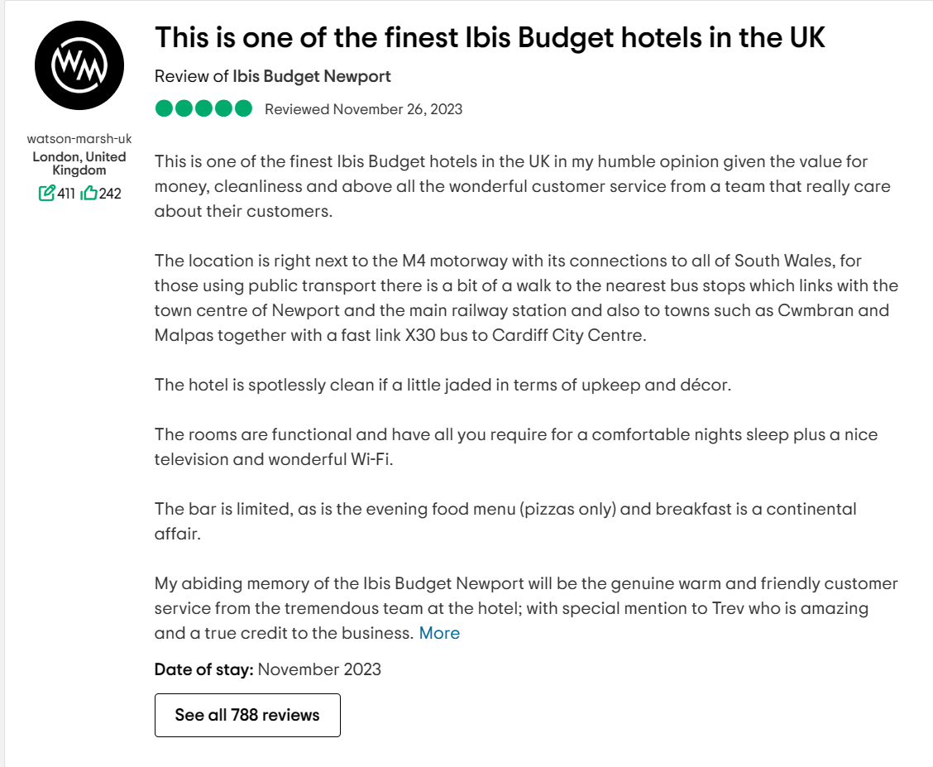
Letter of complaint response 500 words +/- 1-%
Mrs Joanna Blake Beatrice Gherasim
558 Longford Road, Front Desk
Swansea Ibis Budges Newport Hotel
SA1 2AR 164 Malpas Road,
Newport
NP20 5PP
12/02/2024

Dear Mrs Joanna Blake,

We would like to express our utmost gratitude for allowing us the opportunity to resolve the matter promptly. We extend our sincere apologies for the frustrating experience you encountered in Room 330 of our hotel . We highly appreciate your feedback and would like to assure you that your concerns are of utmost importance to us. Upon receipt of your complaint, our primary objective was to address each identified issue thoroughly and take appropriate corrective measures to prevent any recurrence. We would like to outline the steps we have taken and are currently undertaking to rectify the problems you have brought to our attention:

1. Room Cleanliness: We have conducted comprehensive training sessions for our housekeeping team, specifically addressing the challenges you experienced. Our focus has been to train them in meticulous room cleaning practices. Furthermore, we have conducted an extensive survey of all rooms, including room 330, and have implemented necessary corrections to our cleaning protocols.

2. Wi-Fi Service Our IT department has examined and enhanced our Wi-Fi network infrastructure for a more reliable connection. Technical glitches have been resolved and we are confident in the standard level of service.

3. Noise Levels: We're improving our noise control efforts to address the disturbances you mentioned. Our staff has been reoriented on the importance of tranquillity, and we've taken steps to mitigate noise in affected rooms to improve the guest experience.

4. Customer Service: We apologize for the poor service you received. We are reviewing our staff's behaviour and implementing communication and attentiveness training. Your feedback has initiated a customer-centric cultural shift.

Immediate Actions:
In recognition of the inconvenience caused during your stay, we have taken the following immediate actions:

1. Refund: You will receive a full refund for the inconvenience you experienced.
2. Personalized Apology: The staff members involved in your experience have personally extended their apologies.
3. Ongoing Monitoring: We are committed to continuously monitoring and following up to ensure sustained improvements.

Future Steps:
Moving forward, we have planned the following steps to enhance our services and create a better guest experience:

1. Guest Feedback Response Team: We will introduce a dedicated team to address guest concerns in real time.
2. Periodic Surveys: We will conduct regular surveys to gauge guest satisfaction and identify potential areas for improvement.
3. Collaboration with External Quality Assurance Agencies: We will collaborate with external quality assurance agencies to uphold a consistent standard of service.

We apologize for the inconvenience caused and will make necessary changes to ensure a delightful stay for all clients.
We would like to show our appreciation by offering you a complimentary two-day stay at our hotel. This will allow you to witness firsthand the positive changes we are implementing. To coordinate your future reservation, please contact our reservation department.
If you have any further inquiries or apprehensions, please feel free to reach out to us. We are eagerly looking forward to your return and aspire to provide you with an exceptional experience.

Yours sincerely,

Beatrice Gherasim
Front Desk
Ibis Budget Newport Hotel

Component Three:
Contribution to Overall Module Assessment: 50% (1000 words +/- 10%)
Writing in essay format

Introduction
The hotel front office serves as the gateway to guests' experience, and it demands more than just technical expertise. This essay focuses on four key skills that are vital for successful front office operation: customer service skills, communication, organisational skills, and problem-solving abilities. To put an accent on the practical knowledge of the core competencies, industry cases from actual life will be woven into the story (Tanković et al., 2021).

Key Skill 1 – Customer Service Skills

In the hospitality industry, providing excellent customer service is crucial to ensure guest satisfaction. A prime example of this is a well-known hotel chain, known for its exceptional quality of service such as Premier Inn. Every member of the staff, from the concierge to the housekeeping team, is committed to delivering top-notch service, resulting in a seamless and unforgettable experience for guests.

This hotel's key strength lies in its ability to empower its employees to not only meet but exceed customer expectations. The focus extends beyond transactional relationships, and the commitment to creating unique experiences becomes a reality. Every team member strives to understand the individual preferences and needs of their guests and anticipates their requirements proactively. This approach portrays the significance of superior customer service skills that can enhance a hotel's reputation and significantly boost overall guest satisfaction (Jawabreh et al., 2020).

The hotel's commitment to excellence has become a defining feature, leading to customer loyalty, positive reviews, and word-of-mouth recommendations. By emphasizing the value of service, this hotel has set the standard for the hospitality industry, demonstrating that caring for and attending to guests is at the core of a prosperous enterprise (Waqanimaravu and Arasanmi, 2020).

Key Skill 2 – Communication Skills

Effective communication is crucial for the smooth operation of any hotel, including Premier Inn. In the front office, communication skills are essential for a variety of tasks, such as handling customer inquiries, processing reservations, and managing staff schedules. Communication plays a crucial role in service encounters, influencing perceptions and shaping the overall customer experience (Tanković et al., 2021).
Premier Inn not only recognizes but also emphasizes the significance of clarity and empathy in communication as an essential part of responsible service. The staff members undergo rigorous training to communicate effectively, resolve issues efficiently, and provide superior service that exceeds guests' expectations (Lucas, 2020).
Here are some ways in which communication skills are essential for front-office operations at Premier Inn:

1. Customer service: It is crucial for the staff working at the front office to possess excellent communication skills to cater to the needs of guests efficiently and handle any problems that may arise promptly and effectively. This includes being able to listen actively, speak clearly and politely, and respond promptly to inquiries.
2. Reservation management: Front office staff must be able to communicate effectively with customers to process reservations, including taking bookings, confirming reservations, and handling cancellations or changes.
3. Staff management: It is imperative that the front office staff has the capability to effectively communicate with other staff members within the hotel, such as the managers, housekeeping, and maintenance personnel, to ensure the seamless and efficient functioning of the hotel.
4. Crisis management: In the event of an emergency, such as a power outage or a fire, it is crucial that front office staff effectively communicate with both hotel staff and guests to ensure the safety and well-being of all individuals present.
In the digital age, online communication cannot be underestimated. To interact with guests, respond promptly to inquiries, and demonstrate their consistency in customer service, the hotel strategically employs social media. In other words, this comprehensive perception of communication emphasizes the nuances of the skills required for seamless front-office operations, confirming that communication is not just a tool but also the essence of a complete and superior guest experience (Huang et al., 2021).

Key Skill 3 – Organisational Skills

Organisational abilities overcome any barrier between the smooth running of a front office and the dynamism of the hotel business. The organisational skills needed for efficient booking management, coordinating with the other departments, and working on multiple tasks are quite detailed. In hospitality, no organisational effectiveness is only advantageous but critical for achieving effectiveness in operations (Chawla, 2020).
Premier Inn stands as a symbol of organisational efficiency in the hospitality industry. The hotel shows such commitment by investing in sustained training programs that improve the organisational skills of its front office staff. This loyalty is exemplified through the seamless check-in and check-out processes, consistent and efficient inventory management, and standardized hotel operations across all the chain's properties around the world (Ali et al., 2021).
Besides ordinary activities, organisational skills are necessary in crisis management.
The company has a well-defined structure, and standardized procedures, and uses technology and automation to streamline its operations. Premier Inn places a strong emphasis on employee development, regularly reviews and updates its processes and procedures to stay ahead of the competition, and has a customer-centric approach to its operations. The company also works closely with partners and has a robust performance measurement and monitoring system in place. In uncertain challenges, the ability to adapt and organizational agility becomes critical, which makes the role of organizational competencies a pillar of success in the dynamic hotel industry (Olimovich et al., 2020).

Key Skill 4 – Problem-Solving Skills

One luxury hotel chain that stands out for its proactive approach to problem-solving is The Ritz-Carlton. In the hospitality industry, the role of problem-solving skills in the process of service recovery is extremely important (Huang et al., 2021). Known for its exceptional service and attention to detail, The Ritz-Carlton has a reputation for going above and beyond to address guest needs and resolve issues swiftly.

Here's how The Ritz-Carlton demonstrates proactive problem-solving:

1. *Anticipating Guest Needs*: At The Ritz-Carlton, the staff is trained to anticipate guest preferences and needs. They pay attention to details such as room temperature, amenities, and dietary restrictions, creating a personalized experience for guests. (The Ritz-Carlton, 2024).

2. *Empowered Employees*: At the Ritz-Carlton, employees are empowered to resolve guest issues on the spot, without needing to escalate to a manager, ensuring quick and efficient solutions. (The Ritz-Carlton, 2024).

3. *Service Recovery*: The Ritz-Carlton follows a service recovery process when a guest encounters an issue. They apologize sincerely, listen actively, and take immediate action to rectify the situation. (The Ritz-Carlton, 2024).

4. *Learning from Mistakes*: Ritz-Carlton sees mistakes as chances to improve. They hold regular "lineup" meetings where employees share service excellence stories and discuss challenges faced. This learning helps prevent similar issues in the future. (The Ritz-Carlton, 2024).

5. *Personalized Solutions*: The Ritz-Carlton offers tailored solutions to guests, such as room changes or noise-cancelling headphones, based on individual needs. This personalized approach prioritizes guest satisfaction. (The Ritz-Carlton,2024).

Reference List

Adeani, I.S., Febriani, R.B. and Syafryadin, S (2020) Using GIBBS’reflective cycle in making reflections of literary analysis. Indonesian EFL Journal, 6(2), pp.139-148.
Ali, Bayad Jamal, Bayar Gardi, Baban Jabbar Othman, Shahla Ali Ahmed, Nechirwan Burhan Ismael, Pshdar Abdalla Hamza, Hassan Mahmood Aziz, Bawan Yassin Sabir, Sarhang Sorguli, and Govand Anwar. "Hotel service quality: The impact of service quality on customer satisfaction in hospitality." Ali, BJ, Gardi, B., Othman, BJ, Ahmed, SA, Ismael, NB, Hamza, PA, Aziz, HM, Sabir, BY, Anwar, G (2021) Hotel Service Quality: The Impact of Service Quality on Customer Satisfaction in Hospitality. International Journal of Engineering, Business and Management 5, no. 3 (2021): 14-28.
all.accor.com. (2024). Ibis Budget Newport | Affordable Hotel in Newport - ALL. [online] Available at: https://all.accor.com/hotel/6814/index.en.shtml [Accessed 5 Feb. 2024].
Booking.com (2024). ibis budget Newport. [online] Booking.com. Available at: https://www.booking.com/hotel/gb/ibis-budget-in-newport.en-gb.html [Accessed 5 Feb. 2024].
Chawla, S (2021) Factors affecting employee retention strategies hospitality sector. Turkish Journal of Computer and Mathematics Education (TURCOMAT), 12(10), pp.1861-1872.
Fang, J. and Partovi, F.Y (2022) Technology planning in the hotel industry. Tourism Management Perspectives, 44, p.101018.
Huang, A.Y., Fisher, T., Ding, H. and Guo, Z (2021) A network analysis of cross-occupational skill transferability for the hospitality industry. International Journal of Contemporary Hospitality Management, 33(12), pp.4215-4236.
Ibis Budget Newport (2023). User reviews Ibis Budget Newport, Newport- TripAdvisor.co.uk. [online] Available at: https://www.tripadvisor.co.uk/ShowUserReviews-g186463-d1143659-r927503476-Ibis_Budget_Newport-Newport_South_Wales_Wales.html [Accessed 10/02/2024].
Jawabreh, O., Mahmoud, R. and Hamasha, S.A (2020) Factors influencing the employee's service performances in hospitality industry case study AQBA five stars hotel. Geo Journal of Tourism and Geosites, 29(2), pp.649-661.
Lucas, R., 2022. Customer service. McGraw-Hill US Higher Ed USE.
Ngoepe, L.L (2021) Hotel employability of hospitality graduates from private academic institutions (Doctoral dissertation, University of Johannesburg).
Olimovich, D.I., Bakhtiyorovich, T.M. and Salimovna, N.G (2020) Improving personnel training in the hotel business. Academy, (2 (53)), pp.18-19.
Padma, P. and Ahn, J (2020) Guest satisfaction & dissatisfaction in luxury hotels: An application of big data. International Journal of Hospitality Management, 84, p.102318.
Rabiul, M.K., Shamsudin, F.M., Yean, T.F. and Patwary, A.K (2023) Linking leadership styles to communication competency and work engagement: evidence from the hotel industry. Journal of Hospitality and Tourism Insights, 6(2), pp.425-446.
Ritz-Carlton (2024). About us [online] Available at: https://www.ritzcarlton.com/en/about-the-ritz-carlton/our-legacy/ [Accessed 18/02/2024].
Simkus, V., Rhodes, B. and Gutmann, M.U (2023) Variational Gibbs inference for statistical model estimation from incomplete data. Journal of Machine Learning Research, 24(196), pp.1-72.
Tanković, A.C., Kapeš, J. and Kraljić, V (2021) Importance of soft skills and communication skills in tourism: Viewpoint from tourists and future tourism employees. Tourism in Southern and Eastern Europe..., 6, pp.167-185.
Waqanimaravu, M. and Arasanmi, C.N (2020) Employee training and service quality in the hospitality industry. Journal of Foodservice Business Research, 23(3), pp.216-227.
Yang, H., Cheung, C. and Li, W (2022) Intercultural communication competency practices in the hotel industry. Journal of China Tourism Research, 18(1), pp.162-184.

