Downloading SPSS and/or NVIVO software

SPSS is a widely used program for statistical analysis in social science. It is also used by market researchers, health researchers, survey companies, government, education researchers, marketing organizations, data miners,^{[2]} and others.
https://en.wikipedia.org/wiki/SPSS
NVivo is a qualitative data analysis (QDA) computer software package produced by QSR International. It has been designed for qualitative researchers working with very rich text-based and/or multimedia information, where deep levels of analysis on small or large volumes of data are required.
https://en.wikipedia.org/wiki/NVivo

To download a University provided copy of either SPSS or NVivo for personal use and to get your Licence Key sent to you use the following instructions.

Download a University copy of SPSS
You can choose either option 1 or option 2
- Option 1 – Get help from IT technicians.
Call them on this number - 0300 500 5050
Tell them you need them to install SPSS remotely onto your laptop.
OR
- Option 2 – Do it yourself - Instructions below
First go to the UWTSD - Quick links – Select IT Service Desk (University Help Form and login with your student id and password https://webhelp.uwtsd.ac.uk )
- Enter Request for Software and Drivers and select either SPSS or NVivo
- Choose ‘Carmarthen’ as your Location
- Then click Save
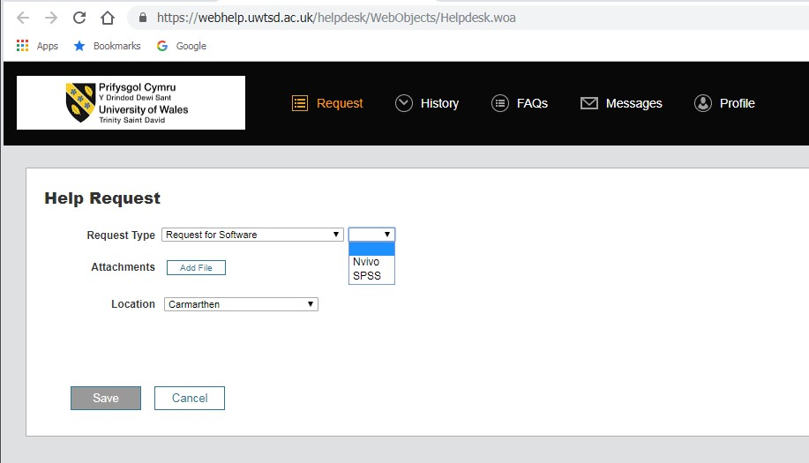
You will be given this Licence agreement form
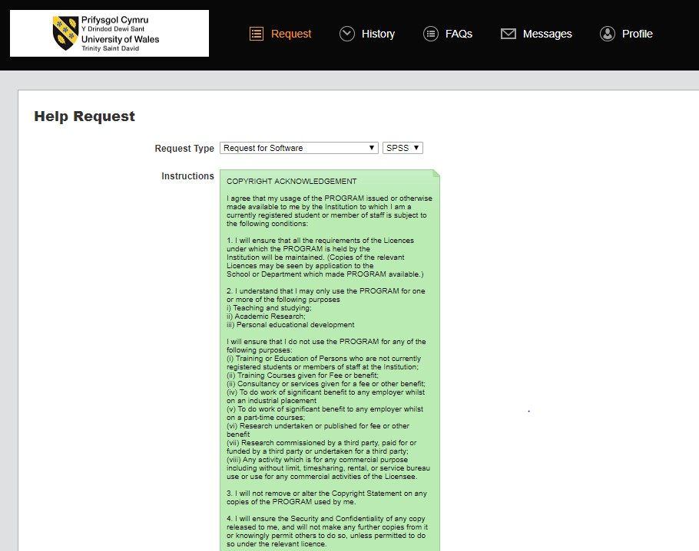
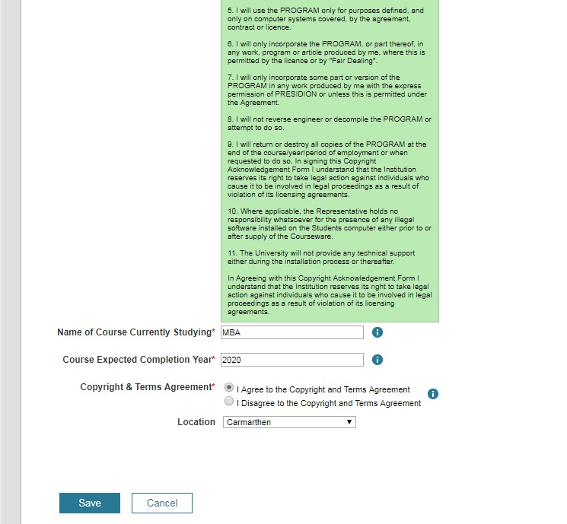

- Enter your course name ‘BA’
- The end date for your course (2022 in cae you intend to use the software of your level 6 Dissertation).
- Location is Carmarthen
- You must also agree to the Terms and Conditions. Note: There is no fee for the licence for you. Click Save

You will then receive a Thank you which should look like this
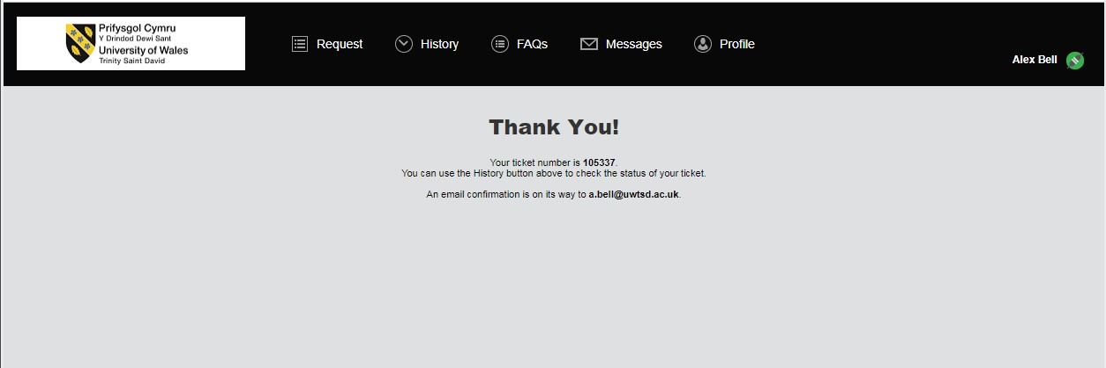

Quite shortly after this you will receive an email to your student email account.
The email will have links to where you can download the software depending on the type of personal computer/operating system you are using.
This email also contains the licence key which you will enter when you install the software
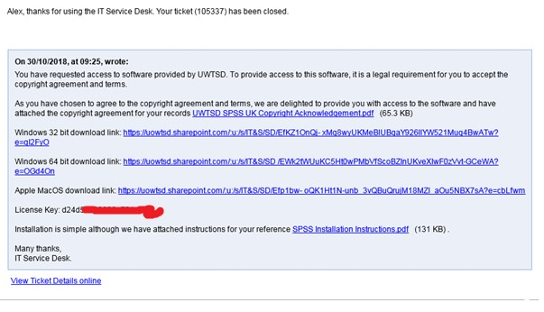
If you need any further help go to the https://webhelp.uwtsd.ac.uk
And request support.

