Jasmine Chelsea Lynette Thomas
Critique on Airbnb
Student Number: 1902630
BMSP6006
Lecturer: Dr. Roisin Mullins

Index
Introduction ………………………………………………………………3
Airbnb’s Landscape………………………………………………………3,4
Airbnb’s Business Model Canvas (BMC)…………………………….4,5,6,7
Strategy-formulation analytical framework (SFF)……………………...8
Grand Strategy Matrix……………………………………………………9,10
Enterprise Resource Planning (ERP)…………………………………….10
Customer Relationship Management (CRM)……………………………10
Supply Chain Management (SCM)…………………………………….10,11
Conclusion………………………………………………………………….11
Reference list……………………………………………………………….12

Introduction
Airbnb is an online marketplace, which allows travelers to book out a seller’s accommodation for a short period of time. Airbnb was created in 2008 when two designers (Brian Chesky and Joe Gebbia) shared their space with three travelers who were looking for a place to stay (Airbnb, Inc.2022). Airbnb offers great deals for cost-efficient alternative to traditional hotel bookings, by targeting a user interface to narrow down a tourist traveling preferences. While guests are finding a preferred accommodation, they are reminded to sign up for a membership that provides an access to contact the hosts directly. As soon as the booking has been confirmed, the host will receive a payment from the guest and Airbnb will take a 3% transaction fee (Steve Wu, Frank Lee, Jeremy Reynard, (2012) UCLA, pp2). It’s obvious that Airbnb has soar to be a successful online accommodation marketplace whilst disrupting the hotel industry on its course.
This report will include a critique examining Airbnb as an example of the sharing economy, and will evaluate Airbnb’s business model, financial landscape, Peer-to-Peer market forces, target groups, problems, strategy, current situation, challenges and suggest recommendations for future growth. To help with this report two sources will be used to aid the critique of Airbnb, one source authored by Steve Wu, Frank Lee and Jeremy Reynard (2012) UCLA and the second source authored by LUQI LI and TABARI, Saloomeh (2019).
Airbnb’s Landscape
It is important to note that the previous year travel came to a standstill when governments were creating travel restrictions to reduce the spread of the virus Covid-19. In addition, Airbnb was significantly impacted by the virus, therefore Airbnb’s financial results of 2021 will be compared to 2019’s financial results. As time has passed more people have been vaccinated and following vaccinations certain travel restrictions have been also lifted, increasing global demand and supply expeditiously. Airbnb’s revenue in 2020 was $335 million, however in 2021 Airbnb’s revenue has raised to an outstanding $1.3 billion, meaning that revenue growth has raised from 5% in the first quarter of 2021 to 10% in the second quarter of 2021 (Airbnb, August 12, 2021)
Airbnb are currently facing a few challenges such as Coronavirus concerns, profit problems, and rebuilding trust. As the new variant of Coronavirus (Omicron) continues to spread, Airbnb are challenged to convince and persuade their customers that the rentals hosted are safe to stay. Although in May 2021, Airbnb implemented new cleaning protocols that were influenced and developed by U.S. surgeon General Dr. Vivek Murthy and other experts within the medical hygiene and hospitality sector. Airbnb has updated the app to show which hosts follow the new cleaning protocols, to assure guests they are safe when staying with hosts within Airbnb. However, the company’s eagerness to persuade customers otherwise might not be enough compared to the efforts and money big hotel chains are spending to convince tourists that their facilities are virus safe. Although hotels have been slacking in following their own hygiene standards which is due to reduced staffing because of the impact of the virus, hotels are better at assuring customers.
The second challenge Airbnb is currently facing are profit problems. With the pandemic hitting 2020 Airbnb revenue in 2020 of 3.4B (billion) was a decrease of 29.70% compared to 2019 financial year which was only before the coronavirus had hit internationally. Net income had fallen from 579.88% to a staggering -4.6B (NASDAQ: ABNB,2021). Due to the Coronavirus Airbnb have suffered financially, a reason for this specifically is travelers are travelling less to avoid becoming affected by the virus.
Rebuilding trust is another challenge Airbnb face, in other words the company have had a few incidents, which has led to guests and hosts feeling upset with the company. In the previous year Airbnb struggled to control unauthorized parties, with two leading to a live shooting. Guests have also found themselves being scammed from their deposits because of fraudulent listings on the site. Airbnb created a refund scheme on December 15th (Airbnb.inc,2022) for guests when they need to cancel their stay because of the pandemic. Although the refund scheme was created to help guests mainly and hosts, the scheme ended making most guests and hosts upset. The reason behind guests and hosts being upset was because guests found the refund process difficult and complicated to use, while hosts figured that the company was doing enough of their ability to compensate all hosts for their lost income.
Airbnb’s Business Model Canvas (BMC)
Diagram one below presents Airbnb’s BMC. A business model introduces the logic of how a business intends on making a profit through nine building blocks. A business model is like a blueprint for a strategy to be implemented through organizational structures, processes, and systems. The nine building segments are included below, beginning with Key Partners. Key partners are the network of suppliers and partners outside the organization that make the business model work (Alexander Osterwalder and Yves Pigneur (2012)), as seen below Airbnb’s Key Partners include:
- Hosts who provide properties and information. Investors who help shape and formulate structure of the business. Insurance Companies which keeps properties secure from damage. Professional Photographers that help advertise properties. And lastly Government and Tourism agencies that enables the company to work with local authorities and tourism agencies.
Key activities are another building block that includes problem solving (Alexander Osterwalder and Yves Pigneur (2012)). As shown in diagram One below key activities for Airbnb include:
- Platform Development which ensures members of Airbnb can access the website or app without technical difficulties. Sales and Marketing expands the number of hosts and guests. Managing bad behaviors and risks which is improving rules and promoting positive behavior between hosts and guests. Protect Sensitive Information in order to keep members information private. And lastly maintaining customer service for the sake of fulfilling a delivery of a promises towards guests toa void bad reviews.
Value Proposition seeks to solve customers problems and satisfy their wants and needs, this is the reason why customers go to the business in order to receive the benefits offered by the business (Alexander Osterwalder and Yves Pigneur (2012)). The Value proposition for Airbnb includes two sections one for hosts and guests:
Hosts:
- Simple and secure to publish which means making it an easy process for hosts to list any property on the app. Making extra money by renting out spaces to tourists. Hosts are their own boss as they can control availability of dates, pricing, and property rules. Provided Home Insurance by Airbnb to cover damages or accidents. Communication is made easy amongst guests and hosts. And finally, Self-Check-In as hosts can send simple instructions on how to enter the property to the guests through e-mail or message.
Guests:
- Money Saving as Airbnb is great value for money. Easy booking process because guests can find nearly over seven million listings in 100,000 cities for 200 countries. Able to choose listings that includes preferences such as spacious properties for big groups, kitchens, pools, washing rooms. Unique experiences for guests as they don’t have to stay in one same hotel room. Ultimately safety checks on hosts and guests to make both feel safe while staying or listing their space.
Key resources can be physical, financial, intellectual, or human, however they are an asset that is required to offer and deliver (Alexander Osterwalder and Yves Pigneur (2012)). Diagram one includes the Key Resources of Airbnb below:
- Airbnb website and app. Employees such as software engineers, analytic data scientists, marketers, and advertisers. And lastly, the millions of listed properties.
Customer Relationship are established and maintained with each customer segment (Alexander Osterwalder and Yves Pigneur (2012)). Diagram one includes the Customer Relationship of Airbnb below:
- Self-Serving Platform is the company’s website and app that’s the main tool for customers to access the service. Personalized Recommendations are what Airbnb provides to customers in order to advertise relevant and preferred listings for guests. Finally, is Customer Service Support, Airbnb provide customers services and support for guests to help resolve any issues that come up during a guest stay.
Channels are the value propositions that are delivered to customers through communication, distribution and sale channels (Alexander Osterwalder and Yves Pigneur (2012)). Diagram one below includes Airbnb’s channels which are:
- Airbnb’s website and app which is the company’s main channel to deliver its services to members. Content marketing, media coverage, and digital ad campaigns are all channels that help drive hosts and guests that are alike to the Airbnb platform.
Airbnb’s Customers are simply Hosts and Guests.
Cost structure is the most important costs incurred while operating the business (Alexander Osterwalder and Yves Pigneur (2012)). For Airbnb cost structures include:
- Platform Development and Maintenance Cost
- Infrastructure Cost
- Sales and Marketing cost
- Advertisement Cost
- Insurance Cost
- Customer Acquisition Cost
- Employee Salary Cost
- Legal and Administrative Cost
- Regulatory Cost
To conclude Airbnb’s BCM is Revenue streams which is the result for value proposition successfully offered to customers and the cash Airbnb generates from each customer segment (Alexander Osterwalder and Yves Pigneur (2012)). Revenue Streams is included in diagram one Below:
- Host Fee – Hosts are charged a fee by Airbnb for listing a property, and there is a 20% service fee on hosts that offer guests experience.
- Travelers Fees – A fee that travelers are required to pay in order to use the Airbnb platform which includes reservation fees, cleaning fees, and service fees.

Diagram One: Airbnb’s BMC

Strategy-formulation analytical framework (SFF)
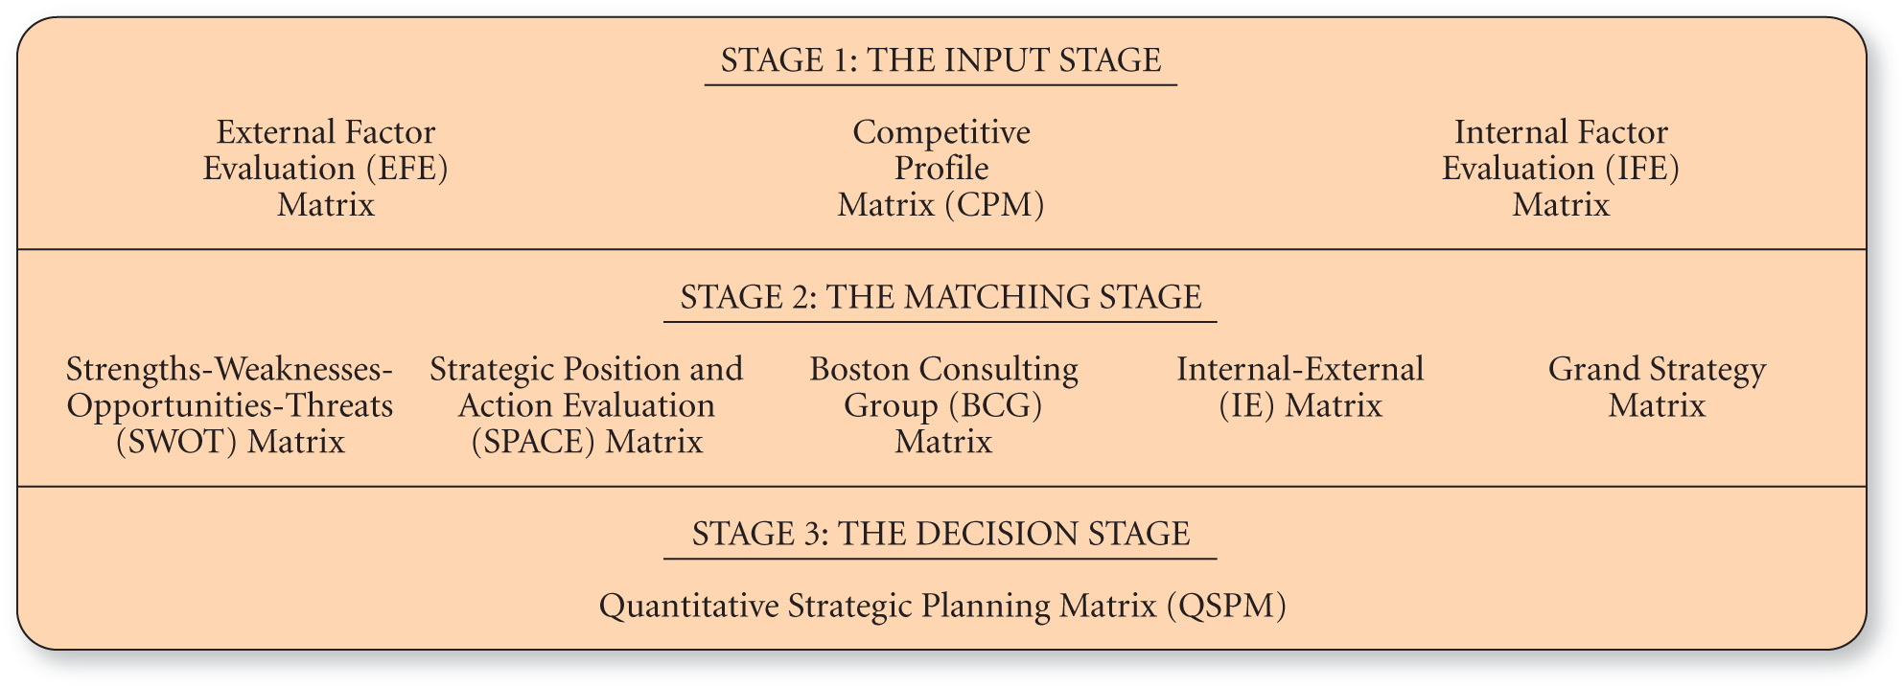
Diagram Two: The Strategy-Formulation Analytical Framework

The diagram above is the strategy-formulation analytical framework (SFF). SFF is simply a decision-making framework for businesses. The tools used within the diagram are all useful to any size business, including Airbnb. The framework helps strategists within organizations to identify, evaluate, and select strategies that might help the business grow.
The first stage of SFF is the input stage, which includes both EFE (External factor evaluation) which is a PESTLE but with quantitative scale, and IFE (Internal Factor Evaluation) which is a SWOT with the quantitative scale.
The second stage of SFF is the matching stage. The matching stage focuses on generating an achievable alternative strategy through aligning external and internal factors. The matching stage consists of SWOT matrix (strengths, weaknesses, opportunities, and threats), SPACE matrix (Strategic position and action evaluation, BCG matrix ( Boston Consulting Group), IE matrix (Internal and External, and lastly the GS matrix ( Grand strategy).
The third stage is called the decision-making stage, this stage includes one technique which is QSPM (Quantitative Strategic Planning Matrix). This technique uses the information from stage one to evaluate the achievable strategies identified within stage two. A QSPM features the relative aesthetics of the alternative strategies and provide an objective to select a specific strategy.
The strategy that will be used to apply to Airbnb will be the Grand Strategy Matrix. The grand strategy matrix is made from a graph with four quadrants as seen below in diagram three.

Grand Strategy Matrix
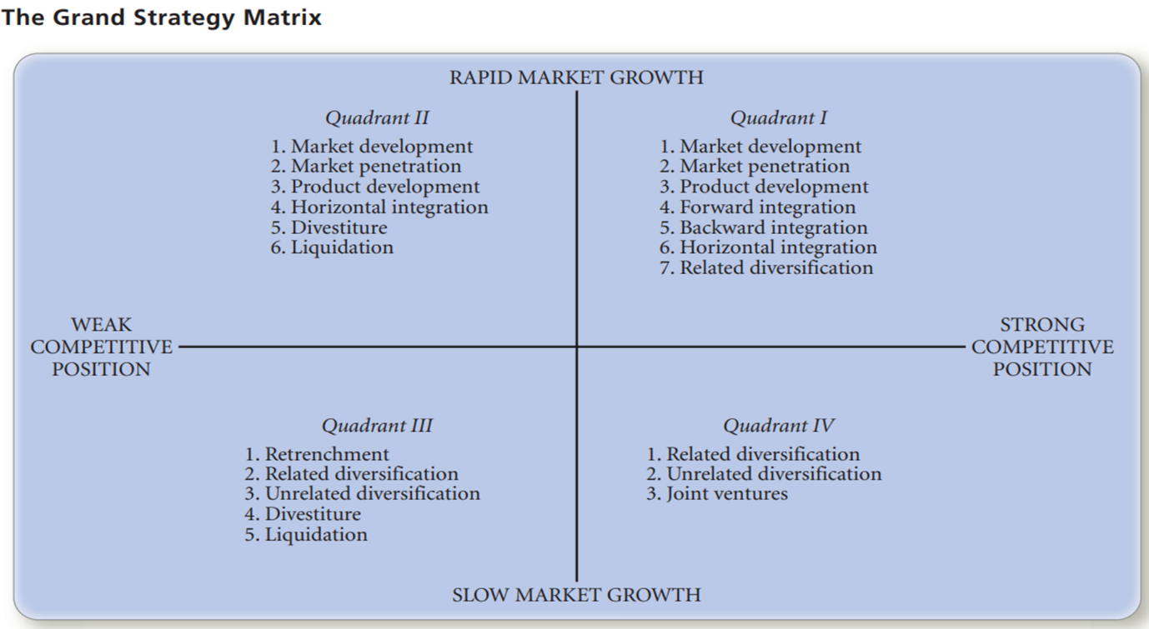
Diagram Three: Grand strategy Matrix

The x-axis represents competitive position with the lest side of the matrix demonstrating weak competitive position, and the right side of the x-axis showing the strong competitive position. The y-axis represents market growth, with the top part demonstrating rapid market growth and the lower part of the y-axis demonstrating the slow market growth.


Diagram Four: Airbnb in the Grand Strategy Matrix
WEAK COMPETITIVE POSITION
SLOW MARKET GROWTH
STRONG COMPETITIVE POSITION
RAPID MARKET GROWTH

Airbnb has a strong position on the grand strategy matrix with the company being between the rapid market growth and strong competitive position. The reason on why Airbnb have been positioned on the top right of diagram four is because the company has a strong competitive position within a rapid growth industry because it is a market leader and offers competitive advantages in it’s brand recognition, easy use, extensive listings, and network effects.
Enterprise Resource Planning (ERP)
ERP is a business process management software that manages and integrates a company’s financials, supply chain, operations, commerce, reporting, manufacturing, and human resource activities. ERP combines all of them together into a single integrated software program that is ran off a single database, therefore different departments can easily share information and communicate with one another. Airbnb can be seen to use ERP system as applications include inventory, invoicing, and analyzing data from customers. Cloud computing allows companies to free up storage and resources, as the company has a third party hosting the system or software needed to do business over the Internet, which applies to Airbnb as they are not only dependent on the internet to run their business, however they also use Amazon Cloud Services where the ERP modules are housed.
Customer Relationship Management (CRM)
CRM is defined by Chaffey (2007) as an approach to build and sustain long-term business with customers. CRM is a system that helps businesses to manage all interactions they have between existing customers and potential future customers. CRM involves using an organizations website for customer development, managing email quality list, applying email marketing, data mining to improve targeting, providing online customer service and personalized web recommendations. Airbnb heavily rely on their CRM, for example when a customer fills out a booking enquiry on their app or website, the information gets stored into Airbnb’s CRM system. Another example of Airbnb relying on their CRM system is when guests book a listing, the data needs to be captured and stored safely to make available to hosts and departments. CRM is also used to process all the financial transactions, refunds, and adjustments made between the company and customers.
Supply Chain Management (SCM)
Supply chain management is the centralized management of the flow of goods and services through suppliers to manufacturers to distributors to final customers. SCM can provide great opportunities to improve product performance and deliver superior value to customers. SCM can have an impact on profitability by reducing operating costs and increasing customer satisfaction and, therefore, company revenues. SCM includes an upstream and downstream supply chain, as well as an internal supply chain.
Upstream supply chain:
- Consists of all activities that are related to the organization suppliers.
Downstream supply chain:
- Refers to activities post-manufacturing, namely distributing the product to the final customer.
Internal supply chain:
- An internal process for transforming the inputs from the suppliers into the outputs.
Airbnb uses SCM as it’s a system that helps manage relationship with their suppliers. The organizations website and app standardize the booking process and handles financial transactions between guests and hosts.
Conclusion
Looking back on the critique it’s obvious that Airbnb has soar to be a successful online accommodation marketplace whilst disrupting the hotel industry on its course. However, there is always room for improvement and Airbnb have a few improvements to make for the organization future growth. Due to the impact of Coronavirus, Airbnb should create a new policy for hosts to guarantee that if their establishment is not following cleaning protocols, the host should have a two week ban from hosting therefore hosts are given an ultimatum to either decide to follow protocols and show evidence or to take down their listing off the Airbnb site. This will also solve Airbnb’s profit problems as customers might feel more comfortable to use the listings within Airbnb. Airbnb also need to simplify their refund process for guests with the intention of satisfying their needs and find a way to compensate hosts.
Other than those challenges Airbnb should keep doing what they are doing currently as they are placed on the best part of the GSM and should aim to stay there for future growth and success.

Reference
Airbnb, (2021), Airbnb second quarter 2021 financial results
Alexander Osterwalder and Yves Pigneur (2012) Business model generation.com: A handbook for visionaries, game changers and challenges
Fortune, (2020), Airbnb 3 biggest challenges on its road to an IPO, Danielle Abril.
LUQI LI and TABARI, Saloomeh (2019).
NASDAQ, ABNB, (2021), Airbnb.inc
Steve Wu, Frank Lee and Jeremy Reynard (2012) UCLA

