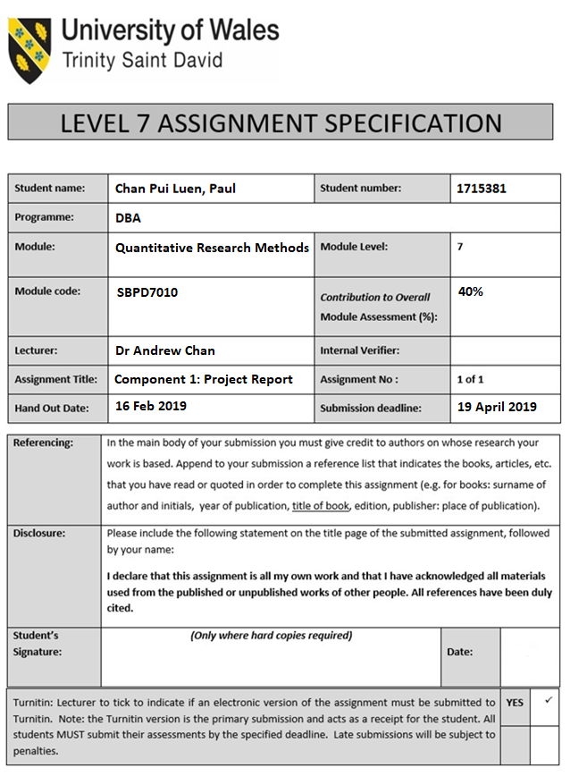



Module:
Quantitative Research Methods (SBPD7010)

Lecturer: Dr Andrew Chan

Component 1: Project Report
Develop a Survey Instrument and Research Strategy of Employee Job Satisfaction and Job Performance in Banking in Hong Kong

by

Student Name: Chan Pui Luen, Paul
Student Number: 1715381

19 April 2019

Table of Contents Page
Introduction ………………………………………………………………………... 4
The Literature Review ………………………………………………………... 4
The Conceptualisation ………………………………………………………... 5
The Hypotheses Development ………………………………………………… 6
The Research Methodology ………………………………………………………… 7
The Scale Development ………………………………………………………… 7
The Data Collection and Sampling Analysis ………………………………………… 8
The Data Analysis ………………………………………………………………… 9
The Findings ………………………………………………………………………… 9
The SPSS Results ………………………………………………………………… 9
Discussion and Conclusions ………………………………………………………… 13
References ………………………………………………………………………… 14
Appendix ………………………………………………………………………… 16

Introduction
The purpose of this project paper is for the University of Wales Trinity Saint David DBA Quantitative Research Methods module (SBPD7010) to use the quantitative research methods to develop a survey instrument and research strategy to test hypothesis to recognize the direct relationship between the employee job satisfaction and the employee’s job performance in Hong Kong banking industry. The writer uses his currently working company for this research study. This company is one of the Hong Kong local renowned banks (‘the Bank’) established in 1947 and it is a listed company in Hong Kong. The Bank has around 1,700 employees and their operations are primary based in Hong Kong. The writer is the Department Head of Operations Support Department of Operations Division in the Bank. He would like to determine each of the job satisfaction factors of the employee job satisfaction are impact on the employee productivity. It is because the writer is facing his staff job satisfaction to impact on the staff job performance and resulted in staff retention. The banking industry is facing the same situation as well in Hong Kong.
The objectives of the research:
- To determine the job satisfaction factors of the employee job satisfaction are impact the employee’s job performance in banking in Hong Kong;
- To define the correlational relationship of the employee job performance by the influence of each job satisfaction factor of the employee job satisfaction in banking in Hong Kong.

The Literature Review
The literature review on the topic of employee job satisfaction and employee’s job performance. The relationship between employee job satisfaction and employee’s job performance is including the job satisfaction factors are Salary & Incentives, Staff Benefit, Training & Development, Social Support, Leadership Influence, Communications and Empowerment. Those factors are impact on the employee productivity and the resulted in job satisfaction and job retention.
The factors of employee job satisfaction factors are applied by the classical management motivation theories like Maslow’s Hierarchy of Needs, The Two-factor Theory of Motivation and the Motivational Theory of Theory X and Theory Y …etc. The employee’s performance measurement refers to the management strategy in the Balanced Scorecard that there have four perspectives proposed includes: Financial perspective, Customer perspective, Internal business processes perspective and Learning and growth perspective (Kaplan et al., 1992; Kopia et al., 2017) or Peter Drucker (1954) introduced the Management by Objectives process to measure the efficiency and the relationship between employee job satisfaction, employee motivation and employee’s performance to see the result on staff retention in the organisation.
The research study is studied the employee job satisfaction factors are recommended from the classical management motivation theories: Maslow’s Hierarchy of Needs that related to the level of effort made by someone to pursue a goal, the employee motivation is closely related to job satisfaction and employee’s performance. (Maslow, 1943) and the Two-Factor Theory of Motivation that the theory found that job satisfaction and job dissatisfaction are act independently on each other. (Herzberg, Mausner & Snyderman, 1959)
The value of the research is the relationship between employee job satisfaction and employee’s job performance that the job satisfaction factors have a positive impact on employee’s job performance as well as organisation’s performance. The increase of the level of the job satisfactory factors drive to increases the productivity as well as on staff retention for the organisations. (Alnasrallah, 2016; Bernanthos, 2018; Dartey-Baah, 2010; Springer, 2011) The employee’s performance and employee job satisfaction are related to the organisation’s performance and the organisation’s strategy management in visions, strategies and objectives.
The research studies have been done in many areas as above-mentioned. There may have not been done in those researches. In the area of the employee job satisfaction and the employee’s job performance research for the banking industry in Hong Kong over the last ten years. The analysis compares the impact of the employee’s job performance by each of the job satisfaction factors (Salary & Incentives, Staff Benefit, Training & Development, Social Support, Leadership Influence, Communications and Empowerment) in resulted on employee job satisfaction for the Bank.

The Conceptualisation
The literature shows the employee job satisfaction to impact on the employee’s job performance positively. The employee job satisfaction factors are introduced into Salary & Incentives, Staff Benefit, Training & Development, Social Support, Leadership Influence, Communications and Empowerment. Those factors are employee job satisfaction to impact on the employee productivity and the resulted in job retention.
This research study introduced the Framework of Job Satisfaction Factors and Employee’s job Performance (Figure 1). The framework based on the relationship between employee job satisfaction and employee’s job performance is including the job satisfaction factors: Salary & Incentives, Staff Benefit, Training & Development, Social Support, Leadership Influence, Communications and Empowerment for the organisation.
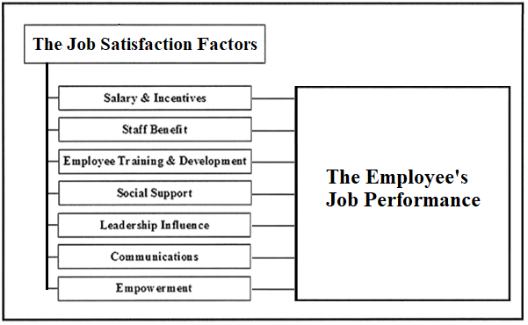
Figure 1. The Framework of Employee Job Satisfaction and Employee’s Job Performance

The Hypotheses Development
The purpose of this study was to perform a quantitative research to exam the relationships on employee job satisfaction and employee’s job performance in banking in Hong Kong. To determine the employee job satisfaction has a positive impact on the employee’s job performance in banking. And to define the correlational relationship of the employee’s job performance by influence on each job satisfaction factor of the employee job satisfaction in banking. There were addressed the research questions and their null and alternative hypotheses as below:
Questions 1. What is the relationship between the employee job satisfaction are impact the employee’s job performance in banking?
Ho: The null hypothesis is that there is no relationship employee job satisfaction and employee’s job performance in banking.
Ha: There is a positive relationship between employee job satisfaction and employee’s job performance in banking.
Questions 2. What is the relationship of the employee’s job performance by the influence on each job satisfaction factor of the employee job satisfaction in banking?
Ho: The null hypothesis is that there is no relationship of employee’s job performance by the influence on each job satisfaction factor of the employee job satisfaction in banking.
Ha: There is a positive relationship of employee’s job performance by the influence on each job satisfaction factor of the employee job satisfaction in banking.

The Research Methodology
This quantitative research study has conducted the correlational research. The correlation method is appropriate when the study is trying to determine more than one dependent variable using to predict one independent variable. Therefore, this method can use in this study to establish the variable of the job satisfaction factors could predict the employee’s job performance. The related correlation techniques like Pearson (Crossman & Abou-Zaki, 2003; Latham & Pinder, 2005) utilized in this study. This study was using the Job Satisfaction Survey data to apply by SPSS for the descriptive statistic, the inferential statistic and the correlation quantitative research analysis. This research studies the effect of the employee job satisfaction on the employee’s job performance in banking in Hong Kong.

The Scale Development
The job satisfaction instrument introduced by Paul Spector in 1994 and used the instrument to measure the employee job satisfaction. Pay, Promotion, Supervision, Fringe benefit contingent rewards, Operating procedures, Co-workers, Nature of work and Communication are the nine factors to access the employee attitudes and aspects about their job. The instrument produces a total score based on average score of all questions’ ratings. The greater job satisfaction indicates the higher scores are on the measurement. And this instrument has been repeatedly investigated for reliability and validity. (Spector, 1994; Springer, 2010)
This research study based on the questions of job satisfaction instrument by Paul Spector in 1994 to develop a new job satisfaction instrument (Appendix). This instrument scale is comprised of 21 questions are based on seven job satisfaction factors: Salary & Incentives, Staff Benefit, Training & Development, Social Support, Leadership Influence, Communications and Empowerment. All responses were made using 6-point Likert-type scale, from 1 is Very strongly disagree to 6 is Very strongly agree.
The following is the new job satisfaction instrument introduced by seven job satisfaction factors and each factor has three related questions. There have 21 questions on job satisfaction scale in this instrument (Figure 2).

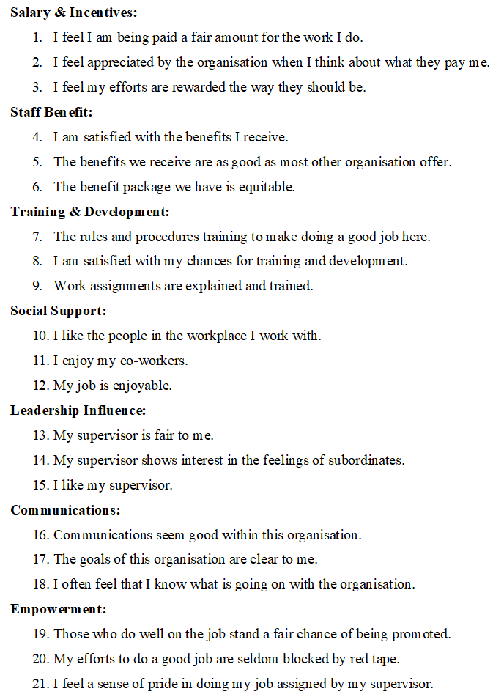
Figure 2. The Job Satisfaction Instrument Questions for each Job Satisfaction Factor

The Data Collection and Sampling Analysis
This study data collection was from the Bank employees and the Bank has around 1,700 employees. The pilot test measured the Bank’s employees to conduct the questionnaire. This was a convenience sample of 20 Bank employees to complete the questionnaire. The respondents pilot test data collected from the Job Satisfaction Survey through Google forms. The respondents were from the Bank in different job levels are Clerk & Senior Clerk, Officer & Senior Officer, Assistant Manager and Manager or above. The demographic information are the gender, age, education background, number of working experience years and job level are the data to study the level of impact on employee’s job performance by the employee job satisfaction (Appendix).

The Data Analysis
The data analysis was from the job satisfaction scale from the Job Satisfaction Survey Part B, the job satisfaction factors classified into seven factors and refer to the Framework of Employee Job Satisfaction and Employee’s Job Performance to explore a phenomenon. Those job satisfaction factors are including Salary & Incentives, Staff Benefit, Training & Development, Social Support, Leadership Influence, Communications and Empowerment. The research data analysis in this study was using the job satisfaction questionnaire data to apply by SPSS for the descriptive statistic, the inferential statistic and the correlation quantitative research analysis. The different job satisfaction factors have a different level of positive impact on the employee’s job performance.

The Findings
The findings are come from analysing data in the research study data to apply by SPSS for the descriptive statistic, the inferential statistic and the correlation quantitative research analysis.

The SPSS Results
Pilot Test Questionnaire Respondent Characteristics (n=20)
 | Value
Respondent gender, Number (%)
Male | 10 (50%)
Female | 10 (50%)
Respondent age, Mean (SD) [Min, Max] | 34.85 (8.536) [24, 56]
Respondent education background, Number (%)
High school or Diploma | 10 (50%)
Degree or above | 10 (50%)
Working experience in banking (year), Mean (SD) | 10.2 (7.1256)
Current job level, Number (%)
Clerk or Senior Clerk | 4 (20%)
Officer or Senior Officer | 6 (30%)
Assistant Manager | 6 (30%)
Manager or above | 4 (20%)
Performance rating as self-rated*, Mean (SD) | 4.35 (0.8751)
*Item was answered using 6-point Likert-type scales with 1 = The Worst, 6 = The Best
Table I-1. The Descriptive Statistics of Pilot Survey Respondent Characteristics

Refer to Table I-1 of the SPSS result of the descriptive statistic of the demographic information, there have 50% of male and 50% of female and the age range is from 24 to 56 years old and the average age is 34.85 years old. There have 50% of employees in the study are holding degree or above. The average of bank working experience is 10.2 years. The job level of 50% employees are Officer or Senior Officer or below and 50% of employees are Assistant Manager or above. The average performance rating as self-rated is 4.35 as 6 is the best performance in the scale.

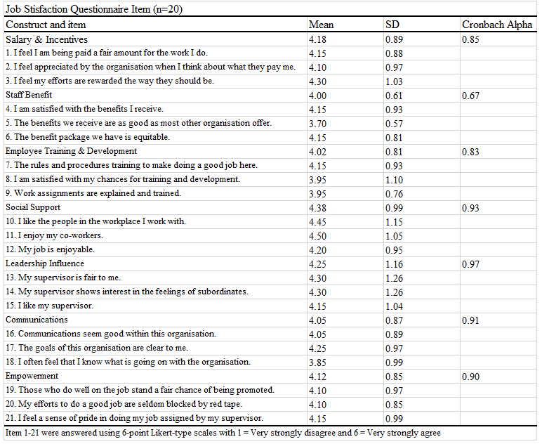Table I-2. The Descriptive Statistics of Job Satisfaction Questionnaire Items

Refer to I-2, The study conducted the descriptive statistical analysis and the reliability test. The Cronbach alpha is for the reliability to measure each of the Job Satisfaction factor. This study is used a minimum threshold of 0.70 for Cronbach Alpha. The instrument produce a total score based on average score of all questions rating. The greater job satisfaction indicates the higher scores are on the measurement.
The range of the Cronbach Alpha rate for those Job Satisfaction factors were from 0.67 to 0.97. The lowest Cronbach Alpha rate was 0.67, that the Job Satisfaction factor is Staff Benefit. The Cronbach Alpha rate of other factors were over 0.70. The Social Support of job satisfaction factor is the highest average score. The mean is 4.38 which is the greatest job satisfaction factor. And the Staff Benefit of job satisfaction factor is the lowest average score. The mean is 4.00 which is the lowest job satisfaction factor.

Correlations between employee job satisfaction and employee's job performance
Measure |  | Employee's job performance
Employee job satisfaction | Pearson Correlation | 0.572**
 | Sig (2-tailed) | 0.008
 | N | 20
**. Correlation is significant at the 0.01 level (2-tailed)

Table II. Correlations between the employee job satisfaction and the employee’s job performance

This study conducted the correlation quantitative research analysis to determine the employee job satisfaction and each Job Satisfaction factor are correlated well with the employee’s job performance. The association scales applied the coefficient rate 0.01 to 0.09 is negligible association, 0.1 to 0.29 is low association, 0.30 to 0.49 is moderate association, 0.5 to 0.69 is substantia association, and 0.7 or above is very strong association (Davis, 1971).
For the research study Question 1, what is the relationship between the employee job satisfaction and the employee’s job performance in banking? The result in the individual correlation coefficient computed among the variable of employee job satisfaction and employee’s job satisfaction for the Bank employees in Table II. They have a positive relationship of 0.572, p < 0.01, was found between employee job satisfaction and employee’s job performance in the Bank. This positive relationship has been supported by some other studies as well. Those research studies are indicated a direct positive relationship between employee job satisfaction and employee’s job performance. (Fisher, 2003; Judge et al., 2001)
The current SPSS correlational result is consistent with the Question 1 hypothesis that there is a positive relationship between employee job satisfaction and employee’s job performance as the substantial association.

Correlations: Salary & Incentive, Staff Benefit, Training & Development, Social Support, Leadership Influence, Communications and Empowerment to Employee's Job Performance
The job satisfaction factors | Correlation between each job satisfaction factor to employee's job performance
Salary & Incentives | 0.743**
Staff Benefit | 0.655**
Employee Training & Development | 0.312
Social Support | 0.547*
Leadership Influence | 0.393
Communications | 0.320
Empowerment | 0.530*
**. Correlation is significant at the level 0.01 level (2-tailed).
*. Correlation is significant at the level 0.05 level (2-tailed).
Table III. Correlations between each job satisfaction factor and the employee’s job performance
For the research study Question 2, what is the relationship of the employee’s job performance by influence of each job satisfaction factor of the employee job satisfaction in banking? The individual correlation coefficient computed among on each variable of employee job satisfaction factors: Salary & Incentives, Staff Benefit, Training & Development, Social Support, Leadership Influence, Communications and Empowerment to the employee’s job performance for the Bank employees in Table III.
The correlation between the job satisfaction factor of Salary & Incentives and the employee’s job performance was significant at the point 0.01 level, r = 0.743, p < 0.01 as the very strong association.
The correlation between the job satisfaction factor of Staff Benefit and the employee’s job performance was significant at the point 0.01 level, r = 0.655, p < 0.01 as the substantial association.
The correlation between the job satisfaction factor of Training & Development and the employee’s job performance was r = 0.312 as the moderate association.
The correlation between the job satisfaction factor of Social Support and the employee’s job performance was significant at the point 0.05 level, r = 0.547, p < 0.05 as the substantial association.
The correlation between the job satisfaction factor of Leadership Influence and the employee’s job performance was r = 0.393 as the moderate association.
The correlation between the job satisfaction factor of Communications and the employee’s job performance was r = 0.320 as the moderate association.
The correlation between the job satisfaction factor of Empowerment and the employee’s job performance was significant at the point 0.05 level, r = 0.530, p < 0.05 as the substantial association.
The current SPSS correlational result is consistent with the Question 2 hypothesis that there is a positive relationship on each job satisfaction factor to the employee’s job performance.

Discussion and Conclusions
In the literature, the relationship between employee job satisfaction and employee’s job performance that the employee job satisfaction has the positive impact on the employee’s job performance. The increase of the employee job satisfaction and employee motivation are driven to increases the employee productivity as well as the organisation performance. (Alnasrallah, 2016; Bernanthos, 2018; Dartey-Baah, 2010; Springer, 2011) This research study is introduced the Framework of Employee Job Satisfaction and Employee’s Job Performance by the literature review. The framework based on the relationship between the employee job satisfaction and the employee’s job performance is including the job satisfaction factors: Salary & Incentives, Staff Benefit, Training & Development, Social Support, Leadership Influence, Communications and Empowerment.
The research findings make theoretical contributions to the field of job satisfaction factors on the employee job satisfaction to have the positive impact on the employee’s job performance in resulted on job retention in banking industry in Hong Kong. The SPSS correlational result is consistent with the Question 1 hypothesis that there is a positive relationship between employee job satisfaction and employee’s job performance as the significant substantial association and then the Question 2 hypothesis that there is a positive relationship on each job satisfaction factor to the employee’s job performance and the Salary & Incentives factor is highest coefficient rate at 0.743 as the significant very strong association with employee’s job performance.
The limitation of this research study is related to the pilot test and the sample size. This was a convenience sample of 20 Bank employees to complete the Job Satisfaction Survey. For the future research study, this questionnaire could be test with more employees within the Bank and/or other banks’ employees in Hong Kong. Although the study has covered almost all bank characteristics. The participants demographic information have 50% of male and 50% of female and the age range is from 24 to 56 years old. There have 50% of employees are holding degree or above. The job level of 50% employees are Officer or Senior Officer or below and 50% of employees are Assistant Manager or above. For the future research study, in the area of the employees work in different function departments in the bank (frontline staff and back-office staff), the organisation’s strategy should direct impact on the employee’s performance. The frontline staff and back-office staff could consider adding in demographic information to test correlation to the employee’s job performance.
In the future, the refining of the Part A of the demographic information and Part B of Job Satisfaction scale in the survey that the Job Satisfaction Survey becomes a reliable and practical tool for employee job satisfaction impacting on the employee’s job performance.

References

Alnasrallah, Y. 2016, “Employee Motivation and Performance”, International Journal of Scientific & Engineering Research, 7(1).

Bernanthos, B. 2018, “Employees’ Performance in Islamic Banking”, European Research Studies, vol. 21, no. 1, pp. 1-42.

Crossman, A., & Abou-Zaki, B. 2003, “Job satisfaction and employee performance of Lebanese banking staff”, Journal of Managerial Psychology, 18(4), 368-376.

Dartey-Baah, K. 2010, “Job Satisfaction and Motivation: Understanding its impact on employee commitment and organizational performance”, Academic Leadership (15337812), 8, 4, Education Source, EBSCOhost, viewed 15 July 2018.

Davis, J A. 1971, “Elementary survey analysis”, Englewood Cliffs, NJ: Prentice-Hall.

Drucker, P. 1954, “Management by objectives and self-control”, Practice of Management.

Fisher, C. 2003, “Why do lay people believe that satisfaction and performance are correlated?”, Journal of Organizational Behavior, 24, 753-777.

Herzberg, F., Mausner, B., & Snyderman, B.B. 1959, “The Motivation to Work’, John Wiley & Sons. Inc., New York, 195.

Johri, R., & Vashistha, N. 2015, “IMPACT OF WORKING ENVIRONMENT AS A MOTIVATINAL FACTOR FOR EMPLOYEES & ITS EFFECT ON THRIE PERFORMANCE: CASE STUDY OF SYDICATE BANK OF INDIA”, CLEAR International Journal Of Research In Commerce & Management, 6, 3, pp. 40-44, Business Source Complete, EBSCOhost, viewed 15 July 2018.

Judge, T A., Thoresen, C J., Bono J E., & Patton G K. 2001, “The job satisfaction-job performance relationship: A qualitative and quantitative review”, Psychological Bulletin, 127, 376-407.

Kaplan, Robert, S, & Norton D P. 1992, “The Balanced Scorecard – Measures That Drive Performance”, Harvard Business Review, January-February, pp. 71-79.

Kopia, J., Kompalla, A., Buchuller, M & Heinemann, B. 2017, “PERFORMANCE MEASUREMENT OF MANAGEMENT SYSTEM STANDARDS USING THE BALANCED SCORECARD”, Amfiteatru Economic, vol. 19, no.11, pp. 981-1002.

Latham, G., & Pinder, C. 2005, “Work motivation theory and research at the dawn of the twenty-first century”, Annual Review of Psychology, 56, 485-516.

Maslow, A H. 1943, “A theory of human motivation”, Psychological review, 50(4), pp. 370.

Spector, P E. 1994, “Job satisfaction survey”, Tampa: University of South Florida.

Springer, G J. 2010, “Job Motivation, Satisfaction and Performance Among Bank Employees: A Correlational Study”, Journal of Global Business Issues, 5(1), 29.

Springer, G J. 2011, “A Study of Job Motivation, Satisfaction, and Performance among Bank Employees”, Journal Of Global Business Issues, 5,1, pp. 29-42, Business Source Complete, EBSCOhost, viewed 15 July 2018.

Appendix



