NPTC Group
Advanced Web Development and Evaluation
BSc Applied Computing Lecturer: Andrew Green
Keiran Howells - 166678
4-12-2019

Contents
Web App 2
The video 2
Written Report 3
Technology Used 3
Techniques Used 4
Password Hashing 4
Authentication 4
Informative Interactive Elements 4
Naming Conventions 4
Validation 5
Design Standards 5
User Acceptance Testing 5
Conclusions 5
Bibliography 7

Web App

The video
The main functions and features of the website are shown through the use of this video: https://www.youtube.com/watch?v=6riCeOxeQRM

Written Report

Technology Used
For the development the main technology items where:
- Xampp
- CakePHP
- PHP My Admin
- Notepad++

Development stated with the creation of a “dbsetup” file; this was a written version of the database and its tables this was then used to create the database. CakePHP was the framework being used for the development of Angel Reviews; CakePHP generated a basic structure and then through a process referred to as “bake” created files and connections to the database providing a basic site for database data manipulation; this was the template which the rest of the website would be created on.
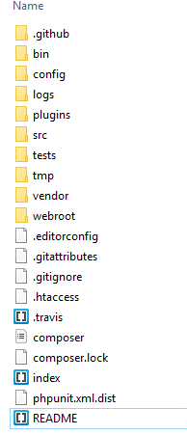  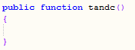 | CakePHP uses a MVC software design pattern; MVC stands for Model, View and Controller. All of these and more are within the src/source folder shown on the right.  The Model files are representations and references to the database tables; within CakePHP this is split into a “Table” and an “Entity”. The Entity controls the fields values which will be used within the site and provides the connections to the column names across the website; this then links with table, this contains the table name, primary key and behaviours for the data as well as validators for the length, data type and more.  The View files are the front end of the site; the view folder extends into the template folder. Within these there are two types of folder, the Pages folder which contained the static pages of the website and the individual table folders which CakePHP auto populates with an index, view, edit and delete for their respected table. Creating pages within these folders allowed for the simple generation of pages which presented the data which is the purpose of the view.  The Controller files are what control the data on the site; it holds the files that control the data requests and queries. There is a controller file created by CakePHP for each of the tables; there is also an “AppController” that is above the rest. The controllers manage data requests, the load, add, edit and delete functions are all within the controllers and are written case by case. Each page will have a section within a controller, the basic static pages with no data from the database are blank like the terms & conditions this is due to the generation process for pages in the site.  These files are in many ways the web app. Understanding just these 3 files allow the creation of a web app; while understanding can be difficult they provide the necessary format and separations for development while reducing the chances of errors with location based restrictions.

Notepad++ was used as a code editor; while basic it functioned as required and was able to assist in the development process by changing the colours of text determined by their type/purpose allowing an editor to read the code easier and be able to differentiate between code and comments instantly as well as many other visual aids.

Techniques Used

Password Hashing
Password hashing; this is the only addition performed on the Model for the website; the simple code uses pre-created CakePHP functions and changes the $value which is the password through a hashing algorithm and returns the hashed value.  While basic this increased the security of the users greatly; even if a user manages to view the database the passwords are safe. | 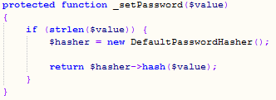

Authentication
Permission based restrictions; as shown in the below their where check statements against the logged in user; this was done to check that the user attempting access was not authorized, if it was true that they were not authorized the user is redirected away.

There is also the “Auth” function which checks if there is a logged in user; the function will trigger when a user is not logged in and attempts to access a page not on the “allow” list shown below.
While this method is brutish and punishing due to is being a statement post action instead of prior they meet the requirement in controlling the pathing on the site with more understanding of cake these could possible be moved to the button click function and prevent button function instead of redirecting away.

Informative Interactive Elements
Another technique used for helping the users of the site is informative interactive elements; buttons display when they are hovered over with colour changes or becoming underlined. The interactive elements were also in most cases clear on their purpose/function with their text being simple like “Login” and “Add a review” clearly informing the user.
Functions where either a button which were designed to appear and function as buttons and the rest where hyperlinks and table column controls which where all in blue text which is common knowledge on the internet as an intractable element.
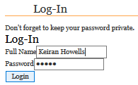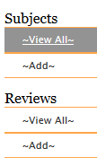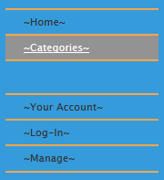

Naming Conventions
Databases tables where named their data set with “db” on the end to define them as the database table name and make it unique allowing for clear differentiation between database references and data references.

The tag “add_DatabaseTable” and “edit_ DatabaseTable” where used to separate the cake.PHP database function pages which are for admin only and the users database function pages.

Most of the website uses camel case due to it being small and allows for eligible sentences without spacing; however due to functions within cake page declaration with camel case caused the requirements of “_” to take the spaces undoing the camel case on the page names.

Validation
Validation is key when you allow people who do not know or understand the database; validation prevents the input of the wrong data which would cause problems if inserted into the database.  The validators are saved within the Model section of CakePHP and are used whenever data goes into the database. | 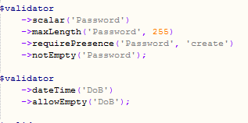

Design Standards
The entire site was created using a single core css file and the formatting for the pages was constant across all of the pages apart from the admin database pages which is to emphasise that they’re not regular pages. Sections where segmented through the use of the header 3 item which contained an underline. While this makes it easier to create the site it also makes it easier for the users to understand the page.

User Acceptance Testing

Task | Could you? | Difficulty of Process | Speed of Process
Sign-Up | Yes | Not difficult | Quick
Search Reviews | Yes | No tab for reviews but can be found with ease for each product | Quick
Create a Review | Yes with ease | No difficulty | Quick
Create a Comment | You can create a comment on a review in view | Not difficult | Quick
Edit a Review | Edit can be done | No difficulty | Quick
Edit a Comment | Same as above | Same as above | Quick
Access Manage | Couldn’t access
Edit other Reviews or Comments | Cannot edit unless admin
Log-Out | Clear button | No difficulty | Quick
Additional Notes

Examination of testing
The tester Callum Poole tested the website; he had a large amount of experience and was able to go through the site at speed completing the tasks with ease and even managed to perform the log-out function without asking for assistance which was a concern. He didn’t manage to access any areas he did not have permission for and performed the functions requested of him. Afterwards when questioning he did not say much but did mention how he didn’t notice the view buttons on the review section that well which is a cause of concern.

Conclusions

An examination of the website against the original specification and the results of the user acceptance testing suggest that the site is fit for purpose; required functions are available and the format is clear enough for the user to understand what they are doing.
The technology used for the development required time to learn and understand however once understood was rather simple and efficient and greatly assisted in the development of the site. The formatting provided the framework for the MVC and reduced the chance of breaking the MVC pathing.
In the end the website meet the requirements however their where several causes of concern, this is as the site was made more on the goal of meeting the requirements and didn’t focus as much as it needed to on user interactions; these are shown by these issues:
The redirects where hard re-directs instead of soft re-directs; when a making a mistake or accessing an area where the user doesn’t have permission instead of being sent back a single page they are sent back to the home page. While this meets the purpose it is not nice to experience and provides a bad user experience. This can be amended though the changing of each redirect written in the websites.
The button “~Log-In~” did not change to the desired “~Log-Out~” after the user has signed in; this is a problem which requires amendment. While the functionality occurs the user will likely not now about this process and will be unable to log-out effectively.
The view button on the review page is small and on the fare right of the page; this makes it out of the way when it is such a key component of the website; also the text view is not the most descriptive since the view allows you to view the subject and its reviews.

Bibliography

