Micros Peripherals and Interfaces
ACDA4004
Student number: 2308626

Contents
Section 1 3
Section 2 4
Section 3 5
Task 1 5
Task 2 5
Task 3 6
Task 4 6
Task 5 6
Task 6 6

Section 1
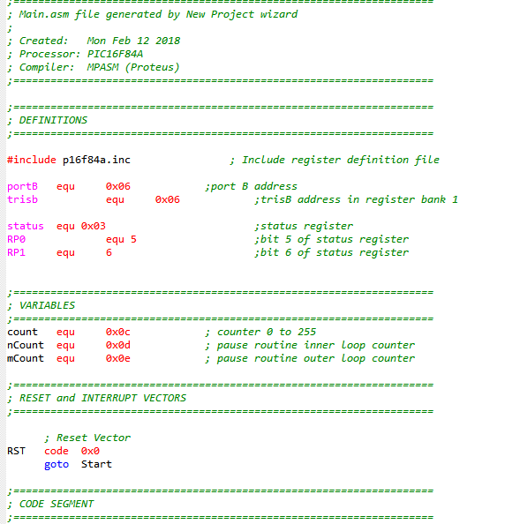
Figure 1
Before we begin with the actual coding process, it's essential to establish the initial setup. This involves configuring the registers, which are critical for controlling the flow of data and instructions within the system. Additionally, we need to define the inputs and outputs to ensure that the program can correctly interact with external devices or data sources. By carefully preparing these elements, we create a solid foundation for our coding endeavours.
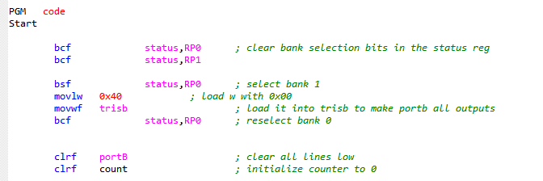Figure 2
Figure two shows the setting up of the program
To ensure proper functionality, I am in the process of resetting the counter and clearing both the registers and the ports. I noticed that the value was set to 0x40, which could potentially lead to complications in the code execution. Therefore, I have changed this value to 0x00 to resolve any issues and maintain the stability of the system.
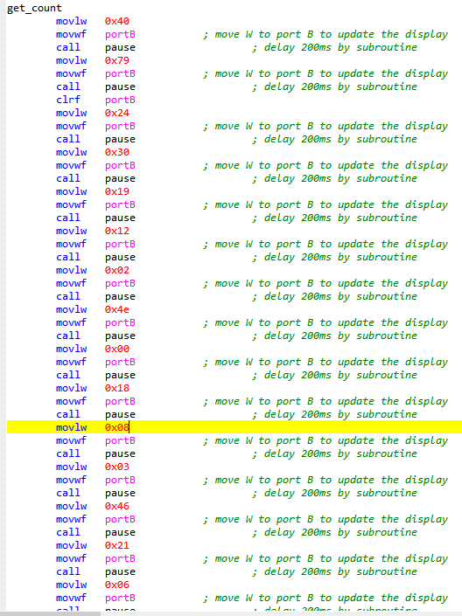
Figure 3
Figure 3 provides a comprehensive illustration of a somewhat cumbersome method for executing this program. The process involves iterating through each line of code one at a time, modifying the variable 'w' accordingly, and continuously reassigning it as the output. I opted for this approach because it simplifies the structure of the code, making it more straightforward to debug and identify any potential errors during the development process. After each time the code updates the output for port B, it invokes a delay subroutine. This subroutine introduces a 0.2-second pause, allowing time for the output to stabilize before transitioning to the next value in the sequence. Although there are certainly more efficient and elegant methods available for programming this functionality, my main goal at the time was to ensure that the program was operational. I prioritized getting a working solution over refining the program to be simpler or more efficient. This focus on functionality over simplicity was a key consideration during the development phase.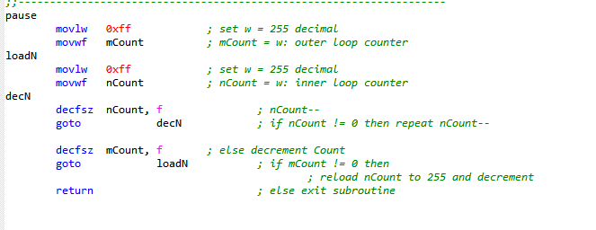
Figure 4
The diagram provides a detailed overview of the delay process, indicating that it produces a delay of 0.2 seconds. This means that there is a brief pause or lag in the system's response time, allowing for smoother operation or improved synchronization with other processes.

Section 2
To effectively display the hexadecimal values from 0 to F on a seven-segment display, I began by calculating the hexadecimal codes that correspond to each of these values. This foundational step laid the groundwork for developing a program that would sequentially cycle through each value, presenting each one on the display in real time.

Focusing on values A through F, I conducted a detailed analysis to determine which specific segments of the seven-segment display needed to be illuminated to accurately depict each character. Each segment can be visualized as a bit in a binary number, where it can either be activated (represented as 1) or deactivated (represented as 0).

I meticulously mapped out the segments associated with the letters A to F, translating the necessary segments into binary numbers. This involved identifying which segments needed to glow to form the distinct shapes of these hexadecimal characters. After establishing the correct binary configurations for each value, I then converted these binary representations into their corresponding hexadecimal codes.

This systematic approach ensures that the appropriate segments light up for each character on the display, resulting in a clear and precise representation of the hexadecimal values ranging from 0 to F. By illuminating the correct segments, the display vividly presents each character, facilitating easy reading and interpretation.
This has given me the following values:
Value binary hex
A 0001000 0x08
B 0000011 0x03
C 1000110 0x46
D 1011110 0x21
E 0000110 0x06
F 0001110 0x0e

Section 3

Task 1

Start

Task 2
This code is designed to provide a simple interaction where pressing one button will display the letter "l" on the screen. Conversely, when you press the other button, the letter "r" will appear instead. This functionality allows for a clear and intuitive way to distinguish between the two actions through visual feedback.
Clear all ports
Set port b to an output
Start
if button 1 is high, set output b to 0x47 so the seven-segment display prints out an L
if button 2 is high, set output b to 0x4e so the seven-segment display prints out an r
else set output b to 0x00
return to start

Task 3
This pseudo code demonstrates the functionality of two buttons—button 1 and button 2—in relation to the LED lights. When button 1 is pressed, the code activates all the LEDs, causing them to light up simultaneously. Conversely, when button 2 is pressed, the code deactivates all the LEDs, resulting in them turning off completely. This simple interface allows for clear and immediate control over the LED lights.
Clear all ports
Set port b to an output
Start
When button 1 is high, set output b to 0x7f to set all the segments to high
If button 2 is high, set output b to 0x00 to clear the seven-segment display
Return to start

Task 4
Clear all ports
Set port b to an output
Create a segment including the values 0-9 in hex
Set digit to 5
Start
Display digit on output b
Subroutine button 1
When button 1 is high, increase the digit value by 1.
Subroutine button 2
When button 2 is high, decrease the digit value by 1 =.
if digit is 10
Set digit to 9
If digit is -1
Set digit to 0
Go to start

Task 5
Clear all ports
Set port b tou output
If button 1 is pressed
Send output through pin b 8 creating a sound throught the buzzer

Task 6

Refrences
Pic16f84a data sheet used throughut the assignment
PIC16F84A Data Sheet

