useraccount
ACCA4024 20/01/2022
Networks and Cyber Security Essentials

Contents
Brief 2
Task 1 2
Disgruntles Employees 2
Task 2 2
Threats and different types of threats 2
Vulnerabilities 2
Attacks 2
.Rekt 3
Task 3 3

Introduction
This assignment will consist of possible breaches based on a scenario, a review on different types of attacks, what rekt file is and the importance of Cybersecurity. I will include a certificate after completing Introduction to packet tracer and also attach a digital badge. I will also create a topology based on scenario. And suggest security devices to add to the network.

Abstract
For task 1 I identified 2 different possible breaches based on the scenario that was given. 1 being that the business and customer were on the same wifi and also there wasn’t process implemented after an employee has been fired. Task 2 was a review of what attacks how they happen are and how they affect your network. Task 3 was creating a packet tracer topology based on the scenario and then proposing security devices that could help secure the network more.

Task 1

Possible security breaches
There are 2 security flows that have and could possibly make your network easily to breach. The first it was stated that Alfred implemented wifi that was used for both the business and for the customers. Because customers are using the same wifi as the business this si allowing access to the system where the companies data comes in and out. An attacker could exploit this by being on the same network. This makes it easier for them to intercept your data packets they could potentially input some malware through the network which will be sent thought your entire network. [1] [2].Try to make sure you use rouge access points to force potential attackers to enter your building.
Another security flow is disgruntled employees that was fired. Knowing that this employee was not only unhappy but also that employee had privilege access to all the business applications is dangers. This employee had a high ranking access to the important part of the business and can now create damage to the company. So making sure that all your physical hardware is stored safe and for the disgruntled employee after being fired. Also making sure the employees access has been eliminated from the network.

Task 2

Threats and different types of threats
A threat to a network is where a harmful condition is implemented into your network through unauthorized access to cause loss, leak information that could harm your business or modify your system in a negative way [3]. Some examples of theatres are Malware, Man in the middle attack and DDOS attacks to name a few. Each attacks your network in a different way but all have the same objective which is to destroy your company’s network.

Vulnerabilities
Vulnerabilities is where a software or hardware system in your network has a flaw that when compromised by an attacker will allow that attacker to gain access to your network. There is two types of vulnerabilities in your network. First being a nonphysical network vulnerabilities that involve your software and or data in your network. For example if you don’t update your OS to the latest update it will have outdates security, which makes it easier to an attacker to get to the OS and add a virus to spared from the OS to the test of the network. Another example of a vulnerabilities is Physical network vulnerabilities, this involves an attacker finding some sort of flow or security mistake in IRL. For example if you forgot to close your server room and an attacker got to the server he would be allowed to upload anything he/she wants to the rest of your businesses network [4].

Attacks
There is 2 different types of attacks Passive and Active. Passive attackers will look to gain access to your network to take important information without making any changes to your data allowing your network to stay the same. But that information could be critical to your business if leaked could put your business in trouble or they will look to sabotage you and ask for money to not realise the information they gain. The other type attack which is an active attack is where they gain access to your network and look to change your data, delating it or finding other ways to harm your network. [5]

There are different attacking techniques for an attacker to use to try and inveterate your network. Some of the more popular techniques or attacks are Malware, Phishing and Distributed Denial of service.
With Malware the criminal will look to infiltrate your network depending on the time of malware. For example he/she can use some sort of virus to infect your network. It accesses your network from an attached email containing the virus. Once opened that virus can then spread to your system and then travel to different parts of your network. Another example of when a
Phishing is where an attacker will look to trick someone apart of your business to give them important information such as passwords and credit card details. The most popular way they do this is by sending an email to victim unsuspecting that they are an attacker acting to be someone they know/trust. [6]
Distributed Denial of service is where an attacker will look to over flood servers in your network to trying to take advantage of your servers capacity limit. Whenever your server will get to a certain limit were it will start to slow down your server and request times become longer that normal and some important request could get ignored slowing down your network and business [7].

.Rekt
REKT or REKTLocker is a ransomware type malware that will try to access your network and encrypt your files. After your files has been encrypted a .rekt will be renamed into your files that have been effected. After this your wallpaper for you desktop will change into Readme.txt. The text file will state that the attacker has the access to decryption key which is what allows you access to your files and the attacker will attempt to sell the key to the users that he/she has targeted. They will most likely ask for online currency for example bitcoin to stop them being tracked by police afterwards.
Implementing a REKTLocker removal software should help. This will help locate identify and delete files that have been compromised. [8]

Task 3

Certificate

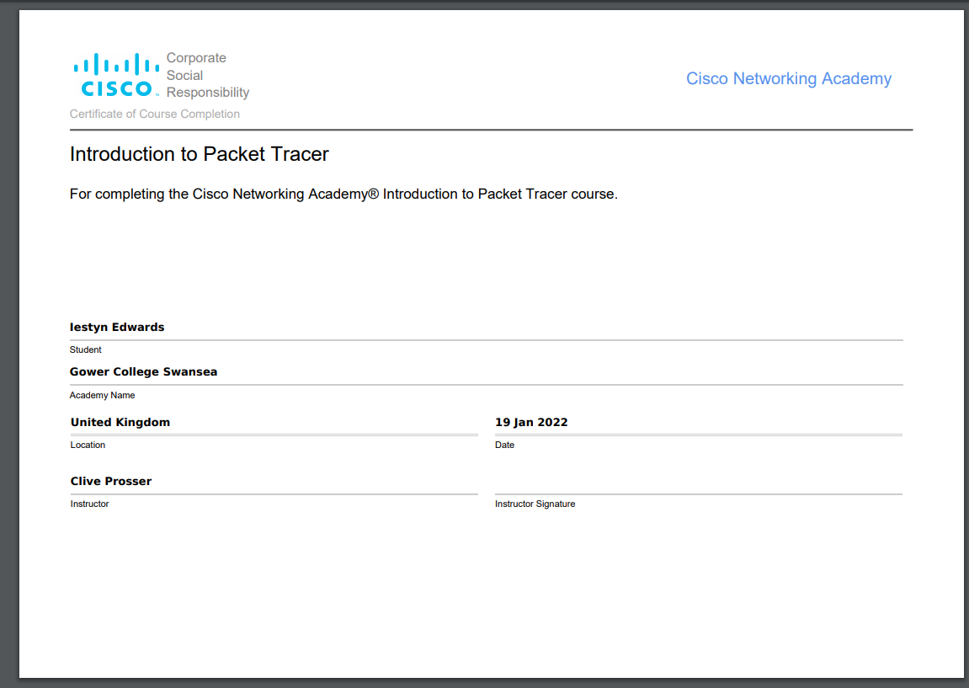

Badge
https://www.credly.com/badges/ed0ade28-28af-4b88-9ee1-0e42268e0d05/public_url

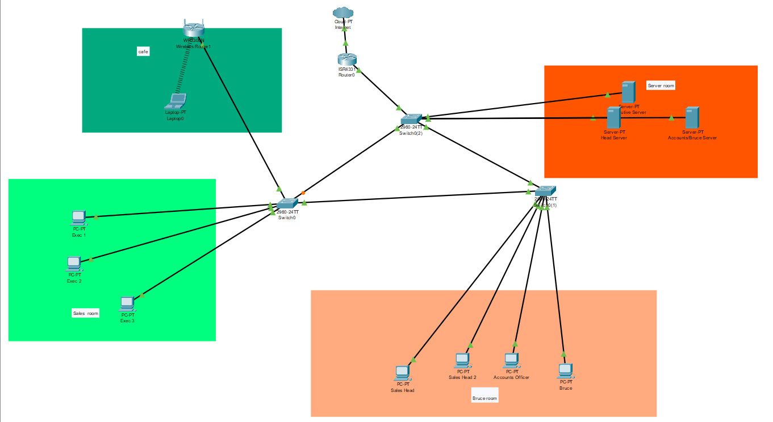

Topology

Sales Room
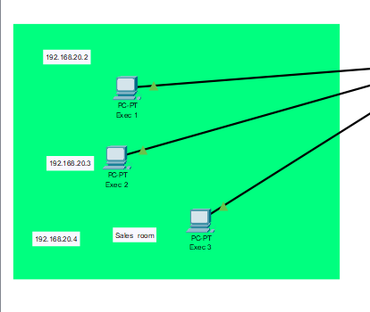

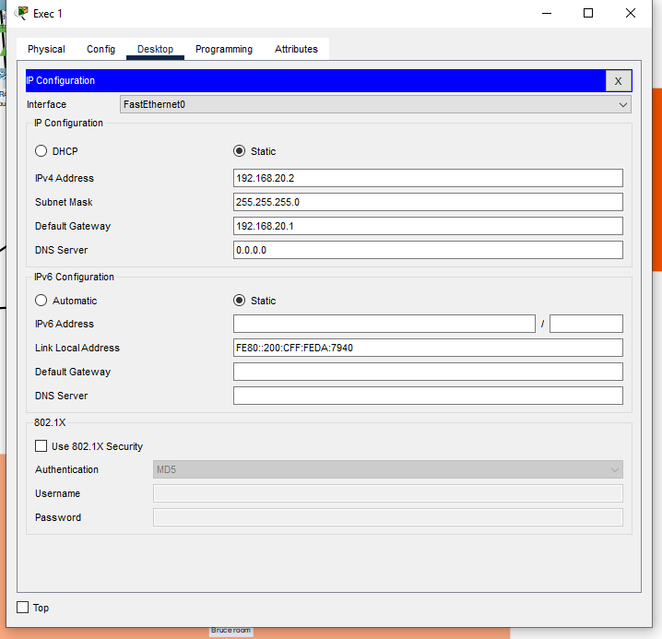
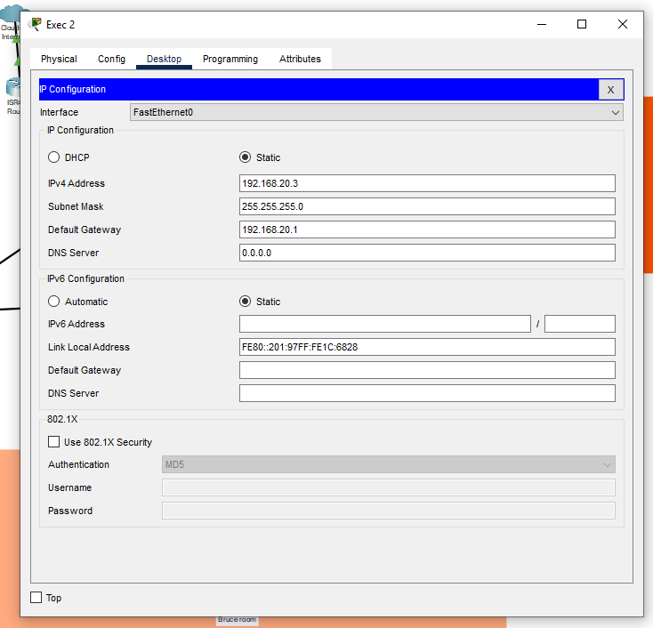
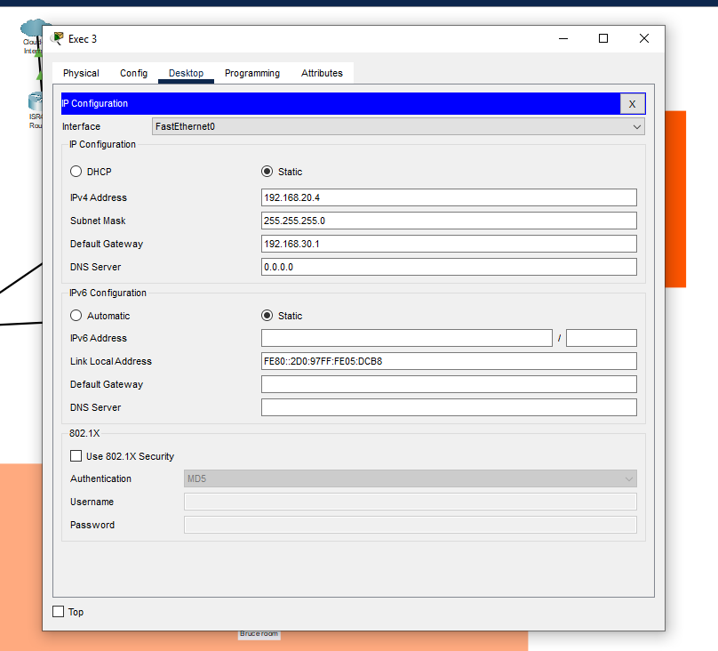

Bruce Room
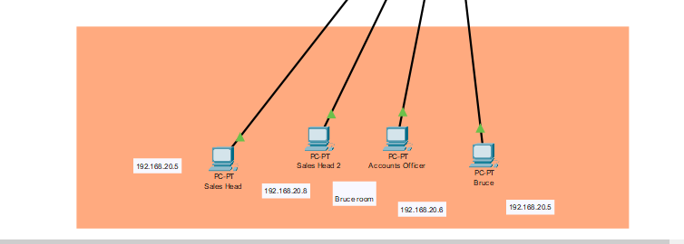
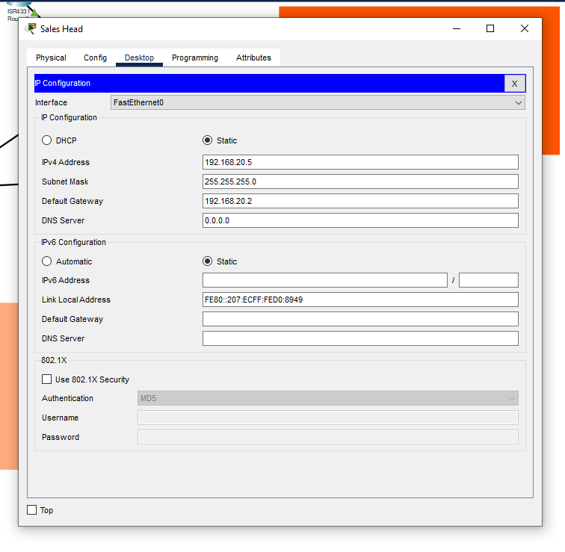
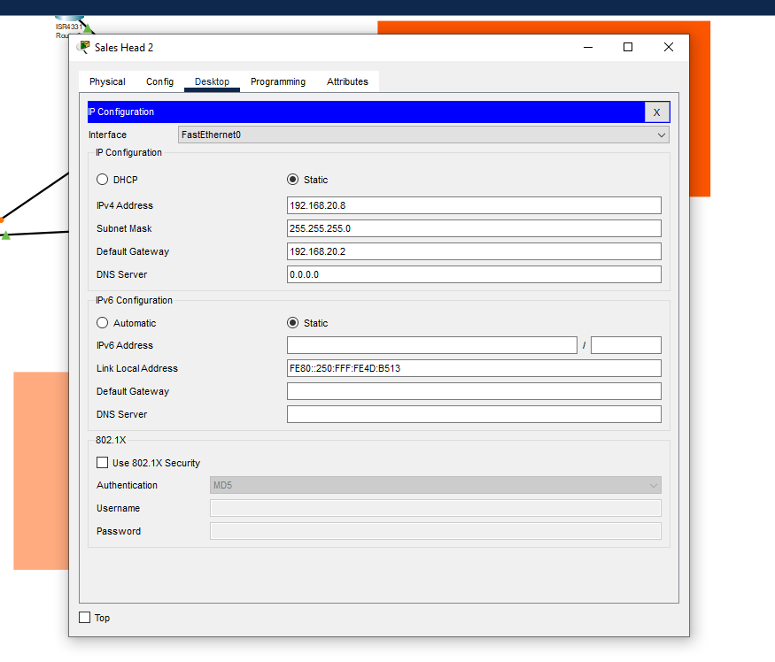
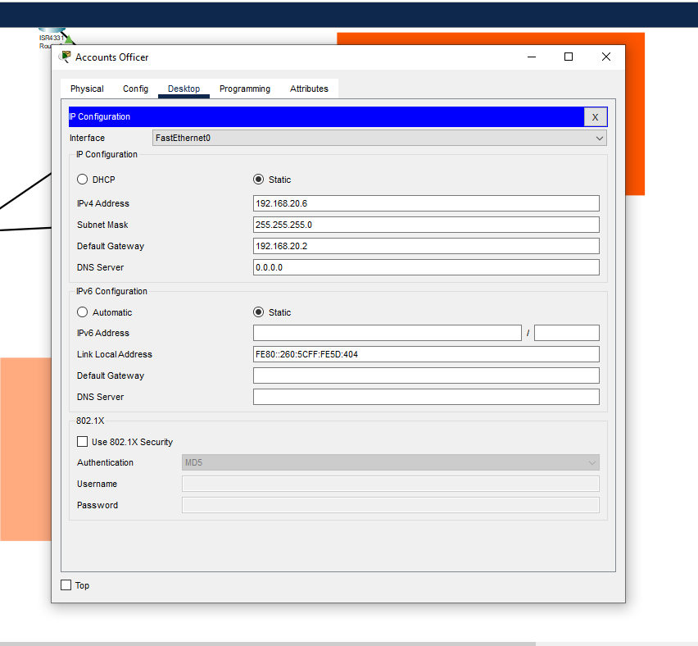
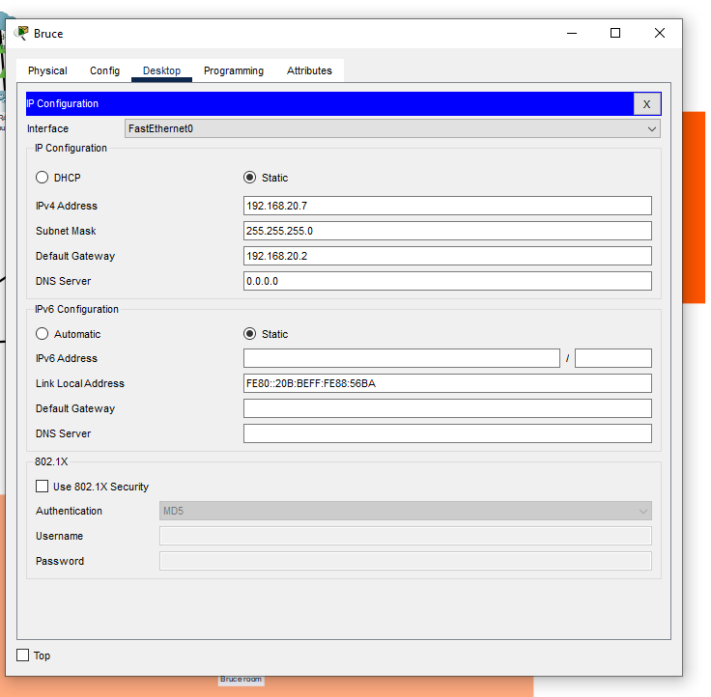

Server Room
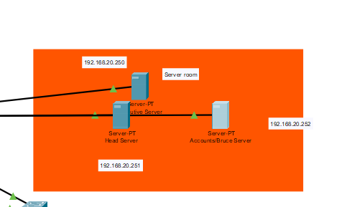

GUI
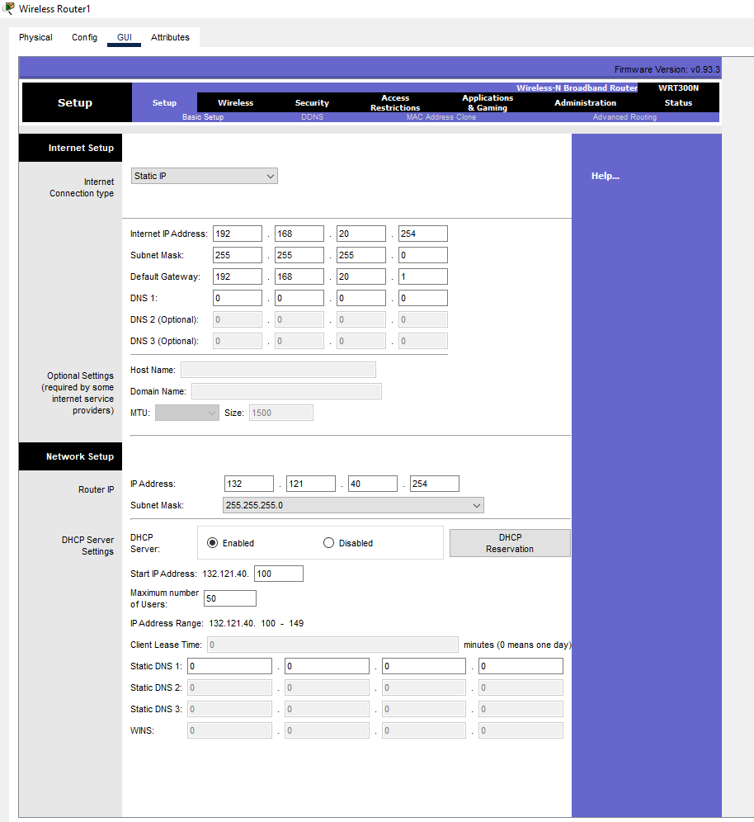
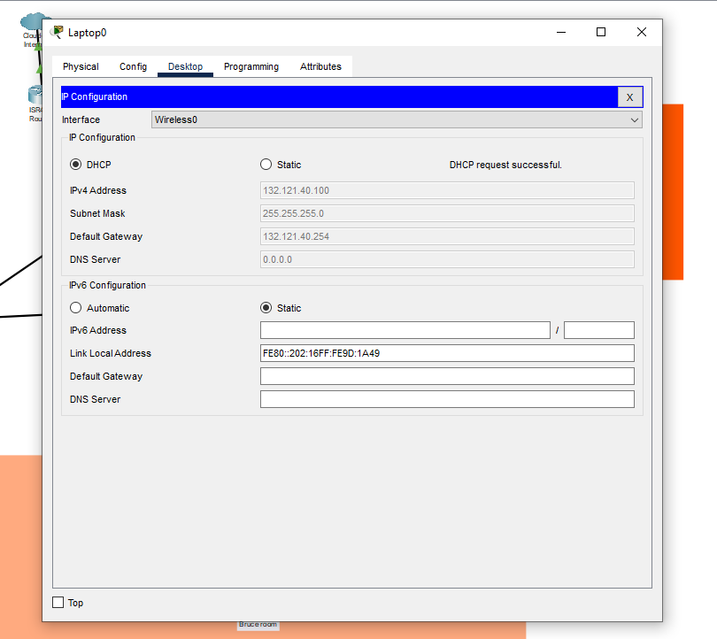

Security devices to help the network
Adding a firewall device can help protect your network. They help stop unwanted traffic that travels through your network. Depending on what type of traffic you want to allow travel around your network and the firewall device will make sure anything else that isn’t included to that list will not let that packet travel through. You could implement a whitelist and blacklist for packets. Whitelist denies access to every all packets expect the once you list as acceptable. Blacklist then allows all packets through expect the once you list as unacceptable. [9]

References

[1] | N. employee, “The risks of public Wi-Fi,” Norton , [Online]. Available: https://uk.norton.com/internetsecurity-privacy-risks-of-public-wi-fi.html. [Accessed 25 January 2022].
[2] | S. Batt, “Why You Should Never Share Your Wi-Fi Password,” MUO, 2 May 2019. [Online]. Available: https://www.makeuseof.com/tag/never-share-wifi-password/. [Accessed 25 January 2022].
[3] | Computer Security Resource Center, “Cyber Threat,” NLST, [Online]. Available: https://csrc.nist.gov/glossary/term/cyber_threat. [Accessed 21 January 2022].
[4] | J. Firch, “Common Types Of Network Security Vulnerabilities In 2022,” Purplesec, 23 September 2021. [Online]. Available: https://purplesec.us/common-network-vulnerabilities/. [Accessed 25 January 2022].
[5] | Network attacks, “Network Attacks and Network Security Threats,” Network attacks, 14 December 2021. [Online]. Available: https://www.cynet.com/network-attacks/network-attacks-and-network-security-threats/. [Accessed 25 January 2022].
[6] | B. Jefferson, “The 15 Most Common Types of Cyber Attacks,” Lepide Home , 8 June 2021. [Online].
[7] | Kaspersky, “What is a DDoS Attack? - DDoS Meaning,” Kaspersky, [Online]. Available: https://www.kaspersky.co.uk/resource-center/threats/ddos-attacks. [Accessed 25 January 2022].
[8] | T. Meskaukas, “What is REKTLocker,” PCrisk, 9 December 2021. [Online]. Available: https://www.pcrisk.com/removal-guides/10351-rektlocker-ransomware. [Accessed 25 January 2022].

