

18th January 2022

Professional Portfolio

Table of Contents
Reflective Commentary 2
References: 6
Portfolio of Evidence: 8
Evidence 1: 8
Section A: Background Information: 8
Section C: Application Form 12
Section D: Covid Procedures 14
Evidence 2: Reflective Logs 18
Evidence 3: Volunteering Process 22
Section A: Volunteering opportunities: 22
Section B: Required Skills 24
References: 25
Appendices: 27
Appendix A: Permission to commence placement 27
Appendix B: Correspondence to secure the placement 28
Appendix C: Placement Diary Dates 30
Appendix D: Covid Procedures Email 33
Appendix E: Placement Information Form 35

Reflective Commentary

I will be reflecting on my volunteer placement experience with Shalom House and how this work has helped me build the basic counselling skills I have learned in Level four and five in Counselling Skills. I will be using Gibb's Reflective Cycle (Lilienfeld & Basterfield, 2020).
I wanted to explore the trauma field of counselling, so I decided to try and apply at New Pathways, within the Carmarthen or Swansea offices. However, this did not become a reality as I have not gotten enough counselling skills experience. Therefore, this option has now been postponed until my third year. I then opted to try the National Health Service (NHS); this also did not become an option as the Covid pandemic had stopped all the volunteering opportunities in this service. Next, I wanted to volunteer with the DPJ Foundation, which offers farmers a counselling service, but they work from home. Then, I contacted the Pembrokeshire Association of Voluntary Services (PAVS), who signposted me to the Volunteering Wales website. Finally, I found the volunteering opportunity at Shalom House in St David's on this site.
I applied directly with Shalom House to be a Palliative Care Centre volunteer. I completed an application form. I received correspondence from Donna Humphrey, the Registered Care Manager, and I started my first shift on 1st November 2021. I attended the first day's morning meeting and learned more about the day centre attendees. According to Lunt et al. (2021), day care is typically discussed in the literature in terms of the respite it provides to caregivers (Rao et al., 2021), rather than any drawbacks or benefits that involvement in day care services may have on older people themselves. Attendance and assistance at the day centre, in my opinion, is beneficial to both those who attend and their caregivers (Hasson et al., 2021). Although I was not given any form of induction or formal training, I shadowed the two staff members to see what duties I would need to undertake during my shift. I then took it upon myself to complete the Legionnaire's and the hoist checks. After a weekend of non-use, it is necessary to run the taps for a few minutes on Monday morning to avoid Legionnaire's disease. I checked all the hoists and charged the battery pack for the portable bath hoist. Then I spend the day speaking to the individuals who come to the day centre. While the atmosphere created by some of the staff was quite upbeat, I felt it essential for me, as a future professional counsellor, to be myself and approach clients in a calm, reassuring manner. I have had conversations with Izzy about the acronyms used and my understanding of them, and I clarified my understanding of DNACPR. I understood this due to my nursing background. We have also spoken of advance care plans, the various illnesses, and the type of death a particular patient could experience. We offer many alternative therapies to promote stress reduction, emotional serenity, anxiety alleviation, and greater confidence and self-esteem (Shalom House, 2021).
I was apprehensive about finding a placement as I have been out of the workplace for a long time due to a horse-riding accident. I was also nervous about finding the correct type of placement. I love the idea of working for a company like New Pathways as I would like to specialise in the field of trauma. I have suffered many traumas, and so has my family. However, as this was not to be, I needed to find something that would fit the prerequisite required by my lecturer. I felt concerned as I did not know where to find a placement. After messaging various companies and getting no response, worry started to set in. I contacted the managers by telephone; however, this did not produce results due to the Covid pandemic. Once I contacted PAVS, they told me about Volunteering Wales, and I found Shalom House. I was slightly concerned about working in a palliative care centre. My mind went through a series of "what ifs". The realisation that I was able to do this and that as a nurse in my past, I had experience, which put my mind at ease, and I applied with confidence.
Working at Shalom House has been both a good and bad experience. I have met some wonderful people who are coming to the end of their lives and are still positive and, surprisingly, not self-absorbed. The staff are kind and loyal and enjoy the work they have chosen to do. However, I feel I would have benefitted from more communication regarding my responsibilities as I felt that they did not fully appreciate my role. The stories from both individuals and the staff are inspiring and sometimes sad. However, the job role can be monotonous as it is the same people and staff that I see on a Monday. Furthermore, working every day could provide enough variety to avoid monotony due to a change of staff and different individuals.
An incident that happened while I was on shift changed the atmosphere. An attendee who usually comes into the centre to use the bath had an 'episode' or akinesia (Balestrino & Schapira, 2019); this is when a person with Parkinson's gets 'stuck within themselves'. I thought he was on the verge of dying. Izzy, the nurse, was summoned, and I had to retrieve his hearing aids so that he could hear the staff. Finally, he revived.
The skills I have been able to practice while on placement have been empathy (Lees-Oakes, 2019; Mearns & Cooper, 2005; Midwinter & Dickson, 2015), congruence (McLeod, 2019; McLeod & McLeod, 2011), self-disclosure (McLeod, 2019), unconditional positive regard (Midwinter & Dickson, 2015), attentiveness (Midwinter & Dickson, 2015), silence (Bassett et al., 2018; McLeod, 2019) and finally, listening (McLeod, 2019). I put these skills into practice every shift as I spend four hours talking and listening to the individuals present that day. It is the perfect opportunity to practice by fully engaging in the conversation. According to Ruiz-Junco and Morrison (2019), the research's central premise is that empathy is beneficial in palliative care.
I enjoy working at Shalom House but may ask for alternate days to experience a day that has some difference so that monotony does not make the experience less enjoyable. I will keep practising all the counselling skills to build on my learning experience. In future, I will have the confidence to apply for placement positions, the university place for my doctorate and finally for employment.

References:

Balestrino, R., & Schapira, A. H. V. (2019). Parkinson disease. European Journal of Neurology, 27(1), 27-42. https://doi-org.ezproxy.uwtsd.ac.uk/10.1111/ene.14108
Bassett, L., Bingley, A. F., & Brearley, S. G. (2019). Silence as an element of care: A meta-ethnographic review of professional caregivers' experience in clinical and pastoral settings. Palliative Medicine, 32(1), 185-194. https://doi-org.ezproxy.uwtsd.ac.uk/10.1177/0269216317722444
Hasson, F., Jordan, J., McKibben, L., Graham-Wisener, L., Finucane, A., Armour, K., Zafar, S., Hewison, A., Brazil, K., & Kernohan, G.W. (2021). Challenges for palliative care day services: A focus group study. BMC Palliative Care, 20(1), 11. https://doi.org/10.1186/s12904-020-00699-7
Lees-Oakes, R. (2019). Counselling theory in practice: A student guide. Counsellor Tutor Ltd.
Lilienfeld, S., & Basterfield, C. (2020). Reflective practice in clinical psychology: Reflections from basic psychological science. Clinical Psychology, 27(4), 1-16. https://doi.org/10.1111/cpsp.12352
Lunt, C., Shiels, C., Dowrick, C., & Lloys-Williams, M. (2021). Outcomes for older people with long-term conditions attending day care services delivered by paid staff or volunteers: A comparative study. Palliative Care & Social Practice, 15(1), 1–15. https://doi.org/10.1177/26323524211030283
McLeod, J., & McLeod, J. (2011). Counselling skills: A practical guide for counsellors and helping professionals (2nd ed.). McGraw-Hill/Open University Press.
McLeod, J. (2019). An introduction to counselling and psychotherapy: Theory, research, and practice (6th ed.). Open University Press/McGraw-Hill Education.
Mearns, D., & Cooper, M. (2005). Working at relational depth in counselling and psychotherapy. SAGE.
Midwinter, R., & Dickson, J. (2015). Embedding counselling and communication skills: A relational skills model. Routledge.
Rao, S. R., Gupta, M., & Salins, N. (2021). The concept of respite in palliative care: Definitions and discussions. Current Oncology Reports, 23(2), 25-25. https://doi.org/10.1007/s11912-021-01015-z
Ruiz-Junco, N., & Morrison, D.R. (2019). Empathy as care: The model of palliative medicine. Society, 56(2), 158–165. https://doi.org/10.1007/s12115-019-00344-x
Shalom House. (2021). Palliative Care Centre. https://www.shalomstdavids.org/

Portfolio of Evidence:

Evidence 1:

Section A: Background Information:

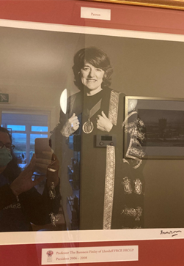
Only limited information on organisational setup and the incorporation of volunteers in specialised palliative care programmes was provided until recently (Woitha et al., 2015).
The Patron:
Professor the Baroness Finlay of Llandlaff FRCP, FRCGP. She is a professor of palliative medicine and works with cancer patients and their families. In addition, she teaches doctors about palliative care. She is regarded as the “Champion of palliative care.”
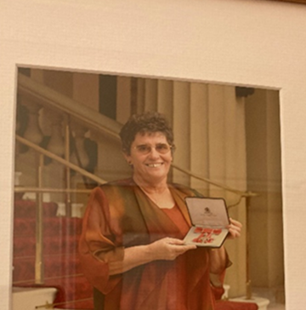
The founder:
Margaret Burnet M.B.E also founded the Pembrokeshire counselling service. Elizabeth nominated her for the MBE for Queens Community Nursing, Pembrokeshire Counselling Service and Shalom House.
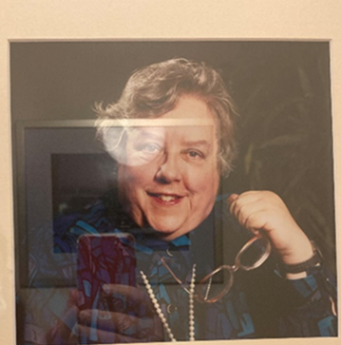
Elizabeth de Guise donated Shalom House to the people of Pembrokeshire for respite palliative care. A Mills and Boons writer, having written 80 novels, Elizabeth required a palliative care service but had to use one outside the county. So she left her house in charge of Margaret and bought another in Goodwick.

Own images used with permission by management (2021).

In 1997, a house on Nun Street in St David's was bequeathed to Shalom House. The house was renovated to meet Hospice requirements after a substantial fundraising effort. As a result, on 23rd November 2007, Shalom House welcomed its first patients.
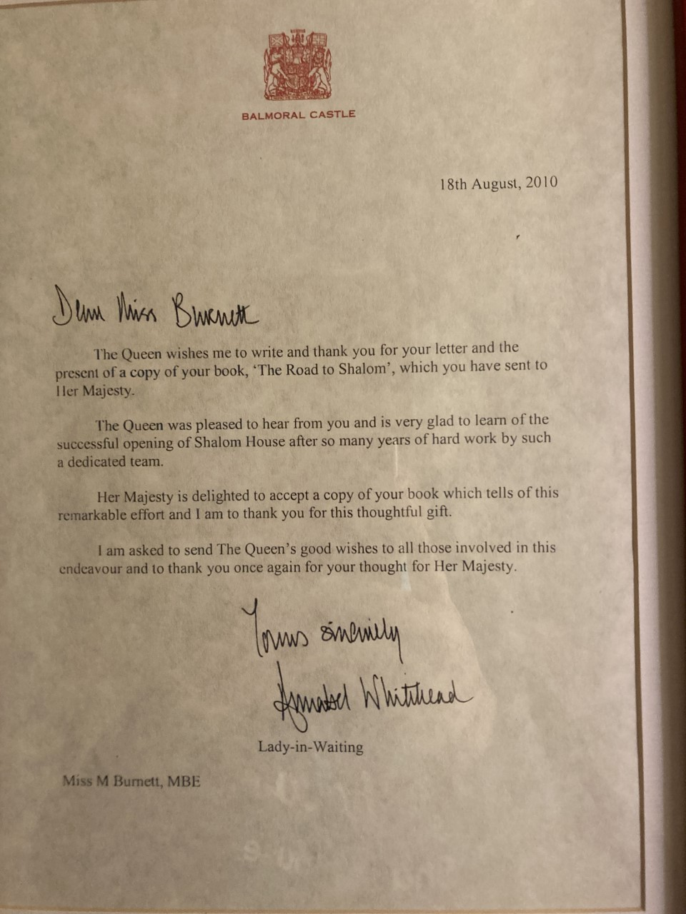
Own images used with permission by management (2021).

Section B: General Information:

This organisation relies on donations and fundraising events to acquire cars, conduct repairs, buy equipment, hire personnel, and maintain the house. Adults in Pembrokeshire who have been diagnosed with life-limiting illnesses can receive care and support from them. They also offer assistance to caregivers and their relatives. They want to make the lives of those who come to Shalom House more comfortable than they would be otherwise. They work to make it possible for people to do the things necessary to them. Help with a wide range of issues is available to those diagnosed with life-limiting illness – for example:
Day care, bereavement counselling, complementary treatments, day, and evening sitting services, and palliative care, within the community and the hospice for inpatients, are now included in the hospice's 'framework' of amenities (Watts, 2012).
- Symptom management such as fatigue reduction and pain control.
- Psychological support is offered for anxiety, tension, fear, and social isolation.
- We improve self-worth and body image, which are sometimes altered after surgery or chemotherapy.
- Complementary therapies are also offered as part of the programme of day care.
Relaxation, stress reduction, emotional calm, anxiety relief, and greater confidence and self-esteem benefit many of the complementary therapies we provide (Shalom House, 2021).

Social engagement, physical and emotional help, symptom management and evaluation, contact with a wide-ranging team, and support from the responsibility of caring on family caregivers are all benefits that have been documented (Hasson et al., 2021).

Section C: Application Form


113, Nun Street, St Davids, Haverfordwest, Pembrokeshire, SA62 6BP.
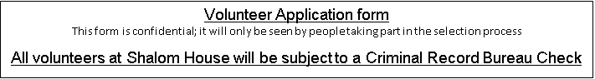
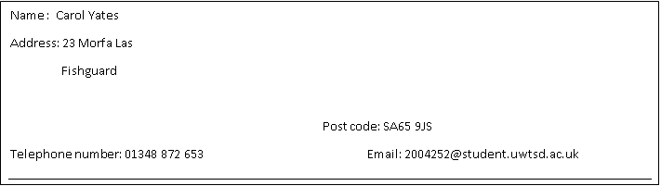
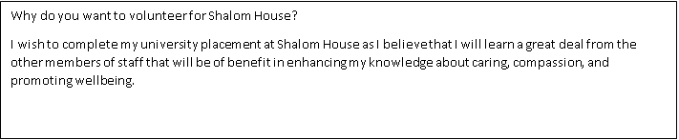
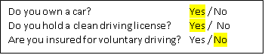
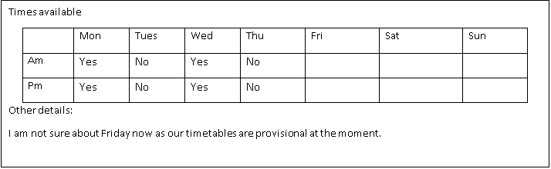
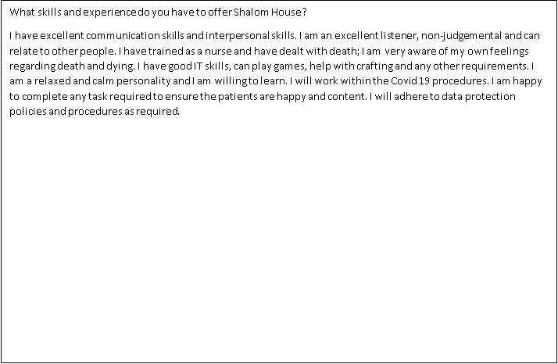
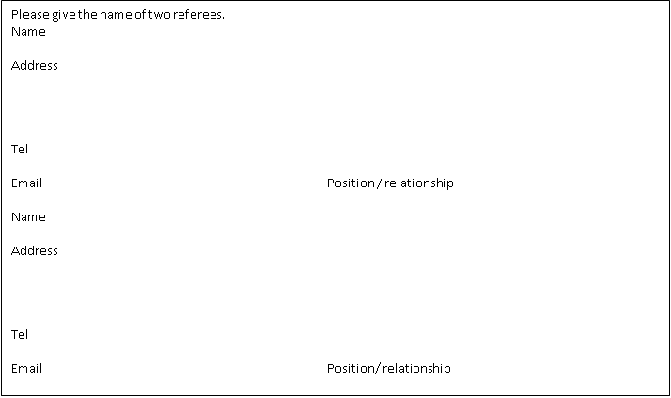

Section D: Covid Procedures

 Covid Procedure: Home Visits
The company are concerned for the welfare of those who use this service. As staff we do a PCR test every Thursday and a LFT test every day that we are on duty. The Welsh Government guidance is always upheld.
We want to make sure that the people we support, our staff and our visitors are as safe as possible during visits especially considering the Coronavirus pandemic.
To continue to support all who always use Shalom Houses services, including when in lockdown restrictions, we have developed the hospice at home service. This allows us to visit individuals within their own homes to provide respite, personal care, complimentary therapies, assessments, or advice.
The following procedures outline the process for staff and the Individuals they visit.
Our visits to Individuals homes:
- All visits with Shalom House must be pre booked at this time.
- All visits are to be recorded within the Nurses diary at Shalom House.
- All staff are to ensure they have their ID card clear for everyone to see / inspect if requested.
- All staff are to wear their uniforms for home visits.
- All staff are to ensure they have an ample supply of PPE, working thermometers, hand sanitiser and rubbish bags for all visits.
- You are to update your "Buddy" with the name, address, and contact details of your visit along with expected time of leaving, then please see "Lone Working".
- On the morning of the visit staff must telephone the Individuals they are visiting to check if anyone within the household has any covid symptoms.
- Staff are to carry out LFT each day they are working for / at Shalom House. Please see "Testing".
- Upon arrival, please record your temperature and those of anyone within the household during the visit in the notes.
- Staff are to ask again about covid symptoms and capture in the records the track and trace contact details of any guests present at any time during the visits.
- If any person's temperature is above 37 degrees, the visit is to end immediately and be rearranged for a minimum of 14 days later.
- Staff are to wear a mask and gloves throughout the duration of the visit.
- We ask, unless medically exempt that all others within the household wear a mask also.
- If Individuals or anyone present does not have a face covering, we can provide these.
- If possible, we ask that windows are open to provide good ventilation.
- Where / when possible social distances will be always maintained.
- If staff are supporting Individuals to leave their home and will be using a staff members / Shalom Houses car please also see the procedure "RVS, Shalom Volunteer / Staff Transport".
- Upon leaving the home staff are take used PPE and disposed of this safely, double bagged into household rubbish.
- Staff are advised to use hand sanitiser after removing used PPE.
- Staff are to update the Individuals records on the shared drive on the day of the visit.
- If you have any queries please do not hesitate to ask at any time.

Shalom House, 113 Nun Street, St Davids, SA62 6BP Tel: 01437 721344
Reviewed – 16/01/2022


Covid Procedure: Using RVS Transport,
Shalom House Transport or Staff Transport

We want to make sure that the people we support, our staff and our visitors are as safe as possible during visits to Shalom House at this time of the Coronavirus pandemic and are asking for your help by:
- Not attending your appointment if you have any Coronavirus symptoms (a new continuous cough, high temperature at or above 37 degrees, loss of taste and/or smell)
- Not attending your appointment if you have been in contact with anyone who has displayed symptoms of coronavirus, or who has confirmed to be coronavirus positive, in the 10 days prior to your appointment
- Not attending your appointment if you are feeling generally unwell, and/or have any other bacterial or viral infections symptoms (not just COVID-19), such as flu like symptoms or nausea, vomiting, diarrhoea or upset stomach.
- All / most of the attendees at Shalom Day Centre are particularly vulnerable due to have a immunocompromised system so we at Shalom House take all precautious available to us.
This is the procedure that attendees must follow when visiting at all times.
Your Visit
- All visits to Shalom House must be pre booked at this time.
- Day centre attendees are to be dropped off only, at this time due to limited numbers we are unable to have carers etc entering Shalom House.
- Attendees must have had their 2 vaccinees plus 3 waiting weeks after before they can attend Shalom House.
- If you need to bring someone with you, please let us know on 01437 721344 so we can factor in the additional numbers.
- A member of staff will telephone you on the morning of your visit to carry out a private, verbal covid risk assessment with you, they will ask about any symptoms you or your household may have before you make your journey to Shalom House.
- Please do not arrive at Shalom House unexpectedly. If you are early, you will be asked to wait in the car park and to return closer to your appointment time. This may be necessary to avoid groups of people waiting in small spaces
- Attendees are asked to arrive at 11am and our latest collection time is 3pm – Monday to Friday (excluding Bank Holidays). This is to allow for additional cleaning before and after attendees visit Shalom House.
- Attendees are to enter and exit via the main porch door only when arriving and leaving Shalom House.
- Upon arrival we will record your temperature, ask again about covid symptoms and track and trace contact details.
- Please wear a face covering from the time you enter Shalom House, unless you have a medical exemption, until you leave. If you do not have a face covering on arrival, we will provide you with one.
- Please apply hand sanitiser which can be found at the door, on tables, toilets and at key points throughout Shalom House.
- Please keep 2 metres apart and follow all displayed guidance and instructions – please ask a staff member if you are unsure of anything.
- Please use sanitiser gel at the entrance and exit and at regular intervals if you are unable to wash your hands.
- If you have any questions please ask, as we understand things are a little different at Shalom House at this time

Using Royal Voluntary Service (RVS) transport:
The RVS have put in place a policy which requires all attendees of Shalom House Day Centre to undertake a lateral flow test (LFT) on the day of travel.
We can support with providing these tests and show attendees how to carry the test out and register their test.
- Attendees are to be provided with a box of LFT prior to the day of attendance
- On the morning of attendance, a member of staff will telephone attendees to carry out a Covid 19 risk assessment, this is to confirm if you or any member of your household are free from Covid 19 symptoms prior to arrival at Shalom House.
- On the morning of the arranged visit the LFT will need to be carried out, please allow 30 minutes for the test to complete the result.
- Prior to accessing the RVS transport the driver will ask attendees to confirm the LFT result.
- Attendees, unless medically exempt, will need to wear a face covering throughout their journey.
- At this time car transport can only carry one attendee per car.
- Passengers are encouraged, if able, to have a car window open to allow for good ventilation.
- Should any attendees need gloves for the journey please let us know.

Using Shalom House transport:
The following applies to staff cars and for volunteer drivers using Shalom House car:
- Staff / volunteers are to ensure the car is cleaned before and after each attendee.
- On the morning of attendance, a member of staff will telephone attendees to carry out a Covid 19 risk assessment, this is to confirm if you or any member of your household are free from Covid 19 symptoms prior to arrival at Shalom House.
- Prior to accessing the transport attendee's temperature will be checked, Shalom House will not be able to transport any person with a temperature above 37 degrees.
- Attendees, unless medically exempt, will need to wear a face covering throughout their journey.
- Staff and volunteers will always wear a mask.
- At this time car transport can only carry one attendee per car.
- Passengers are encouraged, if able, to have a car window open to allow for good ventilation.
- Should any attendees need gloves for the journey please let us know.
- Staff / volunteer drivers are to ensure the car is cleaned with cleaning supplies provided and soft furnishings sprayed in line with product instructions.
If you have any questions about your visit please contact Shalom House as soon as possible on 01437 721344.
Also if you have any specific requirements, please contact us in advance.
Many thanks in advance for your understanding and assistance
Shalom House, 113 Nun Street, St Davids, SA62 6BP Tel: 01437 721344
13th July 2021 - DH



Covid Procedure: Testing Positive – Staff & Household
Any staff member who receives a positive test result (either LFT or PCR) is not to come into Shalom House or attend any home visits or to support any Individual but are to self-isolate immediately.
This is the procedure I must follow if any of my family members or I test positive.

The staff member is to update the Manager immediately who will contact Public Health Wales who will contact TTP and if required Pembrokeshire County Council Environmental Health and Hywel Ddas Community Infection Control teams.
The Manager will update the rest of the team and Trustees at all times as advise is received.
23rd July 2021 - DH

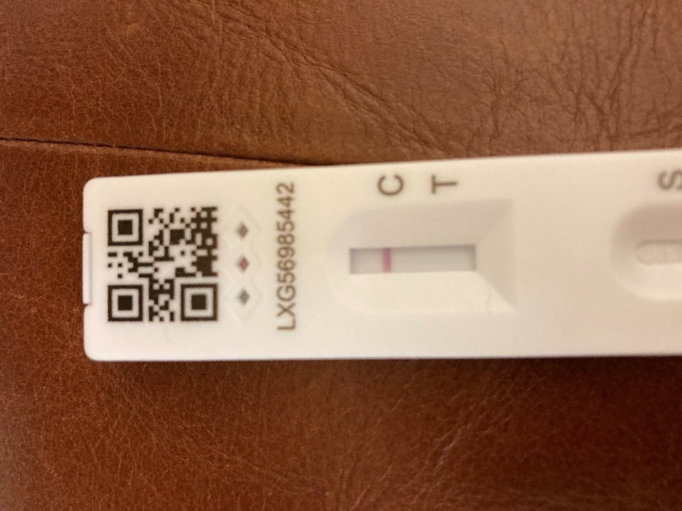
Own images used with permission by management (2021).

Evidence 2: Reflective Logs

Below is a collection of submissions from my reflective logbook about the organisation I elected to represent in my placement. They describe the various activities I completed and my sentiments and thoughts during the process.
 Placement logbook

Student Work Placement Logbook

Logbook
Student Name: | Carol Yates
Name of Host Employer: | Donna Humphreys

Record of project work carried out (add more entries as needed)
Volunteers find their job stimulating and fulfilling, and often emphasise the reciprocal aspect of volunteering by claiming to gain as much as they give (Scott et al., 2021).

Date: | 01/11/2021
Tasks completed: | - A staff meeting.  - Tested the hoists to make sure they were operating correctly.  - I learnt how to operate the fire alarm.  - Learnt about running the taps after the weekend to check for Legionnaire's disease.  - I met the patients and all the staff.  - I sat with the patients, found out how they were all doing, and had a general chat.  - I had lunch with the patients.
Reflection: | I was excited to find out exactly what needed to be done in this position. I had an idea but not entirely. It was lovely to meet all the staff, and they seem to be fantastic people. We had a meeting in the morning in which we found out more about the patients and their conditions. Then I carried out the morning checks by shadowing the staff, and then we waited for the patients to arrive. There were three patients in today, and it was lovely finding out more about them. Patient no 1 arrived 20 minutes early, and Donna came down to ask a question and saw him. She was not pleased as patients are meant to arrive at 11 am and not before due to the Covid procedures. Patient no 2 arrived next, followed shortly by patient no 3. Patient no 1 had his toenails trimmed, and oils rubbed into his feet by Grace. I was told that I would not be allowed to do this as I was not trained. Patient no 3 has a bath in the unique bath and Grace, and Bob help him to do this. However, this is another task I am not able to fulfil. During this time, I spoke with the other patients in attendance to get to know them better. Both were very friendly and willing to talk to me without hesitation. Not an in-depth conversation as this was the first meeting. After that, we had lunch with the patients. Izzy, the nurse, came down and brought a crossword puzzle book. We all answered questions and had some fun doing this, which the patients and staff enjoyed. Patient no 1 left first, followed by patient no 2 when his lift arrived and then patient no 3's wife came in to say hi and collect his things, and Bob helped him get into the car. When I was leaving at 3 pm, Donna asked me to remind the staff that a meeting with the shareholders was happening that afternoon and that the patients had to have left by the time they started to arrive. I passed the message on, said goodbye to the staff members, and left.
Our findings show the importance of providing volunteers with continuing assistance to help them cope with the challenges of helping in a palliative care context according to BEASLEY et al. (2015).

Date: | 08/11/2021
Tasks completed: | - A staff meeting.  - Tested the hoists to make sure they were operating correctly.  - I ran the taps after the weekend to check for Legionnaire's disease and then switched them all off.  - I sat with the patients, found out how they were all doing, and had a general chat.  - I had lunch with the patients.
Reflection: | I was looking forward to another productive day. I found out that three of the patients were not attending today in the staff meeting. Izzy spoke about a patient needing to have a DNACPR in their file as they had expressed a wish for this. Izzy asked if I understood what this acronym meant, and I said that this was a do not resuscitate wish that a patient had, and she added that it was to avoid chest compressions. I explained that I had trained to be a nurse, so I understood what she meant. I then carried out the Legionnaire's checks by running all the taps, and then Donna had a bit of a panic as the taps upstairs had no water. We switched all the downstairs taps off, and the water flowed upstairs, panic averted. I went around and tested all the hoists. After this, I went and folded the dry towels and sheets in the stock room and placed them in the cupboard where they are kept after asking Bob if this is where they needed to go (Covid procedures may have meant they needed to be in a different area for a period). Patient no 1 arrived slightly early again and got settled. Izzy did reflexology on his feet which was fascinating to watch, and then, patient, no 3 arrived. I helped patient no 3 take his coat off and sit down in his chair. We all chatted, and the patients showed us some videos and photos. I had lunch with patient no 1 and made him a cup of tea. Patient no 3 had gone for a bath with Grace and Izzy but ate his lunch when finished. Today I worked with Grace as Bob was off. I had another conversation with Izzy about the advance care planning service that Shalom House offer, and she explained what this was for. She gave a pamphlet to me to have a look over, and afterwards, we spoke about it, and I asked if I could take this home to show my mum. She then told me to look at Paul Satori's website as there were more details on here.
Volunteers in palliative care have been observed to have traits like agreeableness, extraversion, empathy, and emotional toughness. They acquired personal gain, progress, fulfilment, and a better awareness of what is significant in life as a result of their volunteer work (Söderhamn et al., 2017)
Date: | 15/11/2021
Tasks completed: | - A staff meeting.  - Tested the hoists to make sure they were operating correctly.  - After the weekend, I went running the taps to check for Legionnaire's disease and then switched them all off.  - I sat with the patient, found out how he was doing and had a general chat.  - I had lunch with the patient.
Reflection: | Today Izzy was off, so Linda, the nurse, was on shift. In the meeting, I discovered that only patient no 3 would be attending as patient no 1 had changed days, and patient no 2 was still away. Patient no 4 came and had a meeting but did not stay. It was lovely to meet her and speak to her. Patient no 3 had his bath as usual, and I spent time with patient no 4 while she waited for her meeting to start. After his bath, we all had lunch, and then Grace cut his toenails and put oils on his feet while we all just chatted until his wife arrived just before 3 pm to collect him.

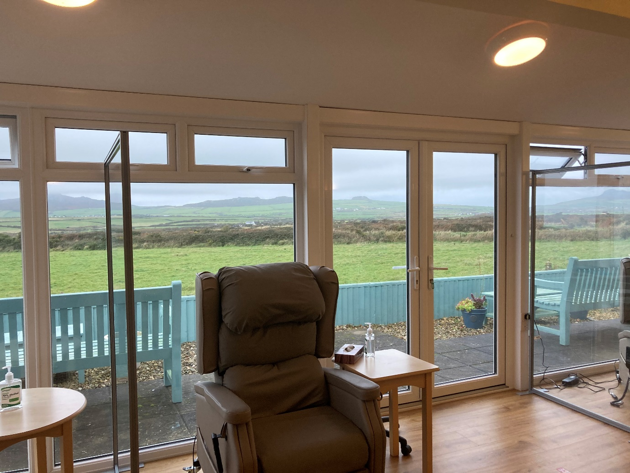

Own images used with permission by management (2021).

Evidence 3: Volunteering Process

Section A: Volunteering opportunities:

Shalom House relies on public members to volunteer their time to this service. They have a few members of paid staff. I am a Palliative Care Centre Volunteer and provide a service to those individuals who use the day centre service. According to Lunt et al. (2021), a day centre is a respite for carers more than those who use them.

Volunteer
We have a fantastic team of Volunteers at Shalom House, who give up their time to support individuals with life-limiting illnesses. They help in so many ways including volunteering in our shops, providing company to patients, helping in the kitchen and garden, and complementary therapy. The time and care that they provide make such a difference to the lives of the people we support at Shalom House.
Shop Volunteers Fishguard
Shop Volunteers St Davids
Shop Volunteer – Stock co-ordinator, Goodwick
Online Retail Volunteer
Palliative Care Centre Volunteer
Complimentary, Beauty and Diversion Therapist Volunteer
Volunteer in Events and Fundraising
Volunteer to drive/organise
Corporate Volunteering
How to apply?
These are the various places that you can volunteer at with Shalom House. Click on the blue heading and it takes you to the relevant information on the website.
Shop Volunteers Fishguard
We currently have vacancies for Volunteers in our Charity Shop, on West Street in Fishguard. Volunteers get involved in a variety of activities including:
• Stock sorting
• Visual Merchandising
• Sales Assistant
Shop Volunteers St Davids
We will be opening a new Charity Shop in St David's in October 2019 and we are keen to recruit a team of volunteers to be part of this exciting venture.
Volunteers will have the opportunity to get involved in a variety of activities including:
• Stock sorting
• Visual Merchandising
• Sales Assistant
The charity shop is already operational in St David’s. This has not been updated on the website even though the site has been updated in 2021.
Shop Volunteer – Stock co-ordinator, Goodwick
To work in our new storage facility at the Frame premises in Goodwick. This is not a customer-facing role, but will be key in receiving, assessing, and sorting stock for our retail outlets.
Online Retail Volunteer
As we develop our online retail sales we are looking for somebody experienced in eBay and photography with a keen eye for quality/branded items. This is an ideal role for a student, somebody with some spare time on their hands or somebody with transport or mobility issues.
Palliative Care Centre Volunteer
We are always looking for extra support at our Palliative Care Centre in St David's. We are keen to find Volunteers who can chat to patients, help in the kitchen or the garden. This role will require volunteers to submit to a DBS check.
Complimentary, Beauty and Diversion Therapist Volunteer
We welcome applications from suitably qualified complimentary and beauty therapists to join our team of volunteers.
If you possess a skill or interest that you feel could be easily shared in short sessions with our patients or carers, we would like to hear from you.
All the above roles require volunteers to submit to a DBS check
Volunteer in Events and Fundraising
Shalom House relies upon donations to help support the costs of providing palliative care in Pembrokeshire. We, therefore, run several events and fundraising activities throughout the year and would welcome the support of volunteers to help us run and administer our events.
Volunteer to drive/organise
We seek expressions of interest from individuals willing to drive or organise drivers/journeys once we secure our vehicle. Drivers will need to submit to a DBS check, first aid and manual handling and lifting training. The roles may involve transporting patients or on other occasions stock for our shops.
Corporate Volunteering
Would your team be interested in a short volunteering opportunity at Shalom House? We often have opportunities for painting, gardening, event marshalling, or fundraising challenges.
How to apply?
If you would like more information about any of the roles or would like to apply, please email info@shalomstdavids.org for more information or complete an application form. Alternatively, please call 01437 721 344 for more information.

Shop volunteer application
These are the application forms to apply with. I however, contacted them via email for my placement and then a form was sent to me via email for completion.
1 file(s) 121.59 KB
DOWNLOAD

House volunteer application
1 file(s) 123.63 KB
DOWNLOAD

According to Whittall et al. (2016) volunteering is known to enhance and increase the range of services that nurses may provide. Volunteers in palliative care, according to literature from Australia and the United Kingdom, react to the social, emotional, and practical aspects of care that professionals do not have time for, ultimately prolonging and enhancing the quality of life.

Section B: Required Skills

The skills I have used within my work at Shalom House are as follows:
- Empathy (Midwinter & Dickson, 2015): People told me about their diagnosis, sick or deceased family members, the suffering and anguish they are going through, and their shock or disbelief at their state. I can relate to them because I have experienced similar feelings.
- Congruence (McLeod, 2019): the ability to be open, truthful, non-judgmental, and genuine. I do not pretend to understand, but I pay close attention to the person having problems speaking.
- Self-disclosure (McLeod, 2019): I recognise how it feels to be in constant agony.
- Unconditional positive regard (Midwinter & Dickson, 2015): Accepting all points of view, always being courteous, and spending time talking to patient no 3, who has difficulties communicating so that he feels included.
- Attentiveness (Midwinter & Dickson, 2015): Attending to what the person is saying and how they are saying it. Recognise when a response is needed.
- Silence (McLeod, 2019): Identifying whether a person wants to converse or be alone, or if they are immersed in their thoughts or dealing with emotions.
- Listening (McLeod, 2019) focuses on the other person's verbal and nonverbal communication.

References:

Beasley, E., Brooker, J., Warren, N., Fletcher, J., Boyle, C., Ventura, A., & Burney, S. (2015). The lived experience of volunteering in a palliative care biography service. Palliative & supportive care, 13(5), 1417-1425. https://doi.org/10.1017/S1478951515000152
Hasson, F., Jordan, J., McKibben, L., Graham-Wisener, L., Finucane, A., Armour, K., Zafar, S., Hewison, A., Brazil, K., & Kernohan, G.W. (2021). Challenges for palliative care day services: A focus group study. BMC Palliative Care, 20(1), 11. https://doi.org/10.1186/s12904-020-00699-7
Lunt, C., Shiels, C., Dowrick, C., & Lloys-Williams, M. (2021). Outcomes for older people with long-term conditions attending day care services delivered by paid staff or volunteers: A comparative study. Palliative Care & Social Practice, 15(1), 1–15. https://doi.org/10.1177/26323524211030283
McLeod, J. (2019). An introduction to counselling and psychotherapy: Theory, research, and practice (6th ed.). Open University Press/McGraw-Hill Education.
Midwinter, R., & Dickson, J. (2015). Embedding counselling and communication skills: A relational skills model. Routledge.
Scott, R., Goossensen, A., Payne, S., & Pelttari, L. (2021). What it means to be a palliative care volunteer in eight European countries: A qualitative analysis of accounts of volunteering. Scandinavian Journal of Caring Sciences, 35(1), 170-177. https://doi-org.ezproxy.uwtsd.ac.uk/10.1111/scs.12832
Shalom House. (2021). Palliative Care Centre. https://www.shalomstdavids.org/
Söderhamn, U., Flateland, S., Fensli, M., & Skaar, R. (2017). To be a trained and supported volunteer in palliative care - a phenomenological study. BMC Palliative Care, 16(1), 18-18. https://doi.org/10.1186/s12904-017-0193-0
Watts, J. (2012). The place of volunteering in palliative care. IntechOpen.
Woitha, K., Hasselaar, J., van Beek, K., Radbruch, L., Jaspers, B., Engels, Y., & Vissers, K. (2015). Volunteers in palliative care – A comparison of seven European countries: A descriptive study. Pain Practice, 15(6), 572–579. https://doi.org/10.1111/papr.12209
Whittall, D., Lee, S., & O'Connor, M. (2016). Factors affecting rural volunteering in palliative care - an integrated review. The Australian Journal of Rural Health, 24(6), 350-356. https://doi.org/10.1111/ajr.12313

Appendices:

Appendix A: Permission to commence placement
RE: Placement form
Ruth Groff <ruth.groff@uwtsd.ac.uk>
Thu 07/10/2021 15:59
To:
- Carol Bridget Yates (2004252) <2004252@student.uwtsd.ac.uk>
Hi Carol, thanks for sending… you are good to go… Ruth
Cofion Cynnes,
Ruth

Ruth M Groff MPS MA FHEA BACP Registered Accredited Member
Programme Manager: M.A. Advanced Counselling Theory and Research
Yr Athrofa | Institute of Education and Humanities – Academic Discipline of Psychology and Counselling
Prifysgol Cymru Y Drindod Dewi Sant | University of Wales Trinity Saint David
SA1 - Campus
Abertawe | 1 Swansea

Ffon | Tel: 01792 482106
e-bost | email: ruth.groff@uwtsd.ac.uk

Appendix B: Correspondence to secure the placement
RE: University placement
Donna Humphrey <donnahumphrey@shalomstdavids.org>
Fri 17/09/2021 10:54
To: Carol Bridget Yates (2004252) <2004252@student.uwtsd.ac.uk>
Cc: Sam Wilson-Croft <samwilsoncroft@shalomstdavids.org>; Donna Humphrey <donnahumphrey@shalomstdavids.org>
RHYBUDD: Deilliodd yr e-bost hwn o du allan i system E-bost Prifysgol Cymru Y Drindod Dewi Sant. Peidiwch ag ateb, na chlicio ar ddolenni nac agor atodiadau oni bai eich bod yn adnabod cyfeiriad e-bost yr anfonwr ac yn gwybod bod y cynnwys yn ddiogel.
WARNING: This email originated from outside University of Wales Trinity Saint David's Email System. Do not reply, click links or open attachments unless you recognise the sender's email address and know the content is safe.

Good morning Carol,

Apologies for the delayed reply, but I am on annual leave until Monday.

I believe this is something we can support you with.

To keep the process moving forward, please see below.

As we work with immunosuppressed individuals, you will need to have had/agree in writing to the following:

- 2 vaccinees plus two waiting weeks
- Continue with any booster programme for Covid 19 vaccinations
- Carry out and register LFT tests for each day you are on placement
- Carry out and resister, a weekly PCR test, held every Thursday
- Wearing of PPE at all times
- Wearing of your student ID at all times
- Wearing of clean uniform at all times
- Adhere to all Covid 19 procedures while on placement

I will need to see your DBS – you are welcome to scan/photo and send over if that helps and, if possible, any verification/letter from your university to confirm your identity and placement on the course, including Tutor contact details.

I will ask Sam (Business Manager) to forward an application form to be completed – mainly, so we have your contact details etc., nothing too in depth.

The day centre is open Monday to Friday, 9 am to 4.30 pm patients attend from 11 am to 3 pm, to allow for enhanced cleaning, and it is closed over the Christmas period, so that will hopefully provide the opportunity for you to complete your placement hours.

If you can send over a mobile number, I will call you on Monday so we can speak in more detail as I appreciate I have requested quite a lot in one email!

Thanks and have a lovely weekend,

Cofion Cynnes / Kind Regards

Donna Humphrey
Rheolwr Gofal Cofrestredig/ Registered Care Manager
Tŷ Shalom / Shalom House
113 Nun Street
St Davids
Pembrokeshire
SA62 6BP
Ffon/Tel: 01437 721344
www.shalomstdavids.org
www.facebook.com/ShalomHousePCC

From: Carol Bridget Yates (2004252) <2004252@student.uwtsd.ac.uk>
Sent: 16th September 2021 11:59
To: Donna Humphrey <donnahumphrey@shalomstdavids.org>
Subject: University placement

Dear Donna,

My name is Carol Yates, and I am a mature student at the University of Wales Trinity Saint David, on the BSc Psychology and Counselling degree. As discussed, I have included the details of the placement. I am required to have a placement within an organisation that allows me to gain exposure to, or observe, practices involved in supporting human care.

In the Level Five Counselling Skills and Approaches module, I am required to undertake the equivalent of a 20-day/120hrs placement (to be negotiated concerning ongoing issues with COVID19). The hours can occur between September and January, and I will negotiate these with you once a placement has been agreed upon. Will a DBS be required?

Please note that this will not be an assessed placement in that there will be no visits from tutors. All that is required is to complete an attendance form at the end of my placement. Once agreed, I will complete a form and forward this to my lecturer, and you will receive an email from the university to confirm the placement.

I look forward to hearing from you.

Kind regards,
Carol Yates

Appendix C: Placement Diary Dates
Below are the diary dates of the days I did or did not attend Shalom House. The gap from December to January is due to the Christmas holiday period.
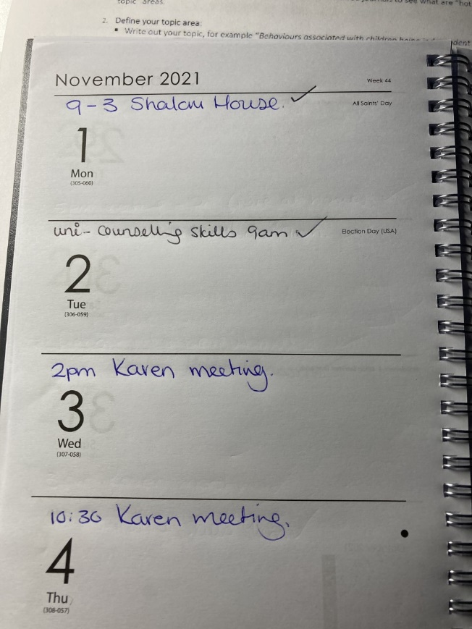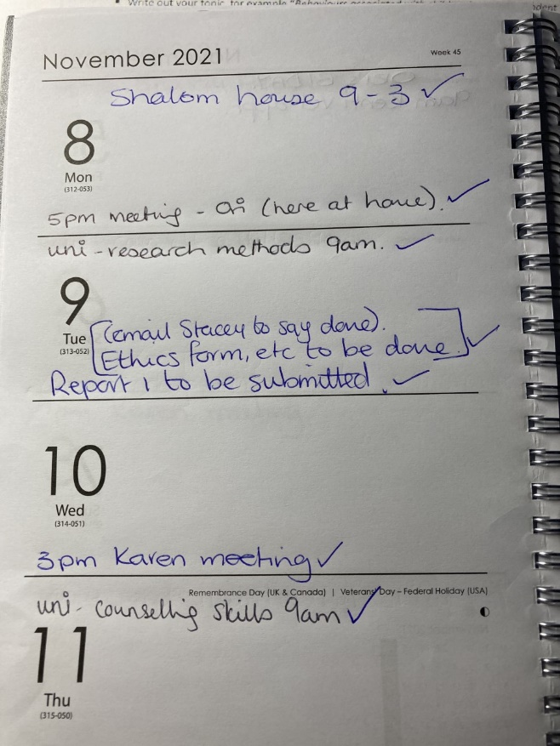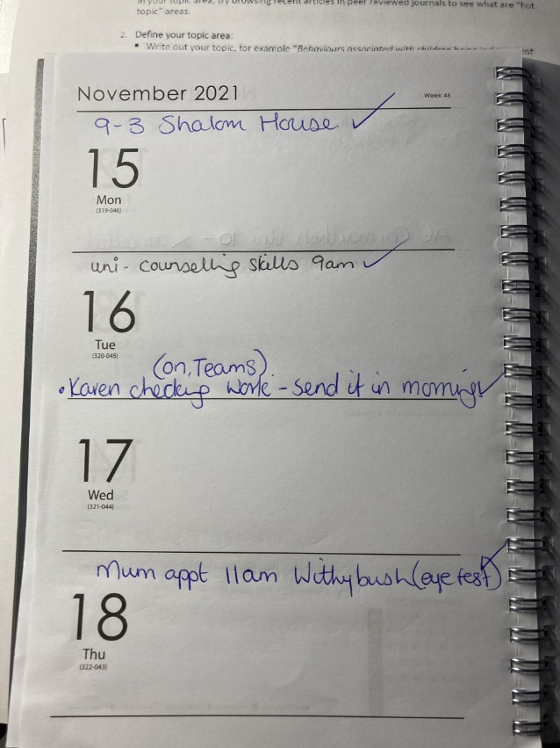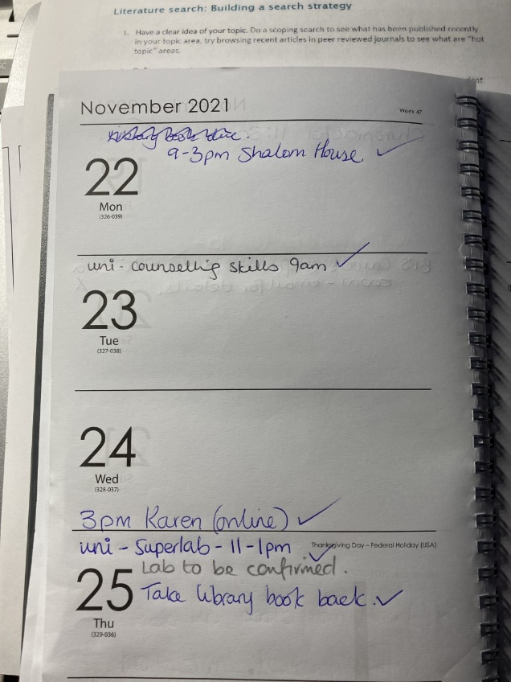
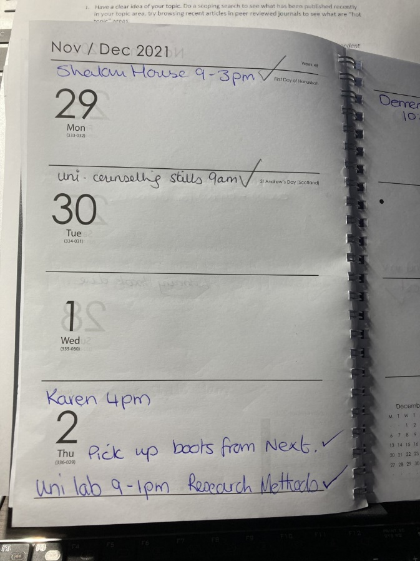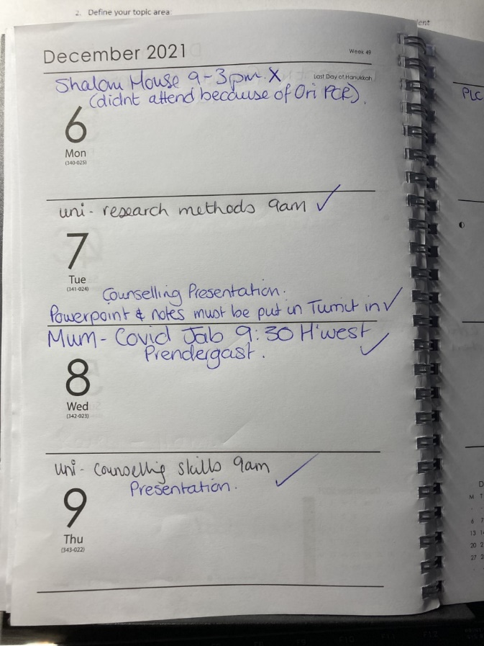
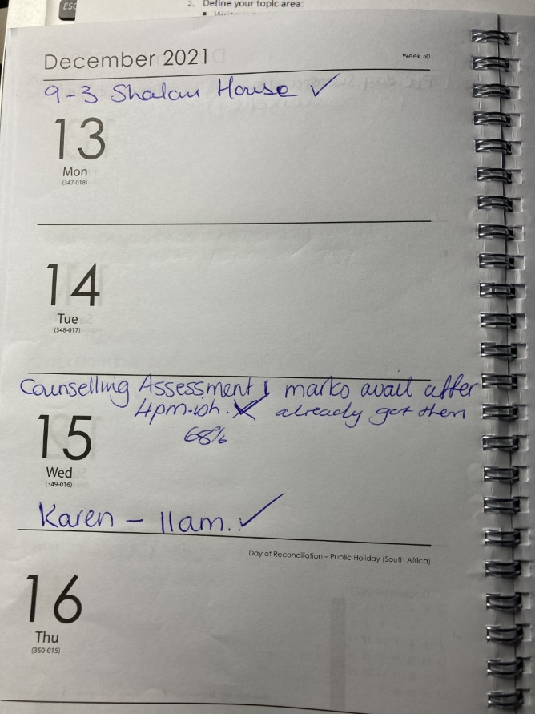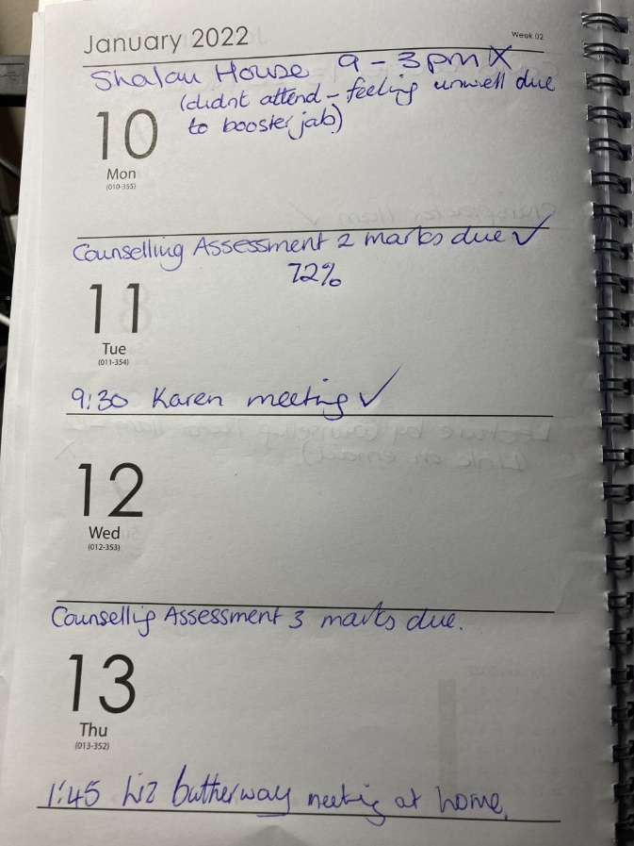
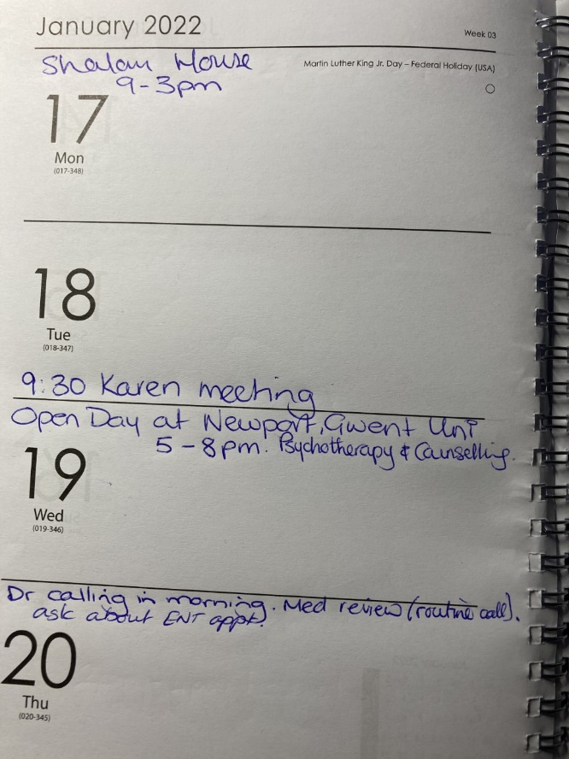

Appendix D: Covid Procedures Email

Shalom - Testing - VERY IMPORTANT read all
DH
Donna Humphrey <donnahumphrey@shalomstdavids.org>
Tue 26/10/2021 14:33
To: Carol Bridget Yates (2004252)
Cc:
RHYBUDD: Deilliodd yr e-bost hwn o du allan i system E-bost Prifysgol Cymru Y Drindod Dewi Sant. Peidiwch ag ateb, na chlicio ar ddolenni nac agor atodiadau oni bai eich bod yn adnabod cyfeiriad e-bost yr anfonwr ac yn gwybod bod y cynnwys yn ddiogel.
WARNING: This email originated from outside University of Wales Trinity Saint David's Email System. Do not reply, click links or open attachments unless you recognise the sender's email address and know the content is safe.

Subject: Testing - VERY IMPORTANT read all

Hi Carol,

Re: Shalom House – Covid testing.

LFT testing - We all carry out a lateral flow test every day that we are working at Shalom House.
PCR testing - We all carry out PCR testing every Thursday.

Staff register their own tests here:

LFT: Report a COVID-19 rapid lateral flow test result - GOV.UK (www.gov.uk) – you can create an account which speeds the process up.

PCR: Register test kits for your organisation - GOV.UK (coronavirus-testing-for-organisations.service.gov.uk)

Our UON is: 99922221

Please read following carefully:

PCR testing:

- Staff are to do their own PCR test on Thursdays every week – not before
- Check barcode on outside of box matches barcode on the label and on the tube – then please write your name and time of test on the spare loose barcode.
- Please seal tube, bag and box and apply security label.
- Please take a photo of the barcode including your initials / time / date of test.
- Please email this photo to me at: donnahumphrey@shalomstdavids.org
- Staff are to then pop their PCR test into a priority post box – no later than one hour before last collection – further details here: Services near you | Royal Mail Group Ltd

LFT testing:

- Staff are to carry out their LFT every day they are working at Shalom.
- As with the PCR testing, please take a picture of the barcodes before coming to Shalom
- Please then email this picture to me at: donnahumphrey@shalomstdavids.org
- Staff are to also register this test online.

Please always ensure you have tests to use, update me when you have less than a weeks supply, PCR tests are easy to keep track of but we all work different shift patters so LFT I need staff to let me know when they are running low.

Thanks

Donna

Donna Humphrey

Registered Care Manager
Shalom House
113 Nun Street
St Davids
Pembrokeshire
SA62 6BP

01437 721344
info@shalomstdavids.org
07796170941



Appendix E: Placement Information Form

Attendance Form
Placement/Work Experience
To be completed by the Placement/Work Experience Setting
Name of Student | Carol Yates
Name of Organisation | Shalom House
Dates: Start Date  End Date  Or Continuing | 1st November 2021  TBC - continuing
Name of individual completing this form.  Please also state your position. | Donna Humphrey  Registered Manager
Please could you answer the following questions about the student:
How was the student's time keeping? Good

How was the student's performance? Satisfactory

Please provide any other information you consider may be of assistance regarding the perfomance of this student.

I discussed this with the team members who work alongside Carol the following was their feedback:

In our opinion Carols performance was / is satisfactory, she did not seem to be able to convey her objectives for her time at Shalom so we were a little unsure of how to 'mentor' her.

Carol has spent time sitting with the patients & they appeared to accept her presence, but she did not appear to show much interest in palliative care or empathy towards them.

We found her rather lacking in enthusiasm and she showed little if no initiative.
We are unsure if Carol has / is achieving her goals during this learning opportunity but hope she is enjoying her time observing the holistic care we give to our patients.

Carol was pleasant enough to staff and patients and appeared to understand when asked the importance confidentiality

Signature: D.Humphrey Date: 06/01/2022
/Can use Ecletronic Signature/

Please return this form to Ruth Groff - ruth.groff@uwtsd.ac.uk

