Please delete the box below and replace it with an “appropriate” passport style photograph that clearly shows your face. Your photo should be roughly the same size as the box:

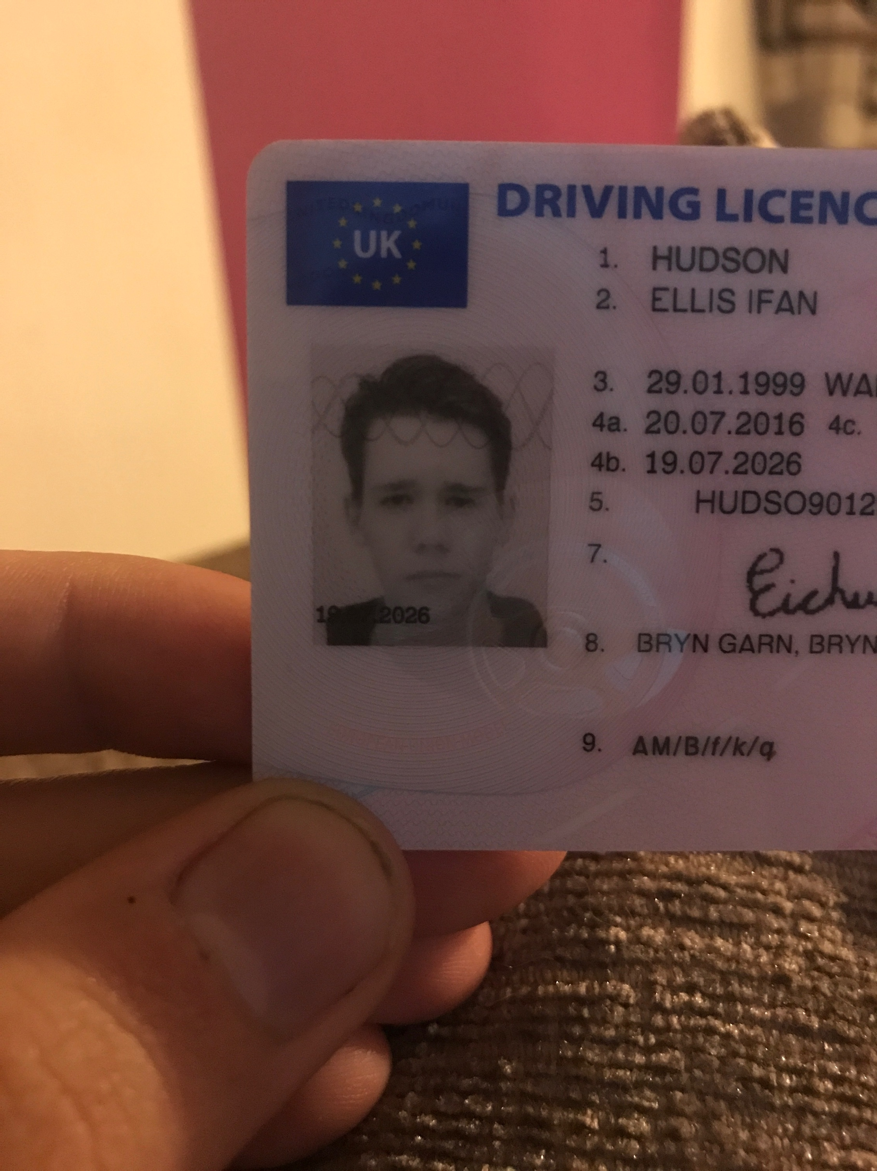

Name: Ellis Hudson

Student number: 1701612

Student email address: 1701612@student.uwtsd.ac.uk

Contact number: 07946604574

Please use the remaining space to give a brief outline of why you have chosen your course of study and any relevant special interests or experiences:

I chose PE as my chosen subject because it has always been my aspiration to become a teacher. I’ve always excelled in the practical side of PE and enjoyed the theory side when introduced to it. Rugby has always been my chosen sport achieving honours playing for various teams, I also played football for Carmarthen county when I was younger but chose rugby when I had to choose between them.

