Leadership and Change

by

2241356

Simon Worth

INSTITUTE OF MANAGEMENT AND HEALTH

15th March 2024.

Table of Contents:

Introduction 3
Section1: Culture 3
Section 2: Challenges 8
Section 3: Recommendations 14
References: 22
Appendix 1 32
Change management theories 32
Appendix 2 33
5 Why’s model 33
Appendix 3 34
PEST analysis 34
Appendix 4 37
Iceberg Theory 37

Introduction
Offering context, the author, a senior paramedic with the Welsh Ambulance Service Trust (WAST), has dedicated approximately 17 years to volunteering or working within the pre-hospital arena. WAST, a commissioned service caters to approximately 3 million people in Wales, spans diverse landscapes, including urban, coastal, and rural areas. Responding to over 250,000 emergency calls annually, WAST boasts a staff of 2600 (WAST 2023). The Senior Paramedic (SP) role is relatively new, having been established for three years. The incorporation of the SP concept aligns with the 'clinical vision' integrated into WAST's long-term strategic plan for clinical leadership (WAST 2022). The primary responsibility of the SP involves active clinical engagement with staff to ensure the secure delivery of ambulance care within their respective clinical teams.

Section1: Culture
Organisational culture plays a crucial role in the success or failure of change initiatives within an organisation and often refers to the shared values, beliefs, and behaviours that shape the way individuals within an organisation interact and work together (Cole et al., 2020). It is an important aspect of an organisation's identity and will influence how employees perceive their work environment (Green, 2007). In addition, organisational culture plays a crucial role within change management, as it directly impacts how well employees adapt to and embrace changes (Irina et al., 2021). Organisational culture is often manifested through symbols, rituals, language, and the overall climate within the organisation. One key element of organisational culture include values, where these are core principles and beliefs that guide the actions and decisions of individuals within the organisation (Voehl and Harrngton, 2016). Equally there are beliefs that are shared convictions and understandings that shape the organisation's identity and influence employee behavior (Haslem et al., 2022), which may also be symbols that are tangible representations, such as logos, uniforms, brand identity that embody the organisation's culture (Smith et al., 2014). Furthermore, shared terminology and communication styles that reflect the organisation's culture will positively embed the employee within an organisation (Voehl and Harrngton, 2016). Encouraging strong and positive organisational culture can facilitate smooth transitions during change initiatives by fostering collaboration, communication, and a sense of purpose (Green, 2007). On the other hand, a resistant or negative culture may impede change efforts, leading to increased resistance, employee dissatisfaction, and the potential for project change failure (Martinelli and Milosevic, 2016). Effectively managing organisational culture during change involves understanding existing cultural norms, aligning them with the desired change initiative, and implementing strategies to shift the culture in a way that supports the organisational objectives (Hayes, 2014). This includes two-way leadership communication, employee involvement, and addressing any cultural barriers that may hinder the change process. Ultimately, a harmonious relationship between organisational culture and change management is essential for achieving successful and sustainable organisational transformations (Kottler 2018).

Change management is a structured and intentional approach to transitioning individuals, teams, and organisations from their current state to a desired future state. It involves planning, implementing, and reinforcing changes to achieve organisational objectives while minimising resistance and maximising employee engagement (Olson and Simerson, 2015). Some suggested key elements of change management include clearly defining the desired future state and developing a strategic plan to achieve it. Involving and aligning leadership to champion change and communicate its importance. Transparent and effective communication to keep stakeholders informed about the change, its reasons, and its progress. Engaging employees in the change process, seeking their input, and addressing concerns will help build buy-in. Training and development to provide the necessary skills and knowledge to employees to adapt to the changes successfully. Sensible and tangible measurement and feedback will help establish change metrics to track progress and gather feedback to continuously improve the change management process. Considering and aligning the change initiative with the existing organisational culture to ensure cultural compatibility. (Lussier and Ache 2010).

Both organisational culture and change management are interconnected, as successfully implementing change often requires an understanding of and alignment with the existing cultural norms within an organisation (Green, 2007). Ignoring or neglecting the cultural aspect can lead to resistance and hinder the success of change initiatives. Some organisations may have a ‘Clan-like’ culture that is characterised by a family-like environment where the organisation feels like an extended family (Lussier and Ache 2010). It emphasises collaboration, mentorship, and a sense of loyalty among employees. Decision-making tends to be participative, and there is a strong focus on employee development. This can lead to high employee morale, strong teamwork, open communication, and a supportive work environment, but may face challenges in adapting to external changes due to a potential resistance to innovation and risk-taking (Voehl and Harrngton, 2016).
In addition, there may be an adhocracy culture that is dynamic, entrepreneurial, and innovative. Organisations with adhocracy cultures are characterised by creativity, risk-taking, and a focus on experimentation. Decision-making is decentralised, and employees are encouraged to think outside the box (Lussier and Ache 2010). This allows for innovation, adaptability to change, and a willingness to take risks, however, it does lack stability, potential for chaos, and difficulty in maintaining consistent processes (Smith et al., 2014).
Some organisations may have a ‘market-culture’ that is results-oriented and competitive. Organisations with a market-culture prioritise achievement, measurable outcomes, and competitiveness, not only against competitors but also within the organisation itself. Emphasis is placed on meeting targets, winning in the marketplace, and outperforming competitors. These allow for tangible goal achievements, competitiveness, and a strong focus on performance. Nonetheless, there is potential for a cutthroat environment, lack of collaboration, and challenges in employee morale (Erçetin and Potas 2019), not to mention the social and ethical responsibility that this culture can brings (Lu et al., 2020).
In larger organisations, a hierarchy culture is often found and is characterised by a structured and formalised work environment. Organisations with a hierarchy culture have clear lines of authority, well-defined roles, and a focus on efficiency. Decision-making is often centralised, and there is an emphasis on stability and control, with clear roles and responsibilities, efficient processes, and stability, it does however lack flexibility and has the potential for slow decision-making, and is often resistance to change (Harrison, 2018).

It has been suggested that each type of organisational culture has its own strengths and weaknesses, and the effectiveness of a particular culture depends on the organisational context and its alignment with the overall business strategy (Chalmers and Brandon, 2023). Organisations often need a blend of these cultures to thrive, and the challenge lies in striking the right balance. For instance, a clan-culture may foster a positive work environment but might struggle with adaptability, while an adhocracy culture excels in innovation but may face challenges in maintaining stability (Lee and Ding, 2022). Organisations need to critically assess their goals, industry demands, and internal-dynamics to determine the most suitable culture or combination of cultures for sustained success (Voehl and Harrngton, 2016). Additionally, the ability to transition between cultures or cultivate a culture that adapts to changing circumstances is crucial in today's dynamic business environment (Errida and Lotfi, 2021).

The existing organisational culture serves as the foundation for change initiatives, where the level of receptivity, resistance, and overall success of a change effort is often influenced by the prevailing culture. A positive and supportive culture can facilitate smooth transitions, while a negative or resistant culture will impede progress (Lam, Nguyen and Tran, 2021). For context, in a clan-culture where collaboration and employee engagement are valued, introducing a change initiative that emphasises teamwork and innovation may encounter less resistance compared to a hierarchical culture that values stability and control. Equally If change objectives are not aligned with the existing organisational culture, it can lead to confusion, resistance, and ultimately the failure of the initiative (Martinelli and Milosevic, 2016).

Understanding the cultural norms and values helps in tailoring change strategies to ensure compatibility and acceptance among employees (Voehl and Harrngton, 2016). These norms guide individuals on how to interact, communicate, and conduct themselves within the context of their community (Canning et al., 2020). For example implementing a performance-driven market culture in an organisation with a predominant clan-culture might create conflict and hinder employee engagement as the focus on competition clashes with the emphasis on collaboration (Li, Wang and Xue, 2024). Furthermore, organisational culture plays a vital role in determining the level of employee engagement during change initiatives. When the change aligns with the cultural values and resonates with employees, it can enhance engagement and commitment (Voehl and Harrngton, 2016). Conversely, a cultural mismatch may result in disengagement and resistance (Stephens and Townsend, 2015). As an example, in an adhocracy culture that values innovation, employees are likely to be more engaged in a change initiative introducing new technologies or processes that align with their preference for experimentation. Within the change process, early identifying and addressing cultural barriers is crucial for successful change management (Stephens and Townsend, 2015). Resistance often stems from cultural factors such as fear of the unknown, distrust, or a perceived threat to established norms. Recognising and managing these barriers helps create a more conducive environment for change (Hayes, 2014). Pragmatically speaking, if you had a hierarchical culture with a strong resistance to change may exhibit cultural barriers when faced with a transformation that requires decentralising decision-making and encouraging more employee involvement.

In summary, the importance of organisational culture on change initiatives lies in its profound influence on how employees perceive, accept, and adapt to change. Recognising the impact of existing culture, aligning change objectives, fostering employee engagement, and addressing cultural barriers are essential steps in ensuring that change initiatives are not only successful but also sustainable (Errida and Lotfi, 2021). Ultimately one could argue that recruiting and identifying candidates with the right attributes are crucial for facilitating change, as individuals with agility traits contribute to organisational flexibility and adaptability (Green, 2007).

Section 2: Challenges
Various Change management theories have been developed over time to provide frameworks and strategies for effectively managing change (Appendix 1). These prominent change management theories offer insights into the complexities of organisational transformation, helping leaders and practitioners guide their teams through periods of transition. In this section, three well-known change management theories will briefly be explored: Lewin's Three-Step Model, Kotter's Eight-Step Model, and Prosci's ADKAR Model. Each theory brings a unique perspective and set of principles to follow, contributing to a holistic understanding of how organisations can successfully navigate change initiatives.

Lewin's Three-Step Model (Appendix 1) for change management is a foundational theory widely used in organisational change (Kurt 1947). The three steps—unfreeze, change, and refreeze—provide a straightforward framework for understanding and implementing change. One of the key strengths of Lewin's model is its simplicity. The three-step process is easy to understand and provides a clear roadmap for change, making it accessible for both leaders and employees (Errida and Lotfi, 2021). It does then allow focus on preparation to the "unfreeze" stage and emphasises the importance of preparing individuals for change by breaking down existing mindsets and creating a sense of readiness. This preparatory phase can enhance the likelihood of successful change implementation. The model recognises the need for a holistic approach to change, involving not only structural modifications but also addressing the psychological aspects of individuals within the organisation, which is arguably the most important of any change management and often overlooked (Burnes, 2020; Lawson and Price, 2013).

Conversely, critics argue that Lewin's model may be too rigid for complex, dynamic environments. In today's rapidly changing business landscape, organisations often face continuous change rather than distinct, linear phases (Ratana, Raksmey and Danut 2020). The "refreeze" stage is criticised for implying a return to stability. In reality, modern organisations may need to remain agile and adaptive, and the model's emphasis on stability may hinder ongoing innovation and flexibility. Furthermore, Lewin’s model assumes a linear progression through the three steps, where in reality, the change process can be iterative and non-linear, involving revisiting earlier stages as new challenges arise (Ratana, Raksmey and Danut 2020). Some critics argue that the model doesn't delve deeply enough into the individual psychological and emotional aspects of change, potentially overlooking the complexities of human responses to change (Burnes, 2020). In conclusion, Lewin's Three-Step Model has enduring value for its simplicity and emphasis on preparation, but its rigidity and limitations in addressing the evolving nature of organisational change should be considered (Harrison et al., 2021). Combining elements of this model with more contemporary approaches may offer a more comprehensive framework for navigating complex change scenarios.

An additional change management model is the Kotter's Eight-Step Model for change (Kotter, 1996) and is a widely recognised and influential framework aimed at guiding organisations through the process of transformation (Appendix 1). While the model has gained popularity for its comprehensive approach, one of the key strengths for Kotter's model provides a comprehensive roadmap for managing change, covering various aspects such as creating a sense of urgency, building a guiding coalition, and anchoring the changes in the organisation's culture (Kotter 1996). The model highlights the crucial role of leadership throughout the change process, emphasising the need for a guiding coalition to drive the change initiative. Kotter’s model places a strong emphasis on integrating change into the organisation's culture, recognising that sustained change requires alignment with the values and norms of the workforce (Kotter 1996).

Notwithstanding, critics argue that Kotter's model, as also with Lewin’s that it may be perceived as too linear and prescriptive. In dynamic and complex environments, the linear nature of the model may not adequately address the iterative and non-linear nature of change processes (McLaren, der Horn and Fein, 2022). The model's first step, creating a sense of urgency, has been criticised for potentially promoting a state of constant crisis, leading to burnout and fatigue among employees (Cameron and Green, 2020). While the model highlights the importance of a guiding coalition, some critics argue that it doesn't place enough emphasis on involving a broader range of employees in the change process, potentially hindering engagement and commitment (Smith, King, Sindu and Skelsky, 2014). Equally the model doesn't delve deeply into addressing individual resistance to change, and critics argue that it may not provide sufficient guidance on managing the psychological aspects of change at the individual level (McLaren, der Horn and Fein, 2022). In summary, Kotter's Eight-Step Model offers a robust and structured approach to change management, but its perceived linearity and potential lack of attention to individual and dynamic aspects of change should be considered. Integrating elements of this model with more flexible and people-centric approaches may enhance its effectiveness in diverse organisational contexts (Harrison et al., 2021).

Unlike the aforementioned models, Prosci’s ADKAR Model for change management is a popular framework that focuses on the individual's psychological process of change (Prosci, 2016). While it has gained widespread recognition for its emphasis on the people side of change, where, the model ADKAR places a strong emphasis on individual change, addressing the specific needs and reactions of people during the change process (Kestersen, 2018). This individual-centric approach is crucial for understanding and managing the human aspects of change. The model is praised for its simplicity and clarity, breaking down the change process into five distinct elements - Awareness, Desire, Knowledge, Ability, and Reinforcement. This simplicity makes it accessible for both leaders and employees (Kestersen, 2018). ADKAR recognises the progression of change at an individual level, highlighting the sequential nature of building awareness, desire, and capability before reinforcement. This structured approach can help organisations navigate the complexities of personal change (Kestersen, 2018).

As with all proposed models, this is not without criticisms, while the simplicity of ADKAR is a strength, some critics argue that it may oversimplify the complexity of organisational change (Lazuardi, Maharaja and Mushy, 2021). Real-world change often involves intricate interplay between various factors, and a solely individual focus may not capture the full picture (Fitzgibbon and Pohl, 2023). Similarly to other models, ADKAR’s linear structure may not fully account for the interconnectedness of its components (Canales 2023; Ketersen, 2018). In practice, individuals may not progress through the stages in a strictly linear fashion, and the model may not adequately address the iterative and dynamic nature of change (Ketersen, 2018; Green 2007). Also, the model primarily focuses on individual change and may not provide sufficient guidance on addressing broader organisational dynamics, culture, or systemic factors that can influence the success of change initiatives (Ketersen, 2018). As with the previous models, critics argue that ADKAR's reinforcement stage, while crucial for anchoring change, might not adequately address the need for continuous improvement and adaptation in today's rapidly evolving business environments (Harrison et al., 2022; Chen and Osei, 2018). In summary, Prosci's Model is a valuable tool for understanding and managing individual change, but its simplicity and exclusive focus on the individual may not fully address the complexities and interconnectedness inherent in organisational change. Integrating ADKAR with complementary frameworks, such as Lewin’s or Kotter, has the potential to enhance its overall effectiveness in navigating the multidimensional challenges of change management.

In conclusion, the critical appraisal of change management theories, including Lewin's Three-Step Model, Kotter's Eight-Step Model, and Prosci's ADKAR Model, has shed light on both their strengths and limitations. While these models offer valuable frameworks for navigating organisational change, their potential rigidity, linearity, and varying degrees of focus on individual versus organisational aspects highlight the need for a nuanced nand adaptable approach. Throughout this appraisal, it becomes evident that a one-size-fits-all solution is inadequate in the dynamic landscape of change management.

Understanding the intricacies of organisational culture emerges as a pivotal factor in determining the success of change initiatives. Organisations must recognise that culture is not a static backdrop but a dynamic, often a hidden force, that significantly influences how individuals and collectives respond to change. Successful change management, therefore, necessitates a deep appreciation of the prevailing culture, ensuring that it becomes an ally rather than an obstacle. It is evident that further research and development is required to explore alternative, flexible and comprehensive strategies that should go beyond current theoretical frameworks. Scholars should investigate novel approaches that recognise the complexities of the relationship between culture and change management and embrace the active use of information systems, such as artificial intelligence and neural networks to optimise this multifaceted quandary.

Nonetheless, whether the pursuit of adaptable strategies that demands a commitment to continuous learning, a willingness to embrace diversity in organisational contexts, and an openness to incorporating insights from various disciplines is indeed possible. At the very least accepting the intricate interplay between culture and change and fostering a culture of curiosity and adaptability, organisations can position themselves to thrive in an ever-evolving landscape, ensuring that change initiatives not only meet short-term objectives but contribute to the enduring success and resilience of the organisation.

Section 3: Recommendations

As discussed previously organisational change, is a multifaceted dynamic process that is crucial for adapting to evolving environments, often encounters significant challenges, more so in larger organisations such as WAST (Bruce 2021). For tangible change to occur there is a need for emphasising the indispensable roles of skilled managers, adequate implementation time, and sufficient budgetary resources in effecting successful and measurable change (Rawson and Davis, 2023). Therefore one could contend that attempting change without these essential three elements in place renders the process exceedingly arduous, if not impossible. It underscores the critical need for strategic planning, competent leadership, and sustained financial commitment to navigate the complexities of organisational transformation, without which it will likely fail (Sancak, 2023). Implementing organisational change with overly small tangible metrics can undermine the entire process, as the metrics lack significance or fail to capture the broader impact of the intended changes, and organisations risk measuring success on superficial or inconsequential grounds (Ouedraogo et al., 2023). Therefore, this narrow focus may lead to misguided priorities, as teams may prioritise achieving minor, easily quantifiable goals rather than addressing the more substantial and transformative aspects of the change initiative and this can be seen within projects within WAST (Appendix 4). Furthermore, when change is mandated (e.g. WASTs Airway Policy), poor leadership and communication combined with no consequence of not embracing change undermines the value in change per se which has a knock-on effect that causes significant dissonance with the employees that do engage with the change process. Consequently, the true value and effectiveness of the change process become obscured, with the organisation potentially missing out on the holistic benefits that meaningful transformation can bring such as employee wellbeing and an efficient and meaningful emergency ambulance service. It is therefore imperative for organisations to establish metrics that align with the overarching goals and long-term vision, ensuring that the process of change is not reduced to a mere checklist of easily attainable, yet ultimately inconsequential, milestones (WAST 2023a) and also requires a robust, timely and agile management structure to respond to areas that are resistant to change.

Therefore the approach that I would introduce would need to start with requires competent leadership capable of steering the organisation through the tumultuous waters of transformation. Effective leadership during change requires a diverse set of competencies of the leader, including visionary thinking, democratic, adaptability, empathy, and strategic decision-making (Alvesson and Sveningsson, 2016). Balancing these competencies and adapting leadership styles to the evolving needs of the organisation is a hugely complex task and without adequate training is destined to fail (Northhouse, 2016). Skilled managers possess the ability to communicate a compelling vision, build consensus, and navigate the intricacies of organisational dynamics. Without such leadership, the implementation of change becomes a daunting, if not impossible task, as managers must contend with resistance, align diverse stakeholder interests, and foster a culture conducive to innovation and adaptation (Fanelli et al., 2020; Hayes, 2014). Unfortunately the fiscally challenging climate makes contracting in specialist project managers a pipe-dream, and unfortunately the large amount of senior staff who are there through time served may not be necessarily be best place to act as managers for change, as eloquently outlined by Peter and Hull (1969). Nonetheless, if WAST are serious for change then non-clinical managers should be seen as a unique specialty in their own right, as it would be in a clinical setting (Aufegger et al., 2020), after all it would seem totally counter intuitive taking the most experience staff and use them less, in a clinical setting, by making them manage the inexperienced staff.

Furthermore, recruiting from within the organisation can pose significant hazards, particularly when the Peter Principle comes into play (Peter and Hull 1969). The Peter Principle asserts that individuals in a hierarchy tend to rise to their "level of incompetence," meaning that employees are promoted until they reach a position where they no longer excel. This phenomenon can be especially problematic when internal promotions are prioritised without a careful assessment of individuals' suitability for higher roles (i.e. just because you are a trained paramedic can you also manage staff). Continually promoting employees based solely on their current performance or tenure may result in leaders who lack the necessary skills or qualities for the demands of their new positions. To ensure optimal leadership and organisational success, it is crucial to avoid succumbing to the Peter Principle and be open to external recruitment when needed. Seeking candidates externally allows for fresh perspectives, diverse skill sets, and individuals who are specifically equipped for the challenges of higher-level roles (Hughes et al., 2018). Balancing internal development with strategic external recruitment is essential for fostering a dynamic leadership team capable of steering the organisation towards sustained growth and success.

With change there is a needs to maintain high levels of employee engagement to aid morale and is crucial for successful change, but with staff’s morale within WAST and the UK at an all time low this will be difficult if at all possible to achieve (Bruun et al., 2022; Thomas, 2022). Leaders must address concerns in a timely manner, provide support, and ensure that employees feel valued and included throughout the transformation period (Aufegger et al., 2020). That said, the existence of competing, contradictory and often poor research in the areas of change management practice suggests a lack of consensus on the most effective leadership strategies during organisational change (Khaw et al., 2023). This ambiguity can leave leaders in a state of uncertainty, trying to balance conflicting advice and recommendations against that of the direction of organisational change, whilst trying to achieve a level of operational output. Leaders must foster a culture of collaboration, innovation, and shared responsibility, but this transition requires a reevaluation of traditional hierarchical structures and a willingness to empower teams, create a sense of ownership and hopefully mitigate resistance (Olson and Simerson, 2015). Balancing these competences and adapting leadership styles based on the unique demands of the change initiative requires a high degree of flexibility and self-awareness throughout, but without adequate training of managers I feel this would not be achievable within WAST currently.

However, time is a critical factor in the success of organisational change and as previously discussed, the importance of managers, who may require added or specific training which would also take time. Rushed implementations often result in insufficient planning, inadequate stakeholder engagement, and a lack of thorough assessment of the organisations readiness for change (Appendix 3 PEST analysis). The gradual nature of cultural shifts within large organisations necessitates time for employees to adjust, adopt new practices, and internalise the envisioned changes, which has been suggested could take 3-5 years (Alvesson and Sveningsson, 2016; Iancu n.d.). A rushed timeline can lead to implementation failures, resistance, and a lack of sustained commitment from stakeholders (Hayes, 2014).

Equally an area that takes time is changing an organisation's culture (Green 2007). Aligning values, behaviours, and norms with new strategic objectives requires a deep understanding of the existing culture and a consistent, well-thought-out plan for transformation. However, this is unlikely to succeed if communication is poor, not tailored to the employees and also the stakeholders who may perceive they are not being listened too. Effective communication is critical during organisational change to ensure that information is disseminated transparently, consistently, and in a timely manner helps alleviate uncertainty and builds trust among employees (Hayes, 2014). Without trust and employee buy-in of change, any transformational change will be slow and likely encounter unnecessary hurdles (Voehl and Harrington, 2016).

The financial commitment to change initiatives is an often-overlooked but pivotal aspect of successful implementation (Martinelli and Milosevic, 2016). Adequate budgetary resources are required for planning, training, technology adoption, and monitoring progress. Lack of financial support can undermine the effectiveness of change initiatives, leading to incomplete implementations, inadequate training, and an inability to measure the impact of the changes accurately (Smith et al., 2014). In the pursuit of organisational change, the importance of having an appropriate budget and flexibility in recruitment cannot be overstated, especially when considering the integration of specialist non-clinicians. These individuals often bring diverse perspectives, specialised skills, and innovative thinking that can be instrumental in driving transformative initiatives. Allocating a sufficient budget allows for competitive compensation and recruitment strategies, attracting top talent capable of steering the organisation towards its desired changes (Smith et al., 2014). Moreover, flexibility in recruitment enables the identification and selection of individuals with the right expertise, regardless of their current organisational affiliations. Embracing this approach acknowledges that expertise in influencing change is not confined to internal ‘clinical’ structures and opens the door to fresh ideas and strategies, so embracing external perspectives, organisations can enhance their ability to adapt, innovate, and successfully navigate the complexities of transformative change.

Equally the implementation of change without a robust system for measurement and evaluation is akin to navigating uncharted waters without a compass! Accurate assessment of the impact of change requires predefined metrics, key performance indicators, and a commitment to ongoing evaluation, but as discussed they have to been relevant and not just easily attainable, but also with stakeholder buy-in. In the absence of these elements, organisations are left in the dark regarding the efficacy of their change initiatives, making it difficult to identify areas for improvement and optimise future strategies (Errida and Lotfi, 2021; (Martinelli and Milosevic, 2016). Equally as with the case in WAST there are too many ‘initiatives’ with poor, one-way communication and no feedback opportunities, employees will often become blinded to change which has been described previously (Abbas, 2023; Sofyan et al., 2023). Dangers arise when change is pursued solely for the sake of change without a clear strategic purpose. Implementing changes without a well-defined rationale can disrupt established workflows, demoralise employees, and lead to a sense of uncertainty within the organisation. This "change for change's sake" approach can undermine employee confidence, erode trust in leadership, and impede overall productivity (Sofyan et al., 2023). It is essential for organisations to avoid succumbing to the allure of change without a thoughtful analysis of its necessity and potential impact. A strategic and purpose-driven approach to change management is imperative, involving thorough communication, employee engagement, and a transparent vision that aligns with the organisation's overarching goals.

In conclusion, the intricate nature of change initiatives within large organisations such as WAST demands a nuanced understanding of the challenges involved. The process of implementing organisational change is intricate and ever-changing, requiring careful consideration of human, cultural, technological, and strategic factors. As discussed, the sheer scale of these entities amplifies the complexities inherent in organisational transformation. Attempting to influence change without the presence of structured and appropriately trained management proves to be a formidable hurdle, often leading to implementation failures and resistance from within. The importance of appointing appropriately trained managers cannot be overstated, as relying solely on the clinical workforce does not guarantee the depth of knowledge and strategic acumen required for navigating the intricacies of change management. To facilitate tangible and lasting change, organisations must prioritise the formalised training and development of their managerial staff, thus ensuring they will then possess the requisite skills to orchestrate effective change strategies. This will enable them to have comprehension of the intricacies of change management and to help them adopt a deliberate, flexible approach to implementation of change. Whilst it is acknowledged there is no quick win, implementing grass-root changes within organisations can cultivate a culture of adaptability, innovation, and sustained growth, ultimately positioning themselves for success in an ever-evolving changing landscape.

References:

Abbas T. (2023). Available at: https://changemanagementinsight.com/too-much-change-in-an-organization/ [Accessed on 5th February 2024].

Haslam A, Jetten J, Maskor M, McMillanB et al., (2022). Developing high-reliability organisations: A social identity model, Safety Science. 153.

Alvesson M and Sveningsson S. (2016). Changing Organizational Culture Cultural change work in progress. NY: Routledge.

Aufegger L, Alabi M, Darzi A. (2020). Sharing leadership: current attitudes, barriers and needs of clinical and non-clinical managers in UK’s integrated care system. BMJ Leader. 4:128-134.

Bergelson I, Tracy C, Takacs E. (2022). Best Practices for Reducing Bias in the Interview Process. Current Urology Reports. 23:11.

Bailey R. (2017). Goal Setting and Action Planning for Health Behavior Change. American Journal and Lifestyle Medicine. 13:6.

Bevanda V, Stanca I and Tarbujaru T. (2022). Modern Management: The Biggest Challenge of an Era Full of Changes. Available from: 10.31410/eraz.2022.133

Bruce J. (2021). Too Big To Change? What Every Business Can Learn From Mega-Divestments. Available at: https://www.forbes.com/sites/janbruce/2021/12/07/too-big-to-change-what-every-business-can-learn-from-mega-divestments/ [Accessed 6th February 2024].

Bruun H, Milling L, Mikkelsen, S. et al. (2022). Ethical challenges experienced by prehospital emergency personnel: a practice-based model of analysis. BMC Medical Ethics. 23.

Burnes B. (2020). The Origins of Lewin’s Three-Step Model of Change. The Journal of Applied Behavioral Science. 56: 32-59.

Cameron E and Green M. (2020). Making sense of change management - a complete guide to the models, tools and techniques of organisational change. London: Koogan Page.

Canales A (2023). Change management and Public Education: what needs to change about change? Available at: https://rb.gy/i7d7j1 [Accessed 5th February 2024].

Canning E, Murphy M, Emerson K, Chatman J, Dweck S and Kray L (2020). Cultures of Genius at Work: Organizational Mindsets Predict Cultural Norms, Trust, and Commitment. Personality and Social Psychology Bulletin. 46:4.

Chalmers R and Brannan GD. (2023). Organizational Culture. In: StatPearls. Treasure Island (FL): StatPearls Publishing. Available from: https://www.ncbi.nlm.nih.gov/books/NBK560543/ [Accessed 5th February 2024].

Chen C and Osei W. (2018). Implementing Change In Organisations — A Study on Limiting Factors for Managers in the Service industry. Available at: https://rb.gy/92kggj [Accessed 4th February 2024].

Cherunilam F. (2015). Business Policy and Strategic Management. New Delhi: Himalaya.

Coles E, Anderson J, Maxwell M. et al. (2020). The influence of contextual factors on healthcare quality improvement initiatives: a realist review. Systemic Review. 9, 94.

David F. (2011). Strategic Management Concepts and Cases. New Jersey: Pearsons Education.

Degnegaard R. (2010). Strategic Change Management Change Management Challenges in the Danish Police Reform. Denmark: Copenhagen Business School.

Erçetin S and Potas N. (2019). Chaos, Complexity and Leadership 2017 Explorations of Chaos and Complexity Theory. Switzerland:Springer.

Errida A and Lotfi B. (2021). The determinants of organisational change management success: Literature review and case study. International Journal of Engineering Business Management.13.

FitzGibbon A and Pohl N. (2023) Unravelling the Complexity Puzzle: Evaluating the Relevance of Traditional Change Management Models in a Complex Environment. Available from: https://rb.gy/boozg0 [Accessed 5th February 2024].

Goldstein H, Pulakos E, Passmore J and Semedo C. (2017) Handbook of the Psychology of Recruitment, Selection and Employee Retention. Oxford: Wiley Blackwell.

Gopal D, Chetty U, O'Donnell P, Gajria C and Blackadder-Weinstein J. (2021). Implicit bias in healthcare: clinical practice, research and decision making. Future Healthcare Journal. 8:1.

Green M. (2007). Change Management Masterclass - A Step by Step Guide to Successful Change Management. London: Philadelphia

Harrison C. (2018) Leadership Theory and Research A Critical Approach to New and Existing Paradigms. Hamilton:Macmillan.

Harrison R, Fischer S, Walpola R, Chauhan A, Babalola T, Mears S and Le-Dao H. (2021). Where Do Models for Change Management, Improvement and Implementation Meet? A Systematic Review of the Applications of Change Management Models in Healthcare. Journal of Healthcare and Leadership. 13:85-108.

Hayes J. (2014). The Theory and practice of change management 4th Ed. Basingstoke: Palgrave Macmillan.

Holt S and Marques J. (2012). Empathy in Leadership: Appropriate or Misplaced? An Empirical Study on a Topic That is Asking for Attention. Journal of Business Ethics. 105. 95-105.

Hughes C, and Rog J, Jones S, et al. (2018). Talent management: A strategy for improving employee recruitment, retention and engagement within hospitality organizations. International journal of contemporary hospitality management, 20:7.

Iancu S. (n.d.). How to Measure Culture Change: 8 Methods for Your Business. Available at: https://www.aihr.com/blog/how-to-measure-culture-change/ [Accessed 5th February 2024].

Irina, L., Avdeeva., Tatyana, A., Golovina., A and Polyanin F. (2021). Change Management Strategy for the Activities of Business Organizations. 90, 01003-. Available from: 10.1051/SHSCONF/20219001003

Kesterson R. (2018). The Intersection of Change Management and Lean Six Sigma The Basics for Black Belts and Change Agents. London: Taylor & Francis.

Khaw, K.W., Alnoor, A., AL-Abrrow, H, Tiberius V and Atsan N (2023). Reactions towards organizational change: a systematic literature review. Current Psychology. 42.

Kotter J. (1996). Leading Change Why Transformation Efforts Fail. NY: Harvard.

Kottler J. (2018) What You Don’t Know About Leadership, but Probably Should Applications to Daily Life. Oxford:University Press.

Knowledge n.d. Available from: https://www.knowledgetrain.co.uk/training-courses/res/images/change-management/change-management-model-adkar-infographic-1031x580.png (Accessed 31st January 2024).

Lewin K. (1947). Group decision and social change. T. Newcomb and F. Hartley, Readings in Social Psychology. New York: Henry Holt and Company.

Lam L, Nguyen P, Le and Tran K. (2021). The Relation among Organizational Culture, Knowledge Management, and Innovation Capability: Its Implication for Open Innovation. Journal of Open Innovation: Technology, Market, and Complexity. 7(1):66.

Lawson E and Price C. (2013). The Psychology of Change Management. Available at: https://www.mckinsey.com/capabilities/people-and-organisational-performance/our-insights/the-psychology-of-change-management#/ (Accessed 5th February 2024).

Lazuardi M, Maharaja S and Muhyi (2021). Change model combination: A comprehensive way for successfully change. Journal of Public Value and Administrative Insight.

Lee M and Ding A. (2022). The Relationship Between Market Culture, Clan Culture, Benevolent Leadership, Work Engagement, and Job Performance: Leader’s Dark Triad as a Moderator. Psychological Reports. 1:3.

Lewin K. (1947). Frontiers in group dynamics: Concept, method and reality in social science; social equilibria and social change. Human Relations. 1.

Li C, Wang C and Xue C. (2024). Clan culture and corporate innovation. Pacific-Basin Finance Journal. 83.

Lussier, R. and Ache, C. (2010) Leadership Theory, Application, and Skill Development. Ohio: South-Western Engage Learning.

Lu J, Ren L, Yao S, Qiao J, Mikalauskiene A and Streimikis J. (2020). Exploring the relationship between corporate social responsibility and firm competitiveness, Economic Research-Ekonomska Istraživanja, 33:1, 1621-1646.

Marques-Quinteiro P, Graça A, Coelho F and Martins D. (2021) On the Relationship Between Authentic Leadership, Flourishing, and Performance in Healthcare Teams: A Job Demands-Resources Perspective. Frontiers in Psychology. 12:692.

Martinelli R and Milosevic D. (2016) Project Management Toolbox 2nd ed. New Jersey: Wiley

Milella F, Minelli EA, Strozzi F and Croce D. (2021). Change and Innovation in Healthcare: Findings from Literature. Clinicoecon Outcomes Research. 5:19.

Mutomorro n.d. Kotter’s 8-Step Change Model. Available at: https://mutomorro.com/wp-content/uploads/2023/04/Kotters-8-Step-Change-Model-Diagram-Step-1.-Create-Urgency-Mutomorro.png (Accessed 31st January 2024).

Northouse P. (2016). Leadership Theory and Practice. Sage:India

Olson A and Simerson, B. (2015). Leading with strategic thinking: Four ways effective leaders gain insight, drive change, and get results. New Jersey:Wiley.

Ouedraogo N, Zaitouni M and Ouakouak M. (2023). Leadership credibility and change success: mediating role of commitment to change. International Journal of Productivity and Performance Management. 72:1.

Peter L and Hull R. (1969). The Peter principle. Morrow.

Prosci (2016) ADKAR Change management model. Available at: https://www.prosci.com/methodology/adkar [Accessed 5th February 2024].

Price-Dowd C. (2020) Your leadership style: why understanding yourself matters BMJ Leader 4:165-167.

Ratana S, Raksmey C and Danut D. (2020).Conceptualising a Framework: A Critical Review of the Development of Change Management Theories. Studies in Business and Economics.15:2.

Rawson J and Davis M. (2023) Change management: a framework for adaptation of the change management model, Transactions on Healthcare Systems Engineering. 13:3, 198-204.

Sancak I. (2023). Change management in sustainability transformation: A model for business organisations. Journal of Environmental Management. 330.

Smith R, King D, Sindu R and Skelsky D. (2014). The Effective Change Manager’s Handbook Essential guidance to the change management body of knowledge. Croydon: Kogan Page.

Sofyan Y, De Clercq D and Shang Y. (2023). Detrimental effects of work overload on knowledge hiding in competitive organisational climates. Asia Pacific Journal Human Resource. 61: 324-354.

Stephens N and Townsend S. (2015). The Norms That Drive Behavior: Implications for Cultural Mismatch Theory. Journal of Cross-Cultural Psychology, 46:10, 1304-1306.

Subba (2009). Business Policy and Strategic Management (Text and Cases). New Delhi: Himalaya

Thomas R. (2022). Harm to patients ‘normalised’ as ‘burned-out’ paramedics work without breaks, care watchdog warns. Available at: https://www.independent.co.uk/news/health/patient-harm-paramedics-burnout-cqc-b2210240.html [Accessed 5th February 2024].

Virarozen n.d. Freeze Unfreeze Change Model ~ Lewin 3-step Change Model: A Simple Yet Effective Framework To Manage. Available at: https://virarozen.github.io/posts/freeze-unfreeze-change-model/ (Accessed 31st January 2024).

Voehl F and Harrngton J. (2016). Change Management - Manage the Change or It Will Manage You. Florida: Taylor Francis.

VPO (2024) Pest analysis template. Available at: https://online.visual-paradigm.com/app/diagrams/#diagram:proj=0&type=PESTAnalysis&gallery=/repository/7fbb1e47-83bc-4e2c-8ec5-4473fd062277.xml&name=PEST Analysis Template [Accessed 5th February 2024]

WAST (2022) Welsh Ambulance Service NHS Trust Integrated Medium-Term Plan 2022/23-2024/25. Available at: https://ambulance.nhs.wales/files/publications/strategies-and-plans/wast-imtppdf/ (Accessed 31st January 2024).

WAST (2023) About Us. Available at https://ambulance.nhs.wales/about-us/ (Accessed 31st January 2024).

WAST (2023a). Our Integrated Medium Term Plan (IMTP) in summary. Available at: https://ambulance.nhs.wales/files/publications/strategies-and-plans/imtp-public-summary-may-2023/ [Accessed 6th February 2024].
WPO (n.d.) Iceberg Theory. Available at: https://i0.wp.com/therightquestions.co/wp-content/uploads/2022/05/iceberg-model.jpg?ssl=1 [Accessed 6th February 2024].

Yukl G. (2013) Leadership in Organisations 8th Ed. NY:University of Albany.

Appendix 1

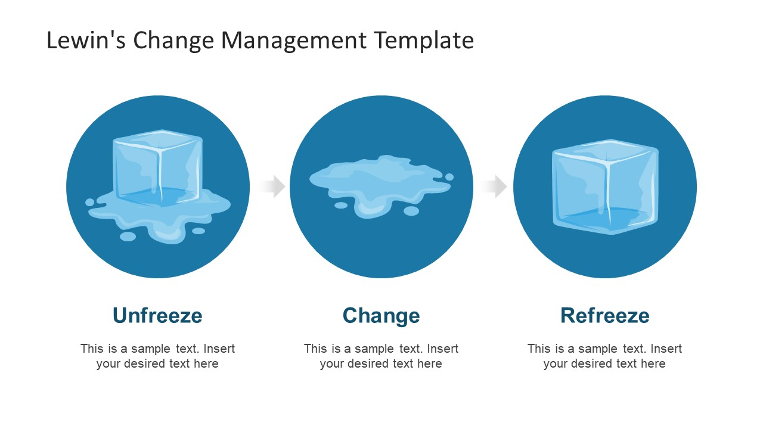
Change management theories

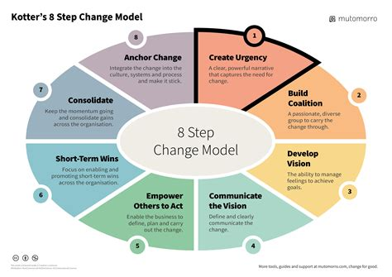
Figure 1: Lewin's Change Management Model (Virarozen n.d.)
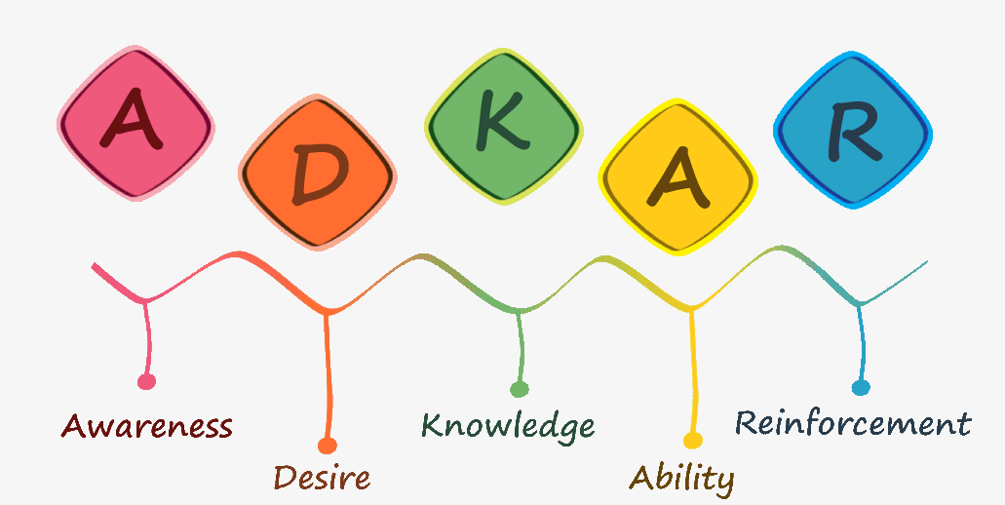
Figure 2: Kotter's Eight-Step Model (Virarozen n.d.)
Figure 3: Prosci’s ADKAR Model (Knowledge n.d)

Appendix 2

5 Why’s model
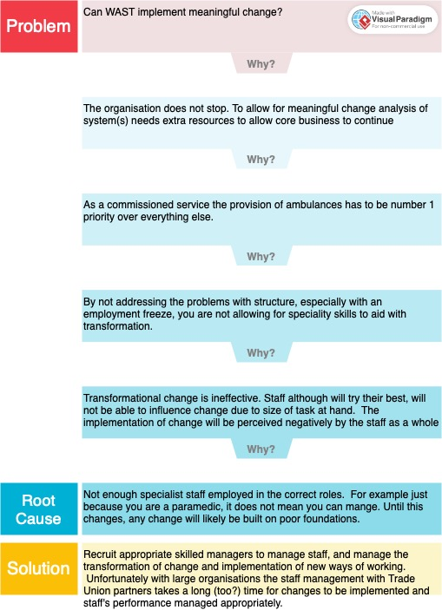
Highlighting some of the issues surrounding changes within a big organisations.

Appendix 3

PEST analysis
A PEST analysis examines the external environmental factors that can impact an organisation. Here's a generalised PEST analysis for WAST:

1. Political Factors:
- Government Policies: Adherence to national healthcare policies and regulations for a commissioned Ambulance services.
- Funding: Reliance on government and local funding for operational and technological advancements.
- Legislative Changes: Compliance with healthcare laws and regulations affecting emergency services. Often reactive to Local/National news and occasionally a Coroner’s hearing.
2. Economic Factors:
- Budget Constraints: The impact of economic downturns on funding for healthcare services and how this may be affected by elections.
- Resource Allocation: Managing financial resources efficiently for personnel, equipment, and infrastructure when there is a freeze on recruitment.
- Economic Disparities: Addressing regional economic variations affecting accessibility and service provision. A careful, political and ethical dilemma to ‘hitting targets’. Put your resources in population dense areas to hit targets, and accept you will always miss targets in rural parts of Wales - ethical / moral dilemma.
3. Social Factors:
- Demographics: Catering to an ageing population with specific healthcare needs is not easy and with limited budget becomes increasingly more difficult.
- Public Expectations: Meeting evolving public expectations regarding response times and quality of care. Whilst there is an expectation, there is a greater awareness that you will not get an ambulance in a timely manner. However, this is often forgotten about and over shadowed by the general NHS problems.
- Cultural Sensitivity: Adapting services to diverse cultural and linguistic communities within Wales.
4. Technological Factors:
- Advances in Medical Technology: Incorporating technological advancements for better patient care with the use of iPads allows clinician's to view patient records. This is helpful with a view to keeping more patients at home and not routinely take all patients to A&E.
- Data Management: Ensuring secure and efficient data handling for patient records and communication.
- Communication Infrastructure: Utilising cutting-edge communication tools for emergency response coordination.

Welsh Ambulance Service has to manage a variety of political, technological, social, and economic issues in order to deliver efficient and timely emergency medical care. WASTs service quality must be maintained and improved by responding to shifts in governmental regulations, the state of the economy, social expectations. Whether or not this is accomplished is up for discussion and interpretation elsewhere.

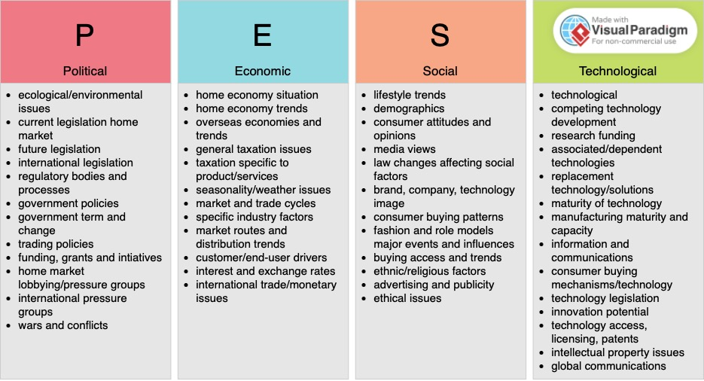

Figure: 5: A PEST analysis template can be employed as a strategic management instrument to evaluate and examine the external macro-environmental elements that may impact an organisation's functions. Organisations can better grasp and identify external factors influencing their business environment with the use of this analysis. Businesses can foresee changes, make well-informed decisions, and develop strategies to take advantage of or adapt to outside forces by looking at these aspects. PEST analysis is frequently used in strategic management and business planning to evaluate the larger environment in which an organisation operates (VPO, 2024).

Appendix 4

Iceberg Theory


The Project Management Iceberg Theory, is a metaphorical representation highlighting the multifaceted nature of project management. Like an iceberg, which only reveals a small portion above the waterline while concealing the majority beneath, projects have both visible and hidden components. The visible tip of the iceberg represents the aspects readily apparent to stakeholders, such as project scope, time, and cost. However, submerged beneath the surface are the less visible factors, including quality, risk, communication, and stakeholder engagement. The theory emphasises that successful project management requires careful attention to all these dimensions, as neglecting the hidden factors can lead to project failure or sub-optimal outcomes.

Fig. 6: Theoretical model outlining the risks of looking beneath the surface (WPO n.d.)

whether this is always achieved is an essay/PhD in it's own right!
ADKAR is an acronym for Awareness, Desire, Knowledge, Ability and Reinforcement
Awareness, Desire, Knowledge, Ability, and Reinforcement
specifically trained in management not automatically assumed as part of a paramedic job role
For context, this current course is the only formal, external managerial course I am aware of for WAST managers that only Senior Paramedics have been enrolled on.
New Policies or guidelines are sent out by email, with the expectation that you have read, understood and that you will implement it immediately.
Unfortunately the outcome for this is only time targets only.

