

Student Name: Mit Ahir
Student ID:
2513323
Programme:
MSc Public Health and Social Care in Practice
Module Code:
LCHS7009
Module Title:
Population Health and Digital Health Promotion
Assessment Title:
Component 1: 2 Blogs
Lecturer:
Dr. Raheela Shaikh
Submission Date:
03 July 2026

TASK 1 – Blogs: 2 entries

Blog 1- Critically discuss the impact of an existing digital technology currently used for a digital health promotion intervention

A public health problem: Rising Rates of Depression and Anxiety among Young Adults
Depression and anxiety represent a growing public health challenge, particularly among young adults. Additionally, the Adult Psychiatric Morbidity Survey found that 25.8% of people aged 16–24 in England have a common mental health condition in the UK, primarily anxiety and depression, in comparison to the 17.5% in 2007 (NHS England, 2025). Among young women aged 16- 24, the prevalence reaches 36.1%, that also highlights a significant gender disparity (NHS England, 2025).
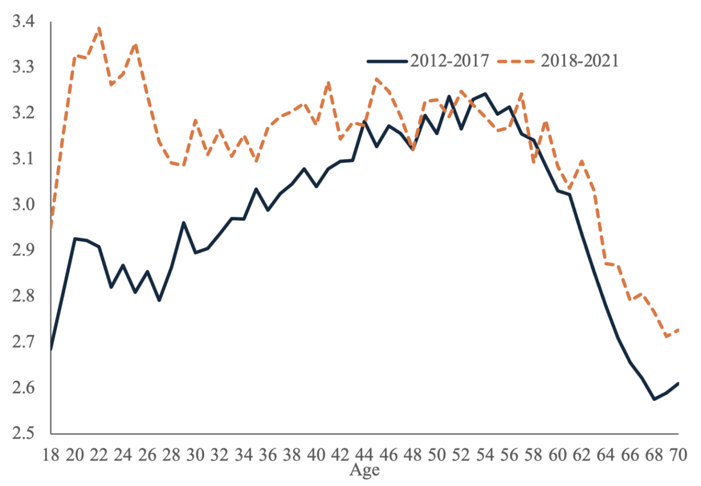
Figure 1: Age profile of anxiety in the UK
(Source: Influenced by Blanchflower and Bryson, 2024)
Anxiety and mental ill-health among UK youth have risen significantly, and young women have experienced the greatest increase in psychological distress (Blanchflower and Bryson, 2024). In addition, 22.6% of adults aged 16–64 now experience a common mental health condition, along with self-harm rates have increased to 10.3%, with the highest prevalence among young adults (NHS England, 2025). NHS England reported that 3.8 million people were in contact with NHS mental health services at the time of 2023 to 2024 (NHS England, 2024). It also demonstrated the growing demand for support. Therefore, these conditions can impair employment, education, social relationships, and overall well-being, which also make effective health promotion interventions beneficial.

Using SilverCloud to Promote Mental Health and Address Depression and Anxiety
SilverCloud is an online Cognitive Behavioral Therapy (CBT) platform adopted in NHS talking therapies that encourages good mental well-being through the use of self-help modules that target anxiety and depression conditions. The application allows the user to interact with a mood tracker and coping methods online. Digital mental health programs have proven effective in reducing symptoms of anxiety and depression, especially those following the CBT approach. According to a meta-analysis of 176 randomized clinical trials that involved 33,567 individuals, mental health smartphone and digital apps proved beneficial in improving anxiety and depression symptoms (Linardon et al., 2024).
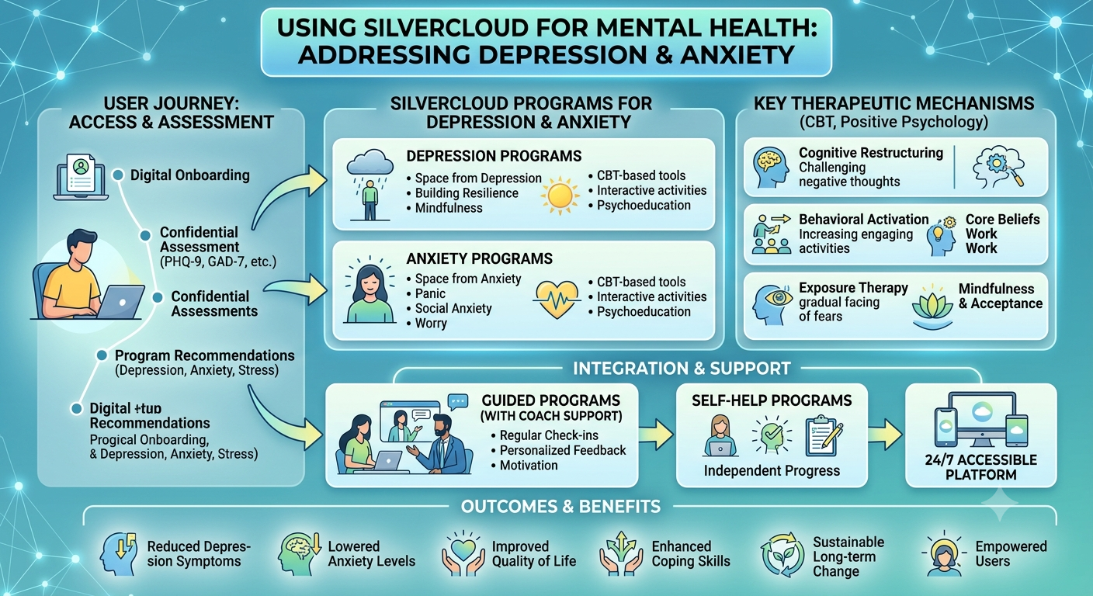
Figure 2: SilverCloud digital health platform to support mental health
(Source: NHS Barnsley Talking Therapies, 2026)

Evidence of SilverCloud’s Impact on Mental Health Promotion
SilverCloud, which is a digital CBT platform, approved by the NHS, leads to better mental health results (NHS Barnsley Talking Therapies, 2026). According to one study involving 464 patients from the NHS, there was a considerable improvement in anxiety and depression symptoms, with a recovery rate of more than 50% (Richards et al., 2020). Furthermore, NHS England highlights increased use of digital interventions in NHS Talking Therapies. SilverCloud has supported over 1 million people, and most users report improvements within the 3 months of use (East London NHS Foundation Trust, 2024).
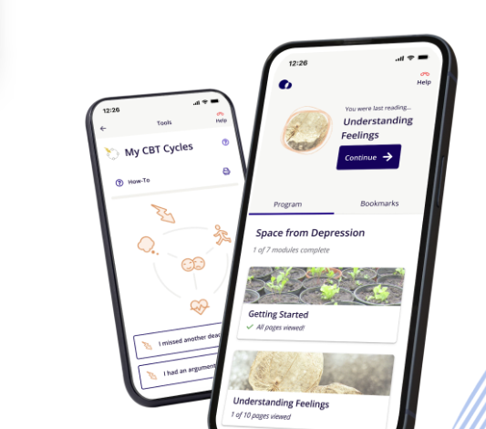
Figure 3: SilverCloud® by Amwell® team
(Source: SilverCloud.amwell.com, 2026)

Critical Evaluation of SilverCloud in Health Promotion
Advantages
SilverCloud improves accessibility to mental health support by giving 24/7 access to an evidence-based CBT program. Moreover, it reduces waiting times, promotes self-management, along with reaches individuals who may be reluctant to seek face-to-face therapy.
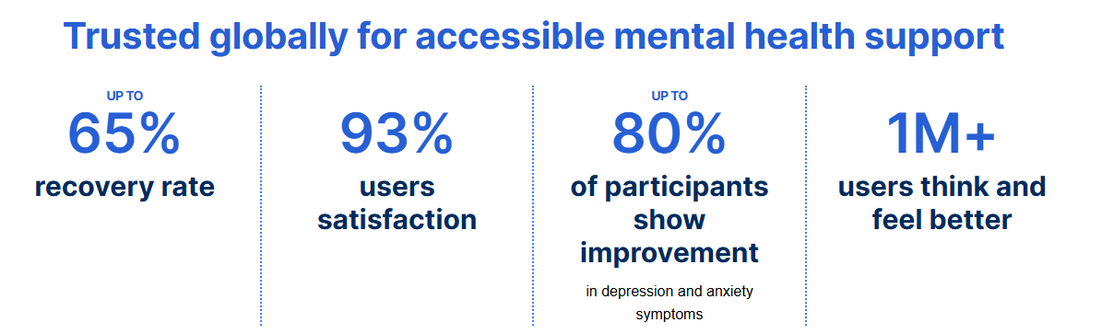
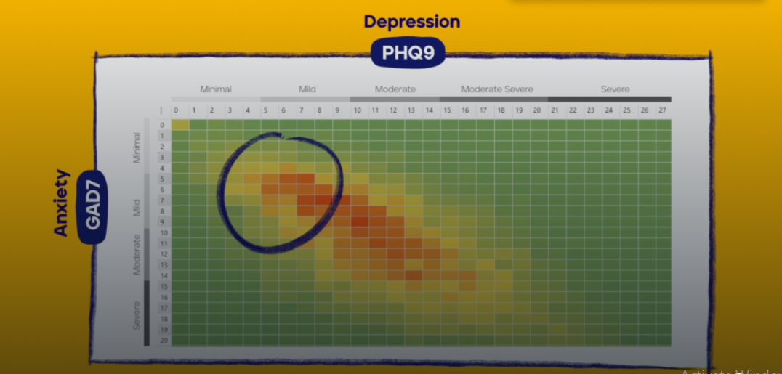
Figure 4: Accessibility of SilverCloud globally and platform at work
(Source: SilverCloud.amwell.com, 2026)
Disadvantages
But it is possible that user engagement would become less over time, and some users need physical contact for their treatment. Moreover, digital exclusion, privacy issues, and non-relevance for serious mental disorders are important limitations of SilverCloud.

Addressing the Shortfalls of SilverCloud
SilverCloud limitations can be overcome by integrating digital therapy with professional assistance, enhancing digital literacy skills, ensuring higher data security, and offering other alternatives to those who have serious mental disorders.

References
Blanchflower, D. and Bryson, A. 2024. Despair and anxiety among UK youth. VoxEU, Centre for Economic Policy Research, 23 October. Available at: https://cepr.org/voxeu/columns/despair-and-anxiety-among-uk-youth (Accessed: 10 June 2026).
East London NHS Foundation Trust, 2024. Computerised CBT. Available at: https://www.elft.nhs.uk/bedfordshire-talking-therapies/how-we-help/computerised-cbt (Accessed: 10 June 2026).
Linardon, J., Torous, J., Firth, J., Cuijpers, P., Messer, M. and Fuller-Tyszkiewicz, M. 2024. Current evidence on the efficacy of mental health smartphone apps for symptoms of depression and anxiety: A meta-analysis of 176 randomized controlled trials. World Psychiatry, 23(1), pp. 139–149.
NHS Barnsley Talking Therapies, 2026. SilverCloud online mental health platform. Available at: https://barnsley-talkingtherapies.nhs.uk/how-we-can-help-you/silvercloud/ (Accessed: 10 June 2026).
NHS England, 2024. England's NHS mental health services treat record 3.8 million people last year. Available at: https://www.england.nhs.uk/2024/10/englands-nhs-mental-health-services-treat-record-3-8-million-people-last-year/ (Accessed: 10 June 2026).
NHS England, 2025. Adult Psychiatric Morbidity Survey 2023–24: Survey of Mental Health and Wellbeing, England. Available at: https://digital.nhs.uk/data-and-information/publications/statistical/adult-psychiatric-morbidity-survey/survey-of-mental-health-and-wellbeing-england-2023-24/content (Accessed: 10 June 2026).
Richards, D., Enrique, A., Eilert, N., Franklin, M., Palacios, J., Duffy, D., Earley, C., Chapman, J., Jell, G., Sollesse, S. and Timulak, L., 2020. A pragmatic randomized waitlist-controlled effectiveness and cost-effectiveness trial of digital interventions for depression and anxiety. NPJ digital medicine, 3(1), p.85.
SilverCloud.amwell.com, 2026. Our solutions. Available at: https://silvercloud.amwell.com/our-solutions (Accessed: 10 June 2026).

Blog 2- Critically discuss the impact of a digital technology designed for a digital health promotion intervention

Identification of the health problem: The Growing Burden of Depression and Anxiety among Young Adults
Depression and anxiety are still prevalent public health issues in young adults in the UK. The Mental Health Foundation Report states that one in six adults has a common mental health condition every week, and young adults rate themselves as having the highest psychological distress out of any other age group (Mental Health Foundation, 2026). Furthermore, young people aged 16–29 have lower life satisfaction and higher anxiety levels than older age groups (ONS, 2025). These conditions can have a negative impact on education, employment, relationships, and quality of life, and hence, innovative digital health promotion interventions are required.
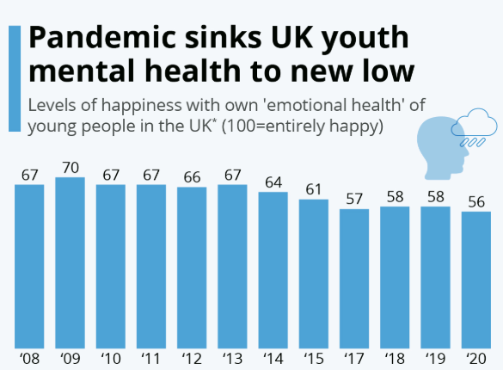
Figure 5: Pandemic sinks UK youth mental health to a new low
(Source: Influenced by Martin, 2021)
The Prince’s Trust Youth Index found that 50% of young people reported worsening mental health, along with 26% felt unable to cope with life (Martin, 2021). It has risen to 40% among those not in education, employment, or training. Using behaviour change theory can also improve engagement; encourage healthier behaviours, increase self-management skills, as well as support sustained mental well-being improvements.

Introducing MindAuraX: A Personalized Mental Health Promotion Technology
MindAuraX is a novel digital health technology that will be newly developed to help young adults with anxiety and depression. It will differ from other mental health apps because it relies on AI and environmental sensing to measure mood by analysing daily interactions, patterns, social engagement, and indicators of stress. The platform will calculate an individual's “mental wellness aura” score and offer wellness content, coping strategies, and wellbeing challenges in a personalised way. It will also provide predictive alerts when emotional distress is present, promoting early intervention, awareness, and proactive mental health management before symptoms get to the extreme level.

Figure 6: MindAuraX: AI-Driven Ecosystem for Proactive Mental Wellness

How MindAuraX Will Be Used in Health Promotion
MindAuraX will be used as a promotion tool to enhance the mental well-being of young adults through artificial intelligence and behavioural analysis. The platform will deliver individual well-being suggestions, stress-management exercises, mental health education, and early indications of emotional distress. The increase in self-awareness and early interventions provided by MindAuraX will assist in minimising anxiety and depression symptoms. Digital mental health interventions can enhance psychological wellbeing and self-management for young people (Babbage et al., 2022).

Critical Impact of MindAuraX on Health Promotion
Advantages
MindAuraX will offer individualised support, help identify emerging mental health issues, and enhance access to mental health support services. The technology will also help promote proactive self-care and ongoing wellbeing monitoring. There can be a substantial reduction in symptoms of anxiety and depression with the use of digital mental health technologies (Kim et al., 2023).
Disadvantages
There could be privacy issues with the platform because of the ongoing data collection. Alternatively, some users might also become so reliant on digital support, and people with low digital literacy might struggle to access the technology.

Addressing the Shortfalls
These challenges will be overcome with strong data encryption, clear consent protocols, mental health literacy resources, and connections with professional mental health providers. Human oversight will ensure that there are appropriate referrals and support for users who need special care.

References
Babbage, C.M., Jackson, G.M., Davies, E.B. and Nixon, E., 2022. Self-help digital interventions targeted at improving psychological well-being in young people with perceived or clinically diagnosed reduced well-being: systematic review. JMIR Mental Health, 9(8), p.e25716.
Kim, J., Aryee, L.M., Bang, H., Prajogo, S., Choi, Y.K., Hoch, J.S. and Prado, E.L., 2023. Effectiveness of digital mental health tools to reduce depressive and anxiety symptoms in low-and middle-income countries: systematic review and meta-analysis. JMIR Mental Health, 10, p.e43066.
Martin, A., 2021. Pandemic sinks UK youth mental health to new low. Available at: https://www.statista.com/chart/23989/youth-mental-health-uk/?srsltid=AfmBOopV7yOztU8RzEI08v6bj_xfB5f3BvGfF85AKE3yyCUprdndkSwV (Accessed: 10 June 2026).
Mental Health Foundation, 2026. Mental health statistics: prevalence, services and funding in England. Available at: https://www.mentalhealth.org.uk/explore-mental-health/statistics (Accessed: 10 June 2026).
Office for National Statistics, 2025. Personal and economic well-being in the UK. Available at: https://www.ons.gov.uk/peoplepopulationandcommunity/wellbeing (Accessed: 10 June 2026).

