By Tyler King 2008275
Tyler King (2008275)

The role of Technology for assessment in teaching
Digital Innovation and Professional Practice. By Tyler King 2008275

Contents Page

 | Page Number
Introduction | 2
Part 1: Literature review | 2-10
Part 2: Justification of digital tool | 11-13
Part 3: Application of digital tool | 14-21
Part 4: Evaluation and Reflection | 25-28

Introduction
This paper will aim to evaluate the role of technology for assessment in teaching, this will be achieved by critically evaluating the role of digital innovation in enhancing teaching and learning. The integration of digital technologies in education has revolutionised the way educators teach, and students learn, so this paper has been broken down in to four parts to analyse the effectiveness of digital tools in teaching and learning. Technology is a vital component in modern day education, so to properly understand the role that technology plays in teaching the paper will begin by reviewing the breadth of literature surrounding the subject, in the form of a narrative review. In part two of this paper there will be a justification for the digital tool chosen to implement in the authors own teaching session, this section will look to link theory and education frameworks to practice by demonstrating a synthesis between innovation, pedagogical theory, and professional practice. Part Three of this paper will provide the reader evidence of the application of the digital tool, which was a Kahoot quiz. The paper will then conclude with a reflection and evaluation of the learning tool implemented and its impact on teaching and learning, this section will consider feedback gained from students who used the digital tool within their session and how this has informed the author moving forward in their own professional development.
The role of the teacher in the digital age and the changing learner
When considering the implementation of digital technologies in teaching and learning it is important to consider the role that the teacher plays to ensure that pedagogy remains at the forefront and technology does not take over. Quinn (2014) highlight that whilst teachers play a pivotal role in integrating and leveraging technology to enhance the learning experience for students, it is important that the learning remains the focus and technology is used to aid this. Johnston, Macneill and Smyth (2019) champion this notion emphasising when educators try and force technology into their teaching it often takes away from the learning and does not result in better learning outcomes for the students. Selwyn (2016) agrees stating technology should complement the content and learning outcomes to ensure best practice and align with professional standards to apply appropriate use of digital and/or other technologies, and resources for learning (Advance HE, 2023). Furthermore, Race (2019) believes teachers serve as mentors and facilitators in guiding students to use technology responsibly and ethically. Sharma (2017) concurs, highlighting educators play a crucial role in teaching students about digital citizenship, online safety, and ethical use of information.
In the evolving digital age Tsybulsky and Avidov-Ungar (2019) draw attention to the fact that the learner has evolved, their needs have changed along with their digital competency and accessibility to technology. It is therefore vital that educators facilitate this digital literacy and foster technology in their teaching that evokes critical thinking, collaboration and problem solving to enhance the learning experience for their students. Eyal (2012) also highlights it is an important role for the students to engage with the technology to allow for collaboration and promote creativity and innovation.
Technology in teaching
Lazar (2015) stipulates that technology in teaching is important for a multitude of reasons, Eady and Lockyer (2013) mirror this view highlighting technology has the potential to enhance the learning experience, engage students, and prepare them for the ever-evolving digital world. Fu and Hwang (2018) underscore technology can also facilitate collaboration and communication among students and educators, with online discussion forums, such as; MOODLE, WhatsApp and Email. Video conferencing tools, such as Microsoft Teams, ZOOM and Skype and collaborative platforms such as Google Classroom, Google Slides and JamBoard also enable students to interact with their peers and teachers beyond the confines of a physical classroom (Szymkaviak et al 2021). Susanto, Rachmadtullah and Rachbini (2020) believe the use of technology in teaching promotes a sense of community and fosters the development of important 21st-century skills such as teamwork, communication, and digital literacy. Keengwe and Onchwari (2011) agree with this adding that by incorporating technology into the classroom, educators can create a more dynamic and interactive learning environment that caters to different learning styles and abilities. Jan (2017) develops on this highlighting it is those learning styles and abilities that need to be taken into consideration when implementing any technology into any teaching session as it is imperative that students are not excluded from participation due to accessibility issues or any additional learning needs.
Makosa (2013) is highly critical of the implementation of ‘complicated technology’ in teaching, citing it could result in an overreliance on technology for the learners, whereby students would be relying too heavily on technology and can lead to a lack of critical thinking skills and creativity. Skenderi and Skenderi (2017) mirror this view warning students could become dependent on technology to do their work for them, rather than developing their own problem-solving abilities. Smith (2020) also draws attention to potential equity issues in relation to education technology as not all students have access to technology, and these accessibility issues can result in them being excluded from learning which would not align to professional standards to promote engagement in learning and equity of opportunity for all to reach their potential (Advance HE, 2023). Whalen (2020) highlights in order to overcome this challenge, educational institutions must prioritise equity by providing access to necessary devices and internet connectivity for all students. Additionally, educators should be mindful of diverse learning needs and ensure that technological resources are inclusive and accessible to all learners (Aguilera-Hermida, 2020).
In contrast, Uerz, Volman and Kral (2018) champion the use of technology in teaching and learning, drawing attention to the application of technology in education allows educators to create dynamic and interactive classrooms that cater to diverse learning styles and abilities. In light of this, a significant impact of technology on pedagogy is its ability to personalise learning experiences. Starkey (2020) develops this further emphasising every student has unique learning needs and preferences, and technology allows educators to tailor instruction and direction accordingly. If this is implemented effectively this would align with professional standards to support and guide learners (Advance HE, 2023). Al-Fraihat, Joy and Sinclair (2020) highlights this can be achieved by utilising adaptive learning systems, such as personalised development plans, that can analyse student performance data and provide personalised recommendations for further study or development. Mastan et al (2022) champions the use of adaptive learning systems highlighting this individualised approach helps students learn at their own pace and ensures that they receive targeted support where needed.
Assessment in teaching
Dunn and Mulvenon (2019) assert assessment in teaching is important for several reasons, as it plays a crucial role in the learning process and student development. Bryan and Clegg (2019) and Black and William (2018) agree highlighting assessment provides valuable information about students’ understanding, knowledge, and skills, allowing teachers to identify areas of strength and weakness. There are three main areas of assessment in teaching that are Diagnostic, Formative and Summative;
Diagnostic: A form of evaluation used to identify students strengths and weaknesses in order to guide instruction and support learning. Digital innovation can aid with diagnostic assessments with data analytics and interactive assessments (Csapo and Molnar, 2019).
Formative: A process that provides feedback to adjust teaching and learning, assists in helping teachers identify areas where students need support. Digital innovation can aid with formative assessments with online quizzes, adaptive learning platforms and learning management systems (Kaya-Capocci, O’Leary and Costello, 2022).
Summative: Helps educators evaluate student learning outcomes and measure progress over time. Digital innovation can aid with summative assessments with online testing platforms, adaptive assessments and collaborative assessments such as presentations (Perry, Meissel and Hill, 2022).
Bloxham and Boyd (2007) draw attention to the fact that through assessment, educators can tailor their teaching methods to meet the individual needs of students, ensuring that they receive the support and guidance necessary for their academic growth. By assessing students’ progress and performance, teachers can adjust their teaching strategies to address specific learning gaps or challenges, this personalised approach to instruction helps to maximise student learning outcomes. Wyatt-Smith et al (2017) are of the belief that effective assessment aligns with the professional standards set out by the Welsh Government by promoting a holistic approach to evaluating student learning, encompassing formative assessment strategies that provide ongoing feedback to support student development, as well as summative assessments that measure overall achievement. By adhering to these professional standards in their professional practice, educators in Wales demonstrate their commitment to high-quality teaching practices that prioritise student learning and success (Advance HE, 2023). Gikandi, Morrow and Davis (2011) agree with this statement declaring by incorporating effective assessment practices into their teaching, educators can create an environment that supports student growth, fosters motivation, and meets the expectations set forth by professional standards.
When considering the implementation of technology to assist in assessment there are many tools that can be used to aid this, a few examples of these are:
- Kahoot
- Google forms
- Mentimeter
- Online polls
- Socrative quizzes
- Flipgrid
The above list is not exhaustive and there are a wide range of online tools that are available to assist in assessment in teaching. These digital tools could also be utilised to gage how the students are feeling and assess their mental wellbeing, this could be a vital tool in remote learning environments where face to face interaction is not possible.
Implementation of digital tools in teaching
Napal, Mendióroz-Lacambra and Penalva, (2020) highlight implementing digital tools in teaching has become increasingly important in today’s educational sector. Clark-Wilson, Robutti and Thomas (2020) champion this notion emphasising with the rapid advancement of technology, educators are recognising the potential of digital tools to enhance student engagement, facilitate personalised learning, and improve overall educational outcomes. Masterman and Manton (2011) draw attention to the implementation of digital tools in teaching sessions also aid in increasing student motivation and engagement. Hussaini (2020) underlines the use of digital tools to provide interactive and immersive learning experiences that can capture students’ attention and make learning more enjoyable. For example, Kahoot! is a popular digital tool that allows teachers to create interactive quizzes and games for students. This tool not only makes learning fun but also encourages active participation and healthy competition among students. Cagiltay, Ozcelik, E and Ozcelik, N.S (2015) found through their studies that the use of serious games in their teaching sessions enhance students problem solving skills and increase motivation, this results in better learning outcomes for students. Zhonggen (2019) championed this notion concluding serious game-based learning proved significantly more effective than non-game based learning when they carried out their own studies.
Benefits and limitations of implementing technology in teaching
Al-Rawashdeh et al (2021) and Sarkar et al (2021) stipulate the integration of technology in education has become increasingly prevalent in modern classrooms, and Shmid (2008) synthesises the implementation offers numerous benefits, such as enhanced engagement, personalised learning experiences, and improved access to educational resources. However, Kemp et al (2014) are critical and argue the implementation of Education Technology (EdTech) also presents certain limitations, including potential distractions, unequal access to technology, and the need for continuous professional development for educators. It is evident that although there are many benefits to implementing technology in the classroom, those same benefits can also serve as limitations. Coleman (2021) shines a light on the digital divide being a significant barrier to the successful incorporation of technology in teaching. Hillier (2020) agrees with Coleman (2021) highlighting the digital divide remains a challenge, as not all students have equal access to technology outside of their learning environment, this inequality can exacerbate educational disparities among students from different socioeconomic backgrounds. UK Parliament (2020) found that there could be a range of contributing factors to individuals being digitally excluded such as; lack of skills, accessibility issues, not having access to adequate devices, and internet issues. All of which would contribute to the digital divide in the UK, which Harvey, Hastings and Chowdrury (2023) believes was worsened during the Covid-19 pandemic. Educators need to be aware of the digital divide so not to exclude their students, and Chelliah and Clarke (2011) considers knowledge and awareness of the digital divide will aid in combatting digital exclusion as help can be put in place to achieve better learning outcomes.

Summary
To conclude, it is evident that technology, if used in the correct manner, can aid in teaching and learning. However, the literature reviewed repeatedly highlighted the need for pedagogy to remain the focus, and the importance of the technology being an aid rather than a focus point. This paper considered the benefits of using digital tools to aid in assessment with teaching and gave examples of how this can be achieved and provided examples of digital tools that can be used to assist in the assessment of students as well as enhancing learning and student engagement. It is clear from the literature studied that the embedment of technology has the potential to improve learning outcomes and aid educators in providing more engaging sessions, it is also evident that the incorporation of technology can also encourage collaboration and teamwork from students and educators alike. As detailed throughout this paper it is crucial for educators to consider the digital divide when embedding technology in their sessions, so not to exclude and isolate students. Ultimately, it is important for educators to remain ethical when incorporating technology into their teaching and consider the needs of their students as well as ensuring that the technology that has been incorporated is relevant to the content they are delivering.

Part 2: Justification for digital learning tool
When considering what digital learning tool I was going to implement in my own teaching session, it was important for me to contemplate what tool I thought would complement the content I was delivering. Panero and Aldon (2016) highlight this is a crucial component to implementing education technology, Greener and Wakefield (2015) are in agreeance emphasising putting the learning outcomes and content at the forefront will ensure that pedagogy will remain the focus. Whilst I was deliberating what digital learning tool to incorporate in to my session on the importance of feedback within teaching, I used the SAMR framework. The SAMR model, developed by Dr. Ruben Puentedura, is a framework that educators use to integrate technology into teaching and learning. It categorises the integration of technology into education into four levels that are: Substitution, Augmentation, Modification, and Redefinition (Franco, 2019).
Substitution: the substitution phase would be where the technology would act as a direct substitute for traditional learning tools, when considering the digital tool in my own teaching session the Kahoot quiz acted as a direct substitute of utilising questioning and answering as a form of assessment.
Augmentation: The augmentation involved the technology acting as a direct substitute but with functional improvement. In regards to the Kahoot quiz this was achieved by gaging the students understanding more efficiently by the record of their answers.
Modification: This level involves significant task redesign. This was achieved by the digital learning tool by fostering more engagement and competitive learning, more than generic questioning and answering could achieve.
Redefinition: At the redefinition level, technology allows for the creation of new tasks that were previously inconceivable. This could have been achieved by the digital learning tool as students could have collaborated remotely. This would not have been possible via generic questioning and answering or pen and paper.
It was important for me to work through each of the levels and see where my digital learning tool could fit in to each, this assisted me in the decision-making process of deciding what digital learning tool to implement.
It was also important for me to consider learning theory when implementing the Kahoot quiz in to my teaching session. Timmis et al (2016) underscores the integration of learning theory with digital learning tools for assessment as crucial for designing effective educational experiences. Caird and Lane (2015) agree with this stipulating by aligning assessment strategies with learning theories, educators can create assessments that cater to different learning styles and preferences. For example, behaviourist approaches may utilise immediate feedback loops in digital quizzes to reinforce desired behaviours, this was achieved in the Kahoot quiz by the introduction of the leader board.
Rai (2020) draws attention to active learning as a learning approach that emphasises the learner’s active participation in the learning process. Loveless (2011) expands on this, explaining this can involve engaging with digital learning tools, such as games, and quizzes, that require the learner to take action and apply their knowledge. Upon reflection, I think in my own session the Kahoot quiz achieved active learning for the students, and also promoted the Constructivism learning theory, for the students to actively construct their understanding and knowledge through experiences and reflection (Mohammed and Kinyo, 2020). Dean and Lima (2022) emphasise it is essential to follow frameworks and theories when embedding technology into teaching to ensure that its use is purposeful, effective, and aligned with educational goals.
In summary, it was important for me to consider learning theory and frameworks before embedding technology in to my teaching session. By following the SAMR framework it gave me the structure to consider the digital tool that I embedded carefully and also ensured I promoted effective use of technology and ensured pedagogical alignment. Upon reflection, if I am to embed technology in to my future teaching sessions I will ensure that I follow similar frameworks so that I can be certain that the technology that I implement is purposeful and adds to the learning.

Part 3: Application of digital tool
In this section I will provide evidence of the implementation of my chosen digital tool. As discussed I chose to incorporate a Kahoot! Quiz within one of my teaching sessions so I could evaluate its effectiveness in aiding in assessment. Below I have attached a lesson plan, feedback forms and annotated screen shots of the Kahoot Quiz.

Lesson Plan Template



Lesson Plan

Topic: The importance of feedback |  | Class: PCET Full time
Date: 21/11/2023 | Length of lesson: 15 Minutes |  | Number of students: 4
Resources required:
Powerpoint
Pen and paper
Kahoot quiz

Aim of Lesson
- To understand the importance of feedback in the teaching setting
- To explore different ways people can give and receive feedback

Learning Outcomes – The Learners Should Be Able To:
- Identify the importance of feedback and feedforward in the teaching setting
- Explain the different ways of giving and receiving feedback
- Be able to give constructive feedback

Previous student knowledge required for the session:
N/A

Anticipated difficulties (if applicable):
N/A

Professional Standards (where are these being met within the session)
V2 promote engagement in learning and equity of opportunity for all to reach their potential
- Group work and discussion

V5 collaborate with others to enhance practice
- Through group work

A3 – Assess and give feedback for learning
- Through Q and A and summative assessment for the lecture

A1 - design and plan learning activities and/or programs
- Through implementation of digital tool

Lesson Detail:

Stage | Focus | Strategy | Time
Introduction  Development  Plenary/conclusion | Introduce myself and the aims and objectives for the session  Define feedback and ask the students to work in pairs to discuss different forums we receive feedback  Get the students to present their findings  Highlight the benefits of feedback in the teaching sector  Kahoot quiz  Recap and open the floor for questions | Chalk and talk pp2  Activity and discussion  Power point PP3  Online activity | 2 mins  5 mins  2 Mins  5 mins

Assessment Strategies: when and how are they included within the lesson?

Through Q+A’s throughout the lecture and the online quiz.

Informal reflection (to be completed after the session)

I think the digital tool complemented the session nicely, it encouraged the students engagement and participation and enhanced learning.
Upon reflection I would use Kahoot in future sessions

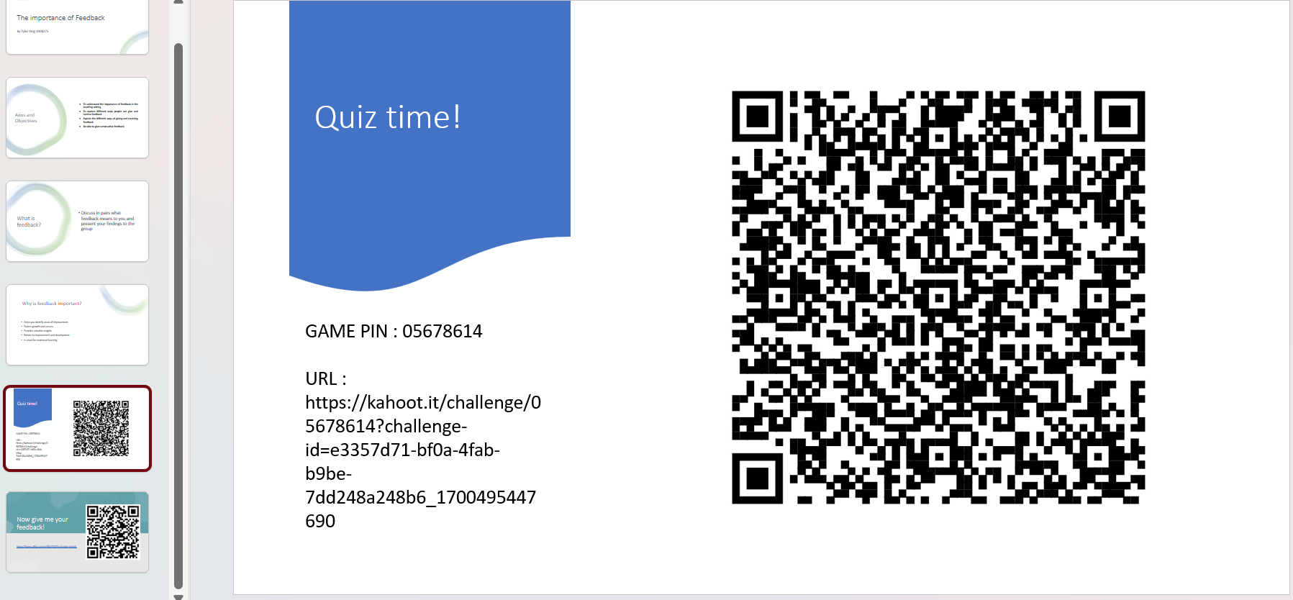
This snapshot shows the Kahoot quiz embedded in to the PowerPoint presentation – the students were able to access the quiz with no technical difficulties

The below screen shot shows the students results from the Kahoot quiz

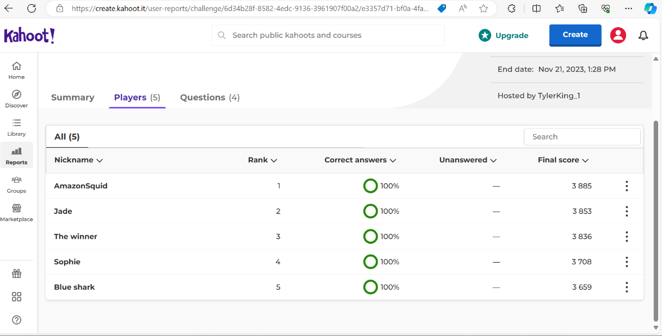

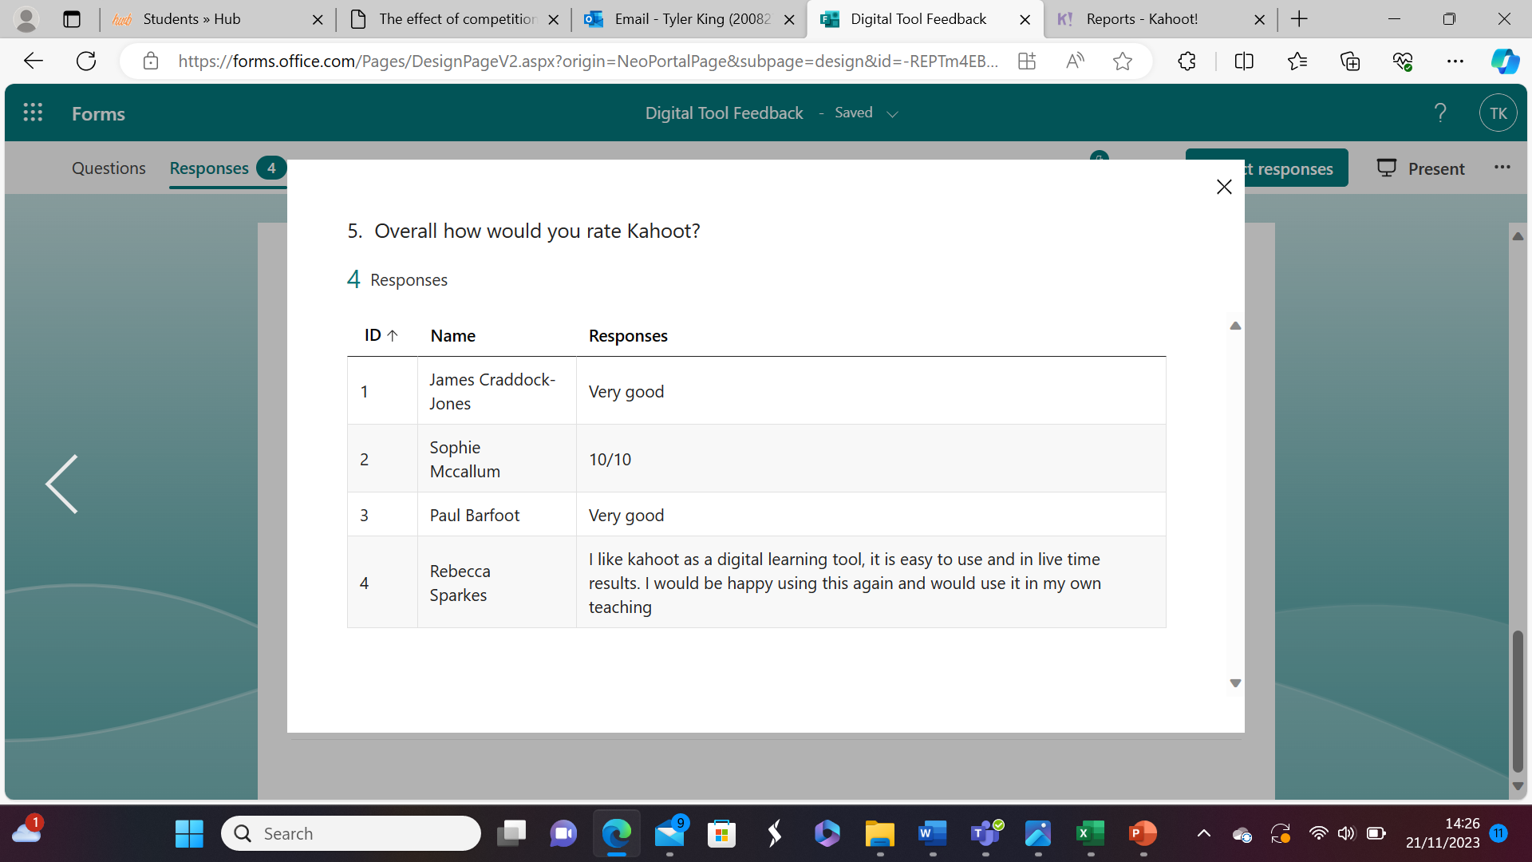
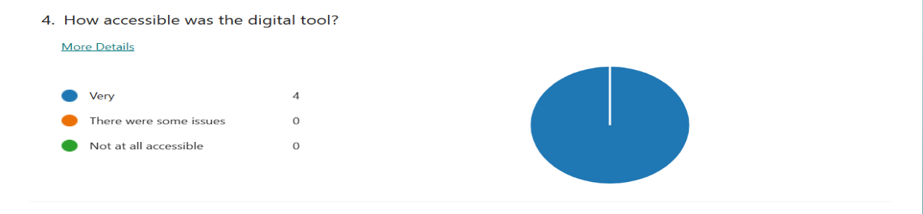
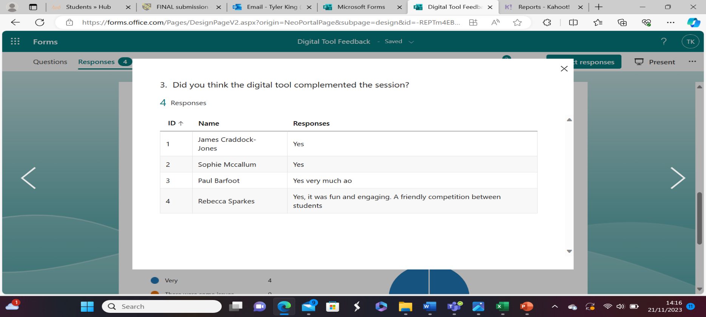
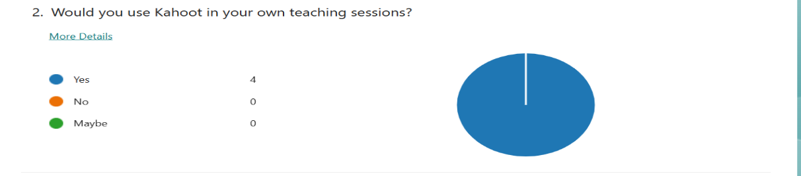

The below snapshots show the students feedback on the digital tool given via Microsoft Forms
Part 4: Evaluation and reflection
In this section I will evaluate the implementation of the Kahoot quiz and assess its impact on teaching and learning, I will consider my learners feedback on the digital tool and how this will inform my future professional development in terms of digital innovation. In this section I will be using Driscoll’s, (2007) three stage reflective model.
What?
I decided to implement my Kahoot quiz in a session I held for five students on the importance of feedback, I embedded the Kahoot quiz within the PowerPoint slides as shown in the previous section. Prior to this, I had been dubious to incorporate any technology into my teaching sessions out of fear of technical issues or potential accessibility issues. When delivering the content, I found that the incorporation of the quiz enhanced student participation and encouraged friendly competition, Cantador and Conde (2010) emphasise competition can be a driver for student motivation and can result in better learning outcomes. All the students engaged fully with the Kahoot quiz and the atmosphere indicated a fun, engaging and friendly atmosphere, this ensured I aligned with professional standards to promote engagement in learning and equity of opportunity for all to reach their potential (Advance HE, 2023). The students were highly complimentary of the Kahoot quiz and all had full marks which indicated solidified learning (Burguillo 2010). The digital tool was incorporated with no technical issues and all students were able to access it with no issues, Davies et al (2021) believes this is vital when implementing technology in teaching to ensure that no learner is isolated due to accessibility issues.

So What?
The fact that all the students were able to access the digital learning tool with no accessibility or technical issues I found to be very reassuring, as this is what had been holding me back from implementing technology into my sessions previously. Romero et al (2012) stipulate when students are engaging in game-based play it often enhances engagement and improves learning environments. I felt that the digital learning tool aided in my teaching and complimented the session and the content well, which Watson (2001) underlines as imperative when incorporating any digital tool in a session. Wentworth, Graham and Tripp (2008) draw attention to pedagogy remaining the focus when incorporating technology in to teaching and I feel that I achieved this within my teaching session. The feedback that I received from my peers was extremely positive, with all of them stating that they would use Kahoot in their own future teaching sessions and giving it a five star rating which reaffirmed to me that I had nothing to be dubious about and I am capable of delivering a session with technology embedded.
Now what?
After the successful implementation of the Kahoot quiz in my teaching session it has given me the confidence to experiment with technology in future sessions. I feel that prior to this I have been hesitant because I pre-empted issues that thankfully I did not encounter within my session, I feel that the application of the digital learning tool was successful and aided in my teaching rather than taking away from it. I would use a Kahoot quiz in my future professional practice and through the research conducted the online tool can be used for a plethora of tasks, not just assessment. It is clear from my teaching experience that the Kahoot quiz aided in fostering a good atmosphere and friendly competition, which Voogt et al (2013) champions as imperative to ensure best practice. Going forward I would like to experiment more with digital tools in teaching and I look forward to implementing these in my future teaching sessions. Throughout the research that I have conducted and the implementation of my chosen digital learning tool I have gathered the importance of pedagogical alignment in regards to digital innovation and going forward in my own teaching practice I will always ensure when embedding technology in to any teaching session that pedagogy remains the focus.
Reference List

Advance He., (2023)., Professional Standards Framework for teaching and supporting learning in higher education 2023. Available at: https://advance-he.ac.uk/knowledge-hub/professional-standards-framework-teaching-and-supporting-learning-higher-education-0 (accessed 12/11/2023)
Aguilera-Hermida, A.P., (2020)., College students’ use and acceptance of emergency online learning due to COVID-19. International journal of educational research open, 1, p.100011.
Al Rawashdeh, A.Z., Mohammed, E.Y., Al Arab, A.R., Alara, M. and Al-Rawashdeh, B., (2021)., Advantages and disadvantages of using e-learning in university education: Analyzing students’ perspectives. Electronic Journal of E-learning, 19(3), pp.107-117.
Al-Fraihat, D., Joy, M. and Sinclair, J., (2020)., Evaluating E-learning systems success: An empirical study. Computers in human behavior, 102, pp.67-86.
Black, P. and Wiliam, D., (2018)., Classroom assessment and pedagogy. Assessment in education: Principles, policy & practice, 25(6), pp.551-575.
Bloxham, S. and Boyd, P., (2007)., Developing effective assessment in higher education: a practical guide: a practical guide. McGraw-Hill Education (UK).
Bryan, C. and Clegg, K., (2019)., Innovative assessment in higher education: A handbook for academic practitioners. Routledge.
Burguillo, J.C., (2010)., Using game theory and competition-based learning to stimulate student motivation and performance. Computers & education, 55(2), pp.566-575.
Cagiltay, N.E., Ozcelik, E. and Ozcelik, N.S., (2015)., The effect of competition on learning in games. Computers & Education, 87, pp.35-41.
Caird, S. and Lane, A., (2015)., Conceptualising the role of information and communication technologies in the design of higher education teaching models used in the UK. British Journal of Educational Technology, 46(1), pp.58-70.
Cantador, I. and Conde, J.M., (2010)., Effects of competition in education: A case study in an e-learning environment.
Chelliah, J. and Clarke, E., (2011)., Collaborative teaching and learning: overcoming the digital divide?. On the Horizon, 19(4), pp.276-285.
Clark-Wilson, A., Robutti, O. and Thomas, M., (2020)., Teaching with digital technology. Zdm, pp.1-20.
Coleman, V., (2021)., Digital Divide in UK Education during COVID-19 Pandemic: Literature Review. Research Report. Cambridge Assessment.
Csapó, B. and Molnár, G., (2019)., Online diagnostic assessment in support of personalized teaching and learning: The eDia system. Frontiers in psychology, 10, p.1522.
Davis, E., Flavin, A., Harris, M.M., Huffman, L., Watson, D. and Weller, K.M., (2021)., Addressing Student Isolation During the Pandemic: An Inquiry into Renewing Relationships and Reimagining Classroom Communities on Remote Instruction Platforms. Journal of Practitioner Research, 6(1), p.2.
Dean, A. and Lima, A., (2022)., Student experience of e-learning tools in he: An integrated learning framework. Humanities Today: Proceedings, 1(1), pp.29-47.
Driscoll, J., (2007)., Practicing Clinical Supervision: A Reflective Approach for Healthcare Professionals. Edinburgh: Elsevier.
Dunn, K.E. and Mulvenon, S.W., (2019)., A critical review of research on formative assessments: The limited scientific evidence of the impact of formative assessments in education. Practical assessment, research, and evaluation, 14(1), p.7.
Eady, M. and Lockyer, L., (2013)., Tools for learning: Technology and teaching. Learning to teach in the primary school, 71.
Eyal, L., (2012)., Digital assessment literacy—The core role of the teacher in a digital environment. Journal of Educational Technology & Society, 15(2), pp.37-49.
Franco, M., (2019)., SAMR and technology integration. Technology and the Curriculum: Summer 2019.
Fu, Q.K. and Hwang, G.J., (2018)., Trends in mobile technology-supported collaborative learning: A systematic review of journal publications from 2007 to 2016. Computers & Education, 119, pp.129-143.
Gikandi, J.W., Morrow, D. and Davis, N.E., (2011)., Online formative assessment in higher education: A review of the literature. Computers & education, 57(4), pp.2333-2351.
Greener, S. and Wakefield, C., (2015)., Developing confidence in the use of digital tools in teaching. Electronic Journal of E-Learning, 13(4), pp.260-267.
Harvey, M., Hastings, D.P. and Chowdhury, G., (2023)., Understanding the costs and challenges of the digital divide through UK council services. Journal of Information Science, 49(5), pp.1153-1167.
Hillier, M., (2020)., Bridging the digital divide with off-line e-learning. In Expanding Horizons in Open and Distance Learning (pp. 110-121). Routledge.
Hussaini, I., Ibrahim, S., Wali, B., Libata, I. and Musa, U., (2020)., Effectiveness of Google classroom as a digital tool in teaching and learning: Students’ perceptions. International Journal of Research and Innovation in Social Science (IJRISS), 4(4), pp.51-54.
Jan, H., (2017)., Teacher of 21st century: Characteristics and development. Research on Humanities and Social sciences, 7(9), pp.50-54.
Johnston, B., MacNeill, S. and Smyth, K., (2019)., Conceptualising the digital university: The intersection of policy, pedagogy and practice. Springer.
Kaya-Capocci, S., O’Leary, M. and Costello, E., (2022)., Towards a framework to support the implementation of digital formative assessment in higher education. Education Sciences, 12(11), p.823.
Keengwe, J. and Onchwari, G., (2011)., Fostering meaningful student learning through constructivist pedagogy and technology integration. International Journal of Information and Communication Technology Education (IJICTE), 7(4), pp.1-10.
Kemp, A.T., Preston, J., Page, C.S., Harper, R., Dillard, B., Flynn, J. and Yamaguchi, M., (2014)., Technology and teaching: A conversation among faculty regarding the pros and cons of technology. Qualitative Report, 19, p.6.
Lazar, S., (2015)., The importance of educational technology in teaching. International Journal of Cognitive Research in Science, Engineering and Education, 3(1), pp.111-114.
Loveless, A., (2011)., Technology, pedagogy and education: Reflections on the accomplishment of what teachers know, do and believe in a digital age. Technology, Pedagogy and Education, 20(3), pp.301-316.
Mąkosa, P., (2013)., Advantages and disadvantages of digital education. Biuletyn Edukacji Medialnej, (2), pp.21-31.
Mastan, I.A., Sensuse, D.I., Suryono, R.R. and Kautsarina, K., (2022)., Evaluation of distance learning system (e-learning): a systematic literature review. Jurnal Teknoinfo, 16(1), pp.132-137.
Masterman, E. and Manton, M., (2011)., Teachers’ perspectives on digital tools for pedagogic planning and design. Technology, Pedagogy and Education, 20(2), pp.227-246.
Mohammed, S. and Kinyó, L., (2020)., Constructivist theory as a foundation for the utilization of digital technology in the lifelong learning process. Turkish Online Journal of Distance Education, 21(4), pp.90-109.
Napal, M., Mendióroz-Lacambra, A.M. and Penalva, A., (2020)., Sustainability teaching tools in the digital age. Sustainability, 12(8), p.3366.
Panero, M. and Aldon, G., (2016)., How teachers evolve their formative assessment practices when digital tools are involved in the classroom. Digital Experiences in Mathematics Education, 2(1), pp.70-86.
Perry, K., Meissel, K. and Hill, M.F., (2022)., Rebooting assessment. Exploring the challenges and benefits of shifting from pen-and-paper to computer in summative assessment. Educational Research Review, 36, p.100451.
Quinn, C.N., (2014)., Revolutionize learning & development: Performance and innovation strategy for the information age. John Wiley & Sons.
Race, P., (2007)., Making teaching work: ‘teaching smarter in post-compulsory education., SAGE., London.
Rai, L., (2020)., Which comes first, the pedagogy or the digital tool?. Open Learning: The Journal of Open, Distance and e-Learning, 35(3), pp.199-200.
Romero, M., Usart, M., Ott, M., Earp, J., de Freitas, S. and Arnab, S., (2012)., Learning through playing for or against each other? Promoting collaborative learning in digital game based learning.
Sarkar, K., Mandal, S., Tarafder, S., Chowdhury, D. and Borman, U., (2021)., Pros And Cons Of Online Teaching Vs. Classroom Teaching Learning Process. International Journal of English Learning & Teaching Skills, 4(1), pp.2657-2668.
Schmid, E.C., (2008)., Potential pedagogical benefits and drawbacks of multimedia use in the English language classroom equipped with interactive whiteboard technology. Computers & Education, 51(4), pp.1553-1568.
Selwyn, N., (2016)., Education and technology: Key issues and debates. Bloomsbury Publishing.
Sharma, M., (2017)., Teacher in a digital era. Global Journal of Computer Science and Technology, 17(3), pp.10-14.
Skenderi, L. and Skenderi, F., (2017)., TEACHERS’PERCEPTIONS OF TECHNOLOGY USE IN THE CLASSROOM. KNOWLEDGE-International Journal, 19(1), pp.213-217.
Smith, C., (2020)., Challenges and opportunities for teaching students with disabilities during the COVID-19 pandemic. International Journal of Multidisciplinary Perspectives in Higher Education, 5(1), pp.167-173.
Starkey, L., (2020)., A review of research exploring teacher preparation for the digital age. Cambridge Journal of Education, 50(1), pp.37-56.
Susanto, R., Rachmadtullah, R. and Rachbini, W., (2020)., Technological and Pedagogical Models. Journal of Ethnic and Cultural Studies, 7(2), pp.1-14.
Szymkowiak, A., Melović, B., Dabić, M., Jeganathan, K. and Kundi, G.S., (2021)., Information technology and Gen Z: The role of teachers, the internet, and technology in the education of young people. Technology in Society, 65, p.101565.
Timmis, S., Broadfoot, P., Sutherland, R. and Oldfield, A., (2016)., Rethinking assessment in a digital age: Opportunities, challenges and risks. British Educational Research Journal, 42(3), pp.454-476.
Tsybulsky, D. and Avidov-Ungar, O., (2019)., Teachers' perceptions on what it means to be a teacher in the digital age. In Society for Information Technology & Teacher Education International Conference (pp. 2076-2084). Association for the Advancement of Computing in Education (AACE).
Uerz, D., Volman, M. and Kral, M., (2018)., Teacher educators' competences in fostering student teachers’ proficiency in teaching and learning with technology: An overview of relevant research literature. Teaching and Teacher Education, 70, pp.12-23.
UK Parliament., (2020)., Covid-19 and the digital divide., https://post.parliament.uk/covid-19-and-the-digital-divide/ (Accessed 11/11/2023).
Voogt, J., Fisser, P., Pareja Roblin, N., Tondeur, J. and van Braak, J., (2013)., Technological pedagogical content knowledge–a review of the literature. Journal of computer assisted learning, 29(2), pp.109-121.
Watson, D.M., (2001)., Pedagogy before technology: Re-thinking the relationship between ICT and teaching. Education and Information technologies, 6, pp.251-266.
Wentworth, N., Graham, C.R. and Tripp, T., (2008)., Development of teaching and technology integration: Focus on pedagogy. Computers in the Schools, 25(1-2), pp.64-80.
Whalen, J., (2020)., Should teachers be trained in emergency remote teaching? Lessons learned from the COVID-19 pandemic. Journal of Technology and Teacher Education, 28(2), pp.189-199.
Wyatt-Smith, C., Alexander, C., Fishburn, D. and McMahon, P., (2017)., Standards of practice to standards of evidence: Developing assessment capable teachers. Assessment in Education: Principles, Policy & Practice, 24(2), pp.250-270.
Zhonggen, Y., (2019)., A meta-analysis of use of serious games in education over a decade. International Journal of Computer Games Technology, 2019.

