
MSc Public Health and Social Care in Practice
Module: Community Care and Management of Longer-term Conditions
Module code: LCHS7003
Assessment Title: Cancer survivorship: Long-term management and community reintegration
Student Name: Md. Mukhlesur Rahman Shepon
Student Number: 2435264
Word Count: 3286
Submission Deadline: 14th November 2025

Table of Contents
Introduction 2
Definition and Burden of Cancer Survivorship 3
Global and UK Prevalence 3
Aetiology and Risk Factors of Long-Term Conditions 4
Risk Factors and Aetiology 4
Long-Term Management and Community Reintegration 4
Management and Reintegration Strategy 5
Impact on Individuals: Physical, Psychological, and Social Implications 5
Physical Implications 5
Psychological and Social Implications 6
Wider Implications on Families and Carers 7
Evidence-Based Treatments Available Through the NHS 8
Current Theoretical Perspectives 9
UK Model: The House of Care and Personalised Stratified Follow-Up (PSFU) 10
Model: Individualised Stratified Following-Up (PSFU) 10
Framework: The House of Care 10
International Model: The Chronic Care Model (CCM) 11
Model: The Chronic Care Model (CCM) 11
National Agenda: NHS Long Term Plan and Personalised Care 13
Local Agenda: Socio-Economic Inequalities and Integrated Care Systems (ICSs) 15
Recommendations for Improving Person-Centred Care 16
Conclusion 17
Reference 18

Contents of Figure
Figure 1: Cancer Statistics for the UK 3
Figure 2: Psychological and Emotional Support 6
Figure 3: Chronic Care Model 12

Introduction
In this report, cancer survivorship is assessed as a severe chronic condition. It explores the physical, psychological, and social burden on individuals and families, critically evaluates the impact of UK health policy (NHS Long-Term Plan) and theoretical models (CCM, PSFU), and suggests evidence-based, person-centred care solutions, such as improved self-management and end-of-life care.

Definition and Burden of Cancer Survivorship
Cancer survivorship refers to the period that begins after a cancer diagnosis and continues through treatment and for the rest of the survivor's life. This includes cancer patients, their careers, and individuals who do not have cancer (National Cancer Institute, n.d.). It is a complicated condition that involves the physical, psychological, social, and economic issues that occur following the diagnosis of cancer (National Cancer Institute, n.d.).

Global and UK Prevalence
The rising population of the survivors is a universal health issue. Globally, it was estimated that 53.5 million individuals were alive within 5 years of being diagnosed with cancer in the year 2022 (World Health Organization [WHO], 2024). This number is an indicator of better early diagnosis and treatment. In the UK, approximately half of individuals with cancer have a 10-year or more survival, and approximately 385,477 people are diagnosed with cancer every year between 2017 and 2019 (Cancer Research UK, 2023). This increase in population demonstrates the high level of long-term and late consequences on people, healthcare, and society (WHO, 2024).
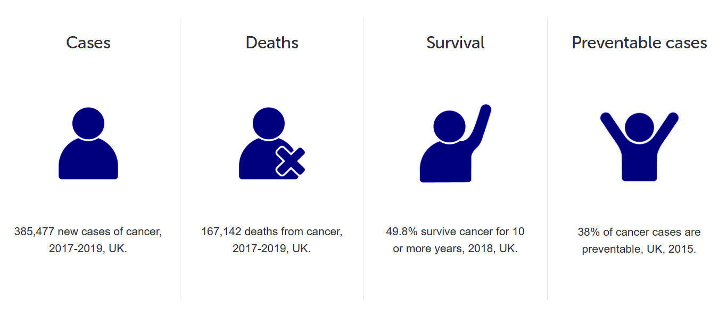
Figure 1: Cancer Statistics for the UK
Source: cancerresearchuk

Aetiology and Risk Factors of Long-Term Conditions
Late effects are the long-term and late effects of the cancer and its treatment, which is the new long-term condition of many survivors (Mayo Clinic, n.d.). These are physical, psychological and social problems, which may be experienced months or even years following the treatment.

Risk Factors and Aetiology
Late effects are multifactorial in nature and related to the type and dose of treatment (e.g., particular chemotherapies, radiation location), age at treatment (primarily survivors of childhood cancer), gender, and general health (Blood Cancer United, n.d.).
Common long-term effects and their primary aetiology include:
- Cardiotoxicity and destruction of the lungs by some chemotherapy agents (such as anthracyclines) or radiation therapy to the chest (MD Anderson Cancer Center, n.d.).
- Radiation exposure or specific hormone therapy-induced secondary cancers or osteoporosis (Blood Cancer United, n.d.; MD Anderson Cancer Center, n.d.).
- Cognitive impairment (so-called chemobrain) and fatigue due to chemotherapy or radiation of the brain, which influences concentration and memory (Mayo Clinic, n.d.).
- Platinum-based chemotherapy agents cause neuropathy (disability in the nerves) (MD Anderson Cancer Center, n.d.).
- Psychological distress or post-traumatic stress disorder (PTSD) or depression is a multifaceted psychological pathophysiology and depends on the trauma of diagnosis and treatment (Blood Cancer United, n.d.).

Long-Term Management and Community Reintegration
Nevertheless, effective management is based on stratification and a person-centred approach that abandons the traditional model of one size fits all (NHS England, n.d.).

Management and Reintegration Strategy
The primary elements of the long-term survivorship care as popularised by the NHS and national efforts comprise:
- Surveillance for recurrence and new cancers.
- Late Effects Assessment and Management: This involves a Holistic Needs Assessment (HNA) to meet physical, psychological and social needs, and then a Survivorship Care Plan in writing (NHS England, n.d.).
- Supported Self-management: By providing health promotion (e.g., physical activity and diet), information, and easy access to specialist services, the survivors may be empowered (NHS England, n.d.).
- Community Reintegration: This is concerned with restructuring previous performance statuses (e.g., employment, education) and reintegration of a new normal and self-identification. Vocational rehabilitation and mitigation of social risks such as financial difficulties are both important components of community reintegration (ResearchGate, 2019; NHS England, n.d.).

Impact on Individuals: Physical, Psychological, and Social Implications
The increasing population of cancer survivors in the UK (which is expected to grow to more than 4 million by 2030) is exposed to a challenging array of long-term and late consequences that have a significant negative impact on their quality of life (QOL) (NHS England, n.d. a; Cancer Research UK, 2023).

Physical Implications
The direct toxicity of treatments in the form of physical long-term conditions is long-lasting and continues even after treatment. Fatigue is an extremely widespread and disabling problem that has been affecting a considerable number of survivors over the years (Mayo Clinic, n.d.). Other problems include:
- Cardiotoxicity (e.g., heart failure and hypertension) and pulmonary injury due to certain chemotherapies (e.g., anthracyclines) and radiotherapy (Binasss, n.d.). As an illustration, female victims of breast cancer are more prone to cardiovascular diseases than their counterparts (Binasss, n.d.).
- Peripheral neuropathy (damaged nerves), which leads to pain and numbness, is often associated with chemotherapy based on platinum (Mayo Clinic, n.d.).
- Secondary cancers, osteoporosis, lymphoedema, and sexual dysfunction are also noteworthy negative consequences that need to be managed chronically (Mayo Clinic, n.d.; Binasss, n.d.).

Psychological and Social Implications
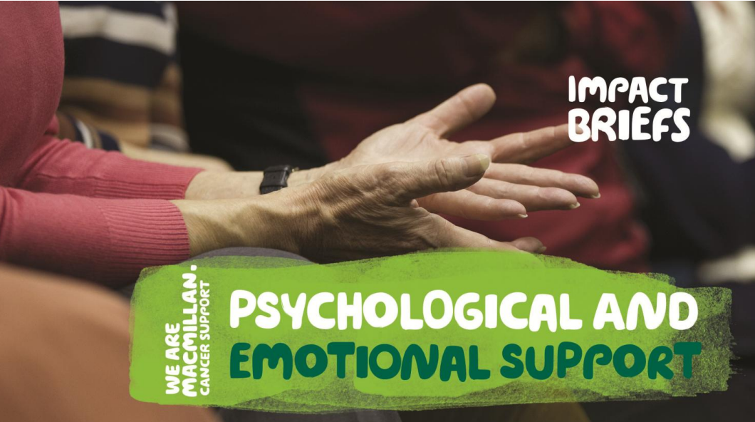
Figure 2: Psychological and Emotional Support
Source: macmillan
It is quite common, as the prevalence of psychological distress surpasses 54 percent of the survivors 10 years after treatment (Macmillan Cancer Support, n.d. a). Some of the important psychological problems are:
- Fear and depression, where younger survivors and comorbid ones are considered high risk (Macmillan Cancer Support, n.d. a).
- Constant, debilitating fear of recurrence (FOR) can be an important cause of reduced QOL (ResearchGate, 2023).
- Impairment of the brain (chemobrain) impairs memory and concentration, daily functioning and the capacity to resume work (Binasss, n.d.; Mayo Clinic, n.d.).
The condition may cause financial distress because of the inability to work, social interactions, and transformations in interpersonal relationships (PMC, n.d. a). Especially young survivors can experience that they are out of pace with their friends because of fertility problems, destruction of careers, and early menopause symptoms (PMC, n.d. b).

Wider Implications on Families and Carers
The effects of cancer survivorship are direly critical to the family unit, especially informal carers (partners, parents, and children). Central to care provision is the family, causing a substantial carer burden (ResearchGate, 2025).
- Psychological Effect on the Carers: Relatives are likely to be as anxious and occasionally even more depressed than the survivor (ResearchGate, 2025). Research indicates that 67 percent of all the carers feel anxious and 42 percent feel depressed, of whom most do not receive official assistance (Macmillan Cancer Support, n.d. a).
- Social and Financial Strain: In most cases, the physical and personal well-being of the carers suffers, and they may experience sleep deprivation and caring stress (ResearchGate, 2025). This stressor has the ability to interfere with family functioning, causing communication problems and reduced mental/physical health of the entire family (ResearchGate, 2025).
- Family-orientated interventions, including open communication and problem-solving, are important in alleviating distress to both a survivor and their family members (Researchgate, 2025).

Evidence-Based Treatments Available Through the NHS
The UK NHS Long Term Plan on Cancer requires a priority on personalised care and the enhancement of the QOL outcomes of survivors (NHS England, n.d. b).
1. Individualised Stratified Follow-Up (PSFU)
- The NHS has adopted the risk-stratified care pathway, which aims at aligning the degree of follow-up with those of the individual. Key components include:
- Holistic Needs Assessment (HNA): Provided at key moments (i.e., at the time of diagnosis and end of treatment), this is an official attempt to evaluate the physical, psychological, social, and practical needs of the survivor (NHS England, n.d. b).
- Personalised Care Plan and Treatment Summary: This is given to the survivor and their GP; it includes the diagnosis, treatment administered, possible long-term consequences, and contact points where the survivor can quickly recover specialist care (NHS England, n.d. b).
- Cancer Care Review: A meeting with the GP can be obtained between 6 and 12 months of diagnosis to talk about requirements and connect the survivor to the services provided locally (Guy's and St Thomas' Foundation Trust, n.d.).
2. Specific Late Effects Management
- Cancer Rehabilitation and Physical Activity: Early cancer rehabilitation and pulmonary physical activity Interventions based on evidence to improve the management of chronic fatigue and physical functioning and lower the risk of developing other conditions (UK Parliament Committees, 2023). The NHS promotes exercise on referral programmes among the survivors (UK Parliament Committees, 2023).
- Psycho-Oncology Services: NHS services are offered to provide psychological treatment and emotional support for anxiety, depression, and fear of recurrence, usually by clinical nurse specialists (CNSs) or by referral to specialist psycho-oncology teams (Guy's and St Thomas' NHS Foundation Trust, n.d.).
- Enhanced Supportive Care (ESC): This model combines palliative care and supportive services (such as pain medicine, dietetics, and physiotherapy) at earlier stages of the cancer pathway in order to proactively address complex symptoms and maximise QOL (NHS England, n.d. a).
- Lymphoedema Management: Treatment, which can be delivered by specialist physiotherapy or lymphoedema clinics, is based upon manual lymphatic drainage massage and compression sleeves (PMC, 2024).

Current Theoretical Perspectives
A change in attitude from acute and reactive disease-concentrated care to proactive, person-centred, and integrated care leads to improved patient outcomes in long-term conditions (LTCs) (NHS England, n.d. b). The theoretical approaches that dominate contemporary LTC management are:
- Self-Management and Patient Empowerment: The main focus of this approach is the patient, who plays a crucial role in dealing with his or her condition (Macmillan Cancer Support, n.d.). Such theories as the Social Cognitive Theory (SCT), in which the emphasis is put on self-efficacy (the confidence to perform an action course), are essential. According to the SCT, when a person is provided with knowledge, skills, and confidence to engage in health behaviours (e.g., take medications, exercise), the interventions will result in improved health outcomes (PMC, 2024a).
- Socio-Ecological Model: According to this approach, individual health behaviours and outcomes are not only dependent on the individual level but also on the combined influence of various levels, such as the interpersonal (social support), organisational (healthcare systems), community, and policy environment (PMC, 2024a). This is a holistic perspective which informs integrated care delivery.
- Goal-Orientated Care (GOC): A modern approach that guarantees that the decisions made in care are supported by the aspects that hold the most significance to the individual (GOC) throughout their lifetime, particularly in individuals with numerous long-term conditions (multimorbidity). GOC facilitates collaborative decision-making between clinicians and patients, aiming to establish individualised objectives (PMC, 2023).

UK Model: The House of Care and Personalised Stratified Follow-Up (PSFU)

Model: Individualised Stratified Following-Up (PSFU)
The NHS has incorporated the PSFU model, especially cancer survivorship, as a risk-stratified model of treatment.
Core Principles: To substitute the conventional, blanket follow-up appointments, which are traditionally led by the consultant, with a more personalised need-based model (NHS England, n.d. a). The risk of recurrence and the severity of the late effects are used to stratify the patients into three pathways (supported self-management, shared care or traditional follow-up).
Mechanism for Enhanced Outcomes: It is expected to enhance outcomes by ensuring that only needed services from specialists are accessed in a timely manner and giving the majority of stable patients the power to control their health (NHS England, n.d. a). This is achieved through:
- Holistic Needs Assessment (HNA): A formal physical, psychological, social and practical needs assessment.
- Personalised Care Plan (PCP): It is a document that provides patients with a clear idea of how they will be treated, the late effects they may have, and the contact details (NHS England, n.d. a).
- Self-Management Support: Supporting patients to be informed and activated in the management of their health (NHS England, n.d. a).

Framework: The House of Care
The House of Care is a general organisational structure that NHS England embraces in its quest to improve the quality of life for individuals with LTCs. It gives a pictorial roadmap of what an effective LTC service needs to comprise (NHS England, n.d. b; PMC, 2016).
Four Walls:
- Commissioning: Obtaining and financing high-quality services.
- Organisational Systems: Evidence-based care in the form of teams (e.g., IT systems, planned care).
- Community and Social Resources: The connection of patients to local support groups and non-clinical services.
- Informed & Active Patients: Patients with the knowledge and skills and confidence to self-manage their health.
Roof: Shared decision-making between the professional and the patient (PMC, 2016).
Mechanism: It operates through the incorporation of the clinical system with those of the community and making the patient empowered and thus making the care comprehensive and focused on the priorities and goals of the individual (NHS England, n.d. b).

International Model: The Chronic Care Model (CCM)

Model: The Chronic Care Model (CCM)
The CCM is the most popular global model developed by Wagner et al. in the US to change the approach to chronic illnesses (PMC, 2024b). The model transforms day-to-day care into being proactive, planned, and population-based (PMC, 2024b).
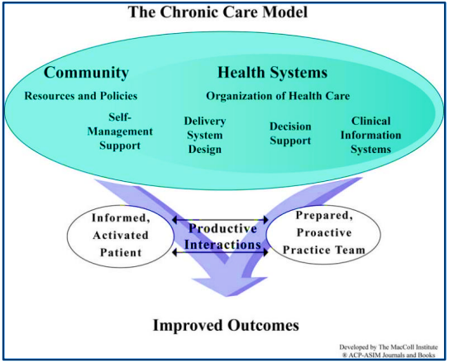
Figure 3: Chronic Care Model
Source: center
Six Interacting Elements:
- Community: Organisational mobilisation (e.g., schools, senior centres) to enhance health.
- Health System: The establishment of a culture of prioritising quality, patient safety, and leadership (PMC, 2024b).
- Self-Management Support: Promoting the central position of the patient by using assessment, goal-setting, and follow-up.
- Design of the delivery system: Defining the roles and tasks of a multidisciplinary practice team, which includes case managers, nurses, and doctors.
- Decision Support: The application of evidence-based rules and specialist knowledge to enhance effective care (PMC, 2024b).
- Clinical Information Systems: The organised population health data and reminders using registries and IT (PMC, 2024b).
Goal: The model is directed to achieve a goal of a productive interaction between a prepared practice team and an informed and activated patient, which will result in an outright outcome improvement (PMC, 2024b).
Mechanism to Improve Results: The CCM addresses all system components – clinical, technological, and community – in a systemic manner to guarantee that the care offered is consistent, evidence-based, and patient-centred, resulting in improved clinical outcomes and patient satisfaction (PMC, 2024b).

National Agenda: NHS Long Term Plan and Personalised Care
The national health and social care agenda in the UK (mainly by the NHS Long Term Plan (LTP) (published 2019)) and the subsequent emphasis on Universal Personalised Care (UPC) offer the political and strategic framework for the improvement of long-term condition (LTC) management, including cancer survivorship (NHS England, n.d. a; NHS England, n.d. b).
1. Switching Hospital to Community Care
One of the fundamental priorities of the LTP is the transition between hospital and community care and offering more proactive, preventive, and coordinated services near home (NHS England, n.d. a).
- Developmental Initiatives: In the case of cancer survivorship, this guides the creation of personalised stratified follow-up (PSFU) pathways (NHS England, n.d., c). This model can transfer stable survivors to a position of being supported by self-management with remote monitoring and relieve specialist capacity to concentrate on difficult cases.
- Critical Examination: This initiative depends on an adequate amount of investment dedicated to community service and general practice, as well as the robustness of digital infrastructure to support remote monitoring and information dissemination. Reports, including one by the CQC, have shown that community services are stressed and disjointed, which endangers the quality of this shift (GOV.UK, 2025).
2. Universal Personalised Care (UPC)
UPC is the political commitment to incorporate individualised approaches throughout the NHS that integrate care to be more responsive to what matters to you, as opposed to what is the matter with you (NHS England, n.d. b).
- Developmental Initiatives: The UPC model is the foundation of the required provision of Holistic Needs Assessments (HNA) and Personalised Care Plans (PCP) to cancer survivors (NHS England, n.d. c). This will be essential to meet the non-clinical, psychosocial, and social care demands (e.g., employment support, mental health) which are prevalent long-term consequences of cancer (Macmillan Cancer Support, n.d.).
- Critical Examination: Despite the sound intention, there is a serious workforce and capacity challenge in the implementation. Most of the frontline employees do not have the required time and training to have meaningful, person-centred conversations that are needed to make shared decision-making and care planning effective (MAG Online Library, 2020). Moreover, the risk is that this individualised approach will turn into a box-ticking undertaking if it is not deeply entrenched in staff culture and clinical systems (MAG Online Library, 2020).

Local Agenda: Socio-Economic Inequalities and Integrated Care Systems (ICSs)
These national agendas are now being implemented locally but through the Integrated Care Systems (ICSs), which have the role of integrating services across local health and social care borders in order to meet the needs of the population they serve (NHS England, n.d. a).
1. Population Health and Integrated Care
ICSs have a political role in enhancing population health and addressing health inequalities (NHS England, n.d., a).
- Developmental Initiatives: In the case of cancer survivorship, ICSs will be encouraged to deploy social prescribing and refer survivors to local voluntary and community sector organisations to assist them in reintegrating into the community, engaging in physical activities, and mitigating isolation (NHS England, n.d. b). This directly talks about the social determinants of health that influence the survivorship outcomes.
- Critical Analysis: Although the ICSs are free to adapt services, the funding pressures and the absence of a long-term and target-specific cancer strategy in England severely limit their capacity to deliver successful transformative interventions (Cancer Research UK, 2025). The ICSs' reliance on fragmented short-term plans, rather than a comprehensive Major Conditions Strategy, results in a lack of focus on enhancing complex survivorship and addressing deeply ingrained inequalities (Cancer Research UK, 2025; KCL, 2024).
2. Tackling Inequalities
The political promises made as part of the national agenda provide specifications for cutting the disparity in the life expectancy of the healthiest and poorest areas by half (The King’s Fund, 2024).
Developmental Initiatives: This notifies local efforts to focus on screening and early diagnosis in deprived locations, and it directly impacts the share of those diagnosed at an early and more treatable period (NHS England, n.d. a). It also explains the controlled introduction of such services as Neighbourhood Health Centres into neighbourhoods with the poorest healthy life expectancy (GOV.UK, 2025).
Critical Analysis: The implementation is not easy, although the political will is present. Systemic problems, including late cancer diagnoses when patients are admitted to the emergency room (a proxy of poor access to primary care in deprived locations) and big regional differences in care quality, exist and need a more substantial political commitment to a whole-system way of investing in workforce and infrastructure, and no single technological solutions (KCL, 2024).

Recommendations for Improving Person-Centred Care
To optimise person-centred care, self-management, and end-of-life care of long-term conditions:
- Mandate Shared Decision-Making: Have an Ensuring Personalised Care Plan (PCP) developed together following a Holistic Needs Assessment (HNA) and aimed at patient-identified outcomes, rather than clinical ones. This creates self-efficacy.
- Incorporate Self-Management Support: Integrate the Health Coaching and Peer Support programme into the regular follow-up care. Such interventions equip the patient with knowledge, skills, and confidence to cope with his or her condition day by day.
- Proactively Introduce Palliative Care: Embark on palliative care considerations during diagnosis and not only during the end-of-life stage of chronic and life-limiting conditions. This enables earlier management of the symptoms and improvement of the quality of life.
- Make advance care planning a priority: Chair and document Advance Care Planning (ACP) in the PCP on a regular basis. This makes sure that the preferences of the patient concerning future care and end-of-life are always respected and transmitted to all settings.
- Train on Empathy and Communication: Invest in interprofessional training of all staff (clinical and non-clinical) in empathetic communication and responding to psycho-existential distress in patients and their careers.

Conclusion
A shift to personalised, integrated care (PSFU and CCM) is necessary to enhance long-term cancer survival outcomes. Although the change is supported in the UK through political agendas via the NHS Long Term Plan, the success of the change will rely on the ability to overcome the workforce constraint and to provide specific funding for self-management support and comprehensive family/carer support, especially to deal with the outstanding health inequalities.

Reference
Blood Cancer United. (n.d.). Long-term and late effects of blood cancer treatment. Retrieved November 11, 2025, from https://bloodcancerunited.org/blood-cancer-care/adults/follow-up-care-survivorship/long-term-late-effects-treatment
Cancer Research UK. (2023). Cancer Statistics for the UK. Retrieved November 11, 2025, from https://www.cancerresearchuk.org/health-professional/cancer-statistics-for-the-uk
Mayo Clinic. (n.d.). Cancer survivors: Late effects of cancer treatment. Retrieved November 11, 2025, from https://www.mayoclinic.org/diseases-conditions/cancer/in-depth/cancer-survivor/art-20045524
MD Anderson Cancer Center. (n.d.). Long-Term Effects of Cancer. Retrieved November 11, 2025, from https://www.mdanderson.org/patients-family/life-after-cancer/long-term-effects.html
National Cancer Institute. (n.d.). Definitions. Retrieved November 11, 2025, from https://cancercontrol.cancer.gov/ocs/definitions
NHS England. (n.d.). Adult Survivorship: from Concept to Innovation. Retrieved November 11, 2025, from https://www.england.nhs.uk/improvement-hub/wp-content/uploads/sites/44/2017/11/Adult-Survivorship-from-Concept-to-Innovation.pdf
ResearchGate. (2019). Reintegration for Post-treatment Cancer Survivors: A Concept Analysis. Retrieved November 11, 2025, from https://www.researchgate.net/publication/337062314_Reintegration_for_Post-treatment_Cancer_Survivors_A_Concept_Analysis
World Health Organization (WHO). (2024, February 1). Global cancer burden growing, amidst mounting need for services. Retrieved November 11, 2025, from https://www.who.int/news/item/01-02-2024-global-cancer-burden-growing--amidst-mounting-need-for-services
Binasss. (n.d.). Cancer survivor late-effects, chronic health problems after cancer treatment: what's the evidence from population and registry data and where. Retrieved November 11, 2025, from https://www.binasss.sa.cr/feb24/20.pdf
Guy's and St Thomas' NHS Foundation Trust. (n.d.). Cancer care and support - Overview. Retrieved November 11, 2025, from https://www.guysandstthomas.nhs.uk/health-information/cancer-care-and-support
Macmillan Cancer Support. (n.d. a). Psychological and Emotional Support. Retrieved November 11, 2025, from https://www.macmillan.org.uk/_images/psychological-and-emotional-support_tcm9-283186.pdf
NHS England. (n.d. a). Enhanced Supportive Care. Retrieved November 11, 2025, from https://www.england.nhs.uk/wp-content/uploads/2016/03/ca1-enhncd-supprtv-care-guid.pdf
NHS England. (n.d. b). Personalised care and improving quality of life outcomes. Retrieved November 11, 2025, from https://www.england.nhs.uk/cancer/living/
PMC. (n.d. a). Cancer survivorship: the impact on primary care. Retrieved November 11, 2025, from https://pmc.ncbi.nlm.nih.gov/articles/PMC3207095/
PMC. (n.d. b). Physical and Mental Health Among Cancer Survivors: Considerations for Long-Term Care and Quality of Life. Retrieved November 11, 2025, from https://pmc.ncbi.nlm.nih.gov/articles/PMC4503227/
PMC. (2024). Long Term and Latent Side Effects of Specific Cancer Types. Retrieved November 11, 2025, from https://pmc.ncbi.nlm.nih.gov/articles/PMC5777532/
ResearchGate. (2023). The impact of cancer on the physical, psychological and social well-being of childhood cancer survivors. Retrieved November 11, 2025, from https://www.researchgate.net/publication/230685217_The_impact_of_cancer_on_the_physical_psychological_and_social_well-being_of_childhood_cancer_survivors
ResearchGate. (2025). The psychological impact of a cancer diagnosis on families: The influence of family functioning and patients' illness characteristics on depression and anxiety. Retrieved November 11, 2025, from https://www.researchgate.net/publication/8414786_The_psychological_impact_of_a_cancer_diagnosis_on_families_The_influence_of_family_functioning_and_patients'_illness_characteristics_on_depression_and_anxiety
UK Parliament Committees. (2023). LTC0052 - Evidence on Management of long-term conditions. Retrieved November 11, 2025, from https://committees.parliament.uk/writtenevidence/44487/html/
Macmillan Cancer Support. (n.d.). Personalised Care. Retrieved November 11, 2025, from https://www.macmillan.org.uk/about-us/what-we-do/campaigns/health-and-social-care/personalised-care
NHS England. (n.d. a). Personalised stratified follow-up (PSFU) for people with cancer. Retrieved November 11, 2025, from https://www.england.nhs.uk/publication/personalised-stratified-follow-up-psfu-for-people-with-cancer/
NHS England. (n.d. b). The House of Care. Retrieved November 11, 2025, from https://www.england.nhs.uk/long-term-conditions/house-of-care/
PMC. (2016). Improving the care of people with long-term conditions in primary care: protocol for the ENHANCE pilot trial. BMC Family Practice, 17(135). https://pmc.ncbi.nlm.nih.gov/articles/PMC5636040/
PMC. (2023). Operationalizing the Chronic Care Model with Goal-Oriented Care. Journal of General Internal Medicine, 38(14), 3290–3293. https://pmc.ncbi.nlm.nih.gov/articles/PMC10570240/
PMC. (2024 a). Models and theories of health behavior and clinical interventions in aging: a contemporary, integrative approach. GeroScience, 46(2), 1591–1608. https://pmc.ncbi.nlm.nih.gov/articles/PMC6549388/
PMC. (2024 b). Evidence On The Chronic Care Model In The New Millennium. Health Affairs, 28(1), 75-84. https://pmc.ncbi.nlm.nih.gov/articles/PMC5091929/
Cancer Research UK. (2025). Our policy on national cancer plans. Retrieved November 11, 2025, from https://www.cancerresearchuk.org/about-us/we-develop-policy/our-policy-on-cancer-services/our-policy-on-national-cancer-plans
GOV.UK. (2025). The state of health care and adult social care in England 2024 to 2025. Retrieved November 11, 2025, from https://assets.publishing.service.gov.uk/media/68fa3b4fe200d653d8b63735/care-quality-commission-state-of-health-care-and-adult-social-care-England-2024-2025.pdf
KCL. (2024). 10 cancer challenges facing the new government. Retrieved November 11, 2025, from https://www.kcl.ac.uk/news/the-10-cancer-challenges-facing-the-new-government
Macmillan Cancer Support. (n.d.). Psychological and Emotional Support. Retrieved November 11, 2025, from https://www.macmillan.org.uk/_images/psychological-and-emotional-support_tcm9-283186.pdf
MAG Online Library. (2020). Practising personalised care. Retrieved November 11, 2025, from https://www.magonlinelibrary.com/doi/10.12968/bjon.2020.29.2.82
NHS England. (n.d. a). 2024/25 priorities and operational planning guidance. Retrieved November 11, 2025, from https://www.england.nhs.uk/long-read/2024-25-priorities-and-operational-planning-guidance/
NHS England. (n.d. b). What is personalised care?. Retrieved November 11, 2025, from https://www.england.nhs.uk/personalisedcare/what-is-personalised-care/
NHS England. (n.d. c). Personalised care and improving quality of life outcomes. Retrieved November 11, 2025, from https://www.england.nhs.uk/cancer/living/
The King's Fund. (2024). General election 2024: the health and care manifesto pledges. Retrieved November 11, 2025, from https://www.kingsfund.org.uk/insight-and-analysis/long-reads/health-care-manifesto-pledges-election-2024

