3/24/2025
University of Wales Trinity Saint David
London campus
Module Name: Scripting and Programming Concepts
Module Code: ACCA 5036

Student Name: Mansur Babayev
Student ID: 2415925

Lecturer’s Name: Koushik Modak

SPC Assignment on
Student Equipment Booking System
Code Link: https://github.com/Mansur2905/Booking-system.git

Table of Contents
Introduction 2
Main Body 2
1. Analysis 2
2. Software Design and Development 5
Design: 5
Implementation Decisions 5
Source Code 5
3. Testing and Debugging Report 7
4. Evaluation 7
Conclusion 7
References 7
Appendices 7

Introduction

Bright Minds Academy is a well‑established but small private tutoring centre that focuses heavily on delivering personalised learning to its students. To support this approach, the academy regularly uses a range of digital equipment, including modern laptops, projectors, and interactive tablets. However, the current method for managing this equipment is completely manual. Tutors write their booking requests on a paper sign‑out sheet kept at the reception desk.
As the academy has expanded, this paper‑based system has started to cause significant problems. Staff often double‑book the same item without realising, paper records go missing, and handwriting can be unclear, which leads to misunderstandings. These issues make it difficult for tutors to plan their lessons properly and sometimes leave them without the equipment they need at short notice. This directly affects the quality of teaching and creates unnecessary stress for both tutors and administrative staff.
The aim of this project is to design and develop a digital “Student Equipment Booking System” using Python. This system will replace the paper sheet with a centralised, computer‑based tool that stores all equipment bookings in one place. By moving to a digital solution, the academy hopes to eliminate double bookings, improve organisation, and make it easier for staff to check equipment availability. Overall, the system is intended to streamline the booking process and ensure tutors always have reliable access to the resources required for their lessons.

Main Body
- Analysis
• Requirements Analysis
To develop an effective software solution, the problem must be broken down using computational thinking methods. Two main areas are abstraction and decomposition. Abstraction means to remove all unnecessary detail, so the program only focuses on the essential functions. For this particular problem we do not need to overcomplicate the task and we are not required to record where in the building equipment is stored, its technical specifications or its maintenance history. Instead, each piece of equipment can be represented by simple name such as “Laptop1”. The booking in the same way can be reduced to three pieces of information such as equipment being used, person who booked it and the date of the booking.
Problem decomposition involves splitting the overall task of creating a booking system into smaller more manageable components. Instead of building a large program all at once, it should be divided into clear functional modules. Four key modules can be derived from solution. Equipment Management module for adding and storing equipment. Booking module for assigning equipment to users on the date of booking. Reporting module for checking current booking. Search module that would allow to find specific records.
To achieve desired outcome and build a robust booking system Python will be used. Python is a general-purpose programming language used for machine learning, data automation and building applications. Due to its simplicity and readability, it allows to solve problems in more efficient ways. It features straightforward syntax, which makes is suitable for beginners and students in the educational projects. Python also includes many built in dictionaries and data structures, this allows to store and manage data without a need for a database. To complete a small project like booking system application, Python is a perfect choice [1].

Functional Requirements
- Add new equipment: The system must allow staff to register new equipment items into the digital inventory. This includes entering a unique name such as “Laptop 1” or “Projector A”. Once added, the item becomes available for booking. This feature ensures the inventory remains accurate as the academy purchases new devices or replaces old ones. It also prevents staff from booking equipment that does not exist in the system.
- Record bookings: Staff should be able to assign a specific piece of equipment to a student or tutor for a chosen date. The system must check that the equipment exists and is not already booked for that date. If the equipment is available, the booking is stored in the system. This feature directly addresses the academy’s current issue of double bookings and ensures that each device is only assigned to one user per day.
- View booking records: The system must provide a clear overview of all bookings. Staff should be able to see which equipment is booked, who booked it, and for which date. This feature helps tutors plan ahead by checking availability before making a request. It also supports administrative staff by giving them a complete picture of equipment usage across the centre.
- Simple Search: Users should be able to search for bookings using either a student’s name or an equipment name. For example, typing “Laptop 1” should display all bookings for that device, while typing a student’s name should show all equipment they have reserved. This feature improves efficiency by allowing staff to quickly locate specific records without scrolling through the entire booking list.
- Low-Booking Alerts: The system should generate an automatic notification when booking activity falls below a certain threshold. For example, if equipment is rarely being booked, the system could alert staff to review usage patterns. This feature helps the academy identify underused resources, plan maintenance, or decide whether certain equipment is no longer needed.
- User-Friendly Interface: The interface must be simple, clear, and easy to navigate, especially since many staff members may not have advanced technical skills. Menu options should be clearly labelled, instructions should be straightforward, and error messages should be easy to understand. A user-friendly design reduces training time and minimises mistakes.
- Scalability: The system should be designed in a way that allows future expansion. Although the current version uses lists and dictionaries, the structure should allow for future upgrades such as adding time slots, integrating a database or introducing user accounts. Scalability ensures the system remains useful as the academy grows [2].

Non-Functional Requirements
In addition to functionality, the system must meet several quality criteria:
- Reliability: The system must consistently store and retrieve accurate booking information. It should not lose data during a session or allow conflicting bookings. Reliability is essential because staff depend on the system to plan lessons and allocate resources.
- Performance: All operations, such as recording booking, adding equipment and searching, must respond quickly. As it is a small scale-system and uses lightweight data structure, it should perform efficiently even with usage of basic hardware. Fast performance is important for user satisfaction and reduction of delays during busy periods.
- Security: Although the system is simple, it must still protect data from accidental loss or unauthorised changes. This includes preventing invalid inputs, avoiding crashes, and ensuring that booking information is not overwritten incorrectly. In future versions, security could be expanded to include user authentication or encrypted storage.
- Accessibility: The system should be accessible to all staff members, regardless of their technical background. This includes clear text prompts, readable formatting, and logical menu navigation. Accessibility ensures that the system can be used confidently by tutors, administrators, and support staff [3].

2. Software Design and Development
Design
    - Pseudo-code:

START PROGRAM

INITIALISE equipment_list as empty list
INITIALISE bookings as empty list

FUNCTION add_equipment():
DISPLAY "Add New Equipment"
INPUT eq_name

IF eq_name is empty:
DISPLAY "Error: Equipment name cannot be blank"
RETURN

IF eq_name (case-insensitive) exists in equipment_list:
DISPLAY "Error: This equipment already exists"
RETURN

APPEND eq_name to equipment_list
DISPLAY "Success: Equipment added"
END FUNCTION

FUNCTION record_booking():
DISPLAY "Record a Booking"

IF equipment_list is empty:
DISPLAY "Error: No equipment available"
RETURN

DISPLAY all equipment in equipment_list
INPUT eq_name

IF eq_name (case insensitive) NOT in equipment_list:
DISPLAY "Error: Equipment not found"
RETURN

INPUT student_name
IF student_name is empty:
DISPLAY "Error: Student name cannot be blank"
RETURN

INPUT date
IF date is empty:
DISPLAY "Error: Date cannot be blank"
RETURN

FOR each booking in bookings:
IF booking.equipment (case-insensitive) equals eq_name
AND booking.date equals date:
DISPLAY "Error: Equipment already booked on this date"
RETURN

CREATE booking_record with keys:
equipment = eq_name
student = student_name
date = date

APPEND booking_record to bookings
DISPLAY "Success: Booking recorded"
END FUNCTION

FUNCTION view_bookings():
DISPLAY "All Booking Records"

IF bookings list is empty:
DISPLAY "No bookings found"
ELSE:
FOR each booking in bookings with index:
DISPLAY index, equipment, student, date
END FUNCTION

FUNCTION search_bookings ():
DISPLAY "Search Bookings"
INPUT query

IF query is empty:
DISPLAY "Error: Search query cannot be blank"
RETURN

INITIALISE results as empty list

FOR each booking in bookings:
IF query (case-insensitive) is in booking.student
OR query is in booking.equipment:
APPEND booking to results

IF results list is empty:
DISPLAY "No matching records found"
ELSE:
DISPLAY all matching records
END FUNCTION

FUNCTION main_menu ():
LOOP FOREVER:
DISPLAY menu options (1–5)
INPUT choice

IF choice == 1:
CALL add_equipment ()
ELSE IF choice == 2:
CALL record_booking ()
ELSE IF choice == 3:
CALL view_bookings ()
ELSE IF choice == 4:
CALL search_bookings ()
ELSE IF choice == 5:
DISPLAY "Exiting system"
BREAK LOOP
ELSE:
DISPLAY "Error: Invalid choice"
END FUNCTION

CALL main_menu ()

Implementation Decisions
- Data Structures:
For this program Python Lists was chosen. A list is very suitable for this program, as it allows to append new items and easy with iteration. For example, “equipment_list = [ ]” is used to store strings that represent available equipment.
Also list of dictionaries was chosen, allows to store in the details of the booking in single logical entity. Storing these dictionaries in a list program can go through them and check for double bookings, view records or perform searches.
Variables:
‘eq_name’: Is a string variable. Temporarily holds equipment names entered by users.
‘student_name’: Is a string variable, that holds student’s name.
‘date’: Is a string variable, holds the date for booking.
‘booking_record’: Is a dictionary that contains equipment, student and date before appended to the main booking list.
‘quiry’: Is a string. The user’s search term, converted to lowercase to support case sensitive information matching.

- Programming Constructs:
This program uses various control structures. For example:
If/elif/else: Used throughout the programme for input validation, to prevent errors such as black fields, duplicates or invalid equipment names.
For loops: Used to iterate through the booking list, when searching or checking for double bookings.
While loop: Used in the main menu, to keep program running until user decides to exit the program.
These constructs allow the program to respond dynamically to user input and handle repeated actions effectively. They also make the program easy to follow.
- Python Modules and Libraries:
No modules and libraries have been used for this project, due to requirements of the project. Project required to be done with emphasis on simplicity and portability. Only core python modules were used in this project due to their lightweight execution and easy deployment on any machine.

Source Code
Screenshot of the of adding equipment section. In this section the lists are defined. There is input and validation. Also it checks for duplication.
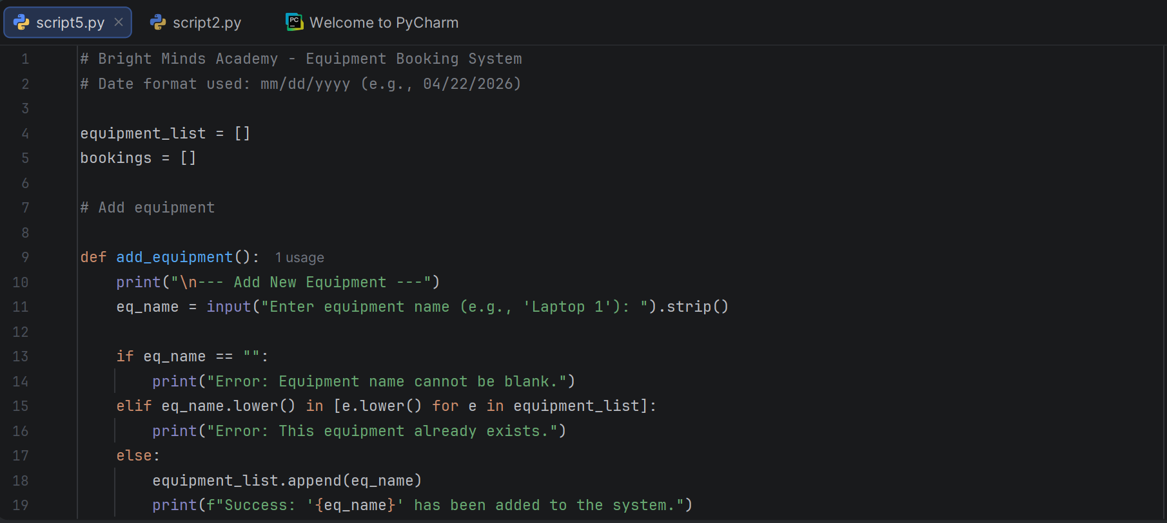

This section is for recording and viewing bookings. In this section data collection and validation performed. This code also prevents double bookings and creates dictionaries, which stores data and then appends it to ‘booking’ list. Also ‘view_bookings’ function displays all the current bookings.
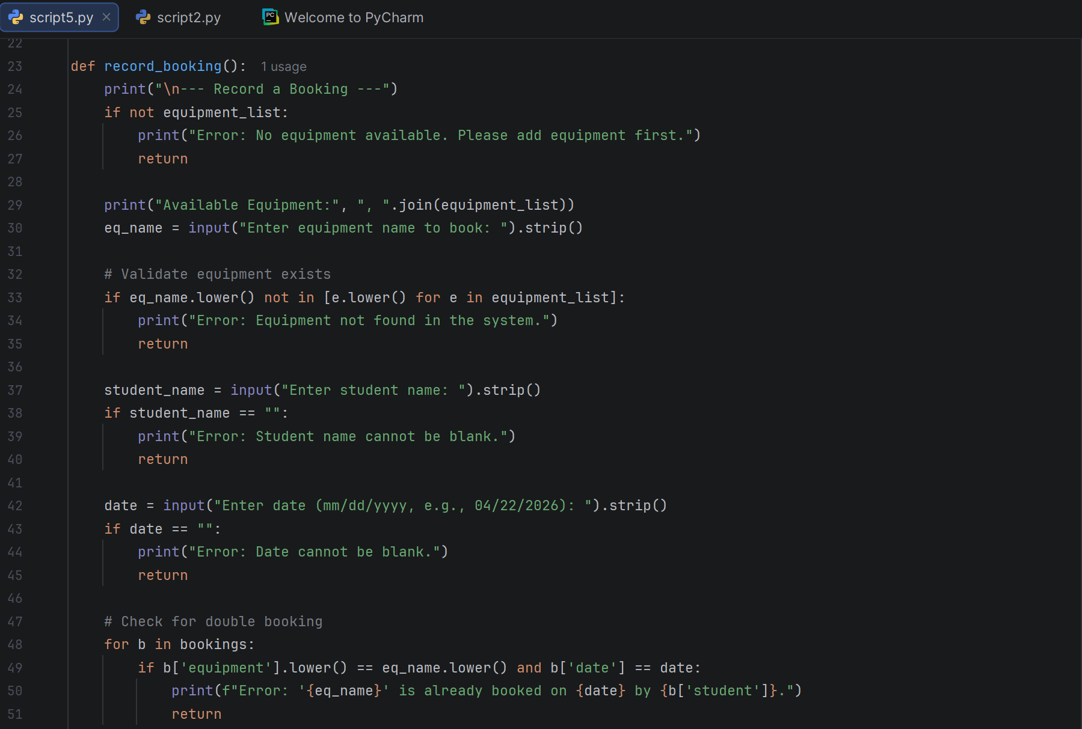
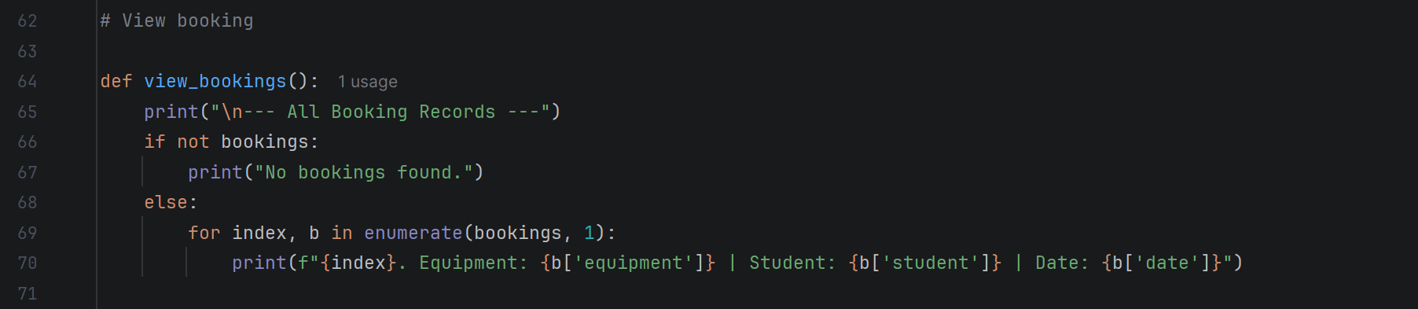

This section contains ‘search_bookings’ function, that allows user search for bookings. This is performed with the help of ‘query’, which is converted to ‘. lower()’ to make search case sensitive. Then it creates a temporary list called 'resulsts’ and if ‘query’ matches any of student’s or equipment’s name it adds that booking dictionary to ‘results’ list. Then it checks if there is anything in ‘results’ list and if so it loops and prints matching records.
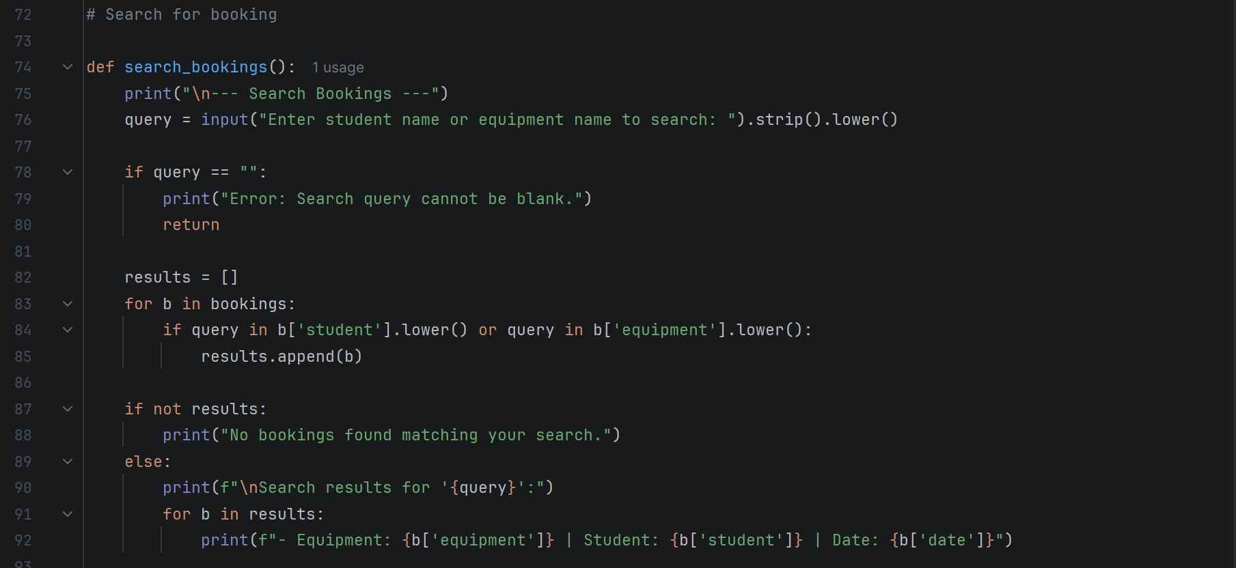

This section is main menu. It includes an infinite loop that keeps program running continuously and displays menu options for user’s input. If/elif/else checks user’s choice and it calls appropriate function according to number entered. If ‘5’ is entered, the ‘break’ command ends the while loop to end the program.
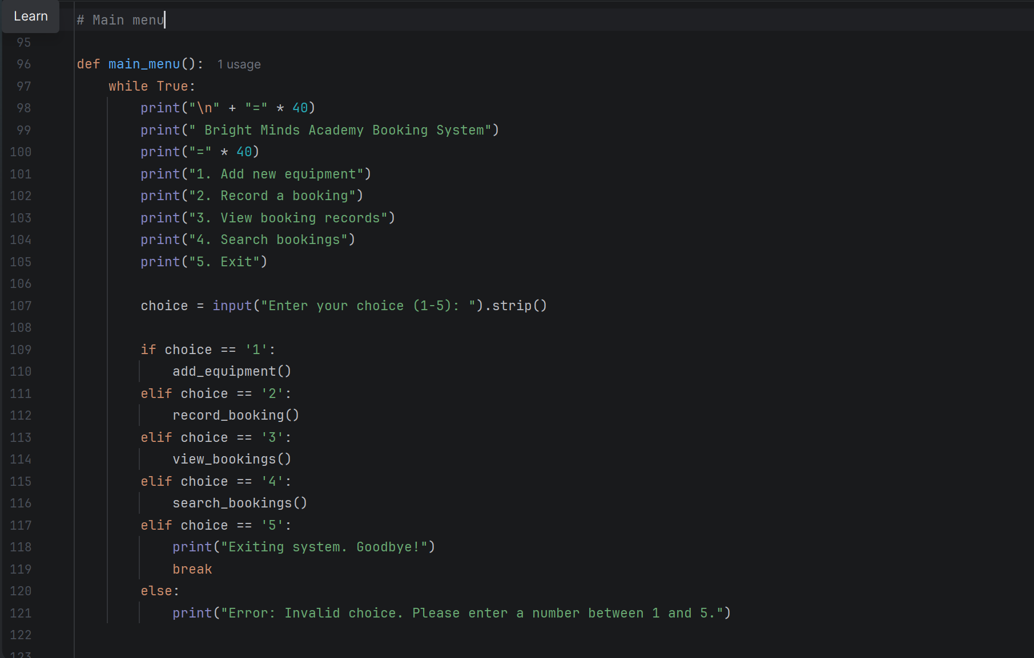
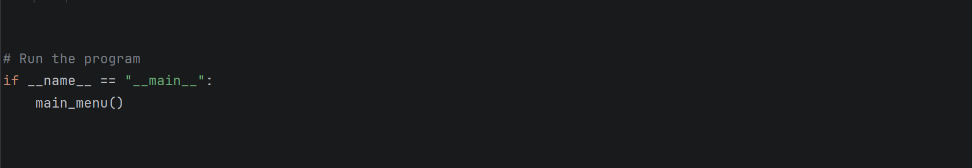

3. Testing and Debugging Report
Importance of Programme testing in Software Development
Testing is a crucial part of Software Development Life Cycle, because it ensures that the final product works as intended and meets all user requirements. The main purpose of testing and debugging is to confirm that software is working correctly under normal and unexpected conditions. In the case of Bright Minds Academy, realising a system that is not fully tested could lead to various issues such as incorrect booking data, system crashes and double-booking problems. Effective testing is essential to maintain data accuracy. It also improves system performance, strengthens security and improves user satisfaction. Testing allows to find bugs that could lead to system crashes, which would cause a disruption of the whole operational process [4].
There are different types of errors, when it comes to programming. Some common types of errors are:
Syntax Errors: These errors occur when the code breaks the rules of the programming language. Some examples of syntax errors include missing colons, forgetting to close brackets or incorrect indentation. Errors like these make entire program stop running and Python usually highlights the exact line where the error occurs. Fixing syntax errors involves reviewing the code structure and correcting mistakes [5].
Runtime Errors: These errors are also known as exceptions. Runtime errors happen when program attempts an invalid operation such as dividing by zero, combing incompatible data types or accessing a dictionary key that does not exist. Runtime errors occur after program has already started and could cause program to stop running unless handled properly.
There are some methods to handle these errors. Validation checks allow to ensure that inputs are valid before using them. Another is to use try/except blocks to catch exceptions and testing the program using unusual inputs, to identify potential errors [6].
Logical Errors: These are the most difficult errors to detect. When logical errors occur, program runs without crashing but produces incorrect results. These errors occur when the logical behind the is not correct. Examples of this could include saving data to the wrong variable or using wrong operator in a calculation. To identify logical errors requires very careful examination of the code such as stepping through the code, printing variables values and checking whether each part of the program runs as expected.
In summary, testing and debugging is an important part of Software Development Life Cycle, ensuring that everything operates in a right way [7].
Test Cases
Adding valid equipment. Program supposed add equipment. The result: equipment added successfully.
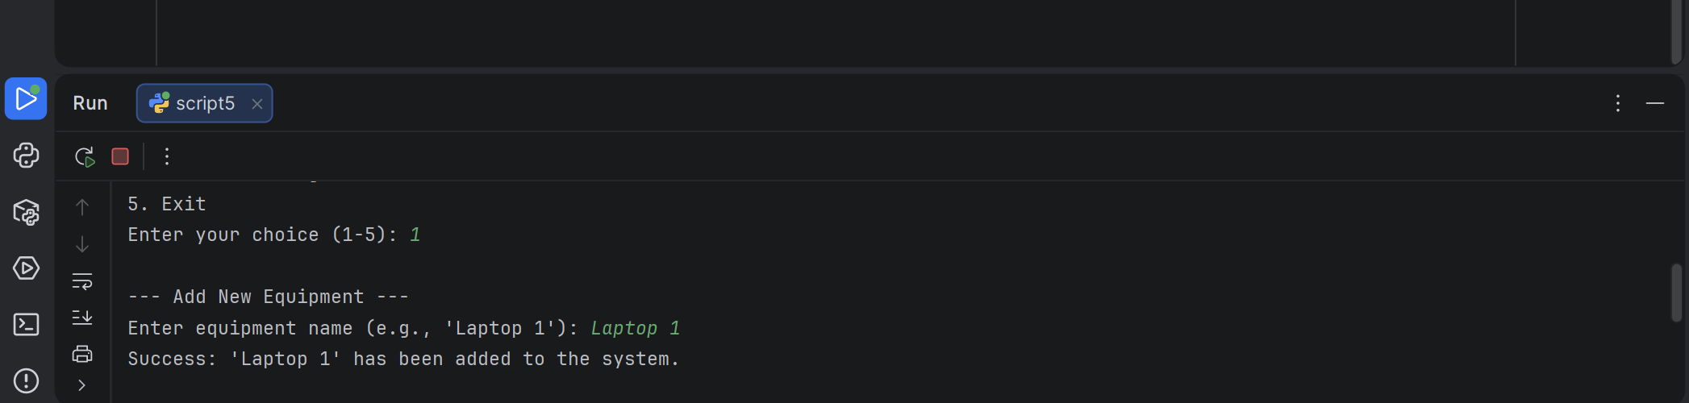
Adding duplicate equipment. Program supposed to recognise duplicate equipment. The result: program successfully identifies duplicate equipment.
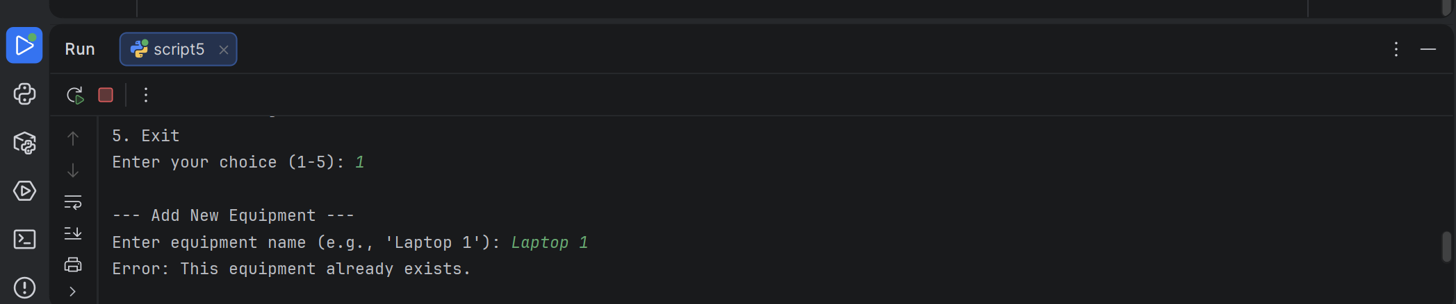

Booking non-existent equipment. The program supposed to show error. The result: as expected.
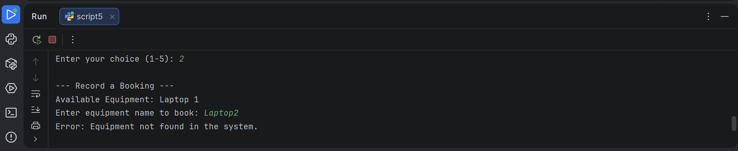
Searching for existing student. Program supposed to successfully find the records. The result: as expected.
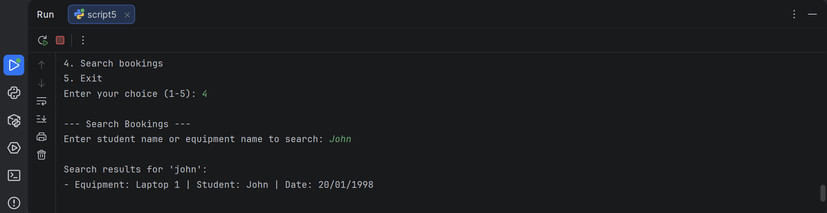

4. Evaluation
• Challenges Faced: Developing an equipment booking system presented several meaningful challenges that contributed to my learning experience. On of the earliest problems was to implement effective input validation. Without proper checks, users could enter blank equipment names, invalid dates or store incorrect data. It required careful planning to design validation rules that were both strict enough to prevent errors and still flexible for users.
Another challenge was handling case sensitivity in user’s input. In early version of the system “Laptop 1” and “laptop 1” were treated as different items, causing problems when searching or booking equipment. The solution was to convert both stored values and user input to lowercase before comparing. That ensured that searches and validations would work regardless of how users typed the text.
Another challenge was building a user-friendly menu system. It might not seem like a big task but surely required attention. The program needed to guide users clearly, handle invalid menu choices and loop correctly without crashing and causing inconvenience. Small mistakes could’ve caused program to crash and stop working.
Finally, the main challenge was to overcome hesitation. Being new to programming concepts it seemed like difficult task at times and difficult to complete. But by braking task into smaller parts and attempting them, it was helpful to overcome hesitation.
• Future Improvements: Current system meets core requirements, but some enhancements could significantly improve its functionality and usefulness in the long term.
Some improvements could include creating Graphical User Interface. This would make the system more accessible to non-technical users. Also, it will include buttons, forms and tables that would improve usability and reduce likelihood of input errors.
Furthermore, future versions could include features like admin dashboard, usage analytics, automated reminders and time slot bookings. These features would make the system more advanced and could boost productivity and make it more adaptable to future demands.
• Self-Reflections:
Completing this project was an amazing opportunity to improve my learning experience and strengthen my problem solving and technical skills. Working with Python allowed me to gain practical experience writing code. Using different data structures like playlists and dictionaries, showed how information is stored in structured and efficient way. Working on project also showed the importance of constant learning and trying to improve the skills.
Overall, this project helped to gain more confidence in attempting other upcoming projects, by dividing and breaking them into more manageable components. It showed that it is possible to develop working software from scratch. And at last, this project showed the importance of testing, documentation and iteration, when trying to produce high quality code.

Conclusion
In conclusion, developing the Bright Minds Academy booking system involved some practical and conceptual challenges that shaped the final outcome of the project. On of the main issues was implementation of effective input validation. Without proper checks, users could enter blank equipment names, invalid dates, or incorrect menu choices, which could cause the program to behave unpredictably or store incorrect data. Designing validation rules that were both strict enough to prevent errors and flexible enough for real users required careful planning.
Another significant challenge was handling case sensitivity in user input. Early versions of the system treated “Laptop 1” and “laptop 1” as different items, which caused problems when searching or booking equipment. This inconsistency made the system unreliable. The solution involved converting both stored values and user input to lowercase before comparison, ensuring that searches and validations worked regardless of how users typed the text.
Preventing double bookings also presented a logical challenge. The system needed to check whether a piece of equipment had already been booked on a specific date before allowing a new booking. Implementing this required iterating through the list of existing bookings and comparing both the equipment name and date. Missing even one condition could lead to incorrect behaviour, so this part of the logic required careful testing and refinement.
Choosing appropriate data structures was another important challenge. The decision to use a list for equipment and a list of dictionaries for bookings required understanding how to store, retrieve, and compare structured data. Managing the relationship between these two lists, ensuring that only valid equipment could be booked, was a key part of the development process.
Building a user-friendly menu system also required attention. The program needed to guide users clearly, handle invalid menu choices, and loop correctly without crashing. Small mistakes in the menu logic could easily cause the program to freeze or exit unexpectedly.
Finally, debugging logical errors proved to be one of the most time-consuming challenges. Unlike syntax errors, logical errors do not stop the program from running, but they cause incorrect results. Identifying these required stepping through the code, printing variable values, and testing different scenarios to understand where the logic was failing.

References
References
[1] M. K. Sharma, "A study of SDLC to develop well engineered software." vol. 8, no. 3, 2017,
[2] J. O. Grady, System requirements analysis, Elsevier, 2010.
[3] Q. L. Nguyen, "Non-functional requirements analysis modeling for software product lines", 2009 ICSE Workshop on Modeling in Software Engineering, pp. 56–61.
[4] S. S. Abunaser, "A methodology for expert systems testing and debugging." 1994,
[5] E. A. Santos, et al., "Syntax and sensibility: Using language models to detect and correct syntax errors", 2018 IEEE 25th International Conference on Software Analysis, Evolution and Reengineering (SANER), pp. 311–322.
[6] M. A. Deepika, Error Handling in Python, Wordsswiggle publication, 2025.
[7] I. E. Bronshteyn, "Study of defects in a program code in Python," vol. 39, no. 6, pp.279–284, 2013,

Appendices

