Catherine Salter
2009547 ECPT6006

Digital innovation in education


Table of Contents

1 Introduction 2
2 The role of creativity and Digital Innovation literature review 3
2.1 Digital technology in pedagogy 3
2.2 Ethical Considerations in Digital Innovation 4
2.3 Digital innovation in practice 5
3 Justification 9
4 Kahoot in action. 12
5 Reflection. 17
Reference list 20

1 Introduction

Part of this assignment will conduct a literature review examining the implications and benefits of digital technology in the further and higher education sectors in the United Kingdom but mainly Wales. It will explore various digital tools that enhance learner experiences, provide valuable feedback for educators, and align with the Digital 2030 framework for Wales (Welsh government, 2019). It will highlight how using digital tools such as virtual reality (VR), artificial intelligence (AI) Google classroom and gamification should not be the primary focus for all lessons but used to scaffold the learner’s education and make the learning more inclusive.
Following the literature review, a justification for using the gamification platform Kahoot will be presented, demonstrating its effectiveness in assessing learners in the chosen setting. This justification will be framed within the Technological Pedagogical Content Knowledge (TPACK) model, developed by Mishra and Koehler in 2006. The TPACK framework helps educators evaluate the benefits of integrating technology into their lessons (Kurt, 2019). There will be a lesson plan which demonstrates how the technology was developed along with evidence. To conclude, a reflection will be given using the Gibb’s reflective model, which analysis the activities effectiveness and identify areas for improvement. Gibb’s reflective model, developed by Professor Graham Gibbs in 1988, is a widely recognised model for structured reflection in various fields, including education and professional development (Channell, 2023).

2 The role of creativity and Digital Innovation literature review

2.1 Digital technology in pedagogy

Research indicates that integrating technology into pedagogy is a promising approach to enhance the quality of teaching and learning. Digital technologies have revolutionised education by creating immersive and captivating learning environments that spark learner curiosity and drive to learn (Kalyani, 2024). Numerous studies have demonstrated strong links between the use of technology and the increase of learner engagement, heightening motivation improved knowledge and outcomes (Scottish government, 2015 and Noor et al., 2022). The Digital experience insight survey conducted in 2023/24 highlighted that innovative technologies in post-16 education in Wales offer interactive and dynamic learning experiences that go beyond the traditional teaching methods (Jisc, 2024). Notably 74% of the learners surveyed reported that digital tools use expanded their learning experiences, however the same survey revealed 60% of learners surveyed mentioned they had experienced Wi-Fi and mobile connectivity issues on campus (Jisc, 2024). This demonstrates that while digital technologies have significantly enhanced education, there is still room for improvement in infrastructure and implementation.
With technology proving to be transforming education the Welsh government has developed the Digital 2030 framework, a strategic initiative aimed at transforming for post-16 education the integration of digital technology. This framework is designed to align post-16 education institutions across Wales and ensure equitable access to technology for all learners (Welsh government, 2019). The Digital 2030 framework outlines a vision where post-16 learning providers seamlessly incorporate digital technology into their delivery methods, fostering innovation through inclusive, accessible, and bilingual approaches to enhance the learner's experience. The strategy aims to equip both learners and staff with the digital capabilities and confidence necessary for success in everyday life and work (Welsh government, 2019). Studies show that when technology instruction is integrated into teacher training methods, it leads to more frequent use of technology for both teacher productivity and learner projects during on-campus courses and in actual classroom teaching (Okojie,2022). This highlights the importance of preparing educators to effectively incorporate technology into their pedagogical practices.
By incorporating multimedia elements, gamification, and personalised learning paths, digital tools cater to diverse learning styles and preferences (Ross, 2024). This adaptability not only enhances learner participation but also fosters a deeper understanding of complex concepts (Kalyani, 2024). However, Newton and Miah, 2017 conducted research of learning styles and their use in higher education, their findings show that there is not enough evidence that supports basing teaching on individual student learning styles. A survey of UK Higher Education academics found that while 58% believed in learning styles, only 33% reported actually using them in practice, they recommend focusing on promoting demonstrably effective teaching techniques rather than adhering to Learning Styles theory (Newton and Miah, 2017).

2.2 Ethical Considerations in Digital Innovation

As digital technologies become more prevalent in education, ethical considerations have come to the forefront.
The impact of technology on learners mental health and well-being is an important consideration. While technology use has been associated with increased symptoms of depression and anxiety among college learners, it also offers opportunities for mental health support (Lattie et al., 2019). Educational institutions need to promote responsible use of technology and ensure that digital tools enhance rather than detract from the learning experience (Edweek, 2024). It is important for post-16 educational institutions to be implementing programs to address cyberbullying, data security, and screen time management. These initiatives aim to enhance social cohesion among learners and positively impact their academic success (Moliner, 2023).
The adoption of emerging technologies, such as Generative AI (GenAI), must be guided by strong ethical frameworks (Hayden, 2024). Key considerations include being proactive about the potential for misinformation, ensuring digital well-being of staff and learners, and implementing educational programs to cultivate digital literacy. Research emphasises the importance of establishing clear policies on how AI-driven decisions are made and communicated in educational settings (Herane, 2024). Transparency in data usage and giving learners control over their data are vital for maintaining trust and integrity in AI-enabled educational landscapes.
The success of digital innovation in education hinges on bridging the digital divide, a challenge highlighted by the COVID-19 pandemic and the shift to blended learning. In 2024, the UK government released a paper addressing the need for affordable technology and a robust nationwide digital infrastructure to support this transition (Gov.uk, 2024). However, the current socioeconomic crisis is exacerbating the problem, with many unable to afford basic internet access or digital devices. Recent data shows that 1.7 million UK households lack broadband or mobile internet access, and approximately 1 million people have reduced or cancelled their internet services due to affordability issues (parliament, 2023). These stark figures cast doubt on the Welsh government's ambitious goal of closing the digital divide by 2030. The persistence of this divide threatens to undermine educational equity and the effective implementation of digital learning strategies. To address this, comprehensive initiatives targeting affordability, infrastructure development, and digital skills training are urgently needed to ensure that all learners can benefit from digital innovation in education (Tudor, 2023).

2.3 Digital innovation in practice

Several digital tools are enhancing the learning experience in post-16 education in the UK, including Artificial intelligence (AI), Virtual reality (VR), Google Classroom, and gamification platforms like Kahoot.
Artificial Intelligence is increasingly being integrated into educational technologies. The University of Salford recognises the importance of preparing learners to work alongside AI to boost productivity and output. Artificial Intelligence (AI) enabling personalised learning experiences, enhancing teaching tools, preparing learners for an AI-driven future, and improving operational efficiency in educational institutions (University of Salford, 2024). As we move forward, the integration of AI in education promises to create more interactive, efficient, and inclusive learning environments, potentially transforming online learning and enabling just-in-time educational opportunities (Department of education, 2025 and Huang et al., 2021, p.33). However, it's crucial for educators and policymakers to approach this integration thoughtfully, ensuring that AI enhances rather than replaces the essential human aspects of education (Kelly, 2025).
Virtual Reality (VR) is revolutionising education by offering immersive and engaging learning experiences across various disciplines (Rodolico and Hirsu, 2023). Learners can interact with 3D visualisations of complex concepts, which is particularly beneficial in STEM subjects. VR also enables virtual field trips, allowing learners to explore historical sites or different parts of the world, and is used in medical training for simulations in safe environments (Radianti et al., 2020). Additionally, VR enhances language acquisition by providing realistic contexts for practice and develops soft skills essential for employment (Lu, 2025). As VR becomes more accessible and affordable, its use in education is expected to grow, complementing traditional teaching methods and preparing learners for a digital future (Ahlawat et al., 2024).
During the COVID-19 pandemic, Google Classroom's adoption accelerated, with the Department for Education recommending it as a tool for remote learning (Brown, 2021). Google Classroom has continued to be an integral part of the digital learning landscape in UK post-16 education. This free web-based platform, part of Google Workspace for Education, enables educators to create engaging and personalised learning experiences for learners (Google for Education, 2023). In post-16 education institutions across the UK, Google Classroom is being utilised to streamline assignments, foster collaboration, and enhance communication between teachers and learners (Ghafar, 2023). The platform's intuitive interface allows for easy creation and distribution of coursework, real-time feedback, and seamless integration with other Google tools such as Docs, Sheets, and Slides (Teachers guide, 2024).
Gamification in post-16 education has gained significant attention in recent years, with researchers exploring its potential to enhance learner engagement and motivation (Costello, 2020, p. 26). This approach involves incorporating game elements such as points, badges, leaderboards, and challenges into educational contexts (Bamford and Moschini, 2024). While gamification has shown promise in improving learner participation and content retention, recent studies have highlighted the need for a more nuanced understanding of its implementation (Costello, 2020, p.4). A systematic mapping study revealed that current research on the effects of post-16 education learners pre-perception of gamification and game-based learning is limited, suggesting that learner’s initial attitudes towards these approaches may impact their effectiveness (Henry et al. 2024). The development of gamification frameworks, such as those based on role-playing game elements, aims to address issues of learner engagement and participation, particularly for at-risk learners with lower activity and involvement (Ntokos, 2019). However, challenges remain in creating practical applications for gamified learning in post-16 education, with some researchers proposing methods to develop gamified experiences without extensive prior knowledge of gamification techniques (Rivera and Garden, 2018). As the field continues to evolve, there is a growing emphasis on understanding the factors that enhance engagement as well as those that may lead to disengagement (Kofinas and Lewis). a study conducted by Kofinas and Lewis invited approximately 900 learners to participate in a gamified competition that would assist with their studies, only 39 learners engaged, when nonparticipating learners were surveyed about their reason for not engaging it emerged that the competition did not contribute towards their assessments and grades. Future studies in the field of gamification in post-16 education should focus on overcoming implementation hurdles and investigating the enduring effects on educational achievements and collaborative skills (Fuchs, 2023).
Quizzes have become increasingly popular as assessment tools in further education in the UK, with platforms like Kahoot leading the way in gamified learning experiences (Ozdemir, 2024). These digital quizzes offer several benefits, including instant feedback, increased learner engagement, and flexibility, for both educators and learners in the post-16 education sector (Mdlalose et al., 2021). Many UK institutions have integrated quiz-based assessments into their curriculum for diagnostic testing, continuous assessment, and exam preparation (Minton and Bligh, 2021). Learners transitioning to post-16 education or encountering new academic subjects often feel overwhelmed and out of their depth. To address this, implementing regular quizzes and formative assessments can provide early feedback, helping learners identify areas for improvement in a low-stakes environment. However, poor performance on early summative assessments can have negative consequences, reinforcing doubts about their abilities, fostering a belief that they do not belong, and undermining their confidence in their potential for success (Pace and Pickford, 2008).
Research has shown positive impacts, with learners using quizzes demonstrating significant improvements in high-stakes examination scores and reporting higher levels of engagement with course material (Morris et al., 2021). Issayeva, 2023 examined the challenges associated with implementing gamification and quizzes as assessment tools in education. Issayeva emphasised that these methods can be significantly time consuming for educators. Developing effective questions, preparing materials, and tailoring content to meet individual learner requirements were identified as particularly demanding tasks. Additionally, Issayeva, 2023 suggested that educators may need to undergo further training or skill development to effectively utilise these assessment approaches. Despite these challenges, quiz-based assessment tools are likely to play an increasingly important role in further education, providing valuable insights into learner learning progress and enhancing the overall educational experience (Weimer ,2017).
These innovations align with the Welsh government's Digital 2030 framework, emphasising equitable access and improved digital capabilities (Welsh government, 2019). While challenges such as the digital divide and ethical considerations remain, strategic implementation and educator training are crucial to maximising the benefits of these tools.

3 Justification

There are a number of scholars that have developed various models for effective integration of technology in planning. These include the SAMR (Substitution, Augmentation, Modification, and Redefinition) model, the Technology Integration Matrix (TIM), and the Technological Pedagogical Content Knowledge (TPACK) framework (Hosseini and Kinnunen, 2021).
The use of Kahoot as an assessment tool for adult learners with Additional Learning Needs (ALN) can be justified through the lens of the Technological Pedagogical Content Knowledge (TPACK) framework. The Technological Pedagogical Content Knowledge framework is an educational model that describes the integration of technology, pedagogy, and content knowledge for effective teaching in the digital age (Sierra et al., 2023). Developed by Mishra and Koehler in 2006, TPACK has become a widely recognised framework for understanding and improving technology integration.
Technological Knowledge (TK)
Kahoot is a user-friendly, web-based assessment tool that requires minimal technological expertise to implement (Kahoot, 2024). Its intuitive interface makes it accessible for both educators and adult learners with additional learning needs, who may have varying levels of technological proficiency (Ozdemir, 2024). The platform's design allows for easy creation of quizzes, polls, and surveys, enabling educators to quickly adapt their assessment strategies to meet the diverse needs of their learners (Stinnette, 2018).
Pedagogical Knowledge (PK)
Kahoot aligns well with several pedagogical principles that are particularly beneficial for adult learners with additional learning needs: Kahoot provides instant feedback to learners, which is crucial for reinforcing learning and correcting misconceptions (Ruffcorn, 2021). This immediate response system is especially valuable for learners with additional learning needs, who may require more frequent reassurance and guidance (Race and Pickford, 2008). The gamification elements in Kahoot, such as points, leaderboards, and time pressure, can increase engagement and motivation among adult learners (Wang and Tahir, 2020). This aspect is particularly important for learners with additional learning needs, who may struggle with traditional assessment methods (Gutuza et al., 2016). Kahoot excels as a formative assessment tool, allowing educators to gauge learner understanding in real-time and adjust their teaching accordingly (Ozer and Nihat Sad, 2019). This flexibility is essential when working with additional learning needs learners, whose progress may be non-linear or require additional support (Griffin and Woods, 2020).
Content Knowledge (CK)
Kahoot's versatility allows educators to create assessments tailored to specific content areas and learning objectives (Asatiani, 2023) For adult learners with additional learning needs, this means that assessments can be customised to focus on essential concepts, scaffold learning, and accommodate different learning styles (Kuhlmann, 2023). The platform's question types, including multiple-choice, true/false, and open-ended questions, enable educators to assess various levels of understanding and skills (Hubbard et al., 2017).
Technological Pedagogical Knowledge (TPK)
Adaptive Learning Kahoot's analytics feature allows educators to track individual and group performance, enabling them to identify areas where additional learning needs learners may need additional support (Stinnette, 2018). This data-driven approach facilitates personalised learning experiences. Inclusive Participation, the anonymity option in Kahoot can encourage participation from additional learning needs learners who might be hesitant to engage in traditional classroom settings (Bertilsson, 2024). This feature promotes a more inclusive learning environment. Kahoot offers versatile assessment options that cater to diverse learning styles and environments (Ozer and Nihat sad, 2019). With key features allowing teachers to turn off question timers, Kahoot shifts the focus from speed to accuracy, promoting a more inclusive learning experience. Focusing on learner-paced challenges allow learners to complete assessments at their own speed, from any location, using various devices. This adaptability is especially advantageous for learners with additional learning needs, as it provides extended time and completing tasks it a place they feel comfortable (Bertilsson, 2024).

Technological Content Knowledge (TCK)
Kahoot's features align well with the specific content needs of adult learners with additional learning needs: Kahoot has a multimodal presentation platform which allows for the incorporation of images, videos, and audio alongside text, catering to diverse learning preferences and supporting additional learning needs learners who may benefit from multiple representations of content (Aibar-Almazan et al., 2024). It is customisable giving educators the ability to adjust question difficulty and time limits to match the content complexity and learner’s abilities, ensuring that assessments are challenging yet achievable for ALN learners (Stinnette, 2018).
Pedagogical Content Knowledge (PCK)
Effective use of Kahoot demonstrates strong PCK: Educators can design Kahoot quizzes that progressively increase in difficulty, which follows Vygotsky’s theory that providing a scaffolded approach will challenge the learners (Bates, 2019, p.48). Regular use of Kahoot can also help reinforce key concepts through repetition and varied question formats, which is particularly beneficial for ALN learners who may require additional practice (Harris, 2023).
Technological Pedagogical Content Knowledge (TPACK)
The integration of Kahoot for assessing adult learners with ALN exemplifies the TPACK framework in action: By leveraging Kahoot's technological features, educators can create assessments that are pedagogically sound and content-appropriate for ALN learners (Heisey, 2021). The platform's ability to provide immediate feedback, track progress, and offer varied question types allows for a comprehensive and adaptive assessment approach (Wang and Tahir, 2020). Kahoot's gamification elements make the assessment process more engaging, which can help overcome some of the challenges ALN learners face with traditional assessment methods.
Data-Informed Instruction: The analytics provided by Kahoot enable educators to make data-informed decisions about their teaching strategies and content delivery. This approach is particularly valuable when working with ALN learners, as it allows for targeted interventions and personalised learning paths (Wang and Tahir, 2020).
Inclusive Learning Environment: By offering multiple modes of interaction and participation, Kahoot helps create a more inclusive learning environment that can accommodate the diverse needs of adult ALN learners (Stinnette, 2018).

4 Kahoot in action.
Lesson plan.
Topic | Time and routine | Class | Pathways 2
Date: 17/2/25 | Length of lesson: On going throughout the day. |  | Number of learners: 4
Resources required:  Analog clock  Digital clock  Blank clocks worksheet  Timetable template  Images for timetable worksheet  White boards and pens  Paper plate |  | Split pins  Scissors  Marker pen  Pencils  Colour pencils  Glue sticks  Computers for Kahoot  Learner sign in cards
Aim of lesson:

To educate learners how to tell the time using analogue and digital clocks.
To develop their understanding how time relates to daily routine.
Learning Outcomes – The Learners Should Be Able To:

By the end of the session, learners should be able to demonstrate the ability to read and interpret time on both analogue and digital clocks.
Create and follow a basic daily routine using a visual timetable
Previous learner knowledge required for the session:

Learners have been following a written timetable displayed on the main whiteboard with support.
Anticipated difficulties (if applicable):

One learner is deaf and has no signing knowledge due to learning difficulties, visual instructions will be given as the learning can read limited instruction.
All learners have additional learning needs and require 1-1 support, questions and answers may need to be read for the learners
Professional Standards (Welsh government, 2017) (where are these being met within the session)

Demonstrate commitment to learners, their learning, safety and well-being.
The lesson focuses telling time and how it relates to daily routine, directly addressing learner’s independent living skills.
Interactive activities support and stretch learners.

Demonstrate dignity, courtesy and respect towards others.
Throughout, I will encourage respectful discussion of existing knowledge.
Encourage learners to be respectful and allow everyone to be heard.
Maintain and update knowledge of my subject(s) and how best to teach and assess them.
It uses a mix of direct instruction and interactive activities for effective teaching.
Know how to use evidence and research to improve my practice.
The lesson content is based on current nutritional research and guidelines.
Plan and deliver effective learning, teaching and assessment.
The lesson has a clear structure with time allocations.
It includes both informative content and practical application.
Using digital platforms to support assessment.
Enable learners to share responsibility for their own learning and assessment.
The challenges allow learners to actively engage in learning.
Critically reflect on own values, knowledge and skills to improve learning.
The request for learner and colleague feedback demonstrates commitment to self-improvement.
Demonstrate a commitment to sustainability.
The college uses recycled paper for all printouts.
Quiz is conducted using technology

Lesson details:
Stage | Focus | Strategy | Time
Introduction  Development  Craft activity  Telling time  Timetable  Plenary/conclusion  Assessment  Recap | Learners to open daily diaries complete their morning entry. Discuss the daily timetable and what will happen throughout the day.  Make paper plate (PP) clocks discussing big hand, little hand.  Talk throughout about o’clock and half past.  Use blank clock worksheets and PP clocks to teach learners to recognise times o’clock and half past. Moving the hands on their clocks and then drawing the hour and minute hands on worksheet.  Cut and stick in visual timetable template to daily diaries.  Using the timetable on white board, learners will write digital time, use PP clocks to make the time then draw hands on the clock. To finish find the corresponding image to activity.  Kahoot  Learners sign in to computers with 1-1 support.  Type in code and Nick name for Kahoot.  Start quiz  At the end of the day recap telling the time and routine by using their daily diaries to say what they did and when. | Use visual timetable on main white board.  Independent learning with 1-1 support.  Tactile hands-on learning helps learners to understand the physical movement of the clock hands.  Visual aids help with retention of learning.  10 questions to assess retention of learning from the morning.  1-1 support to help learners read the questions but not give answers. | Introduction  30 minutes  30 minutes  30 minutes  30 minutes  1 hour  30 minutes
Assessment Strategies: when and how are they included within the lesson?
- Q&A throughout the session
- Practical challenges
- Kahoot quiz
- Recap at end of session
Informal reflection (to be completed after the session)
- Two learners completed all tasks
- Two to complete Kahoot quiz
- The session worked well with breaks and different tasks to keep learners engaged.
- Quiz engaged the learners throughout and the use of a picture of their work was helpful as it tied the learning together.
- Learners requested to continue using Kahoot after the quiz had finished.
- Spoke to tutor about using Kahoot in future assessments of knowledge.
- Ongoing sessions to build knowledge of time and reinforce time to routine.

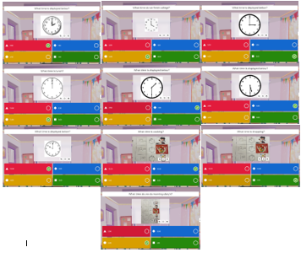
Image 1 The following ten images are the Kahoot questions used in the assessment quiz. They include simple clocks showing o'clock and half past, along with three questions featuring images related to daily routines.

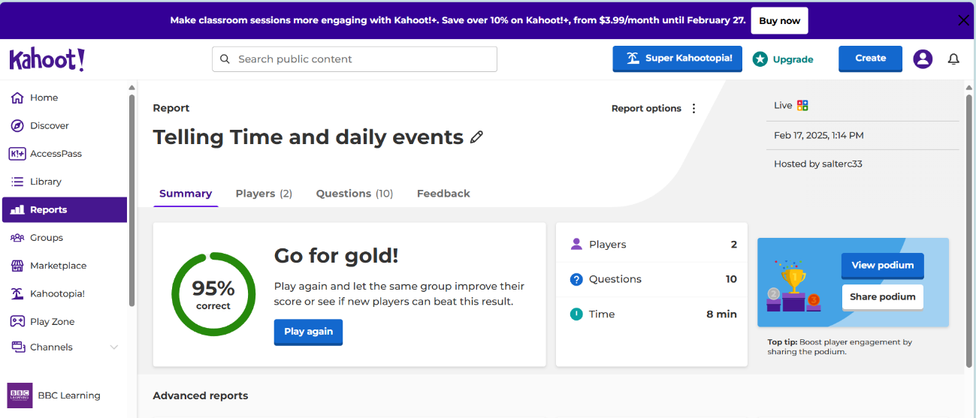
Image 2 Shows how many players took part and how long it took to complete the quiz.

Image 3 Shows how each player scored.
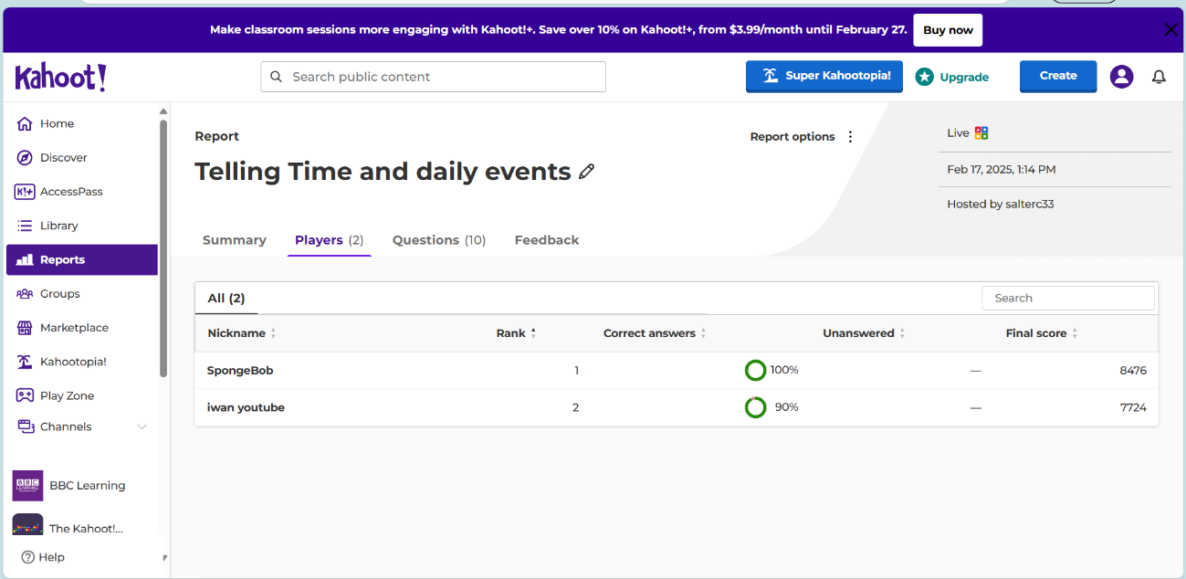

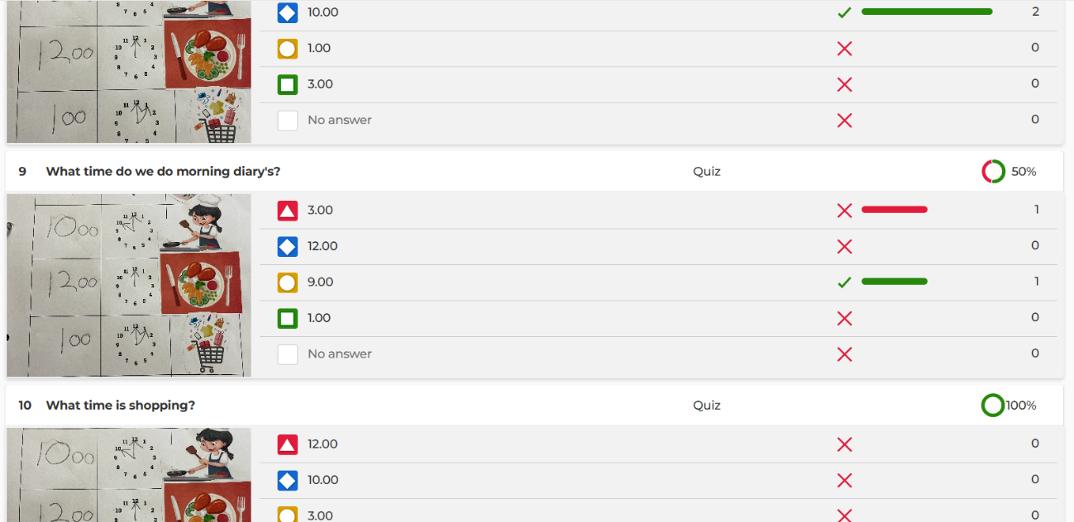
Image 4 Shows how each question was answered.

Image 5 Is a photo of a timetable completed by a learner which was used to create questions for the Kahoot quiz.
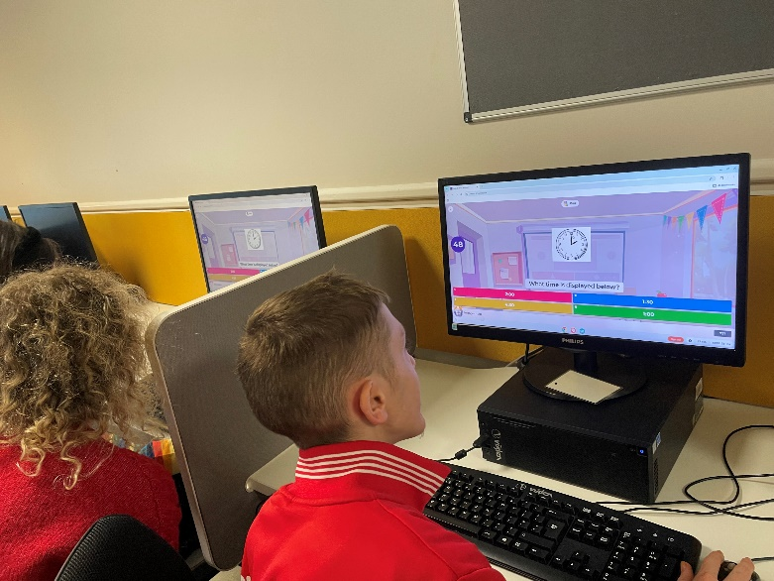
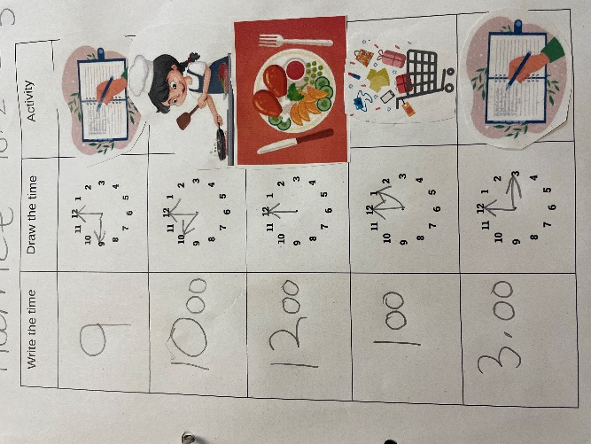
Image 6 is the learners taking part in the Kahoot quiz.

5 reflection.

Description: What happened?
The learners at my setting are adults ranging between 19 and 25 years old, they all have severe learning needs and disabilities. In Pathways two the learners are functioning around middle to higher primary level. All learners can write but out of the five only three are verbal and one learner is deaf. Since starting the new term, the learners have been learning the concept of time and how it can relate to their daily activities while in college and at home. For the purpose of this activity, it was a formative assessment to judge their intake of knowledge so far and the activities taught to them throughout the day. Formative assessment through questions is a good way to see if learners have an understanding and if there are any areas that need strengthening (Gregson and Hillier, 2015, p. 312). The quiz was based on reading the time off an analogue clock, linking time to an event and reading a timetable. Kahoot was used for this assessment as it is free and fairly easy to use for both the learners and educator (Kahoot, 2025).
Feelings: What was thinking?
Learners with severe learning difficulties often struggle with traditional assessments, which can erode their confidence and self-esteem. Comparisons to peers may further diminish their motivation, leading them to disengage from learning activities (Wearmouth, 2019, p. 232). Using interactive tools like Kahoot and other gamification platforms can offer a solution by providing educators with insights into knowledge retention while presenting the activity as a game to learners (Risvi, 2023). This approach reduces assessment pressure, increases engagement, and provides immediate feedback, creating a more inclusive environment that minimises the negative effects. The tutor expressed concerns about implementing a gamification platform, explaining past experiences where learners misused technology in college. Some learners had shown a tendency to avoid work, preferring to use their phones or iPads instead. However, this concern was addressed by emphasising the importance of embracing technology in education. By focusing on educating learners about appropriate technology use, we can prepare them for a digital driven world while mitigating potential misuse. This approach aligns with modern educational practices and helps learners develop essential digital literacy skills (Ghare and Kastikar, 2024).
Evaluation: What was good and bad?
The initial session was originally planned to utilise iPads, but due to the college's limited availability, only six iPads, which were already booked by another group, we had to relocate to the computer room. This change required learners to log into their college accounts to access the internet. Although time had been factored in for the sign-in process, it took longer than expected because all learner’s passwords needed updating. This unforeseen issue significantly impacted the session's timing and flow, highlighting the importance of flexibility in lesson planning and accounting for potential technical difficulties when relying on shared resources in an educational setting (Gregson and Hillier, 2015, p. 231). To enhance their experience, the sound was muted, allowing them to hear their one-to-one assistants read out the questions and four possible answers. Additionally, learners could view both the questions and answers on their screens, not just the coloured buttons which is normally displayed, which enabled them to focus on matching the correct answer without needing to switch their attention between multiple screens. The timer was set for two minutes to enable the one-to-ones to read the question and answers, and to provide learners with sufficient time to process the question and potential answers.
Analysis: What did you make of the event?
As discussed by Pace and Pickford, 2008 the VARK model developed by Neil Fleming, identifies visual learning as one of the four primary dimensions of learning. The learners who took part, benefit significantly from the use of visual aids, which helps to boost their memory retention. Kahoot with its colourful and playful interface aligns well with visual learners this also helped to entice the learners to try something new. The session was highly successful, with learners displaying significant enthusiasm for the Kahoot quiz and maintaining high engagement levels throughout. After completing the assigned quiz, the learners were so captivated by Kahoot that they requested to continue using it during their free time to play quizzes based on their interests, such as SpongeBob and Disney, one learner asked, “Can we do a Kahoot every week I enjoyed that”. Support staff were very positive in their feedback about the session, with comments such as “it was so lovely to see IJ taking part in something without moaning, he was so focused in getting the right answers” and “What a lovely way to assess their knowledge without them knowing they were taking a test”. This feedback was shared with the tutor, who reviewed the quiz and its results. Consequently, the tutor requested that Kahoot quizzes be integrated into the curriculum following each new topic.
Conclusion: What else could you have done?
The duration of the quiz only lasted eight minutes which was good for their first time of experiencing the Kahoot platform, however more questions could have been used to make the quiz last longer. The questions themselves could have become more challenging which would have given further insight to their retention of knowledge. The quiz relied on a single questioning style, which limited the depth of understanding. To foster more comprehensive thinking and understanding, it would be beneficial to incorporate a variety of question types (Hubbard et al., 2017), for example: One question showed a clock face with the hands displaying four o’clock and the question was “What time do you finish college?” while this tested basic time reading, it did explore the learners understanding of time in relation to daily activities. To build upon this concept and encourage deeper thinking, follow up questions could be use for example: present a clock face showing four o’clock and ask, “What do you do at this time?” and provide multiple choice answers representing a range of activities.
Action plan: How will you approach in the future?
The tutor had never used gamification or Kahoot as an assessment tool and was impressed by Kahoot's ability to assess learning and promote engagement, this has led them to request future sessions that utilise Kahoot to evaluate knowledge retention in subsequent learning activities. With additional quizzes created for learner’s free time to help familiarise them with the platform. These quizzes will be refined to include a variety of question types, such as multiple-choice, true or false and matching, with progressive difficulty levels.
Moving forward it would be a good idea to introduce further technology tools and resources that not only facilitate learning but also encourage responsible and effective usage. This approach aligns well with modern pedagogical practices and the evolving needs of students in our increasingly digital world (Jisc, 2024).

Reference list

Ahlawat, p., Tanwar, R. and Ahlawat, R. (2024) Transforming Education with virtual reality, (pp. 263-281). Wiley.com. Available at: https://www.wiley.com/en-us/Transforming+Education+with+Virtual+Reality-p-9781394200474 (Accessed: 21 February 2025).
Aibar-Almazán, A. et al. (2024) ‘Gamification in the classroom: Kahoot! as a tool for University Teaching Innovation’, Frontiers in Psychology, 15. doi:10.3389/fpsyg.2024.1370084.
Asatiani (2023) Kahoot! Review – is it helpful?, Edumentors. Available at: https://edumentors.co.uk/blog/kahoot-review-is-it-helpful/ (Accessed: 21 February 2025).
Bamford, J. and Moschini, E. (2024) ‘The third space, student and staff co-creation of gamified informal learning: An emerging model of co-design’, London Review of Education, 22(1). doi:10.14324/lre.22.1.21.
Bates, B. (2019) Learning theories simplified. 14: ...and how to apply them to teaching. London: SAGE Publications.
Bertilsson, E. (2024) Empowering every learner: Kahoot!’s commitment to accessibility, Kahoot! Available at: https://kahoot.com/blog/2024/09/16/accessibility/ (Accessed: 28 February 2025).
Brown, S. (2021) Digital Education platforms and how they’re helping schools, DfE Digital Data and Technology. Available at: https://dfedigital.blog.gov.uk/2021/02/12/digital-education-platforms/ (Accessed: 28 February 2025).
Channell, M. (2025) Gibbs reflective cycle – A practical guide, TSW Training. Available at: https://www.tsw.co.uk/blog/leadership-and-management/gibbs-reflective-cycle/ (Accessed: 21 February 2025).
Costello, R. (2020) Gamification strategies for retention, motivation, and engagement in Higher Education: Emerging Research and Opportunities. Hershey, PA: Information Science Reference.
Education, D. for (2025) AI teacher tools set to break down barriers to opportunity, GOV.UK. Available at: https://www.gov.uk/government/news/ai-teacher-tools-set-to-break-down-barriers-to-opportunity (Accessed: 21 February 2025).
Fuchs, K. (2023) ‘Challenges with gamification in Higher Education: A narrative review with implications for educators and policymakers’, International Journal of Changes in Education, 1(1), pp. 51–56. doi:10.47852/bonviewijce32021604.
Ghafar, Z.N. (2023) ‘Using google classroom in education: A new tool to facilitate blended learning and improve student outcomes: A systematic review’, Middle East Research Journal of Linguistics and Literature, 3(02), pp. 6–11. doi:10.36348/merjll.2023.v03i02.001.
Ghare, J.J. and Kastikar, A.A. (2024) ‘Digital Literacy and Skill Development’, SSRN Electronic Journal [Preprint]. doi:10.2139/ssrn.4754269.
Google for education (2023) Google for Education. Available at: https://edu.google.com/intl/ALL_uk/workspace-for-education/products/classroom/ (Accessed: 22 February 2025).
Gov. uk (2024) Building Digital UK annual report and accounts 2023-2024. Available at: https://assets.publishing.service.gov.uk/media/6759c4004cbda57cacd34719/BDUK_Annual_Reports-Accounts_2024_-_Certified_copy.pdf (Accessed: 21 February 2025).
Gregson, M., Hillier, Y. (2015) Reflective teaching in further, adult and vocational education. New York: Bloomsbury Academic.
Griffin, P.E. and Woods, K. (2020) Understanding students with additional needs as learners. Cham, Switzerland: Springer.
Gutuza et al 2016 (PDF) Challenges of Assessment of Students with Special Learning Needs
Harris, H. (2023) Student-centered learning with Kahoot!, Kahoot! Available at: https://kahoot.com/blog/2023/06/12/student-centered-learning-with-kahoot/. (Accessed: 21 February 2025).
Hayden (2024) Balancing Innovation and Ethics: Integrating GenAI into Education at BCoT | AI In Education (2023) Ai-in-education.co.uk. Available at: https://www.ai-in-education.co.uk/resources/balancing-innovation-and-ethics-integrating-genai-into-education-at-bcot (Accessed: 21 February 2025).
Heisey (2021) How to use Kahoot! for assessment: Teacher’s best practices. Kahoot! Available at: https://kahoot.com/blog/2021/02/16/kahoot-assessment-teacher-best-practices/.(Accessed: 21 February 2025).
Henry, J., Li, F. and Arnab, S. (2024) ‘On the Pre-Perception of Gamification and Game-Based Learning in Higher Education Students: A Systematic Mapping Study’, Simulation & Gaming, 55(6), pp. 985–1010. Available at: https://doi.org/10.1177/10468781241271082(Accessed: 21 February 2025).
Herane (2024) AI in Education, Balancing Innovation with Ethics, Higher Education Digest. Available at: https://www.highereducationdigest.com/ai-in-education-balancing-innovation-with-ethics/. (Accessed: 21 February 2025).
Hosseini, Z. and Kinnunen, J. (2021) ‘INTEGRATION OF PEDAGOGY INTO TECHNOLOGY: A PRACTICAL PARADIGM’, Education and New Developments 2021 [Preprint]. Available at: https://doi.org/10.36315/2021end086.
https://doi.org/10.36941/ajis-2021-0077 (Accessed: 21 February 2025).
Huang et al (2021)‘A Review on Artificial Intelligence in Education | Academic Journal of Interdisciplinary Studies’ (2021) www.richtmann.org [Preprint]. Available at: https://www.richtmann.org/journal/index.php/ajis/article/view/12463
Hubbard, J.K., Potts, M.A. and Couch, B.A. (2017) ‘How Question Types Reveal Student Thinking: An Experimental Comparison of Multiple-True-False and Free-Response Formats’, CBE—Life Sciences Education. Edited by K.E. Perez, 16(2), p. ar26. Available at: https://doi.org/10.1187/cbe.16-12-0339.
Issayeva, L. (2023) Gamification in Learning & Assessment, Assessment Systems. Available at: https://assess.com/gamification-in-learning-assessment/.
Jisc (2024) Learner digital experience insights survey 2023/24 UK further education (FE) survey findings (no date). Available at: https://repository.jisc.ac.uk/9647/1/DEI-2024-learner-fe-report.pdf (Accessed: 28 February 2025).
Kahoot (2025) Inclusive & accessible learning with Kahoot! | Kahoot!, Kahoot! Available at: https://kahoot.com/accessibility/ (Accessed: 28 February 2025)
Kalyani, L. (2024) The Role of Technology in Education: Enhancing Learning Outcomes and 21st Century Skills, ResearchGate. Surya Publication. Available at: https://www.researchgate.net/publication/379773214_The_Role_of_Technology_in_Education_Enhancing_Learning_Outcomes_and_21st_Century_Skills.
Kelly (2025) 2025 Predictions: AI’s Impact on Education -- THE Journal (2025) THE Journal. Available at: https://thejournal.com/Articles/2025/01/23/2025-Predictions-AIs-Impact-on-Education.aspx
Kofinas, A. and Lewis, N. (no date) Dis-Engaging with Gamification in Higher Education (0143). Available at: https://srhe.ac.uk/arc/16/0143.pdf (Accessed: 28 February 2025).
Kuhlmann (2023) The Essentials of Personalized, Competency-Based Learning (no date) Knowledge Works. Available at: https://knowledgeworks.org/resources/essentials-personalized-competency-based-education/.
Kurt, S. (2019) Technological Pedagogical Content Knowledge (TPACK) Framework - Educational Technology, Educational Technology. Available at: https://educationaltechnology.net/technological-pedagogical-content-knowledge-tpack-framework/.
Lattie, E.G., Lipson, S.K. and Eisenberg, D. (2019) ‘Technology and College Student Mental Health: Challenges and Opportunities’, Frontiers in Psychiatry, 10(246). Available at: https://doi.org/10.3389/fpsyt.2019.00246.
Lu, S. (2025) ‘Interactive virtual reality environments for English language learning: Immersive technologies to enhance language acquisition and communication skills’, Journal of Computational Methods in Sciences and Engineering [Preprint]. Available at: https://doi.org/10.1177/14727978251318803
Mdlalose, N., Ramaila, S. and Ramnarain, U. (2022) ‘Using Kahoot! as a Formative Assessment Tool in Science Teacher Education’, International Journal of Higher Education, 11(2), pp. 43–51. Available at: https://eric.ed.gov/?id=EJ1341192.
Minton, M. and Bligh, B. (2021) ‘Examining the use of Kahoot to support digital game-based formative assessments in UAE higher education’, Studies in Technology Enhanced Learning [Preprint]. Available at: https://doi.org/10.21428/8c225f6e.32b8666f.
Mishra, P. and Koehler, M.J. (2006) ‘Technological Pedagogical Content Knowledge: A Framework for Teacher Knowledge’, Teachers College Record, 108(6), pp. 1017–1054. Available at: https://doi.org/10.1111/j.1467-9620.2006.00684.x.
Moliner, L. (2023) Well-Being. Available at: https://all-digital.org/wp-content/uploads/2023/12/20.12.2023-Digital-Well-Being-Report.pdf.
Morris, R., Perry, T. and Wardle, L. (2021) ‘Formative assessment and feedback for learning in higher education: A systematic review’, Review of Education, 9(3). Available at: https://doi.org/10.1002/rev3.3292
Newton, P.M. and Miah, M. (2017) ‘Evidence-based higher education – Is the learning styles “myth” important?’, Frontiers in Psychology, 8(444), pp. 1–9. Available at: https://doi.org/10.3389/fpsyg.2017.00444
Noor, U. et al. (2022) ‘Learning behavior, digital platforms for learning and its impact on university student’s motivations and knowledge development’, Frontiers in Psychology, 13. Available at: https://doi.org/10.3389/fpsyg.2022.933974
Ntokos, K. (2019) ‘Swords and sorcery: a structural gamification framework for higher education using role-playing game elements’, Research in Learning Technology, 27(0). Available at: https://doi.org/10.25304/rlt.v27.2272.Okojie et al 2022 https://doi.org/10.21061/jots.v32i2.a.1
Ozdemir (2024) Research: Kahoot! Game-based digital learning platform - Tips for Teachers by Craig Barton (2025) Tips for Teachers by Craig Barton. Available at: https://tipsforteachers.co.uk/research-kahoot-game-based-digital-learning-platform/ (Accessed: 28 February 2025).
Ozer, N. and Şad, S.N. (2019) ‘Using Kahoot! as a Gamified Formative Assessment Tool: A case study’, International Journal of Academic Research in Education [Preprint]. Available at: https://doi.org/10.17985/ijare.645584.
Parliament (2023) The Government has ‘no credible strategy’ to tackle digital exclusion - Committees - UK Parliament (2023) Parliament.uk. Available at: https://committees.parliament.uk/committee/170/communications-and-digital-committee/news/196028/the-government-has-no-credible-strategy-to-tackle-digital-exclusion/.
Race, P. and Pickford, R. (2008) Making teaching work : ‘teaching smarter’ in post-compulsory education. Los Angeles: Sage
Radianti, J. et al. (2020) ‘A systematic review of immersive virtual reality applications for higher education: Design elements, lessons learned, and research agenda’, Computers & Education, 147(0360-1315), p. 103778. Available at: https://doi.org/10.1016/j.compedu.2019.103778.
Rivera, E. and Garden, C. (no date) THEORY AND GAMES: DEVELOPING A METHOD FOR GAMIFYING HIGHER EDUCATION. Available at: https://www.napier.ac.uk/~/media/worktribe/output-1206920/theory-and-games-developing-a-method-for-gamifying-higher-education.pdf
Rizvi, N. (2023) Assessments through gamification. Available at: https://www.researchgate.net/publication/353380109_Assessments_through_gamification.
Rodolico, G. and Hirsu, L. (2023) ‘Virtual Reality in education: supporting new learning experiences by developing self-confidence of Postgraduate Diploma in Education (PGDE) student-teachers’, Educational Media International, 60(2), pp. 92–108. Available at: https://doi.org/10.1080/09523987.2023.2262195.
Ross, M. (2025) Visual Learning Techniques. Publifye E-book.
Ruffcorn (2021) Pulse-checks and instant feedback with Kahoot! | Teacher tips (2021) Kahoot! Available at: https://kahoot.com/blog/2021/03/02/teacher-tips-pulse-checks-kahoot/.
Scottish Government (2015) Literature Review on the Impact of Digital Technology on Learning and Teaching - gov.scot, Gov.scot. Available at: https://www.gov.scot/publications/literature-review-impact-digital-technology-learning-teaching/pages/4/.
Sierra, Á.A. et al. (2023) ‘Development of the teacher’s technological pedagogical content knowledge (TPACK) from the Lesson Study: A systematic review’, Frontiers in Education, 8. Available at: https://doi.org/10.3389/feduc.2023.1078913.
Stinnette (2018) Inclusive teaching | Game-based learning in special ed (2018) Kahoot! Available at: https://kahoot.com/blog/2018/04/24/using-kahoot-for-inclusive-teaching/.
Teachers guide (2024) The Importance of Google Classroom - Teachersguide, Teachersguide. Available at: https://teachersguide.net/the-importance-of-google-classroom/.
Technology & Student Wellness: How Tech, Sel, and mental health are now linked (2024) Education Week. Available at: https://www.edweek.org/technology/technology-student-wellness-how-tech-sel-and-mental-health-are-now-linked (Accessed: 21 February 2025).
Tudor, S. (2024) Digital exclusion in the UK: Communications and Digital Committee report, House of Lords Library. Available at: https://lordslibrary.parliament.uk/digital-exclusion-in-the-uk-communications-and-digital-committee-report/.
University of Salford (2025) VR and AI for all: Embracing new technologies at Rochdale Sixth Form College, University of Salford. Available at: https://www.salford.ac.uk/news/vr-and-ai-for-all-embracing-new-technologies-at-rochdale-sixth-form-college (Accessed: 28 February 2025).
Wang, A.I. and Tahir, R. (2020) ‘The Effect of Using kahoot! for Learning – a Literature Review’, Computers & Education, 149(149), p. 103818. Available at: https://doi.org/10.1016/j.compedu.2020.103818
Wearmouth, J. (2018) Special Educational Needs and Disability : the Basics. Abingdon, Oxon ; New York, Ny: Routledge.
Weimer (2017) Do Quizzes Improve Student Learning? A Look at the Evidence. Faculty Focus | Higher Ed Teaching & Learning. Available at: https://www.facultyfocus.com/articles/educational-assessment/quizzes-improve-student-learning/.
Welsh Government (2017) Professional standards for further education teachers and work-based learning practitioners in Wales (2017). Available at: https://hwb.gov.wales/storage/460a740a-7bf1-4c7b-b4ae-348ae380879b/professional-standards-further-education-teachers-work-based-learning-practitioners-wales.pdf.
Welsh Government (2019) Digital 2030 A strategic framework for post-16 digital learning in Wales 2019. Available at: https://www.gov.wales/sites/default/files/publications/2019-06/digital-2030-a-strategic-framework-for-post-16-digital-learning-in-wales.pdf

