

Programme: BA Business Management
Module Code: LCBB4004
Module name: Marketing Fundamentals
Lecture: Tushara Balendran

Assignment 1:
Marketing Fundamentals - Blogging to communicate

Student name: Desislava Nikolova
Student ID: 2120861
Words: 1959

Story of an Apple Company
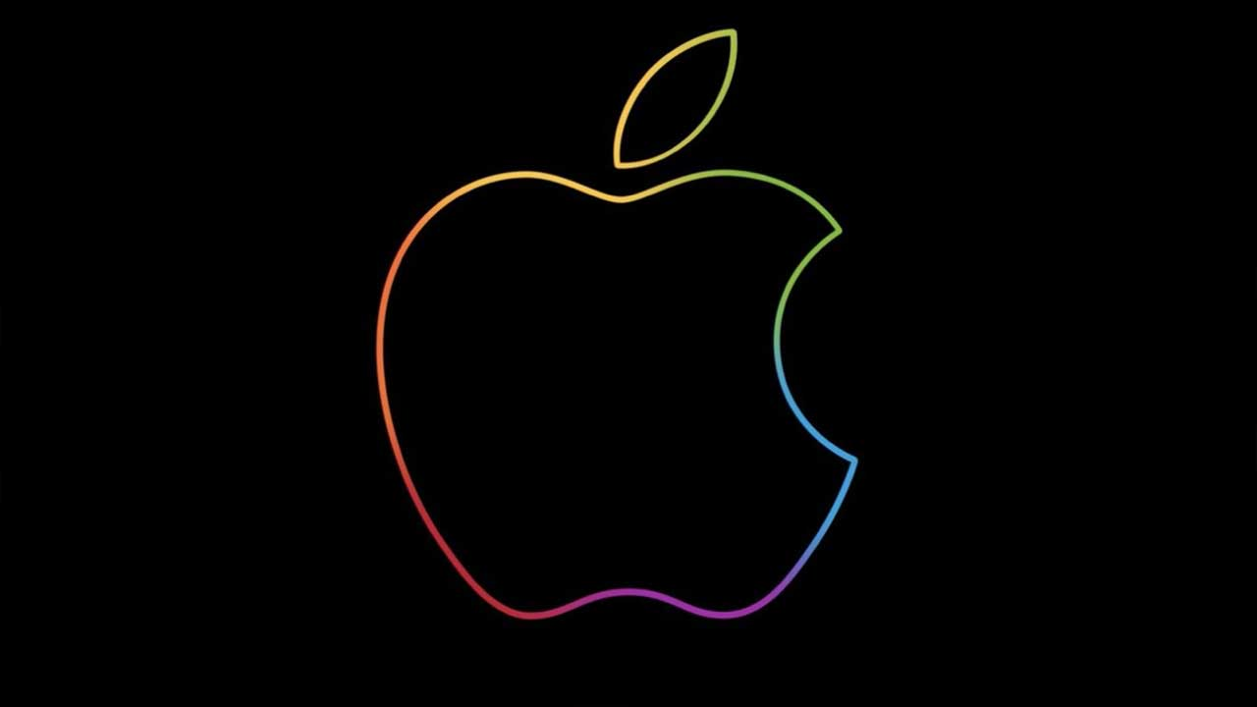
Apple is one of the largest multinational companies in Cupertino, California. The company's core business is specializing in designing and creating electronic devices to meet the needs of consumers.
The Apple company was founded in 1976. Steve Jobs, Steve Wozniak and Ronald Wayne are considered its founders. Currently, the company occupies leading positions worldwide in producing electronic and mobile devices that small and large users love (Hiner, 2014).
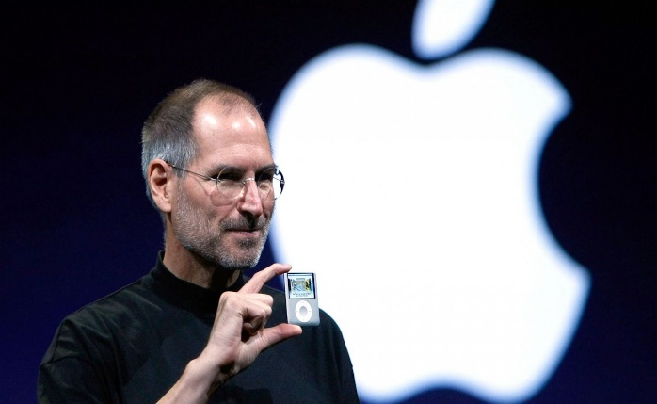
Currently, the company has an extensive portfolio of products related to electronics, computer software and online services.
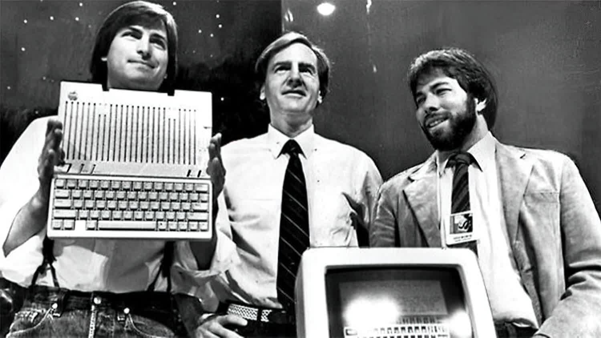
The very first development of the company was carried out in 1977 when the first personal computer was created. This is the Wozniak Apple I. After that, sales of the products began to gradually increase until the second Apple II computer was developed and created.
Interestingly, due to the growing development and success of the company, Wozniak and Jobs decided to expand the business by hiring staff.


Unfortunately, the company's success did not last very long, and in 1985, Steve Wozniak, one of Apple's founders, left along with the company's best employee to date. Pressed by circumstances, Steve Jobs turned his attention to the creation of another company, NeXT (Hiner, 2014).
Despite these changes, Apple continues its development and deployment of activity. In the 1990s, Apple declined its market shares due to the rapid development of competitors - Microsoft and Intel Personal Computers. At this point, the company's management faces a dilemma and difficulties. For this, the board of directors decided to purchase the NeXT company founded by Steve Jobs, bringing it back to the Apple Company and continuing to develop the business. Success was not long in coming, as a little later, in 1998, Apple launched its first iMac. This success led to the company's ability to create a chain of stores, giving rise to Apple Stores.
Gradually, the Apple company began to develop well and released its first phone, which is still preferred by iPhone users today. However, at this moment, the company is changing its strategy. It is moving not only to the production of personal computers but also to creating mobile devices that are attractive to consumers (Kubilay, 2015).
Apple's success was overshadowed when the great Steve Jobs died of cancer in 2011. Despite this event, the company continues to develop to this day. The company is among the most popular technology brands in the US and part of the Big Tech community.
One of the biggest competitors of the brand is Samsung and Huawei.

Come and check our Apple products portfolio!

The company's products are highly numerous and diverse. Apple specializes in the sale of electronic devices - mobile and personal. Apple gives its users a lot of ease and convenience as it offers various products (Kotler & Kevin, 2009).
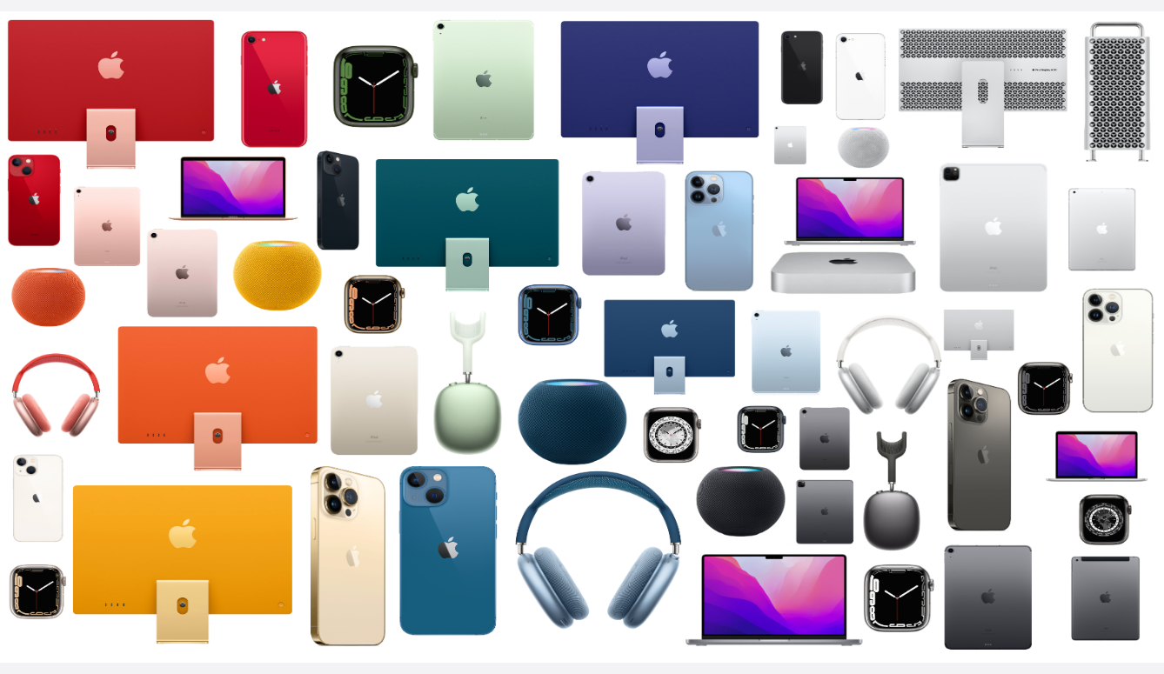
The most basic and first production of the company is personal computers. The Macintosh products are two main types of iMac and its better version iMax Pro. The company also offers its users a smaller and lighter version, the Mac Mini, which is again a desktop computer but more compact and user-friendly.
In addition to personal computers, Apple also produces laptops. There are two main types in the series MacBook Pro and MacBook Air. These professional laptops serve many users for their professional and personal tasks. Laptops have a specially designed Mac OS operating system. It provides an opportunity for Apple users to connect all their devices into one so they can quickly and easily access each one.
The most mainstream and popular Apple products are, of course, the iPhone. Mobile phones have a unique design that is improved and optimized every year with the release of new models. In addition, the product has a dedicated App Store where users can purchase various applications on their mobile devices (Apple, 2022).
Of course, the brand also has a wide variety of other products, such as iPods and IPad. Each of them has unique features that users need. For example, the iPad is a tablet that helps users use various applications on a larger screen than a phone.
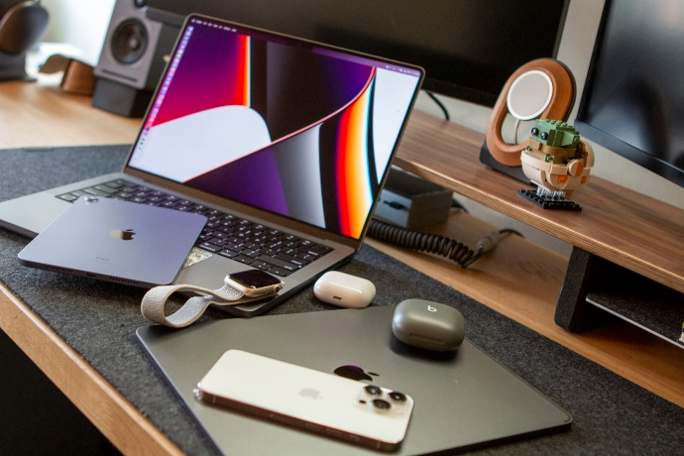
Lastly, we place the unique Apple Watch, which is exceptionally modern and user-friendly. It is a smartwatch that monitors the movement that users exercise and also presents prominent notifications from various applications. Moreover, it enables users to chat on the smartwatch and check their phone even when it is not with them.
The most exciting product is Apple Tv. The company offers devices on which users can watch their favorite movies (Apple, 2022).
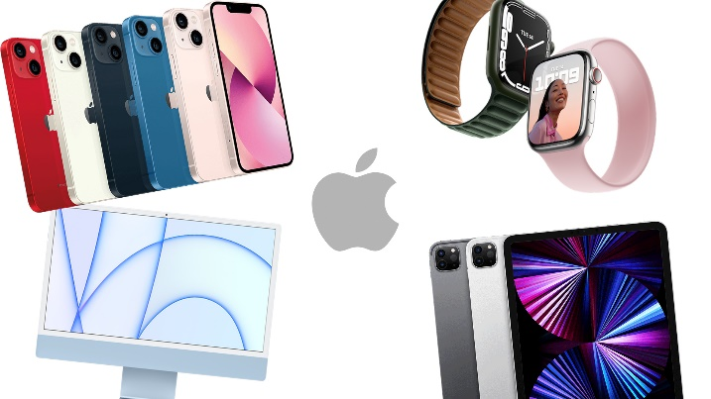
All these devices are interconnected with the software that Apple uses so that users can easily and quickly access them.

In addition to all this, the company also has subsidiaries that have a variety of activities and directions of development:
- Braeburn Capital - The company that manages the main assets of Apple.
- Beats Electrics – This brand is also known as Beats by Dr Dre. Its main activity is related to the production of audio products. In 2014, it was purchased by Apple. It is extremely popular with the production of modern headphones and speakers.
- Beddit- In 2017, the company became owned by Apple. It manufactures various sleep monitoring devices.
- Claris - develops various software that Apple uses for its various devices.
- Drive AI – This is a company of Apple that deals with creating artificial intelligence for driving car systems.

What is the price of technology happiness?
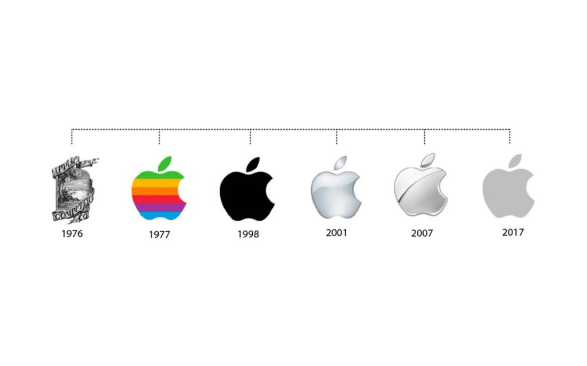
The prices of Apple products are too diverse. Different consumers may own the products but primarily target those in the middle to the upper class. The pricing policy is mainly related to innovations and new devices (Cravens & Piercy, 2006). The prices of the new products are the highest, and the older models are gradually starting to comply and thus become available to consumers from the lower segments. However, the company offers different devices with different characteristics and specifics according to customers' needs, and the prices are diverse and vary for different products. Therefore, the pricing policy is flexible and allows consumers to have friendly products at average prices.
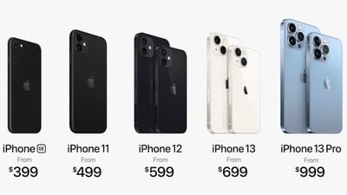
The prices of the products are very diverse depending on users' needs. For example, the price of an iMac depends a lot on its features, but most often, the price ranges from $1,500 to $3,000.

Compared to the iMac, the prices of the intelligent Apple Watch are better and affordable, and you can buy a watch worth $400 to $800. Prices vary depending on the model and its features. This depends on the capabilities and demand of the users, but prices and products for different market segments are offered.
Apple Tv prices also vary but are relatively affordable. The devices can be found on the market at $200 to $500.
The prices of the iPad and iPhone are relatively diverse, and there are different user groups and preferences. iPad prices range between $300 to $900. Despite everything, iPhone prices are the most diverse. Some models start at $400-600 and can go up to $1200-1500.
The prices are very diverse. Different models and features depend on users' needs, personal preferences, and financial capabilities.


Do you know where Apple products can be found?

The placement of the brand is very diverse. Different channels are used to distribute and reach consumers. One of these channels is Apple's stores. The company also uses franchise and sales intermediaries and mobile technology dealers that offer the brand's products to consumers in its online and physical stores.

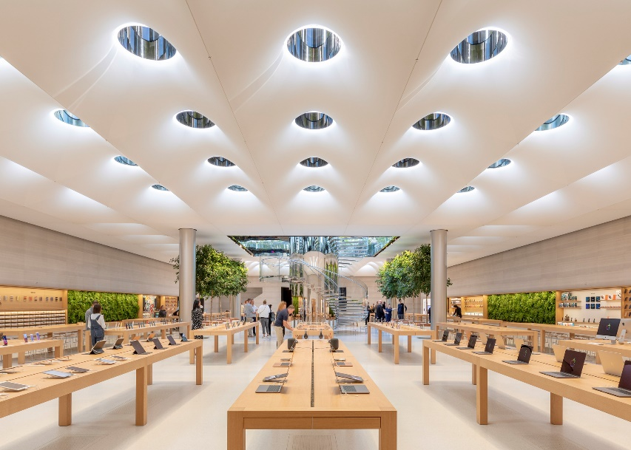
In 2001, the creation of the chain of Apple stores began. Most often, these stores are located in various shopping centers and mall stores, where they are accessible to many consumers and individuals interested in seeing Apple products. In the beginning, the brand had only two stores but gradually expanded its product portfolio and the locations of stores (Etzel et al, 1994).
In the store, users can find a massive range of Apple products. The architectural presentation of the stores is precise, preserving natural colors such as white, black, grey and brown. They often have glass showcases where the brand's products are displayed. There are 300 Apple stores in the United States alone. In addition, the Apple brand has stores on all continents, offering its products through online stores, intermediaries and sales representatives.
In 2015, Apple removed its online store, outsourcing these features to various intermediaries that consumers could easily access through online shopping.

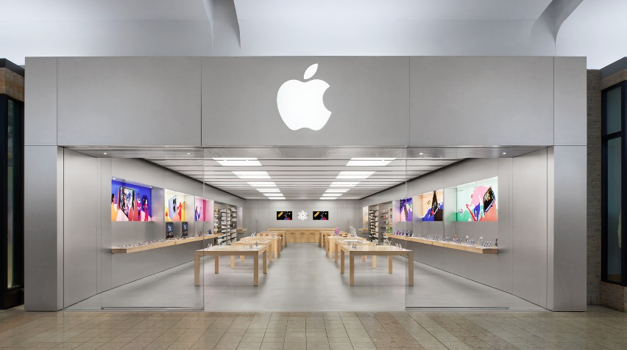
The Apple company also provides franchising opportunities, as anyone wishing to open an Apple store can do so by filling out unique documents and signing a contract (Wazniak & Smith, 2007).
In truth, the most significant contributors are the retailers who sell Apple directly to consumers. These merchants are various retailers but also large mobile network companies that provide the opportunity for consumers to purchase an Apple product.
Apple has a vast distribution network and various ways to reach consumers, which is a big plus for the company in terms of its distribution policy. However, it is important to note that Apple stores are specially selected with specific locations, designs and interiors to distinguish them from other retailers and competitors such as Samsung and Huawei. Typically, these stores are shopped by reel enthusiasts who want to receive special treatment from the staff.
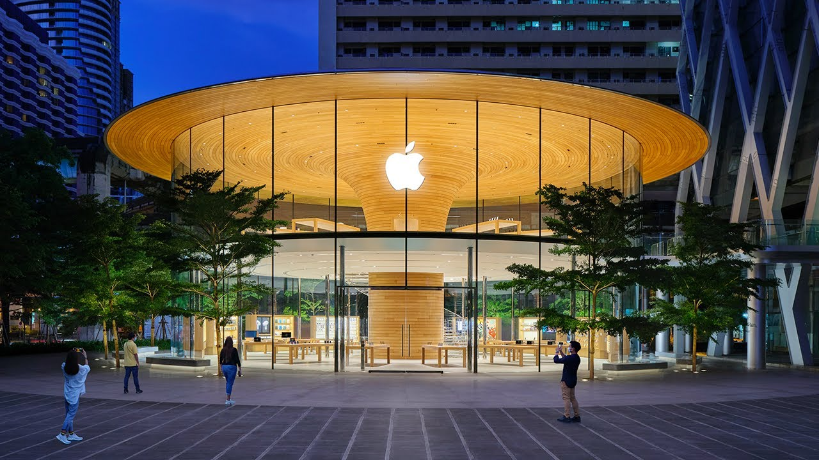

Attention! Attention! Promotion Alert

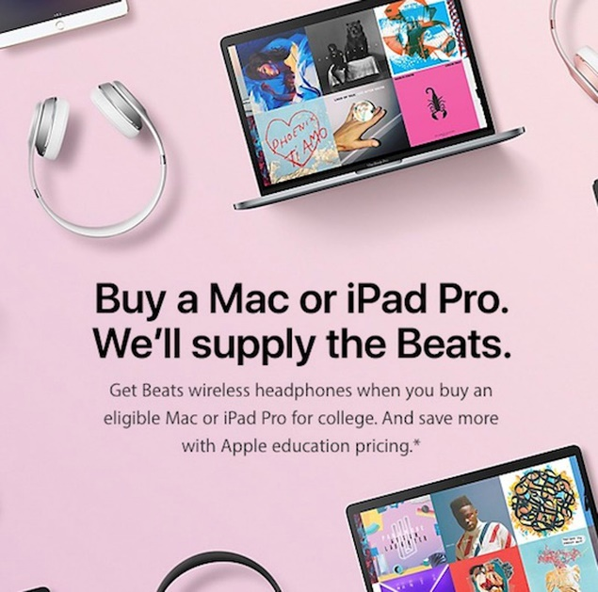
Like most large companies, Apple uses many ways to reach its users through advertising. One of the ways it is implemented is related to the freedom of marketers to promote new Apple products themselves, thus informing consumers about the upcoming premieres of Apple products.

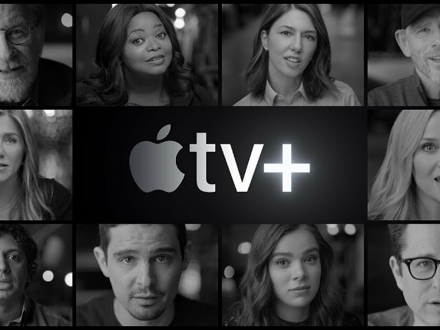
The other way is personal selling and connecting with consumers, with the brand learning about consumers' needs and desires through social media and direct communication. It presents the new products on the Apple website so that every user can view the features and characteristics of the products (Kotler et al., 1999). The company is very well focused on informing its users by constantly updating information on the site about the products. In addition, apple makes television commercials, thus reaching its consumers directly (Kotler, 2000).

Apple products are very often part of film productions, which is also a way to advertise the company's products. Apple appears in the productions as the mobile device used by the actors.
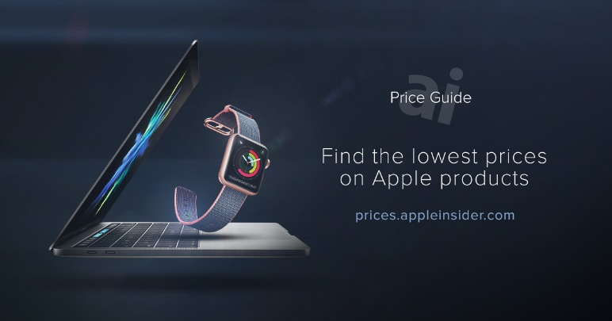
Also, Apple uses famous people to promote the products and how they use them daily. This is one way to reach consumers by using familiar faces such as actors and celebrities who use Apple products.

The company conducts specially created campaigns that lead to results and increase brand sales.
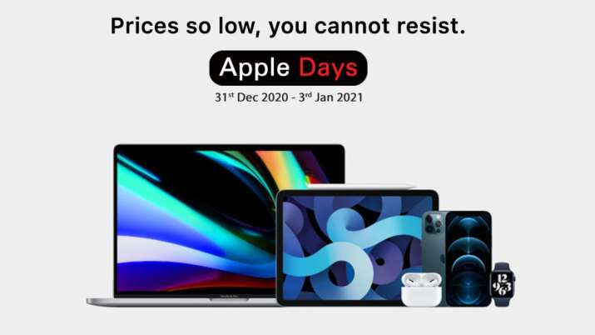
One of Apple's most significant advantages in advertising is that it happens before the product is even on the market for mass sale. The company enables consumers to get a product first by purchasing it before it is even released in the sales network.

Click on those links to access to the social media links:

https://www.facebook.com/apple/

https://twitter.com/Apple

References:
- Apple, (2022). Annual Report, from 10-K, Available on https://s2.q4cdn.com/470004039/files/doc_financials/2021/q4/_10-K-2021-(As-Filed).pdf Last accessed on 26 July 2022
- Capilla, A. (2011). Bringing the best personal computing experience to all. International Journal of Competitive Intelligence, Vol 4., Issues 3
- Cravens, D and Piercy, N. F. (2006). Strategic Marketing, 8th Edition.
- Etzel, M. J; Santon, W. J; and Walker, B. J. (1994). Fundamentals of Marketing, McGraw Hill
- Hiner, J. (2014). Apple’s first employee: the remarkable odyssey of Bill Fernandez.TechRepublic.
- Kotler, P., Armstrong, G., and Wong, V. (1999). Principles of Marketing, 2nd Edition.Upper Sadle River: Prentice Hall
- Kotler, Ph. (2000). Marketing Management, Upper Saddle River: Prentice Hall
- Kotler, Ph., Kevin, L. (2009). Marketign Management, Upper Saddle River: Prentice Hall
- Hiner, J. (2014). Apple’s first employee: the remarkable odyssey of Bill Fernandez.TechRepublic.
- Pearson, D. J. (1992). Strategic Marketing Management: Planning Implementation and Control, Butterworth Heinmann
- Kubilay, Ib. (2015). The Founding of Apple and the reasons behind its success. Procedia – Social and Behaviour Scinece, 195.
- Wozniak, S. & Smith, G. (2007). iWoz. London: Headline Review

