Organisational report – Hyatt Hotels Corporation

Student name: Sarda Anu Stefania Kumar
Student code: 2230813
Module: BMIH5004 Management & Organisational Behaviour
Lecturer name: Scott James
Submission date: 08th November 2024
Word count: 1912

I confirm that I have not used any AI tools in the research and creation of this assignment. I confirm that I have not presented any AI generated materials as my own work. I confirm I have copies of my drafts, notes, and other resources I used, which I may be asked to provide in evidence

Executive summary
Hyatt Hotels Corporation is a leading global hospitality company renowned for its diverse portfolio, which includes luxury, upscale, and economy brands. Committed to delivering exceptional guest experiences, Hyatt has established itself as a prominent player in the industry, emphasising service excellence, sustainability, and employee engagement.
This report aims to provide a detailed analysis of Hyatt Hotels Corporation, focusing on its organisational structure, corporate culture, and strategic goals. It will delve into recent change initiatives that showcase Hyatt's adaptability and responsiveness to evolving consumer needs. Furthermore, the report will explore Hyatt's strategic direction, emphasising its focus on growth, digital transformation, and customer loyalty.
Hyatt operates under a hybrid organisational structure that combines functional and divisional models, ensuring efficient management across its various brands and geographical regions. The company's culture is rooted in its "World of Care" philosophy, fostering an environment of empathy and inclusivity, which enhances employee satisfaction and guest loyalty. Hyatt's corporate goals reflect a commitment to sustainability and diversity, promoting social responsibility and community engagement.
Overall, Hyatt's strategic focus on growth, innovation, and a commitment to a sustainable future positions it for long-term success in the competitive hospitality landscape. This report will elucidate how these elements work synergistically to enhance Hyatt's operational effectiveness and market presence.

Contents
Executive summary 3
Introduction 5
Organisation Structure, Culture, and Goals 5
Organisation Structure 5
Organisation culture 7
Organisation goals 9
Recent Change Initiatives 10
Strategic Direction 11
Conclusions 12
Reference list 13

Introduction
Hyatt Hotels Corporation is a prominent global hospitality company known for its diverse portfolio of brands, including luxury, upscale, and economy segments. Established with a mission to provide exceptional guest experiences, Hyatt has evolved into a leader in the industry, offering accommodations that cater to a wide range of travellers. With a commitment to service excellence, sustainability, and employee engagement, Hyatt continues to enhance its reputation in an increasingly competitive market (Hyatt, 2024).
The aim of this report is to provide a comprehensive analysis of Hyatt Hotels Corporation, focusing on key aspects of its operations. Specifically, the report will cover the organisational structure, culture, and strategic goals of the company. Additionally, it will examine recent change initiatives that reflect Hyatt's adaptability and responsiveness to evolving consumer preferences. Finally, the report will explore Hyatt’s strategic direction, highlighting its emphasis on growth, digital transformation, and customer loyalty. Through this analysis, the report seeks to illuminate how Hyatt positions itself for long-term success in the hospitality industry.

Organisation Structure, Culture, and Goals
Organisational structure defines how tasks are divided and coordinated, while culture encompasses shared values that influence behaviour and engagement. Effective goals should be SMART to align with the organisation's mission (Robbins, 2016).

Organisation Structure
Hyatt Hotels Corporation activates with a hybrid organisational structure that combines elements of functional and divisional models, enabling efficient management of its various hotels and services while maintaining evident lines of responsibility.
At the corporate level, Hyatt employs an operative structure where departments such as finance, legal, human resources, marketing and operations manage definite tasks and areas of expertise. Within the divisional module, hotels and resorts are structured by geographic region or brand, with distinct business units for brands like Alila, Grand Hyatt, and Hyatt Regency, each operating semi-autonomously under its leadership. Geographically, Hyatt is divided into three main regions: Americas, Asia Pacific, and Europe, Africa and Middle East (EAME), allowing teams to cater to the unique needs of customers in those areas (Organimi, 2024).
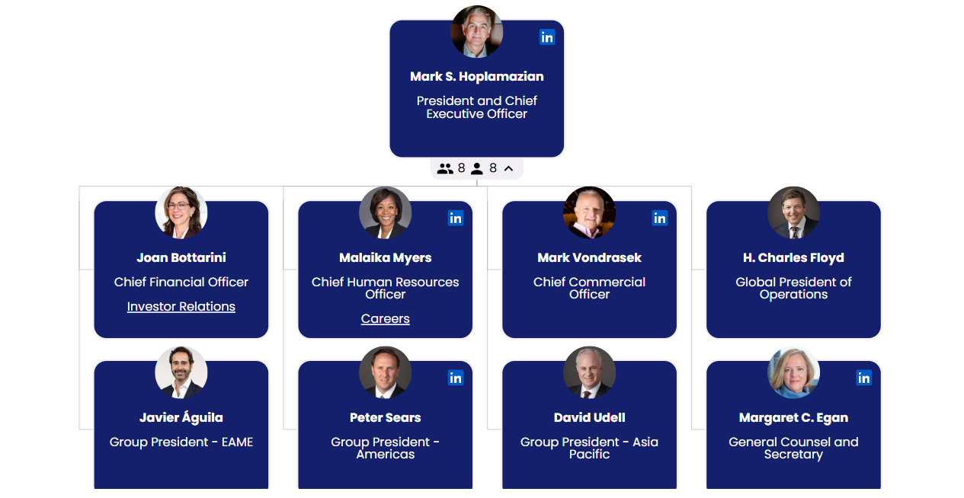
Figure 1 Hyatt Organisation Structure (Origanimi, 2024)
Headquartered in Chicago, Illinois, Hyatt's executive leadership team oversees various functions including operations, marketing, and global development. The company follows a multi-brand strategy, featuring upscale, luxury, and economy segments to meet diverse market demands. Regional divisions further support its operational structure, addressing the specific needs of each market while utilising franchising and management agreements to facilitate growth with minimal capital expenditure (Newsroom Hyatt, 2024).
Support functions in human resources, marketing, and technology enhance talent acquisition, brand positioning, and digital transformation, respectively. Hyatt also emphasises sustainability and corporate responsibility, integrating these initiatives into its operational practices. While facing challenges from traditional hotel chains and emerging competitors like Airbnb, Hyatt sees opportunities for growth in the expanding travel industry, particularly in the post-pandemic landscape (Stay The Night, 2021).
This hybrid structure, alongside its commitment to diverse brand offerings and operational excellence, positions Hyatt favourably in the competitive hospitality market.

Organisation culture
In the 2019 edition of "Management in the Hospitality Industry," E. Mullins addresses the significance of organisational culture and values in hospitality management. He emphasises how a strong culture fosters employee engagement and enhances service delivery.
Hyatt Hotels Corporation’s organisational culture, defined as the shared values, beliefs, and practices that shape the behaviour of its employees, significantly influences its operations (Akpa, 2021).
Hyatt has cultivated a distinctive corporate culture rooted in its "World of Care" philosophy, which significantly impacts its strategies. This culture emphasises empathy and respect, fostering an environment where employees feel valued and supported. By promoting a sense of belonging, Hyatt enhances employee satisfaction and retention, which is essential in the competitive hospitality industry (Businesswire, 2021).
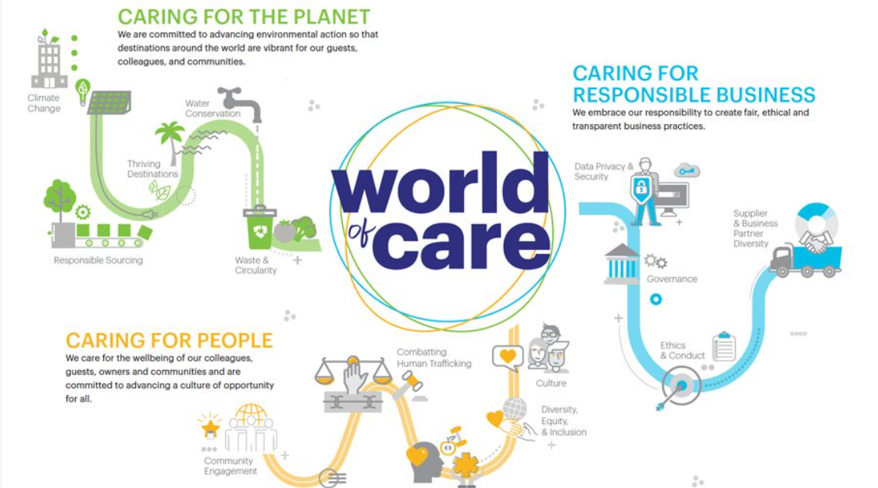
Figure 2 World of Care Hyatt (Otley, 2021)
“Caring for people so they can be their best has been at the core of Hyatt’s story for 65 years. Through World of Care, we embrace our responsibility and opportunity to work together to shape a more sustainable world and future,” said Margaret Egan (2022), executive vice president and general counsel of Hyatt.
At the heart of Hyatt's culture is a commitment to service excellence, with employees trained to prioritise guest experiences. This focus directly enhances customer loyalty and strengthens brand reputation. Inclusivity and diversity are also core values, allowing the company to better understand and serve a diverse clientele. The "Change Starts Here" initiative exemplifies this commitment, incorporating transparency through annual diversity data disclosures and tying executive compensation to DE&I (Diversity, Equity & Inclusion) progress. This accountability ensures that diversity is a key focus in decision-making, enhancing creativity and innovation within the workforce (World Hyatt, 2024).
Hyatt further supports its culture through continuous learning and professional development, providing leadership training and career advancement opportunities. This results in a motivated workforce aligned with Hyatt’s goals. Collaboration and teamwork are vital, promoting operational efficiency, especially in managing multi-brand properties. Corporate social responsibility initiatives encourage community engagement, fostering a sense of pride among employees that translates into dedicated service (Hogan, 2023).
The company’s focus on holistic wellbeing includes initiatives like Global Wellbeing Week and mandatory training on human trafficking, which boost employee morale and empower staff to create a safer, more supportive environment (Le Cuirot, 2023).
Environmental responsibility is another cornerstone of Hyatt’s culture, with an ambitious sustainability framework aimed at reducing greenhouse gas emissions and waste. This commitment aligns with the United Nations Sustainable Development Goals, appealing to environmentally conscious consumers (Businesswire, 2023).
Hyatt’s organisational culture, characterised by care, inclusivity, and a commitment to service excellence, profoundly influences its operations. By prioritising employee wellbeing and community connections, Hyatt not only enhances guest experiences but also cultivates a motivated workforce, driving overall business performance and sustainability (Su, 2020).

Organisation goals
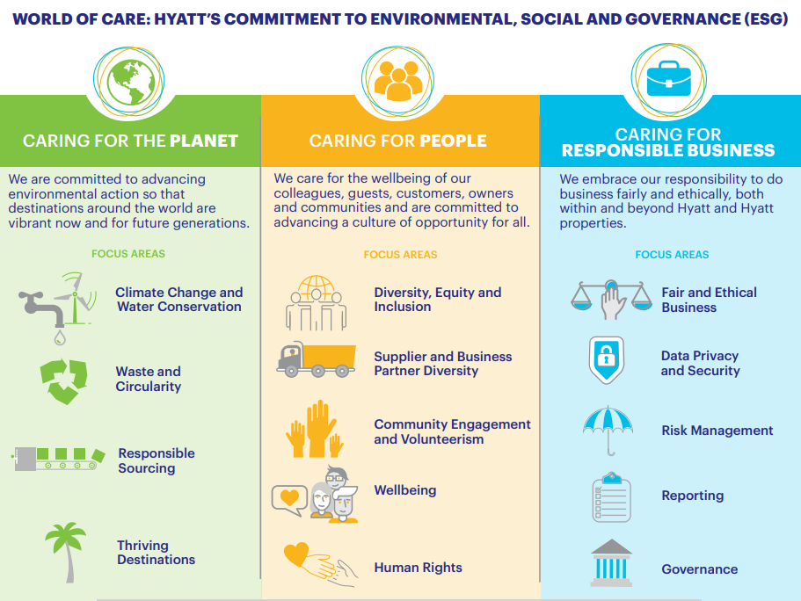
Figure 3 ESG Hyatt (Hyatt, 2021)

Hyatt Hotels Corporation has established clear goals at both corporate and individual unit levels, reflecting its commitment to sustainability, diversity, equity, and inclusion (DE&I). At the corporate level, Hyatt focuses on driving progress against key environmental, social, and governance (ESG) commitments, such as its environmental framework and the "Change Starts Here" initiative. These goals include enhancing diverse workforce representation and improving supplier diversity, with a commitment to sharing annual progress on DE&I metrics.
By fostering a culture of belonging and prioritising DE&I across all dimensions, Hyatt aims to create an inclusive environment where employees feel empowered and valued (Seale, 2021).
Individually, each hotel or resort is encouraged to align with these overarching corporate goals while tailoring their strategies to local market conditions. This includes maximising occupancy rates, enhancing guest satisfaction, and achieving financial targets. Individual units also prioritise initiatives that reflect Hyatt's values, such as community engagement and local partnerships (Investors Hyatt, 2024).
Through its hybrid structure, Hyatt ensures that the corporate and individual goals work together, reinforcing the company's mission to create a more sustainable and equitable world.

Recent Change Initiatives
Hyatt Hotels Corporation has undertaken several significant change initiatives in recent years. One major area of focus has been digital transformation, where enhancements to mobile apps and online booking systems have aimed to improve customer engagement. Additionally, the company has committed to sustainability through initiatives like the "Hyatt Thrive" program, which emphasises reducing carbon emissions, minimising waste, and sourcing food locally (Hyatt, 2011).
Hyatt has also worked to enhance its loyalty program, the World of Hyatt, offering more personalised rewards and benefits to attract and retain guests. Diversity and inclusion programs have been implemented to increase workforce diversity and promote inclusive practices within the organisation. In response to the COVID-19 pandemic, Hyatt introduced enhanced health and safety protocols to ensure guest safety. Furthermore, the company has pursued property expansion and renovation, modernising existing facilities and opening new hotels to better meet evolving consumer preferences (Olsen, 2024).
The impact of these initiatives on the organisation has been substantial. Increased customer satisfaction has been observed due to the digital enhancements, which have streamlined the booking process and improved overall interactions with guests. The loyalty program enhancements have not only attracted new members but also fostered repeat business, reinforcing customer loyalty. Hyatt's commitment to sustainability has positively shaped its reputation, appealing to environmentally conscious travellers.
Lastly, Hyatt has employed feedback mechanisms to monitor the effectiveness of its initiatives, allowing for ongoing improvements. Moreover, the diversity and inclusion initiatives have contributed to improved employee morale and engagement, creating a more inclusive workplace culture (PwC, 2024).
Clear communication of initiatives to employees and guests has facilitated smooth implementation. The company's adaptability, especially in response to the pandemic, demonstrates strong change management practices.
Overall, Hyatt's change initiatives have positively impacted the organisation, with effective management practices contributing to their success.

Strategic Direction
Hyatt Hotels Corporation’s strategic direction focuses on enhancing its global presence, improving guest experiences, and promoting sustainability. The organisation aims to position itself as a leader in the hospitality industry by prioritising growth, innovation, and customer loyalty.
To achieve its long-term objectives, Hyatt has implemented several key strategies. First, the company has emphasised the expansion and diversification of its portfolio, seeking to enter new markets and increase the number of properties under various brands, including luxury and lifestyle segments. This expansion helps Hyatt reach a broader customer base and adapt to different market demands (O’Neill, 2024).
Digital transformation is another critical strategy. Hyatt has invested in technology to enhance the guest experience, streamline operations, and improve booking systems. This includes advancements in mobile applications and contactless services, which have become increasingly important in the post-pandemic landscape (HAPI, 2022).
Hyatt has also focused on sustainability and corporate social responsibility. Initiatives under the "Hyatt Thrive" program aim to reduce the environmental impact of its operations, promote local sourcing, and foster community engagement. This commitment not only appeals to eco-conscious travellers but also aligns with broader societal expectations (Nzuva, 2022).
In addition, Hyatt has worked on strengthening its loyalty programs. The enhancements to the World of Hyatt program are designed to provide more personalised rewards, thereby encouraging repeat business and deeper customer loyalty.
Finally, as the company has emphasised diversity and inclusion within its workforce and leadership, it fosters a diverse workplace, and Hyatt aims to enhance creativity and decision-making, which ultimately contributes to a better guest experience.

Conclusions and recommendations
To improve Hyatt Hotels Corporation's standing in the hospitality industry, several recommendations can be implemented.
First, Hyatt could enhance its commitment to sustainability by setting ambitious, quantifiable targets aligned with the UN Sustainable Development Goals. Establishing a sustainability task force that reports on progress could start within the next year at the corporate headquarters and then expand to individual properties, appealing to eco-conscious travellers.
Second, Hyatt can elevate the digital guest experience by incorporating AI-driven personalisation in its mobile apps. Pilot programs at flagship properties could be launched, focusing on tailored recommendations based on guest preferences.
Finally, to counter competition from platforms like Airbnb, Hyatt could explore partnerships with local businesses to offer curated local experiences. A pilot program in select markets could begin within the next year.
By focusing on sustainability, digital enhancements, employee engagement, diversity, and community partnerships, Hyatt can position itself for long-term success in the competitive hospitality landscape.
Hyatt Hotels Corporation has established a strong foundation through its hybrid organisational structure, commitment to sustainability, and emphasis on employee engagement and diversity. These elements contribute to a distinctive corporate culture that prioritises service excellence and innovation.
By focusing on expanding its global presence and enhancing the guest experience, Hyatt positions itself favourably within the competitive hospitality industry. The successful management of recent change initiatives further underscores its adaptability and commitment to meeting evolving market demands, ultimately driving long-term growth and customer loyalty.

Reference list

  - Akpa V. O., et al. (2021) Organizational culture and organizational performance: A review of literature. International Journal of Advances in Engineering and Management. Organizational-Culture-and-Organizational-Performance-A-Review-of-Literature.pdf
  - Businesswise (2021) Hyatt Launches 'World of Care' with New Commitments to Advance Diversity, Equity, and Inclusion and Responsible Business Practices. Available at: Hyatt Launches 'World of Care' with New Commitments to Advance Diversity, Equity, and Inclusion and Responsible Business Practices | Business Wire (Accessed: 28 October 2024)
  - Dustin S. (2021) Creating an inclusive culture: Five principles to create significant and sustainable progress. Available at: Creating an inclusive culture: Five principles to create significant and sustainable progress | Insights | Heidrick & Struggles (Accessed: 29 October 2024)
  - HAPI (2022) How Hyatt Powers an Innovative Digital Guest Experience with Real-Time Data. Available at: How Hyatt Powers an Innovative Digital Guest Experience with Real-Time Data (Accessed: 29 October 2024)
  - Hogan B. (2023) With a Focus on Progressive Culture and Individual Growth, Working at Hyatt Feels Like a Much-Needed Vacation. Available at: With a Focus on Progressive Culture and Individual Growth, Working at Hyatt Feels Like a Much-Needed Vacation | Built In (Accessed: 28 October 2024)
  - Hyatt (2011). About Hyatt Thrive. Available at: https://www.youtube.com/watch?v=JxgkwJAbQVM (Accessed 28 October 2024)
  - Hyatt (2021) 2021 ENVIRONMENTAL, SOCIAL AND GOVERNANCE HIGHLIGHTS. Available at: 2021WOCHighlights.pdf (Accessed 29 October 2024)
  - Hyatt (2024) THE history OF HYATT. Available at: Hyatt History (Accessed: 28 October 2024)
  - Investors Hyatt (2024) News Details. Available at: Hyatt Hotels Corporation - Hyatt Shares Environmental and Social Impact Reporting, Eclipses Critical DE&I Goals and Sustains Momentum with Key 2023 Initiatives (Accessed: 28 October 2024)
  - Le Cuirot B. (2023) World WellBeing Week Sets New Milestone, Reaching Millions Worldwide. Available at: World WellBeing Week Sets New Milestone, Reaching Millions Worldwide - WellBeing World (Accessed: 28 October 2024)
  - Newsroom Hyatt (2024) Hyatt Announces New Americas Organizational Structure and Senior Leadership Appointments. Available at: Hyatt Newsroom - News Releases (Accessed: 29 October 2024)
  - Nzuva S. M. (2022) “The Role of Corporate Social Responsibility in Promoting Business Growth and Sustainability in the Hospitality Industry”, Asian Journal of Economics, Business and Accounting, 22(23), pp. 89–103. Available at: 10.9734/ajeba/2022/v22i2330739 (Accessed 29 October 2024)
  - O’Neill S. (2024) Hyatt Pursues Standard Hotels: What’s Behind the Luxury Lifestyle Play. Available at: Why Hyatt Covets Luxury and Lifestyle Hotels: "A Network Effect" (Accessed: 29 October 2024)
  - Olsen K., et al. (2024) The most award-friendly hotel program: Everything you need to know about World of Hyatt. Available at: World of Hyatt guide: Everything you need to know - The Points Guy (Accessed 29 October 2024)
  - Organimi (2024) Hyatt Hotels’ Organizational Structure. Available at: Hyatt Hotels' Organizational Structure [Interactive Chart] Organimi (Accessed: 28 October 2024)
  - Otley T. (2021) Hyatt launches new ESG platform, World of Care. Available at: Hyatt launches new ESG platform, World of Care – Business Traveller (Accessed 28 October 2024)
  - PwC (2024) Hyatt’s talent strategy transformation. Available at: Hyatt’s talent strategy transformation: PwC (Accessed : 29 October 2024)
  - Robbins, S. P., et al. (2016) Essentials of organizational behaviour. Pearson Canada. Essentials of Organizational Behavior, Global Edition, 15ed
  - Su C.H.J. and Chen C.D. (2020) Does sustainability index matter to the hospitality industry. Tourism Management. Available at: Does sustainability index matter to the hospitality industry? - ScienceDirect (Accessed: 29 October 2024)
  - The evolution of the hybrid model in hospitality, Posted by Stay the Night | February 22, 2021 The evolution of the hybrid model in hospitality - Stay the Night
  - World Hyatt (2024) DIVERSITY, EQUITY & INCLUSION. Available at: Diversity, Equity and Inclusion | Hyatt World of Care (Accessed: 28 October 2024)
  - Zacks Equity Research (2024) Hyatt (H) Unveils Strong Growth Plans for 2024 and Beyond. Available at: Hyatt (H) Unveils Strong Growth Plans for 2024 and Beyond | Nasdaq (Accessed: 28 October 2024)

