Name – Kaitlyn Done
Student Number – 2003632

ECAD6010 - Part 2

Researching the Learning: what, how, and why am I teaching?

Appendices

Contents Page

Appendix A – Ethics form page 3 – 17

Appendix B – Observation schedule page 18-19.

Appendix C – Questionnaire page 20-21.

Appendix D – Focus Group Transcripts page 22-25.

Appendix E - Questionnaire Responses page 26.

Appendix F – Questionnaire Responses page 26.

Appendix G – Focus Group Interview Responses page 27.

Appendix H – Focus Group Interview Responses page 28.

Appendix I – Focus Group Interview Responses page 28.

Appendix A – Ethics Form
APPLICATION FOR ETHICAL APPROVAL

RESEARCH STUDENTS
This form is to be completed by the student within SIX months for full-time students and TWELVE months for part time students, after the commencement of the research degree or following progression to Part Two of your course.

Once complete, submit this form via the MyTSD Doctoral College Portal at (https://mytsd.uwtsd.ac.uk).

This document is also available in Welsh.

RESEARCH STAFF ONLY
All communications relating to this application during its processing must be in writing and emailed to pgresearch@uwtsd.ac.uk , with the title ‘Ethical Approval’ followed by your name.

STUDENTS ON UNDERGRADUATE OR TAUGHT MASTERS PROGRAMMES should submit this form (and receive the outcome) via systems explained to you by the supervisor/module leader.

In order for research to result in benefit and minimise risk of harm, it must be conducted ethically. A researcher may not be covered by the University’s insurance if ethical approval has not been obtained prior to commencement.

The University follows the OECD Frascati manual definition of research activity: “creative work undertaken on a systematic basis in order to increase the stock of knowledge, including knowledge of man, culture and society, and the use of this stock of knowledge to devise new applications”. As such this covers activities undertaken by members of staff, postgraduate research students, and both taught postgraduate and undergraduate students working on dissertations/projects.

The individual undertaking the research activity is known as the “principal researcher”.

Ethical approval is not required for routine audits, performance reviews, quality assurance studies, testing within normal educational requirements, and literary or artistic criticism.

Please read the notes for guidance before completing ALL sections of the form.

This form must be completed and approved prior to undertaking any research activity. Please see Checklist for details of process for different categories of application.

SECTION A: About You (Principal Researcher)
1 | Full Name: |  | Kaitlyn Done
2 | Tick all boxes that apply: |  | Member of staff: | ☐ | Honorary research fellow: | ☐
 | Undergraduate Student | ☒ | Taught Postgraduate Student | ☐ | Postgraduate Research Student | ☐

3 | Institute/Academic Discipline/Centre: | University of Wales Trinity Saint David
4 | Campus: | Carmarthen
5 | E-mail address: | 2003632@student.uwtsd.ac.uk
6 | Contact Telephone Number: | 07861138701
 | For students:
7 | Student Number: | 2003632
8 | Programme of Study: | BaEd Primary Education with QTS
9 | Director of Studies/Supervisor: | Nicola Evans

SECTION B: Approval for Research Activity
1 | Has the research activity received approval in principle?  (please check the Guidance Notes as to the appropriate approval process for different levels of research by different categories of individual) |  | YES | ☒ | NO | ☐
 |  |  |  |  | Date
2 | If Yes, please indicate source of approval (and date where known): Approval in principle must be obtained from the relevant source prior to seeking ethical approval | Research Degrees Committee |  | ☐
2 |  | Institute Research Committee |  | ☐
2 |  | Other  Julia Holloway, Module Lead |  | ☒ | 28.11.22

SECTION C: Internal and External Ethical Guidance Materials
 | Please list the core ethical guidance documents that have been referred to during the completion of this form (including any discipline-specific codes of research ethics, location-specific codes of research ethics, and also any specific ethical guidance relating to the proposed methodology). Please tick to confirm that your research proposal adheres to these codes and guidelines. You may add rows to this table if needed.
1 | UWTSD Research Ethics & Integrity Code of Practice | ☒
2 | UWTSD Research Data Management Policy | ☒
3 | British Educational Research Association | ☒

SECTION D: External Collaborative Research Activity
If there are external collaborators then you should gain consent from the contact persons to share their personal data with the university. If there are no external collaborators then leave this section blank and continue to section E.
1 | Institution
2 | Contact person name
3 | Contact person e-mail address
4 | Is your research externally funded? |  | YES | ☐ | NO |  | ☒
5 | Are you in receipt of a KESS scholarship? |  | YES | ☐ | NO |  | ☒
6 | Are you specifically employed to undertake this research in either a paid or voluntary capacity? | Voluntary | YES | ☐ | NO | ☒
7 |  | Employed | YES | ☐ | NO | ☒
8 | Is the research being undertaken within an existing UWTSD Athrofa Professional Learning Partnership (APLP)? | If YES then the permission question below does not need to be answered. | YES | ☐ | NO |  | ☒
9 | Has permission to undertake the research has been provided by the partner organisation? | (If YES attach copy)  If NO the application cannot continue | YES | ☐ | NO |  | ☒

Where research activity is carried out in collaboration with an external organisation
10 | Does this organisation have its own ethics approval system? | YES | ☐ | NO | ☒
 | If Yes, please attach a copy of any final approval (or interim approval) from the organisation (this may be a copy of an email if appropriate).

SECTION E: Details of Research Activity
1 | Indicative title: | An exploratory case study arising from practice (noticing) and investigated further through identified research tools. The assignment concludes with the identification of an intervention which can be piloted throughout Professional Teaching Experience and evidenced through reflection in the Professional Learning Standards (professional learning standards).
2 | Proposed start date: | 17th Jan 2023 | Proposed end date: | 28th January 2023
Introduction to the Research (maximum 300 words per section)
Ensure that you write for a Non-Specialist Audience when outlining your response to the points below:
- Purpose of Research Activity
- Proposed Research Question
- Aims of Research Activity
- Objectives of Research Activity
Demonstrate, briefly, how Existing Research has informed the proposed activity and explain
- What the research activity will add to the body of knowledge
- How it addresses an area of importance.
3 | Purpose of Research Activity  To develop research skills by undertaking research using a range of methods, into approaches to support the development of writing skills, to improve practice.
4 | Research Question  How do teachers support the development of writing skills in a Foundation Learning Class?
5 | Aims of Research Activity  To develop a deeper understanding and explore how children experience pedagogical approaches in the classroom.  To explore what approaches teachers use to support the development and progression of writing skills in the classroom.
6 | Objectives of Research Activity  In order to gain a deeper understanding, this research will involve:  - Observation - of 4-5 pupils in Year 2 class  - Focus group – (the pupils observed)  - Questionnaires – distributed to staff in years 1 and 2  (this box should expand as you type)
Proposed methods (maximum 600 words)
Provide a brief summary of all the methods that may be used in the research activity, making it clear what specific techniques may be used. If methods other than those listed in this section are deemed appropriate later, additional ethical approval for those methods will be needed. You do not need to justify the methods here, but should instead describe how you intend to collect the data necessary for you to complete your project.

7 | To collect the data for my project, the initial method I will use is observation. I will observe how 4-5 pupils respond to the pedagogical approach through the use of an observation schedule, which will also involve the Leuven Scale to measure the level of engagement throughout. I have chosen this method as observations are useful to gather information about something and it provides an opportunity to record events. Another research method I intend to use is questionnaires. Although they can be time consuming, and misinterpreted by participants, they are a useful tool to gather a range of responses from a large number of people and will allow for statistical collection of data. I will send these out to teachers and support staff in years 1 and 2 as they use the same approach to teaching the literacy skills that are explored and I will ensure that my questions can be understood. The final research method I intend to use is a focus group, which will involve the observed pupils, to explore their views and experiences. Focus groups are a beneficial method as it enables you to collect data from a range of people at the same time, group dynamics can quickly highlight areas, opposing views etc. However, it is important to consider power struggles and ensure that the group of pupils are carefully considered. This will ensure that the dynamic works well and is easily managed.  (this box should expand as you type)
Location of research activity
Identify all locations where research activity will take place.
8 | The location of the research will take place in a large Primary School in Pembrokeshire.  (this box should expand as you type)
Research activity outside of the UK
If research activity will take place overseas, you are responsible for ensuring that local ethical considerations are complied with and that the relevant permissions are sought. Specify any local guidelines (e.g. from local professional associations/learned societies/universities) that exist and whether these involve any ethical stipulations beyond those usual in the UK (provide details of any licenses or permissions required). Also specify whether there are any specific ethical issues raised by the local context in which the research activity is taking place, for example, particular cultural and/or legal sensitivities or vulnerabilities of participants. If you live in the country where you will do the research then please state this.
9 | No  (this box should expand as you type)

10 | Use of documentation not in the public domain: Are any documents NOT publicly available? | NO | ☒
10 |  | YES | ☒
11 | If Yes, please provide details here of how you will gain access to specific documentation that is not in the public domain and that this is in accordance with the current data protection law of the country in question and that of England and Wales.  (this box should expand as you type)

 | Does your research relate to one or more of the seven aims of the Well-being of Future Generations (Wales) Act 2015? | YES | NO
12 | A prosperous Wales | ☒ | ☐
13 | A resilient Wales | ☒ | ☐
14 | A healthier Wales | ☐ | ☒
15 | A more equal Wales | ☒ | ☐
16 | A Wales of cohesive communities | ☐ | ☒
17 | A Wales of vibrant culture and thriving Welsh language | ☐ | ☒
18 | A globally responsible Wales | ☐ | ☒
19 | If YES to any of the above, please give details:
 | The research relates to some of these as it explores the opportunities of development and resilience in learners. The research looks closely at approaches that are in place at the school to improve writing and other literacy skills. Therefore, with the improvement of key literacy skills and understanding, Wales could become more prosperous and resilient. In terms of a ‘more equal Wales’, with these opportunities for development, pupils will be given a better chance in the future, therefore creating equal opportunities for success. (this box should expand as you type)

SECTION F: Scope of Research Activity
 | Will the research activity include: | YES | NO
1 | Use of a questionnaire or similar research instrument? | ☒ | ☐
2 | Use of interviews? | ☐ | ☐
3 | Use of focus groups? | ☒ | ☐
4 | Use of participant diaries? | ☐ | ☒
5 | Use of video or audio recording? | ☒ | ☐
6 | Use of computer-generated log files? | ☐ | ☒
7 | Participant observation with their knowledge? | ☒ | ☐
8 | Participant observation without their knowledge? | ☐ | ☒
9 | Access to personal or confidential information without the participants’ specific consent? | ☐ | ☒
10 | Administration of any questions, test stimuli, presentation that may be experienced as physically, mentally or emotionally harmful / offensive? | ☐ | ☒
11 | Performance of any acts which may cause embarrassment or affect self-esteem? | ☐ | ☒
12 | Investigation of participants involved in illegal activities? | ☐ | ☒
13 | Use of procedures that involve deception? | ☐ | ☒
14 | Administration of any substance, agent or placebo? | ☐ | ☒
15 | Working with live vertebrate animals? | ☐ | ☒
16 | Procedures that may have a negative impact on the environment? | ☐ | ☒
17 | Other primary data collection methods. Please indicate the type of data collection method(s) below. | ☐ | ☐
 | Details of any other primary data collection method:  (this box should expand as you type) | ☐ | ☐
If NO to every question, then the research activity is (ethically) low risk and may be exempt from some of the following sections (please refer to Guidance Notes).

If YES to any question, then no research activity should be undertaken until full ethical approval has been obtained.

SECTION G: Intended Participants
If there are no participants then do not complete this section, but go directly to section H.

 | Who are the intended participants: | YES | NO
1 | Students or staff at the University? | ☐ | ☒
2 | Adults (over the age of 18 and competent to give consent)? | ☒ | ☐
3 | Vulnerable adults? | ☐ | ☒
4 | Children and Young People under the age of 18? (Consent from Parent, Carer or Guardian will be required) | ☒ | ☐
5 | Prisoners? | ☐ | ☒
6 | Young offenders? | ☐ | ☒
7 | Those who could be considered to have a particularly dependent relationship with the investigator or a gatekeeper? | ☐ | ☒
8 | People engaged in illegal activities? | ☐ | ☒
9 | Others. Please indicate the participants below, and specifically any group who may be unable to give consent. | ☐ | ☒
 | Details of any other participant groups:  (this box should expand as you type) | ☐ | ☒

Participant numbers and source
Provide an estimate of the expected number of participants. How will you identify participants and how will they be recruited?
10 | How many participants are expected? | All year 1 and 2 teachers and support staff  4-5 pupils from observation and focus group (selected from different ability groups)  (this box should expand as you type)
11 | Who will the participants be? | As above  (this box should expand as you type)
12 | How will you identify the participants? | ‘Child 1, 2, 3’  Teachers and support staff will be identified by ‘Teacher 1, 2’ etc.  In terms of my rationale for choosing my sample, I decided to choose 4-5 pupils of different abilities to ensure that I can gather relevant data from a variety of pupils at different points in their literacy development. This will be interesting to compare experiences.  (this box should expand as you type)

 | Information for participants: | YES | NO | N/A
13 | Will you describe the main research procedures to participants in advance, so that they are informed about what to expect? | ☒ | ☐ | ☐
14 | Will you tell participants that their participation is voluntary? | ☒ | ☐ | ☐
15 | Will you obtain written consent for participation? | ☒ | ☐ | ☐
16 | Will you explain to participants that refusal to participate in the research will not affect their treatment or education (if relevant)? | ☒ | ☐ | ☐
17 | If the research is observational, will you ask participants for their consent to being observed? | ☒ | ☐ | ☐
18 | Will you tell participants that they may withdraw from the research at any time and for any reason? | ☒ | ☐ | ☐
19 | With questionnaires, will you give participants the option of omitting questions they do not want to answer? | ☒ | ☐ | ☐
20 | Will you tell participants that their data will be treated with full confidentiality and that, if published, it will not be identifiable as theirs? | ☒ | ☐ | ☐
21 | Will you debrief participants at the end of their participation, in a way appropriate to the type of research undertaken? | ☒ | ☐ | ☐
22 | If NO to any of above questions, please give an explanation
 | (this box should expand as you type)

 | Information for participants: | YES | NO | N/A
24 | Will participants be paid? | ☐ | ☒ | ☐
25 | Is specialist electrical or other equipment to be used with participants? | ☐ | ☒ | ☐
26 | Are there any financial or other interests to the investigator or University arising from this study? | ☐ | ☒ | ☐
27 | Will the research activity involve deliberately misleading participants in any way, or the partial or full concealment of the specific study aims? | ☐ | ☒ | ☐
28 | If YES to any question, please provide full details
 | (this box should expand as you type)

SECTION H: Anticipated Risks

Outline any anticipated risks that may adversely affect any of the participants, the researchers and/or the University, and the steps that will be taken to address them.

If you have completed a full risk assessment (for example as required by a laboratory, or external research collaborator) you may append that to this form.
1 | Full risk assessment completed and appended? |  | Yes | ☒
1 |  |  | No | ☐
2 | Risks to participants  For example: sector-specific health & safety, emotional distress, financial disclosure, physical harm, transfer of personal data, sensitive organisational information
 | Risk to participants:  Confidentiality  Anonymity  Accusations of harm  Positionality – pupils may feel obliged to answer ‘correctly’  Emotional distress – pupils may feel uncomfortable to talk in front of other pupils | How you will mitigate the risk to participants:  Only people agreed in Ethics form will have access  Ensure names are redacted  Keep doors open, in an area where other people can view and access.  Outline the study at the beginning, ensure the pupils know they have the right to withdraw and they need to answer honestly  Ensure they are aware that they can withdraw at any point and ask for assent.  Give pupils the option to write their answers to questions if they feel uncomfortable answering in front of others.  (this box should expand as you type)
3 | If research activity may include sensitive, embarrassing or upsetting topics (e.g. sexual activity, drug use) or issues likely to disclose information requiring further action (e.g. criminal activity), give details of the procedures to deal with these issues, including any support/advice (e.g. helpline numbers) to be offered to participants. Note that where applicable, consent procedures should make it clear that if something potentially or actually illegal is discovered in the course of a project, it may need to be disclosed to the proper authorities
 | (this box should expand as you type)
4 | Risks to the investigator  For example: personal health & safety, physical harm, emotional distress, risk of accusation of harm/impropriety, conflict of interest
 | Risk to the investigator:  Accusations of harm  Relationships with teacher in the class  (this box should expand as you type) | How you will mitigate the risk to the investigator:  Keep doors open, in an area where other people can view and access.  Ensure that they are aware of the aims and objects for the research and understand it is to improve personal practice and not to observe or make judgements of their classroom practice.  (this box should expand as you type)
5 | University/institutional risks  For example: adverse publicity, financial loss, data protection
 | Risk to the University:  Damaging reputation  (this box should expand as you type) | How you will mitigate the risk to the University:  Ensure to be professional and abide by code of conduct at all times.  (this box should expand as you type)
6 | Environmental risks  For example: accidental spillage of pollutants, damage to local ecosystems
 | Risk to the environment:  (this box should expand as you type) | How you will mitigate the risk to environment:  (this box should expand as you type)

 | Disclosure and Barring Service
 | If the research activity involves children or vulnerable adults, a Disclosure and Barring Service (DBS) certificate must be obtained before any contact with such participants. | YES | NO | N/A
7 | Does your research require you to hold a current DBS Certificate? | ☒ | ☐ | ☐
8 | If YES, please give the certificate number. If the certificate number is not available please write “Pending”; in this case any ethical approval will be subject to providing the appropriate certificate number.

SECTION I: Feedback, Consent and Confidentiality

1 | Feedback  What de-briefing and feedback will be provided to participants, how will this be done and when?
Explain to children what I will do with the data, the purpose of the research, who will see it, confidentiality and anonymity, right to withdraw etc.

(this box should expand as you type)
2 | Informed consent  Describe the arrangements to inform potential participants, before providing consent, of what is involved in participating. Describe the arrangements for participants to provide full consent before data collection begins. If gaining consent in this way is inappropriate, explain how consent will be obtained and recorded in accordance with prevailing data protection legislation.
Explain what the research is and what their role would be if they participate. Ask for assent, and consent from parents of children and the teachers involved.

(this box should expand as you type)
3 | Confidentiality / Anonymity  Set out how anonymity of participants and confidentiality will be ensured in any outputs. If anonymity is not being offered, explain why this is the case.
I will refer to the participates by number – eg, child 1. The audio recordings will be destroyed as soon as possible (after they have been transcribed). The data will be stored on a password encrypted device. The only people who will have access to the information is myself and those at University who will be marking the assignment.

(this box should expand as you type)

SECTION J: Data Protection and Storage

 | Does the research activity involve personal data (as defined by the General Data Protection Regulation 2016 “GDPR” and the Data Protection Act 2018 “DPA”)? | YES | NO
1 | “Personal data” means any information relating to an identified or identifiable natural person (‘data subject’). An identifiable natural person is one who can be identified, directly or indirectly, in particular by reference to an identifier such as a name, an identification number, location data, an online identifier or to one or more factors specific to the physical, physiological, genetic, mental, economic, cultural or social identity of that natural person. Any video or audio recordings of participants is considered to be personal data. | ☒ | ☐
 | If YES, provide a description of the data and explain why this data needs to be collected:
2 | I need to collect qualitative data because it will give rich data to the research that is relevant to the research question  (this box should expand as you type)
 | Does it involve special category data (as defined by the GDPR)? | YES | NO
3 | “Special category data” means sensitive personal data consisting of information as to the data subjects’ –  (a) racial or ethnic origin,  (b) political opinions,  (c ) religious beliefs or other beliefs of a similar nature,  (d) membership of a trade union (within the meaning of the Trade Union and Labour Relations (Consolidation) Act 1992),  (e) physical or mental health or condition,  (f) sexual life,  (g) genetics,  (h) biometric data (as used for ID purposes), | ☐ | ☒
 | If YES, provide a description of the special category data and explain why this data needs to be collected:
4 | (this box should expand as you type)

 | Will data from the research activity (collected data, drafts of the thesis, or materials for publication) be stored in any of the following ways? | YES | NO
5 | Manual files (i.e. in paper form)? | ☒ | ☐
6 | University computers? | ☒ | ☐
7 | Private company computers? | ☐ | ☒
8 | Home or other personal computers? | ☒ | ☐
9 | Laptop computers/ CDs/ Portable disk-drives/ memory sticks? | ☒ | ☐
10 | “Cloud” storage or websites? | ☒ | ☐
11 | Other – specify: | ☐ | ☒
12 | For all stored data, explain the measures in place to ensure the security of the data collected, data confidentiality, including details of backup procedures, password protection, encryption, anonymisation and pseudonymisation:
Everything will be password encrypted to ensure confidentiality, participates will be referred to a number, eg. Child A, to ensure they are kept anonymous.

(this box should expand as you type)

 | Data Protection
 | Will the research activity involve any of the following activities: | YES | NO
13 | Electronic transfer of data in any form? | ☒ | ☐
14 | Sharing of data with others at the University outside of the immediate research team? | ☐ | ☒
15 | Sharing of data with other organisations? | ☐ | ☒
16 | Export of data outside the UK or importing of data from outside the UK? | ☐ | ☒
17 | Use of personal addresses, postcodes, faxes, emails or telephone numbers? | ☐ | ☒
18 | Publication of data that might allow identification of individuals? | ☐ | ☒
19 | Use of data management system? | ☒ | ☐
20 | Data archiving? | ☐ | ☒
21 | If YES to any question, please provide full details, explaining how this will be conducted in accordance with the GDPR and Data Protection Act (2018) (and any international equivalents, where appropriate):
All data will be encrypted and kept in password protected cloud storage on the University Office 365 system which will not be shard. Any USB sticks used to store or transfer data will be password protected. All data transfers will be encrypted, and password protected. All participants will be given a unique identifier to ensure confidentiality and this list will be kept securely in the password protected folder. The data will be stored until the completion of the project and then deleted. In accordance with the DPA2018, participants will have the right to ask to see what data is held relating to them, and this data will be deleted immediately if the participants request this, in which case the data will not be used in the project.

(this box should expand as you type)
22 | List all who will have access to the data generated by the research activity:
Raw data – Researcher
Anonymised – University marking team

(this box should expand as you type)
23 | List who will have control of, and act as custodian(s) for, data generated by the research activity:
Researcher

(this box should expand as you type)
24 | Give details of data storage arrangements, including security measures in place to protect the data, where data will be stored, how long for, and in what form. Will data be archived – if so how and if not why not.
All data will be stored in accordance with GDPR regulations and password encrypted. At the first opportunity, the raw data will be deleted.

(this box should expand as you type)
25 | Please indicate if your data will be stored in the UWTSD Research Data Repository (see https://researchdata.uwtsd.ac.uk/ ). If so please explain. (Most relevant to academic staff)
No

(this box should expand as you type)
26 | Confirm that you have read the UWTSD guidance on data management (see https://www.uwtsd.ac.uk/library/research-data-management/) | YES | ☒
27 | Confirm that you are aware that you need to keep all data until after your research has completed or the end of your funding | YES | ☒

SECTION K: Declaration
The information which I have provided is correct and complete to the best of my knowledge. I have attempted to identify any risks and issues related to the research activity and acknowledge my obligations and the rights of the participants.

In submitting this application I hereby confirm that I undertake to ensure that the above named research activity will meet the University’s Research Ethics and Integrity Code of Practice which is published on the website: https://www.uwtsd.ac.uk/research/research-ethics/
1 | Signature of applicant: | K E Done | Date:  28.11.22

For STUDENT Submissions:
2 | Director of Studies/Supervisor: | Julia Holloway | Date:  5/12/22
3 | Signature: | Julia Holloway | Date:  5/12/22

For STAFF Submissions:
4 | Academic Director/ Assistant Dean: |  | Date:
5 | Signature: |  | Date:

Checklist: Please complete the checklist below to ensure that you have completed the form according to the guidelines and attached any required documentation:
☐ | I have read the guidance notes supplied before completing the form.
☐ | I have completed ALL RELEVANT sections of the form in full.
☐ | I confirm that the research activity has received approval in principle
☐ | I have attached a copy of final/interim approval from external organisation (where appropriate)
☐ | I have attached a full risk assessment (where appropriate) ONLY TICK IF YOU HAVE ATTACHED A FULL RISK ASSESSMENT
☐ | I understand that it is my responsibility to ensure that the above named research activity will meet the University’s Research Ethics and Integrity Code of Practice.
☐ | I understand that before commencing data collection all documents aimed at respondents (including information sheets, consent forms, questionnaires, interview schedules etc.) must be confirmed by the DoS/Supervisor, module tutor or Academic Director.

RESEARCH STUDENTS ONLY
Once complete, submit this form via the MyTSD Doctoral College Portal at (https://mytsd.uwtsd.ac.uk).

RESEARCH STAFF ONLY
All communications relating to this application during its processing must be in writing and emailed to pgresearch@uwtsd.ac.uk , with the title ‘Ethical Approval’ followed by your name.

STUDENTS ON UNDERGRADUATE OR TAUGHT MASTERS PROGRAMMES should submit this form (and receive the outcome) via systems explained to you by the supervisor/module leader.

Appendix B – Observation Schedule

Observation Schedule
Time scale – every 10 minutes
Context: Talk for Writing lesson –
Reading the story aloud using the actions they previously created to go with the words to help remind them of the story.
Character descriptions –
- Character on board and whole class think of adjectives to describe them.
- In ability groups – think of their own adjectives to describe a character from the story (writing in sentences).
Leuven Scale of Involvement – 1-5
1)Extremely low
Simple, repetitive, and passive activity. Seems bored, absent minded, lacking energy and aimless when trying to engage in tasks. Unwillingness, lack of cognitive demand. The child may ‘stare into space’.
2)Low – Frequent interrupted activity
The child is sometimes engaged. Half of the observed period includes non-activity, not concentration and staring into space. Restlessness, boredom, easily distracted.
3)Moderate – Mainly continuous activity
The child is busy at an activity at a routine level, no real signs of involvement. Some progress but lacking energy and full concentration. Completing tasks and engaging superficially. The child can be easily distracted.
4)High – Continuous activity with intense moments
The child has intense moments of activity, appearing engrossed and not easily distracted. After interruptions from the surrounding environment, their level of activity resumes.
5)Extremely high – Sustained Intense Activity
The child shows continuous intense activity revealing the greatest involvement. Concentrated, creative, full of energy, persistent. They seem enthusiastic and intensely engaged.

Child | Additional notes
  Intro – practicing story | Describing the characters – whole class | Writing own descriptive sentences.
A  High ability | 5 – Eyes on the board the entire time – doing all actions and reading the story. Enthusiastic, engaged, on task. | 4 – Contributing to class discussion – suggesting adjectives to describe the characters. | 4 – Extended sentences – using adjectives.  5 – Engaged and on task – responding to feedback given by the teacher, re-drafting paragraph using the corrections and feedback.
B  Middle / high ability | 5 – Using the actions to remember the story – on task, engaged, excited to retell the story. | 5 – super engaged – discussing the story and characters, thinking of adjectives to describe them. | 3 – referring to the board for some ideas, using descriptive vocabulary. However, slightly disengaged, swinging legs, playing with rubbers when stuck on what to write. Talking to others – distracting, when struggling to think of ideas.  4 – after receiving feedback and support from teacher – back on track, writing again, using commas, thinking of adjectives.
C  Middle ability | 4 - joining in, on task – trying to remember the actions and seems focused. | 2 – seems unbothered, looking around the room. Sometimes paying attention to other pupils’ ideas. However, often staring into space. | 3 – Writing sentences about the character. However, loses focus, talking to others, playing with pencils. Then back on track writing sentences but only using the words in the example on the bored – no deep thinking and learning taking place.  3 – as above.
D  Low ability | 2 – occasionally joining in – seems very distant, Not concentrating, just doing the actions they see the teacher do. Staring into space, looking around the room. | 3 – thinking of ideas to describe the characters- hand up. However, lacking enthusiasm, distracted easily. | 3 – Writing sentences about the chosen character. However, only with support (feeding them ideas they could use). Writing the adjectives given rather than deep learning and thinking. Superficial engagement – no real signs of involvement.  2 – very slow writing pace towards the end of the lesson – seems bored and restless. Trying to look for other things to occupy themselves – swinging on chair, talking to others.

Looking through books –
Comparing work prior to and post to Talk for Writing scheme - writing has developed and improved massively – extended sentences, more description.

Appendix C – Questionnaire

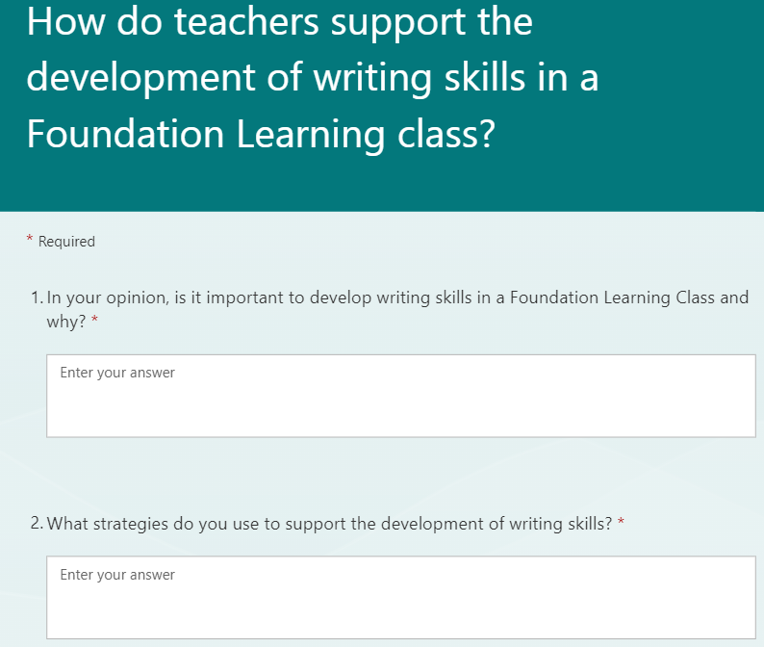

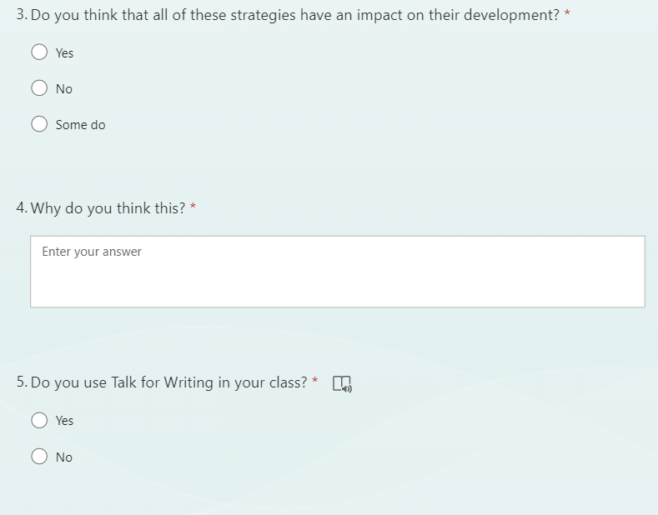

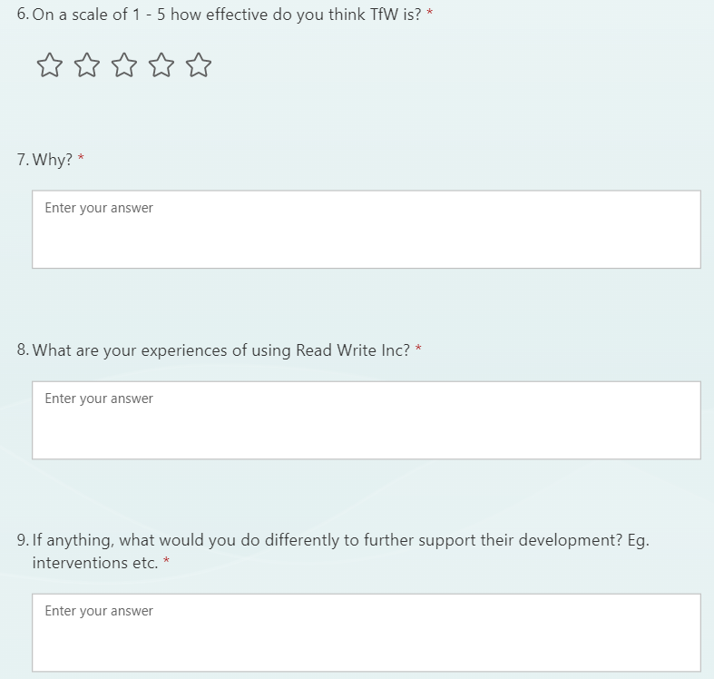

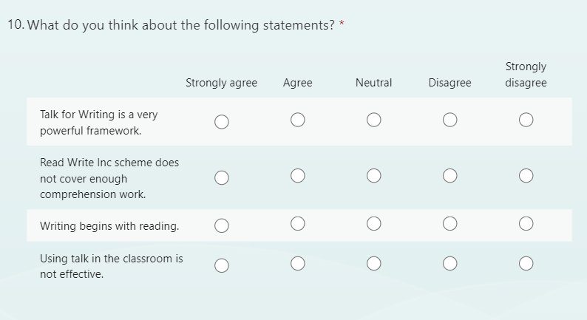

Appendix D – Focus Group Transcripts
Me: Today I would like your help with my work in university if that’s ok with you. I need to ask you some questions and I want you all to answer honestly, there are no right or wrong answers, I just want you to tell me what you think. If you don’t want to do this that is fine, just tell me at any point and we can stop the interview. I will ask you a couple of times throughout to double check you want to carry on, use your learning thumbs to show me how you feel. As I told you before we started, I am recording your voice just to help me when I need to write up what you say later on and this will be deleted straight after. No names will be mentioned and no one will know who you are, the only people that will read the conversation we have is people in my University, my teachers. Are we all happy to continue? If not that is absolutely fine.
(All thumbs up)
Me: So my first question for you all is do you like Talk for Writing sessions?
Child 1 Yeah I love it
Child 3 Yes and me I’m like very very over the bar. If there was a bar about how much I liked it I would be over it! I really really like them.
Child 2 I don’t like it I love it
Child 4 Umm its fun.
Me: That’s lovely! So why do you think you do Talk for Writing?
Child 3: Because its good. It’s gonna help you when you’re older to write and read.
Me: Excellent. Why else might you do Talk for Writing in class?
Child 2: Well because umm if you have a job when you’re old you will probably need to write something.
Me: Yeah you might need to write something. What do you think?
Child 1: I think we do it because it helps us learn and it helps us know how to write stories and know what we can put in them.
Child 4: Yeah it’s fun and it helps us write.
Me: Yeah possibly! It might help us with our writing skills. So what do you think in particular helps you with your writing?
Child 1: Ummmm?
(All pupils looked confused by the question)
Me: So in talk for writing what stages do you have?
Child 4: We can act it out using actions for remembering it.
Child 2: Yep and we have innovating when we get to box up with the class about the story so we know what we can put in ours.
Child 3: Yeah that’s also good. We umm I think we do our story maps which I do like and then we can make a new one when we do a writing one. And we can make up our own story about anything if we just change some of the words. So its like we have our own one we want to write about.
Me: Do you think that going through each stage as a whole class helps you with your writing?
Child 3: Well technically yes.
Child 2: Yeah I love doing it.
Child 1: Thumbs up
Child 4: Yesssss.
Child 2: I love doing it! It helps me make mine better.
Child 3: Miss well I’m doing a double thumb.
Me: Wow a double thumb! So you think it really helps. Why do you think Miss breaks it down into each stage? So we have the imitation stage where you make actions for your story to help you remember it. You make your story maps to retell the story. Then you innovate the story, which like you said is boxing it up and coming up with a class version, looking at key parts of the story. And then you make your own. Why do you think you do it this way?
Child 2: To help us learn it.
Me: Yeah but what is it that you’re learning?
Child 3: Well I think we’re learning about writing and doing the actions together can help you.
Child 4: So we know what to write about
Me: What about you?
Child 1: so when we write ours, we can put in more information about the characters and have more ideas.
Me: Are you all happy to continue? Thumbs up middle or down.
(All thumbs up)
How do you feel about creating actions as a group to retell the story?
Child 2: Umm a bit nervous.
Me: Why do you feel nervous?
Child 2: Because umm if Miss picks me to do it in front of the class and I do something wrong I feel nervous that its not good.
Me: Aw don’t worry I’m sure your ideas are brilliant! How do you feel?
Child 3: I feel brave. I feel brave because if I choose the action by myself and we do it then I feel proud that it’s mine.
Me: That’s a nice feeling isn’t it! How would you feel?
Child 1: I would feel a little bit shy but also a lot heart warmed because when we do it it makes me feel happy that we make them all together. It makes me remember it more.
Child 4: Ummm I find it easy.
Me: So my next question is Why might your teacher want you to create actions for the words in the story before writing?
Child 3: Because we have to think.
Child 2: We have to think ourselves and it makes us create our own ideas.
Child 1: I can even do it if my eyes are closed!
Child 2: Yeah me too!
Child 3: It helps us remember it without looking at it.
Me: Do you enjoy Read Write Inc phonic sessions?
Child 4: ahhh yes! (Big smile)
Child 2: I do because I get to learn new words and new things.
Child 3: Yeah I do writing but we have to do the same thing every day and we write but it’s okay with me. But yeah we do writing, and lots of things like the sounds and words.
Child 1: I do because its very fun. When I go into (said teacher’s name) class I feel brave.
Me: Why do you feel brave?
Child 1: Because every single time I go into Read Write Inc it’s not my normal class so I feel brave. And I try to push myself.
Child 4: After we learn new words we sometimes play a game.
So why do you think that you do these?
Child 2: Umm because it helps you write and learn how to read. It helps us learn new sounds.
Me: Okay so why might you need to learn how to read and write?
Child 2: so if you had to write a note when you’re older and you didn’t know how to write then you couldn’t do it so we need to know how so we can book something if we need to.
Me: Why do you think we do read write inc?
Child 3: Because we can use the grids to help us write. The Fred fingers is good for words.
Child 1: To read and write the words, it helps us know what sounds are the same in the words.
Child 4: umm I don’t really know.
Me: I have two more questions. Who’s happy for me to carry on or would you like to stop?
(Thumbs up)
Do you enjoy being split into different groups across years 1 and 2?
Child 2: Yeah because we get to see new friends and new people.
Me: Yeah you do! People who may not be in your class every day.
Child 3: Yeah sometimes I get nervous though because I don’t really know any children. Only like one or two.
Child 1: I feel calm and relaxed because almost all of my friends are in that class. And I know some of the other people in the class.
Me: What about you? How do you feel about going into a different class?
Child 4: Umm kinda weird because we mix our classes every day and then we go back to being in the right one after so it’s kinda weird.
Me: Ahh right so you think it’s weird going from one class to the other?
Child 4: Yeah a bit.
Me: My last question then. Thank you so much for all your help! How else do your teachers help you with your writing?
Child 2: Sometimes when you struggle with your work, the teachers help you with mistakes and show you what you need to spell right. They help you because they sometimes give you a read write inc card or do Fred Fingers with you to sound them out.
Me: Anyone else have any other ways your teacher helps you with your writing?
Child 3: Teachers are always there to help you because if you get stuck the teachers can always help. They can help you be unstuck and work out how you can write stuff.
Child 1: Basically if you get stuck on a word, sometimes the show you by writing it on a whiteboard or on the table or Fred it out with you so you know how to spell it.
Child 4: They help me Fred out the sounds. Sometimes I don’t know a lot of words. I know them, but I don’t know what they look like and they help me by showing me what it looks like sometimes with writing it or they tell me to remember to Fred it.

Appendix E – Questionnaire Responses

Q1 – In your opinion, is it important to develop writing skills in a Foundation Learning class and why?

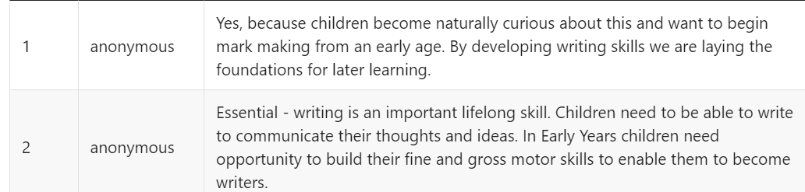

Appendix F – Questionnaire Responses

Q5 – Do you use Talk for Writing In your class?
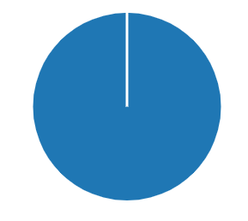
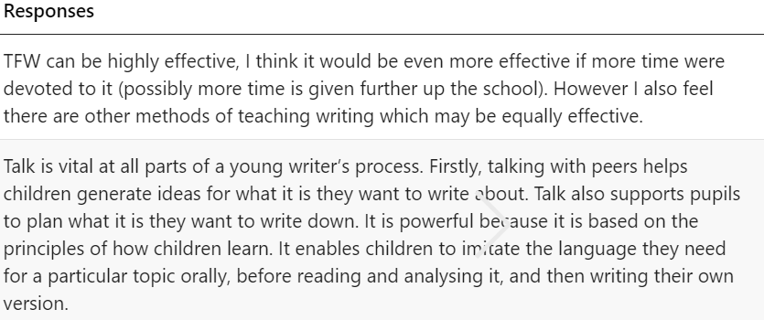

H –

Appendix G – Focus Group Interview Responses

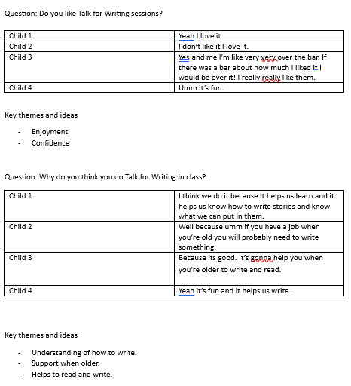

Appendix H – Focus Group Interview Responses

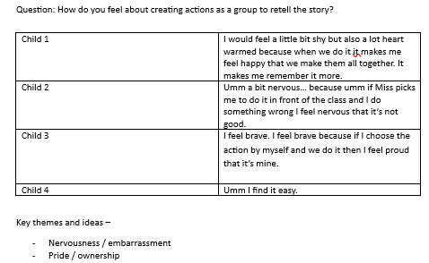

Appendix I – Focus Group Interview Responses


