1,506 × 629



Name: Vishal Choudhary

Id - 2412600
Module: International Business Concepts
Module code: LCMB7034

Professor name- Balendran Kandasamy

Title: International Business Report: Analysis of the Retail Industry in India and Evaluation of Costco’s Market Entry Strategy

Table of contents
SECTION 1: MAIN REPORT 2
1. Introduction 3
2. Industry and Country Overview 3
2.1 Overview of the Indian Retail Industry 3
2.2 Economic Importance of the Industry 4
2.3 Key Players in the Industry 4
2.4 Competitive Positioning and Market Gap 5
3. Porter’s Diamond Model Analysis of the Indian Retail Industry 6
3.1 Factor Conditions 7
3.2 Demand Conditions 8
3.3 Related and Supporting Industries 9
3.4 Firm Strategy, Structure, and Rivalry 9
3.5 Government and Chance Factors 10
4. Evaluation of Costco in India 10
4.1 Overview of Costco (Brief) 10
4.2 Market Attractiveness Analysis (PESTLE + Cultural) 11
4.3 Entry Mode Strategy 13
4.4 OLI Framework Analysis 14
Ownership Advantages (O) 14
Location Advantages (L) 14
Internalisation Advantages (I) 15
4.5 Competitive Challenges 15
4.6 Critical Evaluation of Success Potential 16
5. Conclusion 17
SECTION 2: REFLECTIVE ACCOUNT 18
6. Reflection using Gibbs Reflective Cycle 18
6.1 Description 18
6.2 Feelings 18
6.3 Evaluation 19
6.4 Analysis 19
6.5 Conclusion 19
6.6 Action Plan for Future Improvement 20
References List 22

SECTION 1: MAIN REPORT

1. Introduction
Globalisation, digital transformation, and seeking new areas of growth have pushed retail internationalisation to a rate of rapid increase over the last 20 years. Big multinational retailers are also moving to open prospects in other economies as they grow out of saturated domestic markets to capture the emerging consumer trends of the emerging economies marked by growth in incomes and urbanisation (Verhoff et al., 2021). Of these markets India is one of the highly growing markets with a dynamic middle class, favourable demographic mix and an emerging organised retail market and therefore it is a strategic market to international retailers (IBEF, 2025).
The report is about the retail and wholesale warehouse sector in India with concern to its structure, level of competition and growth prospects. In such a frame, Costco Wholesale Corporation is chosen as the center object of study as an exemplar of a multinational company that has a distinctive, low-cost, membership-focused business model. This report aims at discussing the competitiveness of the Indian retail industry and critically discusses the potential of Costco to successfully enter and sustain in the Indian market.

2. Industry and Country Overview

2.1 Overview of the Indian Retail Industry
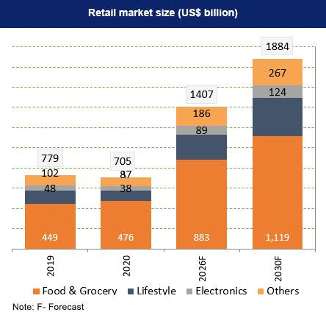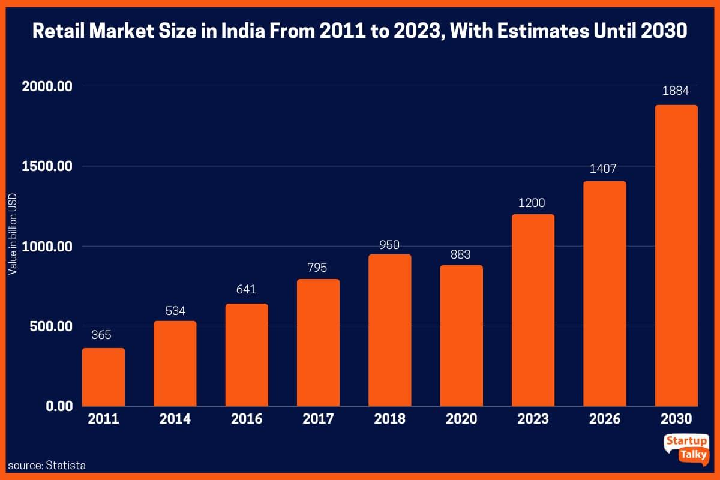
Figure 1: Growth of the Indian Retail Market (USD Trillion)
Source: India Brand Equity Foundation (IBEF) (2025)
The retail industry in India is among the rapidly developing markets worldwide and a key sector of the Indian economy. The amount of the entire market is approximated at about USD 1.3-1.4 trillion, and forecasts show that the market will continue to grow due to increased consumption and demographic benefits (IBEF, 2025). This industry has a macroeconomic role as it takes approximately 10 percent of the GDP and an almost 8 percent proportion of the total employment in India.
The presence of both organised and unorganised retail is a hall mark of the Indian retail industry. Conventionally organised formats like kirana stores, street vendors and small family owned enterprises have dominated the industry with this particular market sharing almost 7580 percent of the total market. Nonetheless, the growth pace of organised retail, such as supermarkets, hypermarkets, and online shopping, is accelerating, fuelled by foreign investments, digitalisation, and evolving consumer tastes (Kearney, 2024). The organised retail sector is projected to increase to an extent that is much faster than the unorganised one hence depicting a structural change towards the modern retail formats. The industry has also changed with the emanation of online commerce and internet shopping. Increasing internet penetration, smartphone usage, and adoption of digital payment systems will encourage the market of e-commerce to grow to USD 350 billion in the year 2030 (Statista, 2025). Uniting online and physical experiences retailing has been among the major strategic focus points of companies, allowing them to promote better interaction with customers and productivity levels. This change is more applicable to international entrants since it is decreasing the entry barriers but increasing competition.

2.2 Economic Importance of the Industry
The retail industry has a significant contribution to the economic growth of India, in addition to the direct contribution to GDP. One of the biggest job creators, it sustains more than 40 million jobs, both low-skilled on the front line in traditional retail to high-skilled in logistics, data analytics and digital platforms (IBEF, 2025). This renders the sector a significant contributor to inclusive development and income earnings.
The other major issue that supports retail growth is urbanisation. The urban population of India will surpass 600 million by 2030, making focal points of demand and enabling the development of modern retail networks: shopping centres and warehouse delivery networks (World Bank, 2025). At the same time, the booming growth of the middle classes, estimated to number more than 500 million consumers, has boosted buying power and preference of superior, brand, and value based products.

2.3 Key Players in the Industry
The competition in the Indian fashion retail market is extreme both between the local conglomerates and between the world players with their unique strategic advantages.
Reliance Retail is a domestic company and the leading player in the market, having many formats of operation such as grocery, electronics and fashion. Its competitive advantage is based on its integrated supply chain, aggressive pricing model, and large physical and virtual footprint, which is enhanced by products like JioMart. Likewise, the Tata Group with its Trent and Star Bazaar ventures concentrates on brand trust and positioning brand quality, and on tailored retail experiences, which aims to target urban middle- and upper-income customers.
A robust presence has also been made by international players. The case of Walmart acquisition of Flipkart has seen Walmart initiate a digital-first approach, which is taking advantage of the booming segment of e-commerce in India. Amazon India will be working on a marketplace business model, focusing on customer convenience, logistical efficiency, and a diverse product range, which will be enabled through sophisticated technology and the last-mile delivery channels.
Together these firms also heighten competition because they are able to use economies of scale, technological innovation and customer relationships such that new entrants find it difficult to enter into the industry.

2.4 Competitive Positioning and Market Gap
The Indian retail industry is deeply competitive, influenced by the three main dimensions which are pricing approaches, supply chain competency, and business models.
Pricingwise, local competitors like Reliance Retail are using penetration pricing and discount-based pricing strategies to appeal to the price conscious customers. Likewise, Amazon and Flipkart involve themselves in constant promotional campaigns and price wars especially during festive seasons. This is because of the high price elasticity of Indian customers, which plays a key role in buying behaviors.
On the supply chain side, major companies have invested a lot in the integrated logistics network, warehousing as well as the data-based inventory management systems. As an example, the distribution infrastructure and fulfilment centres of Amazon and Reliance can facilitate the use of speed and cost-effectiveness in their delivery. Such abilities are vital in such a geographically diverse market as India, where logistics issues may affect operational performance.
On the business model, omnichannel and platform businesses prevail which entail physical shops alongside online interfaces. Although this helps to increase access and convenience, it also introduces a very competitive environment in which it is challenging to differentiate.
Unless competition eliminates it, then there is a possible market niche in the wholesale warehouse retail sector, especially as a form of bulk purchasing via membership basis models. Although the Indian consumers remain extremely price sensitive, a developing group of urban, wealthy and small business clientele is now appreciating bulk purchasing, quality guarantees and economies of scale. This is a relatively underdeveloped market as compared to the Western markets.
This loophole offers an opportunity to Costco, which has it as its business model based on the business scheme of high-volume low-margin sales and customer loyalty based on membership. Costco could set itself apart in terms of the previously existing competition by targeting urban middle- and upper-income consumers, as well as small enterprises. Its success however lies in how it can localise this model to the local consumer behaviour especially where bulk buying and paid memberships are not very deep rooted in the market.

3. Porter’s Diamond Model Analysis of the Indian Retail Industry
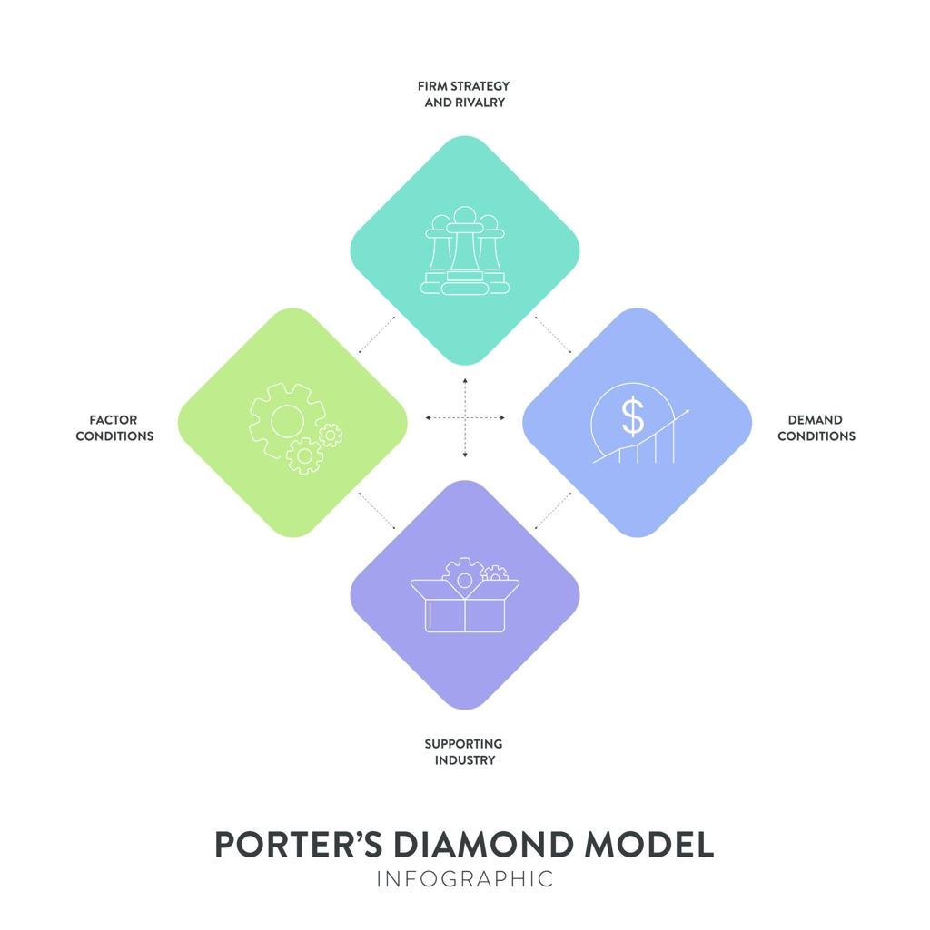
Figure: Porter’s Diamond Model
Source: Porter, (1990)
Porter's Diamond Model is used to give a methodical examination of the international competitiveness of an industry in a particular nation (Porter, 1990). The Indian retail industry can be analysed through the prism of this model to illustrate the factors of structural advantages and limitations that affect the success of multinational retailing firms like Costco.

3.1 Factor Conditions
Factor conditions denote the availability and quality of production factors like labour, infrastructure and capital. India also has a big benefit in terms of availability of high labour volume, which is not only inexpensive but also well-endowed, characterized by over 500 million labour force, one of the largest labour markets of the world (World Bank, 2025). India has significantly lower labour cost than the developed economies, and this allows the retailers to keep operational costs low and facilitates cost leadership strategies.
Nevertheless, regardless of this benefit, the factor of the infrastructure limitation is also a key drawback. Lack of logistics efficiencies, low cold storage capacity and disjointed warehousing contributes to high costs of operation and supply chain collapse. The logistics cost in India is approximated to be approximately 13-14 percent of GDP which is quite a few times compared to the global average cost of 8-9 percent (Kearney, 2024). Moreover, transport bottlenecks and unstable last mile delivery mechanisms pose further problems especially in rural and semi-urban areas.

3.2 Demand Conditions
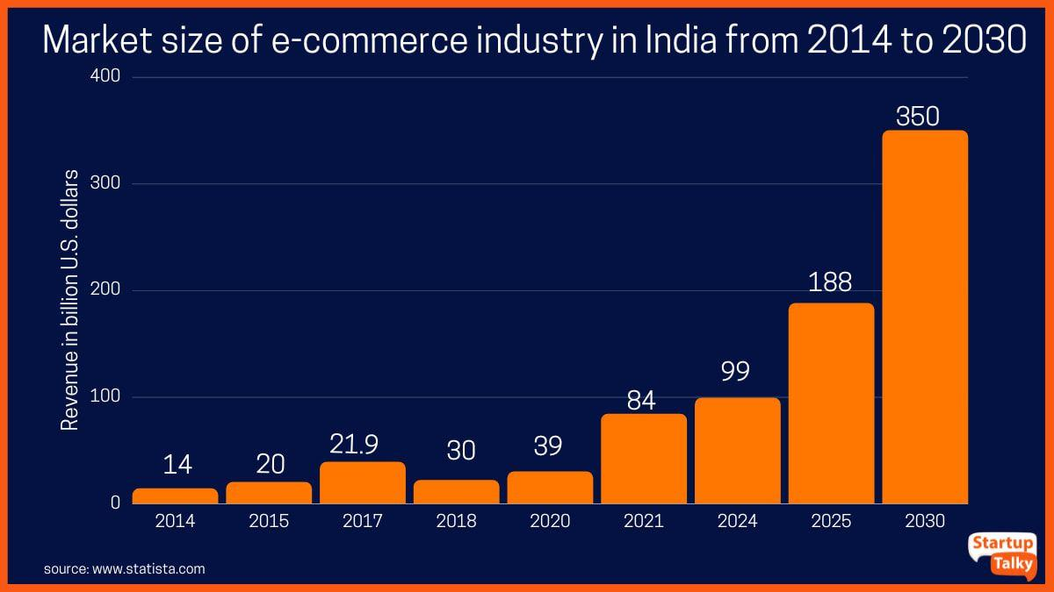

Figure 3: Growth of E-commerce Market in India (2020–2030 Forecast)
Source: Statista (2025)
The Indian retail environment is extremely dynamic and demand conditions would be central to retail competitiveness. The vast population of the country, which is diverse, and has over 1.4 billion people offers large markets. One of the key drivers is the fast rate of middle-class population that is estimated to reach more than 500 million in 2030 and also increases disposable income and consumption levels (IBEF, 2025).
Nevertheless, the emphasis of Indian consumers is on high price sensitivity which has a great impact on the buying behaviour. Competitive pricing will require retailers to use competitive pricing to draw and maintain customers. Simultaneously, an increasing trend exists in the movement towards quality, branded products and offerings at a value-price point, especially by urban consumers.
The shift to the organised and modern forms of retail, such as supermarkets, hypermarkets, and internet-based stores is the other trend. This trend has been enhanced by the growing use of online technologies, with e-commerce growing at a considerable pace.
Hence, India's demand environment offers a scale opportunity as well as growth prospects but it also needs companies to strike a delicate balance between cost-efficiency and value deliverance.

3.3 Related and Supporting Industries
High related and supporting industries also improve the competitiveness in the retail industry. That India has experienced tremendous growth in the areas of logistics, supply chain management, and digital infrastructure, which forms crucial drivers of contemporary retail, is notable. This is because the advancement of suppliers and production networks of FMCGs guarantees stable supply of goods to the market at favorable prices which will facilitate the high-volume retail business. Also, the growth of the logistics providers and warehouses has made distribution efficient, but there are loopholes. One of the strengths is the digital payment ecosystem in India that was initiated by such projects like Unified Payments Interface (UPI). Indian digital transactions have been on an exponential rise as billions of transactions are being completed each month, making retail processes run smoothly and customers become more convenient (Statista, 2025).

3.4 Firm Strategy, Structure, and Rivalry
Intense competition and dynamic strategic behaviour are the features of the Indian retail sector as they can have a great impact on the competitiveness of the industry. Key competitors like Reliance Retail, Amazon and Walmart (through Flipkart) are fierce in terms of pricing strategies, technological advancement and coverage of distribution channels. The market is highly competitive and in the process of price wars and promotional campaigns, the firms are often found to offer them particularly over the festive seasons. Although Reliance Retail relies heavily on the continuum of brick-and-mortar shops and strong supply chain, Amazon and Flipkart concentrate on digital and logistical operation and customer-oriented services. A competitive environment promotes on-going innovation, such as the introduction of omnichannel retailing, personalised marketing strategies, and data analytics. Still, it puts a strain on the profit margins as well, and it is hard to find a foothold among new entrants.

3.5 Government and Chance Factors
The government policies are very important in determining the retail environment in India, especially to the foreign entrants. The nation has introduced very restrictive Foreign Direct Investment (FDI) laws in multi-brand retail, which constrains the level to which foreign firms can undertake their operation on an autonomous basis. An example is that FDI in multi-brand retail is limited to 51 percent government authorization, providing an extra barrier to entry (World Bank, 2025).
Such control restrictions frequently force multinational companies to use joint venture or partnership options, which makes the control more complex and less powerful. Moreover, to operate in compliance with local sourcing needs and regulations can add to the operating costs.
Government efforts like Digital India, infrastructure development programmes and ease-of-doing-business reforms on the positive side are slowly turning the business environment to the better. Nevertheless, the risk of regulatory uncertainty and changes in policies still exists.
E-commerce and digital retail have also expanded rapidly on the factors that are affected by chance like improvements in technology and change in consumer behaviour further changing the competitive environment.

4. Evaluation of Costco in India

4.1 Overview of Costco (Brief)
Costco Wholesale Corporation enjoys a warehouse retail layout that requires membership; this makes it unique as opposed to a normal retailer. Customers are required to pay a yearly membership charge to be able to have access to bulk products at highly discounted rates. This is the model that will allow Costco to sell in large volumes at low profit margins, which will support its cost leadership approach (Costco, 2025).
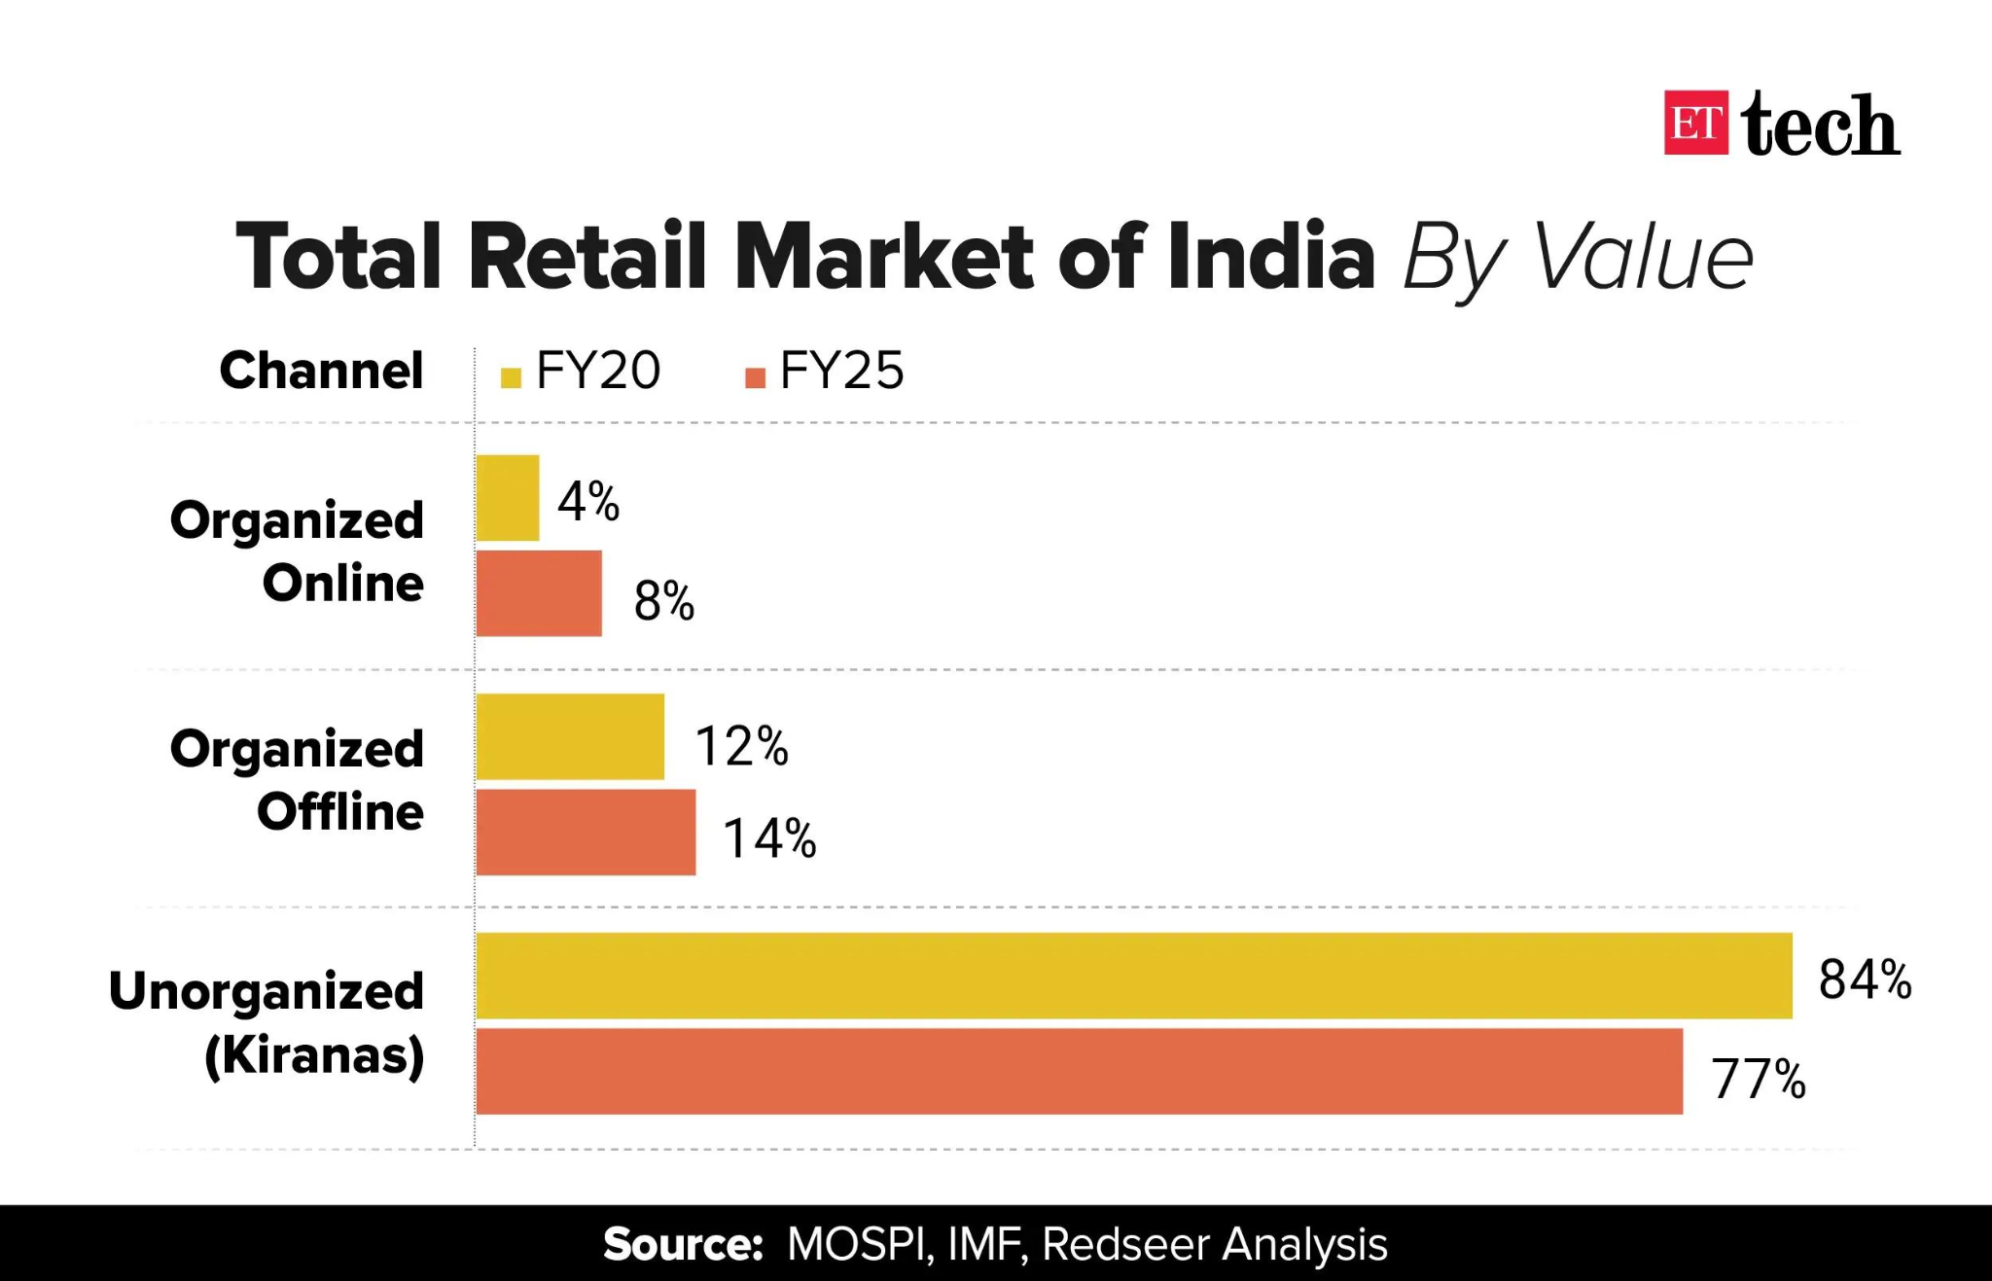
Figure 2: Structure of Indian Retail Sector (Organised vs Unorganised)
Source: Kearney (2024)
One of the main advantages that Costco has is its minimal product assortment (SKU rationalisation) and a well-developed own brand, Kirkland Signature, that boosts the margins without compromising the perceived quality. Operational efficiency, integration of the supply chain, and customer loyalty makes the company successful worldwide with membership renewal rates of more than 90 percent in the core markets. Nevertheless, one should pay close attention to adapting this model to India as there are certain differences in consumer behaviour and market structure.

4.2 Market Attractiveness Analysis (PESTLE + Cultural)
Factor | Key Insights (with Data & Stats) | Implications for Costco
Political & Legal | Government approval of 51% FDI in multi brand retail is available in India while local sourcing is strict (World Bank, 2025). The complexity of regulations and state diversities amplify compliance effort. | Are barriers to entry high? × Costco probably requires a joint venture/ partnership model. Less supervision of operations.
Economic | Size of retail market 1.4 trillion generating about 10-percent of GDP (IBEF, 2025). By 2030, the middle class is expected to have more than 500 million. Consumer behaviour is however dominated by high price sensitivity. | Develops high demand but a demanding pricing approach is needed. The low-cost model employed by Costco fits perfectly, but there can be a threatened margin.
Social & Cultural | India is a family-oriented collectivist society (Hofstede, 2025). Customers are willing to make numerous smaller purchases as opposed to bulk purchases. Buy decisions depend on trust and relationship. | Membership + bulk buying model can be perceived negatively. Needs consumer training and localisation.
Technological | The e-commerce market in India is estimated to be 350 billion by the year 2030 (Statista, 2025). Nuanced development of digital payment (UPI transactions in billions monthly). | Possibility to incorporate omnichannel retail strategy. But dominant online rivals (Amazon, Flipkart) put additional pressure.
Environmental | Raised interest in sustainability, packaging laws, and one that reduces waste. The retailers should become environmentally friendly (Kearney, 2024). | Costco needs to make changes in packaging (bulk to sustainability issues). Green positioning opportunity.
Legal (Consumer & Labour) | Complicated state labour legislation and regulations. The law on consumer protection is getting tough. | The complexity of the operation enhances the cost and management.
The PEST analysis shows that India is a high-growth, but structurally complicated environment to Costco.
On the opportunity front, good economic fundamentals like the rapidly growing middle income, increasing disposable income, and a high consumer base provide huge demand opportunities. The price-sensitive market in India is responsive to cost leadership strategy, whereas the bulk purchasing model would benefit the urban affluent and small businesses interested in getting value and efficiency in India. Moreover, new insights into digital infrastructure offer possibilities to Costco, enabling the company to implement an omnichannel strategy to increase its market presence and operational extent.
Nevertheless, there are considerable obstacles. The presence of regulation limiting foreign retail entry restricts strategic flexibility and heightens reliance on local partners. More importantly, cultural misfit is also a major problem as India is used to buying in smaller quantities but making higher frequency as opposed to bigger volume purchases as it is the key business concept of Costco. In addition, the presence of strong established competitors like Reliance Retail, Amazon, and Walmart increases pricing and margin pressure.
Thus, as much as India has good growth opportunities, the success of Costco will be determined by its capacity to transform the global business model to reflect the local consumer behaviour, regulatory environment and competition. The potential opportunities may be overwhelmed by the structural barriers without such adaptation.

4.3 Entry Mode Strategy
Choosing a viable entry mode is a key determinant to the success of the Costco business in India since it is a complex market with unique issues. A joint venture (JV) is the best strategy that can be adopted in contrast to wholly owned subsidiaries and franchising.
A wholly owned subsidiary would allow Costco complete control of operations and brand control, but the FDI limitations in India on multi-brand retail (maximum of 51 percent with government permission) impede this option and limit operations (World Bank, 2025). Also, there is the risk posed by high capital investment and regulatory compliance in case a foreign entrant who is not familiar with the local market wants to venture into the market.
Although incurring less investment, franchising would restrict Costco in enforcing its standardised warehouse format, pricing approach and command over its supply chain, which are at the core of its competitive edge.
Conversely, a joint venture will enable Costco to collaborate with a local company where there will be access to market understanding, regulatory and existing channels of distribution. This minimises entry risk and increases cultural adaptation especially in a market where consumer behaviour is complex and decentralised retail structure.
Hence, JV offers middle ground, giving Costco an international competency with the local competency and thus it is the most feasible way to enter the Indian market alongside the most suitable strategy.

4.4 OLI Framework Analysis

Ownership Advantages (O)
Costco has considerable ownership advantages that can be used to support its competitiveness across the world. Its membership-based business model creates a consistent and repeated revenue stream and presents high customer loyalty rates, where its renewal is over 90 percent in its key markets (Costco, 2025). Furthermore, the bulky procurement system and efficient global supply chain used at Costco substantiate a high volume/low margin strategy that allows saving lots of money (Rugman and Verbeke, 2001).
The profitability of the company is boosted by its own brand, the Kirkland Signature, without any perceived product quality difference, which supports the value proposition (Costco, 2025). In addition, its reduced product assortment strategy is better in improving turnover and efficiency in the operation of the company.
The ownership benefits might not be completely transmissible to India, however. The retail-based model of membership is quite a new concept in India, and customers might hesitate to pay upfront subscription in a very cost-conscious market (IBEF, 2025).

Location Advantages (L)
India has a considerable amount of location specific advantages that appeal to multinational retailers. The economic potential is high based on the size of the retail market in the country at about USD 1.4 trillion and the contribution to GDP at about 10%. (IBEF, 2025). Also the rising rate of the middle-class population which is estimated to rise to above 500 million by the year 2030 is boosting their consumption and demand of organised retail formats.
The cheap labour prices additionally increase the operational viability, and the development of retail is backed by urbanisation and digital adoption (World Bank, 2025). The retail ecosystem is also enhanced by the development of e-commerce and digital payment systems.
Although there are these benefits, there are major limitations. The logistics costs of India are about 13 to 14 percent of GDP, which shows inefficiencies in the infrastructure and supply chain systems (Kearney, 2024). There are also direct regulatory obstacles in entry such as limitations on foreign direct investment in multi-brand retail (World Bank, 2025).

Internalisation Advantages (I)
Internalisation benefits are those which benefit Costco in terms of control over its operation as opposed to using other external intermediaries. The business model of Costco relies on centralisation of procurement, pricing and stocking and this aspect guarantees uniformity and cost effectiveness (Dunning, 1988).
Costco enjoys the advantage of wholly owned operations in developed markets enabling it to execute its strategy in such markets. But in India the viability of full ownership is constrained by India's FDI optimization and regulatory overheads, which require other forms of entry, such as joint ventures (World Bank, 2025).
As much as partnerships ease market entry, it can also decrease operations control and introduce problems of coordination which could undermine the internalisation benefits of Costco. Though the OLI framework indicates that Costco has great ownership advantages and India has favorable location benefits, there are a number of weaknesses that could impede successful implementation. The main problem is the mismatch between the bulk purchasing strategy of the Costco and the Indian consumer behaviour that is characterised by small scale and regular purchases (Kearney, 2024).
Additionally, the fee system membership can become an obstacle, especially in a market that is prone to a free access retail format and strong price rivalry (IBEF, 2025). Other existing players like Reliance Retail, Amazon and Walmart equally boost competition curbing chances of market penetration (Statista, 2025). Operational-wise, inefficiencies in infrastructure and expensive logistics can lower the efficiency of the supply chain-based model of Costco. Further, the use of joint ventures because of the regulatory restrictions can reduce the strategic control and compromise consistency. Altogether, the OLI framework shows that there is much to be taken advantage of but the interpretation shows that Costco needs to adjust its global business model to that of the local market. There will be no such localisation and its traditional competitive advantages will not translate into any long-term success within the Indian retail environment.

4.5 Competitive Challenges
The threat to entry in India posed by high competition and market structure are also major limitations to entry into India by Costco. One of the key issues is the hegemony of Reliance Retail since it is the biggest retailer in India and has a massive presence both physically and electronically. Reliance capitalizes on an integrated supply chain, pricing strategies that are aggressive as well as extensive market penetration to enable it to effectively serve price sensitive consumers (Reliance Retail, 2025). The presence of strong local knowledge and supplier networks makes it very hard to be able to enter it.
Besides that, the threat to e-commerce posed by other competitors like Amazon and Flipkart (Walmart) has changed the competitive situation. These companies make use of sophisticated logistics systems, data analytics, and omnichannel tactics to provide convenience, competitive prices, and fast shipping. It is expected that by 2030, the e-commerce market in India will grow to USD 350 billion, which will increase the competition of both physical and hybrid retailing (Statista, 2025).
The other vital challenge is that of mis-alignment of consumer behaviour with the business model of Costco. Indian customers usually make small quantities but frequent purchases unlike the Costco model of bulk purchases and paid subscriptions. This forms a backlash against initial subscription charges, especially with such a price-sensitive market (Kearney, 2024).
All these put together make it more challenging to get a sustainable competitive position in India that Costco is pursuing.

4.6 Critical Evaluation of Success Potential
The success of the Costco in India is not assured but depends on how it can balance the good global capabilities and diverse local market conditions. Although the Indian retail market has tremendous growth opportunities, structural and behavioural challenges present a high-risk, high-reward environment to enter.
Opportunity wise, the USD 1.4 trillion retail market in India and the quickly growing middle-income ranges create huge demand opportunities (IBEF, 2025). The cost leadership business model and the cost procurement efficiencies adopted by Costco will suit the price sensitive consumers well, especially among affluent households and small businesses in urban areas that love to buy in big quantities in pursuit of value. Besides, scalable operations are enabled by the expansion of digital infrastructure and the structured retail (Statista, 2025).
Nonetheless, this potential is jeopardized by critical risks. Indian consumers do not have the same buying behaviours as Costco is doing in the United States; they tend to buy in small quantities and every few minutes instead of buying in large quantities (Kearney, 2024). This poses a mismatch in structure with the membership-based model of Costco. Furthermore, well-established supply chains, local knowledge, and pricing power of such powerful incumbents like Reliance Retail and Amazon render competitive entry difficult.
There are a number of conditions which need to be satisfied in order that Costco can achieve success. First, the company should change its business model, and it might be a smaller pack size, configurable membership, or a hybrid retail format. Second, strategic joint ventures can be made to overcome regulatory and local market complexities. Third, a more market-fit, i.e., niche, strategy, e.g. by focusing on SMEs, urban professionals, and institutional buyers.
Compared to the India strategy through Flipkart that Walmart has implemented, focusing on digital penetration rather than the physical retail format, the traditional format of the warehouse of Costco might need to be localised more to be competitive. Thus, it cannot succeed by copying its international format, but rather by being responsive to its market and specific innovations.

5. Conclusion
In this report, a critical analysis of the Indian retail business and an assessment of whether Costco can enter the market or not as applied to the major global business models have been done. The analysis illustrates that India is a very attractive and complex market with high growth opportunities, high number of consumers, and growing middle-class. The size of the industry, which is currently estimated at about USD 1.4 trillion, the combined trends of rising urbanisation and adoption of digital, gives great potential to multinational retailers (IBEF, 2025). This allure is however muted by the structural problems such as inefficiencies in infrastructure, regulatory impediments, and stiff competition.
Costco has a number of strengths that can facilitate its international expansion strategy; these strengths comprise its strategy of cost leadership,; efficient supply chain and its membership-based business model, which had been found to be effective in developed markets. These benefits are in line with the price-sensitive nature of India to some extent. However, the analysis sheds light upon major weaknesses, especially the incongruity approach of Costco to the Indian consumer behaviour and the expensive-to-join model in India. There are also great domestic and foreign competitors like Reliance Retail and Amazon that further restrict the chances of entry.
Overall analysis shows that Costco can enter India but under certain circumstances. Its ability to tailor its business model, establish strategic local partnerships and go to the right customer segments will see success. This conclusion is squarely in line with the objective of the report, which can determine industry competitiveness and possible success of Costco. Finally, although India presents grand long-term prospects, Costco would need to embark on a localised and adaptable approach in an attempt to gain sustainable competitive advantage in the dynamic Indian market.

SECTION 2: REFLECTIVE ACCOUNT

6. Reflection using Gibbs Reflective Cycle

6.1 Description
This was an evaluation paper, whereby an international business report was developed examining the Indian retail market, and the potential of Costco to enter into the market. The search started with finding an appropriate country-industry combination with an adequate amount of secondary data. India was chosen because of its booming retail market and Costco was chosen as a top-related multinational company with a unique business model.
The research process entailed a lot of consultation with scholarly articles, business reports (IBEF, Kearney, Statista) and company reports and publications to create a solid evidence base. The report was organized using critical models like Porters Diamond Model, OLI paradigm and PESTLE analysis. The writing project encompassed structuring the material into a logical academic format, making sure that the parts are logically related to each other and not discussing but analysing them critically. Furthermore, throughout the report, appropriate referencing in the form of the Harvard style was adopted.

6.2 Feelings
In the beginning, the task seemed complicated because of the need to incorporate numerous theoretical models with practical data in the industry. Some confusion occurred in the selection of suitable sources and their credibility, especially the differentiation between the academic sources and the non-academic sources.
Although the analysis phase required application of theoretical models like the Porters Diamond and OLI in a real world situation was not easy. Not only was it necessary to know the theories but also critically decide on how they can be applied to the Indian retail market. Sometimes, it was hard to cope with the great amount of data and focus on the assignment goals clearly.
But confidence grew as the work continued. It became easier to interrelate theory and practice and the report format became clearer. After filling out each section offered a feeling of achievement, especially when formulating critical arguments, as opposed to the description of information.

6.3 Evaluation
There are a number of features about the process that worked. To start with, the fact that the sources used in the report were reliable and up-to-date enhanced the academic quality of the report. The use of data and statistics facilitated supporting arguments and enhanced credibility. Secondly, the use of various frameworks offered a detailed and systematized study, which allowed gaining a better insight into international business strategy.

6.4 Analysis
This assignment was a major contribution to the achievement of some of the main academic and professional skills. Critical thinking was one of the most significant skills acquired. Instead of taking information literally, the process involved an assessment of the relevancy, reliability, and the implications of data. To illustrate, the analysis of the business model of Costco in Indian consumer behaviour case included recognising opportunities and constraints instead of considering it can be transferred directly.
Second, the development of research skills was achieved by using a wide range of sources, such as academic journals, industry reports, as well as the publications of companies. This skill to determine the credibility of the sources and combination of the information about various points of view enhanced the level of analysis. This empowered referencing skills and academic integrity knowledge as well. The second important aspect in development was the use of theoretical frameworks.

6.5 Conclusion
In general, this assignment has taught me a lot about international business strategy and academic research processes. One of the key learning results was the significance of matching theoretical-based methods and practical data to generate meaningful analysis. There was also the realization that critical assessment is required instead of descriptive writing that is important in attaining greater academic performance.
In addition, the assignment consolidated the significance of good planning, time management, and credibility of a source. The acquisition of these skills has led to confidence in working on complex analytical assignments and writing academic reports of professional level. The information acquired on international retail dynamics and market entry strategies will also come in handy in future study and career growth.

6.6 Action Plan for Future Improvement

Area for Improvement | Identified Issue | Action Steps | Expected Outcome
Critical Analysis | Initial over-reliance on description | Practice writing analytical paragraphs using “why” and “so what” approach | Stronger arguments and higher-level academic writing
Time Management | Too much time spent on research phase | Create structured timeline with deadlines for each section | Balanced time allocation and improved efficiency
Use of Frameworks | Difficulty applying theory to practice initially | Engage in more case studies and practical applications | Better integration of theory with real-world scenarios
Academic Writing | Need for more concise and precise expression | Review academic writing guides and seek feedback | Improved clarity and professionalism
Referencing Skills | Minor inconsistencies in Harvard style | Use referencing tools and double-check citations | Accurate and consistent referencing
Research Depth | Limited initial source variety | Use academic databases (Google Scholar, journals) more extensively | Higher quality and more credible sources

References List
Amazon Inc. (2025) Annual report 2025. Available at: https://www.aboutamazon.com/investor-relations (Accessed: 28 April 2026).
Coresight Research (2025) Retail in India: Trends and outlook. Available at: https://coresight.com/research/india-retail-retail-2025/ (Accessed: 28 April 2026).
Costco Wholesale Corporation (2025) Annual report. Available at: https://investor.costco.com (Accessed: 28 April 2026).
Dunning, J.H. (1988) ‘The eclectic paradigm of international production: A restatement and some possible extensions’, Journal of International Business Studies, 19(1), pp. 1–31. Available at: https://doi.org/10.1057/palgrave.jibs.8490372
Hofstede Insights (2025) Country comparison: United States vs India. Available at: https://www.hofstede-insights.com (Accessed: 28 April 2026).
India Brand Equity Foundation (IBEF) (2025) Retail industry in India. Available at: https://www.ibef.org/industry/retail-india (Accessed: 28 April 2026).
India Brand Equity Foundation (IBEF) (2025) Retail Industry in India. Available at: https://www.ibef.org/industry/retail-india (Accessed: 28 April 2026).
Kearney (2024) Indian Retail: The Next Growth Story. Available at: https://www.kearney.com (Accessed: 28 April 2026).
JLL (2025) India retail market dynamics. Available at: https://www.jll.com/en-in/insights/market-dynamics/india-retail (Accessed: 28 April 2026).
Johanson, J. and Vahlne, J.-E. (2009) ‘The Uppsala internationalization process model revisited’, Journal of International Business Studies, 40(9), pp. 1411–1431. Available at: https://doi.org/10.1057/jibs.2009.24
Kearney (2024) Indian retail: The next growth story. Available at: https://www.kearney.com/industry/consumer-retail/article/indian-retail-s-journey-toward-a-sustainable-future (Accessed: 28 April 2026).
Ken Research (2024) India retail market outlook. Available at: https://www.kenresearch.com/industry-reports/india-retail-market (Accessed: 28 April 2026).
Kumar, V., Rajan, B., Venkatesan, R. and Lecinski, J. (2020) ‘From market driven to market driving’, Journal of Marketing, 84(1), pp. 1–24. Available at: https://doi.org/10.1177/0022242919884150
Pantano, E., Pizzi, G., Scarpi, D. and Dennis, C. (2020) ‘Competing during a pandemic? Retailers’ ups and downs during COVID-19’, Journal of Business Research, 116, pp. 209–213. Available at: https://doi.org/10.1016/j.jbusres.2020.05.036
Porter, M.E. (1990) The competitive advantage of nations. New York: Free Press.
Porter, M.E. (1990) The Competitive Advantage of Nations. New York: Free Press.
Prahalad, C.K. and Doz, Y.L. (1987) The multinational mission: Balancing local demands and global vision. New York: Free Press.
Reinartz, W., Wiegand, N. and Imschloss, M. (2019) ‘The impact of digital transformation on retailing’, Journal of Retailing, 95(3), pp. 1–16. Available at: https://doi.org/10.1016/j.jretai.2018.12.002
Reliance Industries Limited (2025) Reliance Retail overview. Available at: https://www.ril.com/OurBusinesses/Retail.aspx (Accessed: 28 April 2026).
Reuters (2025) ‘Costco to expand operations in India with new capability centre’, Reuters. Available at: https://www.reuters.com/world/india/us-retail-giant-costco-set-up-global-capability-centre-india-employ-1000-people-2025-07-21/ (Accessed: 28 April 2026).
Rugman, A.M. and Verbeke, A. (2001) ‘Subsidiary-specific advantages in multinational enterprises’, Strategic Management Journal, 22(3), pp. 237–250. Available at: https://doi.org/10.1002/smj.153
Singh, R. (2023) ‘Growth of retail sector in India’, International Journal of Research, 10(2), pp. 45–52. Available at: https://journalcra.com/article/study-growth-retail-market-india (Accessed: 28 April 2026).
Statista (2025) E-commerce market size in India. Available at: https://www.statista.com (Accessed: 28 April 2026).
Statista (2025) E-commerce Market Size in India. Available at: https://www.statista.com (Accessed: 28 April 2026).
Verhoef, P.C., Broekhuizen, T., Bart, Y., Bhattacharya, A., Dong, J.Q., Fabian, N. and Haenlein, M. (2021) ‘Digital transformation: A multidisciplinary reflection and research agenda’, Journal of Business Research, 122, pp. 889–901. Available at: https://doi.org/10.1016/j.jbusres.2019.09.022
Walmart Inc. (2025) Annual report 2025. Available at: https://corporate.walmart.com (Accessed: 28 April 2026).
World Bank (2025) India economic update. Available at: https://www.worldbank.org/en/country/india (Accessed: 28 April 2026).

