

RESULT

ASSIGNMENT DETAILS AND FEEDBACK
SOUTH WEST WALES CENTRE FOR TEACHER EDUCATION
Sections marked with * should be completed by module lead
Student name: |  | Student P number: | 1700470
Programme: * | PGCE Primary
Module: * | The Enquiring Teacher | Module Level (6 or 7):* | 7
Module code: * | M7X2152 | Contribution to Overall  Module Assessment (%): * | 100%
Module Lead:* | Catherine Morgan
Assignment Title:* | Write a critical and analytical essay that discusses your practitioner research ‘lesson study’ in relation to a chosen field. | Assignment No (x of x):* | 1/1
Start date:* | 09/01/18 | Submission deadline:* | 16/04/18
Return date of provisional marks & written feedback:*

Referencing: | In the main body of your submission you must give credit to authors on whose research your work is based. Append to your submission a reference list that indicates the books, articles, etc. that you have read or quoted in order to complete this assignment (e.g. for books: surname of author and initials, year of publication, title of book, edition, publisher: place of publication).
Submission: | All assignments must be submitted to Turnitin unless otherwise instructed by the Lecturer.  Note: the Turnitin version is the primary submission and acts as a receipt for the student. Late submission of the electronic version of the assignment will result in a late penalty. Penalties for late submission: Up to one week late, maximum grade D. Over one week late, Refer. Only the Extenuating Circumstances Panel may grant an extension. | Date: | 16/04/18

Module lead to tick to indicate if a hard copy version of the assignment must be submitted.* | YES
 | NO

Learning Outcomes tested  (from module syllabus) | Assessment Criteria: To achieve each outcome a student must demonstrate the ability to:
•Design and apply appropriate research methodologies demonstrating a critical understanding of the nature of educational research  •Conduct a small scale research enquiry to improve an aspect of personal practice and learner outcomes, showing some originality and rigour in the application of appropriate research skills  •Critically evaluate research evidence, showing sound judgement of complex data to support pedagogic decisions  •Critically reflect upon the importance of ethical procedures within classroom based research, and apply these procedures appropriately | - Discuss the intended professional data collection justifying its suitability and purpose;  - Support the study by referring to a range of relevant literature;  - Integrate theory and practice with regard to the pedagogic context;  - Undertake a critical evaluation of the study;  - Discuss the ethical issues that should be considered during the study  - Write a well-structured piece of work in a coherent writing style

TASK DESCRIPTION

Write a critical and analytical essay that discusses your practitioner research ‘lesson study’ in relation to a chosen field.

This should be 6000 words in length.

Further details regarding the structure of the work will be available on Moodle.

You will also be required to submit an Ethics Form as part of the assessment of this module. This will be submitted on the 28th February.

GUIDANCE FOR Students IN THE COMPLETION OF TASKS

NOTE: The guidance offered below is linked to the assessment criteria overleaf.

- Subject Knowledge and Understanding (which includes using research-informed literature and knowledge and understanding of the subject)

Your work must be informed and supported by scholarly material that is relevant to and focused on the task(s) set. You should provide evidence that you have accessed a wide range of sources, which may be academic and/or governmental; these sources may include academic journal articles, textbooks, current news articles, organisational documents, and websites. You should consider the credibility of your sources; academic journals are normally highly credible sources while websites require careful consideration/selection and should be used sparingly. Any sources you use should be current and up-to-date, mostly published within the last five years or so, though seminal/important works in the field may be older. You must provide evidence of your research/own reading throughout your work, using in-text citations in the main body of your work and a reference list that is alphabetical at the end of your work. Please use the Harvard referencing system.

Your work must demonstrate the growing extent of your knowledge and understanding of concepts and underlying principles associated with the subject area. Knowledge relates to the facts, information and skills you have acquired through your learning. You demonstrate your understanding by interpreting the meaning of the facts and information (knowledge). This means that you need to select and include in your work the concepts, techniques, models, theories, etc. appropriate to the task(s) set. You should be able to explain the theories, concepts, etc. meaningfully to show your understanding. Your mark/grade will also depend upon the extent to which you demonstrate your knowledge and understanding; ideally each should be complete and detailed, with comprehensive coverage.

- Intellectual Skills (Analysis)
Your work must contain evidence of logical, analytical thinking, evaluation and synthesis. For example, to examine and break information down into parts, make inferences, compile, compare and contrast information. This means not just describing what! But also justifying: Why? How? When? Who? Where? At all times, you must provide justification for your arguments and judgements. Evidence that you have reflected upon the ideas of others within the subject area is crucial to you providing a reasoned and informed debate within your work. Furthermore, you should provide evidence that you are able to make sound judgements and convincing arguments using data and concepts. Sound, valid conclusions are necessary and must be derived from the content of your work. There should be no new information presented within your conclusion. Where relevant, alternative solutions and recommendations may be proposed.

- Pedagogic and Professional Applications (Practical Application and Deployment)

You should be able to demonstrate how the subject-related concepts and ideas relate to pedagogic situations or a particular education context. How do they work in practice? You will deploy models, methods, techniques, and/or theories, in that context, to assess current situations, perhaps to formulate plans or solutions to solve problems, some of which may be innovative and creative. This is likely to involve, for instance, the use of pedagogic examples and cases, the application of a model within relevant educational context. You should show awareness of the limitations of concepts and theories when applied in particular educational contexts. Your work must provide evidence of the attributes expected in professional practice. This includes demonstrating your individual initiative and/or collaborative working. Where relevant, you should show awareness of any ethical issues that relate to your discussion.

- Key Transferable Skills (Skills for Professional Practice)
You must communicate effectively in a suitable format, which includes written and oral presentation. Work should be coherent and well structured in presentation and organisation.

marking criteria and Student FEEDBACK

This section details the assessment criteria. The extent to which these are demonstrated by you determines your mark. The marks available for each criterion are shown. Lecturers will use the space provided to comment on the achievement of the task(s), including those areas in which you have performed well and areas that would benefit from development/improvement.

Common Assessment Criteria Applied | Grade  awarded
1. Subject Knowledge and Understanding (which includes using research-informed literature and knowledge and understanding of the subject)
Extent of research and/or own reading, selection of credible sources, application of appropriate referencing conventions. Extent of knowledge and understanding of concepts and underlying principles associated with the discipline.
2. Intellectual Skills (Analysis)
Analysis, evaluation and synthesis; logic, argument and judgement; analytical reflection; organisation of ideas and evidence
3. Pedagogic and Professional Applications (Practical Application and Deployment)
Deployment of pedagogic methods, materials, tools and techniques; application of concepts; formulation of innovative and creative solutions to solve problems. Attributes in professional practice: individual and collaborative working
4.Key Transferable Skills
Deployment of appropriate media; presentation and organisation.

Assignment Grade (Assessment grades are subject to ratification at the Exam Board. These comments and marks are to give feedback on module work and are for guidance only until they are confirmed. ) | Late Submission Penalties (tick if appropriate)
 | Up to 1 week late | D Max
 | Over 1 week late | Fail

Level 7 | Assessment Criteria Descriptors for Primary PGCE with QTS  This format emphasizes the holistic nature of judgements to be made by markers. Equal weighting is given to each section. Plagiarism or non-submission will result in F (0%) grading.
Assessment Criteria | Fail - grade E | Weak pass– grade D | Pass – grade C | Pass – grade B | Pass – grade A
Assessment Criteria | Poor | Weak Pass | Satisfactory | Good | Excellent
Overall judgement | Poor understanding, unsystematic, incomplete and/or inaccurate | Understanding of main issues demonstrated | Satisfactory understanding demonstrated with satisfactory analysis | Good understanding of basic principles and relevant evidence, with a coherent and logical argument | Highly thoughtful answer informed by wider reading, showing clarity of thought, personal insight and some originality
Subject Knowledge and Understanding  (Conceptual)  (Reading) | Basic misunderstanding, misconceptions, or misinterpretations - Some superficial knowledge in places | Main concepts understood with limited evidence of critical insight | Sound understanding of concepts and critical engagement with ideas | Good understanding of key concepts; knowledge of wider implications; critical engagement | Engaged critically and systematically with the main concepts and theories: excellent engagement
Subject Knowledge and Understanding  (Conceptual)  (Reading) | Poor and/or inappropriate literature, lacking accuracy, unsound, limited/dated range of sources | Satisfactory range of reading overall although this may be limited in some way | Satisfactory range of reading drawn from the recommended list and other sources | Good range of relevant literature from a variety of sources beyond recommended list | Clear evidence of independent thinking informed by a selective range of reading from a variety of sources
Intellectual skills  (argument)  ( professional data collection: research design/data collection )  (presentation of findings/analysis)  (critical /reflective evaluation) | Little sense of an argument lacks coherence.  Generally descriptive or anecdotal | Argument is balanced with some differing viewpoints presented. Some questioning of assumptions | Argument presented shows satisfactory evidence of critical and analytical reflection. | Strong argument developed. Good evidence of critical and analytical reflection | A well-structured critical argument is presented with evidence of synthesis of viewpoints
 | Professional data collection is inappropriate/ flawed /not discussed | Professional data collection is mainly suited to purposed; beginnings of critical considerations | Professional data collection is suited to purpose and considered critically. | Professional data collection well suited to purpose, justified with clear identified focus | Professional data collection logical and sophisticated; comprehensive understanding of appropriate techniques
 | Findings presented with little or no framework or discussion; or discussion of findings is descriptive. Few conclusions are drawn or conclusions drawn are inappropriate. | Findings are presented with basic analysis and some limited but appropriate conclusions | Findings presented with some analysis and criticality with justified conclusions | Findings presented in a critical and analytical framework. Thoughtful conclusions, firmly based upon the evidence presented | Findings presented in a critical and analytical framework. Insightful conclusions, firmly based upon the evidence presented
 | Little or no evaluation attempted; no or limited reflection | Evaluation and reflection is present but may be limited | Satisfactory critical evaluation of study; satisfactory reflection | Good critical evaluation of study; good reflection | Critically reflective evaluation of work informed by excellent reflection.
Pedagogic and Professional applications  (linking theory to practice)  (professional reflection)  (working in a group)  (ethical conduct where appropriate) | Little or no evidence of engagement or superficial engagement and understanding with respect to the pedagogic and professional context(s) | Some engagement and understanding with respect to the pedagogic and professional context(s) | Sound engagement and understanding with respect to the pedagogic and professional context(s) | Good evidence of integration of theory and practice with respect to the pedagogic and professional context(s) | Excellent integration of theory and practice with respect to the pedagogic and professional context(s)
 | No evidence of reflection | Some evidence of reflection whilst beginning to make links with own practice and thinking | Satisfactory evidence of critical reflection whilst beginning to make links with own practice and thinking | Good evidence of critical reflection whilst making links with own practice and thinking | Demonstrates an excellent level of understanding of critical reflection as a learning process
 | Inability to work with others or works within a group but lacks self direction or group responsibility | Responsibility for planning and developing courses of action; shows awareness of group responsibility | Initiates and occasionally leads tasks/processes for won work and where appropriate for others. | Chooses goals and can self-direct; able to co-operate within a group and can take the lead | Accepts accountability for determining and achieving personal and/or group outcomes
 | Ethical issues not or superficially considered | Some awareness of ethical issues | Appropriate ethical issues raised and discussed; bias/prejudice not noted | Good, clear understanding of ethical issues; awareness of bias and prejudice | Ethical issues have been addressed effectively; bias/ prejudice discussion includes attempts to nullify this
Key/Transferable Skills  (presentation)  (spelling, punctuation and grammar)  (structure)  (referencing techniques) | Poor presentation of written work | Presentation of written work is weak | Satisfactory presentation of written work | Good presentation of written work | Excellent presentation of written work
 | Significant errors in spelling, punctuation or grammar | Some errors in spelling, punctuation or grammar | Spelling, punctuation and grammar are satisfactory; few errors in written language | Spelling, grammar and punctuation are good; very few errors in written language | Excellent standard of written language. No or very minor errors in written language
 | Poor structure with unclear writing style | Structure is present but may be underdeveloped, writing style is mostly coherent | Satisfactory structure with coherent writing style | Good structure with a coherent writing style | Effective structure and highly coherent writing style which fully engages the reader
 | No use or limited use of protocols and conventions including Harvard referencing | Some following of protocol and conventions of Harvard referencing | Satisfactory use of Harvard referencing protocols and conventions | Good use of Harvard referencing protocols and conventions | Harvard system used accurately, consistently and effectively with all sources

Student Self Evaluation Form

This section repeats in brief the common assessment criteria detailed on previous pages. The extent to which these are demonstrated by you determines your mark. Using these criteria, tick the box that best indicates the level of achievement you feel you have achieved with regard to each of them.

Common Assessment Criteria Applied
Common Assessment Criteria Applied | REFER |  | D |  | C |  | B | A
 | OUTRIGHT FAIL | UNSATISFACTORY | SATISFACTORY | GOOD |  | VERY GOOD |  | EXCELLENT
1. Subject Knowledge and Understanding (which includes using research-informed literature and knowledge and understanding of the subject) |  |  |  |  |  | x
2. Intellectual Skills (Analysis) |  |  |  | x
3. Pedagogic and Professional Applications (Practical Application and Deployment) |  |  |  | x
4. Key Transferable Skills |  |  |  | x

PLEASE COMMENT ON AREAS IN WHICH YOU FEEL THAT YOU HAVE PERFORMED WELL | PLEASE COMMENT ON AREAS you feel that you need TO DEVELOP
I feel that overall, I have understood the purpose of this assignment and have written an informative research study on our research question.  I think that I have worked on my analytical element of essay writing from my previous essay. | Even though I have said I have improved in my analyzing in this essay I still believe I have room for further improvement in this area of essay writing.

Student’s Name |  | Date
Student’s Signature

TET Research Study
1700470

Aim, Focus and purpose of the research
When it came to decide what area of learning I would like to focus this research study on I recalled a series of persuasive writing lessons. The issue that interested me was that the children in my class were able to write enhanced, detailed letters of persuasion based on their topic of chocolate, but when it came to discussion, the class seemed to forget all the features of persuasion they had used so well in their writing. With this in mind, I decided that I wanted to focus this study on a way to enable the children in my class to relate these written persuasive skills to their use of persuasion in Oracy. I took an interest in this matter specifically as I believe that once a child has obtained skills such as these, they need opportunities to include them in Oracy activities, so they can discover how these skills can be transferable and useful in real life contexts.

Research context
With this focus on persuasion within my class and my thoughts for research, I turned to my partner to discuss the matter and establish if it was relatable to her class as well. After a brief discussion, we came the realisation that it was a literacy topic that had been covered in both of our classed this half term, thus we had both witnessed the issue. From here, between us we thought of different activities we had witnessed at university or came across in research that could help us work on our two classes’ persuasive Oracy skills. From this we decided on a drama technique, Conscience Alley which we had been show during a lecture. Next, my partner and I developed the research question: “How can we develop persuasive skills through a conscience alley activity in a key stage 2 classroom?”. For my class, this meant that they were going to receive the opportunity to transfer their written persuasive skills into their oral skills, which are essential when to comes to putting together an argument during a debate. These are also the skills that are the foundation children need to develop into successful, confident adults in the future.

Literature Review
As previously mentioned, the main drive for my personal desire to research this topic is the development of Oracy skills, then branching specifically into persuasive Oracy skills. So with this in mind, I looked further into these topics by reading books, journals, government documents and other online materials, looking specifically at the document produced by Voice 21. Voice 21 is a campaign that has been set up in England with the focus on developing Oracy skills within schools from Early Years through to Further Education facilities. Within their campaign they have carried out research into a variety of different aspects of Oracy in education, looking at other researcher’s studies, collecting case studies and also carrying out their own questionnaires and interviews (Millard and Menzies, n.d.). Teachers from these interviews have stated that they believe that Oracy is important, due to it being “the bedrock of pupils’ ability to use language and communicate” (Millard and Menzies, n.d.). They also explain that Oracy is the key to children’s future, which I previously stated is something that I believe to be true. It affects all areas of life; employers want staff that are able to communicate clearly and with sensitivity to the matter, within society we need citizens who are going to engage democratically and for ourselves we want to feel like we have a voice and we our opinions are values. There is a need to develop Oracy from a young age and continue it throughout school, to ensure that we are sending confident speakers out into the real world. This is related specifically to persuasive oral skills also, as research states that in the ‘real world’ persuasive skills are regularly needed. For example, in formal contexts such as a job interview in sales or management, and also on a personal level like a relationship. This all continues to support the point that I have established about children needing to develop these skills.
One experimental study shows (Millard and Menzies, n.d.). that persuasion based activities, such as debates where the pupils have to reason and build up an argument, help to improve their argument building skills which can then be transferred into other lessons, not just the topic they have complete the activity in. Trickey and Topping carried out research into “the effect of collaborative philosophical enquiry on 11 and 12-year olds”, and from their debate-based research, they found that the children involved developed greater self-esteem and self-confidence and they also saw a reduction in their levels of anxiety and dependence on others. Another positive piece of research in this area is an action study carried by Jenson (2008), which highlights that there is a possible link between history lessons including debate activities and pupils’ development if empathy. Furthermore, the development of Oacy skills at a young age is supported by neuroscientific research which states that from childhood to adulthood, the brain almost quadruples in size due to synaptogenesis, which is the process of new connections being made in the brain. Research says that these types of connections are fuelled by ‘talk’, therefore, developing Oracy in schools is not only crucial to developing the children’s abilities, but also contributing to developing the brain as well. Also in this area, there is research by Goswani (2015) which considers developing Oracy skills at a young age to aid the development of memory.
Voice 21 have broken Oracy down into “The Four Strands” (see appendix 1) The first strand is physical, and within this strand there are several different elements that inspire speech and effective communication, such as fluency and pace. This draws attention to the mistake that many people make; Oracy is not just about the speech, but how the words are spoken. The term was coined in 1965 by Andrew Wilkison and his team at Birmingham University.
The issues I have come across with the development of Oracy on such a high level in schools comes from secondary teachers within the Voice 21 campaign. (see appendix 2) The top three being: not enough time to carry out these type of activates (e.g. debates), the activities making shy and quiet children uncomfortable, and the distracting or disruptive behaviours that come with this type of activities. Even though this feedback has come from secondary school teachers, I believe that they are valid reasons that are mirrored in primary school. However, I also believe that some of these problems can be solved by introducing the activities at an earlier age. When I become a qualified primary school teacher, I aim to include Oracy based activities across a range of topics within the curriculum to help develop these life skills, which, in turn, will begin to make these children prepare for debate activities in secondary schools, abolishing the teachers’ issue of shy children and disruptive behaviours.
Looking more specifically at the development of persuasive skills, research says (English Speaking Union, 2012) that debates help children to develop metacognitive strategies, which aids the development of persuasive speech or writing. These types of strategies help to develop the children’s ability to reflect and think. Current evidence on the matter advocates that these strategies can show gains of as much as 9 months progress. It also states that the competitive nature of such debates and similar activities can be the pushing force behind motivating students to become engaged and as a result learning more.
Looking at research into the effect drama techniques (Chiriță, 2015)
have on teaching language specifically, I have found that drama techniques help to direct the focus to the way in which verbal and non-verbal communication skills work together, which relates back to The Four Stands of Oracy that Voice 21 refers to. An online journal states that drama activities help pupils tremendously, not only by developing confidence, but also by helping them develop on a personal and creative level. It also explains that the use of drama techniques tend to result in the pupils becoming more active and early engaged in the learning.
Similarly, J. -P. Cuq (Chiriță, 2015) said that “a technique is a process, which is directly connected with a particular element involved in the teaching/ learning process...” relating this back to our study, conscience alley (drama technique) will contribute to the development of Oracy skills, specifically persuasive oral skills. With this research in mind, I am keen to look specifically at persuasive oral skills, as opposed to the wider research area of Oracy skills in general.

Lesson Study design
The methodology used within this study is lesson study research, which is a form of action research. Lesson study is collaborative classroom professional learning where two or more teachers work together, developing practice in the classroom, focusing on the needs and learning of real pupils, and trying to solve a teaching or leaning based problem which is affecting pupil progress. Lesson studies introduced to the UK by Pete Dudley are proven to be successful with the PISA results of countries using this approach, such as Japan where the teaching model was developed, being higher than the countries not using this approach.
This type of research encourages collaboration and reflection. Cordingley et al. (2004) suggests that the professional learning takes place over time, and is not just a one-off event. With this in mind, during our research the first researcher will administer a lesson, whilst the second researcher takes observational notes to reflect upon afterward. Next, we may adapt the lesson to account for any unforeseen circumstances that have happened and may need improving to further the learning in the second lesson.
To do this we looked into several different ways of collecting the data we require. We decided that observation notes and an interview were the best methods. We have selected this method of data collection as it will provide us with qualitative data, which research states will provide us with complex, textual descriptions and my partner and I believe that this will greatly inform our results. Subsequently to this decision, we also created a table that includes all of the persuasive features we are looking for during each part of the lesson (introduction, main activity and plenary), and plan to tick the available box every time each of the three target pupils use that feature (see appendix 3-8). We plan to look at the number of ticks at each part of the lesson, and aim to hopefully see an increase in their verbal use of the persuasive features during the conscience alley activity. This allows us to collect clear and explicitly measurable quantitative data alongside the interviews and observation notes, providing us with both qualitative and quantitative data for our results.
Then, following the lesson, we will interview the target pupils and shorthand notes will be made. Additionally, the interviews will be voice-recorded on a school iPad and transcribed. Understandably, there were advantages and disadvantages to consider when making these decisions. For example, we contemplated not recording and transcribing the interviews as a time-saving strategy, allowing us to spend more time evaluating the results of the study. There is also the issue that the audio file create may be of poor quality, or there may be background noise which would make it difficult to transcribe. There is also the issue of different intonation, emphasis and accents used during the interview, which is difficult to depict in a transcript. This then produces the risk of stripping some of the meaning the participant intended to get across. Nevertheless, we decided it was appropriate to audio-record and transcribe the interviews to provide us with concrete data that we could look back on for confirmation.
Additionally, the questions used in the interviews will be open-ended, which gives the children the opportunity to answer in whichever way they like, and their answers will not be lead in any way by the teacher. We have also considered the following when writing the interview questions; firstly, we want the questions to give the children the opportunity to give detailed answers (the use of opened questions will help with this). Secondly, we plan on ensuring all of the target children are asked all of the questions and get the chance to answer, and also that they have the chance to answer these questions without being interrupted or rushed. The observation element of this will be beneficial as even though we are likely to receive truthful answers to the interview questions, there is always the possibility we do not ask the right questions to find out essential information, meaning during the observation we may unveil important factors what we may not have considered while designing the study.
For this interview process, we have decided to use a focus group of children with in each class. These children will be the three target children that the observer will focus on during the lesson. Using a focus group will provide us with qualitative data for us to work from after the study. As the use of an interview itself had its positives and negative, using a focus group is the same. There is firstly the concern of validity, the target children may be giving us the answers they think that we want to hear, they might be trying to please us as opposed to giving us their honest opinions, or they may just recall and element of the lesson incorrectly. With this being said, we will have to keep in mind that his method of collecting data may not me completely creditable. However, we are anticipating that as long as we select children with a range of abilities and attitudes towards learning from the classes, this small quantity of children should accurately reflect and represent the class a whole. Another advantage of using a focus group for the interview section of this study specifically is that interviewing these three target children will more be time efficient. If we were to interview the whole class it would take up hours of teaching time and the transcription process would be too time consuming, therefore, a target group of three is more efficient. Using these target children is also useful to the observer, as they will be able to focus on the three children rather than trying to observe the whole class. Observing the whole class is too big of a target group, and we worried that we would not be able to collect detailed, informative data or see clear progression throughout the lesson.
The two lessons carried out in this study were reflected upon using the ARC model provided by the university. After looking at a range of different reflective models including, Schön’s Reflection in action and reflection on action and Brookfueld’s Four lenses, but we decided upon this type of reflection as it was the format we were most familiar with, having used them throughout our classroom placement. Hegel (1991) is the first person to have brought attention to reflective practice, he said that “what we live through and observe will not lead us to the same conclusion as others...” (McIntosh,2010. p.39) which highlights the fact that reflection is very important, because even though my partner and I were both in the two lessons, one of use may have seen something different and we would have had different experiences having taken on a different role in each lesson. With this in mind, I think that reflection is essential as it will either confirm what is being understood theoretically or it will raise questions and potentially make us reconsider our hypothesis.

Ethical considerations
There is an array of ethical elements to consider when doing research in a classroom, such as the risks to the participants. The children being observed in this study could experience stress, invasion of opinion and knowledge, disruption to their daily routine or worry about the usage of the data. Having thought about these risks, my partner and I have created an assent form for the children to sign, if they are willing, prior to the lesson (see appendix 13). This form provides them with extra information and aims to fully inform them and expectantly answer any questions or queries they may have about the lesson. To ensure our results are not bias or influenced in any way by the power dynamic between us as teachers and the children, there will be no incentives offered and the children will be made full aware that they have the option to opt out of the research at any time. Within this research, there will be no risk of physical harm as the activity will be carried out on school property, where appropriate risk assessments have taken place.
As well as the potential risks to the participants, which we have just considered, there are also the risks to the university and to us as investigators. As students at this university, we are aware that during this research we will be representing the university and therefore need to uphold the appropriate professional and ethical views. Another important factor that we are aware we need to consider is the partnership of between the school and the university, and not to jeopardize it by acting unprofessionally. We will be sure not to fabricate or edit any of the results from this research and we will not plagiarise other people’s work during the study. We will also be sure to be aware of the school’s individual safeguarding policies to ensure we do not put our personal safety or professional name at risk, and also to minimize any danger of adverse effects on our research activity. Our activity, observation and questioning are low risk to pupils’ wellbeing and during the activity and interviews there will be a class teacher or teacher’s assistant present.
All other areas of ethics have been considered and addressed within the Ethics form (see appendix 12)

Lesson Studies & Analysis
In reference to our lesson, the introduction got the children thinking about their persuasive skills and also activated their prior knowledge, as they had to sell the teacher an object in front of them (using persuasive skills). Then, the main activity of our lesson was based around the first chapter of Charlotte’s Web, by E.B White. The opening of the book highlights the issue of whether or not to kill the runt of the litter. The children watched a short clip from the film where Sophie tells her father that he cannot kill the pig, and they both give a valid reason for their side of the argument. Following this clip, one child left the room and the rest of the class was split into two groups, one group for killing the pig (the father’s argument) the other group against killing the pig (Sophie’s argument). Each group were given the extract from the book to read, and they were also give a fact sheet. They were told to use these and their prior knowledge to come up with one sentence to persuade the child who had left to agree with their point of view. Following this, they carried out the conscience alley.

Lesson Study 1
The first lesson study took place in my partner’s school; therefore, she taught the lesson and I observed. During this lesson, as I was the observer, I found that our method of collecting observation notes during the activity worked effectively. I was able to sit near the group which contained our target children, and ticked each time I heard them use a persuasive feature on our list. When it came to the main activity, I decided that whereas the sheets we were using were effective for our needs, there was the issue that they were only broken down into Introduction, main activity and plenary. This was a slight issue as the lesson was not as clean cut as that; the children had the time to prepare for the conscience alley, and were therefore using persuasive skills at this time as well. To resolve this issue on the spot, I decided to use different colour pens to highlight at what time during the main activity, for example, they were using the (see appendix 3-8). This seemed to be an effective solution as we were able to clearly see on our notes what skills were used in the conscience alley, and also what skills they were able to use during preparation as they may not have used all of them in their single persuasive sentence. After conferring with my partner about this after the lesson, she agreed that it solved that issue, so this was then carried on into the second lesson.
From the lesson itself, the only area we decided to change was the interview process at the end of the activity. In this first lesson study we found that carrying out the interview as a group resulted in the three target children repeating each other, rather than thinking of their own ideas. So, to resolve this and gain a true reflection from the three children, we decided to change the process for lesson study 2. Another issue we picked up upon during the interview portion of this lesson was that my partner found herself prompting the children for more detailed answers, she felt that she knew where they were going with their answer so tried to help them along. However, this can be seen as leading the answers in the direction we wanted them to go in. This again was something we took into consideration moving on to the second lesson study.
We believe that within this first lesson, the children achieved the aim of our study. In the introduction activity they were able to use their persuasive skills, some to an impressive degree. This class had previously had a lesson in which they carried out a debate, so they had already begun to develop their skills orally. However, some of the class struggled. During the conscience alley activity, all of the children were able to give a strong argument and a lot of them had begun to think about and incorporate the new features we had introduced, such as body language and vocal intonation. Looking at the observation notes that we collected during this lesson (see appendix 3&4), it is evident that child 2, for example, went from using one bossy verb in the introduction activity to using a total of four in the process of the main activity. This is also evident in almost all the other specific persuasive skills we focused on, except for child 2 and 3 with rhetorical questions. They both used them in both activities but the same number of times, there was no development as a result of the main activity. As for the physical element of Oracy we took from the Voice 21 work, it can be noted that all three children being observed included all of the different physical elements of Oracy we introduced to them while taking part in the conscience alley activity, in comparison to only a few elements they used in the introduction activity.
Moving on to the interview section of this lesson study, it is evident that (appendix 9) the children are slightly older and more mature than the children in lesson study 2. In these interviews, you can see evidence of the potentially leading question my partner used to prompt more detailed answers form the children. Overall, you can see that the children were able to list some of the features of persuasive Oracy that we used in the lesson and also included some of the physical features form the Voice 21 that we included. The children in this interview we able to give real life examples of ways they could use these skills in the future, showing that they were already thinking of transferring these skills to the real world and how the things we had taught them could help them. This is evident when one child answered: “in an entrepreneurial challenge”. This answer was given by child 3, showing that they were thinking of the type of thing they may complete in in comprehensive school, and the oral skills that they would be able take from this to support them in their future.

Lesson Study 2
The second lesson study took place in my school, in which I taught the lesson and my partner observed. As previously mentioned, within this lesson my partner adapted my coloured pen idea to make the observational schedule the most effective it could be.
At the end of this lesson, we took a different approach to the interview process. The three target children were interviewed individually. These interviews were still carried out in an open library space with a teaching assistant present. The three children answered the same questions, and their answers were recorded in the same way. We did find, as expected, that we received a variety of different answers in comparison to in the previous lesson study, as they had not heard the answers from each other. Our other concern from the first lesson study was leading questions, we avoided this as the teacher I only asked the question, providing no more detail than what was necessary. I occasionally simplified it if the child did not understand, and then followed up their answers with “can you think of anymore?” or “is that all you can think of?” as not to direct their answers in anyway, taking away any element of researcher bias.
The class used in the second lesson study had not experienced oral persuasion in a debate lesson like the first class. Therefore, the introduction activity was slightly more challenging for them, but they manage to all contribute. Again, as in the first lesson study, by the conscience alley activity every child in the class, not only the three target children, produced a persuasive statement to try and convince the child walking down the alley to agree with their views. As before, several children in this class also began to demonstrate some of the new skills such as projection of their voice and gestures. By looking at the data, we have deducted from this lesson that we can clearly see (appendix 5&6) that there was a major increase in the number of persuasive adjectives all three of the target children were using in the main activity in comparison to the introduction activity. As before, you can also see that by the time the children were taking part in the conscience alley activity, they had taken note of and integrated the physical elements of Oracy we had introduced in the lesson.
Looking at the interviews (appendix 10) from this lesson study, all three children identified that they enjoyed this activity as it was “different” and not like the lessons they were used to. Additionally, all three children who took part in the focus group interviews after this activity were also able to list some of the features they had been using, including the new physical ones. Interestingly, within these three interviews, child 3 was the only one who related these persuasive skills back to writing (in a letter). However, child 1 and 2 did manage to give examples of how they would use these skills orally in the future, showing that they had taken form this lesson what we had wanted them to.
Overall, from the data we have collected from these two lesson studies, we can see that there is a definite increase it the children’s usage and ability when it came to persuasive oral skills while using a conscience alley activity.

Research Findings (in relation to related literature and research)
After carrying out this study, I believe that we have proved our research question to be correct. I think that we have shown that you can develop persuasive Oracy skills via a conscience alley activity. It is clearly evident from both lesson studies (appendix 3-8) that the use of persuasive langue and skills increased between the introduction activity and the main activity.
For my class, this means that this lesson study has allowed them to link their previous knowledge on persuasive writing to their new ability of persuasive oral skills. Hopefully, as my class were Year 5, they will be able to take these skills forward and develop them further in Year 6 and comprehensive school. I hope that they will now be able to effectively participate in future debate activities using the physical Oracy skills that they have learned to accompany their written persuasive skills. Continuing to participate in activities like this will further prepare the children for their future, as, like one of the focus group children said, these types of skills will help them in later life.
Moreover, for my class, I believe that this activity has been the beginning of them developing metacognitive strategies of thinking, as previously mentioned in the literature. In the interview process with my class, they began to reflect on these skills and within the activity they saw the competitive nature of it a thrived off this to motivate their arguments. The topic we picked for this activity gave the children an insight into real world arguments as the points they were all putting forward were valid, despite being based around the story.
In relation to the research into the subject matter prior to the study, I found that the use of a drama technique did, in fact, positively engage the children. Personally, I could see a personal development of confidence in some of the quieter children in the class. Also, from the feedback we received in the interview portion of this research we can also agree that the children found the activity exciting and different.
It can be seen in both lesson studies that after the children had been introduced and shown the importance of physical Oracy skills, they eagerly implemented them into their persuasive arguments during the conscience alley. Therefore, as research previously stated, the drama activity drove the focus to the connection between verbal and non-verbal oral skills.

Conclusion
From researching, teaching, reflecting and collecting the results from this study, I have greatly expanded my own knowledge on teaching Oracy skills. I believe that they are arguably one of the most essential set of skills as a primary school teacher I will ever need to teach, right across the range of ages in primary school. As research states, if the children are not able to verbally express themselves, they are going to truly struggle to express themselves on paper.
Having an expressive arts background, I was always interested in how I would be able to incorporate these skills into other areas of learning. From this study, I can now see the benefits that come from using drama techniques in other lessons and will be sure to continue to implement drama-based activities not only in my future placements and jobs, but also across the curriculum, especially within English. I have noticed that they helped to develop confidence, and as Donaldson (2015) has stated, we should aim to be developing “healthy, confident individuals”. Having seen first-hand the difference in confidence in some of the quieter children from just this one activity, it has inspired me to continue to promote drama techniques, such as conscience alley, more in schools and classes. Drama can be incorporated in many helpful ways, and can be seen as more than drama lessons and Christmas concerts.
The methodology used in this study proved to have many strengths but also just as many limitations. To begin with, the observation sheet we were using during the lessons was beneficial as it was clear and specific, and as an observer I knew exactly what I was looking for and it produced clear results. However, we had specifically listed the persuasive features we were looking for, which could be said to have made us narrow minded when observing. The children may have been using another feature that we had not included in our list, so, as a solution we added an ‘extra comment’ box. However, we did still primarily focus on the specific skills we had listed.
One of the main limitations of our research method was the small sample size we were required use. By only carrying out this study in two classes in two schools, we were not able to collect a large amount of data. Additionally, there were not many variations between the two schools being used. Therefore, the study has the possibility of being regarded as unreliable and cannot be generalised because it has not been carried out on a large scale.
Despite the sample size, I do think that the use of focus groups was useful as it meant the observer had a focus point. We were able to base ourselves near the required group and listen for the skills we needed. Nevertheless, this was also a limitation as it was only three children out of a class of twenty-eight and thirty, therefore, were may have not been getting a authentic reflection of the development in the class as a whole.
Finally, there were some downfalls to the interview section of the study. In the first lesson study, my partner found herself prompting the children being interviewed to get more detail out of the questions. As well as this, we found the three children being interviewed together lead to similar answers, which is something we resolved in the second lesson study by separating the children. Another issue with our interview process links to the previously mentioned issue of the focus group size, we may not have been getting a full representation of the class form these three children. Nonetheless, this element of the study worked impeccably after we revised the use of misleading questions. The use of open-ended questions enabled the children being interviewed to give detailed and in-depth answers. As a pair, we had precisely planned the way in which the questions were phrased, and we tried to use language that the children were going to understand.
If I were to carry out this lesson again, I would ensure the topic of the lesson was relatable to the children, something they could come up with a strong argument for, as this seemed to work in my favour for this lesson as they all either knew the book or film of Charlotte’s Web. I would also like to include a different plenary activity, as I am aware that despite the activity being interactive, which worked well with my class, it was not an appropriate activity to see the development of their oral persuasive skills, just their knowledge other them.
Recommendations
If I were to carry out this study again I would like to do it on a larger scale, looking at a variety of school in different areas. For example, I think the inclusion rural/city schools and low/high free school meals would deem different results. I would also like the opportunity to carry out a couple of lessons leading up to the main activity to ensure the children had been working on their persuasive skills recently. In reflection of lesson study two (see appendix12), if I was required to carry out the conscience alley activity again with such a large class, I would be tempted to split the class in two, and have two separate allies so that the children are not stood around waiting for their turn for so long.
I think it is important to share good practice like this, and I have already introduced the activity to the class teacher who plans on reusing the activity as the class responded so well. From this, I hope the activity is passed around the school and other classes use it too. With the plan of sharing this kind of practice, I also aim to use this activity and other drama-based activities I have come across in my research in my next placement, and hopefully share it with any school I work with in the future.

Reference List

Chiriță, M. (2015). USING DRAMA TECHNIQUES WHILE TEACHING/LEARNING FRENCH AS A FOREIGN LANGUAGE IN AN ACADEMIC CONTEXT. Review of Artistic Education, (9/10), pp.186-190.

Clark, R. and Delia, J. (1976). The Development of Functional Persuasive Skills in Childhood and Early Adolescence. Child Development, 47.

Denscombe, M. (2014). The Good Research Guide - For small-scale social research projects. 5th ed. Berkshire: Open University Press.

Dudley, P. (2014). Lesson Study: a handbook. [ebook] Cambridge. Available at: http://lessonstudy.co.uk/wp-content/uploads/2012/03/new-handbook-revisedMay14.pdf [Accessed 12 Apr. 2018].

Five Components of Effective Oral Language Instruction. (n.d.). [ebook] Dublin. Available at: http://pdst.ie/sites/default/files/Oral%20Language%20Booklet%20PDF.pdf

Glazzard, J. and Palmer, J. (2015). Enriching primary English. Glasgow: Critical publishing limited

Greig., A., Taylor, J. and MacKay, T. (2013). Doing Research with Children. 3rd ed. London: SAGE Publications.

Grugeon, E., Hubbard, L., Smith, C. and Dawes, L. (2001). Teaching Speaking and Listening in the Primary School. 2nd ed. New York: David Fulton Pub.

Interpersonal Skills Online. (2018). Developing Your Persuasive Skills: Make Your Voice Heard. [online] Available at: http://interpersonalskillsonline.com/persuasive-skills

McIntosh, P. (2010). Action Research and Reflective Practice. Oxon: Routledge.

Millard, W. and Menzies, L. (n.d.). The State of Speaking in Our Schools - Oracy. [ebook] lkm. Available at: https://docs.wixstatic.com/ugd/2c80ff_c167ea8db0c845b887113b1c8a62ebef.pdf

Mukherji, P. and Albon, D. (2010). Research methods in early childhood. [S.l.]: London: SAGE Publications.

Orr, R. (2017). 100 Ideas for Primary Teachers. London: Bloomsbury Publishing PLC.

Prendiville, F. and Toye, N. (2007). Speaking and listening through drama 7-11. London: Paul Chapman Pub.

Smith, P. and Davies, L. (2014). Subject teaching in primary education. 1st ed. London: Sage.

Speaking Frankly - The case for oracy in the curriculum. (2012). [ebook] London: English- Speaking Union. Available at: https://www.esu.org/__data/assets/pdf_file/0025/13795/ESU-Speaking-Frankly.pdf

White, E. and Williams, G. (2003). Charlotte's web. St Ives: Puffin, pp.1-3.

Van Ments, M. (1990). Active talk. London: Kogan Page.

Appendices

Appendix 1
Four Strands – Voice21

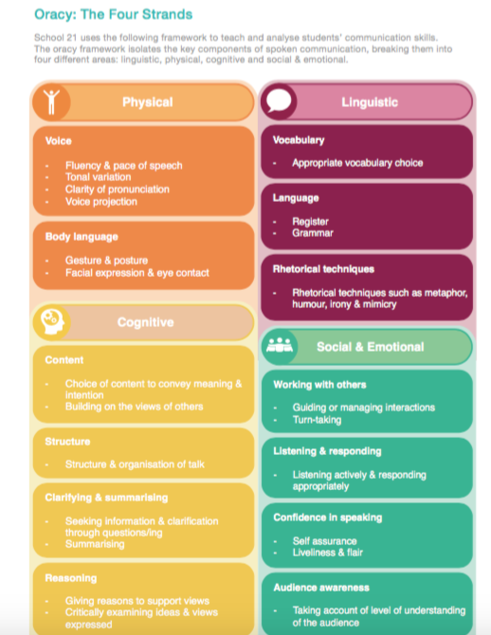

Appendix 2
Graph of limitation – Voice 21

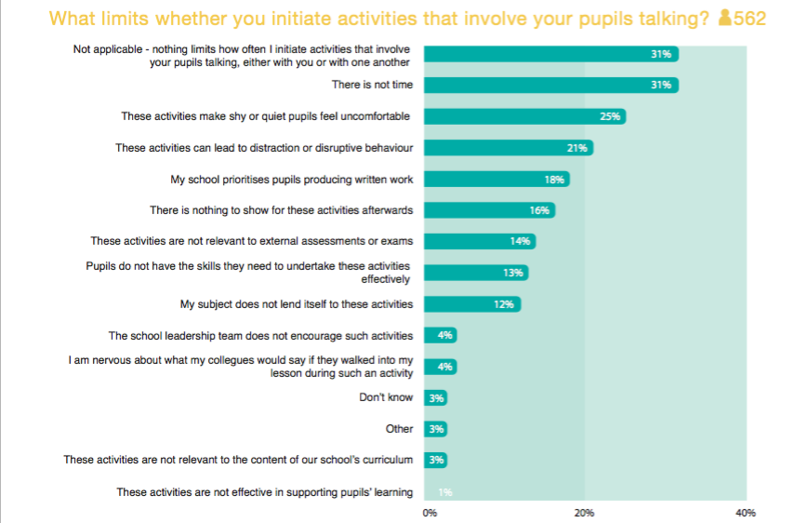

Appendix 3
Observation notes from lesson 1

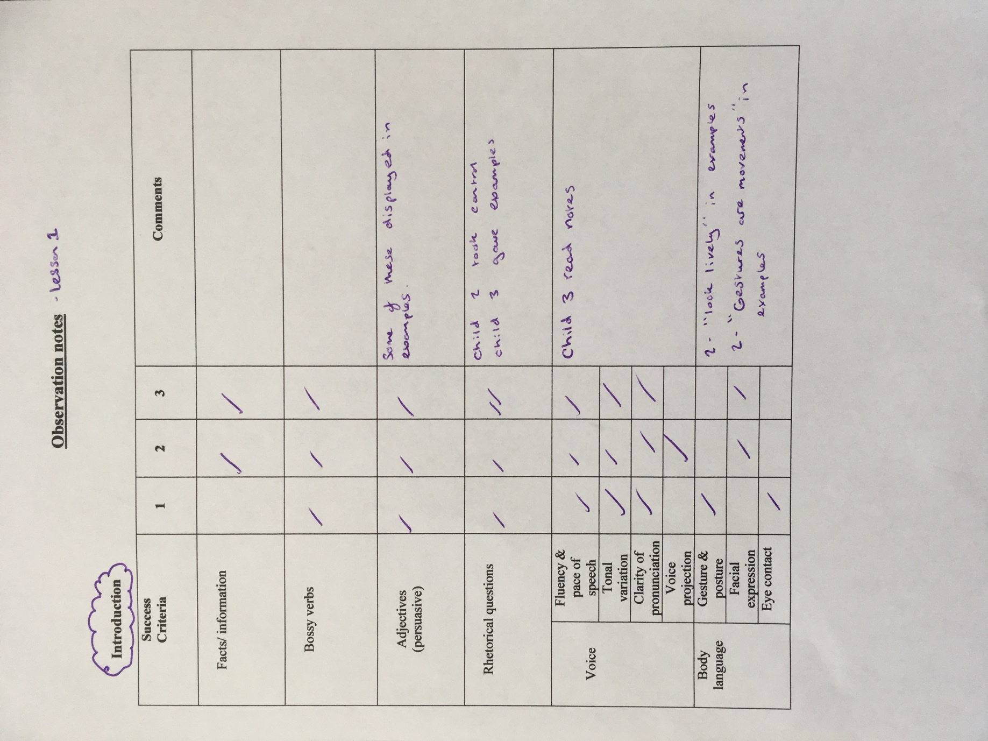

Appendix 4
Observation notes from lesson 1
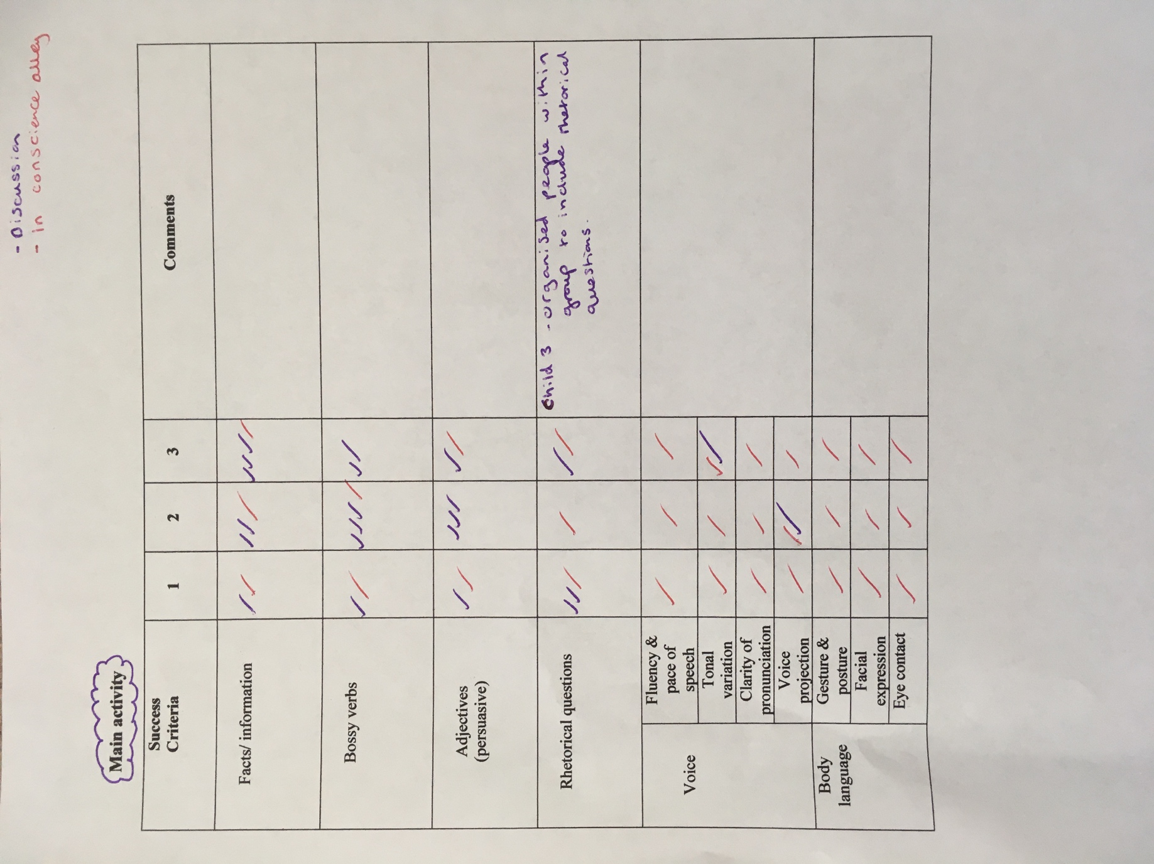

Appendix 5
Observation notes from lesson 1
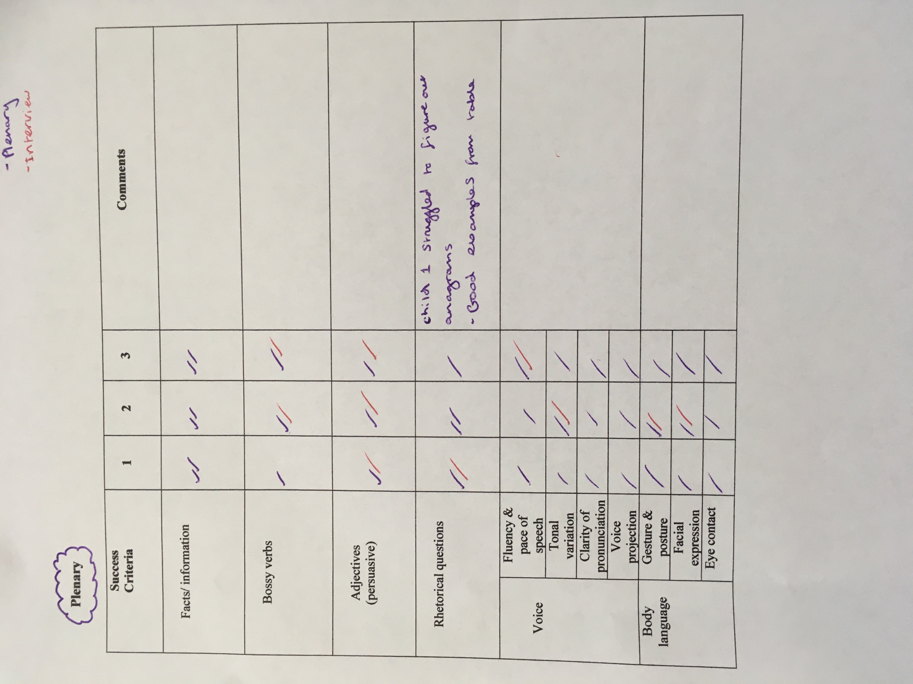

Appendix 6
Observation notes from lesson 2
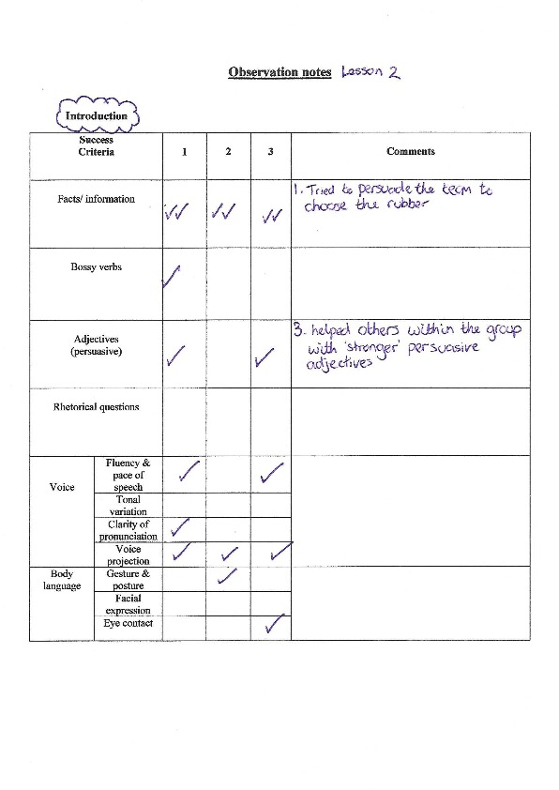

Appendix 7
Observation notes from lesson 2
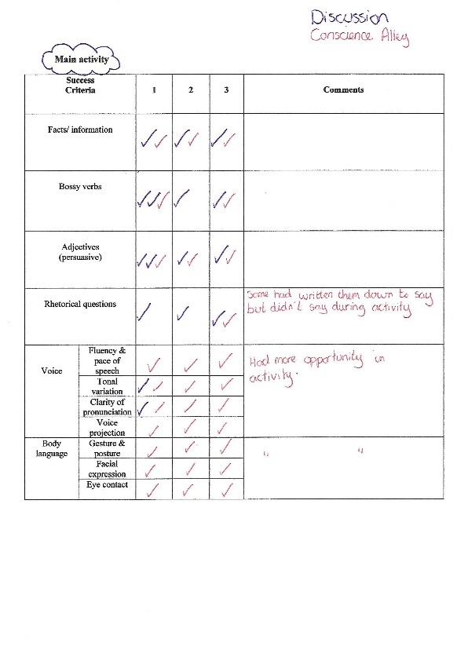

Appendix 8
Observation notes from lesson 2
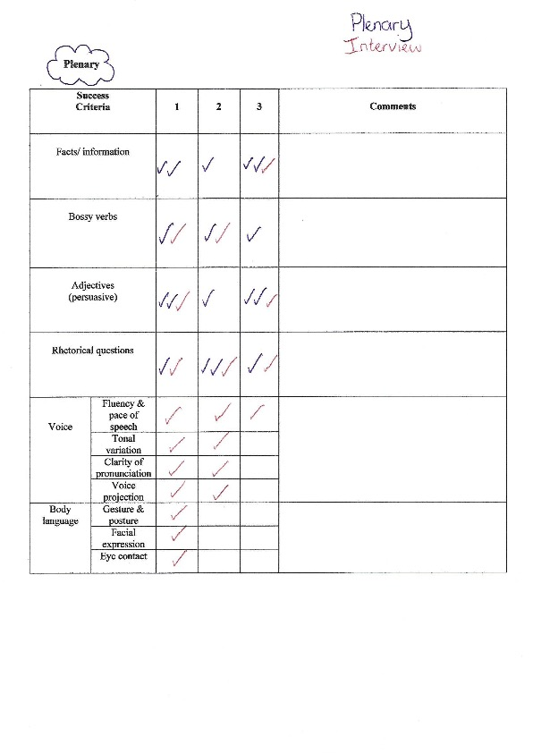

Appendix 9
Interview transcript from lesson 1
Transcript Lesson 1

Teacher: What did you think of the lesson?
Child 2: I thought that the lesson was very interesting and I think in future reference it will help me in life to make decisions because you need these things in life.
Teacher: What was your opinion during conscience alley?
Child 2: I think my opinion is that if it was in reality I wouldn’t kill the pig because we were deciding whether to kill the runt which is a pig which is weak and under developed or whether we should not kill the pig. I realised there were several things that would affect a pig that wasn’t killed and that would be killed.
Teacher: why have you changed your opinion since conscience alley?
Child 2: I don’t think it’s right to kill animals unless you have to
Teacher: was it the argument that convinced you or is it your opinion?
Child 2: It’s just my opinion.
Teacher: What skills do you think are essential for persuading someone?
Child 2: I think that you need to have expression so that you can persuade someone to get this or buy something. You need adjectives to also help you describe or persuade someone to do something you want them to do and also to use bossy verbs or expression or change your voice to support your reasons as well.
Teacher: Where else could you use these persuasive skills?
Child 2: If I were to persuade someone to stop doing something and if they say why I can give reasons using those skills.

Teacher: Okay same questions to you, what did you think of the lesson?
Child 3: I think the lesson was really interesting and really fun to discuss persuasive skills with our friends and classmates.
Teacher: What was your opinion during conscience alley?
Child 3: At the start I thought it was really sad to kill the pig but then at the end when I had listened to everyone’s opinions I realised that it would be better for him to be killed.
Teacher: why is that?
Child 3: Because if he had lived it would have affected the other pigs and possibly humans as well.
Teacher: What skills do you think are essential for persuading someone?
Child 3: I think you need to be very confident in what you saying to be able to persuade the person. Umm I dunno.
Teacher: How about any particular skills you would use to persuade someone?
Child 3: I’d use adjectives and some bossy verbs to get them on my side.
Teacher: What skills do you think are essential for persuading someone?
Child 3: In the future If we were doing an entrepreneurial challenge or if we had to try and persuade someone to stop doing something.

Teacher: What did you think of the lesson?
Child 1: I thought the lesson taught me a lot about making decisions and the right thing to do. I also though it was really fun and interesting as well.
Teacher: What was your opinion during conscience alley?
Child 1: My opinion was it helped to make the right choice, what to do and it taught me a lot about pigs.
Teacher: What skills do you think are essential for persuading someone?
Child 1: You need to know what your going to say to make it work out.
Teacher: How would you do that?
Child 1: I would plan it before saying anything so you don’t make a mess of it.
Teacher: What type of things would you include in that plan?
Child 1: Rhetorical questions and adjectives.
Teacher: What skills do you think are essential for persuading someone?
Child 1: You could use them in a job interview to persuade them to give you the job and trying to sell someone something.

Appendix 10
Interview transcript from lesson 2
TET Interview Transcript Lesson 2

What did you think of the lesson?
Child 1 – I thought it was fun!
Teacher – Fun, anything else?
Child 1 – It was different to the lessons we usually have
Teacher – Different in a good way or a bad way?
Child 1 – In a good way.

What was your opinion during conscience alley?
Teacher – What did you think during this activity?
Child 1 – Umm, it was fun and interesting… umm, I think the right side won!
Teacher– Did you think anything about the actual activity?
Child 1 – It was a fun way of doing it.(a debate)

What skills do you think are essential for persuading someone?
Child 1 – You need to be able to speak in front of a crowd.
Teacher – Lovely.
Child 1 – You need to be umm, use facial expressions and like use different tones of speech.
Teacher – Anything else?
Child 1 – Use different ways or types of saying things, like rhetorical questions and umm things…
Teacher – Can you expand on “things for me?
Child 1 – Adverbs and adjectives.
Teacher – Can you think of any more…? If not that’s fine…
Child 1 – No that’s all I can remember.

Where else could you use these persuasive skills?
Child 1 – Umm, like to persuade someone to read a book or try something new out.
Teacher – Lovely, thank you very much.

What did you think of the lesson?
Child 3 – It was really enjoyable because we did the countdown thing.
Teacher – You liked the countdown activity, did you?
Child 3 – Yes and it was also fun listening to each other’s arguments.

What was your opinion during conscience alley?
Child 3 – It was really good.
Teacher – Was there anything about the activity you enjoyed?
Child 3 – Umm, it was just really fun.

What skills do you think are essential for persuading someone?
Child 3 – Umm… rhetorical questions, facts and information and adjectives.
Teacher – Is that all you can remember?
Child 3 – I think pace was in there, umm that’s all I can think of…
Teacher – Lovely, that’s fine.

Where else could you use these persuasive skills?
Child 3 – In letters to other people.
Teacher – Is that everything you can think of?
Child 3 – Yes.
Teacher – Okay great thank you.

What did you think of the lesson?
Child 2 – umm, I really liked it and I like working in groups.

What was your opinion during conscience alley?
Child 2 – Umm, I didn’t want to kill the pig.
Teacher – Okay, and that was the side of the argument you were on, so what did you think of that activity, with the two lines?
Child 2 – I liked it because other people got to give their opinions about what they think about the argument.
Teacher – Lovely.

What skills do you think are essential for persuading someone?
Child 2 – Umm, speaking up and not being quiet, and being persuasive.
Teacher – Okay, how can you be persuasive?
Child 2 – Umm, by adding a rhetorical question.
Teacher - Anything else?
Child 2 - Umm talking quiet a lot.
Teacher – Okay, can you think of anymore?
Child 2 – Umm bossy verbs, umm I can’t remember anymore.
Teacher – That’s fine.

Where else could you use these persuasive skills?
Child 2 – Umm at work and umm maybe like debating whether or not to have a sleep over or something on the weekend.
Teacher – Lovely thank you.

Appendix 11
ARC reflection from lesson 1

Model Beirniad Wedi Adfyfyrio (BWA)

Assisted Reflective Conclusions (ARC) Model
Dyddiad/Date: 27/03/18
Digwyddiad critigol (Ffocws)/Critical incident (focus): conscience alley lesson

Profiad/ Experience

Teimladau/  Feelings  Beth yw eich teimladau ynghylch y profiad?  “What are your feelings regarding the experience?” | We feel todays lesson was interesting and beneficial for the children. The structure of the lesson worked well as my partner and I didn’t make it too difficult to observe the lesson and track the children’s learning.  There were areas we will amend before tomorrow’s lesson with another class in order to get more accurate and fair results surrounding the interviewing technique. After discussion with my partner we have agreed this is a valid reflection on the lesson as a whole.
Cofio a Deall/  Remember and Understand  Allwch chi restru’r agweddau ar y profiad dysgu a aeth yn dda?  “Can you list the aspects of the learning experience that went well?”  Pa elfennau o’r profiad dysgi oedd yn siomedig?  “What were the elements of the learning experience that were disappointing?” | The children were engaged throughout the lesson and displayed improvement in their range of persuasive skills throughout the activity. We also recognised that the children were able to put their examples into real life context.  The introduction worked well as it activated their prior knowledge and it was good for the observer to note their current knowledge on persuasive skills.  The fact sheets were also beneficial as my partner and I thought these were essential as some of the children may not have seen this film or read the book before therefore they may not have knowledge on the outcome. The children may not know anything about pigs and providing them with facts and information can back their argument up. In future ideally, we would ask the children to investigate the facts and information but to keep within the scope of this research lesson we provided these details to ensure we kept within the time limit.  You could see from the children engagement levels and interview answers that they enjoyed the plenary and it ensure we got some answers for the observation. However, we were unable to take in detail observation notes as the task did not provide room for the children to elaborate on answers or meet all requirements.  We were disappointed with some of the answers within the interview as we feel because they were done side by side some answers were copied between children not giving them chance to give their own realistic answers.  In this first lesson we were unable to use the hall which is where we were hoping to complete the lesson providing enough space for the lesson to be completed. On the other hand, we had a lot less pupils than expected and were able to move the classroom around providing enough space for the task and for the children to explore and indulge in the activity at hand.
Gwerthuso a dadansoddi/  Evaluate and analyse  Beth fyddwch chi’n cadw’r un fath i sicrhau dysgu ac addysgu effeithiol yn y dyfodol?  “What will you keep the same to ensure effective teaching and learning in the future?”  Beth oedd achos yr elfen siomedig bwysicaf?  “What was the cause of the most important disappointing element?” | We will keep the same lesson plan and PowerPoint for the next lesson as the children found it engaging and interesting. The feedback from the lesson was great but there were a few things that needed to be changed in order for us as observers to get accurate results for the research.  We will also ensure that a child goes down conscience alley listening to both arguments and giving a decision at the end. This worked well in this lesson as the children could see the results of their persuasive skills and when that child gave examples that they heard in conscience alley it showed them putting into context which was the aim of this lesson.  In the next lesson we will provide the fact sheets and book extracts in the same way and re-iterate to the children what key persuasive skills they should be using by keeping the PowerPoint up during the activity.  In future this wouldn’t be taught as a one of lesson as with all things taught you would need to link it to further lessons and develop their knowledge and skills throughout. Unfortunately, due to this being a research lesson it can only be carried out the one time.  If I was to teach this lesson again I would ensure I built up the children’s knowledge and skills prior to it by using the conscience alley in other situations for them to know the setting saving time explaining the activity.  The cause behind the children repeating answers during the interview and stumbling on their answers could be due to the fact of listening to the prior interviews and sitting near peers who can hear your answers giving them pressure and stress.  Another disappointing element within the lesson was the plenary where the children may not have had as much opportunity as the rest of the lesson to give examples and display their use of persuasive skills.
Casgliadau a chamau gweithredu/  Conclusions and actions  Beth yw eich atebion posibl i’r materiaon siomedig a nodwyd?  “What are your possible solutions to the disappointing issues identified?”  Beth ydych yn mynd i’w wneud nesaf?  “What will you do next?” | In the next lesson my partner will interview the children separately ensuring their answers are more accurate and don’t feel pressured by peers.  When administering the plenary in the next lesson my partner will ask for more examples surrounding the persuasive skills in the anagram task. This will ensure the children have more opportunity to display their knowledge of persuasive skills.  If we were teaching these skills in future we would look to organise a series of lessons developing the children’s knowledge and use of the exercise in different contexts.
Y profiad newydd / Transformed experience

Appendix 12
ARC reflection from lesson 2

Model Beirniad Wedi Adfyfyrio (BWA)

Assisted Reflective Conclusions (ARC) Model
Dyddiad/Date: 28/03/2018
Digwyddiad critigol (Ffocws)/Critical incident (focus): Developing persuasive skills using a conscience alley.
Profiad/ Experience
Teimladau/  Feelings | I think that overall this lesson was successful and accommodating to our study.  After discussion with my partner we have agreed that this is valid reflection on the lesson as a whole.
Cofio a Deall/  Remember and Understand | The lesson as a whole went well as all the children in the class seemed to be engaged and focused on the activities.  The children all contributed and when questions were asked a majority of the class had they hands up with answers.  The introduction to this lesson was an essential element as it was the only chance I had with the class to quickly activate their prior knowledge of persuasive skills, they had not covered it in class for a few weeks, so it was not fresh in their minds. Ideally, I would have liked the opportunity to go in to the class in the weeks leading up to the lesson to ensure they were frequently using these skills. I think that the introduction achieved it purpose, it got the children thinking about these skills and as the activity progressed the children were coming up with more ideas.  During the main body of this lesson, after the instructions were given there was a buzz in the hall with all the children sharing ideas. To begin with a lot of them were coming up with the same argument so I got them to work together as the group me make their argument stronger with a variety of different points. A handful of children required further reminding of how to use some persuasive features, there were able to remember them but struggled to give an example.  When it came to carrying out the main activity all the children participated and each child provided a persuasive statement for their side of the argument. Also, a majority of them through about the new features we had introduced such as body language.  I think the plenary activity was a good way to end the lesson as it was an activity the whole class participated in and enjoyed. Most of the children successfully unscrambled the words and were able to give examples of the persuasive features.
Gwerthuso a dadansoddi/  Evaluate and analyse | The children in this lesson in our opinion met the learning objective as they were able to transfer the persuasive skills they had previously used in the verbal skills.  One problem that occurred during this lesson was due to the size of my class. Within the class there were 28 children, which is a large number for one conscience alley activity. To overcome this the future, I think that I would split them into four groups and have two separate conscience allies, so the argument run a bit quicker and the person walking down the middle would be able to focus more on the arguments being presented to them.  At the end of the main activity he child that had gone down the conscience alley was about to feedback which side of the argument she agreed with and why this was her choice. This child not only gave an example of what someone had said but was able to pick out some of the persuasive features that child had used. I think that this highlights the fact that after this activity the children were not only able to transfer these written skills to oral skills but also notice them being used by others.
Casgliadau a chamau gweithredu/  Conclusions and actions | To overcome the issue based around the class size, in the future I think that I would split them into four groups and have two separate conscience allies, so the argument run a bit quicker and the person walking down the middle would be able to focus more on the arguments being presented to them.  An additional difficulty with managing behavior during this lesson was that the lesson took place in the hall, for more space, however this was an unusual area for the children to have a normal lesson in, so they were louder than normal, and it took a few attempts to get them to listen initially. However, this larger space was essential for this activity as it would have been extremely difficult to have create the alley within the classroom, with this in mind I would use the hall to carry out this activity again because events benefits of the space outweigh the added behavior management required.  Another thing that could have been seen as an issue with this lesson is that it was a one-off lesson. The children had not been looking at this story prior to the activity therefore there were a few children in the class who had never seen the film and did not know anything about the story. I do not think that this was a major issue for the lesson as it was a topic the children had prior knowledge on and the rest of the book was not important during the activity. As previously mentioned I would have liked the opportunity to take a few lessons leading up to this one to get them thinking about debates and their persuasive language.
Y profiad newydd / Transformed experience

Appendix 13
Ethics Form

APPLICATION FOR ETHICAL APPROVAL

In order for research to result in benefit and minimise risk of harm, it must be conducted ethically. A researcher may not be covered by the University’s insurance if ethical approval has not been obtained prior to commencement.

The University follows the OECD Frascati manual definition of research activity: “creative work undertaken on a systematic basis in order to increase the stock of knowledge, including knowledge of man, culture and society, and the use of this stock of knowledge to devise new applications”. As such this covers activities undertaken by members of staff, postgraduate research students, and both taught postgraduate and undergraduate students working on dissertations/projects.

The individual undertaking the research activity is known as the “principal researcher”.

Ethical approval is not required for routine audits, performance reviews, quality assurance studies, testing within normal educational requirements, and literary or artistic criticism.

Please read the notes for guidance before completing ALL sections of the form.

This form must be completed and approved prior to undertaking any research activity. Please see Checklist for details of process for different categories of application.

Full Name: |  |  | Kirsty Victoria Harris
Tick all boxes which apply:
Member of staff: | ☐ | Student: |  | X | Honorary research fellow: | ☐

SECTION A: About You (Principal Researcher)

Faculty/School/Centre: | Yr Athrofa
Campus: | Townhill
E-mail address: | 1700470@student.uwtsd.ac.uk
Contact Telephone Number: | 07412423526
For students:
Student Number: | 1700470 | Undergraduate | ☐
Programme of Study: | Primary PGCE | Taught Postgraduate | X
Director of Studies/Supervisor: | Jayne Morgan | Research | ☐

SECTION B: Approval for Research Activity

Has the research activity received approval in principle?  (please check the Guidance Notes as to the appropriate approval process for different levels of research by different categories of individual) |  | YES | ☐ | NO | ☐
 |  |  |  | Date
If Yes, please indicate source of approval (and date where known): | Research Degrees Committee |  | ☐
 | Faculty Research Committee |  | ☐
 | Other (write in) TET team  Jayne Morgan |  | X | 28/02/18

Approval in principle must be obtained from the relevant source prior to seeking ethical approval.

SECTION C: External Ethical Guidance Materials

Please list the core ethical guidance documents that have been referred to during the completion of this form (including any discipline-specific codes of research ethics, and also any specific ethical guidance relating to the proposed methodology). Please tick to confirm that your research proposal adheres to these codes and guidelines.
BERA (2011) Ethical Guidelines for Education Research | x
University of Wales Trinity Saint David (2017) Research Ethics & Integrity Code of Practice. | x
Code of Professional Conduct and Practice for Registrants with the Educational Workforce Council (2017) | x

SECTION D: External Collaborative Research Activity

Does the research activity involve collaborators outside of the University? |  | YES | ☐ | NO | X
If Yes, please provide the name of the external organisation and name and contact details for the main contact person:
Institution
Contact person name
Contact person e-mail address

Where research activity is carried out in collaboration with an external organisation
Does this organisation have its own ethics approval system? | YES | ☐ | NO | X
If Yes, please attach a copy of any final approval (or interim approval) from the organisation

SECTION E: Details of Research Activity

Indicative title: | How can we develop persuasive skills through a conscience alley activity in a key stage 2 classroom?
Proposed start date: | March 2018 | Proposed end date: | April 2018
Purpose of research activity (including aims and objectives)
Outline the purpose, aims and objectives of the research activity, including key research questions. Show briefly how existing research has informed the proposed activity and explain what the research activity will add and how it addresses an area of importance. (Maximum 300 words)
The main purpose of this research is to see if an activity such as conscience alley, will help the pupils persuasive, oracy skills. Conscience alley, is considered a drama-based activity. During this research we endeavour to compare the use of persuasive skills the target pupils understand before, during and after the conscience alley, using success criteria. The pupils have complete persuasive writing work and have prior knowledge of aspects of persuasive language, this activity will develop these skills further.
We look to follow LNF guidelines as out research will include:
- Communicating for a range of purposes.
- Engaging in activities that focus on words, their derivation, meanings, choice and impact.
- Following up points in group discussion, showing agreements or disagreement giving reason.
The key research questions will be based around a number of persuasive skills that will develop the pupil’s knowledge in literacy.
The interview questions within the focus group will be open ended to allow for elaboration and honest opinions. These question will be followed up by “Why?”, “How?” or “What do you think?” to prompted more detailed responses from all of the pupils. The answers will be recorded on a school Ipad, transcribed in school and then deleted.
Professor Neil Mercer discussed how persuasive skills are beneficial.
This research will develop of our knowledge of teaching techniques such as the conscience alley activity. The existing research surrounding this activity are:
- Smith, P. and Davies, L. (2014). Subject teaching in primary education. 1st ed. London: Sage.
- Glazzard, J. and Palmer, J. (2015). Enriching primary English. Glasgow: Critical publishing limited.
- Orr, R. (2017). 100 Ideas for Primary Teachers. London: Bloomsbury Publishing PLC.
According to Nippold.A et al (2005) using persuasive skills is a demanding task with the need to use complex language to analyses, discuss and resolve controversies in a way that is clear, convincing and considerate of diverse points of view.
(this box should expand as you type)
Proposed methods
Provide a brief summary of all the methods that may be used in the research activity, making it clear what specific techniques may be used. If methods other than those listed in this section are deemed appropriate later, additional ethical approval for those methods will be needed. (Maximum 600 words)
Research with in the journal article ‘Children and School-Based Research: 'Informed Consent' or 'Educated Consent'? highlights the issues that arise in the process of gaining consent and suggests that whole-class participation is a good idea as it allows the researcher to introduce the activity and give information about it.
Before going into the schools to carry out this research we will be collecting informed consent from the parent/guardians of every pupil in the classes, ensuring the three target pupils have returned their forms. To be sure that this research is complete in the most efficient way we will ensure that we have a set of reserve target pupil to observe, in case due any reason the initial target pupils are not available during the lesson, we do not get parental consent, or the child decides that they do not wish to participate in the research.

The BERA guidelines suggest that our responsibilities as researchers are founded on a basis that
our actions and behaviour is ethically acceptable and justifiable. Therefore, we have a responsibility
to inform all pupils what the lesson will involve beforehand. This is why we will be providing them with assent forms to initial, explaining the research and their involvement to the pupils.
BETA suggests that research methods must be appropriate to the purpose of the research undertaken. The initial method of observation we will use will be success criteria at the beginning of the lesson, during the activity and then at the end of the activity. Following this the target pupils will be interviewed, using open ended questions to ensure as an interviewer we will not be directing their answers in anyway. The pupil’s responses to these questions will used to mark the final success criteria and any additional information will be made on each individual sheet.
We have used the following literature, looking at a variety of research methods:
- Mukherji, P. and Albon, D. (2010). Research methods in early childhood. [S.l.]: London: SAGE Publications.
- Greig., A., Taylor, J. and MacKay, T. (2013). Doing Research with Children. 3rd ed. London: SAGE Publications.

Lesson study is collaborative classroom professional learning where, two or more teachers work together, developing practice in the classroom, focusing on the needs and learning of real pupils and trying to solve a teaching or leaning based problem which is affecting pupil progress.
Lesson studies introduced to the UK by Pete Dudley are proven to be successful with the PISA results of countries using this approach, such as Japan where the teaching model was developed, being higher than the countries not using this approach.
This type of research encourages collaboration and reflection. Cordingley et al, 2004. suggests that the professional learning takes place over time and is not just a one-off event. With this in mind the first researcher will administer a lesson, whilst the second researcher takes observational notes and reflecting upon it afterward. Next, we may adapt the lesson to account for any unforeseen circumstances that happened and may need improving to further the learning in the second lesson. The second researcher will then administer this adapted lesson, whilst the first researcher observes. Further details on Lesson Studies can be found in:
- Lessonstudy.co.uk. (2018). Lesson Study: a handbook | lessonstudy.co.uk. [online] Available at: http://lessonstudy.co.uk/lesson-study-a-handbook] [Accessed 22 Feb. 2018].
(this box should expand as you type)

Location of research activity
Identify all locations where research activity will take place.
Two primary schools within Yr Athrofa’s partnership with UWTSD.
Research activity outside of the UK
If research activity will take place overseas, you are responsible for ensuring that local ethical considerations are complied with and that the relevant permissions are sought. Specify any local guidelines (e.g. from local professional associations/learned societies/universities) that exist and whether these involve any ethical stipulations beyond those usual in the UK (provide details of any licenses or permissions required). Also specify whether there are any specific ethical issues raised by the local context in which the research activity is taking place, for example, particular cultural sensitivities or vulnerabilities of participants.
N/A

(this box should expand as you type)

SECTION F: Scope of Research Activity

Will the research activity include: | YES | NO
Use of a questionnaire or similar research instrument? | ☐ | X
Use of interviews? | X | ☐
Use of diaries? | ☐ | X
Participant observation with their knowledge? | X | ☐
Participant observation without their knowledge? | ☐ | X
Use of video or audio recording? | X | ☐
Access to personal or confidential information without the participants’ specific consent? | ☐ | X
Administration of any questions, test stimuli, presentation that may be experienced as physically, mentally or emotionally harmful / offensive? | ☐ | X
Performance of any acts which may cause embarrassment or affect self-esteem? | ☐ | X
Investigation of participants involved in illegal activities? | ☐ | X
Use of procedures that involve deception? | ☐ | X
Administration of any substance, agent or placebo? | ☐ | X
Working with live vertebrate animals? | ☐ | X
Other primary data collection methods, please explain in this box  A focus group will be observed and interviewed | x | x

If NO to every question, then the research activity is (ethically) low risk and may be exempt from some of the following sections (please refer to Guidance Notes).

If YES to any question, then no research activity should be undertaken until full ethical approval has been obtained.

SECTION G: Intended Participants

Who are the intended participants: | YES | NO
Students or staff at the University? | X | x
Adults (over the age of 18 and competent to give consent)? | ☐ | X
Vulnerable adults? | ☐ | X
Children under 18? | X | ☐
Prisoners? | ☐ | X
Young offenders? | ☐ | X
Those who could be considered to have a particularly dependent relationship with the investigator or a gatekeeper? | ☐ | X
People engaged in illegal activities? | ☐ | X
Others (please identify): | ☐ | X

Participant numbers and source
Provide an estimate of the expected number of participants. How will you identify participants and how will they be recruited?
We will be using a class from one school with approximately 27 pupils in it and a class from the second school with approximately 30 pupils in it. We will be using three target pupils from each class and these three pupils will take part in the focus interview after the lesson.
Target children will be selected dependent on whether the consent form for them has been returned and have given assent.
(this box should expand as you type)

Information for participants: | YES | NO | N/A
Will you describe the main research procedures to participants in advance, so that they are informed about what to expect? | X | ☐ | ☐
Will you tell participants that their participation is voluntary? | X | ☐ | ☐
Will you obtain written consent for participation? | X | ☐ | ☐
Will you explain to participants that refusal to participate in the research will not affect their treatment or education (if relevant)? | X | ☐ | ☐
If the research is observational, will you ask participants for their consent to being observed? | X | ☐ | ☐
Will you tell participants that they may withdraw from the research at any time and for any reason? | X | ☐ | ☐
With questionnaires, will you give participants the option of omitting questions they do not want to answer? | ☐ | ☐ | X
Will you tell participants that their data will be treated with full confidentiality and that, if published, it will not be identifiable as theirs? | X | ☐ | ☐
Will you debrief participants at the end of their participation, in a way appropriate to the type of research undertaken? | X | ☐ | ☐
If NO to any of above questions, please give an explanation
(this box should expand as you type)

Information for participants: | YES | NO | N/A
Will participants be paid? | ☐ | X | ☐
Is specialist electrical or other equipment to be used with participants? | ☐ | X | ☐
Are there any financial or other interests to the investigator or University arising from this study? | ☐ | X | ☐
Will the research activity involve deliberately misleading participants in any way, or the partial or full concealment of the specific study aims? | ☐ | X | ☐
If YES to any question, please provide full details
(this box should expand as you type)

SECTION H: Anticipated Risks

Outline any anticipated risks that may adversely affect any of the participants, the researchers and/or the University, and the steps that will be taken to address them.

If you have completed a full risk assessment (for example as required by a laboratory, or external research collaborator) you may append that to this form.

Full risk assessment completed and appended?

Yes ☐
No X
Risks to participants
For example: emotional distress, financial disclosure, physical harm, transfer of personal data, sensitive organisational information
As we have read the University Guidelines on Ethical Research, UWTSD Research, Ethics and Integrity Code of Practice (2017) and BERA Ethical Guidelines for Educational Research (2011), we are aware of the chance of the participants being as risk and how to ensure that there is no risk to participants.
The pupils involved in this research will be give an explanation of the research and given assent forms to sign and be fully informed that if due to any reason they do not want to be part of the research they have every right to withdraw. We will also obtain parental/guardian consent for every child who will potentially be involved in the researcher.
My partner and I will follow the guidelines set out in our school’s safeguarding policy which we both have read. Our interview will take place in an open plan library, opening into the corridor and opposite the classroom the pupils are used to working in. We will be sure that we stick to all legal requirements related to the storage and use of data. All questions used in the interview will be open ended to ensure they pupils have the opportunity to answer in their own way.
The risk to the participants caused by the research could include stress, invasion of opinion and knowledge, disruption to their daiy routine and worry about data usage. These points are taken into consideration and as a result extra information has been provided in the assent form before the pupils agree to participate. The results of the research could be seen as biased or influenced due to power dynamics of teachers to pupils. With this in mind the participants will not be offered any incentives and will be aware they have the option to participate, only if they want to.
There will be no risk of physical harm during this activity as it will be carried out on school property where appropriate risk assessments have taken place.
(this box should expand as you type)
If research activity may include sensitive, embarrassing or upsetting topics (e.g. sexual activity, drug use) or issues likely to disclose information requiring further action (e.g. criminal activity), give details of the procedures to deal with these issues, including any support/advice (e.g. helpline numbers) to be offered to participants. Note that where applicable, consent procedures should make it clear that if something potentially or actually illegal is discovered in the course of a project, it may need to be disclosed to the proper authorities
N/A

(this box should expand as you type)
Risks to investigator
For example: personal safety, physical harm, emotional distress, risk of accusation of harm/impropriety, conflict of interest
During our enquiry, we will stick to normal school safeguarding policies to ensure that we do not
put our personal safety or professional name at risk. We will treat pupils equally and will not show preferential treatment, in accordance with the safeguarding policy.
The interview potion of this research will take place in an open plan library area opposite the classroom. During these interviews there will there will be myself and a second UWTSD student asking the three target pupils some prepared questions based on the lesson they have just taken part in.
My partner and I will be teaching the lesson in the school hall to provide us all the with appropriate space we require to carry out our activity. The entire lesson and the interview process afterwards will be conducted with another adult present, teaching assistant or class teacher.
As student teachers who have been on placement in these schools we have professional relationships with the pupils that could be considered as a relationship of power. With this in mind we will be considering the pupils feelings during this process and nor pressuring them in any way throughout the lesson and allow them to not be part of the research if that if what they want.

(this box should expand as you type)
University/institutional risks
For example: adverse publicity, financial loss, data protection
As a student at this university we are aware that during this research we will be representing the university and there for need to uphold the professional and ethical views of the university. Another important factor that we are aware we need to consider the partnership of between the school and the university and not jeopardize it by acting unprofessionally. We will be sure not to fabricate or edit any of the results from this research just to match my initial question and we will not plagiarise other people’s work during my study.

(this box should expand as you type)
Adverse outcomes
List measures put in place to limit any adverse effects or outcomes of research activity where appropriate. Include any emergency protocols.
We will stick to both schools’ safeguarding policies to minimise any risks of adverse effects of our
research activity. Our activity, observation and questioning is low risk to pupils wellbeing. We will be prepared to deal with any unexpected occurrences during the lesson, as well as keeping in line with the schools’ health and safety rules.

(this box should expand as you type)

Disclosure and Barring Service
If the research activity involves children or vulnerable adults, a Disclosure and Barring Service (DBS) certificate must be obtained before any contact with such participants. | YES | NO | N/A
Has a DBS certificate been obtained? | X | ☐ | ☐

SECTION I: Feedback, Consent and Confidentiality

Feedback
What feedback will be provided to participants, how will this be done and when?
No direct feedback will be offered to the pupils as we will need to analyse the data before we know
what the results are. However, the head teachers and the class teachers will be able to read the written assignments, on request.
The pupils will be informed that their participation during this lesson has been very helpful.

(this box should expand as you type)
Informed consent
Describe the arrangements to inform potential participants, before providing consent, of what is involved in participating. Describe the arrangements for participants to provide full consent before data collection begins. If gaining consent in this way is inappropriate, explain how consent will be obtained and recorded.
A consent form will be sent home with every child in the classes being used prior to the research, for the parent/guardians to give their written consent for their pupils to take part in the research. Also for the pupils involved to give their own assent, they will be provided with a form of their own at the beginning of the lesson with an explanation of the research, for them to read and sign themselves.

(this box should expand as you type)
Confidentiality / Anonymity
Set out how anonymity of participants and confidentiality will be ensured in any outputs. If anonymity is not being offered, explain why this is the case.
The pupils will be made aware at the beginning of the lesson that they can opt out of the research if they wish to do so. This research will remain completely anonymous as the three target pupils from each class will be identified as 1, 2 & 3 and their names will not be used in any documents including the observational notes, meaning there will be no way for them to be identified. Whilst taking assent only initials will be taken and no full names will be disclosed.
We will be storing the answers from the interviews and the observation notes in paper form. After we finish the assignment, all copies of the manual files will be destroyed.

(this box should expand as you type)

SECTION J: Data Protection and Storage

In completing this section refer to the University’s Research Data Management Policy and the extensive resources on the University’s Research Data Management web pages (http://uwtsd.ac.uk/library/research-data-management/).
 | YES | NO
Does the research activity involve personal data (as defined by the Data Protection Act)?  “personal data” means data which relate to a living individual who can be identified—  (a) from those data, or  (b) from those data and other information which is in the possession of, or is likely to come into the possession of, the data controller, and includes any expression of opinion about the individual and any indication of the intentions of the data controller or any other person in respect of the individual. | ☐ | X
If YES, provide a description of the data and explain why this data needs to be collected:
(this box should expand as you type)
Does it involve sensitive personal data (as defined by the Data Protection Act)?  “Sensitive personal data” means personal data consisting of information as to –  (a) the racial or ethnic origin of the data subject,  (b) his political opinions,  (c ) his religious beliefs or other beliefs of a similar nature,  (d) whether he is a member of a trade union (within the meaning of the Trade Union and Labour Relations (Consolidation) Act 1992),  (e) his physical or mental health or condition,  (f) his sexual life,  (g) the commission or alleged commission by him of any offence, or  (h) any proceedings for any offence committed or alleged to have been committed by him, the disposal of such proceedings or the sentence of any court in such proceedings. | ☐ | X
If YES, provide a description of the data and explain why this data needs to be collected:
(this box should expand as you type)

Will the research activity involve storing personal data on one of the following: | YES | NO
Manual files (i.e. in paper form)? | ☐ | x
University computers? | ☐ | X
Private company computers? | ☐ | X
Home or other personal computers? | ☐ | X
Laptop computers/ CDs/ Portable disk-drives/ memory sticks? | ☐ | X
“Cloud” storage or websites? | ☐ | X
Other – specify: | ☐ | X
For all stored data, explain the measures in place to ensure data confidentiality, including details of password protection, encryption and anonymisation:
We will be storing the answers from the interviews and the observation notes in paper form. No
pupil’s will be named, and the paper files will be stored safely at home. We will not allow anyone
apart from the three of us to access or see the documents. After we finish the assignment, all
copies of the manual files will be destroyed. Any electronic data will be password protected. The interview will be recorded on a school device, using an audio app. These recordings will be transcribed in school and deleted.
The files will be archived in-line with UWTSD policy and Dara Protection Act.
(this box should expand as you type)
Will the research activity involve any of the following activities: | YES | NO
Electronic transfer of data in any form? | ☐ | X
Sharing of data with others at the University? | X | ☐
Sharing of data with other organisations? | ☐ | X
Export of data outside the European Union or importing of data from outside the UK? | ☐ | X
Use of personal addresses, postcodes, faxes, emails or telephone numbers? | ☐ | X
Publication of data that might allow identification of individuals? | ☐ | X
Use of data management system? | ☐ | X
Data archiving? | X | ☐
If YES to any question, please provide full details, explaining how this will be conducted in accordance with the Data Protection Act (and/or any international equivalent):
We will include in the assent forms for the pupils that staff members of the University will see their answers to the interview questions as part of our assignments. Part II of the Data Protection Act 1998 ‘Rights of Data Subjects and Others’, suggests that the pupils are entitled to be informed that other people will be viewing the data which they shared. The pupils will be made aware that the staff members will see the research but will not know their names or identities.
Electronic data will be password protected and archived upon completion of the assignment.

(this box should expand as you type)

List all who will have access to the data generated by the research activity:
Kirsty Harris
Sarah Bowen
Head teachers (access to data from their school)
Class teachers (access to data from their own class)
(this box should expand as you type)
List who will have control of, and act as custodian(s) for, data generated by the research activity:
Kirsty Harris
Sarah Bowen

(this box should expand as you type)
Give details of data storage arrangements, including where data will be stored, how long for, and in what form. Will data be archived – if so how and if not why not.
We will have manual files which will be kept by us until we finish our assignments. Our manual files will be destroyed on the 16th April at the latest. The interview will be recorded on a school device, using an audio app. These recordings will be transcribed in school and deleted.

(this box should expand as you type)

SECTION K: Declaration

The information which I have provided is correct and complete to the best of my knowledge. I have attempted to identify any risks and issues related to the research activity and acknowledge my obligations and the rights of the participants.

In submitting this application I hereby confirm that I undertake to ensure that the above named research activity will meet the University’s Research Ethics and Integrity Code of Practice
Signature of applicant: |  | Date: | 26/02/18

For students:
Teacher / Senior Mentor: | Nicola Bridgeman
Signature: | NE Bridgeman
Date: | 26/02/18

Supervisor: | Jayne Morgan
Signature: | JE Morgan
Date:

Checklist: Please complete the checklist below to ensure that you have completed the form according to the guidelines and attached any required documentation:
X | I have read the guidance notes supplied before completing the form.
X | I have completed ALL RELEVANT sections of the form in full.
X | I confirm that the research activity has received approval in principle
☐ | I have attached a copy of final/interim approval from external organisation (where appropriate)
☐ | I have attached a full risk assessment (and have NOT completed Section H of this form) (where appropriate)
X | I understand that it is my responsibility to ensure that the above named research activity will meet the University’s Research Ethics and Integrity Code of Practice.
X | I understand that before commencing data collection all documents aimed at respondents (including information sheets, consent forms, questionnaires, interview schedules etc.) must be confirmed by the DoS/Supervisor, module tutor or Head of School.

RESEARCH STUDENTS AND STAFF ONLY
All communications relating to this application during its processing must be in writing and emailed to pgresearch@uwtsd.ac.uk , with the title ‘Ethical Approval’ followed by your name.
You will be informed of the outcome of your claim by email; therefore it is important that you check your University and personal email accounts regularly.

STUDENTS ON UNDERGRADUATE OR TAUGHT MASTERS PROGRAMMES should submit this form (and receive the outcome) via systems explained to you by the supervisor/module leader.

This form is available electronically from the Academic Office web pages: http://www.uwtsd.ac.uk/academic-office/

Application Process

All staff research projects and all research students must submit the Ethical Approval Form to the University Ethics Committee via the Academic Office (pgresearch@uwtsd.ac.uk). Staff research directly in relation to personal study for taught undergraduate or Masters programmes should be submitted via the Faculty procedures explained below.

Taught masters and taught undergraduate research Ethical Approval Forms are considered within Faculties. Faculties will provide details of the specific processes for this. Where the Ethical issues within any single ethical application are of particular concern the Faculty will refer these to the University Ethics Committee. Any student activity that involves the collection of primary data needs to undergo Ethical approval, this includes assignment work as well as dissertations.

Notes for guidance in completion of this form

Section A: About You

Please complete all relevant sections

Section B: Approval for research activity
Research proposals must be approved in principle before applying for Ethical Approval. The proposal approval only becomes final when the ethical approval is received.

The process for proposal approval varies according the individual and programme of study:
- Research students, by application on form PG1 to the Research Degrees Committee
- Taught students by review of research proposal within Faculties (Faculties provide specific details of these processes)
- Staff, by agreement by the Head of School/Assistant Dean

Section C: External Ethical Guidance materials
Many discipline areas are required to operate with the discipline specific codes of research ethics (for example health, psychology, education etc.), any such codes must be listed and you must tick to confirm that you have consulted with these.

Section D: External Collaborative Research Activity
Provide details of the external collaborative partners, where appropriate you might want to submit a copy of the external collaboration agreement with the Ethical Approval Form. If the partner requires the research to be subject to its own internal Ethical approval process then please provide details of that process and a copy of any final (or interim) approvals received from the organisation.

Section E: Details of Research Activity
Remember that the individuals reviewing this Ethical Approval Form may not have seen your research proposal, and also may not be experts in the specific area of your research. The information provided should therefore be jargon free and clearly stated.

Indicative Title: please use the same title as used on the research proposal.
Purpose: the Ethical approval process will want to ensure that the methods you propose are adequate and appropriate to address the research aims and objectives. Excessive additional data collection can be seen as unethical.
Proposed Methods: the Ethical approval process seeks to ensure that you understand the methods that are intended, and that the implementation of those methods will be appropriate and without unnecessary impact on respondents. Please be specific.
Location: this needs to mention geographical location and also local situation (for example, within Local Authority Offices in Cardiff, using a private room but close to other individuals). If you are collecting data within an organisational setting then you need to explain the permissions that you have obtained to do this.
Research Activity outside of the UK: please complete this section in detail, and note any guidance you have received. Also describe your own familiarity (or not) with the location that you will be utilising.

Section F: Scope of Research Activity
Please tick ALL of the research activities that might be undertaken. If any additional types of activity are intended then please add an extra box and describe these.
If you have answered no to all questions in F then sections G and J do not need to be completed. Section H should be considered, and may be completed. Signatures are still required in section K.

Section G: Intended Participants
Please tick all categories that might apply.
Numbers & Source: if you are using a series of different methods or research activities please list numbers for each stage/phase. Be clear about how you will find respondents. Will you use intermediaries, and if so how? How will you ensure compliance with your sampling strategy?
Information for participants: all participants should be appropriately informed about the research, what is expected of them and what will happen to the information that they provide. The Ethical review process does not ask to see this documentation, but requires this to be reviewed and approved by the Director of Studies in the case of research students, the supervisor/module tutor in relation to students on taught programmes and the Head of School/Assistant Dean in relation to staff research.

Section H: Anticipate Risks
All research carries some level of risk. The answers you provide to questions in this section will be reviewed to ensure that you have an appropriate understanding of the type of risks involved and how you can mitigate against these risks. If you have completed a full risk assessment, as required for example for laboratory work, field work, clinical tests, diving operations, or by a collaborative partner, you may append that to this form. In that case, please tick the box indicating this has been provided. You will not then be required to complete Section H.
Risk to participants Think very carefully about how your actions/questions/discussions might affect the people you are involving as participants. You might identify the risk as small but it would still be a risk. Many types of question have the potential to make respondents less content with their life / job; you need to recognise and try to ameliorate any such effects
If these are business owners, time with you may reduce profit.
In some locations physical risk is very real to both participants and yourself, please consider this.
Risk to you, the researcher Think about where you will meet people, if there are any dangers involved in the location. If you are meeting people as individuals think about using a public place. In general do not visit people in their own homes or remote locations. If you are talking to individuals about certain issues think about how their responses might affect you emotionally. What about the risk of collecting insufficient data?
Risk to the University When undertaking your research, you are acting as a member of the University (student or staff). Professionalism is important, so it is important to be well organised and well prepared. Punctuality, clarity etc. are all part of this. What will you do to ensure this? You must ensure you do not harm the good name of the University in any way and do nothing to undermine the reputation of the research it conducts and sponsors. Upholding high standards of conduct and integrity are vital in this regard. You must also conduct the research in such a way to minimise the potential for claims of negligence made against the University, its researchers and any collaborating individual or organisation. In this respect you should always comply with ethical, legal and professional frameworks, obligations and standards as required by statutory and regulatory authorities, as well as the university’s Research Integrity and Ethics Code of Practice. Research misconduct in this respect can take many forms, including:
- fabrication: making up results or other outputs (eg, artefacts) and presenting them as if they were real
- falsification: manipulating research processes or changing or omitting data without good cause
- plagiarism: using other people’s material without giving proper credit
- failure to meet ethical, legal and professional obligations: for example failure to declare competing interests; misrepresentation of involvement or authorship; misrepresentation of interests; breach of confidentiality; lack of informed consent; misuse of personal data; and abuse of research subjects or material
- improper dealing with allegations of misconduct: failing to address possible infringements such as attempts to cover up misconduct and reprisals against whistle-blowers

Adverse Outcomes. Think carefully about the possibilities, and cover here

Section I: Feedback, Consent and Confidentiality
Feedback to participants: outline your approach. Will interview transcripts be shared with respondents to check accuracy? Will summaries of questionnaire analysis be made available to respondents in some way? Will an overview report be provided? How and when?
Informed consent: Draft letter / e-mail / or heading (or footer) section of questionnaire must be approved by DoS/supervisor (if research student), supervisor/module tutor if taught student, or Head of School / Assistant Dean if a member of staff.
Confidentiality/Anonymity. Explain clearly how you will ensure confidentiality and anonymity.

Section J: Data Protection and Storage
Before completing this section it is necessary to read the University’s Research Data Management information. The questions that follow are designed to ensure compliance with the Data Protection Act as well as established research protocols.

Many research activities will involve electronic transfer of data and use of data management systems in the summarisation and analysis of data. You will need to explain these in relation to compliance with the Data Protection Act.
Think carefully about who will have access to your data, this will include supervisors and examiners. Also that a thesis will be made available via the University library and the British Library system. If you are seeking an access bar for a period of time after completion then mention it here. If you will provide a copy of your findings, or intend to give a presentation, to a facilitating/ supporting/accessing organisation then explain that in this section. But also think about the general principle of data sharing, as explained in the Research Data Management information.
In terms of storage of data please ensure security, and also mitigate against loss of data.

Section K: Declaration

Ensure the appropriate countersignatures have been provided
Look carefully at the checklist and ensure that you comply with and tick all that are relevant to your research.

Appendix 14
Lesson 2 Assent form



