This is article about my chosen career, computer science. Lorem ispum much more text to 250. Figure 1 below is showcasing task 1 for component 1 for this module.
Create an Online e-portfolio that include your answers to each of the following 4 tasks below. Include several citations in each task answer and a list of references at the end of each task. See guidance on the following page on how to create your e-portfolio and submit it’s link & screenshot evidence of your work in a word document to TURNITIN. A Submission Template is provided on the following page.

- IEEE Referencing & written summary on essential academic and employment skills (350 words):
  - Produce a written summary with some supporting visuals (images/figures), on the topic of essential skills for study and employment (approx. 250 words) in your Career area. The summary should consider:
    - How the development of such skills will support you in your chosen Career after you graduate.
    - Citations and a list of references should be included (Approx. 4/5 sources). Using the IEEE referencing standard (UWTSD IEEE Ref. handbook) include citations and a reference list (including 1 online source, 1 credible book, 1 credible article and 1 AI source).
  - Submit your work to the Turnitin link (labelled: Task 1b - Turnitin Similarity check practice) on Moodle and check your similarity score. In the same document as your summary above, include a reflection of approx. 100 words on:
    - Your similarity score and how you could improve it next time.
    - Using the ‘Generic Assessment criteria / GAC’ as a guide, state the mark out of 100% you would award yourself and briefly explain why. The ‘Generic Assessment criteria’ is located at the bottom of the Assignment Specification below.
After you create your e-portfolio in task 4 below, include your answer to Task 1 in your e-portfolio.
Optional: The additional learning resources in Moodle Unit 1 can also help you to complete this task.

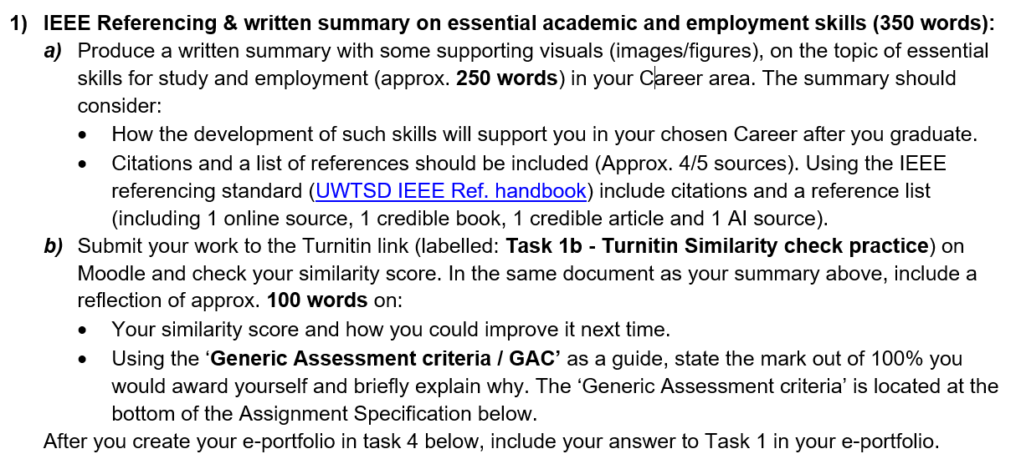
Fig. 1: Overview of task 1, component 1.

