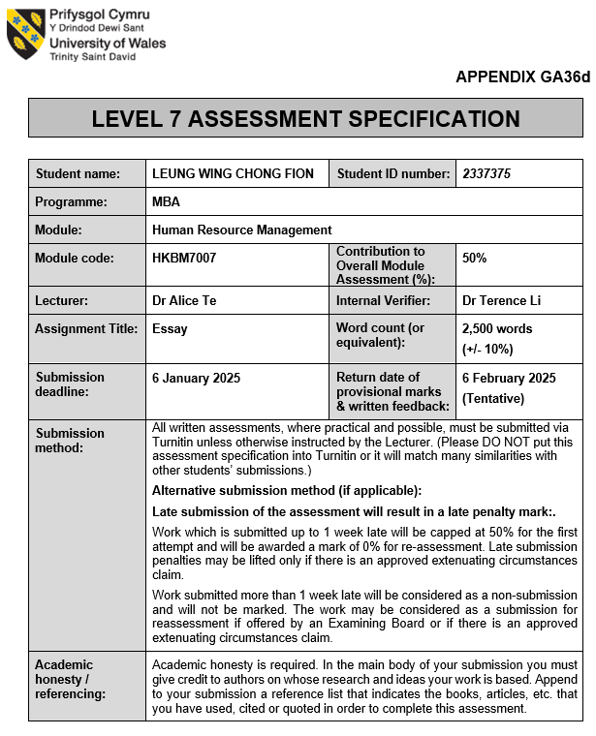

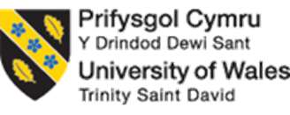

UWTSD MBA
HKBM7007 Human Resource Management

HR Management Challenges in Nissin's Expansion to Korea

Student Name | ： | LEUNG WING CHONG FION
Student ID Number | ： | 2337375
Date of Submission | ： | 6 January 2025
Lecturer | ： | Dr Alice Te

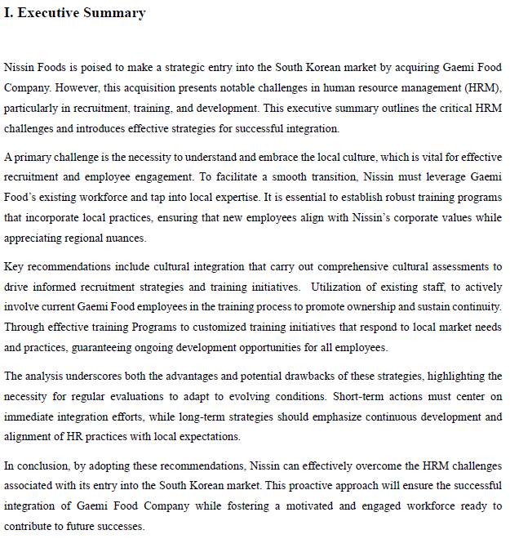

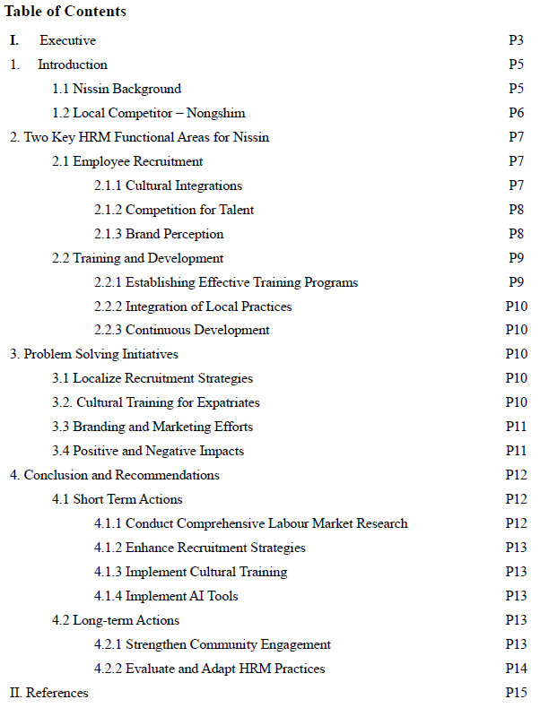
- Introduction
Nissin Foods' recent foray into the vibrant South Korean market poses a distinct set of human resource management challenges, especially in the critical areas of employee recruitment and training and development (Staff Reporter, 2024). In this essay, it will explore the HR management challenges that Nissin encounters during its ambitious expansion into Korea, drawing insightful comparisons with the hurdles faced by Barilla in its own international growth journey. By analyzing these challenges, aim to uncover the intricate dynamics of competing in diverse markets and the essential strategies that drive success.

Nissin Background
Nissin Foods, founded in Japan in 1958, is a trailblazer in the instant noodle industry, celebrated for its groundbreaking innovations and extensive global outreach (nissin, n.d.). The company made history by launching the first instant ramen, a product that not only transformed the food industry but also offered a new level of convenience to busy lifestyles (nissin, n.d.). Over the decades, Nissin has broadened its product portfolio significantly, tailoring its offerings to meet the diverse tastes and preferences of consumers around the world (nissin, n.d.). Its recent expansion into South Korea illustrates this commitment, as Nissin seeks to tap into the rapidly growing instant noodle market by catering to local culinary traditions and flavors (Staff Reporter, 2024).
Figure 1.1 illustrates Nissin's robust strategic expansion into international markets, spanning Asia, Europe, and America (Nissin Group, 2024). The World Instant Noodles Association Report reveals that Nissin proudly stands among the top seven countries and regions in the instant noodle industry (World Instant Noodles Association, 2023). However, a significant growth opportunity awaits in the Republic of Korea, currently ranked eighth, making it an ideal target for Nissin's ambitious expansion and market penetration (World Instant Noodles Association, 2023). Moreover, Nissin's recent acquisition of Gaemi Food signals its strong determination to tap into the South Korean market, highlighting the critical need for effective human resource management to support this venture (Staff Reporter, 2024).
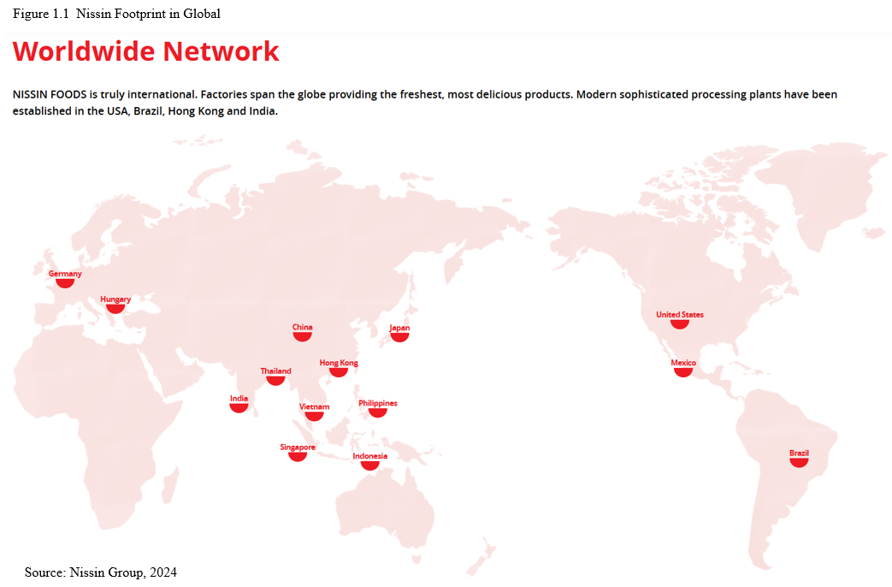

1.2 Local Competitor - Nongshim
Nongshim, established in 1965, is a prominent South Korean food company that specializes in instant noodles, snacks, and beverages (NONGSHIM, 2021). As one of the largest food manufacturers in Korea, Nongshim significantly contributes to the local economy and maintains a strong international presence, exporting its products to over 100 countries (NONGSHIM, 2021). With a dedicated focus on quality and flavor, Nongshim has successfully positioned itself in the global food market, with beloved products like Shin Ramyeon exemplifying its commitment to excellence (NONGSHIM, 2021). This combination of innovation and tradition allows Nongshim to continually enhance its offerings and meet the diverse tastes of consumers around the world (NONGSHIM, 2021).

- Two Key HRM Functional Areas for Nissin
In analyzing the key challenges associated with Nissin's expansion into South Korea, two critical human resource management functions become evident, Employee Recruitment and Training and Development. These areas are fundamental to ensuring that Nissin can effectively assimilate into the local market while simultaneously developing a highly competent workforce that aligns with its strategic corporate objectives (Diard, 2023). Enhancing the business process to offer comprehensive HR support through integrated talent management on a global scale is essential for driving success and fostering growth (Diard, 2023).

Employee Recruitment
The recruitment process in global HR is crucial for identifying talented individuals who possess the qualifications necessary for job description on an international scale (Diard, 2023). Utilization of Existing Staff that with engage current Gaemi Food employees in the training process to foster a sense of ownership and continuity is an advantage for Nissin easily penetrate to Koare market. Given the varied certifications and educational standards across different regions, navigating the hiring landscape can be challenging (Diard, 2023). To attract and retain top talents, it is essential to negotiate salaries meticulously, extend compelling job offers, and draft precise contracts (Diard, 2023). These individuals may harbor uncertainties regarding job security and career advancement within a foreign company (Diard, 2023). Nissin's acquisition of the local firm represented a strategic decision that has been positively received in the community. Additionally, the management team faces the challenge of implementing effective recruitment strategies that align with local cultural standards. It is also important to recognize that the perceptions held by local communities about Nissin will significantly influence its brand image and overall acceptance in the market.

2.1.1 Cultural Integration
Nissin must adeptly navigate the complexities of South Korean corporate culture, which is distinguished by hierarchical structures and strong interpersonal relationships (Abdul Aziz M., 2020). This cultural context plays a significant role in shaping recruitment strategies, as local candidates tend to favor organizations that adhere to these cultural norms (Abdul Aziz M., 2020). It is imperative for Nissin to tailor its recruitment practices to align with the expectations of the local workforce while simultaneously maintaining its corporate identity (Abdul Aziz M., 2020). Nissin may consider modifying its recruitment processes to reflect the intricacies of Korean corporate culture, which places considerable emphasis on hierarchy and personal connections. Failing to acknowledge these cultural nuances may pose challenges in attracting local talent, who are likely to prioritize employers that resonate with the cultural values (Hofstede, G., 2001). Additionally, the influence of Confucianism on workplace dynamics in Korea underscores the necessity for foreign companies to comprehend and adapt to these established cultural norms to achieve successful integration (Hofstede, G., 2001).

2.1.2 Competition for Talent
The labor market in South Korea is distinctly competitive, particularly within the food and beverage sector (Lee, Oh and Rowley, 2024). Nissin encounters considerable challenges in attracting skilled professionals, as many candidates receive multiple job offers and consequently possess elevated salary expectations alongside substantial demands for comprehensive benefits (Lee, Oh and Rowley, 2024). To succeed in this demanding environment, Nissin must offer attractive compensation packages and establish clear pathways for career advancement that may direct compare with Nongshim Group (Research Methodology, 2012). Moreover, the food industry in South Korea is characterized by a high degree of saturation, with numerous established brands making it increasingly, Nissin can leverage acquisition of Gaemi Food Company, to ease the barrier of without significant investments in branding and recruitment strategies (Kim & Park, 2017). To address these challenges, Nissin must adopt innovative methods to differentiation to attract top-tier talent, thereby fostering a robust workforce that will contribute to its ongoing success in this dynamic industry (Lee, Oh and Rowley, 2024).

2.1.3 Brand Perception
As a foreign entity, Nissin may face skepticism from potential employees who exhibit a preference for established local brands, such as Nongshim. To address this perception, it is essential for Nissin to implement strategic branding and marketing initiatives designed to cultivate trust and recognition within the local market. By strengthening its reputation, Nissin can mitigate entry barriers and position itself as a credible and attractive employer (Abdul Aziz M., 2020). As a newcomer, Nissin navigates the reluctance of local candidates who may favor established brands like Nongshim, which are often perceived as more dependable and culturally resonant (Lee, J., 2018, pp.92, 123–130). By proactively addressing these challenges, Nissin can aim to position itself as a leading employer in the region.

Human Resource Management (HRM) in South Korea presents valuable opportunities for growth and development, despite certain challenges. By fostering a deep understanding of local culture, implementing innovative talent management strategies, and ensuring compliance with regulatory frameworks, organizations can effectively navigate these challenges. Companies that embrace these approaches are well-positioned to thrive in the dynamic South Korean market.

Training and Development
Learning and development are essential components of international human resources (HR) that not only motivate individuals but also cultivate a thriving corporate culture. Investing in the training and development to multinational team aligns with organization's mission while promoting a culture of inclusivity and collaboration. This strategic approach not only strengthens Nissin workforce but also gives a significant competitive edge, showcasing on the commitment to enhancing employees' skills on an international level (Diard, 2023). To successfully integrate Gaemi Food, Nissin must prioritize training employees in both the technical skills essential for snack production and the corporate culture and values that embody Nissin’s global standards (Abdul Aziz M., 2020). This dual approach will foster a cohesive work environment that enhances productivity and aligns with corporate commitment to excellence (NISSIN Foods Company Limited, 2024). These initiatives actively involve employees, and HR managers must skillfully balance global training standards with local expectations, which can occasionally lead to conflicts in program design (Diard, 2023). Moreover, effective training has a direct impact on product quality and customer service, significantly influencing overall consumer satisfaction (Diard, 2023).

2.2.1 Establishing Effective Training Programs
Nissin must prioritize the development of training programs that align with its global standards while also addressing the specific requirements of local markets. This endeavor requires an in-depth understanding of consumer preferences and the adaptation of product knowledge training accordingly (Brewster et al., 2016). It is important to recognize that employees possess diverse expectations regarding training and skill development, often shaped by the previous experiences with local companies that may offer more hands-on or collaborative training approaches (Brewster et al., 2016).

2.2.2 Integration of Local Practices
To effectively engage with South Korean consumers, it is essential for employees to receive training that enhances cultural sensitivity and deepens understanding of local consumer behaviors (FoodBev Media, 2024). This training is crucial for creating products that truly resonate with this market (FoodBev Media, 2024). It is beneficial for Nissin to tailor its training and development initiatives to resonate with South Korean work culture (FoodBev Media, 2024). Emphasizing the importance of teamwork, communication styles, and active employee participation in training sessions will create a more engaging learning environment. Nissin can cultivate programs that encourage collaboration, ultimately leading to improved employee satisfaction and productivity (Abdul Aziz M., 2020).

2.2.3 Continuous Development
Considering the rapidly evolving food industry, Nissin should prioritize continuous training and development to keep employees abreast of new products, technologies, and market trends. Investing in ongoing learning opportunities not only strengthens the company's competitive edge but also enhances employee engagement and satisfaction, positioning Nissin for long-term success (Research-Methodology, 2012).

- Problem-Solving Initiatives

3.1 Localized Recruitment Strategies
Nissin actively collaborates with local recruitment agencies to gain valuable insights into the labor market and effectively attract qualified candidates. This constructive approach not only addresses cultural differences but also aligns recruitment practices with local expectations, paving the way for a more inclusive and diverse workforce (Glover, Nissinboim and Naveh, 2020).

3.2 Cultural Training for Expatriates
Nissin has developed cultural training programs specifically designed for expatriate managers. These programs equip them with the skills to navigate the nuances of the Korean corporate landscape, ultimately reducing cultural misunderstandings and fostering stronger, more productive relationships between management and employees (Glover, Nissinboim and Naveh, 2020).

3.3 Branding and Marketing Efforts
Nissin is committed to enhancing its marketing strategies to increase brand recognition and acceptance among Korean consumers. By effectively communicating the quality and innovation of Nissin’s products, to build trust and loyalty in the local market, ensuring a positive perception of the Nissin brand (Glover, Nissinboim and Naveh, 2020)

3.4 Positive and Negative Impacts
Nissin transforms its recruitment outcomes by implementing localized recruitment strategies that resonate with the diverse cultural and professional landscape of the region. This approach will enable the company to attract a highly qualified talent pool, individuals who not only possess the necessary skills but also share the values and ethos of Nissin’s corporate culture.
Moreover, Nissin needs to further invests in comprehensive cultural training programs for expatriates, which have proven invaluable in enhancing management practices. Those training will foster a deeper connections and collaboration between expatriate leaders and local employees, resulting in a more cohesive and supportive work environment that promotes productivity and teamwork. In parallel, Nissin’s dynamic marketing initiatives have significantly boosted brand awareness, allowing the company to carve out a prominent presence in the fiercely competitive Korean market. Through strategically crafted campaigns, it will build consumer trust and loyalty gradually, establishing a brand synonymous with quality and reliability for Korean consumers.
The initiatives in question are highly resource-intensive and require a significant commitment of both time and financial resources. This requirement can impose substantial constraints on Nissin's operational budget, especially during the critical initial phases of market entry. Furthermore, the processes of cultural adaptation and brand integration may experience delays, and the brand acceptance may not occur as swiftly as anticipated. These challenges may prolong the timeline for achieving the operational objectives and attaining profitability. Therefore, it is imperative to recognize that these upfront investments are essential for establishing a strong foundation for long-term success and market sustainability.

4. Conclusion and Recommendation
In conclusion, Nissin Foods encounters considerable challenges as it pursues expansion into the South Korean market, particularly regarding employee recruitment and training and development. The cultural disparities between Japan and South Korea present distinct obstacles that may hinder effective communication and workplace cohesion. The competitive labor market in South Korea complicates efforts to attract and retain qualified talent, as prospective employees often have various job opportunities available. Nissin's brand perception within this new market may require enhancement to address potential hiring and operational issues.

To effectively navigate these complexities, implementation of strategic interventions is imperative to ensure successful integration and optimize operational effectiveness. While Nissin has commenced several problem-solving initiatives, including forming local partnerships and developing targeted recruitment campaign. This should encompass a comprehensive strategy that delineates both short-term initiatives—such as focused marketing efforts to bolster brand awareness—and long-term action plans directed toward cultivating a strong organizational culture, investing in employee development, and establishing a robust training framework (Nissin Group, n.d.).

4.1 Short-Term Action
There are some recommendations that can implement with short-term insight, 0 – 12 months.

4.1.1 Conduct Comprehensive Labour Market Research
Invest in comprehensive market research to gain a deep understanding of local consumer preferences and labor market dynamics. This information will be essential in informing recruitment strategies (Brewster, C., Chung, C. and Sparrow, P., 2016).

4.1.2 Enhance Recruitment Strategies
Engage with local recruitment agencies to develop recruitment processes that are compatible with the cultural values of Korea as well as the legal requirements. It is essential to emphasize aspects such as job security and opportunities for career development, as these elements are highly regarded in the region (Hofstede, G., 2001).

4.1.3 Implement Cultural Training
Develop and implement structured cultural training programs for expatriate managers to enhance the understanding of the local workplace dynamics. This initiative aims to improve the
management effectiveness by equipping them with the necessary skills to navigate and engage with diverse cultural contexts effectively (Stankevičiūtė and Savanevičienė, 2018).

4.1.4 Implement AI Tools
The AIchat application allows employees to gather information more efficiently, changing the way for interact with digital tools, Korea is relatively high-tech country (International Trade Administration, 2024), people are high acceptance on digital platforms. It helps to standardize of knowledge among employees, particularly benefiting both new hires and experienced staffs in the sales department (Avanade, 2024). With AI assistance, establish feedback mechanisms that to enhance employee engagement, with leadership team react with real time feedback and get latest data-analysis by AI to identify areas of concern and adapt strategies accordingly (Sari et al., 2020).

Long-Term Action
For build sustainable growth, long-term actions are needed to implement with by 1 – 3 years

4.2.1 Strengthen Community Engagement
Embrace corporate social responsibility initiatives that not only foster goodwill but also deepen relationships with local communities. By doing so, you can significantly enhance brand perception and build lasting consumer loyalty. Furthermore, implement dynamic training and development programs that prioritize both product knowledge and cultural competencies. This commitment will ensure sustained employee engagement and markedly improve service quality (Stankevičiūtė and Savanevičienė, 2018).

4.2.2 Evaluate and Adapt HRM Practices
It is imperative to conduct regular assessments of Human Resource Management (HRM) practices to ensure they are effectively aligned with the expectations specific to the local context and the dynamic conditions of the market. This comprehensive evaluation should entail a detailed examination of various components, including recruitment strategies, training programs, and performance evaluation methodologies, to guarantee that these processes remain impactful and relevant to the organization's goals and workforce needs (United States government, n.d.).

II. Reference


