
Understanding Organisational Structure and Culture
LCBB4009
Component 1: Practical: Individual Presentation
Title: Designing A Structure for Tesco
Student name: Ilie Marin
Student ID: 2512903

Table of Contents
Slide 1: Title Slide 3
Slide 2: Organisational Structure Definition 3
Slide 3: Functional Structure 4
Slide 4: Functional Organisational Chart 5
Slide 5: Divisional Structure 5
Slide 7: Divisional Organisational Chart 6
Slide 8:Matrix Structure 7
Slide 9: Matrix Organisational Chart 8
Slide 10: Conclusion 9
SLIDE 11: References 10

Slide 1: Title Slide
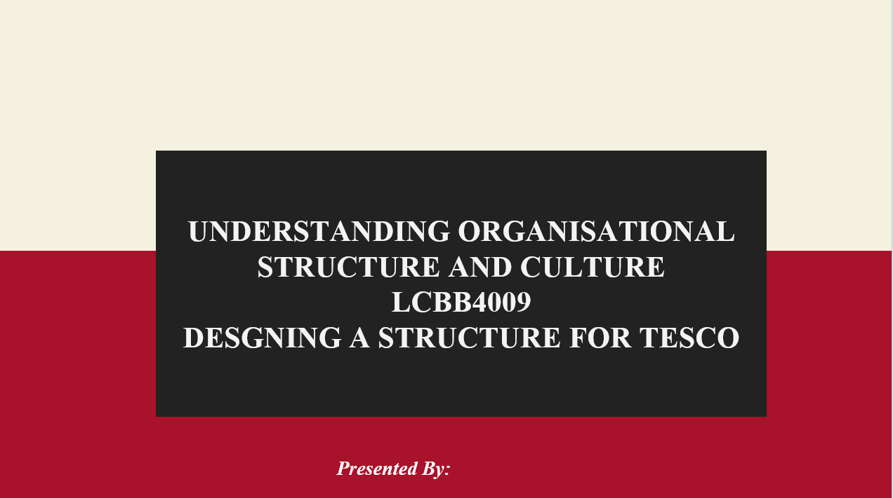

Slide 2: Organisational Structure Definition
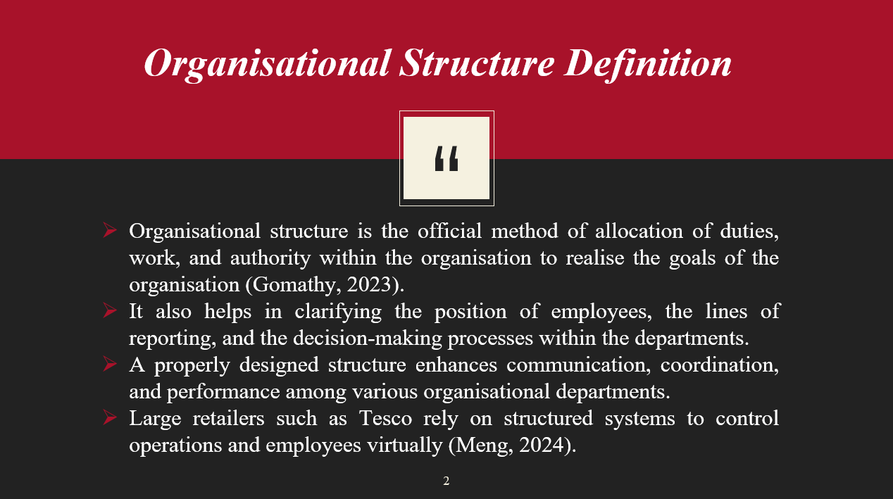
This slide explains organisational structure as the formal system that defines roles, responsibilities, authority, and reporting relationships within a company. A clear structure improves coordination, communication, and decision-making, enabling large organisations like Tesco to manage employees and operations efficiently across departments.

Slide 3: Functional Structure
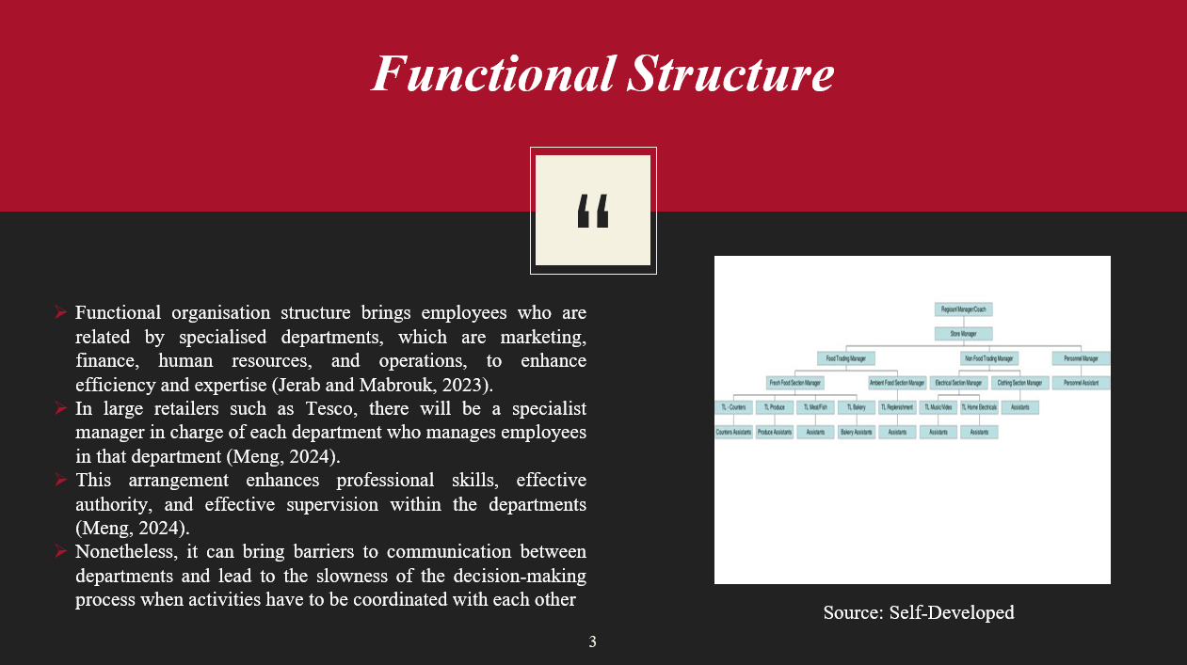
With a functional organisational structure, the employees are pooled in groups according to specialised departments like marketing, finance, human resources, and operations. At Tesco, there are departments that are led by a specialist who directs the work of the employees. This system enhances skills and efficiency, although it can also introduce communication obstacles and a reduced rate of interdepartmental decision-making.

Slide 4: Functional Organisational Chart
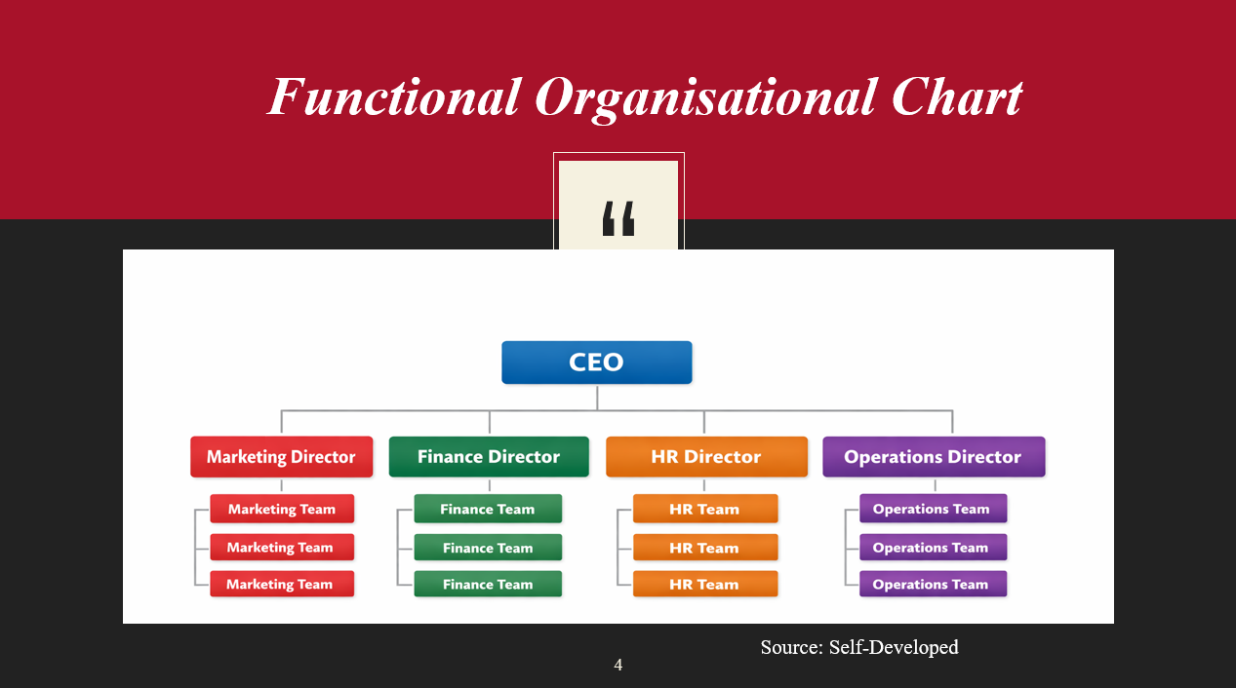
This slide represents the functional organisational chart of the organisation. CEO is in the top position where under CEO there are four type of directors such as marketing, finance, HR and operational.

Slide 5: Divisional Structure
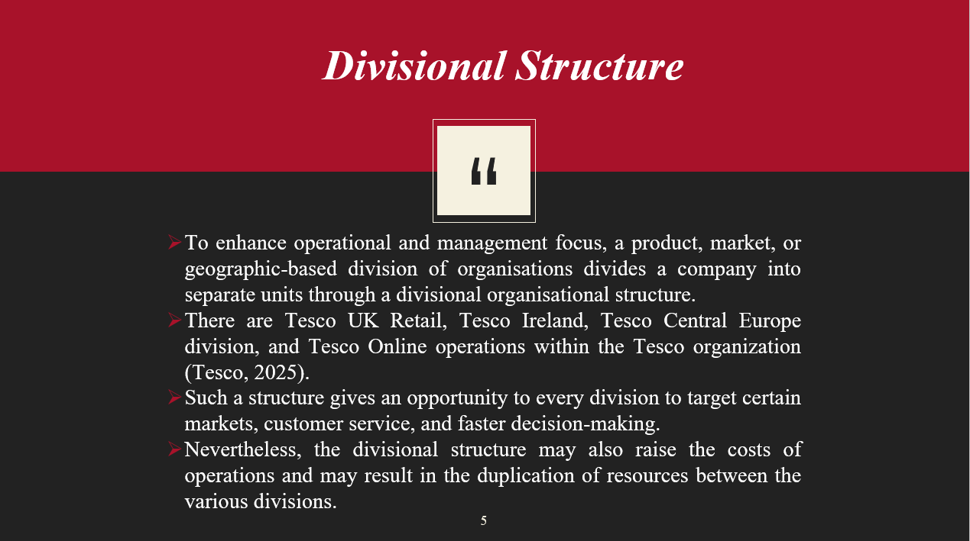
A divisional organisational setup divides an organisation into various parts that are focused on the products, markets, or geographic location. Divisions of Tesco are UK Retail, Ireland, Central Europe, and the Online operations. This arrangement allows every division to specialize in so far as its particular market is concerned, but it can raise the operating cost and cause duplication of resources.

Slide 7: Divisional Organisational Chart
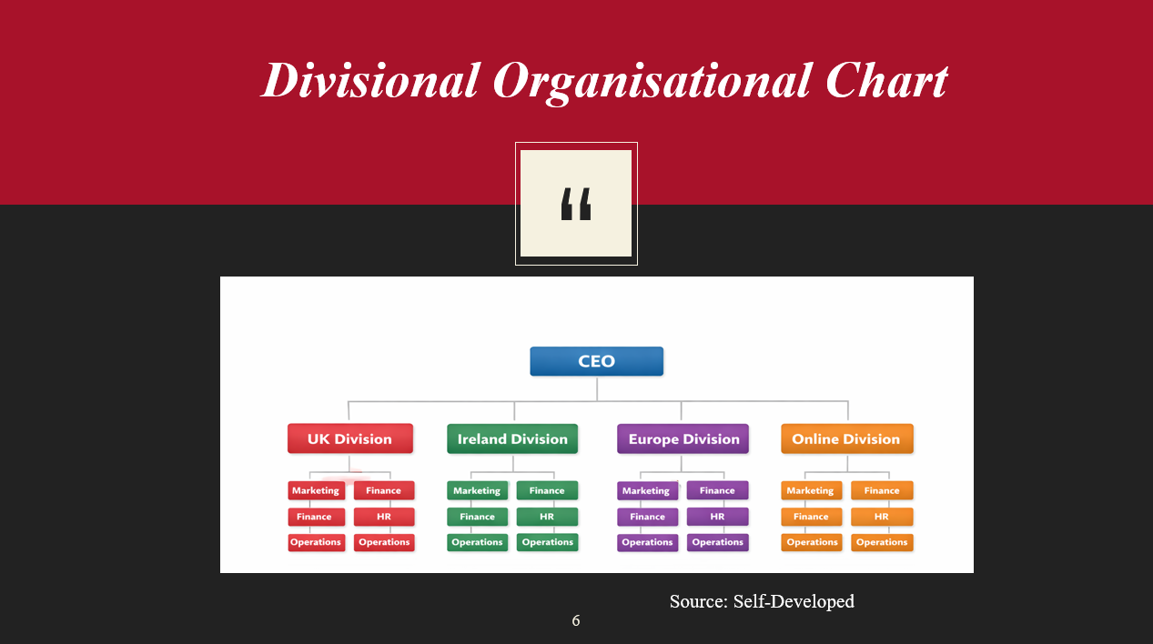
This slide shows the divisional organisational structure of Tesco Plc. It has been showed that there are four named division which are UK division, Ireland division, Europe division and online division. Under each of the divisions there are marketing, finance, HR, operational team available.

Slide 8:Matrix Structure
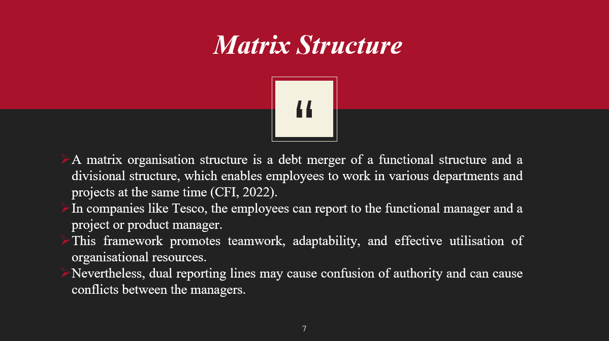
A matrix organisational structure is a combination of the functional and divisional structure. At Tesco, the employees are allowed to report to a functional manager and a project manager. This design promotes resource utilization, flexibility, and teamwork. Nevertheless, the two-line reporting may occasionally lead to conflicts and misunderstandings among the managers.

Slide 9: Matrix Organisational Chart
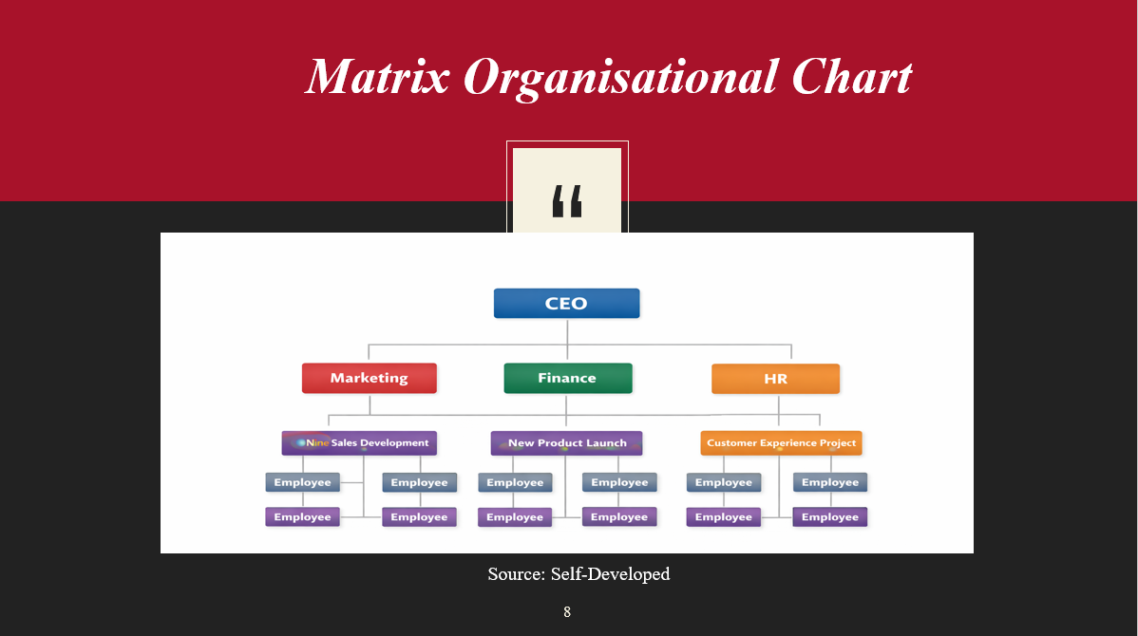
Here in this slide a matrix organisational chart has been presented. Under CEO there are marketing, finance and HR department and under each of the department there are sales developmentor, project launcher, customer experience developer. At last in the fourth stage there are employees stands.

Slide 10: Conclusion
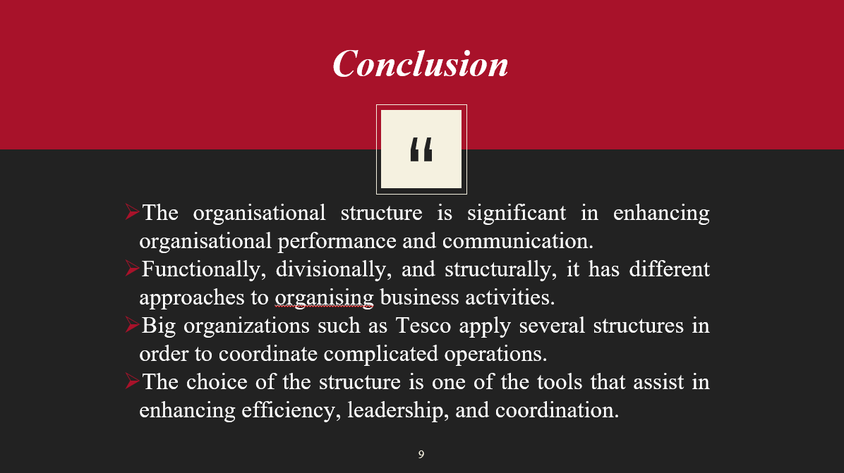
This slide is the final slide and present a conclusion. For Tesco, functionally, divisionally and structurally different approaches has been presented in this entire presentation.

SLIDE 11: References
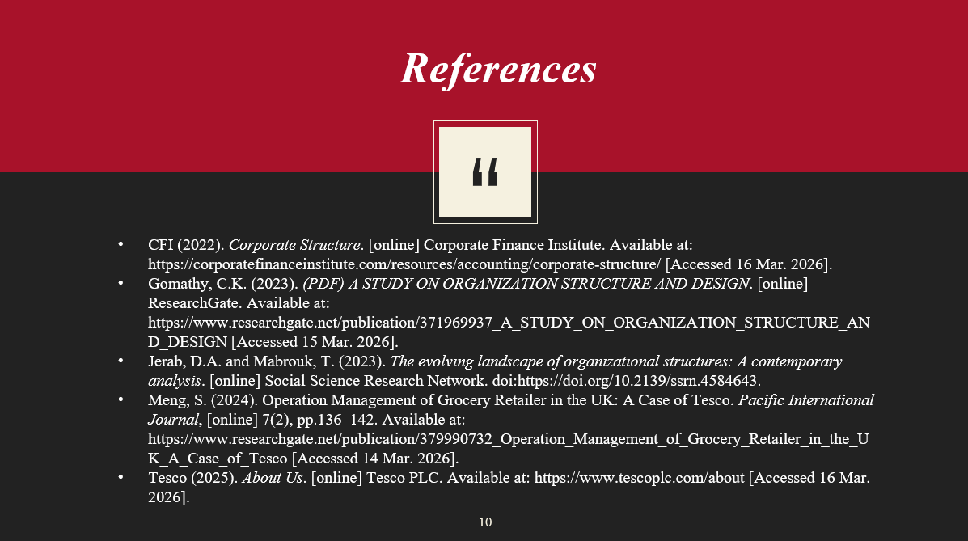
CFI (2022). Corporate Structure. [online] Corporate Finance Institute. Available at: https://corporatefinanceinstitute.com/resources/accounting/corporate-structure/ [Accessed 16 Mar. 2026].
Gomathy, C.K. (2023). (PDF) A STUDY ON ORGANIZATION STRUCTURE AND DESIGN. [online] ResearchGate. Available at: https://www.researchgate.net/publication/371969937_A_STUDY_ON_ORGANIZATION_STRUCTURE_AND_DESIGN [Accessed 15 Mar. 2026].
Jerab, D.A. and Mabrouk, T. (2023). The evolving landscape of organizational structures: A contemporary analysis. [online] Social Science Research Network. doi:https://doi.org/10.2139/ssrn.4584643.
Meng, S. (2024). Operation Management of Grocery Retailer in the UK: A Case of Tesco. Pacific International Journal, [online] 7(2), pp.136–142. Available at: https://www.researchgate.net/publication/379990732_Operation_Management_of_Grocery_Retailer_in_the_UK_A_Case_of_Tesco [Accessed 14 Mar. 2026].
Tesco (2025). About Us. [online] Tesco PLC. Available at: https://www.tescoplc.com/about [Accessed 16 Mar. 2026].

