

Formal Report

Project Management in Royal Mail,
Adapting to Impacts of the Coronavirus Outbreak

Students name: Veronika Topolcanyova
Students number: 1806303
Module: Project Planning and Management in workplace
Submission day: 3 July 2020

Executive Summary

This report is a critical analysis of tools and techniques used by organisation and its response to a global outbreak of Covid-19. Royal Mail is one of the country's essential services and in order to keep service running they had to implement safety changes to their services to protect employees and the UK's public from spreading a virus. Project life cycle has 4 stages and each stage can only be achieved by using project management tools and techniques. This report is created to define, analyze and evaluate every step of initiation, planning, execution and closure phase of this project.

Table of contents

Content Page number
1.0 Introduction…………………………………………………………………………………….4

2.0 Findings…………………………………………………………………………………………..5

2.1 Initiation Phase……………………………………………………………………………….6
2.1.1. Quad chart……………………………………………………………………………..............6
2.1.2. Stakeholders……………………………………………………………………………………….7

2.2 Planning Phase………………………………………………………………………………..8

2.2.1. Risk Analysis……………………………………………………………………………………….9
2.2.2. Iron Triangle……………………………………………………………………………………..10
2.2.3. Pestle…………………………………………………………………………………………………..12
2.2.4. Swot…………………………………………………………………………………………………….12
2.2.5. Work Breakdown Structure………………………………………………………………….13
2.2.6. GANTT Chart………………………………………………………………………………..........14

2.3. Implementation Phase………………………………………………………….........15

2.3.1. Network Diagrams………………………………………………………………15

2.4. Execution Phase…………………………………………………………………………….16

2.4.1. Monitoring and Evaluation………………………………………………….16
2.5. Project Closure………………………………………………………………………………18
3.0 Conclusion………………………………………………………………………………….....20

4.0 Recommendations…………………………………………………………………………21

5.0 Reference List………………………………………………………………………………..22

1.0 Introduction

In the beginning of January 2020, the world has experienced an unprecedented event; global outbreak of Covid-19, a virus that attacks respiratory system and is similar to flu, however scientists believe that is mutated into much more aggressive form spreading rapidly between population. It becomes crucial for businesses which remained open for public to manage a project within organisation in order to protect their stakeholders.

What makes it a project?

Following government advice every company needs to take actions and implement changes to their business, for instance adhering to social distancing rules. This action requires more activities to be initiated and planned, implemented in a set time frame and at the end evaluated and this activity makes it a project. Project management tools and techniques are helping managers to realize the project and will be critically analyzed in the main body of this report.

2.0 Findings

Lapp, B. and Lesser, M. J., (2003) defines a project as “a temporary endeavor undertaken to create a unique product or service...the purpose of a project is to attain the objective and close the project.”

The Royal mail objective is to keep the country running and connected during the coronavirus outbreak.

Project scope is what needs to be achieved and the work that must be done to deliver a project. (Totally, 2018). Using project life cycle work needs to be sequenced into phases from initiation to its closure.

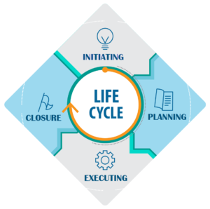

https://d1jnx9ba8s6j9r.cloudfront.net/blog/wp-content/uploads/2019/02/Project-Management-Life-Cycle-Icon-1-2-300x298.png

According to Murray - Webster and Dachner (2018), project management is the implementation of actions, procedures and techniques to achieve these objectives standards under the admitted framework.


https://www.apm.org.uk/resources/what-is-project-management/#Bok7

2.1 Initiation Phase

2.1.1. Quad chart

A quad chart is a combination of graphs and words used to give details/overview of a company's proposal or innovation project. (Quad charts, 2020)

Quad chart is a useful tool and beneficial for the project as it clearly displays the purpose of the project, why it is needed, who are the stakeholders, goals and secondary benefits of the project and how success is measured. A Motivating factor in this project is to keep public and businesses running and connected but with safety measures implemented to keep everyone safe. Employees along with the customers are high priority because keeping employees safe and protected means they feel safe at work to deliver the service and customers supporting business which has financial impact on royal mails profit.

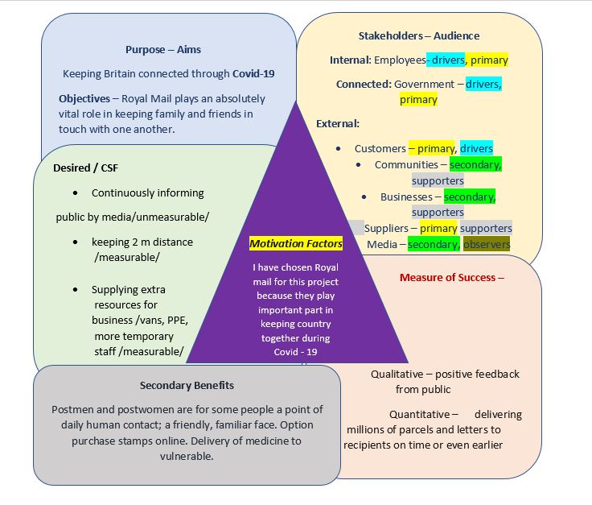

2.1.2. Stakeholders

According to Gerber and Du Plessis (2009), stakeholders are individuals and organisations who are affected by your business actions and who influence your business actions. Internal Royal mail’s stakeholders are employees and government and external stakeholders are customers, suppliers, media, local communities, businesses, charities and associations. Keeping stakeholders informed and engaged is crucial for business success and profitability.

The objective of collaboration with stakeholders is to maintain trust, protect the company's reputation and provide safe service to the public. (Our Approach to Stakeholder Engagement, 2018)

‘’We are doing everything we can to protect our people while remaining open for business and offering delivery services throughout the UK. ‘’ (Coronavirus: how we're protecting our staff and customers | Royal Mail Group Ltd, 2020)

There are many ways to keep stakeholders informed. It is important to inform stakeholders immediately after government announcement of lockdown measures to avoid confusion and misleading information about services to public. Internal stakeholders can be updated on what's happening by daily briefings, monthly reviews, business emails, and webinars, for those who work from home for instance using Microsoft teams or skype. External stakeholders can be informed through media, letter, website, social media or business administration.

Why is it important to analyze stakeholders?

Stakeholders analysis and management (2020) states that, it is a process of identifying stakeholders and their interest in company and assessment of their influence and impact on organisation but also it identifies how are they impacted by organisation actions, in order to build right strategies to support collaboration and relationships between each other.

Stakeholders analysis
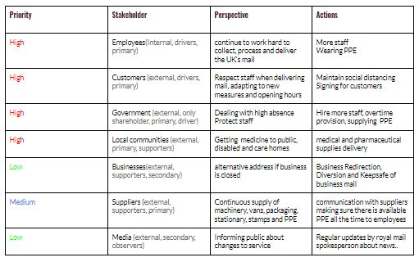

2.2 Planning Phase

2.2.1. Risk Analysis

Raftery (2003) stated that our task is not to avoid risk but to recognize it, assess it and to manage it. The point of the analysis is to establish the extent of risk in order to do something about it.

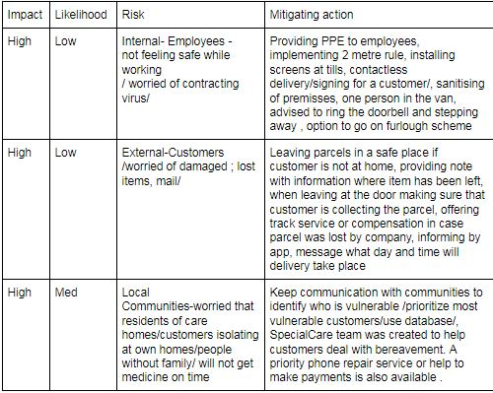

2.2.2. Iron Triangle

Not long after the government announced lockdown Royal mail was criticized for putting employees at risk and only focusing on profits as there have been lack of PPE for employees and they didn't feel safe to stay in work. So, implementing these issues into the iron triangle tool it safe to say that putting pressure on employees would affect quality of service and put a bad reputation on business. If employees don't feel safe in the workplace they might go on furlough and self-isolate at home and that would cause short staff and more time and resources to support an already heaving workload.

My boss doesn't care about my wellbeing..."I'm scared that my job will be in danger if I refuse to do a task because I believe it puts me in an unsafe position,"

https://st3.depositphotos.com/13533222/16997/v/1600/depositphotos_169976598-stock-illustration-sad-postman-with-sweat-on.jpg

However, a spokesperson for Royal mail assured the public and commented that they were doing everything they could to maintain social distancing where possible and provide employees with equipment needed.
"We have already made a series of adjustments to our parcel-handling procedures to protect our colleagues and our customers."(Corker, 2020)

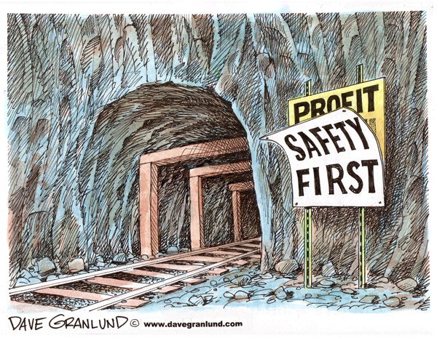
https://www.davegranlund.com/cartoons/wp-content/uploads/color-miner-safety-web.jpg

New rules of one person only per van were implemented and put into practice. (safety increased, cost increased, quality remained the same).

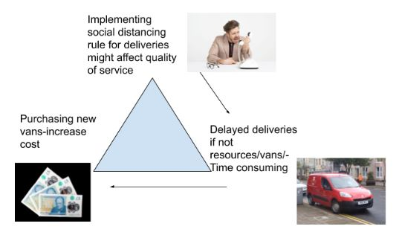

Royal mail is experiencing financial loss in business and to enhance their profit they raised stamp prices and explained that it was a necessary move in order to save the sustainability of the service and maintain the quality expected by their customers. (Royal Mail to raise price of stamps to offset losses, 2020)
Putting this in iron triangle quality will remain the same, customer satisfaction would decrease but this step would be beneficial for the company’s profit.

2.2.3. PESTLE

LEGAL - Royal mail needs to take immediate action and carry out a COVID- 19 risk assessment because as every company they have a legal responsibility to protect staff and public from risk of spreading of Covid-19. By ignoring law and not providing PPE for employees or not implementing safety measures in the workplace, companies could face fines for breaching safety law and even this could be classified as a criminal offence and facing imprisonment for up to 2 years. Current legislation states that you must adhere 2 m distance and provide PPE for employees e.g. Screens, shields, masks, gloves and hand sanitizers. (Other people's homes - Working safely during coronavirus (COVID-19) - Guidance - GOV.UK, 2020)

TECHNOLOGICAL - Employers have a responsibility to provide all equipment to employees if working from home, for instance mobile phones, landline phones, computers, tablets and others.

Coronavirus has a negative impact on economic factors however it has positive impact on social factors. Seems like money and profit play a second role in this unprecedented time and the company is more focusing on safety and togetherness in these difficult situations, keeping the country connected and running, prioritizing vulnerable people and helping businesses to survive.

2.2.4. SWOT

Strengths - dealing with workload during coronavirus, high employee absence and providing support to customers via technology (Internal focus)

Weaknesses - unsafe handling of mail - complaints from customers regarding leaving mail unsafe or damaged (Internal focus)

Threats - competitors, using royal mails situation (absenteeism, bad feedback from public, financial loss) for own growth and overtaking the market (External focus)

Opportunities - taking feedback into consideration, assess what is an issue and fix the problem. Identify ways for improvement and prove public about quality of services provided for many years to keep customers loyal and develop new customers network (External focus)

2.2.5. WORK BREAKDOWN STRUCTURE

The Work Breakdown Structure /WBS/ is a deliverable oriented hierarchical decomposition of the work to be executed by the project team to accomplish the project objectives and create the required deliverables. (A guide to the project management body of knowledge (PMBOK guide), 2004)

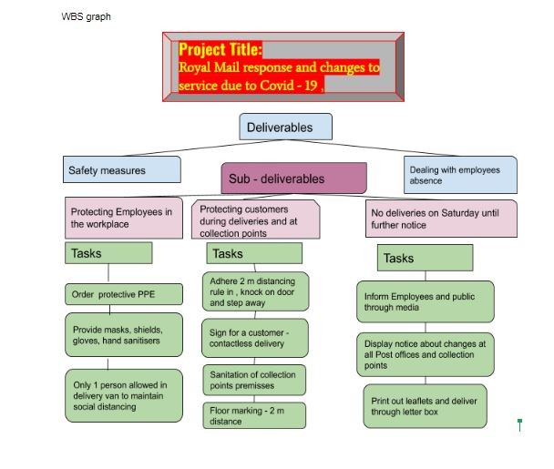

2.2.6. GANTT CHART

What is Gantt chart?

It is a useful and effective tool to manage a complex project, its progress with its tasks and subtasks. It proves the correct planning of tasks over the duration of the project. (Rebiere and Rebiere, n.d.)

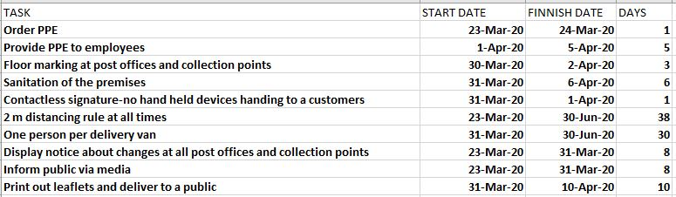

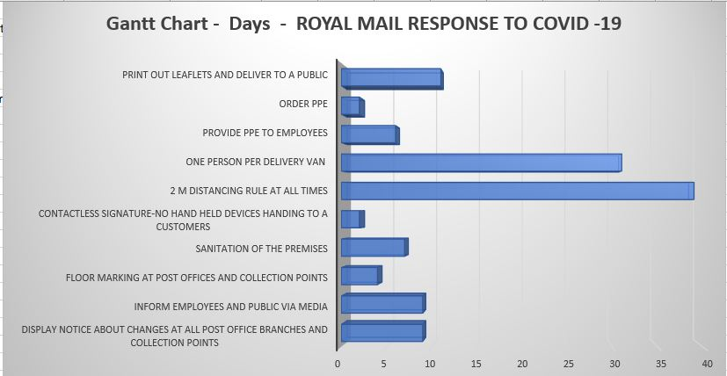

2.3. Implementation Phase

2.3.1. Network Diagrams

The network is a sensible augmentation of Gantt’s milestone chart consolidating the adjustments so as to demonstrate links between and among all the milestones in a whole project. One of the best-known project techniques for network analysis is Critical Path. (Introduction to Project management, 2020)

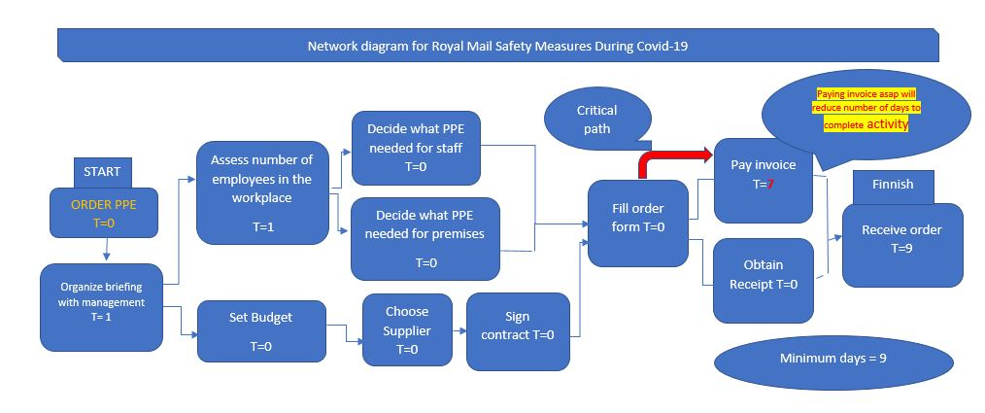

Using network diagram Royal mail could easily avoid issues at the beginning of the project when they lacked PPE for their employees. Critical role played in this case between ordering and receiving PPE which was shortened by companies paying for invoices immediately after order. In the future they ordered in bulks which prevented shortage. Creating a network diagram for every activity is important for companies to identify gaps in the project and find out what could be done better, faster, cheaper to save resources and stay within approved budget.

2.4. Execution Phase

2.4.1. Monitoring and Evaluation

Why Evaluation?

Monitoring and Evaluation (M&E) are important to assess if a project is achieving its objectives. (Why is Monitoring & Evaluation Important for NGO’s?, 2020)
Hard measurements are used to measure quantity and soft measurements are used to be measured only in relative terms. (Tarr, 2011). Outcome is what is being evaluated and results is feedback, feelings, behaviours or actions obtained.

Stakeholders | Outcome | Hard  -measurable | Soft-experience, process, attitude | Reaction | Learning | Behaviour | Results
Employees-internal | Continue to deliver and collect UK’s mail | Objectively -record Number of delivered mail in a week(performance) | Received positive feedback from public about hard working staff | Appreciation, satisfaction - public clapping for royal mail essential workers | Adapt to new measurements quickly, problem solving | Positive attitude, following safety measurements to protect themselves and public | Public is more patient with delivery times,staff feeling safe working
Customers-external | Feeling safe collecting mail from local points | Number of collected parcels per week | Customers Feel safe, adhering to social distancing 2m rule and controlled entrance to premises | Continuing to come and collect parcels and visiting post offices | Quickly adapt to safety measures | Not effective- informing customers they might keep distance 2m when receive mail  Effective-changing might for must by law (Delta evaluation) | Customers behaviour changed towards royal man and woman positively, stepping away from door when ring the bell
Businesses-external | Help businesses selling items | Number of businesses using click and drop on marketplaces | Working from home keep business running | Dealing with business closure threat, surviving in tough times | Learning how to use tracking app and Dropbox online service | Positive- businesses are happy and keep selling online while they doors are closed | local businesses are promoted and registering increase in sale
Suppliers-external | Keep supply PPE and stationary | Amount of PPE delivered | Keeping employees safe | Fluent communication | Contactless deliveries | Fast delivery of supplies | Improved cooperation between suppliers and RM

Recognition is an important part of the evaluation process as employees need to feel valued and have positive feelings about their work and effort during a coronavirus outbreak. Royal mail experienced a high volume of staff who decided to isolate themselves and use the option of furlough scheme. But the ones who stay and work hard on the project to keep business running and at the same time make the workplace safe for staff and public should be recognized and rewarded by the company. It will help to keep staff motivated, lower absenteeism, inspire others to come back to work and hopefully improve productivity and company’s growth.
Royal mail’s CEO Stuart Simpson visited a Gatwick mail center to thank hard working teams for their effort, dedication and commitment and stated that the company is extremely proud of their support, attendance and continuing to process record amounts of mail every day. Team has shown great spirit and dynamics in this enormously busy time. (‘A memorable day’, 2020)

Hard and Soft Evaluation

This project was not initiated to make profit, but to keep businesses, and the public connected during difficult times, that means hard evaluation could be for instance used to measure the amount of deliveries processed. In this case soft evaluation can give us a clearer picture of the project and assess if the project met objectives, was it useful or what needs to be done to improve services and experience in the future.
By learning and adapting to government guidelines royal mail stakeholders have changed their attitude and behaviour in order to protect themselves. Measurements as 2 meter distancing, contactless deliveries and use of PPE were followed and results had positive outcomes classified as most effective and useful measures applied.

2.5 Project Closure

Was the project successful? Let’s evaluate...

After all, completed phases, the project is coming to the end. In Royal mail response to Covid-19 project it’s going to be mid evaluated as the fight against coronavirus is still continuing and measures need to be in place to protect the nation. So how did we do?
Overall, the project is a success, the company is continuing to deliver service, customers receive their mail and employees are slowly coming back to work.
Reflecting back on the initiation phase, some measures could be put in place maybe sooner to avoid chaos and unknown. Dealing with pandemic is new for every business and unknown situation for everyone including government and stakeholders. Following safety guidelines, company informed their stakeholders about changes to service and customers quickly adapted to the situation. Project was delivered within a scheduled time frame and the company stuck to a budget.
Evaluating project does not mean to look for the mistakes to blame people but mostly to avoid the same mistakes in the future and to learn and improve.

Delta evaluation - what can be improved? What can be done differently or better?

Royal mail struggled with resources and PPE so next time the company will have to make sure to stock up on PPE (ordering in bulks) and hire more temporary staff to cover absences.

Reflecting back on techniques and tools used in this project, every single one of them has its purpose in the project’s stage. Putting actions in a time frame of a Gantt chart will give us approximate deadlines, critical paths could save a company's money and work breakdown structure divides all necessary steps which need to be taken into deliverables and sub-deliverables. They are all beneficial to the project and necessary for the project proposal.
Kolb’s experiential learning tool is useful and helps when looking back at the project purpose.

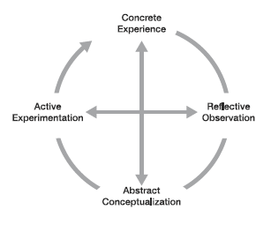
https://journals.gre.ac.uk/index.php/compass/article/view/12/28

According to Kolb, effective learning occurs when a person undergoes a concrete experience followed by observation of and reflection on that experience which leads to the formation of abstract concepts (analysis) and generalizations (conclusions) which are then utilized to test future hypotheses, resulting in new experiences. (Kolb's theory of reflection | Center for Excellence in Teaching and Learning, 2020)

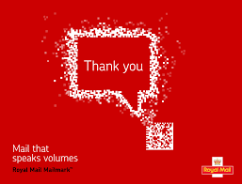
3.0 Conclusion

Finally, at the mid stage of the project it is crucial for the company to reflect on how successful the project is, if it's meeting its objectives, analyze if communication with stakeholders was done properly and project management communicated clearly with all stakeholders, setting budget, criteria, deadline, outcomes and deliverables. Important is to pay attention to actions that need improvement and highlight points which were working well and made the project successful. In general, all phases of the project were followed and thus royal mail can continue to provide services to the UK’s public without fear of spreading Covid - 19. Management has done a good job at creating graphs and implementing safety measures to a business and with collaboration of employees and customers it will be easy to maintain in the future.

4.0 Recommendations

Recommendation for the company is to improve the communication with employees and communicate with stakeholders on a daily basis making sure they don't miss on any updates or changes to the business.

Another suggestion is to stock up on PPE and stationery equipment to prevent shortage in the future.

And at last, but not least, let employees know that they are valued and safety always comes first before profit.

As a project manager myself , based on the Belbin’s team roles I would fit into Team worker role clearly because I am team player, efficient negotiator, flexible and quickly adapt to a new environment and therefore i don’t like making decisions I will collaborate and discuss problem with qualified and skilled professional to make sure I am making a right choice which would have positive effect on project.
As a coordinator role I have clear visions, usually organized and following steps I can meet set deadlines avoiding stress and mistakes. I am a natural leader who recognizes other values and always takes into consideration ideas and suggestions of other people which could benefit the project.

5.0 Reference List

A Guide To The Project Management Body Of Knowledge (2004). 3rd ed. Newtown Square, Pa.: Project Management Institute, p.6.

Cetl.uconn.edu. 2020. Kolb's Theory Of Reflection | Center For Excellence In Teaching And Learning. [online] Available at: <https://cetl.uconn.edu/kolbs-theory-of-reflection/#. [Accessed 3 July 2020].

Corker, S., 2020. Royal Mail 'Putting Profits Before Safety'. [online] BBC News. Available at: <https://www.bbc.co.uk/news/business-52243179. [Accessed 2 July 2020].

Gerber, K. and Du Plessis, N., 2009. Marketing Communication. Cape Town: Pearson Education South Africa, p.2.
Gov.uk. 2020. Other People's Homes - Working Safely During Coronavirus (COVID-19) - Guidance - GOV.UK. [online] Available at: <https://www.gov.uk/guidance/working-safely-during-coronavirus-covid-19/homes. [Accessed 2 July 2020].

FundsforNGOs. 2020. Why Is Monitoring & Evaluation Important For Ngos?. [online] Available at: https://www.fundsforngos.org/featured-articles/monitoring-evaluation-important-ngos/. [Accessed 18 June 2020].
Introduction To Project Management. (2020), [pdf.] p.20. Available at: https://www.manage.gov.in/studymaterial/PM.pdf. [Accessed 10 June 2020].
Lapp, B. S. & Leser, M. J. (2003). 360-degree project management. Paper presented at PMI® Global Congress 2003—EMEA, The Hague, South Holland, The Netherlands. Newtown Square, PA: Project Management Institute.

Managers.org.uk. 2020. Stakeholder Analysis And Management. [online] Available at: <https://www.managers.org.uk/knowledge-bank/stakeholder-analysis-and-management. [Accessed 28 May 2020].

Managementstudyguide.com. 2020. What Is A Project ?. [online] Available at: <https://www.managementstudyguide.com/what-is-project.htm. [Accessed 29 June 2020].

Murray-Webster, R. and Dalcher, D., 2018. APM Body Of Knowledge 7Th Edition An Evolving Structure: Progress Report. 7th ed. [eBook] apm. Available at: <https://www.apm.org.uk/media/24069/bok7-whats-changed-akt11950-with-links.pdf. [Accessed 29 June 2020].

Myroyalmail. 2020. ‘A Memorable Day’. [online] Available at: <https://www.myroyalmail.com/news/2020/07/%E2%80%98-memorable-day%E2%80%99. [Accessed 3 July 2020].

Our Approach To Stakeholder Engagement. (2018) [pdf] royalmailgroup. Available at: https://www.royalmailgroup.com/media/10219/royal-mail-stakeholder-engagement-approach.pdf. [Accessed 1 July 2020].

Raftery, J., 2003. Risk Analysis In Project Management. London: E & FN Spon, p.20.
Rebiere, C. and Rebiere, O., n.d. Mastering The Gantt Chart: Understand And Use The "Gantt Project" Open Source Software Efficiently!. (Google books) Guide Education, p.4.

Royalmail.com. 2020. Coronavirus: How We're Protecting Our Staff And Customers | Royal Mail Group Ltd. [online] Available at: <https://www.royalmail.com/d8/coronavirus-protection> [Accessed 3 July 2020].

Tarr, J., 2011. Performance Measurements – Designing The Guidance System For Your Organization: The ACA Group. [online] Theacagroup.com. Available at: https://www.theacagroup.com/performance-measurements-designing-the-guidance-system-for-your-organization/#:~:text=Soft%20vs.,measured%20only%20in%20relative%20terms. [Accessed 18 June 2020]
The Guardian. 2020. Royal Mail To Raise Price Of Stamps To Offset Losses. [online] Available at: https://www.theguardian.com/business/2020/feb/21/royal-mail-to-raise-price-of-stamps-to-offset-losses. [Accessed 3 July 2020].

Totally. 2018. How To Define The Scope Of A Project | Totally. [online] Available at: https://totally.tech/quick-guides/how-to-define-the-scope-of-a-project/. [Accessed 1 July 2020].

Thank You Royal Mail. (2020) [image] Available at: <https://www.royalmail.com/sites/royalmail.com/files/2019-11/mailmark-customer-presentation.pdf> [Accessed 3 July 2020].

Webarchive.nationalarchives.gov.uk. 2020. Quad Charts. [online] Available at: https://webarchive.nationalarchives.gov.uk/20140410093358/http://www.science.mod.uk/Engagement/CDE/quad_charts.aspx. [Accessed 28 May 2020].

