Red, White & Black - Protest and Rebellion in Graphic Design

Summary - 100

Introduction - 400

Colours have been used within both art and design for many years. However, the combination of red, white and black throughout times of war, rebellion and social change has been a recurring event.

As history has shown us, the combination of these colours have been detrimental to periods of rebellion and social change. Therefore, it’s important to gain an in-depth understanding of how these colours come together and how they are used to in times of rebellion to persuade, inform or change. Furthermore, as the world moves on, it is important to understand the background behind previous periods of social change and how this will influence change in the future.

Overtime, research on the use of these colours and their effects on rebellion and protest has been very little. However the aims of this study is to look deeper into how red, white and black have affected protest and rebellion through graphic design.

What are colours and what does red, white black mean within symbolism and psychology

Red, white and black have been deemed the most important combination of colours by “Anthropologists and art historians [as they] have discovered that culturally, the human perception of colour begins with three primary colours: black, white and red” (Aboel Magd, 2013) This conveys that each colour symbolises the three fundamental symbols of life which are life, purity and death. Red is suggested as a colour that represents life as well as death as it’s the colour of blood, black is considered the symbol of “death, seperation and slavery”. However white is considered the “symbol for purity and ‘all that is good’” (Aboel Magd, 2013)

It’s often debated whether black and white are colours as they don’t have a specific wavelength likewise to red. However, it can be proposed that these are colours because they are both on the electromagnetic spectrum but instead of dispersing one wavelength, white contains all the colours (wavelengths) of the spectrum and black had no colours (wavelengths).

On the contrary, the power of these colours can be further explained by Leatrice Eiseman, who explains that white “works well for contrast, in signage, at point of purchase, in packaging, or any other usage where it will catch the eye.” From this statement, it can be suggested that white is seen as a colour that captures the eye, especially when it's used in contrast to other colours.

As well as that Eiseman goes onto describe that, black is “the most powerful, dramatic, elegant and expensive presence.” This statement conveys that black is an authoritative colour and has a striking impact on the eye. To reiterate, the combination of both white and black are very powerful colours and can be described as “most classic combination of strength and clarity, power and purity.”

The science behind how we see these colours is really interesting because when colour is perceived through the human eye, it is seen as a light. This light is then transmitted through to the retina through layers called ‘rods’ and ‘cones’. In the retina, rods can only detect black and white light whilst cones can recognise “red (long wavelengths), blue-violet (short wavelengths) and green (middle wavelengths)” (Anderson Feisner., 2001) This information is then transmitted to the brain that tells us what colour is seen.

History of Colours

Throughout history, humans have been able to use colours to express a range of emotions, thoughts and to symbolise real and false events. However the uses of red, black and white have been used within art for hundreds and thousands of years.

Before there were verbal ways of talking with one another, colour was a form of communicating various thoughts and feelings.

During the Palaeolithic times, humans used red and black to leave marks, drawings and warnings to communicate with one another. An example of how these colours have been used is in the Lascaux Caves in France, where the Stone age man used mainly “red ochre and black, symbolic of life (blood) and death” (Cole, 1993) Yet during these times “white is almost completely absent at first sight” however most of the walls depicted in these caves were white/light coloured and if they weren’t the stone aged man tended to scrape “the dust off the wall surface to create an area of white” (Petru, 2006)

Colour wasn’t as easily available during these times like it is today not only in the prehistoric period but carrying through to Ancient Egypt and Ancient Rome, people had to collect their minerals and ground them together “glue, gum, gelatin, or egg albumen.” (Anderson Feisner., 2001)

Although the importance of ochre was to initially create marks and drawings, it could also be said that the aesthetic of the colour was also a big factor in why the stone age man used it.

Tammy Hodgskiss, an archaeologist at the University of Wiwatersand who has been studying the use of ochre for many years, states “I think the initial attraction was the color. The awareness of its other uses came gradually, over time.” (Tarlach, 2018) From this statement we can gather that colour throughout the palaeolithic period was about more than just the uses of it but this is when humans realised it was more about the aesthetic of the colour.

How the use of colour (red, white and black) was involved in art becoming more ‘graphic’

In the early 20th century is when art started to look more ‘graphic’ and artists started to blur the lines in terms of what was considered art. One particular artist who intended to blur the lines was Fernand Léger. Léger was a French painter who was part of the cubist movement who worked alongside Pablo Picasso and Georges Braque.
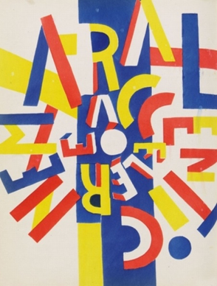
However, dissimilar to Picasso and Braque, Léger was said to have “moved cubism away from the initial impulses of its founders.” (Meggs and Purvis, 2012) This statement suggests that by Léger using his own style of working, he was able to push cubism in a different direction. This is very similar to Georges Braque as he first started with his passion for Fauvism but then by pushing boundaries and experimenting with different concepts, Braque and Picasso developed the art of cubism, a movement with very ‘graphic’ styles.

Looking at one of Fernand Léger’s pieces of work called “La fin du monde” which was created in 1919, it’s almost hard to believe that this piece of work was created 100 years ago, especially with the vibrancy of the colours and the shapes that very vaguely resemble letterforms. It could be suggested that Léger was unconsciously intending to blur the lines in terms of whether his work is more artistic or graphical because his work “pointed the way toward geometric letterforms” (Meggs and Purvis, 2012) which you could say is more of a ‘graphic’ style than artistic.

The use of the colour red in this piece of work is interesting. It’s not said why he used these primary colours but by Léger using these colours and shapes and exploring the relationship between them, it could be said that he “helped define the modern design sensibility after World War I” (Meggs and Purvis, 2012) especially in terms of pushing more geometric design elements within the art and design world.

Moreover, around the same time as cubism, the works of De Stijl (My Style) occurred. De Stijl can be described by Tate as “a circle of Dutch abstract artists who promoted a style of art based on a strict geometry of horizontals and verticals” (Tate, 2019)

De Stijl was first founded by Piet Mondrian and Theo van Doesburg who’s work “stripped-down formal vocabulary principally consisting of straight lines, rectangular planes, and primary color.” Especially after the destruction that came with World War 1, their aim was “to achieve a visual harmony” and create work that brought back normality and peace. (Moma.org, 2019)
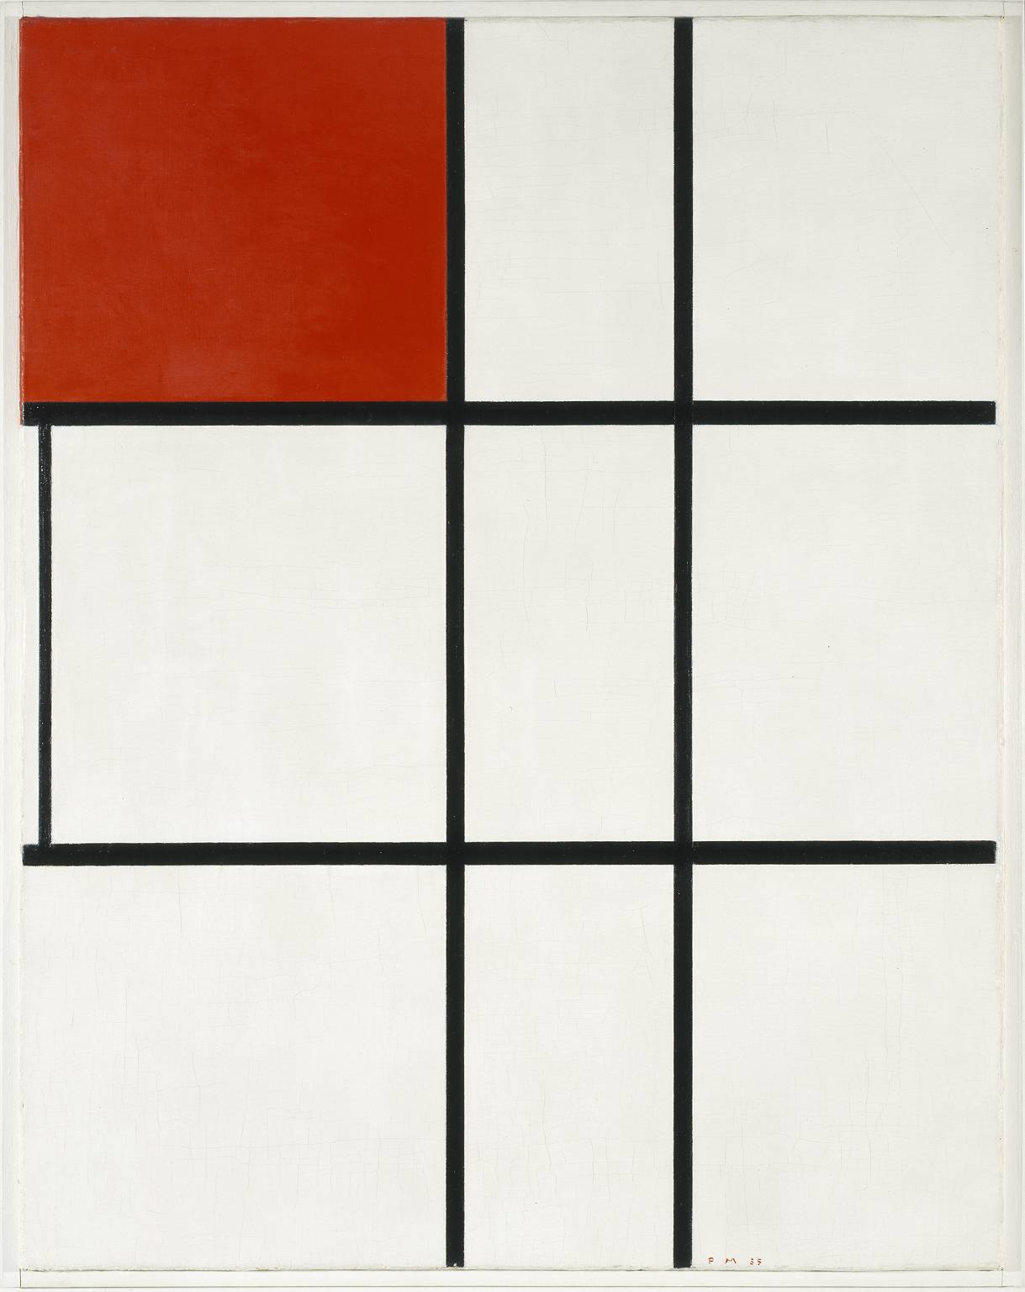
However whilst Léger was using more geometric letterforms within his work, Mondrian and other De Stijl artists broke those letterforms down again by using lines and colour to form a new way of communicating and obscured the lines in terms of what was considered ‘graphic’.
One of Mondrian’s pieces ‘Composition B (No.II) with Red 1935’ consists of vertical and horizontal black lines, a white background and a singular red square. This composition feels very balanced as red is a powerful colour but it works well with combined with the white background. Tate further reinstates “With planes of primary colour balancing planes of non-colour (white, grey or black) and vertical lines opposing horizontal lines, and both acting to define the planes, his works embodied, he thought, principles of balance and harmony.”

How red, white and black were used throughout the Russian Revolution

The Russian Revolution was a time of political and social rebellion in Russia. For many years, Russia had been controlled by a monarchy called the “Romanovs” and Tsar Nicholas II was Emperor. The Russian Revolution started in 1905, where people protested for fairer working and living conditions. In reaction to the rebellion, Nicholas created a representative state body called the “Duma” which was created to allow more democratic participation by citizens in creating legislation and allowed Tsar Nicholas II to stay in power. During the end of World War 1, the Russian Revolutions of 1917, finally ended the Russian Empire with removal of the Tsar.

In reaction to the rebellion and World War 1 (1914-1918), came the work of Suprematism and Constructivism. Russian Constructivism was first founded in Russia around 1915 by Vladimir Tatlin and Alexander Rodchenko. The constructivists thought that “art should directly reflect the modern industrial world.” (Tate, 2019) This is very similar to what the Futurism and Dadaism movement intended to do as they all wanted to go against what was stereotypically art and they wanted to create using the modern world as an influence through their own creative ways.

It has been said that Rodchenko, through his work “rejected the established artistic conventions of self-expression and aesthetics, dedicating himself with revolutionary fervour to bringing art to the masses.” These ideas of a modern world linked to greater empowerment of the masses put this new art in the midst of the historic changes taking place.

However, Russian Suprematism was founded in 1913 by Kasmir Malevich who was inspired by what was happening around him but expressed through the use of colours and geometric forms. Kasmir Malevich was a Russian artist who had a massive influence on the pushing forward of both Suprematism and Constructivism in Russia during the 1920s. Conversely to Vladimir Tatlin’s work which was heavily reflected in the “turbulence of World War 1” and the Russian Revolution, Malevich was more interested in the expression of what his work could signify. For that reason, Malevich founded the style of ‘Suprematism’ after working with the influence of both futurism and cubism. Suprematism was the name of his style of painting which consisted mostly of basic geometric shapes and vibrant colours. Malevich believed that he didn’t need his work to be illustrated with pictures or designed to be practical, as stated by Meggs “He rejected both utilitarian function and pictorial representation” (Meggs and Purvis, 2012) Instead he wanted to create an experience of emotions through using colour, shapes and forms.

Malevich created lots of work in the style of suprematism. One of his pieces shown called the ‘Red Square’ is also known as the ‘A peasant woman in two dimensions’ which was made in 1915. It can be described as the “...abandoning of all materialism. The painting is a representation of simplicity in its purest form with a red quadrilateral on a white field.” (Kazimirmalevich.org, 2019) As mentioned earlier, Malevich wanted his work to be simple and he wanted to get as far away from natural form as he could. However, contradictory to Malevich, Rodchenko used a lot of illustrative images within his work and often combined these images with shapes to give it that constructivist style. On the other hand, Malevich and Rodchenko are both very comparable as their work shows the fascination between colour and shape during the 1920s.
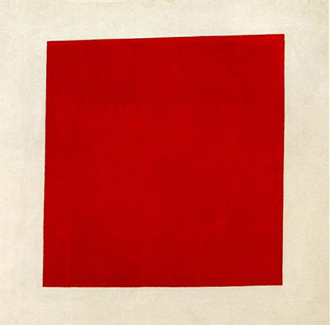
Similarly to the red square, the ‘black square’ was created and was the most popular painting out of the two. Although, Malevich never explained the meaning behind both the red and black square, it could be suggested that the use of contrasting the two colours (red and white, black and white) shows the power that colour has.

Another artist who contributed to the works of constructivism was El Lissitzky, who happened to be teaching at the same art school as Malevich. Lissitzky was massively inspired by Malevich as stated by Phillip B Meggs “Malevich was teaching there and became a major influence on Lissitzky.” (Meggs and Purvis, 2012)

El Lissitzky who was also known as Lazar Markovich Lissitzky “is widely known as a Russian avant-garde artist who made significant contributions to abstract art the 1920s.” (Tupicyna et al., 1999)

This piece of work was one of Lissitzky's most popular pieces of work called ‘Beat the Whites with the Red Wedge’ which was created in 1919. The meaning behind this piece is very clear in terms of its political connotations. However, the thought process from the design point of view is fascinating.

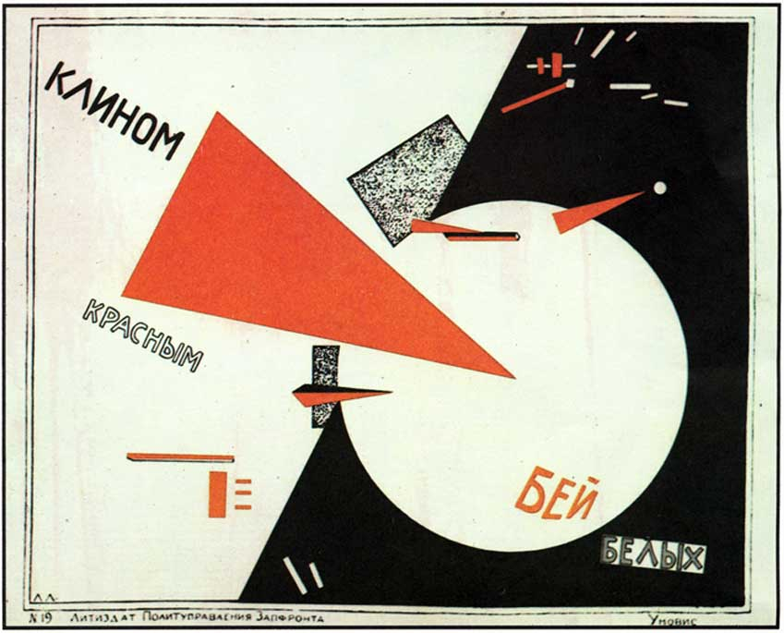
During Lissitzky’s time at the art school teaching both Graphic Design and Architecture in Vitebsk, he developed a certain style in his work that he named ‘PROUNS’ which conveyed to the founding of a new art which can also be described as “(an acronym for “projects for the establishment [affirmation] of a new art)” (Meggs and Purvis, 2012) ‘PROUNS’ was, in other words; the work of two dimensional art that had an illusion that it was three dimensional which hadn’t really been seen before in graphic design history. It could be said that Lissitsky was trying to blur the lines between what was real and what was not with the use of graphic design and architecture which Lissitzky called the “interchange station between painting and architecture” (Meggs and Purvis, 2012). An example of how ‘PROUNS’ is used is within Lissitsky’s piece ‘Beat the Whites with the Red Wedge’ where the contrast of white and black and the consolidation of layering shapes creates the illusion of three dimensional art.

It is clear that the use of the colours red, white and black in this piece of work are not just used for the aesthetic of colour but are used to symbolise a deeper, more political meaning. It could be suggested that the red triangle was taken from the Bolshevik army emblem and used as a symbol. This triangle is then seen going into the white circle which can symbolise the white (Imperial) army, who were fighting the Bolshevik army. It is really fascinating how the use of red, white and black combined with the use of positive and negative space with a few shapes, can symbolise and mean so much.

How red, white and black had influence during World War 2

Further proof of the power and influence of the red, white and black colour combination is displayed in the adoption of the swastika symbol by the Nazis during World War 2 (1939 -1945).

Once a symbol of health, well being and luck but now regarded as a symbol of hatred, the Swastika to most people has and will always be deemed a negative symbol ever since World War 2 and the Holocaust. However, the Swastika hasn’t always been a negative symbol and has been used for hundreds and thousands of years within many different cultures.

Before World War 2, there was “a huge fad for the swastika as a benign good luck symbol” (Campion, 2014). In other words, a ’benign’ symbol can be described as ‘gentle and kind’ by Oxford Dictionaries (Lexico Dictionaries | English, 2019). As well as that the symbol was regarded as a token of ‘good luck’ and ‘well-being’ and was mainly used “by Hindus, Buddhists and Jains for millennia and is commonly assumed to be an Indian sign” (Campion, 2014).

There are many interpretations of the swastika in nearly every culture and religion but three versions in particular are very similar in appearance, yet have very different meanings. It could be implied that there are two different meanings to the ‘Swastika’ depending on which way it is facing. If it is going clockwise, it is considered a symbol of good luck. However if it is going anticlockwise it is suggested that this is in connection with bad luck. This could also be further explained by Mundorf & Chen who state that “The good luck symbol in India is depicted in a clockwise rotation, and the counterclockwise image is sauvastika which is associated with misfortune and bad luck.” (Mundorf and Chen, 2006)

The reasoning behind the Nazi’s adoption of the Swastika was because they saw similarity in texts between their own language and Indian which drew them to the conclusion that they must have shared some form of history together as a result of the text looking comparable. This can be further explained by Mukti Jain Campion who states that the “idea was seized upon by anti-Semitic nationalist groups who appropriated the swastika as an Aryan symbol to boost a sense of ancient lineage for the Germanic people.” (Campion, 2014) From this statement, it can be suggested that the Nazis used the fact that they had a link in history with India to make Germanic people feel that there was ancestry behind the symbol.

Red, white and black were used in the Nazi Swastika also known as ‘Hakenkreuz’. Hitler used these three colours because they symbolised his time in the german empire as a soldier and he “regarded them as [his] most sacred possession” (Hitler et al., n.d.)

However, in Hitler’s manifesto called ‘Mein Kampf’ he discloses that he used the colour red in the posters to attract people’s attention. Hitler states

“We chose red for our posters after particular and careful deliberation, our intention being to irritate the Left, so as to arouse their attention and tempt them to come to our meetings” (Hitler et al., n.d.).

As well as that he used red to “win over the socialists and to connect to the pre-Weimar flag” (Mundorf and Chen, 2006). From these statements, it can be implied that during Hitler’s reign as a leader, the use of red was highly thought of as a colour that stood out and was used to attract and persuade people into his absurd demands. As well as that, red is known for enhancing human performance as it is “consistently associated with a higher probability of winning”(Hill and Barton, 2005) which could suggest the use of it within the swastika as Hitler wanted to ‘win’ over the communists.

Moreover, it could be suggested that Hitler was tempted in using the same colours in the Nazi flag as the pre-Weimar flag which were red, black and gold. However, he states “hoisting the old colours would be no symbol of our special aims” and that he was eager to create a new appearance for the new movement. Supplementary to that, Hitler states his opinions about white not being “a colour capable of attracting and focusing public attention.” and black “embodying no significance to empress the will behind our movement”. However later on, he does then go on and state that “the effectiveness of these three colours is far superior to all the others and they are certainly the most strikingly harmonious combination to be found.” (Hitler et al., n.d.)

Since Hitler adopted the Swastika, it is clear to suggest that any positivity that surrounded the symbol, has been tarnished forever. It could be said that Hitler almost used the symbol along with the combination of the colours red, white and black and did the complete opposite of what it originally stood for. Instead of it being a ‘gentle and kind’ symbol and a token of good luck and well-being, Hitler eliminated any positivity and filled it with hatred and “synonymous with fascism”. (BBC News, 2014)

How red, white and black have been used within the Bauhaus

The very same combination of colours (red, white and black) that were used in the swastika were being used within the Bauhaus during the same time, yet were used in two very different ways.

The Bauhaus was an art school that was founded in 1919 by Walter Gropius. The school was stated as “The building of the future” (Ball and Ruben, 2004) and can be described by Tate as “a revolutionary school of art, architecture and design” (Tate, 2019) The Bauhaus’ purpose was to bring a new form of art into peoples’ lives and it was used as a community where artists could come together and create and inspire one another. Especially after the effects of World War I, when all seemed lost, the Bauhaus stepped in to encourage people to create and revive the new world. As well as that, the Bauhaus wanted to step away from the traditional assumptions of what art should be and it desired it to be “urban and technological” as it “embraced 20th-century machine culture” (MacCarthy, 2007)

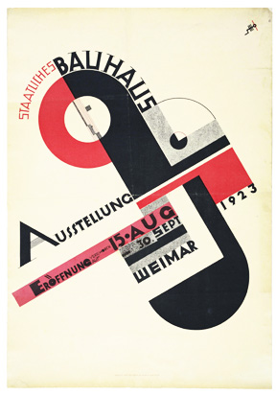
There were many great artists who played an essential role in the development of the Bauhaus. However, one artist in particular was Joost Schmidt who created the poster for the Bauhaus exhibition in Weimar in 1923. This poster conveys the Bauhaus’ distinctive style combined with geometric shapes, square typeface, bold colours and machine forms which were inspired by the industrialisation and social changes of the 1900s.

Although it is unknown why Schmidt decided to chose this combination of colours, it could be suggested that he was inspired by the work of constructivists in reaction to the Russian Revolution. Especially as El Lissitzky’s piece, ‘Beat the Whites with the Red Wedge’ looks very similar to Schmidts Poster in reference to the contrasting colours and geometric shapes used. It could also be suggested that there is a link between both works as Lissitsky was enthusiastic about the relationship between Graphic Design and Architecture, even creating the name, ‘PROUNS’ for the connection. Likewise to the Bauhaus who were also fascinated with the connection between art, architecture and design and how these three principles could come together as one.

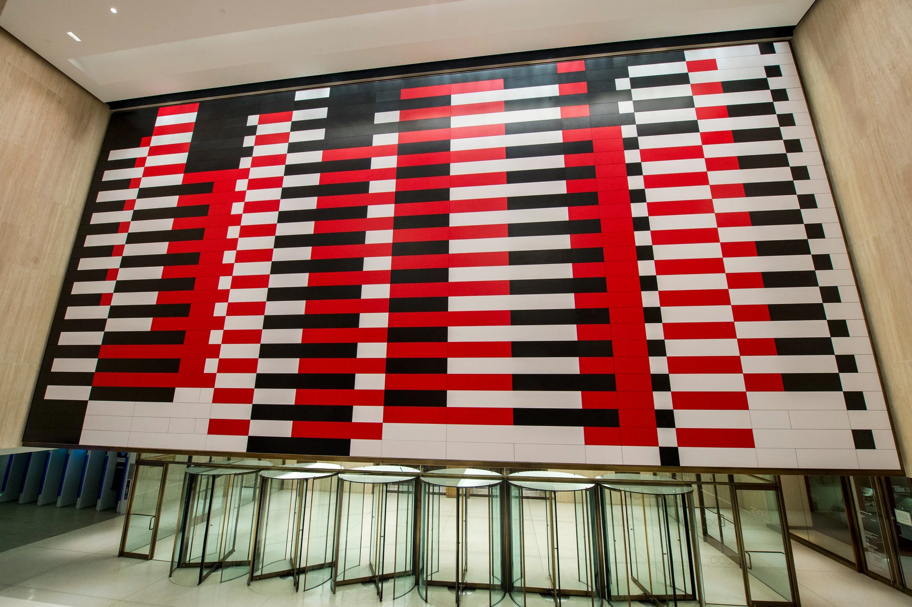
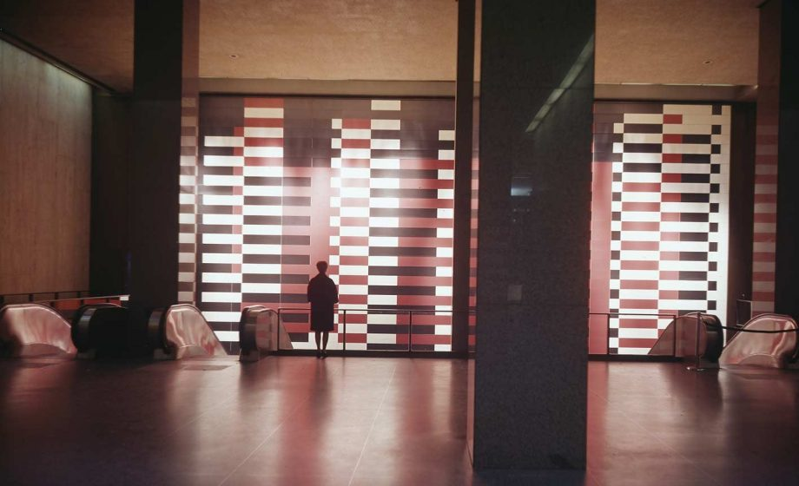
Moreover, the use of colour was highly thought of during the teachings at the Bauhaus. One out of many teachers at the Bauhaus who “became absorbed with how colour reacts and interacts” (Anderson Feisner., 2001) was Josef Albers. Alber’s created many pieces whilst exploring the relationship between colour, having said that, his famous mural “Manhattan” which was originally placed in the Pan Am building in Manhattan in 1963, was taken down in 2000 as representatives of the building thought it wasn’t working anymore. However, in 2016 when plans for mural to be restored “the building owners reached out to the Albers Foundation to propose recreating the mural.” (Coleman, 2019)

The mural consists of the colours red, white and black in a geometric rectangle format which looks like it has been weaved together.

Although it's unsure why he combined these three specific colours, Edith Anderson Feisner states that “Albers used few colours and strong contrasts in rectilinear format. These formats were used over and over again to investigate the infinite colour combination possibilities and their varying effects” (Anderson Feisner., 2001) This could suggest that Albers didn’t use them for a specific reason, he was just looking into the effects of the combination of these three colour had as a collective piece.

It could be proposed that even after the Bauhaus was shut down in 1933, due to the rise of Adolf Hitler and the Nazis, the design ideas and influence of colour created at the Bauhaus still remained up until today and influence many for the future.

How red, white and black have been used within Swiss Design

During the 1950s the Swiss Design Style, also known as ‘International Typographic’ Style emerged. This style developed right through to the 1980s but still has lots of relevance in today’s society. The Swiss Style was considered a newer version and an expansion of the Bauhaus which was formed during the 1920s. Similarly to the Bauhaus, the Swiss style adopted and shared the use of geometric shapes and colours. However, dissimilar to Bauhaus, Swiss style tended to use more photography and colours within their work and tended to use only ‘Helvetica’ and ‘Univers’ typefaces, whereas Bauhaus used more variety of sans serif typography.

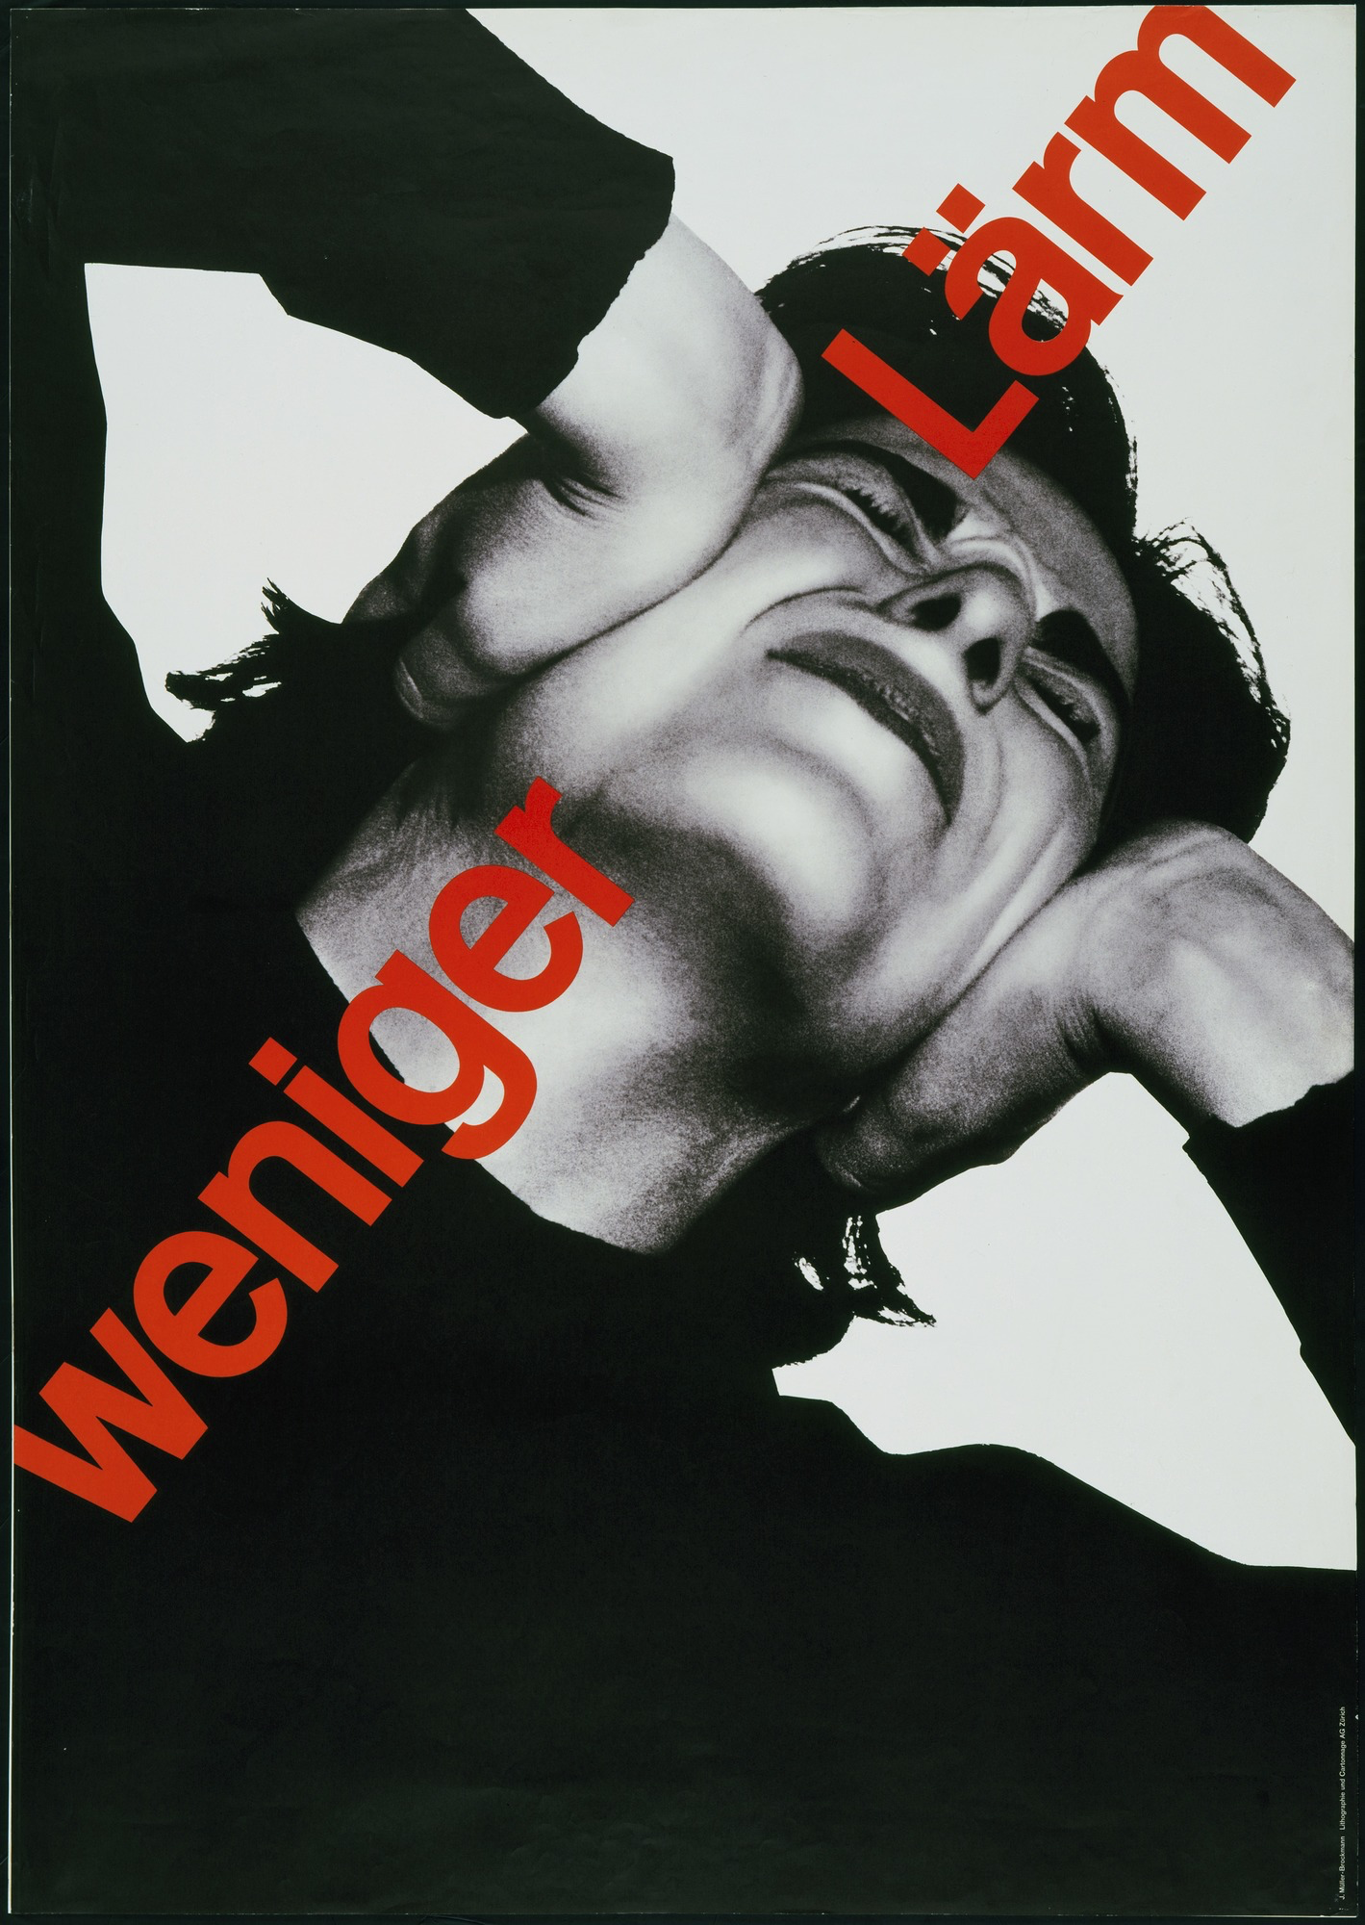
One artist who played a big part in the development of Swiss Style design is Josef Müller-Brockmann who could be considered as “one of the most important and prolific voices of twentieth century graphic design” (Purcell, 2006). Müller-Brockmann was a Swiss Graphic Designer who in 1936 started his own design studio in Zurich, which is where he designed lots of his posters. Kerry William Purcell goes onto say that Müller-Brockmann considered his posters to mark “social economic, political, and cultural events, as well as mirrors of intellectual and practical activities." (Purcell, 2006)

One of Müller-Brockmann’s pieces that has really stood out in terms of how the colours red, white and black have helped protesting is in his piece called “Weniger Lärm, 1960”. This piece shows someone covering their ears with their hands looking very distressed combined with the words ‘Weniger Lärm’ which can translate to ‘less noise’ in a red sans serif typeface. The purpose of this poster was to raise awareness of noise pollution that was increasing during the 1950s. This is in contrast to the period of the 1930s when people were captivated by the speed of technology; especially with cars and aeroplanes becoming more advanced and celebrated. Although Müller-Brockmann was known to use a combination of photography and type within his posters, it is unknown why he used the colour red for the typeface and the black and white image. Despite that, we can gather that the use of the black and white image brings more attention to the positive and negative space which is highlighted by the clothing worn. This negative and positive space also makes the red typeface more prominent and makes the message of the image of more importance.

How Punk was influenced by red, white and black through the 1970s

In the 1970s emerged the punk rock scene, where the use of dark colours were highly thought of as it allowed ‘punks’ to express themselves, “to ally with subculture, to identify with like-minded others, to distance themselves from social ideas they dislike, to be individually creative.” (DeLong and Martinson, 2012)

Punk rock is often heavily associated with music, however it has been applied to many areas including poetry, fashion, politics and design. Danny Fields who is the former Ramones manager states that punk “implies youth (“youthiness”?), sexiness, originality, belonging, spontaneity, rebellion, humor (one hopes) and a mode that’s very stylish and a bit transgressive.” (D. Shea, 2016)

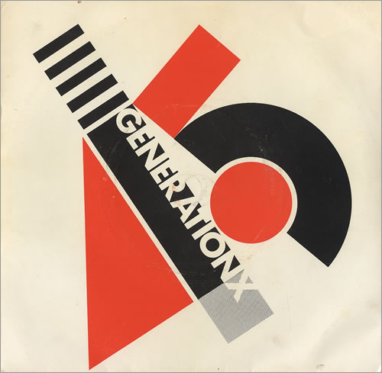
There were many great graphic designers creating record sleeve covers during this time for instance; Peter Saville, Malcolm Garrett and Alex Steinweiss. However, one artist in particular was regarded as “one of the most influential and enigmatic of graphic designers” (BBC, 2015) of the 1970s and 1980s. Previously known as Colin Fulcher, Barney Bubbles studied lots of different mediums during the early stages of his creative career by studying photography, typography and graphic design at Twickenham College of Technology.

Bubbles found an interest in creating record sleeves for bands and eventually started working alongside many big artists during the 1970s some of which include, Elvis Costello, Hawkwind, The Damned and Generation X.

In 1977, Bubbles created a record sleeve for Generation X for their album ‘Your Generation Day by Day 45’. The use of the geometric shapes and combination of black red and white colours in this sleeve cover reminds us of the works mentioned earlier of Russian Constructivism and the Bauhaus. Furthermore, it has been said that Bubbles was heavily inspired by the works of Henryk Berlewi who was a polish designer who worked alongside the Constructivism and De Stijl movements (Lynam, 2015). As well as that, Berlewi often worked with black, red and silver on white paper similar to El Lissitzksy who he was “decisively influenced by” (Meggs and Purvis, 2012).

It could also be suggested that during the 1980s is when “graphic designers gained a growing understanding and appreciation of their history” (Meggs and Purvis, 2012) and started to revive movements from the 20th century and bring them back, which is also known by the term ‘Retro’. It could be said that this is what Bubbles was doing in the Generation X record sleeve, he was reviving the works of constructivism by using geometric shapes and red, white and black colour combinations that were used by El Lissitsky and Henryk Berlewi.

How the colours red, white and black have been used for protest during the 21st century

In the early 21st century a lot is going on in terms of social and political change. People were starting to become more concerned about ‘globalism’ where large corporations, together with political alliance of political power seemingly controlled the wealth of the world. These large bodies perceived power greater than some countries and therefore the power of democracies to remove these ‘rulers’ were limited. In retaliation to this, protests took place at large institutions like the Stock Markets and outside the UN to try to protest against the undemocratic nature of these large organisations.

The combination of the colours red, white and black are still being used as a means to protest against social injustice. In this part of the chapter, it will be discussed how the combination of these colours were used during the Occupy movement.

The Occupy movement first took place in Wall Street, New York in September 2011. The purpose of this movement was for people “to express their outrage at corporate greed and social inequality” (Addley, 2011) and within a month it’s political and social message “spread to over 950 cities in 80 countries. (Adi, 2015)
Micah White and Kalle Lasn were considered one of the most influential people who inspired the Occupy movement. Micah was the co-founder of the movement whilst Lasn was the founder of Adbusters which was considered “the very leftwing, very well-designed magazine that has railed against consumerism since 1989.” (Kingsley, 2012)
Lasn was expressed to be the man of the branding behind the movement. He and his colleagues created a poster showing a ballerina on the back of a bull which was situated near Wall Street. The poster consists of a black and white image with red bold capitalized text that reads “WHAT IS OUR ONE DEMAND?” as well as the bold capitalized text in white that reads “#OCCUPYWALLSTREET”, “SEPTEMBER 17TH.” and “BRING TENT.” Aesthetically, the use of the black and white image contrasting with the bold red text reminds us of the Weniger Lärm piece by Josef Müller-Brockmann that was looked at earlier. However, from an emotional and psychological perspective it reminds us of the revolutionary movements in Russia because of how the poster is worded, ‘our demand’ meaning the demands of the masses (public). The use of the red text implies the power of their demand.
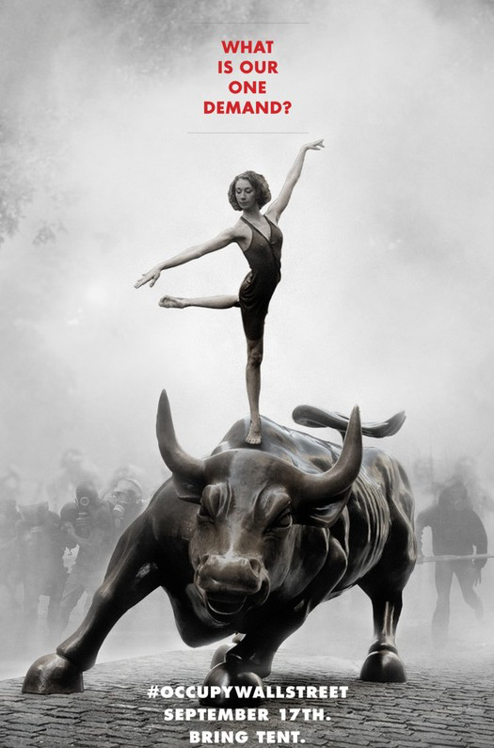
One complication with the Occupy movement is that it didn’t have a consistent branding throughout the movement, whether that was by intention or not. Occupy Wall Street had a variety of different logos but they mainly consisted of a clenched fist in the colours red, white and black. Tae-Sik Kim further restates “Occupy, was usually red or black (85 items) or was white on a red or black background (18 items).” (Kim, 2015)
However, when the Occupy movement came to London in October 15th in 2011, Jonathon Barnbrook designed a new logo for the movement as they were forced to find a new one as the old logo looked identical to the London Underground sign. 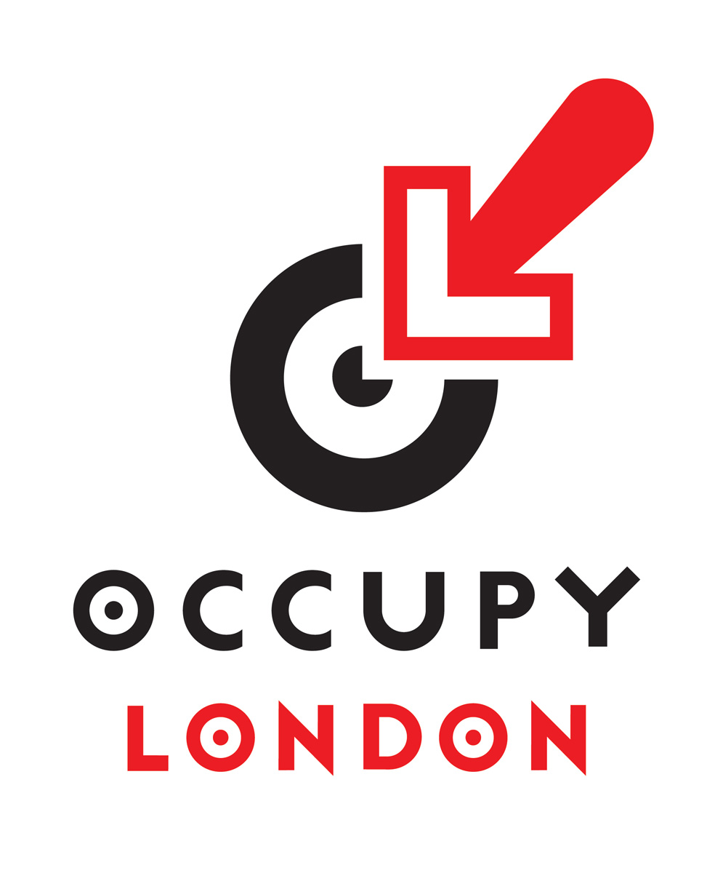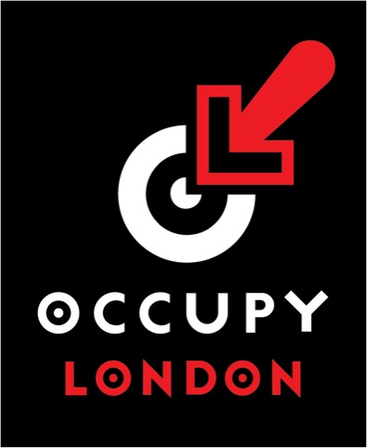
For the new occupy logo, Barnbrook used the “O” for Occupy and “L” for London and used these to create shapes that mimic a target. Furthermore, he uses the colours red, white and black in both versions which suggests that these were colours that represented the occupancy movement especially with the same combination of colours used in the poster created by Lasn. However, it could be said that,
“Although red and black were widely used by local Occupy groups as the color components of their Facebook profile images, the two colors did not specifically symbolize the Occupy Movement, unlike recent social movements that were symbolized by colors” (Kim, 2015)
Speaking to Jonathon Barnbrook about the colours he used within the logo, he states “It is the colour combination that I have defaulted to for many years. I am interested in the history of typography and many illuminated manuscripts use this colour combination.” He further goes on to explain that he was inspired by movements like Futurism, Dadaism and Constructivism as this is where these basic combinations of colours were used. Especially through the works of Constructivism and El Lissitzky as he states “red and black in constructivist work just seems to push the message with more energy and more emphasis”. This further reinstates the power and energy alone that this combination of colour has. Furthermore, he mentions that he wanted to step away from the usual clenched fists logo and give it a modern twist as it had to be reproduced easily
“so it should be chunky enough to stand being drawn by hand, work in one colour but when another colour was possible I felt it had to be a colour that was easily obtainable and a good contrast.“ (Barnbrook, 2019)

Conclusion

To conclude, given the images we have seen over the last 100 years, this combination of colour will continue to be reminiscent of links to periods of revolution and social change. Memories of these images are deeply embedded in our psyche that it arouses the same feelings that change is needed or is coming.

The use of these colours and its contrast can’t be seen as subtle and always creates feelings of drama and interest, particularly when this is combined with its use of simple shapes.

It’s inevitable that the forms of art and graphics will continue to develop its use in ever new and exciting ways in the future.

