University of Wales Trinity Saint David

Wales Institute of Science & Art

BEng Manufacturing Systems Engineering

Module: Control Technology (ACMA6001)
Assignment Title: Predictive Maintenance Strategies

Name: Mathew Soroka
Student ID: 2406846
Date: September 2026

Table of Contents
Table of Figures 3
Table of Tables 3
1. Introduction 4
2. Maintenance Strategies 5
2.1 Reactive, preventive and predictive maintenance 5
2.2 Availability, safety and quality 5
3. Condition Monitoring & Fault Diagnosis 7
4. Case Study Model 9
5. Comparative Analysis 10
6. Discussion 13
7. Conclusions and Recommendations 14
8. References 15
9. Appendix 17
9.1 Appendix A1 - Confusion-matrix results by fault and model 17
9.2 Appendix A2 - Tooth-fault NN label inversion (polarity correction relative to SVM) 18

Table of Figures
Figure 1 - Monitron vibration threshold-alarm dashboard (source: author’s own, Amazon CWL1, 2026). 7
Figure 2 - SVM feature-separation histograms showing feature separability per fault (plotted from the provided dataset). 10
Figure 3 - SVM, untuned NN and tuned NN confusion matrices across the three faults (five-fold cross-validation). 11

Table of Tables
Table 1 - Confusion-matrix outcomes for fault detection (Melgaard et al., 2022). 10

Introduction
Pump P-2201A is the crude charge pump on the crude distillation unit (CDU) at Aberdaron Point Refinery, driven by a 630kW motor through a two-speed gearbox. As one of the most critical machines on site, its failure carries serious consequences. If it trips before the standby can be started, the whole unit shuts down at roughly £45,000 an hour, followed by a 10 to 12 week wait for a replacement gearbox. This proved to be a genuine risk in 2024, when the gearbox failed during a start-up after gear damage had developed unnoticed over several months. The reliability team responded by fitting condition monitoring, using a casing-mounted accelerometer and shaft tachometers.
At present an engineer still reviews this data by hand at approximately two-week intervals. As the site has only one such pump assembly and little real failure data, a physics-based Simulink model is used to generate labelled vibration data for healthy and faulty conditions. Two classifiers are then compared on it, a feature-based support vector machine (SVM) and a raw-spectrum neural network (NN).
The aim is to determine and justify to the reliability manager which classifier better automates fault detection and diagnosis. To do so, the report first reviews maintenance strategies and condition-monitoring methods, before describing the dataset, comparing the two classifiers and recommending an approach.

Maintenance Strategies
How an operator maintains its equipment directly affects availability, safety and product quality. It is also a large share of an asset's whole-life cost (Pinciroli et al., 2023). The options range from reactive to fully predictive, so P-2201A provides a useful case for why the choice matters.

2.1 Reactive, preventive and predictive maintenance
Reactive, or run-to-failure, maintenance acts only after a breakdown. It minimises planned work but exposes the organisation to unplanned downtime, secondary damage and safety risk, which for P-2201A means a CDU shutdown of about £45,000 per hour plus a multi-week rebuild. Preventive maintenance instead services on a fixed schedule, reducing stoppages but, because it follows supplier intervals rather than condition, prompting work later judged unnecessary (Zonta et al., 2022).
Predictive maintenance (PdM) uses real-time monitoring to predict developing failures, so interventions may be planned in advance. Es-Sakali et al. (2022) report cost reductions of 25 to 35% and breakdown reductions of 70 to 75% against reactive regimes, though Nunes et al. (2023) stress that such gains depend on the asset's criticality rather than applying universally. PdM carries sensor and analytics costs, so it is justified where criticality warrants it, which for P-2201A the cost and lead-time exposure clearly does.

2.2 Availability, safety and quality
Availability is measured through Mean Time Between Failures (MTBF) and Mean Time To Repair (MTTR), combined in Overall Equipment Effectiveness. By detecting degradation early, PdM raises MTBF and shortens effective MTTR, as parts and labour can be marshalled before the standby is exhausted. This is decisive given the 10-to-12-week gearbox lead time.
Safety implications are just as direct as the availability ones. On a crude charge pump a seized output shaft is a potential loss-of-containment event rather than merely a production loss, so early detection carries real process-safety value. A silently drifted instrument can also mask a developing fault or raise false alarms that erode operator trust. This is reflected in industry standards such as BS ISO 17359, the guidelines for condition monitoring and diagnostics of machines. They direct monitoring towards root-cause failure modes and rank criticality by safety and environmental impact (BS ISO, 2018).
Product quality is also affected, as breakdowns introduce process variability that degrades capability. By keeping equipment within its healthy envelope, PdM stabilises the conditions on which distillation quality depends. These benefits are realised in practice through wireless platforms such as Amazon's Monitron (Chen et al., 2023). As Section 3 sets out, a trained classifier then interprets that stream more intelligently than a fixed threshold alarm.

Condition Monitoring & Fault Diagnosis
Condition monitoring (CM) judges the health of an asset from measured signals so faults are caught before failure. It is useful to separate detection, recognising that something has changed, from diagnosis, identifying which fault it is. On P-2201A vibration is the primary indicator, since a developing mechanical fault changes how the machine vibrates (Ma et al., 2025). Gear tooth damage and shaft wear, alter the vibration, whereas sensor drift is an instrument fault that does not.
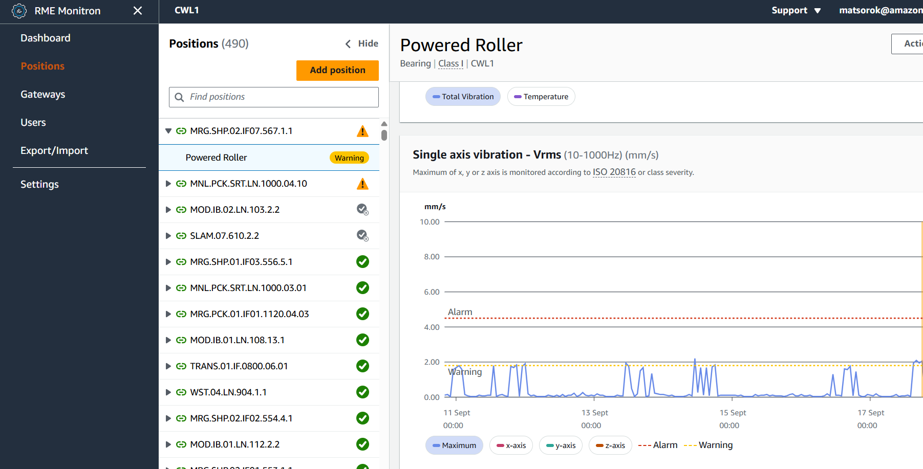
The simplest method is the manual review used on P-2201A today, where an engineer inspects vibration trends at roughly two-week intervals, which is intermittent and can miss a developing fault. A more automated option is the threshold alarm, comparing an overall level (typically Vrms) against fixed limits. Amazon does this with Monitron, whose sensors send vibration and temperature readings to the Amazon Web Services (AWS) cloud, where they are checked against ISO limits and shown on a dashboard (Figure 1). This is effective and standards-based, but an overall level only shows that something has changed, not which fault it is.
Figure 1 - Monitron vibration threshold-alarm dashboard (source: author’s own, Amazon CWL1, 2026).

Signal processing goes further still by working with the frequency content of the signal. The fast Fourier transform (FFT) breaks the spectrum into components, so a fault can be matched to the frequency range it excites. Indicators such as root mean square (RMS) and kurtosis then track the degradation over time. Tiboni et al. (2022) note that reliable diagnosis depends on separating genuine fault changes from normal variation in speed and load. These methods suit the two mechanical faults but offer little for sensor drift, which produces no fault frequency to find.
Machine-learning methods instead learn the fault-to-signal mapping from data, so a trained classifier can diagnose directly rather than merely flagging a change. Feature-based models such as support vector machines learn from engineered measurements, whereas deep networks work from the raw spectrum. This deep approach has been shown to track developing bearing defects in real time (Shi et al., 2023). Zhu et al. (2023) argue that its automated feature learning is what lets deep methods overcome the reliance on expert-chosen features and the over-fitting that limits conventional machine learning. The trade-off is that they need more data and are harder to interpret.
Conventional CM is cheap, clear and dependable at detection, but it does not identify which fault is present and misses sensor drift. Artificial intelligence (AI) methods can diagnose all three, at the cost of needing good data. A classifier is therefore worth using on P-2201A if it names the faults accurately, alongside the threshold monitoring already in place. Sections 4 and 5 test this on the synthetic data.

Case Study Model
P-2201A is a single pump assembly with no history of recorded failures, so there is too little real fault data to train a classifier. A physics-based Simulink model of the drivetrain, built from Simscape Driveline blocks, is used instead to produce labelled data for healthy and faulty conditions. Kahr et al. (2022) note that measured failure data is scarce and machine-specific, whereas simulation covers more.
Three fault modes are built into the Simulink model, gear tooth damage, output shaft wear and sensor drift, each controlled by its own parameter (ToothFaultGain, ShaftWear and SDrift). In fault labelling, every run receives a code from 0 to 7 formed by adding the faults, so one number records whether it is healthy, has one fault, or a combination.
The data comes from an ensemble simulation, meaning the model is run many times across different fault settings to give 208 runs. The first ten seconds of each are removed to take out the start-up transient, so only steady running is kept, where a fault shows its true signature.
The two models then use this prepared data in different ways. For the SVM, feature extraction reduces each signal to eighteen summary measurements saved with the fault label. The neural network instead uses the full frequency signal and identifies the patterns itself. Both use the same runs and labels for the Section 5 comparison.

Comparative Analysis
The two approaches were compared on the same 208 runs and the same fault labels, so any difference in performance reflected how each method used that data rather than a different dataset. Each fault was treated as a separate yes or no problem.
The two models drew on that shared data in different forms. The SVM was trained on the eighteen extracted features, known as the feature data. The neural network instead took the normalised frequency spectrum of the raw signal, with normalisation learned from the training data only so no test-set information leaks into training. Before training each network, rng(0) was used to fix MATLAB's random number generator, so the weights and biases initialise identically and the results are repeatable. The network was assessed first with its default settings and then after tuning. As the dataset is small, five-fold cross-validation was used throughout, testing every run once and averaging over five splits so a single lucky or unlucky split cannot distort the result.
Performance was judged using accuracy alongside the confusion matrix, whose four outcomes are defined in Table 1.
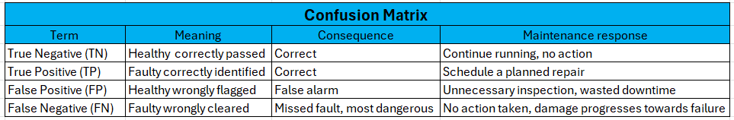
Table 1 - Confusion-matrix outcomes for fault detection (Melgaard et al., 2022).

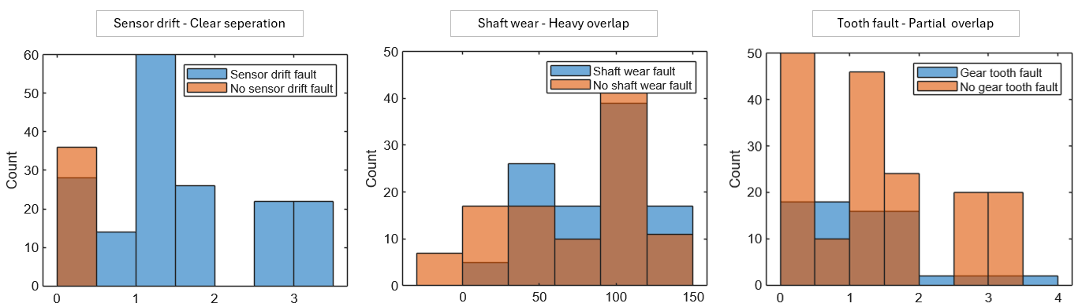
Rather than the raw signal, the SVM learns from the eighteen features. Feature selection keeps only the most useful ones for each fault, an approach well established for rotating-machine fault diagnosis (Yu et al., 2022). On this basis it detected sensor drift and gear tooth damage well, at 89.9% and 94.7%, but struggled with shaft wear at only 60.6%. Why the SVM performed as it did on each fault can be seen in the feature histograms in Figure 2.
Figure 2 - SVM feature-separation histograms showing feature separability per fault (plotted from the provided dataset).
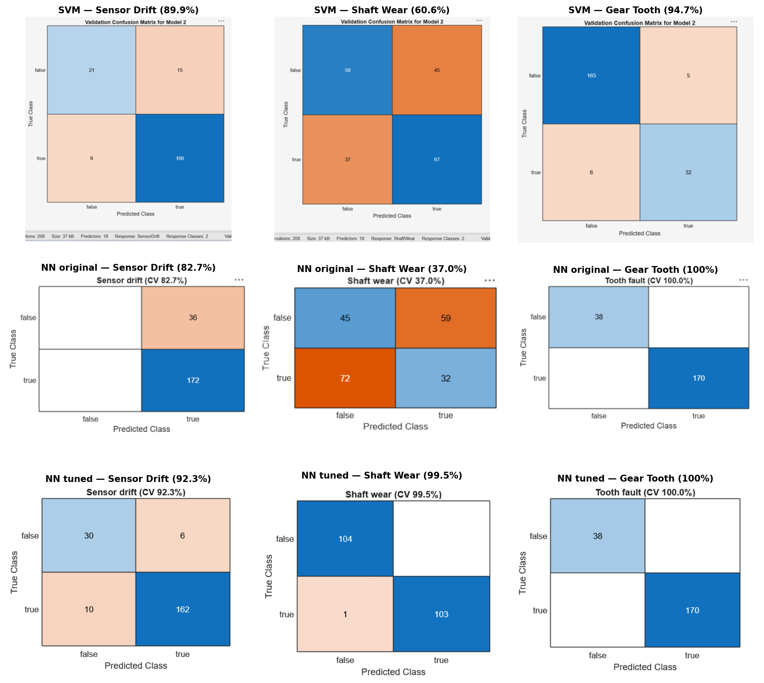
For sensor drift the two groups separate almost completely, which is why the SVM reached 89.9%. For shaft wear the faulty and healthy runs overlap across the whole range, so no clear boundary exists, matching the weak 60.6%. Gear tooth damage sits between the two, consistent with 94.7%. The per-fault results for all three models are shown in the confusion matrices in Figure 3, with the full counts given in Appendix A1.
Figure 3 - SVM, untuned NN and tuned NN confusion matrices across the three faults (five-fold cross-validation).
In its default state the neural network was worse, reaching just 35.6% on shaft wear, while its 82.7% on drift came from labelling almost every run as faulty rather than from real detection. Tuning the network changed this picture markedly. Lowering the regularisation, reducing the hidden layer and switching the activation to tanh raised shaft wear from 35.6% to 99.5%, while lifting drift to 92.3% and holding gear tooth at 100%. The tuned network therefore outperformed the SVM on every fault, most importantly solving the shaft-wear case that both had previously failed.
Overall, the tuned neural network was the strongest performer, beating the SVM on all three faults and detecting shaft wear almost perfectly. The reason accuracy alone can mislead, along with what this means for deployment, is examined in Section 6.

Discussion
The results show that some faults are far easier to detect than others. Gear tooth damage was the easiest, at 100% for the network and 94.7% for the SVM, because the tooth-mesh disturbance leaves a strong repeating signature in both the features and the spectrum. Sensor drift was next, because a drifting sensor adds a steady offset that shows up clearly in the measurements. Shaft wear was the hardest, since its effect overlaps with normal speed and load changes, so no single feature separates it from healthy running. This is why the SVM fell to 60.6% on shaft wear, where tuning the network mattered most.
A high accuracy figure can mislead, so the confusion matrices matter. The most important cell is the false negative, a missed fault, since on a crude charge pump this lets damage progress toward failure and possible loss of containment. A false alarm is less costly but still erodes trust and wastes downtime. This is where the tuned network stands apart, missing only one shaft-wear fault of 104 with no false alarms, against the SVM which missed 37 and raised 45. The default network showed the opposite failure, scoring 82.7% on drift while detecting nothing useful. The predictive to functional failure (P-F) interval captures why these matters. A missed fault leaves no usable window, whereas early detection widens the time to plan a repair, which is decisive given the ten-to-twelve-week gearbox lead time.
For deployment on P-2201A, the tuned neural network is the most suitable model, since it detects all three faults reliably, including the shaft wear that both the SVM and the default network missed. The key lesson is that the improvement came from tuning rather than the method alone, as lower regularisation let the network learn the fault patterns instead of over-smoothing them. The SVM remains a useful, simpler cross-check, but the tuned network gives the safety margin the pump requires.

Conclusions and Recommendations
This report compared a linear support vector machine with a raw-spectrum neural network for detecting three faults on the P-2201A drivetrain. The SVM was reasonable but weak on shaft wear, while the network was poor until it was tuned. Once tuned, the network detected all three faults reliably, reaching 92.3% on sensor drift, 99.5% on shaft wear and 100% on gear tooth damage.
The recommendation for the refinery is to deploy the tuned neural network as the primary classifier, since it detects the safety-critical faults reliably, with the SVM kept as a simpler cross-check. The missed-fault rate should be treated as more important than overall accuracy. The main limitations are the small synthetic dataset and the reliance on tuning. A data-quality issue was also noted in the tooth-fault labels. In the raw data used by the neural network the fault appears to be coded the opposite way round to the feature data. This reversed the network's tooth-fault output, as shown by the confusion matrix and code in Appendix A2. A future fix would apply the logical NOT operator to the labels to reverse the true and false values, so the two datasets align. Further work should gather more balanced fault data, verify label conventions, then confirm the tuned settings on live plant data before deployment.

References
Chen, J., Huang, R., Chen, Z., Mao, W. and Li, W. (2023). Transfer learning algorithms for bearing remaining useful life prediction: A comprehensive review from an industrial application perspective. Mechanical Systems and Signal Processing, [online] 193, p.110239. doi:10.1016/j.ymssp.2023.110239. Available at: https://doi.org/10.1016/j.ymssp.2023.110239 [Accessed 9 September 2026].
Es-Sakali, N., Cherkaoui, M., Mghazli, M.O. and Naimi, Z. (2022). Review of predictive maintenance algorithms applied to HVAC systems. Energy Reports, [online] 8(9), pp.1003–1012. doi:10.1016/j.egyr.2022.07.130. Available at: https://doi.org/10.1016/j.egyr.2022.07.130 [Accessed 8 August 2026].
ISO (2018). ISO 17359: Condition monitoring and diagnostics of machines - general guidelines. [online] Available at: https://cdn.standards.iteh.ai/samples/71194/c551f4c170654bb19be2ee017d144969/ISO-17359-2018.pdf [Accessed 9 Sept. 2026].
Kahr, M., Kovács, G., Loinig, M. and Brückl, H. (2022). Condition monitoring of ball bearings based on machine learning with synthetically generated data. Sensors, [online] 22(7), p.2490. doi:10.3390/s22072490. Available at: https://doi.org/10.3390/s22072490 [Accessed 12 September 2026].
Ma, L., Li, Z., Yang, S. and Wang, J. (2025). A review on vibration sensor: Key parameters, fundamental principles, and recent progress on industrial monitoring applications. Vibration, [online] 8(4), p.56. doi:10.3390/vibration8040056. Available at: https://doi.org/10.3390/vibration8040056 [Accessed 10 September 2026].
Melgaard, S.P., Andersen, K.H., Marszal-Pomianowska, A., Jensen, R.L. and Heiselberg, P.K. (2022). Fault detection and diagnosis encyclopedia for building systems: A systematic review. Energies, [online] 15(12), p.4366. doi:10.3390/en15124366. Available at: https://doi.org/10.3390/en15124366 [Accessed 15 September 2026].
Nunes, P., Rocha, E. and Santos, J.P. (2023). Using intelligent edge devices for predictive maintenance on injection molds. Applied Sciences, [online] 13(12), pp.7131–7131. doi:10.3390/app13127131. Available at: https://doi.org/10.3390/app13127131 [Accessed 28 August 2026].
Pinciroli, L., Baraldi, P. and Zio, E. (2023). Maintenance optimization in industry 4.0. Reliability Engineering & System Safety, [online] 234, p.109204. doi:10.1016/j.ress.2023.109204. Available at: https://doi.org/10.1016/j.ress.2023.109204 [Accessed 15 August 2026].
Shi, H., Song, Z., Bai, X., Hu, Y., Li, T. and Zhang, K. (2023). A novel digital twin model for dynamical updating and real-time mapping of local defect extension in rolling bearings. Mechanical Systems and Signal Processing, [online] 193, p.110255. doi:10.1016/j.ymssp.2023.110255. Available at: https://doi.org/10.1016/j.ymssp.2023.110255 [Accessed 11 September 2026].
Tiboni, M., Remino, C., Bussola, R. and Amici, C. (2022). A review on vibration-based condition monitoring of rotating machinery. Applied Sciences, [online] 12(3), p.972. doi:10.3390/app12030972. Available at: https://doi.org/10.3390/app12030972 [Accessed 30 August 2026].
Yu, H.T., Kim, H.J., Park, S.H., Kim, M.H., Jeon, I.S. and Choi, B.K. (2022). Classification of rotary machine fault considering signal differences. Journal of Mechanical Science and Technology, [online] 36(2), pp.517–525. doi:10.1007/s12206-022-0101-2. Available at: https://doi.org/10.1007/s12206-022-0101-2 [Accessed 17 September 2026].
Zhu, Z., Lei, Y., Qi, G., Chai, Y., Mazur, N., An, Y. and Huang, X. (2023). A review of the application of deep learning in intelligent fault diagnosis of rotating machinery. Measurement, [online] 206, p.112346. doi:10.1016/j.measurement.2022.112346. Available at: https://doi.org/10.1016/j.measurement.2022.112346 [Accessed 17 August 2026].
Zonta, T., da Costa, C.A., Zeiser, F.A., de Oliveira Ramos, G., Kunst, R. and da Rosa Righi, R. (2022). A predictive maintenance model for optimizing production schedule using deep neural networks. Journal of Manufacturing Systems, [online] 62, pp.450–462. Available at: https://doi.org/10.1016/j.jmsy.2021.12.013 [Accessed 28 August 2026].

Appendix

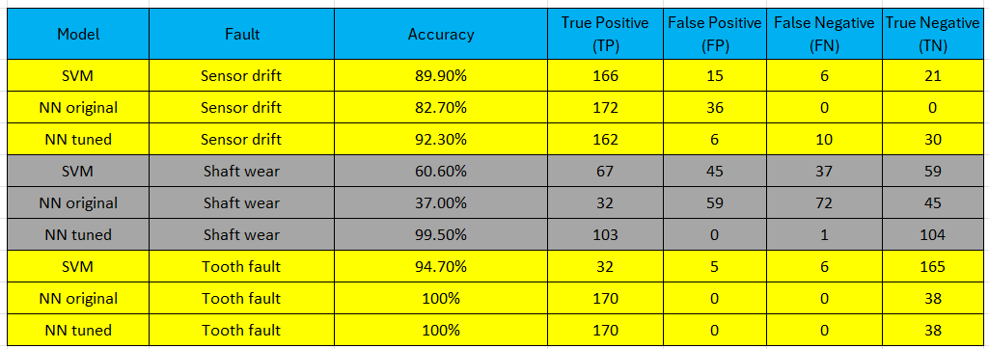
Appendix A1 - Confusion-matrix results by fault and model

9.2 Appendix A2 - Tooth-fault NN label inversion (polarity correction relative to SVM)


