EXAMINATIONS 2016 / 2017
ARHOLIADAU 2016 / 2017

Answer Sheet

Student Name: Ralph Whittaker

Student P Number: P148322

NAME OF COURSE/PROGRAMME: | Test Range Engineering
YEAR OR LEVEL: | Level 5
NAME OF MODULE/UNIT/EXAM PAPER: | Finite Element Analysis
MODULE NO: | M5X00398
DATE OF EXAMINATION: | 11th February 2017
START TIME: | 11:00
FINISH TIME: | 13:00
TIME ALLOWED: | 2 hours

INSTRUCTIONS TO CANDIDATES:

Students need to submit all the Solidworks files and the Word document containing their answers.

1 A)

14000RPM/60 = 233.3333333333333 revolutions per second
1/233.3333333333333 = 0.0043 secs per revolution
2 (revolutions) x 0.0043 = 0.0086 seconds to be solved

B) 14000RPM/60 = 233.3333333333333 revolutions per second

233.3333333333333/ 360 = 6.48 steps/ seconds

c)
Top of conrod
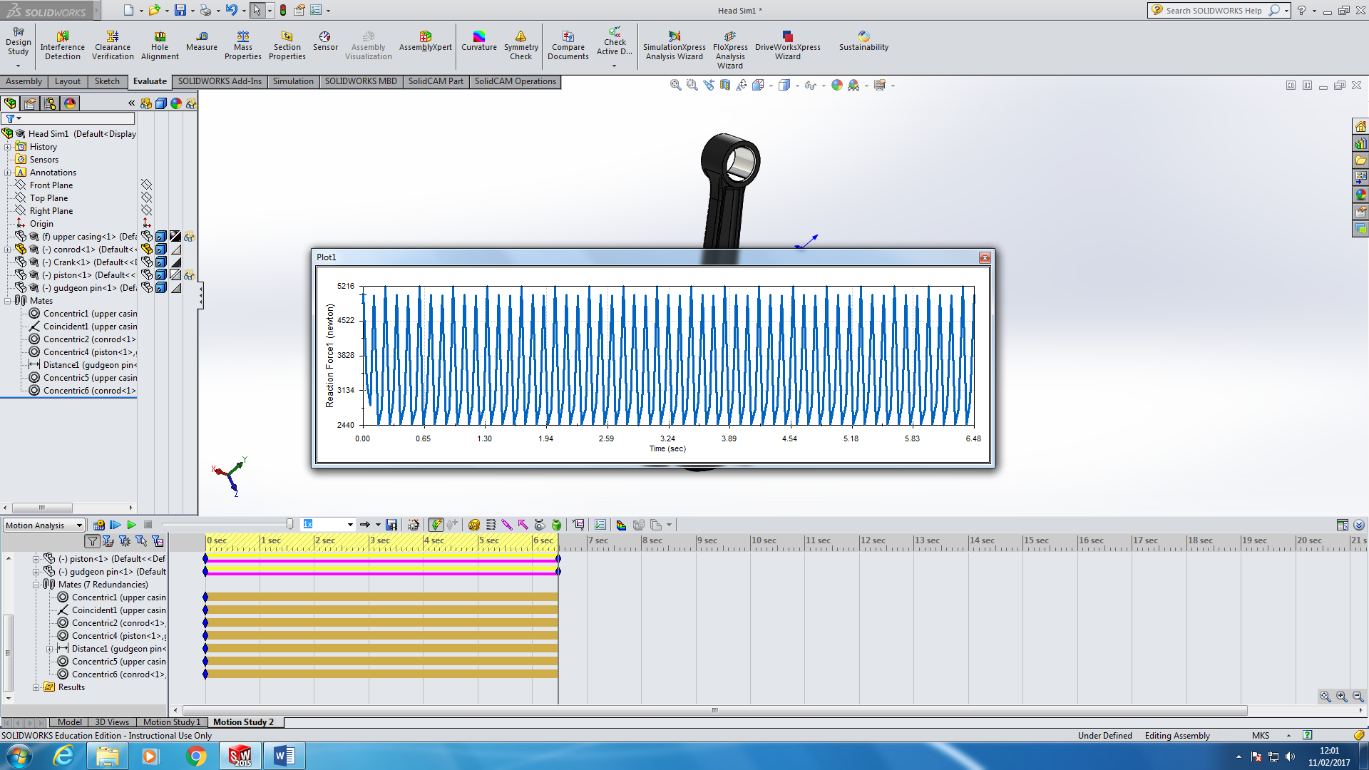
Bottom of conrod
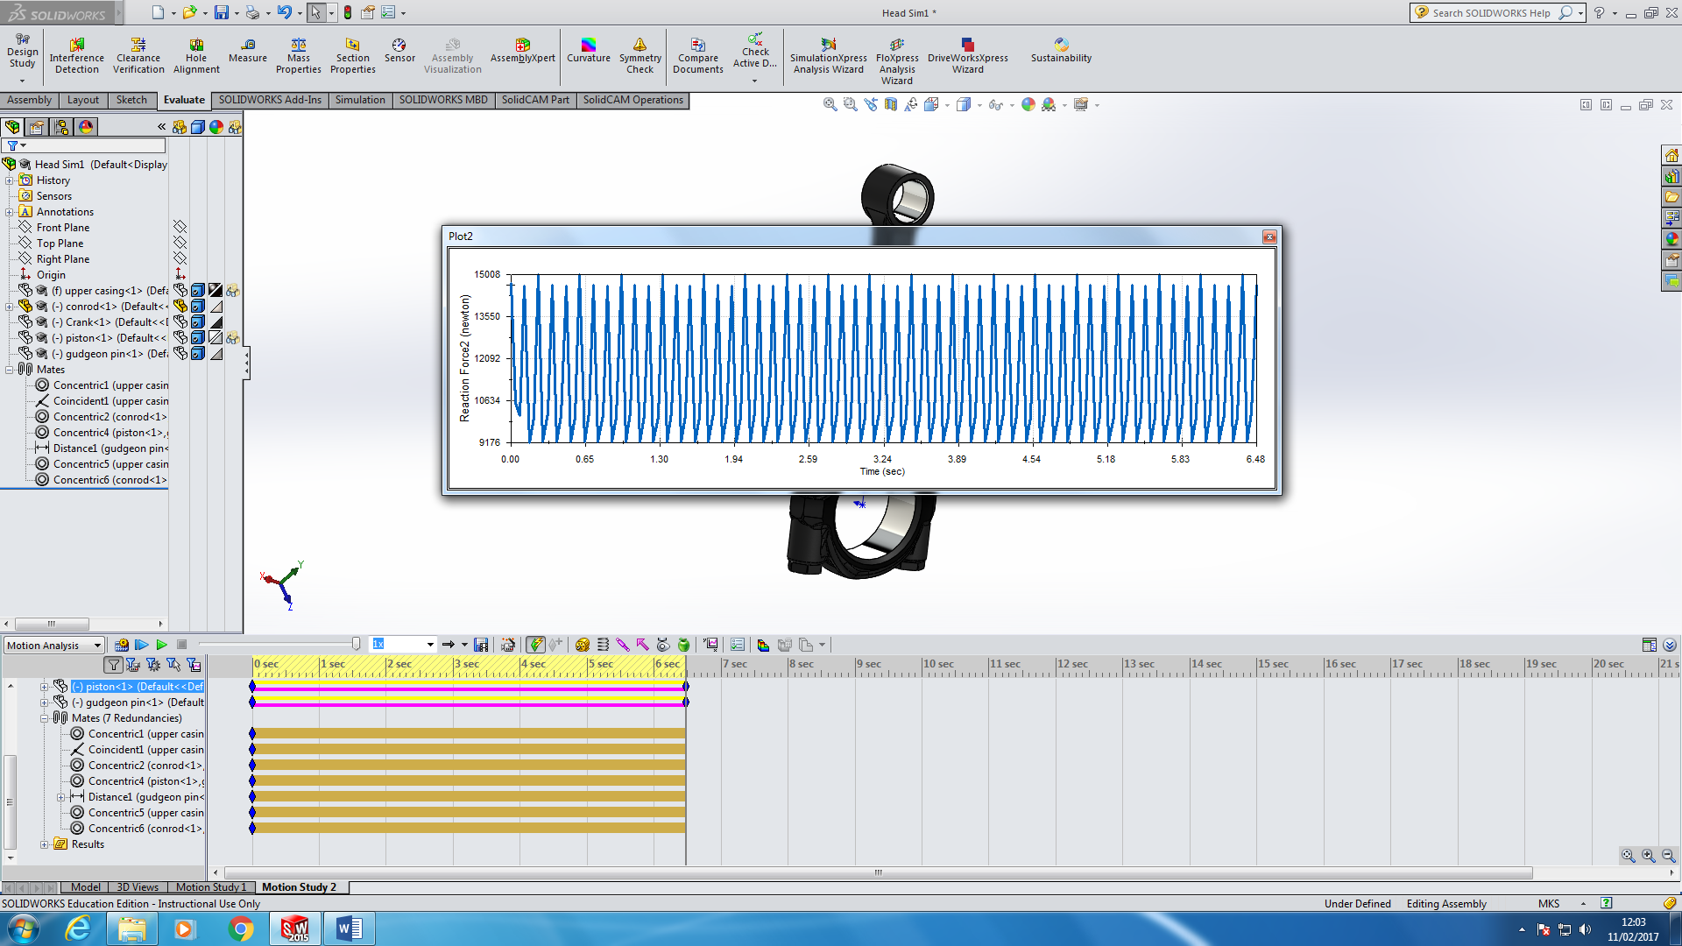

D) Lad bearing faces for the ConRod are

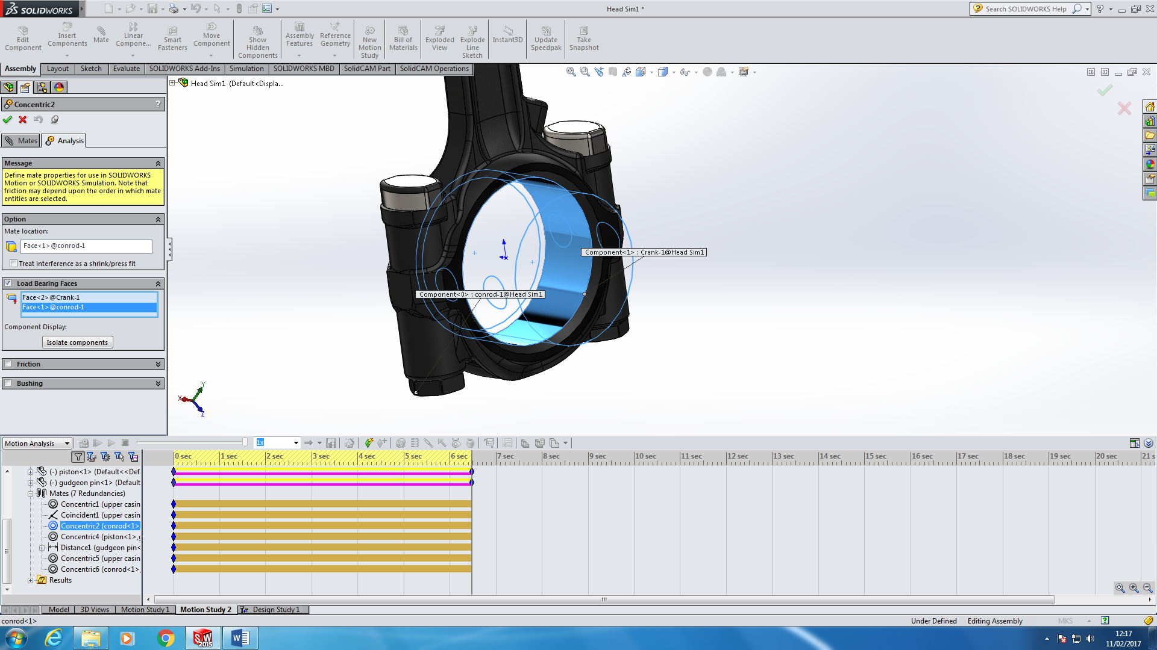

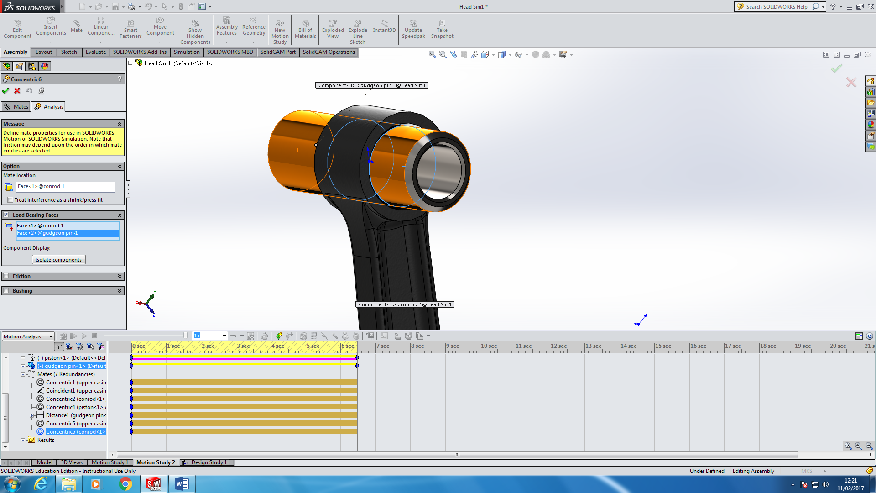

E)
Plot the forces
Analyse where the peak force is
Select the plane but with an offset of 5 degress

2.

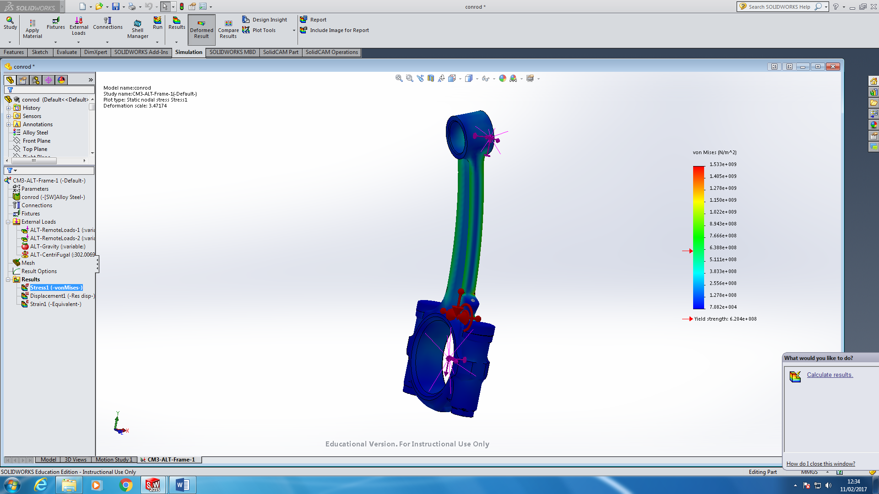
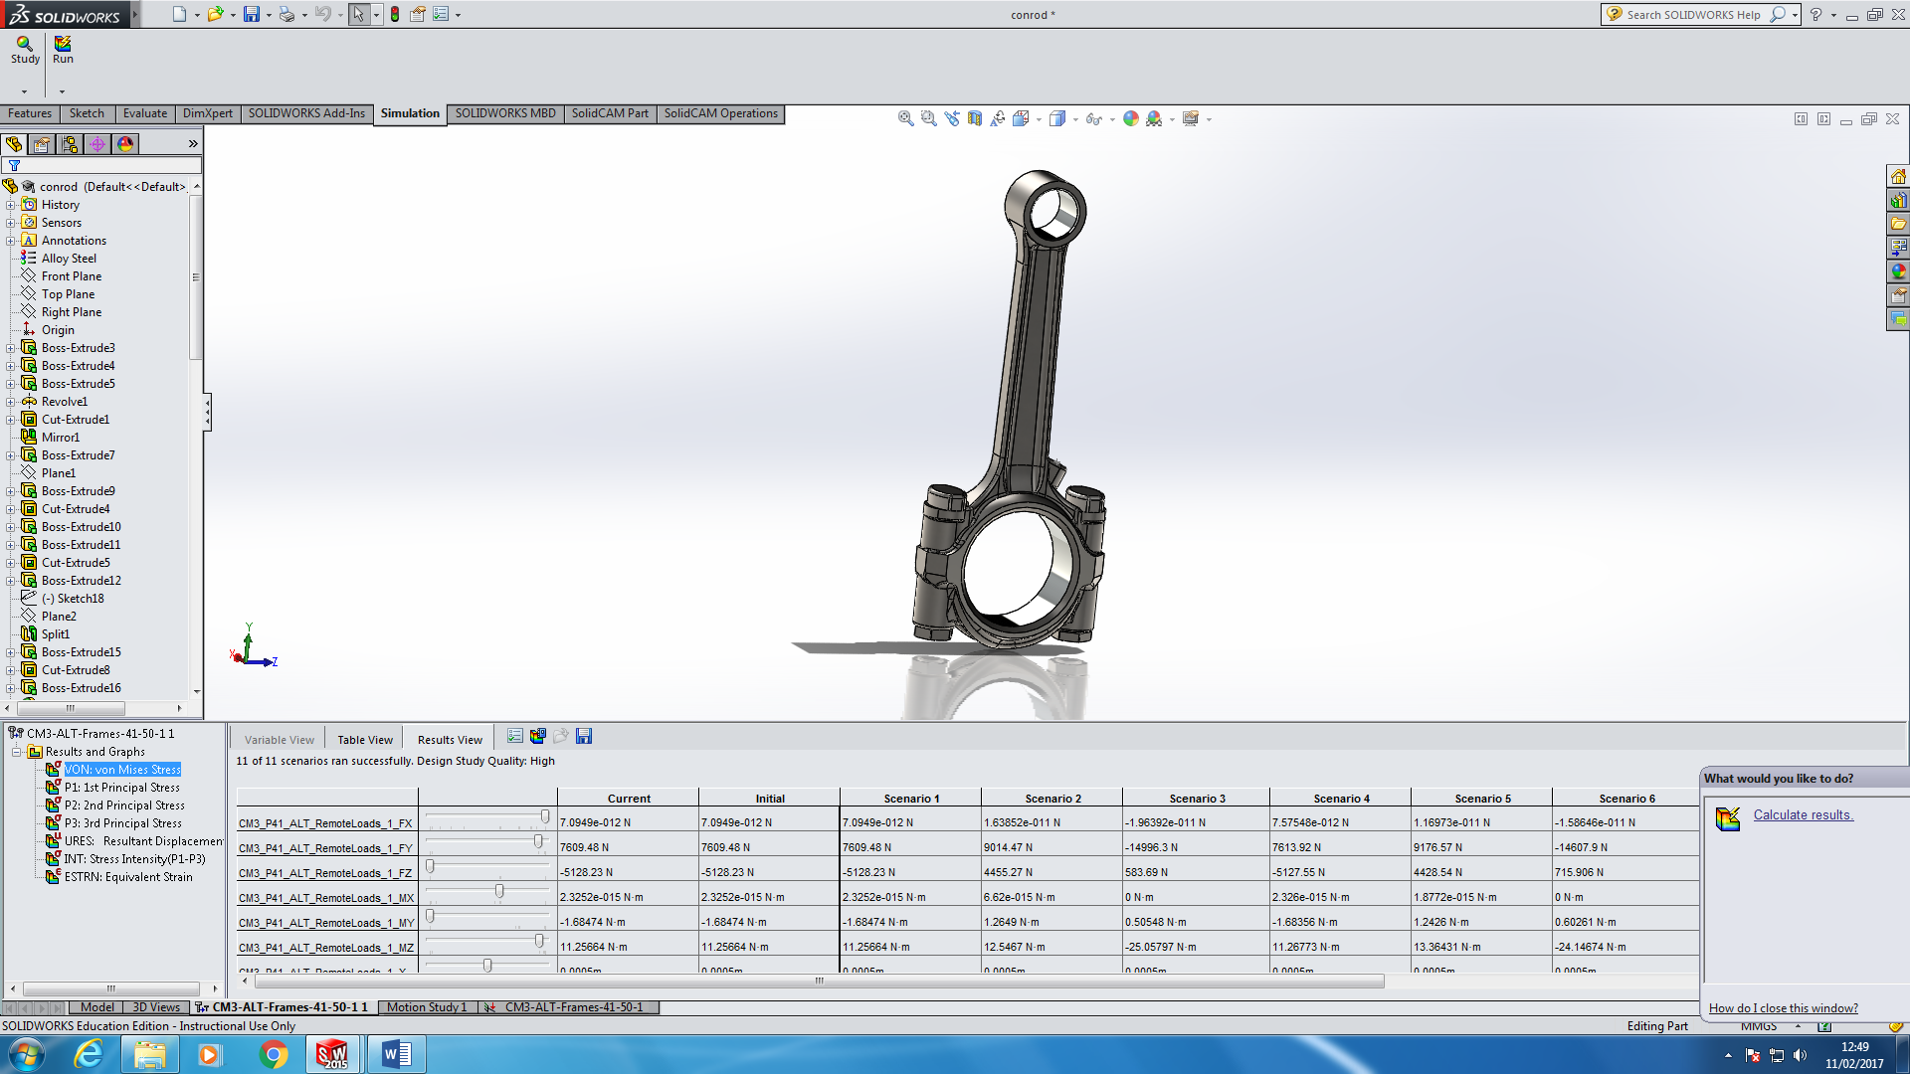
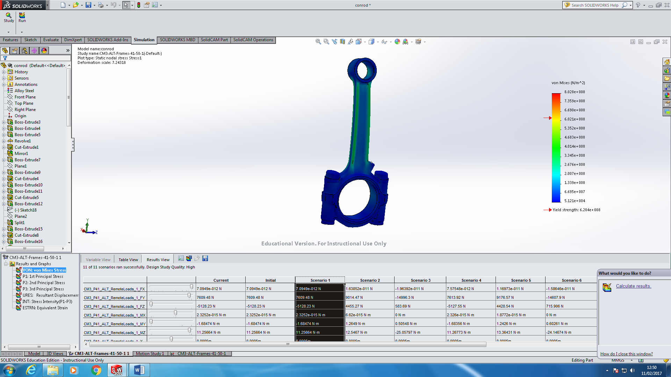

Von mises peak stress is 1112000000 N/M^2
It occurs on the lower section (Shoulder) of the conrod as seen below in red
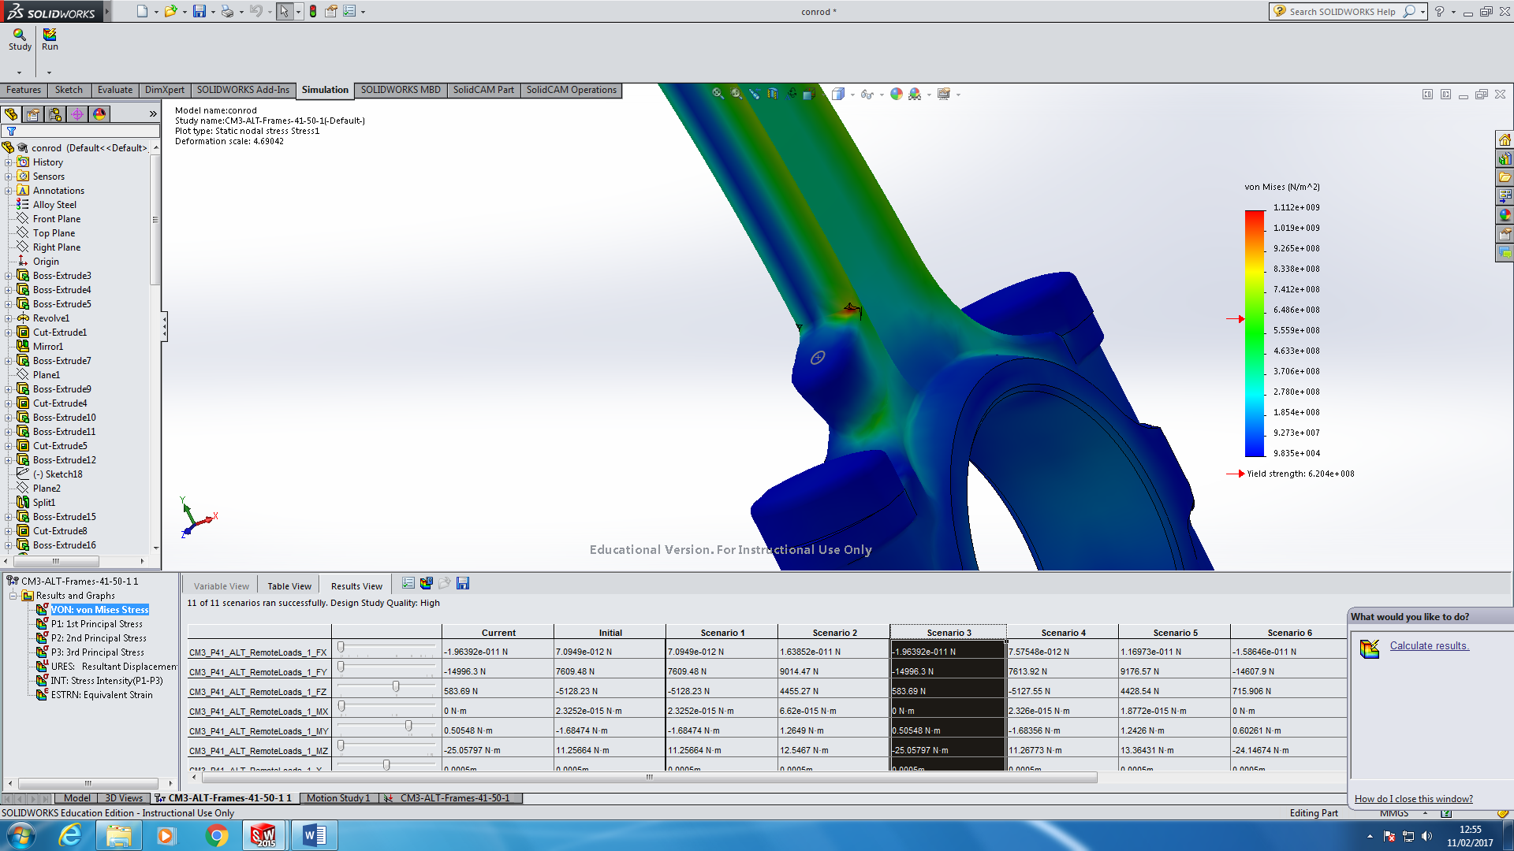

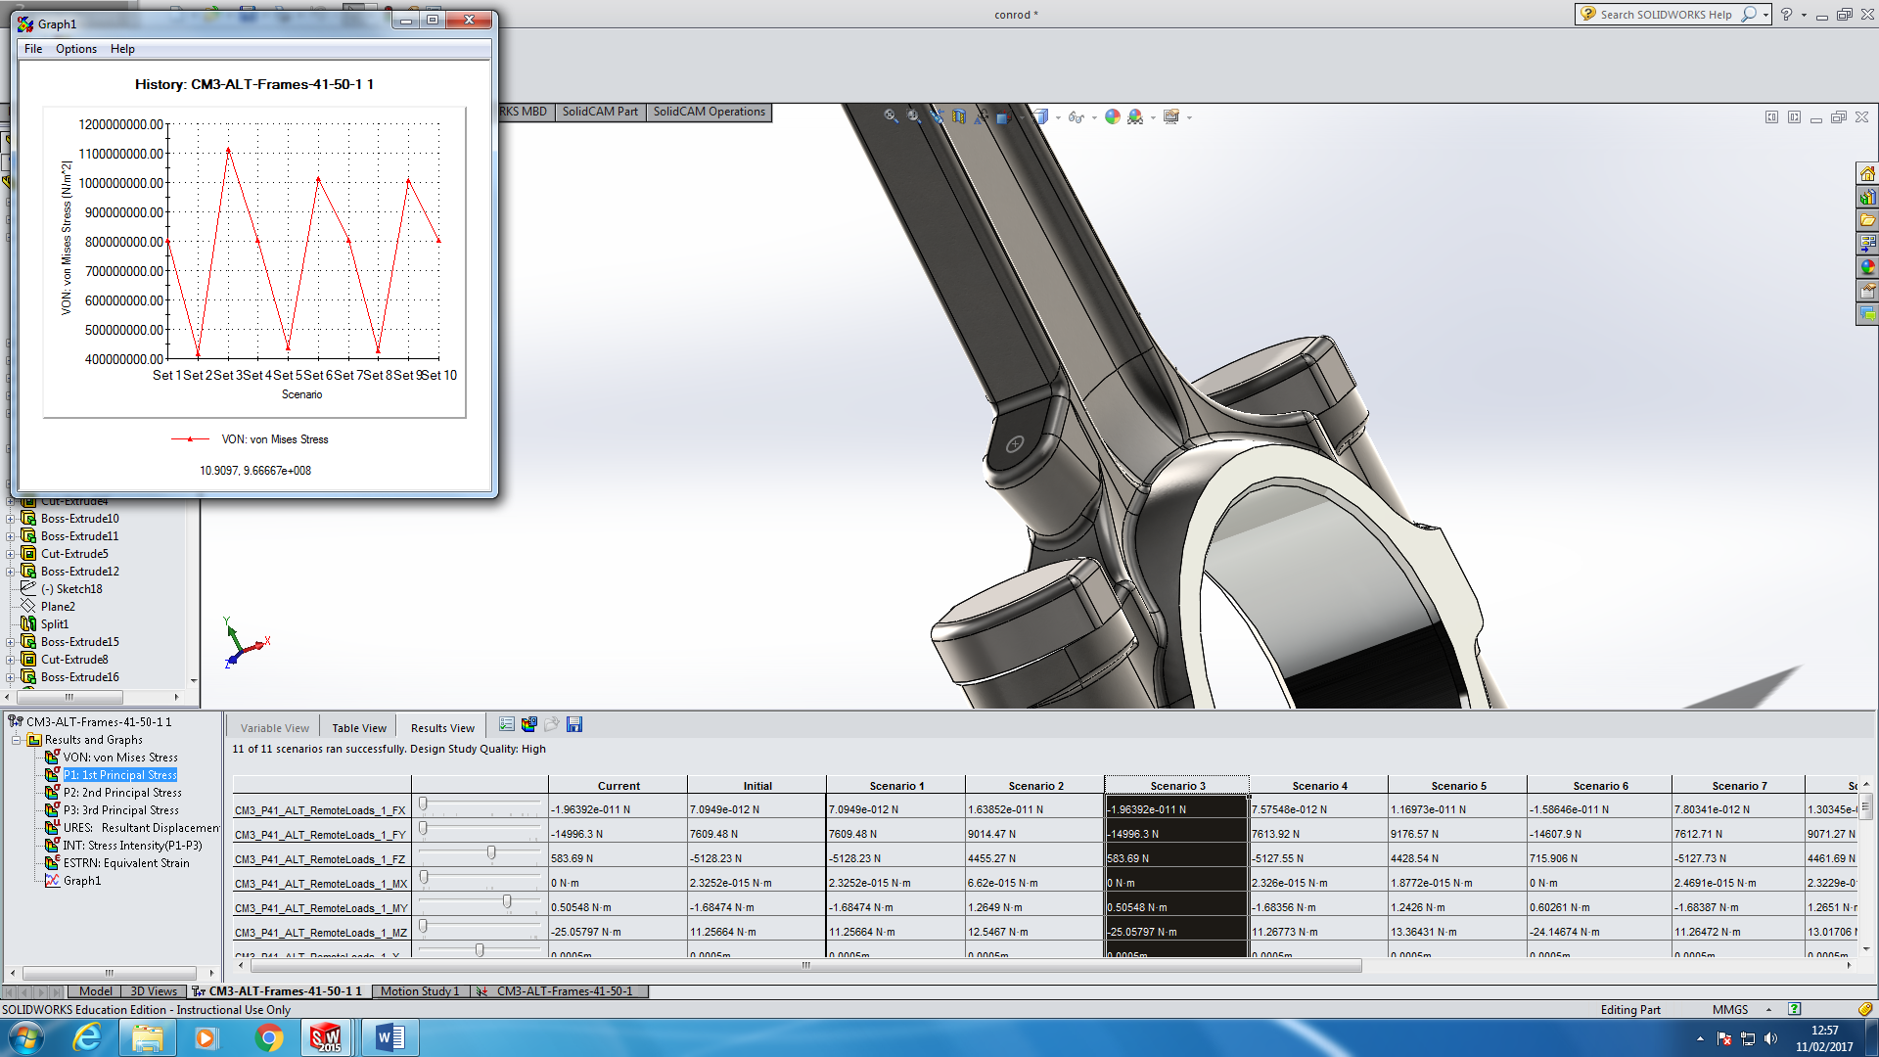

Also as seen on the graph plot.

Deformation is:

c)
No the conrod would fail, it cannot withstand the current loads, it would fail under stress and its design need amending a have a safer FOS level, of at least twice (2). It would crack at this shoulder join due to the forces applied to it.

3. Changing the material would strengthen the conrod.

