Evaluation Essay

Google Headquarter King’s Cross Project


Milena Adzhemova (2129045)
UWTSD, London
Lecturer: Md Sadeque Imam Shaikn
Data: 16.04.24
Contents
Introduction 2
Successful or failure is HQ King’s Cross project? 3
Monitoring and Controlling and Closure 3
SWOT analysis of HQ King’s cross project 7
PESTEL analysis of HQ King’s cross project 8
Lessons learnt from this project 9
Sustainability 9
CDG Google report 2023 10
CSR – Corporate Social Responsibility 12
PPP – People, Planet, Profit 13
Conclusion 14
References 15

Introduction

In this evaluation essay it will be evaluate Google HQ King’s Cross project in London. In earlier essay - assessment one, the project was detailed shown and analysed by critical / success factors, as could be sawn in one still running project.
According to McIntyre, F. (2017) characteristics in Google Headquarter, Kings Cross project are that Bjarke Ingels Group and Heatherwick Studio are designers of the project; it is 93 thousand square meters business office, constructed by healthful materials through Google healthy material program. Google will use 60 000 square meters of the building in combination with the building on 6 St. Pancras and one more building for its campus, where will be accommodate 7 000 employees.
This Google Landscaper is the first completely designed and owned construction of Google in Europe and outside United States. It is eleven storey building, 72 meters tall in its highest part, made from steel, glass and timber, with 25 meters long swimming pool, two hundred meters running trail on the roof and a sports hall with an overview of London. The first levels will be occupied by retail spaces and two stories above will be situated the office, which will be flexible workspace with a lot of daylight.
Google HQ King’s Cross is found on King’s Cross in London, and it is known as Platform G. It extends 330m along the non-vehicular boulevard between Granary Square and Kings Cross station.
This assessment will be focused on two main points – control and monitoring, and closure of the project.

Successful or failure is HQ King’s Cross project?

Monitoring and Controlling and Closure
The project life cycle includes 5 phases:
- Initiating -> 2. Planning -> 3. Execution ->4. Monitoring and Controlling -> 5. Closure
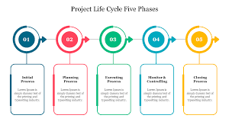
The first step in Execution of a project is Monitoring and Controlling and this the process that ensure was followed the original plan.
In monitoring and controlling t has to be compared the plan in scope and quality, in staff and schedule, budget and cost, time and cost trade-offs.
Monitoring and controlling measures are:
- Critical Path,
- Network diagram,
- Scheduling
- Analysis of Value
In Closure are included the applicable reports for scheduling, budgeting, risk, quality, quality lessons and a lesson given from evaluation of the project.
Based on the critical/success factors the Google HQ King’s Cross project is successful. Critics criticize the project, but actually the big IT Giant is doing quite well on everyone of the ten core elements. These ten fields shaw all of the domains and processes needed for managing every stage in a project. They give structured knowledge for presenting a project within the budget, on time, and meeting the requirements.
The three main factors in a project are cost, quality, and time. Everyone will ask first for three of them.
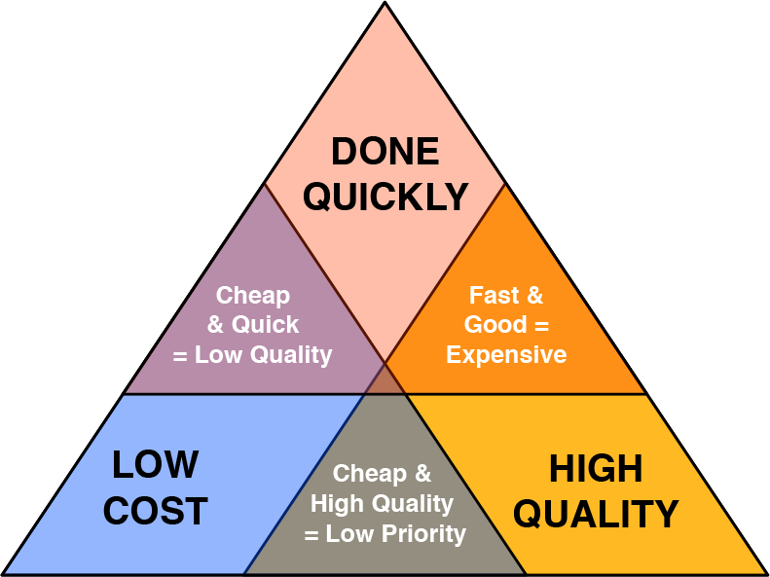 (medium.com, 2018)
Cost - According to Guy@evosite.co.uk (2023) the work on HQ King’s Cross project was started in 2018 with a planned cost of around one billion pounds. Covid 19 pandemic caused delay in the construction and altered some working practices as hybrid and remote work, and this was unknown when the IT Giant was signed the contract. Till now it is not available information the project cost to be increased, which means that for now the performance in cost is successful.
Time – The project firstly was planned to start in 2014 and it was started with delay of 3-4 years. At the same time change in the plan increase the quality of the project. Other point in our valuation is how big delay is normal for so big project. The quality is prioritised in construction and compromises with it can be dangerous.
Quality - HQ King’s Cross is horizontal skyscraper and it is one of the first in this new kind of building, and it is the new future in office construction. (officereality.co.uk, 2022) The Landscaper allows the daylight to get deep inside the building, it is energy efficient, build with healthy materials. There is a Longdon view from the site, twenty-five meters swimming pool and garden on the roof.
assets.officereality.co.uk (2022)

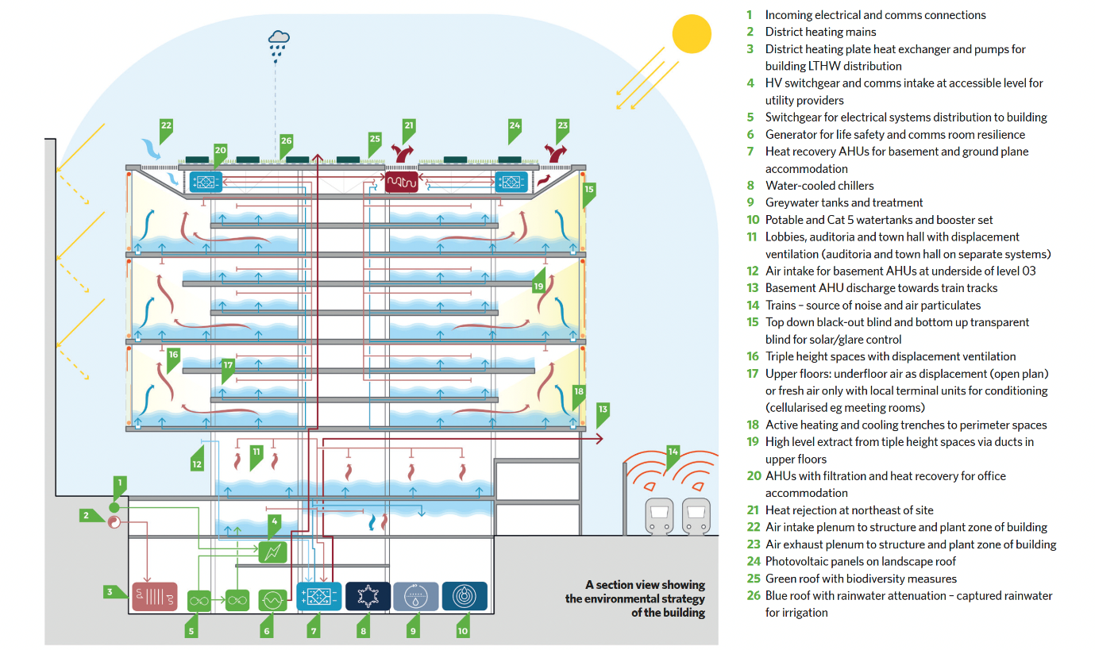
cibsejournal.com (2023)
Below is given a quick viewing of the other core elements:
Scope - Google identified, limited and made a decision what to be included or excluded in the project. They create well established plan, they collected requirements, divided the work to smaller parts (WBS) and made a validation.
Stakeholders – Google choose deeply knowledgeable, experienced, and proved in their work stakeholders.
- Lendlease - global leader in building and designing innovative environmental places, as a main contractor
- AKT II, B certified corporation, as a structural engineer
- Bjarke Ingles Group (BIG) and Heatherwick Studio as concept architects
- BDP – Cat A in architecture, lightning and design, as a design architect
- Gillespies – expert planners, architects and designers, as a landscape specialist
- Gardiner & Theobald – with eighteen offices in UK and US, as cost managers
- Atelier Ten as environmental and building service designer and energy analyst.
Communication – As an IT company specialised in communication their work in this core element is excellent. In the project BIM (building information modelling) allowed early contribution between the contractors and has key role in coordinating services.
Human Resources – When the project was started there was an issue with human resources, then Google made changes.
Risk – Google used risk management strategy to avoid the risk.
Procurement – The project includes combination of employee wellbeing, sustainability, and architectural innovation.
Integration - All elements in the project (resources, tasks, deliverables, and stakeholders) are coordinated and the processes run efficiently.

SWOT analysis of HQ King’s cross project

STRAINTHS | WEAKNESSES
Scope  Cost  Time  Risk  Stakeholders  Communication  Quality  Procurement  Integration | HR  Scope  Time
TREATS | OPPORTUNITIES
Work from home  Bad feedback and strikes from some employees | Profit from retailers  Community engagement  Higher prestige will higher the profit from advertising, investors, and Google services

In scope it was identified and limited and it was decided what to be included in the project or excluded. The plan was established. Google collected requirements, divided the work to smaller parts and made a validation.
They collaborated with knowledgeable and experienced stakeholders.
The Communication in the project is on elevated level. It was used BIM, and it was advanced early contribution between the contractors.
It was used risk management strategy to avoid the risk.
In Procurement management the investors have to highlight the combination of well-being, sustainability, and innovation.
Excellent integration is necessary as all parts in the project has to be coordinated and to work effectively.
Issue in Human resources was found and changed.

PESTEL analysis of HQ King’s cross project
According to thestrategystory.com (2023) main factors, affected Google in PESTEL are:
Political | Economical | Sociocultural | Technological | Environmental | Legal
Government regulation of digital and internet advertising  The main Google’s revenue is from online advertisement and factors as data privacy low, ad regulation, and content policies can affect the company’s profit.  International Trade Policies: Google is global company and if is affect by trade policies, as embargos, tariffs, or antitrust laws.  Access of information: The government controls the access to internet information.  Taxation Policies:  Google’s profit is affected by the tax policy.  .  Data Privacy and Cybersecurity Legislation:  GDPR can affect Google’s operations.  Political Stability: Political instability in the country will affect negatively the growing of Google. | Global Economic Health:  In economic prosperity the business will invest more in ads and raise Googles profit.  Exchange Rates: Google’s revenue is exchanging in dollars and the exchange rate affects the company’s profit.  Inflation Rates. The inflation might increase the operation cost.  Low inflation could allow Google to invest more.  Interest Rates: These rates can affect the company decision to invest.  Unemployment Rates:  In unemployment there are more candidates, but it also can cause low power of consumers and the ads revenue to be lower.  Technological Investment Trends:  The investments in technology and internet can offer more opportunities.  Customers habits for consuming:  The paid Google’s services vary by the ability and willingness to spend. | Digital Culture Adoption:  The digital learning and internet use present more opportunities for the IT Giant’s services  Security concepts and Privacy  Concerns: Different societies have different opinions for privacy data and security.  Language and Localization: Google offers different languages and work accurately to the different cultures .  Customer behaviour and attitude : Changing user behaviours and attitudes towards technology, work-life balance, and sustainability can affect Google. For remote work will be used Google’s productivity tools as Google Workspace and Google meet.  Demographics: The population, ages, income levels and distribution have impact in the business.  Social Movements: climate change or social justice can change brand reputation and the company’s standing in society.  Health Consciousness:  Google provide heftier lifestyle via Google fit. | Rate of Technological Advancement:  The rate of change has to be kept for Google competitiveness.  Artificial Intelligence and Machine Learning: Improving in these areas will bring competitive advantages to Google.  Cybersecurity:  The cybersecurity is important for Google services and the company has to invest in it.  Cloud Computing: Technological developments that enhance cloud services’ speed, security, and ability can provide growth opportunities for Google.  5G Technology: 5G networks can significantly enhance the speed and functionality of Google service.  Blockchain Technology:  It influences cloud computing, secure transactions and other Google services.  Quantum Computing:  Virtual and Augmented Reality: Technological advancements in VR and AR could provide Google with new avenues for growth, such as Google’s ARC ore platform. | Energy Consumption: Google is pressed to invest in energy effective offices and in renewable energy.  E-Waste:  Google has to invest in reducing, recycling, and managing the e-waste.  Climate Change: The impacts of climate change can disrupt Google’s operations.  Carbon Footprint: Google set ambitious targets for carbon neutrality, due to a pressure from consumers, investors, and regulations.  Regulations:  They regulate how much energy is used, the waste disposal, measure the carbon emissions. Google services performance is dependent from the regulation  Societal Expectations: Google is sustainable and put high targets to meet the expectation. | Data Privacy Laws:  They affect how the data to be collect, process, and store.  Intellectual Assets Laws: Google has to protect the intellectual  property for itself and to others.  Antitrust and Rivalry Laws: These laws promote competitions and protect from monopoly. Google’s operations and potential growth strategies depends from  Employment Laws:  Google has to manage working conditions, wages, equal opportunities, and diversity properly.  Cybersecurity Laws:  Protecting the data of users is legal and ethically.  Advertising Laws:  These laws regulate what can be broadcast and how.  Tax Laws:  Taxes laws affect the profit.

- In Pandemic situation
In Covid 19 pandemic Alphabet, which is father’s company of Google raise its profit with 162 %, which is more than double. The lockdown growth the digital services and encourage the advert. In Covid Alphabet increase its revenue from advertising to fifty-five billion dollars, as 6 billion are from Google ads.

- In Recession
The profit of IT Giant depends on advertising. In recession or other economic shock, the advert can be affected and to due to negative impact in Google’s revenue and the profit.

Lessons learnt from this project

Google had an issue in HR, which was solved, but it caused delay and raise the cost.
The lesson for the other investors is they to be extremely careful in everyone core part in the project and to be able to predict unexpected circumstances, which can fail it. In project, which cost a huge amount of money and the investors has to have enough reserves and to use only low level of risk, to collaborate with experienced stakeholders and partners and never to compromise the quality in the construction.

Sustainability
According to Morfaw, J. (2014) in Brundtland report in 1987 is written that sustainable development is improvement, which meet the needs of the present without affecting the capability of the future generations to meet their needs.
In project sustainability this is associate with supervising of project, organizations, institutions, or programs and include efficient production and effectiveness.
Components of sustainability are:
setting the project lifecycle (initiating, planning, executing, monitoring and control, closure), full analysis, stakeholder involvement, clear goal, and philosophy, environmental, financial and risk assessment, HR.
Managed sustainability plan is crucial key for the successful of the project. The project has to be completed and to help the stakeholders in future and supporting with the sustainability principles.
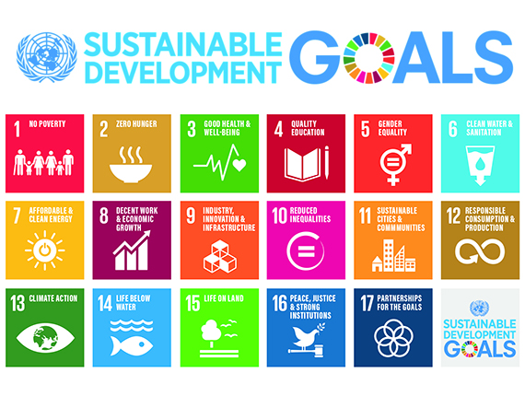
th.bing.com (no date)

CDG Google report 2023
Google sustainable strategy
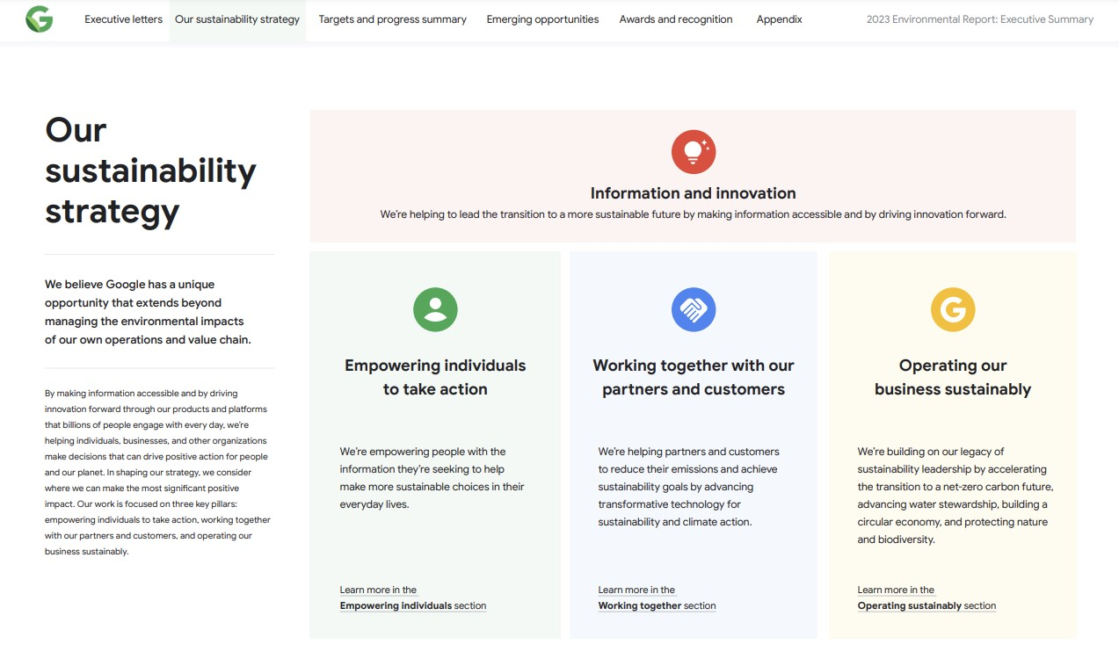Google environmental report (2023)

Googles Sustainability strategies are:
- 1.Empowering individuals to act
- 2.Collaborating with our partners and customers
- 3.Running our business sustainably
Google targets and progress summary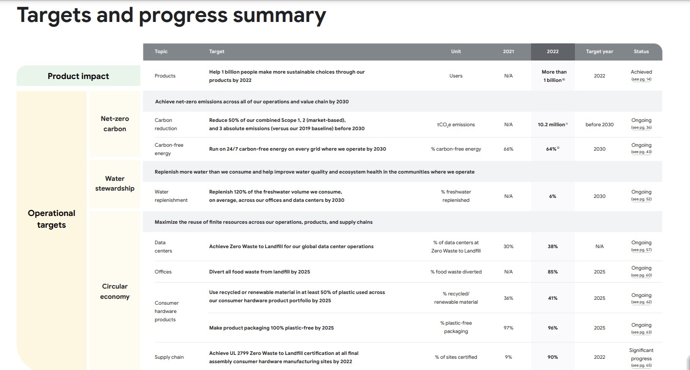
Google report (2023)

CSR – Corporate Social Responsibility
According to Investopedia.com (2024) CSR is self-acting business model that helps the company to be social to the public, its stakeholders and itself.
Categories of CSR are:
- Ethical responsibility
- Environmental Impacts
- Humanitarian responsibility
- Fiscal responsibility
In Google HQ King’s Cross Project can be seen all of them. With improving the society Google growth its brand image.
CSR strategy is mostly for big corporations. More successful and famous businesses have more responsibilities and higher standards of ethical behaviour.

PPP – People, Planet, Profit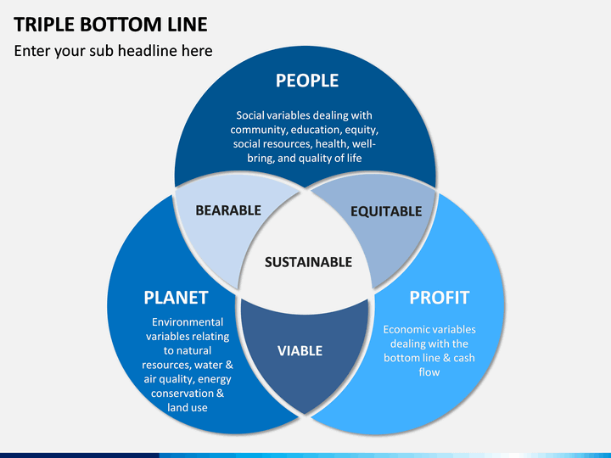
cdn.sketchbubble.com
The triple bottom line is a concept in the business. It says that the companies have to measure their environmental and social impacts, not only focus on their profit. (online.hbs.edu, 2023)
Google is pressed by the government, consumers, and investors to reduce the waste and carbon oxide in their product and services and to make their offices energy efficient. Google has high social and environmental targets in its sustainability.

Conclusion
Google’s Landscraper is innovative and symbolize its commitment to London. It redefines office architecture and flourishing the IT sector.
Google is not worried to spend 1 billion pounds for such a huge office for its employee. Covid 19 changed the work shift and boost the hybrid work and distance workforce. But actually, Covid increased Googles profit due to the lockdown and the higher interest of online services. The revenue from Google and its fathers company Alphabet advertising increase proportionally on this interest and growth to 162% in 2021. Google get to 6 billion dollars revenue in the pandemic, only from ads. Google HQ King’s Cross project is nearly finished and very soon it will be ready to satisfy Googlers, Londoners, Visitors and all of his stakeholders. Everything in the Landscraper support the hybrid work and the flexible working practices.
Based on the Google work in this project it could be given recommendation to other investors with similar projects.
Google HQ King’s Cross is a huge project, professionally managed with perspectives in the future work of the company. Google was following the necessary steps in the ten-core element of a project.

References
McIntyre, F. (2019) The gallery: Google’s Kings Cross HQ, New Civil Engineer. Available at: https://www.newcivilengineer.com/archive/the-gallery-googles-kings-cross-hq-04-06-2017/ (Accessed: 30 April 2024).
(no date) Archinect. Available at: https://archinect.imgix.net/uploads/gy/gy1kioz352vg93yp.jpg?fit=crop&auto=compress%2Cformat&w=1200 (Accessed: 30 April 2024

Guy@evosite.co.uk (2023) Googles new HQ costs 1 billion pounds but is it enough to tempt people back in to the office?, Office Reality. Available at: https://www.officereality.co.uk/blog/googles-new-landscaper-hq-at-kings-cross-london-costs-1-billion-pounds-but-is-it-enough-to-tempt-people-back-in-to-the-office (Accessed: 30 April 2024).
Blog (no date) Office Reality. Available at: https://www.officereality.co.uk/blog (Accessed: 01 May 2024).
Pearson, A. (2023). Arriving on Platform G: Google’s new Kings Cross office. CIBSE Journal (Accessed: 31 April 2024).
Larson, E and Gray C. (2018) Project Management: Managerial Process 7th Edition, McGraw Hill.
Behold London’s ’Landscaper’! Google’s new UK HQ – as long as the shard is tall (2022) The Guardian. Available at: https://www.theguardian.com/business/2022/jul/01/behold-londons-landscraper-googles-new-uk-hq-as-long-as-the-shard-is-tall (Accessed: 31 April 2024).
Prynn, J. (2022) New Pictures of £1bn google HQ featuring pool and Rooftop Running Trail. Evening Standard. Available at: https://www.standard.co.uk/homesandproperty/property-news/google-hq-new-office-kings-cross-london-plans-b994436.html (Accessed: 01 April 2024).
Adamson, C. (2022) Google’s New London office is a $1bn mistake, Business Age. Available at: https://www.businessage.com/post/googles-new-london-office-is-a-1bn-mistake (Accessed: 31 April 2024).
What we do (No date) Lendlease. Available at: https://www.lendlease.com/au/what-we-do/ (Accessed: 31 April 2024).
Google PESTEL Analysis (2023) The Strategy Story. Available at: https://thestrategystory.com/blog/google-pestel-analysis/ (Accessed: 1 May 2024).
Madurai, V. (2018) Quality, time and money, Medium. Available at: https://medium.com/@vivekmadurai/quality-time-and-money-39278f990092 (Accessed: 02 May 2024).
Morfaw, J.(2014) Fundamentals of Project Sustainability. Available at: https://www.pmi.org/learning/library/fundamentals-project-sustainability-9369 (Accessed: 02 May 2024).
17 Sustainable Goals (No date) Bing. Available at: https://th.bing.com/th/id/OIP.EKIvjO8yU1ZB3a8AUKCFQgAAAA?rs=1&pid=ImgDetMain/ (Accessed: 02 May 2024).
https://archinect.imgix.net/uploads/gy/gy1kioz352vg93yp.jpg?fit=crop&auto=compress%2Cformat&w=1200
(No date) Archinect. Available at: https://archinect.imgix.net/uploads/gy/gy1kioz352vg93yp.jpg?fit=crop&auto=compress%2Cformat&w=1200 (Accessed: 02 May 2024).
Alphabet: Revenue soars for Google owner as Covid Lockdown Boom Continues (2021) The Guardian. Available at: https://www.theguardian.com/technology/2021/apr/27/alphabet-google-revenue-quarterly-earnings (Accessed: 02 May 2024).
2023 environmental report - google sustainability (no date) Sustainability. Available at: https://sustainability.google/reports/google-2023-environmental-report/ (Accessed: 02 May 2024).
Triple Botom Line (No date) Scetchbubble. Available at: https://cdn.sketchbubble.com/pub/media/catalog/product/cache/1/image/720x540/c96a280f94e22e3ee3823dd0a1a87606/t/r/triple-bottom-line-slide1.png (Accessed: 02 May 2024).
Meredith, J. and Mantel, S. (2009) Project Management: A Managerial Approach, Asia: John Wiley and Sons.
Larson, E. and Gray, C. (2018) Project Management: The Managerial Process 7th Edition, McGraw Hill.

