

ASSESMENT 1
REPORT

BMHP6009: LIVING WITH CARE: THE OLDER PERSON

NAME OF THE STUDENT: JOHNSON B. AKEJU
STUDENT ID: 1919481
LECTURER: DIOLA BIJLHOUT

O1

TABLE OF CONTENTS
Introduction……………………………………………………………………………………….. 2
Discussion…………………………………………………………………………………………. 2
Meaning to be an elderly person in the UK and Finland……………………………………... 2
“Statistics for the aging population and changes in recent years” …………………………. 2
“Theories of loneliness and isolation…………………………………………………………… 5
Effect of loneliness and isolation on an older person living within a care setting………….. 6
Legislation and policies to raise awareness and reduce loneliness and isolation in the elderly population………………………………………………………………………………………….. 7
Comparison of local, national, and global providers of services for the older person in line with government policy………………………………………………………………………………... 9
“The potential adjustments that may be made to consider how technology might be utilized to support lonely seniors.…………………………………..………………..……………………… 10
Recommendation…………………………………………………………………………………. 11
Conclusion………………………………………………………………………………………… 11
References………………………………………………………………………………………… 13
Appendices………………………………………………………………………………………… 15

INTRODUCTION
Elderly people want assistance and comfort to maintain a healthy lifestyle free from anxieties at this vulnerable time in their lives. (Maresova et al., 2019). Families that are ignorant of the changes in these individuals ‘home behavioural routines regularly mistreat elderly persons. The stages of a person’s life that are the most successful include birth, childhood, adolescence, adulthood, and eventually old age (Maresova et al., 2019).
These periods each have unique difficulties and barriers. With each level that is also accomplished, sharpness decreases on a physical and psychological level is seen. This report highlights to evaluate how loneliness and social isolation affect the older population. It will compare our nation’s existing elder care laws and programs with those of at least one foreign nation known as Finland. My research hereby consider how technology may be utilized to care for elderly persons who are lonely to modify programs intended to reduce senior loneliness. Lastly, recommendations for improvements will be needed to develop older person care in UK and Finland.

DISCUSSION
MEANING TO BE AN ELDERLY PERSON IN THE UK AND FINLAND
Age is a number that is widely used to symbolize the process of aging naturally. According to tradition, those who are 65 or older are referred to as elderly. (Maresova et al., 2019).
Most people consider someone to be elderly if they are over the age of 65. It is difficult to apply a specific definition since everyone ages physically at a different rate. A person at 75 may, for instance, be in greater health than one at 60. Comparatively, in Finland elderly person means, that there are “5.5 million people”, and “14 percent of the population will be 75 or older by 2030, up from 11 percent in 2018” (Land and Lewis, 2018). The decline in births is a trend that is a considerably more recent phenomenon. Further, the laws of Finland contain measures for a veteran-friendly setting, suitable housing, accessible transportation, and home support services. Seniors are given the option to stay in their homes for as long as they are able and want to, even if they need intensive care and social assistance (Pellander, 2018.).

“STATISTICS FOR THE AGING POPULATION AND RECENT CHANGES
As cultures get older and more urbanized, loneliness becomes increasingly prevalent. (Schürer et al., 2018). The likelihood of individuals being retired, living in smaller homes, unwell, or disabled has increased as the percentage of people over 65 increased from 5% in 1911 to 16% in 2011.On the other hand, a higher percentage of people now reside in metropolitan areas, single-person households make up more houses (compared to 8–10% in 1911 and 28% of all residences in 2016), and generational groups are declining (Schürer et al., 2018).Moreover, one in five people in the UK are now over 60, and by 2025, that number is expected to increase to “18.5 million from 14.9 million”. “In the UK, 75% of persons aged 75 and older have experienced many diseases, and this percentage rises to 82% for those who are 85 and older”. “Between 2007-2008 and 2013-2014, the number of adults 60 and older who attended emergency rooms increased by two-thirds”, which is more than would be anticipated by demographic trends alone (Hardwick et al., 2022). The UK’s Aging population in recent years changed 12.3 million people, or over 19 percent of the UK’s population, were 65 or older in 2019. When contrasted to the UK’s general population, which expanded by 7% between 2009 and 2019, people in this age group increased by 23% over that time predates contemporary ideas of seclusion. ((Pellander, S., 2018).
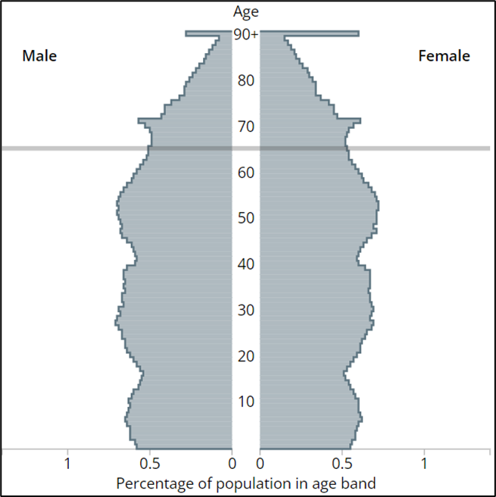

Fig: Age Pyramid Structure or UK Ageing Population (Line depicts Aging Population in the UK starting from 65 years) (source: Hardwick et al., 2022

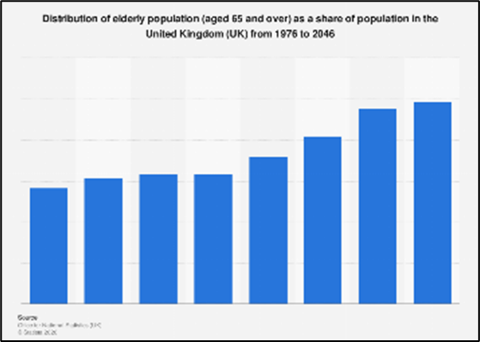

Fig: UK Elderly Population (1976 to 2046)
(Source: Hardwick et al., 2022)
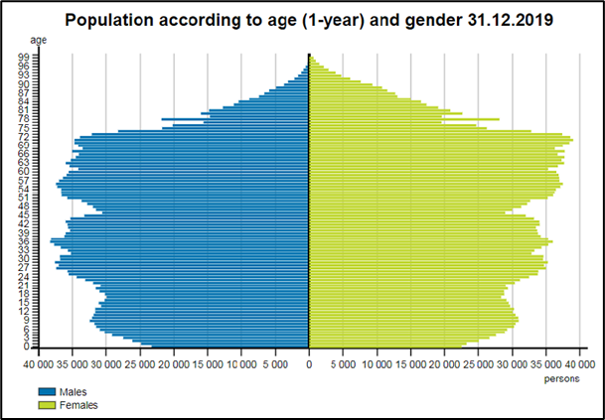
Finland by 2030, 14 percent of Finland’s population (5,5 million people) would be 75 years of age or older, up from 11% in 2018. (Al popi et al., 2019). Further, compared to the Finnish country Finland’s population is among the oldest in all of Europe, and it is currently experiencing a historical period in which four generations live together. The growing Finnish lifespan, the rising mean lifespan for first-time mothers, and declining birth rates are all contributing to the demographic’s steady aging (Tynkkynen et al., 2022).“The share of over-65-year-olds of the population will increase from the current 22 percent to 26 percent by 2030 and to 29 percent by 2060”

Fig: Age Pyramid Structure or UK Ageing Population (Line depicts Aging Population in the UK starting from 65 years) (So urce: Hardwick et al., 2022)
“THEORIES OF LONELINESS AND ISOLATION
Theory or Weiss’s Theory of loneliness
Although loneliness has always existed, psychological research on it has only recently started to get attention. Attachment theory, which was created by psychiatrist John Bowlby in the second half of the 20th century, emphasizes the value of a strong emotional bond between the child and the caregiver. (Dore, S., 2018.)
It predates contemporary ideas of seclusion. According to this theory, children who have insecure attachments behave in a way that makes them popular with their classmates but also makes them feel lonely. These rejections prevent individuals from gaining social skills and increase their degree of mistrust toward other people, which prolongs their loneliness (Suri, Gargand Tholia, 2019). Robert S. Weiss, a sociologist, based his well-researched psychological theory of loneliness on attachment theory. Weiss identified six social requirements, and whether we feel lonely may depend on whether these needs are met. The desire for connection, social integration, nurturing, self-assurance, a sense of dependable allyship, and assistance through difficult times are among these necessities. To combat loneliness, Weiss advocated using friendship in addition to, not as a replacement for, a solid, intimate relationship with another individual. This matches the predictions of attachment theory. Loneliness is distinct as a personality trait that is linked to poor human contact patterns and may even encourage by the behaviourist hypothesis, a specific philosophical perspective (Vedder et al., 2022). For example, traits like social anxiety, social inhibition (shyness), depression, violence, and low self-esteem make it very difficult to engage in ways that are fruitful and enjoyable. These characteristics are also linked to loneliness.
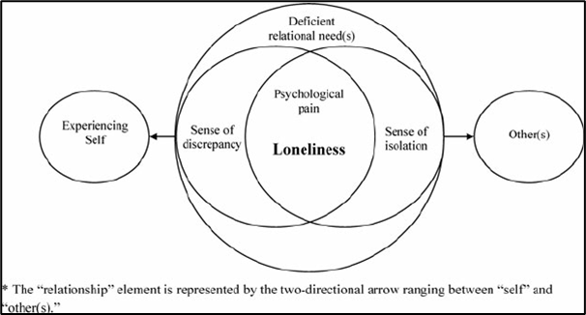

Fig: Experiment Model of Loneliness (Source: Switzer’s et al., 2022)

CONCEPT OF LONELINESS AND ISOLATION
Being alone or cut off from others causes horrible loneliness. Lack of social connections or having few individuals to routinely speak with constitutes social isolation. While being among other people might make one feel lonely, living alone can make one feel socially isolated or lonely. Due to changes in their social health relationships brought on by aging, hearing, vision, memory loss, disability, problems getting about, or the loss of relatives and friends, older people are more likely to experience social isolation and loneliness. The likelihood of someone being admitted to a care facility or emergency department increases when they are lonely or alone. Furthermore, loneliness and social isolation are linked to increased risks for-

- Elevated blood pressure
- Heart problems
- Obesity
- Stress and Depression,
- Dementia,
- Illnesses that contribute to the decline of the intellect and,
- Mortality (Macdonald, Nixon, and Deacon, 2018).
Physically isolated people may not get enough exercise, drink too much alcohol, smoke, or sleep enough, all of which raise the risk of serious medical illnesses. People who are lonely experience emotional suffering. A person’s perspective on the world may alter when they experience a loss of connection and belonging. Someone who is always alone themselves could feel unsafe and have mistrust towards other people. Both physical and emotional anguish can raise the body’s stress levels. Long-term occurrences may result in inflammation (excessive or protracted release of chemicals that may harm tissues) and reduced resistance (ability to fight off illness). This increases your risk of developing chronic diseases and might make you more vulnerable to catching some infectious infections. One’s mental health may be harmed by social isolation and loneliness. Indeed, studies have linked an increased risk of acquiring chronic illnesses, such as Alzheimer’s, with social isolation and loneliness (Macdonald et al., 2018). Older person’s ability to perform everyday duties like driving, paying bills and other necessities of life may be impacted by having little or no social interaction and spending a lot of time on other activities.

EFFECT OF LONELINESS AND ISOLATION ON AN OLDER PERSON LIVING WITHIN A CARE SETTING

“Loneliness acts as like an activator for other illnesses. (Pellander, S., 2018.) The care setting is the place where a “Medically aid-eligible individual lives and receives care”. (Pellander, S., 2018). Care centres, residential care facilities, assisted living, special care contracted households, and elder care homes are a few examples of healthcare environments. Furthermore, overlaying the impact of the loneliness and isolation for older persons living in these mentioned care settings would eventually link social isolation and loneliness to a wide range of medical and mental illnesses, including hypertension, heart disease, obesity, a weakened immune system, anxiety, depression, cognitive decline, Alzheimer’s disease, and even mortality. Eventually, these illnesses associated with an older person would be getting their care in the mentioned care settings and can maintain the rest of their life in a positive approach. Further, the most common causes of loneliness and isolation in older persons are bereavement and retirement, poor physical health would have an impact with a positive approach in care settings as these are the place where the care of the individuals will be getting care by the carer. Further in Finland different care settings such as “Adult Home Assisted Living Programme (ALP)” would help the older person with their care approach as compared with the UK care setting where residential care setting where the services such as meal services, activities to excite physical and mental health and wilth the managed assistance with daily living events to a small community of senior will has taken care of (Perissinotto et al., 2019). Both in UK and Finland, the impact of loneliness and isolation influence the resident’s quality of life where Clinical effects of loneliness include depression, difficulty sleeping, high blood pressure, sluggishness, loss of function, cognitive decline, and overall mortality. (Perissinotto et al.,2019). Furthermore, Limited finances, divorce, separation, or being widowed would also impact loneliness and isolation in the older person living in care settings in UK and Finland. (Pellander, S., 2018.)

LEGISLATION AND POLICIES TO RAISE AWARENESS AND REDUCE LONELINESS AND ISOLATION IN THE ELDERL.

Legislation for both UK and Finland Would tend to Follow “The Care Act 2014” for ending Loneliness and Isolation for older people (see appendix 1). In our aging culture, loneliness and social isolation are serious public health issues (Starns, 2019). Currently, this includes research from organizations like Age UK and the Institute of Public Health in Ireland recommendations from the National Institute for Clinical Excellence. Analyses from the Social Care Institute for Excellence, and information gathered by the UK’s Campaign to End Loneliness and to combat loneliness, the “Canadian Counselling and Psychotherapy Association (CCPA)” has provided advice. During the coronavirus pandemic, the government began a huge drive to combat social isolation and loneliness. The goal of the campaign was to ensure that people of various ages and backgrounds wouldn’t always feel lonely at home.
In its networked world (2018) policy, the UK government said that it will exert "national leadership" in the struggle against loneliness. (NHS 2018) This would include:
- The group preferred using indicators to assess loneliness, such as living environment, self-management autonomy, social interface, human rights therapeutic environment, and recovery based practice. (NHS 2018)
- Maintainable improving common areas and infrastructure, making sure that the housing system takes loneliness into account, lowering stigma and raising knowledge of the value of social ties, and promoting neighbourhood organizations and digital literacy are all
examples of how to combat loneliness (Ratcliffe, Wigfield and Alden, 2021).

Campaigns
The aim is to raise awareness of loneliness and isolation in the elderly population or older age where UK government has supported with a famous campaign named “Campaign to End Loneliness- Connection In Older Age” (Patel, Wardle and Parikh, 2019).


Fig: Campaign
(Source: Patel, Wardle and Parikh, 2019)
According to the Campaign to end Loneliness, meaningful interactions are important for people of all ages. In the UK, nine million lonesome individuals go without the assistance and company we all require. (Age UK 2020). Everyone can live a life free from continual loneliness, according to their vision. Since 2011, they have concentrated on researching isolation and connection. We work together with hundreds of other organizations and members of the public to share data, information, and research to improve the lives of elderly. They encourage everyone to interact with one another and unite the many parts of the UK. (Perissinotto et al., 2019). The use of Artificial Intelligence to tackle loneliness is another means of encouraging the elderly, A I, as popularly called is an intelligence that stimulates human intelligence, an example is Alexa.
Activity theory: Introduction of passive and active exercises, aerobic and anaerobic exercises within and outside the home


Fig: Deserted Streets of Helsinki During Covid-19 Outbreak
(Source: Stening, 2021)
Images of Helsinki’s empty city streets during the Covid-19 outbreak were used by the Finnish NGO “HelsinkiMissio” to depict how the environment seems to the lonely. Its goal is to draw attention to the suffering that unplanned isolation creates and to raise awareness for those who do experience it and require more support than before. The promotional track for “HelsinkiMissio” is titled “For some, this is how the cosmos has always felt”. Make the solitary individuals realize they are not alone (Stening, 2021).
Some Finnish Government Policies for refraining from Loneliness and Isolation are: -
- “Socially sustainable Finland 2020- Strategy for social and health policy”
- “Quality recommendation to guarantee a good quality of life and improved services for older persons 2020–2023” - “The Aim is an Age-friendly Finland”

Comparison of local, national, and global providers of services for the older person in line with current initiatives and policy
UK | FINLAND
Local- Adult Care Services-FAST 24  They have a team of expert care givers who specialize in adult care.  - Providing support 24X7  - Skilled and friendly staff  - Assistance with socialization  - Experiences of over 15 years  - Individual and family care  - Cheap service provision   | Local-Interlinks- The INTERLINKS program supports older individuals in need of long-term care and those who advocate for it in Europe (LTC). We wish to motivate those people who work for a non-governmental organization, for the government, and in the patient and healthcare sectors (NGOs).  
National-Eclipse Home Care- Eclipse Homecare provides a range of care services to help the elderly, sick, and people with disabilities stay if they can at home.  UK Government Initiatives for older people (Massaro et al., 2018).  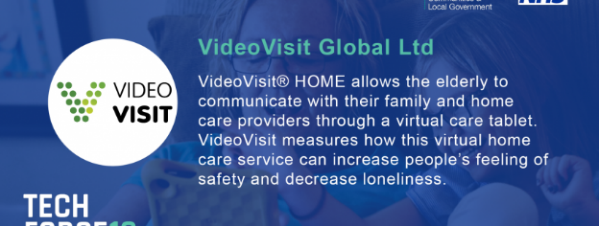   | National-Finnish Government Support for older persons over their initiates in policy that are implemented pre and post Covid-19 outbreak. Eg- “Video Visit HOME”
Global- WHO for elderly care and Global senior services


(Stening, 2021).

THE POTENTIAL ADJUSTMENTS THAT MIGHT BE UTILIZED TO ENHANCE THE SUPPORT PROVIDED TO LONELY ELDERLY.

The prospective future of care for older persons is that older persons with greater coping mechanisms have generally higher emotional health and are truly prepared for future care. Positive health care results for older patients are linked to a high level of optimism. That includes improved quality of life and higher survival rates, and less difficulty and distress when making wellness related decisions. Furthermore, positive clinical results for elderly, such as greater survival, improved quality of life, and less difficulty and pain in making healthcare decisions, are associated with high levels of optimism. The changes that could be made to the program aimed at addressing the issues of loneliness among the elderly would be to get moving with exercise, reduce stress, lifts the spirits, and gives older persons a tonne of extra energy (Fried Hamilton and Berardo, 2022). Volunteering for older people as older adults feel better about themselves when they lend a hand to others. Keep in touch with family members, friends, and neighbours by phone, on the internet, or in person, and consider acquiring a pet. The technology could help the provision of care provided to older people by optimally using rudimentary telecommunication, and online interaction through telehealth videoconferencing to provide support for them. Further, during the COVID-19 outbreak, teleconferencing software and apps gained popularity on both a social and professional level. These apps can take the role of previous in-person visits by friends, relatives, and volunteers to combat loneliness.

RECOMMENDATION
Some of the suggestions that can be made for improvement are;
- Develop a feeling of purpose especially among friends and family
- Recognize and manage depression’s warning symptoms proactively.
- Learn how to assist others in our daily tasks.
- Establish a relationship to improve elders’ quality of life.
- Continue to move, both physically and mentally.
- Identify a chance for the elderly to get the proper care.
- Concerning technology older people can be cared for suggestion by providing for instance, a low-cost telepresence device might be given to those who have been recognized as being at risk of loneliness (Hudson et al., 2020).
- A well-trained and well-motivated health care worker must be provided with older care.
- A proper care service provider must be enhanced to provide services to older people to improve the superiority of life.

CONCLUSION
Hence to conclude, even if they cannot halt the aging process, they can learn how to deal with the circumstances that emerge to safeguard the health of those we care about. Memory loss, confusion, and Alzheimer’s disease are some of the most common health issues that affect the elderly. In the Uk, the NHS provide excellent elderly care, which may be received alone or with the aid of a professional, preventing loneliness and hopelessness. Users provide them with a life outside of work and a sense of community that gives them vigour and energy, enabling them to stay up. As we age, our speed and mobility inevitably decline. Cooking, breastfeeding, bathing, cleaning, and getting dressed might become challenging daily tasks for older adults. Occasionally, someone may be expected to do each of these duties in the capacity of a caretaker, support worker or career. Older adults’ bones and muscles begin to deteriorate as they become older, and they frequently lose their hearing and vision as well as some mobility. In Finland as well, elderly persons are also impacted by dementia, which affects roughly 10 percent of those over 65 and 32 percent of those who are truly 85 years or older. (Stening, 2021). Most of the elderly are within their homes being managed till they pass away.
Birth decline is a considerably more in Finland, and this makes population of elderly to reduce in comparison to UK. Further, the laws of Finland contain measures for a veteran-suitable elderly which makes housing accessible. Seniors are given the option to stay in their homes for as long as they are able and want to, even if they need intensive care and social assistance. (Pellander, S., 2018).

REFERENCES
Alpopi, C., Nica, E., Oancea, M.D.N. and Balu, P.E., 2019. Aspects Of Sustainable Development In The Perspective Of The Population Aging Phenomenon. Quality-Access to Success, 20.
Fried, H., Hamilton, M. and Berardo, R., 2022. Closing integrative gaps in complex environmental governance systems. Ecology and Society, 27(1).
Hardwick, N., Marriott, J., Mason, K. and Steinbrecher, M., 2022. Human Rights and Systemic Wrongs: National Preventive Mechanisms and the Monitoring of Care Homes for Older People. Journal of Human Rights Practice.
Hudson, J., Ungar, R., Albright, L., Tkatch, R., Schaeffer, J. and Wicker, E.R., 2020. Robotic pet use among community-dwelling older adults. The Journals of Gerontology: Series B, 75(9), pp.2018-2028.
Land, H. and Lewis, J., 2018. Gender, Care and the Changing Role of the State in the UK. In Gender, social care and welfare state restructuring in Europe (pp. 51-84).
Macdonald, S.J., Deacon, L., Nixon, J., Akintola, A., Gillingham, A., Kent, J., Ellis, G., Mathews, D., Ismail, A., Sullivan, S. and Dore, S., 2018. ‘The invisible enemy’: disability, loneliness, and isolation. Disability & Society, 33(7), pp.1138-1159.
Macdonald, S.J., Nixon, J. and Deacon, L., 2018. ‘Loneliness in the city’: Examining socioeconomics, loneliness and poor health in the North East of England. Public Health, 165, pp.88-94.
Maresova, P., Javanmardi, E., Barakovic, S., Barakovic Husic, J., Tomsone, S., Krejcar, O. and Kuca, K., 2019. Consequences of chronic diseases and other limitations associated with old age–a scoping review. BMC public health, 19(1), pp.1-17.
Massaro, A., Maritati, V., Savino, N., Galiano, A., Convertini, D., De Fonte, E. and Di Muro, M., 2018. A study of a health resources management platform integrating neural networks and DSS telemedicine for homecare assistance. Information, 9(7), p.176.
Patel, R.S., Wardle, K. and Parikh, R.J., 2019. Loneliness: the present and the future. Age and ageing, 48(4), pp.476-477.
Pellander, S., 2018. The ageing body as a bordering site: Narrowing definitions of dependency for elderly family reunification in Finland. Nordic Journal of Migration Research.
Perissinotto, C., Holt‐Lunstad, J., Periyakoil, V.S. and Covinsky, K., 2019. A practical approach to assessing and mitigating loneliness and isolation in older adults. Journal of the American Geriatrics Society, 67(4), pp.657-662.
Ratcliffe, J., Wigfield, A. and Alden, S., 2021. ‘A lonely old man’: empirical investigations of older men and loneliness, and the ramifications for policy and practice. Ageing & Society, 41(4), pp.794-814.
Schürer, K., Garrett, E.M., Jaadla, H. and Reid, A., 2018. Household and family structure in England and Wales (1851–1911): Continuities and change. Continuity and Change, 33(3), pp.365-411.
Starns, B., 2019. Safeguarding Adults Together under the Care Act 2014: A multi-agency practice guide. Critical Publishing.
Stening, K., 2021. Identifying Capabilities to Enhance Co-creation and Participation in Service Development.
Suri, S., Garg, S. and Tholia, G., 2019. Attachment style perceived social support and loneliness among college students. International Journal of Innovative Studies in Sociology and Humanities, 4(5).
Switsers, L., Qualter, P., Pan, H., Barreto, M., De Donder, L., Victor, C., Dury, S., Hammond, C. and Dierckx, E., 2022. Exploring the demographic and situational characteristics of older British people experiencing loneliness as positive within the BBC loneliness experiment. Aging & Mental Health, pp.1-7.
Tynkkynen, L.K., Pulkki, J., Tervonen-Gonçalves, L., Schön, P., Burström, B. and Keskimäki, I., 2022. Health system reforms and the needs of the ageing population—an analysis of recent policy paths and reform trends in Finland and Sweden. European Journal of Ageing, pp.1-12.
Vedder, A., Boerner, K., Stokes, J.E., Schut, H.A., Boelen, P.A. and Stroebe, M.S., 2022. A systematic review of loneliness in bereavement: Current research and future directions. Current opinion in psychology, 43, pp.48-64.

Appendices
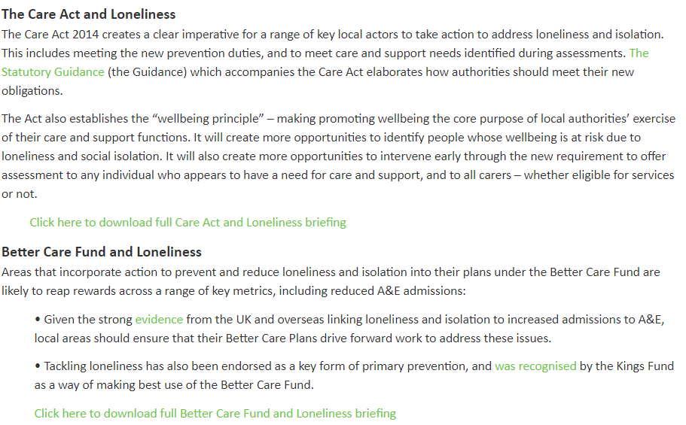
Appendix 1 Legislation

