Alexandre Brama Sabata Bari (2508298)
Student ID: 2508298
Group: 4

Assignment 1
Software solution for business (ACCA4026)
University of wales trinity saint david
London Campus

Contents
Introduction 2
Task 1- E-commerce Website Builders/Software Solutions 2
Shopify 2
Squarespace 2
Comparison 2
Summary 3
Task 2- Mind Mapping 3
Introduction to Mind Mapping 3
Benefits of Mind Mapping in Business 3
Mind Map Example (Screenshot + Explanation) 3
Task 3- Office Applications 4
Introduction 4
Microsoft Word 4
Microsoft PowerPoint 5
Microsoft Excel 5
Microsoft Access 5
Practical Application 5
Excel- IF Function (Screenshot + Explanation) 5
Excel- VLOOKUP or Pivot Table (Screenshot + Explanation) 6
Task 4- Communication and Collaboration tools 6
Introduction 6
Communication Tool (Microsoft Teams) 7
Collaboration Tool (Google Docs) 7
Practical Features 7
Communication Tool Feature (Screenshot + Explanation) 7
Collaboration Tool Feature (Screenshot + Explanation) 8
Conclusion 8
References 8

Introduction
E-commerce websites are platforms where buying and selling happens online [1]. They allow businesses to display products, take payments and manage orders without needing a physical store. This makes it easier for businesses to reach more customers and operate at any time. In this section, I will be looking at two popular e-commerce platforms, Shopify and Squarespace, and comparing how they work, what they offer, and which type of user they are more suitable for.

Task 1- E-commerce Website Builders/Software Solutions

Shopify
Shopify is a platform mainly built for e-commerce, meaning it is designed specifically for online stores. It allows businesses to create a website, manage products, take payments and track orders all in one place [2]. One of the main advantages of Shopify is how easy it is to use, especially for beginners, because it provides ready-made templates and tools to quickly set up a store. It also supports different payment methods and can connect with a lot of external apps, which makes it more flexible for businesses that want to grow. However, Shopify usually requires a monthly subscription and some features may cost extra.

Squarespace
Squarespace is a website builder that also includes e-commerce features. It is well known for its design and layout, making it a good option for businesses that care about how their website looks. It allows users to create a website and sell products [3], but its e-commerce tools are not as advanced as Shopify. Squarespace is easier to use when it comes to design and creating visually appealing pages, but it is more suitable for smaller businesses or individuals who do not need complex online store features.

Comparison
Both Shopify and Squarespace allow users to create online stores, but they focus on different things [4]. Shopify is more focused on the business side of e-commerce, with stronger tools for managing products, payments and scaling a business. On the other hand, Squarespace focuses more on design and simplicity, making it better for users who want a clean and attractive website. Shopify is more suitable for businesses that want to grow and expand, while Squarespace is better for smaller projects or users who prioritise design.

Summary
Overall, both platforms help businesses sell online, but they do it in different ways. Shopify is stronger when it comes to functionality and business growth, while Squarespace is better for design and ease of use. The best option depends on what the business needs.

Task 2- Mind Mapping

Introduction to Mind Mapping
Mind mapping is a visual way of organising ideas around one main topic. It starts with a central idea and then branches out into smaller related points. This makes information easier to understand because the links between ideas can be seen clearly. In a business context, mind mapping can help with planning, brainstorming and organising tasks [5].

Benefits of Mind Mapping in Business
Mind mapping is useful in business because it helps organise information clearly and improves understanding. It can be used for planning projects, brainstorming ideas and structuring tasks [6]. It also makes it easier to see relationships between different parts of a project, which can improve decision making. Another benefit is that it can save time, as it allows ideas to be presented in a simple and visual way instead of long text [5].

Mind Map Example (Screenshot + Explanation)
Below is an example of a mind map showing how different areas of a business can be organised. The central idea represents the main topic, and the branches represent related areas such as marketing, finance and operations. This shows how mind mapping can be used to break down complex ideas into simpler parts.
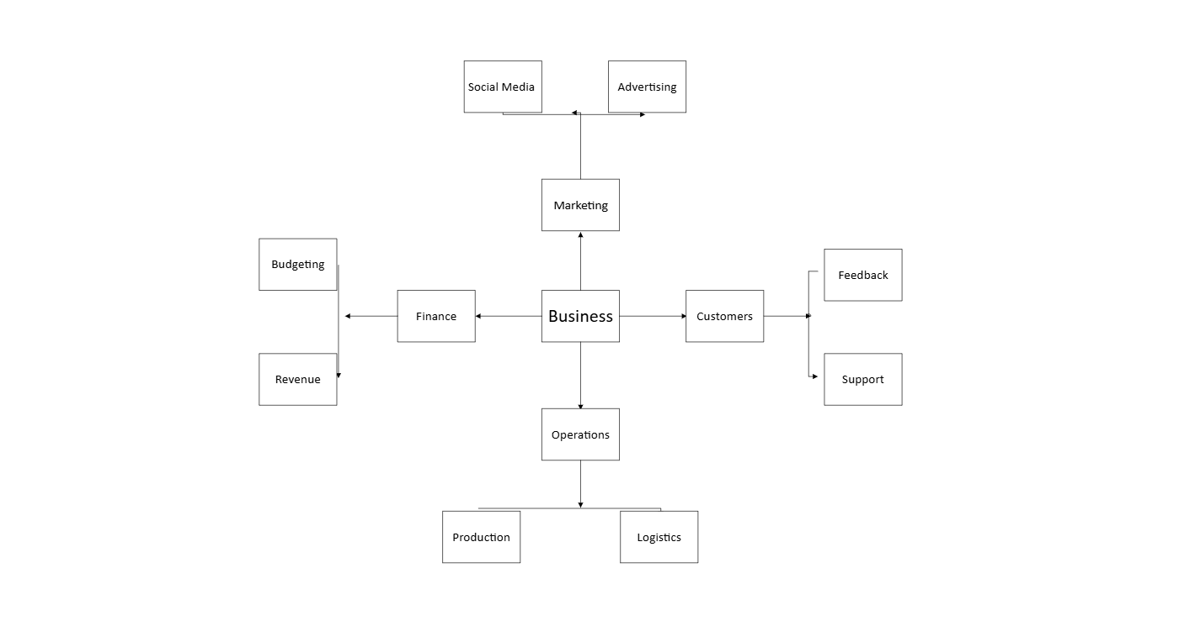
Mind map showing key areas of a business created using Microsoft Visio

Task 3- Office Applications

Introduction
Office applications are important in business as they help create, organise, present and analyse information. Tools such as Microsoft Word, PowerPoint, Excel and Access are widely used in organisations to support daily operations [7]. In this section, I will explain each of these applications, their main features, benefits and limitations, and how they are used in a business environment.

Microsoft Word
Microsoft Word is a word processing application used to create and edit documents. It is commonly used in business for writing reports, letters and documents [7]. One of its main features is formatting tools, which allow users to structure text clearly using headings, fonts and layouts. It also includes features such as spell check and templates, which improve accuracy and save time. The main benefit of Word is that it makes it easy to create professional documents. However, it can be limited when handling large amounts of data compared to other applications like Excel.

Microsoft PowerPoint
Microsoft PowerPoint is used to create presentations, which are commonly used in business meetings, training sessions and reports [8]. It allows users to combine text, images, charts and animations to present information in a clear and visual way. One of its main features is slide design, which helps organise information step by step. It also includes templates and themes, making presentations look more professional. The main benefit of PowerPoint is that it helps communicate ideas clearly to an audience. However, if not used properly, presentations can become too crowded or unclear.

Microsoft Excel
Microsoft Excel is a spreadsheet application used to organise, calculate and analyse data. It is widely used in business for tasks such as budgeting, tracking sales and managing data. One of its main features is the use of formulas and functions, such as IF and VLOOKUP, which allow users to perform calculations automatically [9] [10]. It also includes tools like charts and tables, which help present data clearly. The main benefit of Excel is that it can handle large amounts of data efficiently. However, it can be difficult to use for beginners, especially when dealing with complex formulas.

Microsoft Access
Microsoft Access is a database management system used to store and organise large amounts of data. It is commonly used in business to manage information such as customer records, stock and transactions. One of its main features is the ability to create tables, queries, forms and reports, which helps structure and retrieve data efficiently [11]. The main benefit of Access is that it allows businesses to manage data in a more organised and structured way compared to Excel. However, it can be more complex to use and is not as flexible for quick data analysis.

Practical Application

Excel- IF Function (Screenshot + Explanation)
In this example, the IF function was used in Microsoft Excel to perform a logical test and return different results based on the condition. The function checks whether a value meets a certain condition and then returns one result if it is true and another if it is false [9]. This is useful in business for tasks such as categorising data, checking conditions and automating decisions.
The screenshot below shows how the IF function was applied to data in Excel. This demonstrates how businesses can use formulas to save time and reduce manual work when handling data.

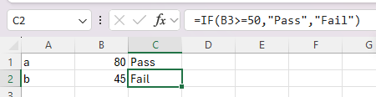

Excel- VLOOKUP or Pivot Table (Screenshot + Explanation)
In this example, the VLOOKUP function was used in Microsoft Excel to search for specific data in a table. It allows users to find information based on a value and return a related result from another column [10]. This is useful in business for tasks such as retrieving product details, prices or customer information.
The screenshot below shows how the VLOOKUP function was applied. This demonstrates how businesses can quickly find and organise data without manually searching through large tables.

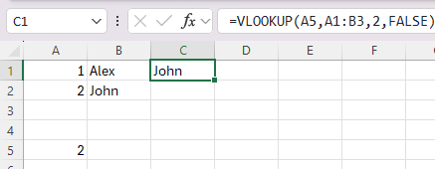

Task 4- Communication and Collaboration tools

Introduction
Communication and collaboration tools are important in modern businesses as they help teams work together and share information efficiently. These tools allow employees to communicate in real time, organise tasks and collaborate on projects [12]. In this section, I will look at Microsoft Teams as a communication tool and Google Docs as a collaboration tool.

Communication Tool (Microsoft Teams)
Microsoft Teams is a communication platform used in businesses for messaging, video calls and meetings. It allows teams to communicate instantly through chat and organise conversations into different channels [13]. One of its main features is video conferencing, which allows teams to hold meetings remotely. The main benefit of Microsoft Teams is that it improves communication and makes it easier for teams to stay connected. However, it can be overwhelming for new users due to the number of features available.

Collaboration Tool (Google Docs)
Google Docs is a collaboration tool that allows multiple users to work on the same document at the same time. It is widely used in businesses for creating and editing documents online. One of its main features is real-time editing, where changes can be seen instantly by all users. It also includes commenting and sharing features, which improve teamwork [14]. The main benefit of Google Docs is that it makes collaboration faster and more efficient. However, it requires an internet connection to work properly [15].

Practical Features

Communication Tool Feature (Screenshot + Explanation)
In this example, Microsoft Teams was used to demonstrate a communication feature. The screenshot below shows how messages can be sent instantly between users. This feature allows team members to communicate quickly and efficiently, improving teamwork and reducing delays [13].

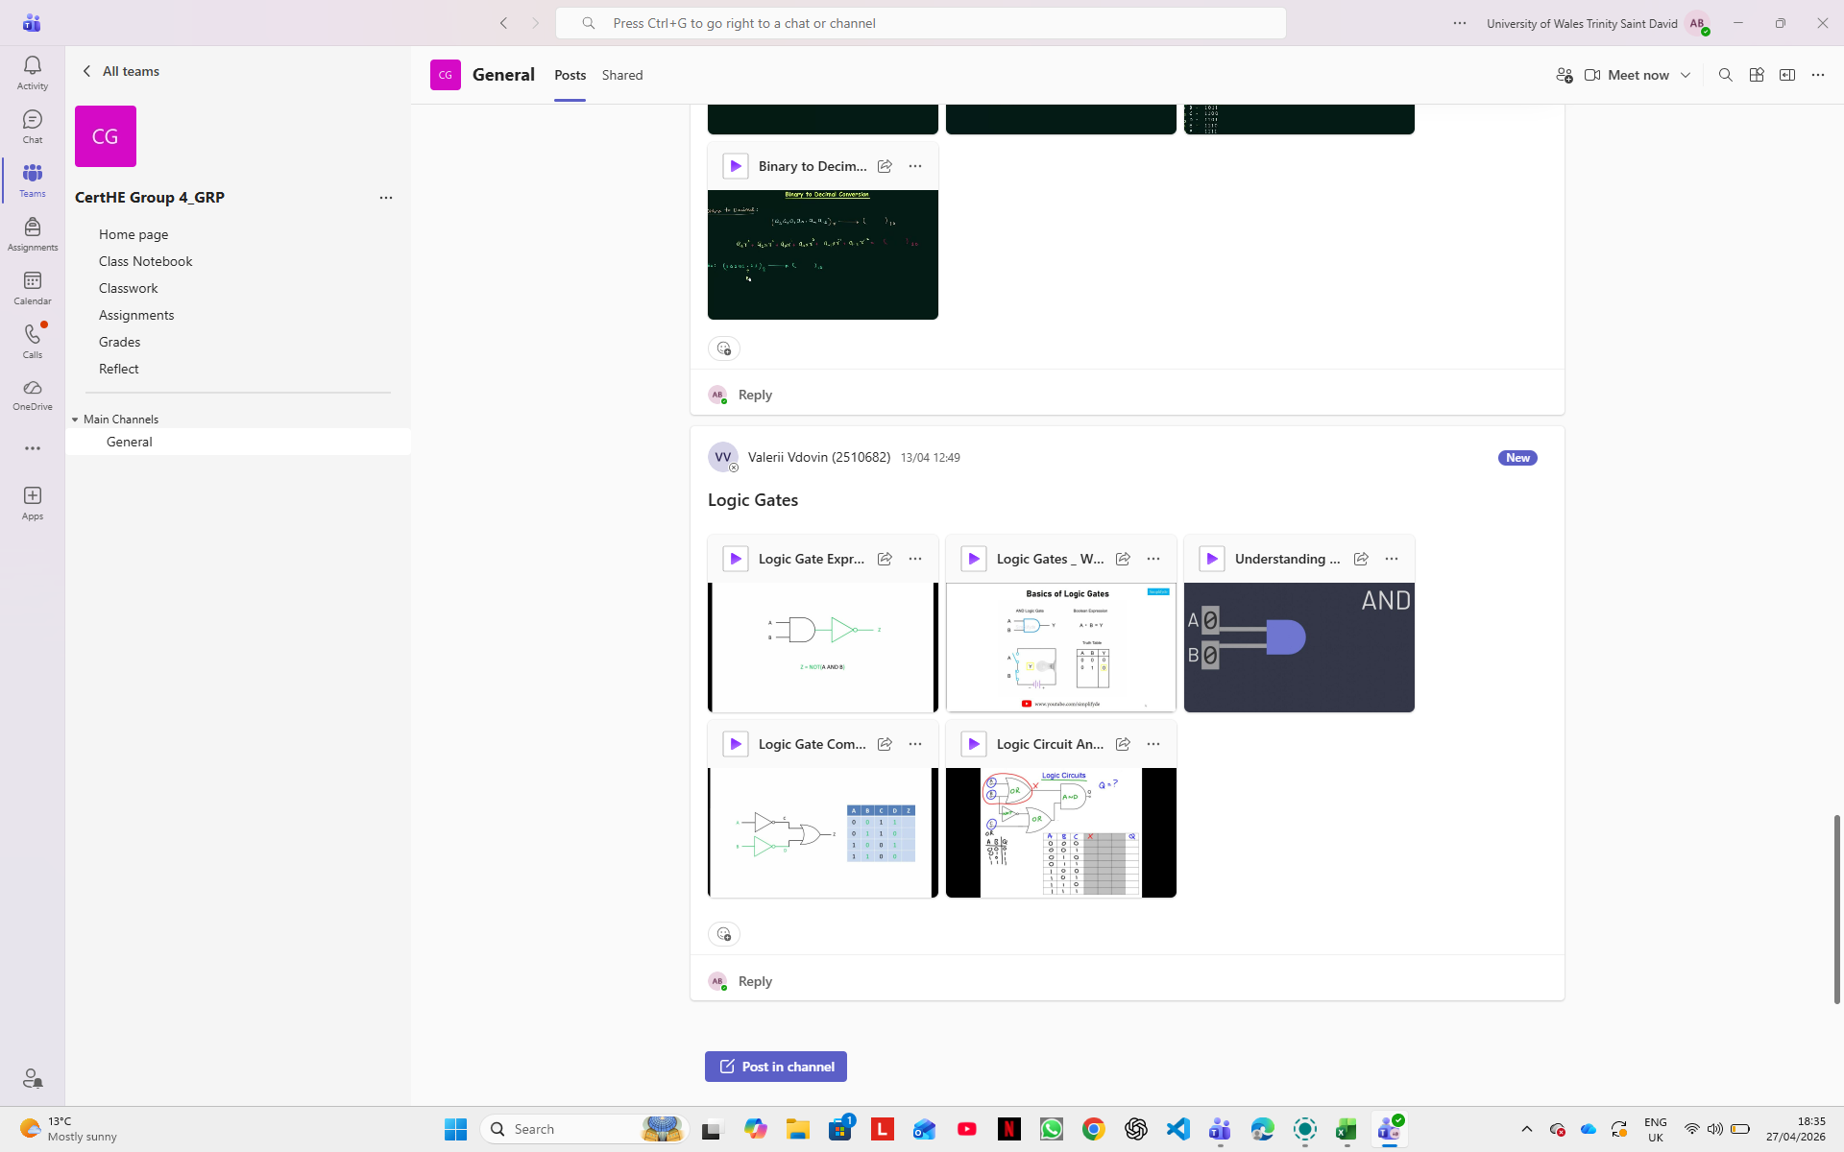

Collaboration Tool Feature (Screenshot + Explanation)
In this example, Google Docs was used to demonstrate a collaboration feature. The screenshot below shows how multiple users can edit a document at the same time. This allows teams to work together more efficiently and keep all information updated in real time [14].

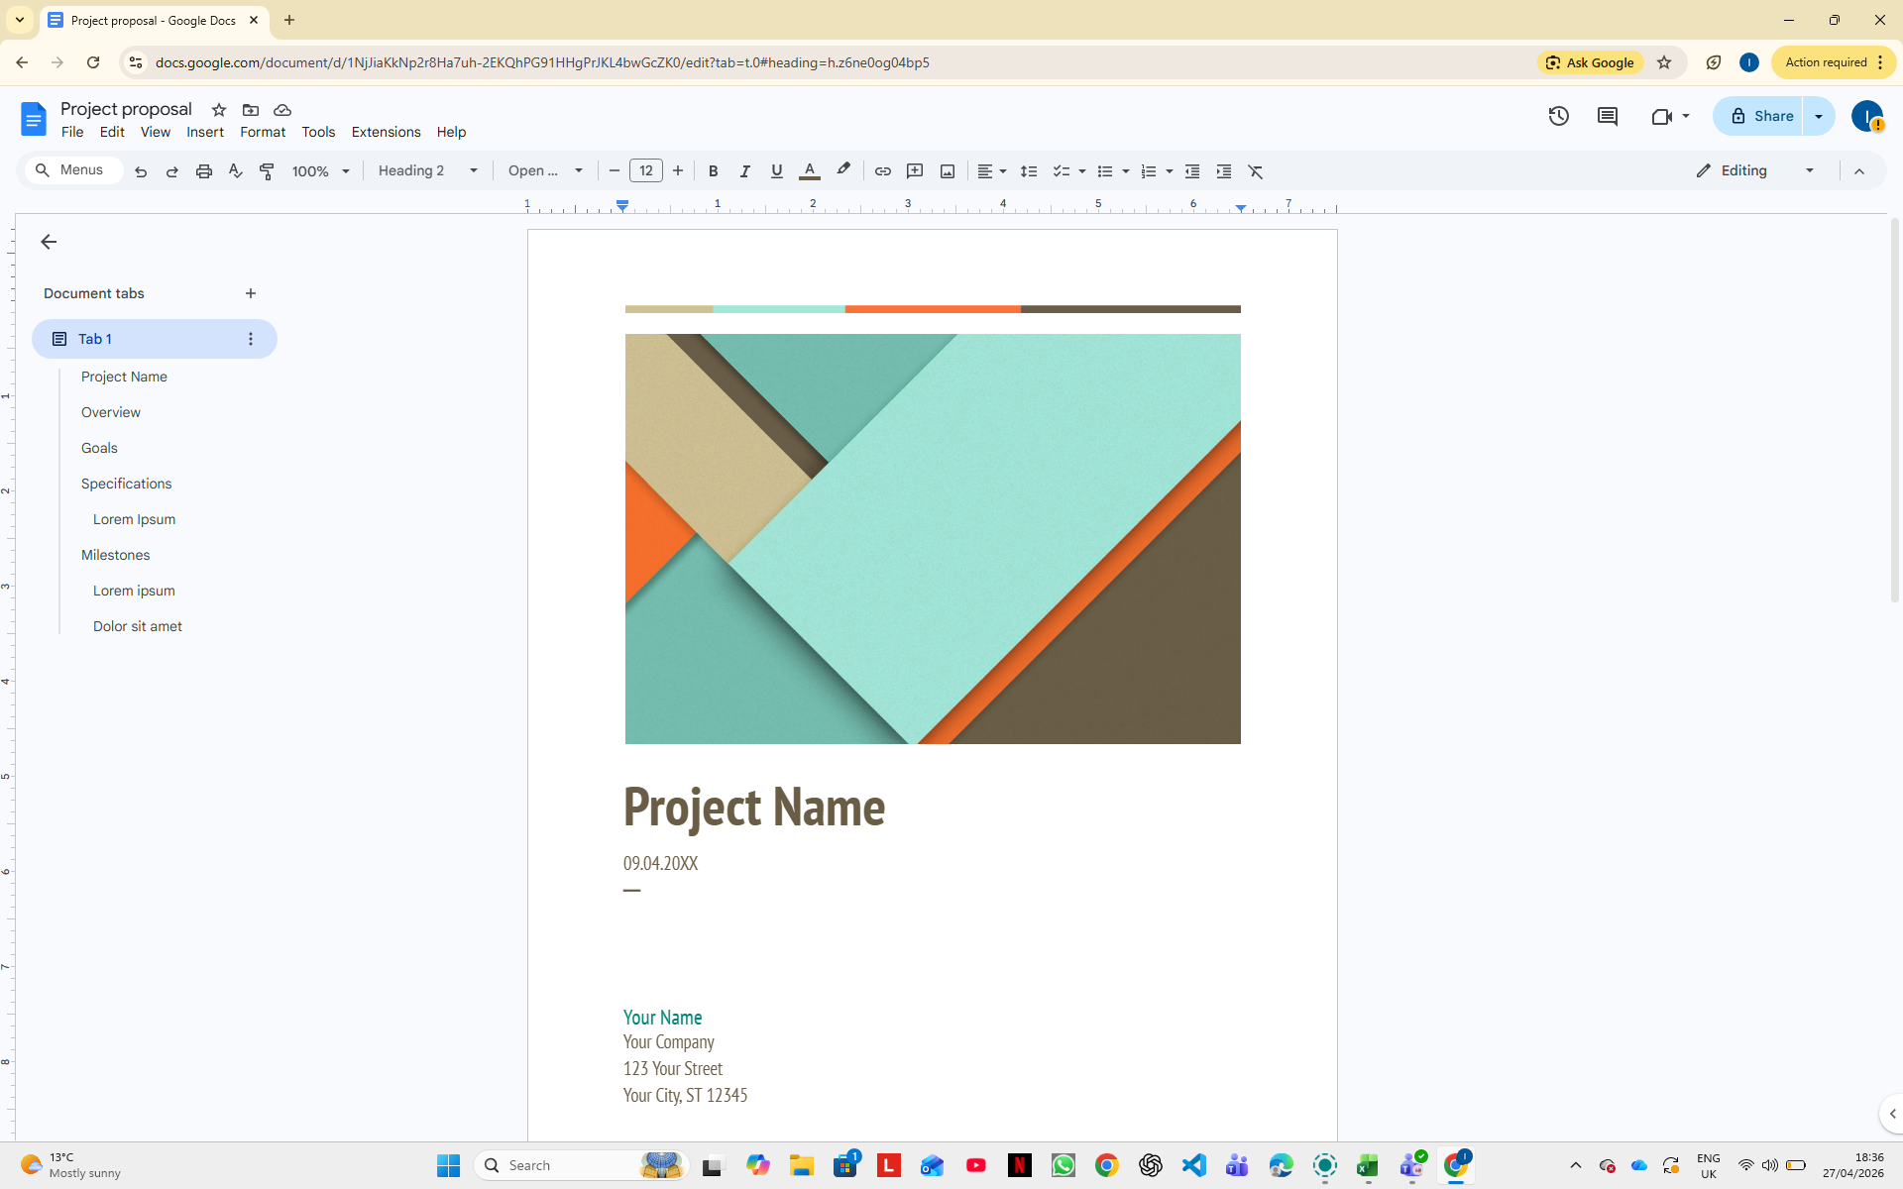

Conclusion
In conclusion, this assignment helped me understand how different software applications can support a business in real situations. E-commerce platforms such as Shopify and Squarespace can help businesses sell online, manage products and reach more customers without needing to rely only on a physical shop. The mind map section also helped me see how business ideas can be broken down in a clear way, instead of having everything written as long text. It made it easier to organise the main areas of a business, such as marketing, finance, operations and customers.

I also learned more about how Microsoft Office applications are used in business. Microsoft Word is useful for creating professional documents and reports, while PowerPoint helps present information clearly. Excel was one of the most useful parts for me because the IF function and VLOOKUP showed how data can be handled quicker and with less manual work. Microsoft Access also showed me how businesses can store and organise information in a more structured way, especially when dealing with records, customers or transactions.

The communication and collaboration section showed me that businesses do not just need software for documents or data. They also need tools that help people work together. Microsoft Teams can support quick communication through chat and meetings, while Google Docs allows people to work on the same document at the same time. This is important because modern businesses depend on teamwork, sharing information and keeping work updated.

This assignment also links to my future goal of working in cybersecurity. In cybersecurity, it is not only about technical tools or coding. It is also about being organised, documenting work properly, analysing information and communicating clearly with other people. For example, Excel could be used to organise security logs or incident data, Access could help store structured information, and tools like Teams or Google Docs could help when working with a security team or writing reports.

Going forward, I will take these software skills with me because they are useful for both university work and future employment. They have helped me understand how businesses use technology every day, and how important it is to manage information properly. For a future cybersecurity role, this is important because security work depends on accuracy, clear communication and good organisation. Overall, this assignment gave me a better understanding of how software solutions support business operations and how these same skills can be useful in my future career.

References

[1] | BigCommerce, “What is Ecommerce,” March 2026. [Online].
[2] | Shopify, “Shopify Payments,” [Online]. Available: https://help.shopify.com/en/manual/payments/shopify-payments.
[3] | Squarespace, “Adding products to your store,” [Online]. Available: https://support.squarespace.com/hc/en-us/article/205811338-Adding-Products-to-your-store.
[4] | J. Costa and R. Castro , “SMEs Must Go Online-E-Commerce as an Escape Hatch for Resilience and Survivability,” Journal of theoretical and Applied Electronics Commerce Research, vol. 16, no. 7, pp. 3043-3062, 2021.
[5] | M. J. Somers, K. Passerini, A. Parhankangas and J. Casal, “Using mind maps to study how business school students and faculty organize and apply general business knowledge,” The International Journal of Management Education, vol. 12, no. 1, pp. 1-13, 2014.
[6] | L. T. Eriksson and A. M. Hauer, “Mind Map Marketing: A Creative Apporachin Developing Marketing Skills,” Journal of Marketing Education, vol. 26, no. 2, pp. 174-187, 2004.
[7] | Microsoft , “Create a document in word,” [Online]. Available: https://support.microsoft.com/en-us/office/create-a-document-in-word-aafc163a-3a06-45a9-b451=cb7250dcbaa1.
[8] | Microsoft, “Create a presentation in PowerPoint,” [Online]. Available: https://support.microsoft.com/en-gb/office/create-a-presentation-in-powerpoint-422250f8-5721-4cea-92cc-202fa7b89617.
[9] | Microsoft, “IF function,” [Online]. Available: https://support.microsoft.com/en-gb/office/if-function-69aed7c9-4e8a-4755-a9bc-aa8bbff73be2.
[10] | Microsoft, “VLOOKUP function,” [Online]. Available: https://support.microsoft.com/en-us/office/vlookup-function-0bbc8083-26fe-4963-8ab8-93a18ad188a1.
[11] | Microsoft, “Create a database in Access,” [Online]. Available: https://support.microsoft.com/en-gb/office/create-a-database-in-access-f200d95b-e429-4acc-98c1-b883d4e9fc0a.
[12] | J. N. Lane, P. M. Leonardi, N. S. Contractor and L. A. DeChurch, “Teams in the Digital Workplace: Technology’s Role for Communication, Collaboration, and Performance,” Small Group Research, vol. 55, no. 1, pp. 139-183, 2024.
[13] | Microsoft, “Chat with others in Microsoft Teams,” [Online]. Available: https://support.microsoft.com/en-gb/office/chat-with-others-in-microsoft-teams-0c71b32b-c050-4930-a887-5afbe742b3d8.
[14] | Google, “Share files from Google Drive,” [Online]. Available: https://support.google.com/docs/answer/2494822?co=GENIE.Platform%3DDesktop&hl=en-GB.
[15] | V. Jackson, A. Van der Hoek and R. Prikladnicki, “Collaboration Tool Choices and Use in Remote Software Teams: Emerging Results from an Ongoing Study,” in 15th International Conference on Cooperative and Human Aspects of Software Engineering (CHASE 2022), 2022.

