Hotel standards, Reputation, Management and service culture
Module name: Hospitality and Guest Service Management
Tutor Name: Luciana Suardi
Name: Iuliana-Daniela Giurea
Student Number: 2226406
Executive summary
This study explores the significance of hotel quality, reputation, administration, and service ethics in the hospitality sector. By maintaining reputation and standards is emphasised to attract and retain customers and be competitive. A service-oriented culture and efficient management practices are crucial to providing memorable interactions. This research has used the example of Premier Inn. It offers recommendations for improving online reputation management, client feedback, employee recruitment and training, operational efficiency, and effective communication method that use the hotel chain. The reports suggest how hotels can improve their quality, reputation, management, and service culture.
Table of Contents
Introduction 4
Hotel Standards 4
Importance of maintaining high hotel standards 4
Identifying the hotel standards impact guest satisfaction and loyalty. 5
Reputation Management 5
Strategies for building and maintaining a positive reputation 5
Management Practices 7
Importance of effective management practices in achieving high standards and reputation 7
Service Culture 8
Importance of developing and fostering a service-oriented culture 8
Strategies for the hotel industry to create a positive service culture 8
Conclusion 9
Reference 10

Introduction
The term hospital industry includes hotels, restaurants, accommodations, meals, personal service and more. Basically, the hotel, reputation, management and service culture are made for customer satisfaction and loyalty. The hospitality sector is based on giving customers more than they expected. The success of a hotel depends heavily on the high quality of its services, as well as its reputation, management, and service culture. This report aims to investigate these aspects' importance in the hospitality sector.

Hotel Standards
The term "hotel standards" refers to a hotel's facilities, services, and general excellence standards (Phophan and Banjongprasert, 2021). Hotel standards encompass recommendations from professionals in the field of hospitality.

Importance of maintaining high hotel standards
Guests' happiness, loyalty, and impression of an accommodation depend on the staff's ability to uphold consistent expectations.
Cleanliness: Cleanliness is an integral part of every high-quality hotel. Hotel guests often expect a clean and well-maintained experience throughout the entire hotel. Maintaining a clean space has many benefits, including making visitors feel more relaxed and protecting employees from hazards. It is essential to ensure that guests feel at home by keeping the rooms and bathrooms clean and sanitised and the lobby and other public spaces clean.
Comfort: The guest's comfort level is another critical aspect of hotel quality. Guests depend on a good night's sleep, fully operational conveniences, and a relaxing atmosphere. Hotels may guarantee customers a comfortable stay by furnishing rooms with luxurious bed sheets, ergonomic decor, effective noise reduction measures, and comfortable environmental controls.
Safety: Standard hotel procedures prioritise guest safety. Hotels have a responsibility to ensure the safety of their guests at all times (Ervina et al., 2021). Guests are reassured and feel more comfortable knowing that safety features like fire alarms, security cameras, and emergency exits have been installed and that the staff has been educated to respond appropriately in an emergency.
Maintaining these high standards in hotels, it can bring a positive outcome for the hospital industry by fostering guest satisfaction, as well as building a good reputation.

Identifying the hotel standards impact guest satisfaction and loyalty.
Guest satisfaction and repeat visits are directly related to a hotel's level of quality (An et al., 2019). The total quality of a hotel stay is improved when basic needs like cleanliness, comfort, and safety are routinely met or exceeded. Guests happy with their stays can become repeat visitors and promote the hotel to others. Hotels can earn repeat business from satisfied patrons and the referrals of their friends by prioritising and maintaining high-quality standards.

Reputation Management
Strategic actions made by hotels to monitor and enhance their reputation among customers, online reviewers, and the broader public are known as "reputation management" in the hospitality sector. Guests' feedback and complaints must be replied to, and the hotel's reputation has to be developed through open conversation and involvement (Grljević et al., 2019). Reputation management's value comes from its impact on guests' impressions, bringing in new customers, encouraging repeat business, and keeping a company ahead of the competition.

Strategies for building and maintaining a positive reputation
To sustain a positive reputation, the hotel industry must maintain the following things;
Online reputation management: In this digital era, it is essential to constantly check and sustain reputation through online reviews and monitor social media and tourist booking sites. Businesses can succeed over new customers immediately, responding to guest evaluations, resolving issues, and highlighting positive experiences. For example, Premier Inn Hotel in the UK has sustained its online reputation by proactively responding to guest evaluations and interacting with clients on review sites like TripAdvisor (premierinn.com, 2023).
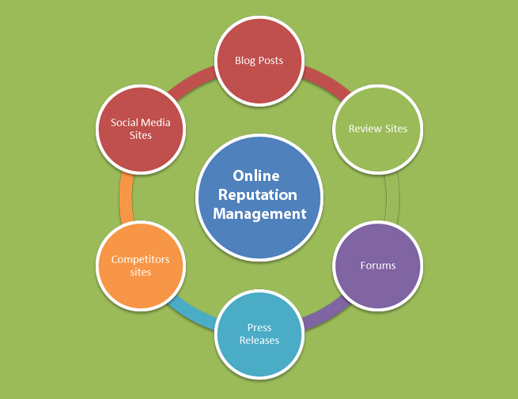
Figure 1 : Strategies for building and maintaining a positive reputation
(Source: Tanrısevdi et al., 2022)
Guest feedback and reviews: Guest feedback is essential, and hotels should seek feedback via questionnaires, comment cards, and online reviews (Tanrısevdi et al., 2022). Hotels may improve customer service and address issues quickly by carefully assessing consumer feedback. Premier Inn regularly surveys clients to improve their services.
Staff training and performance: By well-trained and customer-focused staff are essential. Hotels must train their staff carefully to deliver excellent service. Performance reviews and award programmes can keep workers motivated. Premier Inn trains its staff to deliver consistent service across its hotels.
Crisis management and handling complaints: Resolving complaints from visitors quickly and effectively is reputation management. The hotel should handle guest complaints and issues. Premier Inn's customer care team responds quickly, resolves issues, and provides guests when necessary.
Moreover, these methods can boost guest satisfaction and loyalty at Premier Inn.

Management Practices
The conventional organisational structure of a hotel includes the following divisions: front desk, housekeeping, food and beverage, promoting, and accounting. A manager can control each division by observing every function effectively. Managers of individual departments report to the hotel's general manager, who is responsible for the hotel as a whole.

Importance of effective management practices in achieving high standards and reputation
Good management practices are crucial regarding the quality and reputation of a hotel. Due to efficient management, it can operate every function smoothly, use resources and train and motivate each employee. By improving guest happiness, loyalty, and reputation, can bring success to well-managed hotels with high standards, quick service, and a happy work environment (Suleri et al., 2021). Furthermore, the following things can help the hotel industry sustain its reputation by meeting these criteria.
Staff recruitment, training, and retention: A hotel manager needs to hire, train, and retain their employees well (Marinakou and Giousmpasoglou, 2019). Careful hiring, in-depth training, and an encouraging work atmosphere can increase staff morale and productivity. When businesses successfully recruit, train, and retain employees, they can better serve their customers and grow their businesses.
Operational efficiency and resource management: The success of a hotel depends significantly on the management and efficiency of its operations and resources. Premier Inn uses technological solutions and streamlined processes to maximise room utilisation to achieve this goal (premierinn.com, 2023). Through effective operations and proper resource utilisation, effective resource management helps maximise profits, reduce waste, and improve customer service quality.
Communication and coordination between departments: For the hotel's operations to run smoothly, there must be strong communication and collaboration between the various divisions. Premier Inn encourages effective teamwork by holding regular departmental meetings, using extensive communication tools, and encouraging cooperation between departments. As a result, everyone is on the same page and works together to provide outstanding service and meet customers' expectations.

Service Culture
For a hotel to have a strong service culture, all employees must adopt an approach and values that place an increase on providing 5-star service to every guest (Priyo). It is defined by a commitment to the satisfaction of its customers, a drive to perform their expectations, the encouragement of staff innovation and participation, a focus on constant improvement, and a real motivation to provide guests with a pleasant experience.

Importance of developing and fostering a service-oriented culture
The hospitality sector emphasises growing and preserving a service mentality among employees (Colmekcioglu et al., 2022). As a result, customers are happier, staff are motivated and increase loyalty. Positive reviews, new customers, and satisfied friends come from a service-oriented mindset. It represents the hotel from the other hotels and gives it a competitive advantage in the market.

Strategies for the hotel industry to create a positive service culture
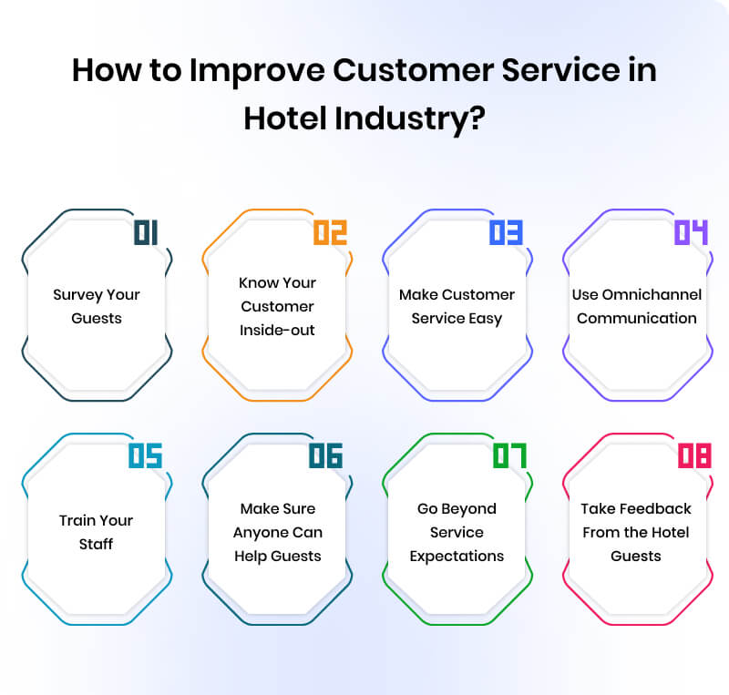
Figure 2: Strategies for the hotel industry to create a positive service culture
(Source: Liu et al., 2022)

Leadership and employee engagement: Strong leadership and buy-in are required to promote an employee service mentality. Premier Inn recognises the importance of having leaders who may stimulate and encourage their staff. Staff involvement is excellent because of the consistent communication, training, and recognition programmes that are in place.
Empowerment and accountability: A service-oriented culture emphasises different tools and personal responsibility. Employees at Premier Inn have confidence in responsibility and are encouraged to please customers (Liu et al., 2022). Having defined goals and responsibilities helps employees take satisfaction in their work and ultimately benefits customers.
Continuous training and development: A strong commitment to learning and growth is essential in a service culture. Premier Inn invests much in training programmes, including customer service workshops and leadership development initiatives, to improve the knowledge and abilities of its staff. Constant training gives workers the skills they need to provide first-rate service to customers.
Recognition and rewards: An appreciation and reward system is crucial in developing a culture of service. Employees that consistently provide Premier Inn's signature 5-star service are recognised and rewarded. Employees can be encouraged and inspired to continue providing excellent service through programmes like "Employee of the Month" and "top performer" awards.

Conclusion
In conclusion, the success of the hospitality sector is linked to the industry's standards, reputation, management, and service culture. Guest happiness, loyalty, and advantage of competition result from maintaining high standards, having a good reputation, using efficient management practices, and having a service-oriented culture. Hotels can improve their bottom line by putting a premium on upholding and raising standards, managing their reputation, using effective management techniques, training and developing their staff, and developing a service-oriented culture. Hotels may succeed in today's competitive hospitality market by constantly meeting guest expectations.

Reference
An, S., Suh, J. and Eck, T., (2019). Examining structural relationships among service quality, perceived value, satisfaction and revisit intention for Airbnb guests. International Journal of Tourism Sciences, 19(3), pp.145-165.
Colmekcioglu, N., Dineva, D. and Lu, X., (2022). “Building back better”: the impact of the COVID-19 pandemic on the resilience of the hospitality and tourism industries. International Journal of Contemporary Hospitality Management, (ahead-of-print).
Ervina, E., Taufiq, R. and Masatip, A., (2021). Guest satisfaction on star hotel preparedness in new normal era of COVID-19. APMBA (Asia Pacific Management and Business Application), 10(1), pp.21-38.
Grljević, O., Bošnjak, Z. and Bošnjak, S., (2019). Contemporary data analysis techniques for online reputation management in hospitality and tourism. Facta Universitatis, Series: Economics and Organization, pp.059-073.
Liu, D., Han, S. and Zhang, J., (2022). The golden mean: Research on the mechanism of customer participation in employee service innovation. Journal of Retailing and Consumer Services, 68, p.103040.
Marinakou, E. and Giousmpasoglou, C., (2019). Talent management and retention strategies in luxury hotels: evidence from four countries. International Journal of Contemporary Hospitality Management.
Phophan, K. and Banjongprasert, J., (2021). The Influence of MICE Standard on Hotel Performance: The Mediating Role of Communication. Journal of Innovation and Management, 6(1), pp.161-177.
premierinn.com (2023) Premier Inn Hotels: Book Direct, Premier Inn hotels | Book direct. Available at: https://www.premierinn.com/gb/en/home.html (Accessed: 01 June 2023).
Suleri, J., Meijer, R. and Tarus, E., (2021). Exploring hotel identity by focusing on customer experience analysis. Research in Hospitality Management, 11(2), pp.113-120.
Tanrısevdi, A., Öztürk, G. and Öztürk, A.C., (2022). A supervised data mining approach for predicting comment card ratings. International Journal of Contemporary Hospitality Management.

