  Component One: Student Journal (learning log) 750 words +/- 10%  Contribution to Overall Module Assessment: 25% | Student No: | 2242724
 | Module Title: | Hotel Placement: Hotel Administration and Front Office Operations
 | Module Code: | BMIH4004
 | Lecturer: | DANIEL PAYNE
Introduction
According to Bardi, (2011), a reflective journal refers to the recording of personal thoughts and experiences throughout the learning process of the course. In this reflective journal, a detailed analysis of placement experiences of the front office area in “VILLAGE HOTEL SWINDON” in the role of guest service associate illustratrated here. The key skills that are required for front office placement include communication skills, teamwork skills, and task management skills. The main aim of this reflective journal is to illustrate critical thinking, self-awareness and a clear understanding of the Gibbs reflective model presented in this part.
Gibbs Reflective model
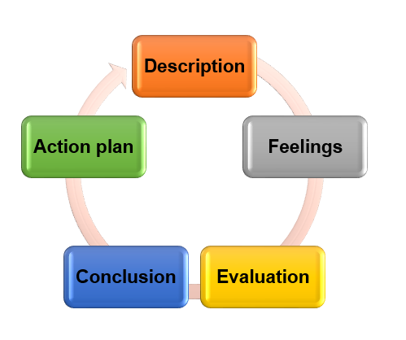
Figure 1: Gibbs Reflective model
(Source: Self-created)
Description
At the beginning of the reflection, the overall tasks, and responsibilities that took place in the front office area mentioned. At the time of performing the role of Guest Service Associate, I learned about some of the responsibilities of the guest service associate. The task of the customer service associate is managing customer concerns along with objectives to maintain positive customer relationships in the “VILLAGE HOTEL SWINDON.” My job role was to interact directly with the customers, listen to their problems and concerns, and recommend product services as per customer requirements (Village-hotels.co.uk, 2024). During the time of task division, I have observed the importance of effective communication and professionalism to ensure guest satisfaction. I believe having proper communication skills will assist me in guiding the team members appropriately in the front office department. Communication skills are the abilities that help the customer service associate maintain effective communication techniques to guide the customers (Corgel et al., 2011). On the other hand, at the time of performing this job role professionalism plays a vital role in maintaining company culture.
Feelings
During the time of placement experience, I have learned about the importance of communication skills and professionalism. Communication skills help the customer service associate the chance of meeting the requirements of customers (Tesone, 2010). At the time of performing this placement experience, I had the chance to meet the customer's requirements. These skills assist me in dealing with the client appropriately when checked in into the hotel and also check out. I noticed that sometimes guest services were unable to address the query properly, which hinders the smooth running of the "VILLAGE HOTEL SWINDON”. Another challenge I faced when I didn’t have the right guest. Keeping in mind the challenges utilising communication skills was necessary. At that time, I also had the chance to improve teamwork skills, which helped me maintain the hotel working rules.
Evaluation
At the time of performing this job role as a guest service associate, I have utilised my performance skills. I have learned that effective guest service staff mostly need to be careful about managing multiple tasks. I have learned that to offer a good guest service I have to improve my conflict resolution skills to resolve any kind of challenges that are created in Village Hotel Swindon. I believe that having communication skills will assist me in resolving any kind of conflict as well as challenges.
Analysis
The impact of placement experience in the front office area job role is that they are bound to provide guest service to the customer (Tewan, 2009). With the help of communication skills, I will get the chance to understand the customer requirements and identify the challenges, which are created when a customer checks in to the hotel.

Action plan

Objectives | Specific | Measurable | Achievable | relevant | Time scale
To improve interpersonal skills to achieve the customer service associate job role | These skills are important for front office placement because they would guide me to interact with a variety of people. | These skills are measurable by completing the task accurately and appropriately. | These skills are achievable by dealing with critical people and establishing trust and a supportive environment. | The interpersonal skills are relevant for the front office area because they would help me create personal relationships in the workplace. | 3 months
To enhance technical skills for solving critical challenges in the front office job role | The technical skills are specific because it would emphasize problem-solving skills and analytical skills. | The technical skills measured by assignments and digital tasks. | The technical skills achieved through peer-to-peer assignments and online courses. | The technical skills are relevant for the front office area because they would guide me in solving critical challenges. | 4 months

Conclusion
The overall experience summarizes a reflective journal that ended with the help of Gibbs’s reflective model. This reflective model consists of a description, analysis, feelings, evaluation, and action plan. In the description part, specific tasks and responsibilities in office area job professionals have been described. The feelings part mentioned some of the challenges and surprises that encountered in the job role. During the time describing the placement experience, I observed that being a customer service associate communication skills, and teamwork skills play a vital part. These two skills will motivate me to provide better service to the client.

Component Two
Contribution to Overall Module Assessment: 25%
Trip Advisor Review Response 150 words +/-10%
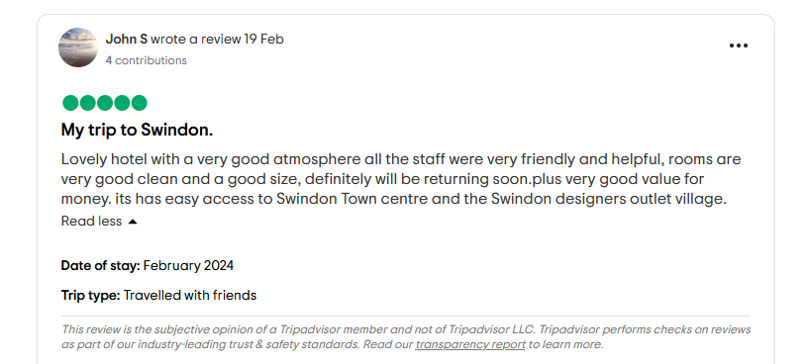
Figure 2: Review response of TripAdvisor
Source: TripAdvisor.co.uk, 2024

Thank you so much for your positive response about Village Hotel Swindon it is helpful for us to know that the hospitality experience was quite good to you. We feel enchanted that you find out our staff member friendly and whole hospitality was good. The positive response was quite effective for our team members to understand the demanding factor of customers. The fact, which you have mentioned, means a lot to us and we feel pride to delivering you great service. It makes us happy to hear that you recommend this hospitality service industry to your friends and family, which would increase our brand value. The fact that you have mentioned in this review will help my team members for enhancing better service in future. Another fact I would love to mention is that the team members of our Village Hotel Swindon make your journey memorable Thank you from the bottom of our hearts again for your kind words and we look forward to see you again.

Letter of complaint response 500 words +/- 1-%
Village Hotel Swindon
Shaw Ridge Leisure Park
Whitehill Way
Swindon
SN5 7DW

January 10th , 2024

Subject: Coherent about the complaint letter

Dear Mrs Joanna Blake,

Thank you for the time to communicate with us and for writing this letter to give feedback about our service when you stayed in room 330 of Village Hotel Swindon. We are really sorry to mention that we cannot meet your expectations. In this perspective, we need to mention the fact that in every aspect we desire to address your needs and give you a better solution that is available in this village Hotel Swindon hotel.
We would like to inform you that we have decided to find out the proper solutions that you have mentioned in the form of a complaint note. As you mentioned that, the room was not clean enough during the time of your stay, keeping in mind this fact we have decided to improve the knowledge of cleaning areas through training for the staff members.
We will be in contact with you in the coming days to make the best and most effective attempt to gain your confidence in our hotel. Additionally, we will further evaluate the solutions that will be prevented in future and we will take necessary solutions to prevent it.

We decided to improve our employability and problem-solving skills. We are really sorry to mention the fact that the customer service, which was provided to you, was terrible. Concerning about the fact we have decided to increase the skills of customer service among the staff members and give them proper knowledge about solving the problems.
On the other hand, another problem you mentioned was the technical service such as Wi-Fi and you mentioned that the service was quite slow and frustrating. Concern about this issue the management team of this hotel decided to enhance their technical skills. Improving these skills would support them in finding out solution when this kind of problem happen again. The organisation decided to hire eligible staff members who have appropriate knowledge about giving proper service to the clients. We have provided proper training programmes to the staff members to increase their knowledge about understanding the queries of customers. Additionally, you have mentioned that the staff members were not responsive when you needed them. To find the proper solution to this kind of issue we have decided to divide tasks among the staff members properly. Allocating tasks among the staff members would provide them the ideas about who performs which duties.
Another challenge, which you have faced, is noise levels that were quite excessive. Keeping in mind your feedback, we have decided to take the steps such as turning off the appliances when not used, lowering the TV volume.
In order to resolve the Wi-Fi challenge, which you have highlighted, we have hired a candidate who has better knowledge about resolving this kind of technical issues. For instance, we have hired specific staff members who have knowledge of software programming.
Thank you for taking the time to give feedback about our service and write the letter.

Warm regards,
Line manager of Village Hotel Swindon
ADDRESS: SHAW RIDGE LEISURE PARK, WHITEHILL WAY, SWINDON, SN5 7DW.

Contribution to Overall Module Assessment: 50% (1000 words +/- 10%)
Component 3: Essay
Introduction
This module focused on illustrating the relevant skills that are required for working in the hospitality industry. These skills mostly focused on key industry skills including customer service skills, communication skills, organisational skills and problem-solving skills. The above-mentioned skills are required for getting the front office job roles. The application of the chosen skills improves the business functionalities of Village Hotel Swindon customer service associates and it increases the rate of production of the chosen organisation.
Key Skill 1 – Customer Service Skills

According to ASET, (2013), customer service is the practice of providing help and support to new customers and existing customers. Customer service skills are crucial for automation and self-service that continue to rise. Hotel industries such as Village Hotel Swindon prefer to have reliability skills, sensitivity skills, Accountability skills, and positivity, knowledge, and intelligence skills among their employees. For instance, the application of customer service skills helps the employees of "Village Hotel Swindon” to learn about managing human interactions effectively and naturally. Having these types of skills would guide the employees to interact with the customers and after reading customers' emotions would be helpful to keep the service on track (Fallon and Rutherford, 2011). The employees of the hotel industry must be sensitive during the time of giving service to the customers. On the other hand, the positive skills of hotel industry employees help them to be solution-oriented, confident, unflappable, and proactive. Most hotel brands hire candidates who have deep knowledge about products and services and internal methods. For instance, the customer service associate of Village Hotel Swindon applies customer service skills to solve critical challenges, of customers through the procedure of communication and counselling. Any employee of the hotel industry must be concerned about face-to-face interaction with the client and have the eligibility to empathize with the customers. For instance, the application of customer service skills helps the customer service associate in building a better brand image and hence increasing profit.
Key Skill 2 – Communication Skills

Based on the view of Fanthorne, (2004), communication skills are the capability of giving a different kind of information and receiving a different kind of data as well. To get the job role of customer service associate having communication skills plays a vital role. This skills guide the employees of the Village Hotel Swindon to share their thoughts with the clients in any one-to-one meeting or virtual calls. For instance, the customer service associate of Village Hotel Swindon has communication skills that help them to solve their difficulties via emails, handwritten notes, or sign language. Village Hotel Swindon customer service associates to get proper information that would help increase the performance of the employees apply these skills. For instance, the customer service associate of Village Hotel Swindon applied communication skills to get information from the team members. Customer service associates to avoid any kind of distraction apply this skill and it also assists in connecting the team members in the Village Hotel Swindon. For example, the customer service aspect of Village Hotel Swindon collaborated with other business organisation to generate more revenues. It has been observed that having good communication skills and application of these skills assists the customer service associate to engage with more staff members and clients (Johnston et al., 2012). After the application of these skills customers of Village Hotel Swindon have the chance of getting multiple layers of information to exchange.
Key Skill 3 – Organisational Skills

Based on the view of Vallen and Vallen, (2014), organisational skills are the set of techniques that are used for facilitating the efficiency of future-oriented learning, problem solving, and completion of tasks. These skills are the ability to manage time efficiently, prioritize tasks, and set goals. Based on the application of these skills, the customer service associate of Village Hotel Swindon manage their time and accomplish the assigned tasks carefully. For instance, application of these skills would assist the customer service associates with the chance of being more focused on their responsibilities. On the other hand, these skills assist the employees and customer service associates the chance to complete their tasks in a structured way. For instance, the application of these skills would support those staff members who have more workload than others do. Good organizational skills are applied for giving a chance to customer service associates to create space for others (Wood, 2013). The organisational skills help the customer service associate the chance to support the organisation. For instance, the application of this skill would help the customer service associate the chance to track the necessary information from the customers and staff members.
Key Skill 4 – Problem-Solving Skills

As stated by Williams et al., (2020), problem-solving skills are the ability to identify challenges, brainstorm and analyse answers and implement the best solutions. For instance, the application of problem-solving skills helps the customer service associate the chance to empower the staff members' personal life but also professional lives. Problem-solving skills can be applied to developing practical solutions and creative solutions to improve the performance of staff members of Village Hotel Swindon. On the other hand, customer service associates to assist the staff members in thinking analytically when any problem arises apply problem-solving skills. The customer service associate of Village Hotel Swindon can apply problem-solving skills to provide better ideas that save customers time as well as money. After the application of these skills, the chosen organisation collaborate with team members effectively. Application of these skills helps them to find out proper strategies to build better insights and they could find appropriate resources that could support the business function (Hammer, 2016). Based on this, the customer service associate of the organisation builds up necessary skills by the application of problem-solving skills.

Conclusion
This module guides the learners and provides the chance to understand customer service skills. These skills are important because they would improve the quality of front-office operations. Communication skills are important here because of building proper connections among the staff members and customers. These skills built up the necessary strategies to collaborate with the team members. These communication skills are applied to create a better organizational culture. Other skills are also illustrated here, which are problem-solving skills, organisational skills, organisational skills, and Customer Service Skills. Customer service skills assist the customer service associate with the chance to deal with the customers about any kind of issues.

Reference List

Component 1
Bardi, J. (2011) Hotel Front Office Management, Wiley, London
Corgel, JB, Sturman, MC and Verma, R. (2011) The Cornell School of Hotel Administration on Hospitality: Cutting Edge Thinking and Practice, John Wiley & Sons, Incorporated, Hoboken.
Tesone, D. (2010) Principles of management for the hospitality industry. London: Routledge.
Tewan, J.( 2009) Hotel Front Office: Operations and Management, Oxford Higher Education Press
Component 2
https://www.tripadvisor.co.uk/Hotel_Review-g187049-d191626-Reviews Village_Hotel_Swindon-Swindon_Wiltshire_England.html
Component 3
ASET,( 2013), ASET Good Practice Guide for Work-based and Placement Learning, ASET, Sheffield
Fallon, M. And Rutherford, D. (2011)Hotel Management and Operations, Wiley, London
Fanthorne, C (2004) Work Placements – Survival Guide for Students Macmillan, Basingstoke
Hammer, J. (2016) Revenue superstar! The simple rules of hotel revenue management. Great Britain: Amazon.
Johnston, R Clark, G. Shulver, M.( 2012) Service Operations Management, Pearson, London
Vallen, G.K. and Vallen, Jerome J. (2014) Check-in check-out: managing hotel operations Ninth edition. Pearson New International.
Village-hotels.co.uk, (2024). Swindon Town Centre Hotel with Pool: Village Hotel Swindon Village Hotel - Swindon. Available at: https://www.village-hotels.co.uk/swindon (Accessed: 10 February 2024).
Williams, K, Woolliams, M and Spiro, J. (2020)Reflective writing, Macmillan International, Oxford.
Wood, R. (2013) Key Concepts in Hospitality Management, Sage, London

