TASK 2 - Illustrated Book Project Proposal Task
500 words, due 5pm Feb 12th, submitted via moodle.
Formatting: please use the headings below making use of the advice and resources provided. References should be made using the Harvard format.

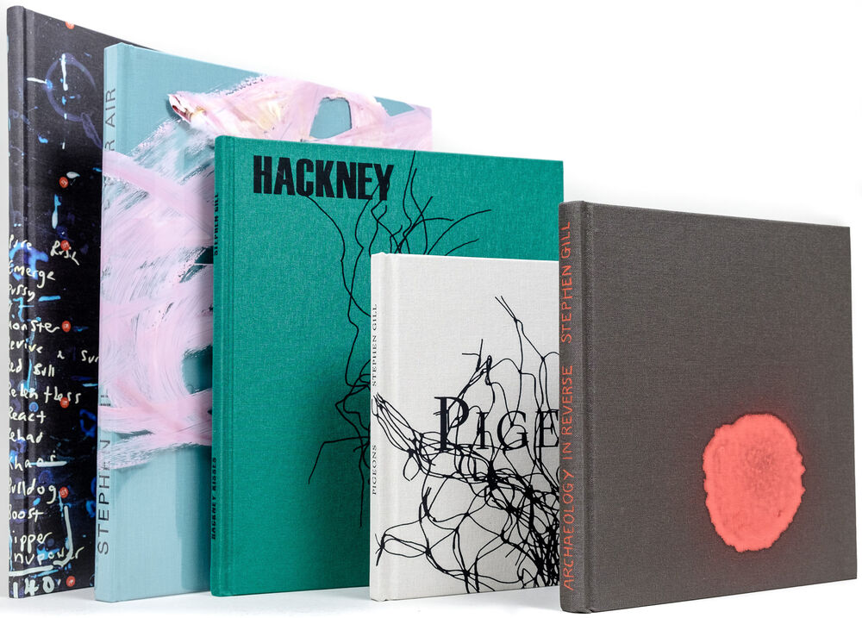
Name: Suzanna Borowiec

Theme/Context
Provide a brief summary of the theme or subject you want your work to focus on. You might include details about the impact you hope to achieve, how the book format will help you connect with your audience, and what will make your work stand out. (300 – 500 words)
The subject and theme I currently want to explore is a maternal relationship (between me and my mother), as well as the themes of grief and illness. For the creation of the book, I was thinking of a scrap book/diary layout (for example including writing from my mother, old photographs etc.) due to it being driven by real experiences and the vulnerability I am aiming to showcase. I want the audience to feel connected with the book and the narrative inside, to feel a story being told whilst reflecting on their own experiences with the themes I am presenting. Through creating a book that feels personal in a physical sense, the audience will be able to immerse themselves more fully within it.

Influence
Highlight the work of a photographer who currently inspires your work. Analyse an image of theirs and explain your interest in their work. Consider style, theme, context, practical technique. (300 – 500 words)

Whilst thinking about this project, my main inspiration is Shuli Huang’s short film ‘Will You Look at Me’ (2022). In this piece of work the director presents a series of moving images of his and his mother’s life whilst a deeply emotional and vulnerable conversation between them plays over the footage. Another inspiration currently is Krzysztof Kieslowski's ‘Talking Heads’ (1980) which similarly to the previous artist, it shares the subject of vulnerable conversation between people which is what I am interested in whilst thinking about how it can be incorporated in a book form and help me with the photograph element. Visually, I am inspired by the artists of the Provoke movement such as Daido Moriyama, with his highly contrasted, monochrome, evocative photographs that capture raw emotion of the moment.

https://globalqueercinema.com/f/will-you-look-at-me-dang-wo-wang-xiang-ni-de-shi-hou-2022

Book Form
Referencing the session PowerPoint on Moodle (or another relevant source), discuss at least one book that has influenced you. Explore its visual and aesthetic qualities, social or historical context, impact, or practical methods relevant to your theme. You may also evaluate its overall effectiveness. (300 – 500 words)

The main influence for me, starting this project, has been Tiago Coelho’s ‘Dona Ana’ (2022). The aspect of the book that has inspired me is the collaboration between the photographer and the subject. The subject felt as though she was not fully represented in the book therefore, she added her own annotations which made the book feel a lot more personal and stand out overall, as well as reinforcing the aim of the book.

