Personal reflection:
St Fagans. An archaeologist perspective
By Lillian York 2317170
6th October 2023
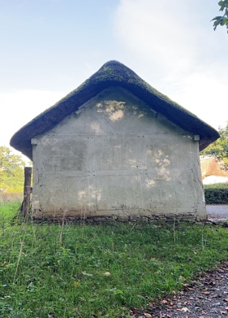
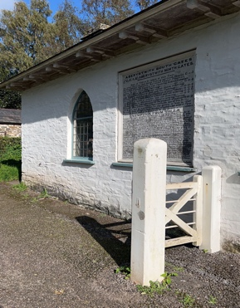
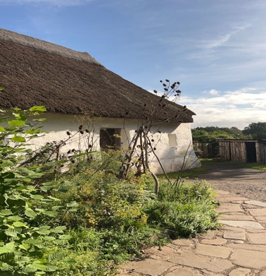
Hendre’r-ywydd Uchaf Farmhouse:
Located in: Llangynhafal
Built in 1508 Re-erected in: 1962.

During the time period this house was built in, it was considered ‘luxurious’ by the standards of the tutors.

The family also shared the two lower bays with their cattle and the three upper bays is where the family formed their home.

By the family sharing their house with their cattle, it shows how important their livestock means to them.
Do they view their cattle as equal to them? Or are they protecting the cattle from potential predators?

(St Fagans National Museum of History 2023-Information board 12)
Tollhouse:
Located in: Penparcau Aberystwyth
Built in 1771 and re-erected in 1968.

During this time period roads were built and maintained by the Turnpike Trusts.
These roads were used by poor farmers, who would have to pass the toll gates, chains and barriers and would get charged multiple times a day.
Because of the unfairness, this made the people extremely angry. This led to men protesting and they attacked 250 toll houses between 1839- 1844. These men would wear women’s clothing as a disguise and call themselves the ‘Daughters of Rebecca’.
This protesting shows us the unfairness the farmers felt. And how the lower classes were treated and taken advantage of by the authorities.
(St Fagans National Museum of History 2023-Information board 16)
Nantwallter cottage:
Located in: Taliaris
Built around 1760 re-erected in 1993.
During the year in 1785, a man called Morgan David Morgan, rented out this cottage for around £9 a year which is £1,743.09 today.

The family which was renting the cottage kept a pig and grew their own vegetables meaning that they had food all year round as money was scarce for them.

The cottage walls were made of a mixture of clay, stone and straw which was called ‘clom’. The thickness of these walls meant the house stayed cool in summer but warm in winter.

As the family were self-sufficient, this meant that they worked within a community, as they had friends and family who would help with any of the building work. Which shows a sense of community, and order.
(St Fagans National Museum of History 2023-Information board 13)
St Fagans is a beautiful heritage site located in Cardiff.
St Fagans brings the history of wales to life, by having over 60 different attractions for the visitors to not only see, but to experience.

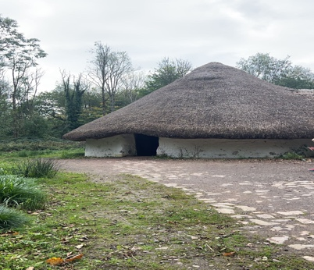
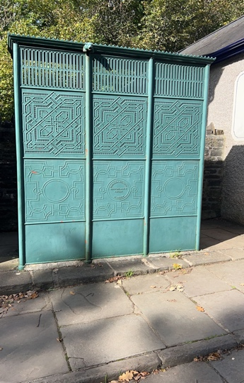
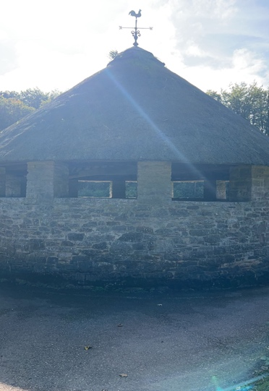
Bryn Eryl Iron Age Roundhouse
Located in: Anglesey.
Built 2,300 years ago.
People lived in circular homes during the Iron Age, with thatched roofs. Most of the homes had walls of stone, and ‘clom’. It took over 300 tonnes of clay and earth to build these walls, meaning that they were extremely thick. The people who owned these houses, would use natural pigments to paint the inside of the walls.

These people also grew crops and kept animals. Such as, sheep, horses and cattle. These families were wealthy, and were connected to people from Cheshire, and would import salt from the Cheshire plain which was used to persevere as well as flavour their food.

By looking at this information we can tell that it would have taken a lot of time and effort for these families to build and maintain their house. By the painting of the inside walls, we can see that the families took great pride in their homes,
Just like people of today do too.
(St Fagans National Museum of History 2023-Information board 33)

Urinal
Located in: Llanwrtyd Wells
Built around 1900 re-erected in 2010.

Public toilets became very common during the Victorian times. Even though they were mostly for men, there were a few provided for women.
This was because women, were seen as the home makers. That they shouldn’t really have a reason to leave the house as they were considered to stay at home more.

During the Second World War, many urinals were destroyed and used as raw material as they were made out of cast iron and used for the war effort.

We also know that these were manufactured in Scotland, as the Scottish manufacturer is engraved onto the wrought.

If we look at the design, we can see a single gargoyle looking out from the top of the urinal.
What does this gargoyle mean?
Is it just a waterspout or does it have a deeper meaning to keep evil spirits away?

From looking at the urinals alone, we know that women were looked at as lower than men in this time period. That women had a role to stay home and cook, clean and raise the children (if they weren’t privileged enough to have household staff and a governess.)

Around the same time as the urinals were being manufactured, we know that the Suffragettes were founded, and the movement of women’s rights took off.
(St Fagans National Museum of History 2023-Information board 22)
Cockpit:
Located in Denbigh
Built around 1660 and re-erected in 1970.
Cockfights were extremely popular; they were also very cruel and vicious. People would spend loads of money betting on the fights. The bird fought each other using sharp spurs which were on their legs. These were used to rip though the flesh of the other bird.
The fight would only end when one bird was killed or seriously injured.

This cockpit was built in the yard of the Hawk and Buckle inn, purposefully just for cockfighting. After the ‘Preservation of Cruelty to Animals Act 1849’ banned this game, it was then used ironically as a slaughterhouse.

The cockfights were a way for the community to be brought together. People of all different classes would come and bet on fights.
People who wouldn’t normally even look at each other in the street, were all in one room, forgetting about which class they were in while laughing and joking with whoever they were near to.
(St Fagans National Museum of History 2023-Information board 20)
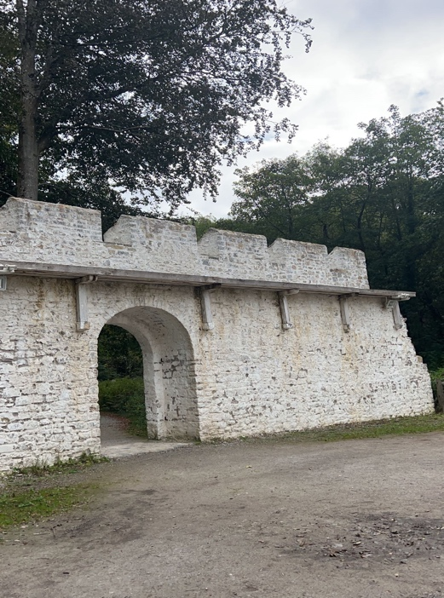
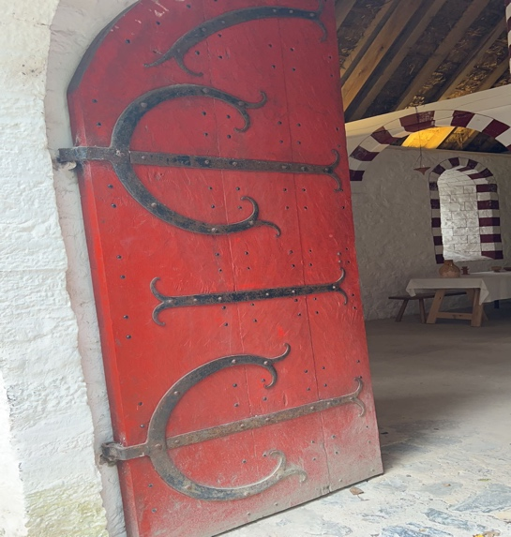
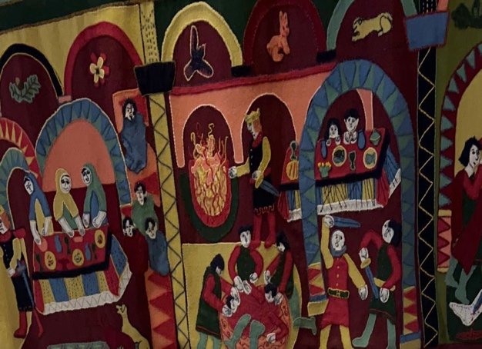
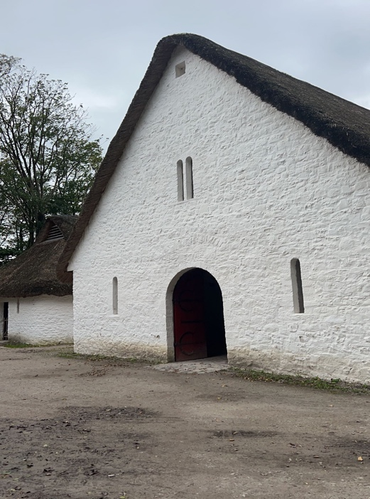
Llys Llywelyn
Medieval prince’s court
Located in: Anglesey.

Prince of Gwynedd, also known as Llywelyn the Great, was one of the most powerful rulers before the English Conquest in 1282.

Llywelyn would travel with his retinue around many courts. The surrounding tenants would farm the land nearby land to provide food and supplies for his visit.

In the Middle Ages, they used wallhangings. These would keep the cold and the damp away and would also be used for decorations.

By looking at all the artefacts, we know that Llywelyn was a very important man and very respected.
He had, a chief Falconer, who would look after the birds. As well as hundreds of people within a court, everyone had to provide food or labour for the prince.
He also had the Bishop of Bangor to advise him, as well as many other important people to serve him.

(St Fagans National Museum of History 2023-Information board 34)

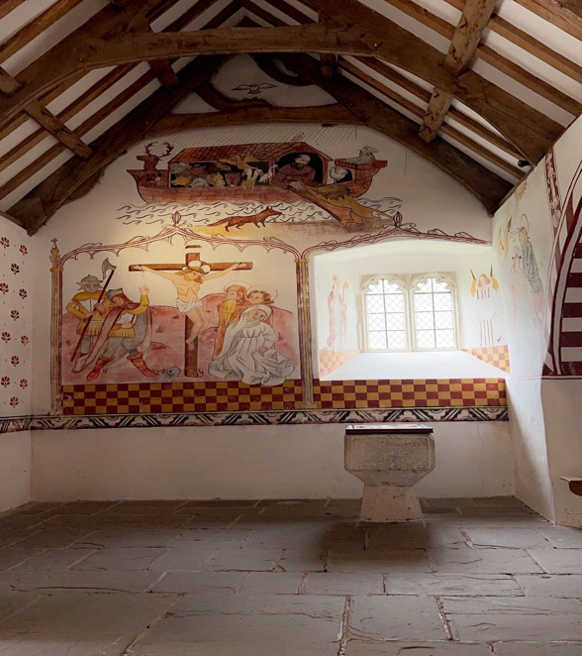
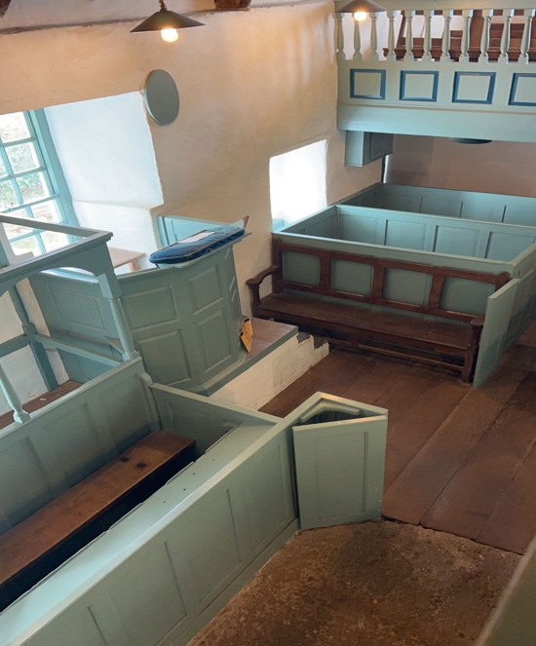
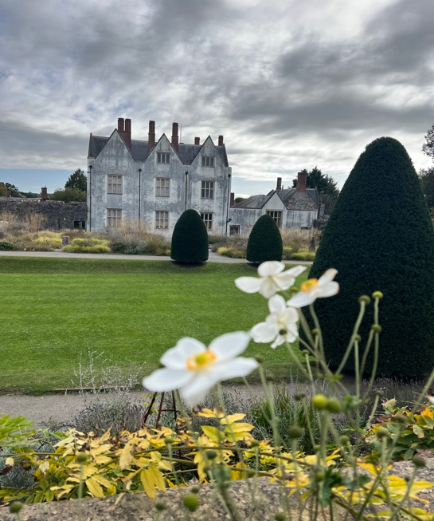
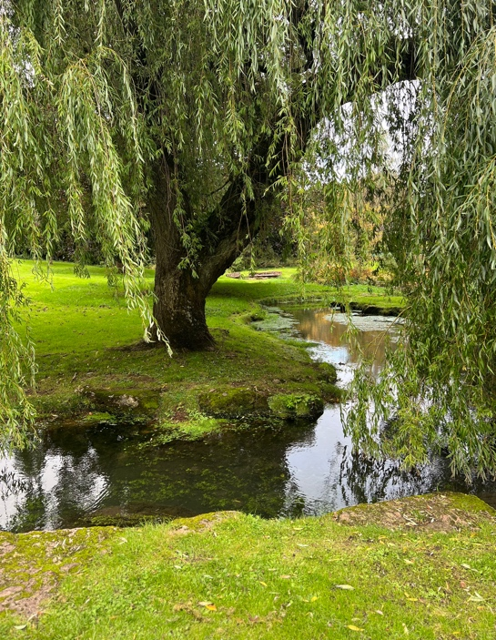
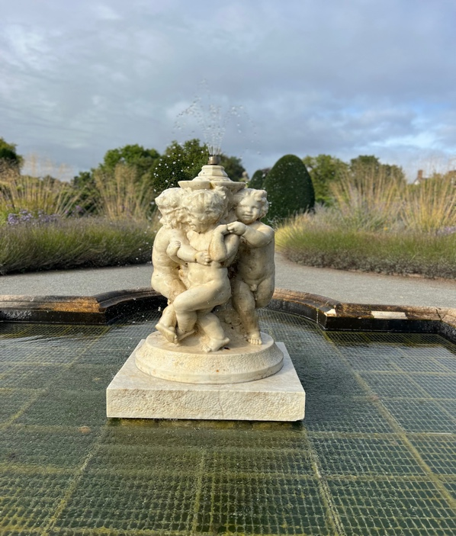
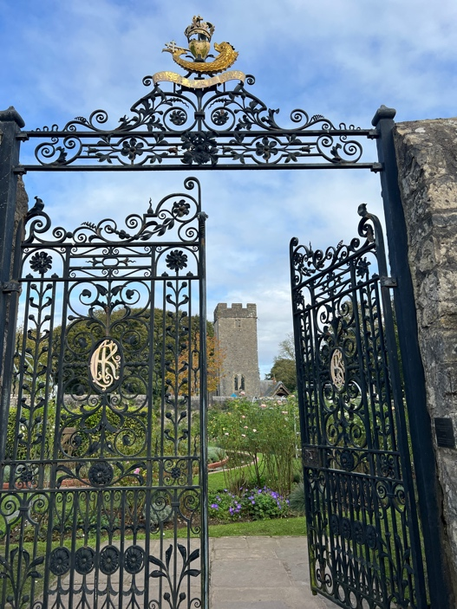
Conclusion:

St Fagans is a beautiful historical site. With many things for people of all different ages to enjoy and explore, all while learning about the past of Wales. There’s so much to do and see, I would recommend spending two days if you want to be able to thoroughly explore the museum.

