MASTER OF BUSINESS ADMINISTRATION

FINANCIAL MANAGEMENT

LCMB7002

ASSESSMENT COMPONENT: FINANCIAL PERFORMANCE AND MANAGEMENT

BYD COMPANY LIMITED

Student name: kunjal Ghanshyambhai Amreliya

Student ID: 2531260

Lecturer name: Shengfeng Mei

Word count: 5181

Table of Contents
1. Introduction 4
2. Financial Health Check 4
2.1 Overview of BYD Financial Performance 4
2.2 Profitability Ratio Analysis 5
2.3 Liquidity Ratio Analysis 6
2.4 Efficiency Ratio Analysis 7
2.5 Gearing (Leverage) Ratio Analysis 8
2.6 Investment and Cash Flow Analysis 9
2.7 Key Financial Strengths and Threats 9
3. Working Capital Management Analysis 9
3.1 Working Capital Overview 9
3.2 Cash Operating Cycle Analysis 10
3.3 Strategies to Improve Liquidity 11
3.4 Short-Term vs Long-Term Financing 11
4. Strategic Financial Restructuring Plan 12
4.1 Need for Financial Restructuring 12
4.2 Proposed Financial Strategies 12
4.3 Impact on Shareholder Value and Capital Structure 14
4.4 International and Ethical Considerations 14
5. Investment Appraisal and Capital Budgeting 15
5.1 Introduction to Investment Appraisal 15
5.2 Payback Period (PBP) Analysis 15
5.3 Accounting Rate of Return (ARR) 16
5.4 Net Present Value (NPV) 16
5.5 Internal Rate of Return (IRR) and Profitability Index (PI) 17
5.6 Project Recommendation 17
5.7 Capital Rationing Decision 18
6. Conclusion 18
References 20
Appendices 26
Appendix A: Income Statement of BYD 26
Appendix B: Balance Sheet of BYD 28
Appendix C: Cashflow Statement of BYD 30
Appendix D: Ratio Analysis 32
Appendix E: Investment Appraisal 35

1. Introduction
Electric vehicle (EV) is an expanding industry, which has been driven by environmental issues, government policies, and technological advancement. BYD is one of the pioneer firms within this industry, and it is a Chinese multinational company dealing with electric vehicles, battery technology and renewable energy systems. In this report, the financial position of BYD from 2020-2024 is analysed using the ratio analysis and working capital evaluation. It is also suggesting financial restructuring plans as well as the analysis of three investment projects with the use of capital budgeting techniques to identify the most economically viable project.

2. Financial Health Check

2.1 Overview of BYD Financial Performance
After 2020, BYD has recorded high financial growth. The revenue of the company grew by approximately 396% as it was CNY 156,597.7 million in 2020 and CNY 777,102.5 million in 2024. There was also an increase in net income, which increased by CNY 4,234.27 million to CNY 40,254.35 million, meaning that profitability is increased and market penetration is widening (Annual Report, 2025a). This development is justified by increasing global demand for electric vehicles and battery technology, and government incentives, and growing awareness of sustainable transportation (Shamsuddoha and Nasir, 2025). Total assets of BYD have grown between CNY 201,017.3 million in 2020 and CNY 783,355.9 million in 2024 due to significant spending on production facilities, research and development of products, as well as expansion of supply chains (Annual Report, 2025b). The equity of shareholders also increased by CNY 64,453.9 million to CNY 198,688.2 million, and this has fortified the financial base of the company (BYD, 2025). Nevertheless, total liabilities increased to CNY 584,667.7 million, which is a sign of greater leverage with fast growth [Refer to Appendix A].

2.2 Profitability Ratio Analysis
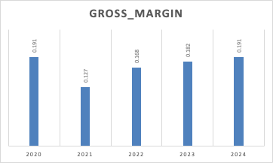
Figure 1: Gross Margin Trends
(Source: Self-Developed)
As per Nasution and Yusleny (2023), profitability ratios are used to determine the capacity of a firm to make earnings in relation to revenue, assets, and equity. The gross profit margin was low, ranging between 12.7 and 19.,1 within the period. The margin was 19.1% in 2020 and 12.7% in 2021, which demonstrates rising production costs and chains of supply disruptions. It, however, bounced back to 19.1% in 2024, which is a sign of increased efficiency in operations and economies of scale. The operating profit margin increased steadily, whereas it was 3.0% in 2021 to 5.9% in 2024. This growth shows that the efficiency in operations has also been improved as the company increased production and streamlined manufacturing operations.
The net profit margin has risen by 2.7% in 2020, up to 5.2% in 2024, showing that the company has better profitability when operating costs, interest expenses, and taxes are considered. Studies show that companies that make substantial investments in EV innovation tend to have better financial results when technologies start to be adopted in all parts of the world (Mishra, 2025). The return on assets (ROA) improved in 2024 at 5.1% in comparison with 2020 at 2.1%, which means that assets are better used to increase profits. Another good indicator is that the return on equity (ROE) increased greatly between 6.6 in 2020 and 20.3 in 2024, which indicates great value creation to the shareholders [Refer to Appendix D]. The increase in the profitability indicators is also consistent with the trends in the industry as EV manufacturers enjoy increasing profitability numbers thanks to technological progress and economies of scale (Katterbauer et al., 2025).

2.3 Liquidity Ratio Analysis
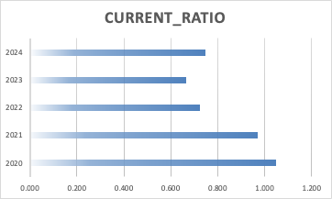
Figure 2: Current Ratio Trends
(Source: Self-Developed)
Liquidity ratios test how a firm is able to settle its short-term liabilities. The current ratio has decreased to 0.75 in 2024 as compared to 1.05 in 2020, which reflects that the current liabilities have increased at a higher rate compared to the current assets. A ratio that is less than 1 is an indication of possible liquidity pressure. The quick ratio also decreased from 0.75 in 2020 to 0.51 in 2024, indicating a rise in inventory as compared to liquid assets. Cash ratio has improved in 2024 as compared to 0.14 in 2020, which is an indicator that the company has more cash reserves than it has had in previous years [Refer to Appendix D]. Operating cash flow is what supported the growth of cash reserves, and it rose to CNY 133,453.9 million in 2024 compared to CNY 45,392.7 million in 2020 (Annual Report, 2025c). High operating cash flows are of great importance to EV manufacturers because they fund research, battery development, and infrastructure. Nair and Prajapati (2025) indicates that the necessary liquidity level is crucial to EV firms because the industry is highly capital-intensive.

2.4 Efficiency Ratio Analysis
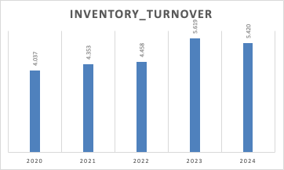
Figure 3: Inventory Turnover Trends
(Source: Self-Developed)
Efficiency ratios are used to assess the level of efficiency with which a firm manages to use its resources and assets. The inventory turnover ratio was 4.04 in 2020, but in 2024, it had risen to 5.42, which means that it has become more efficient in terms of inventory management and the rate at which products are sold. The receivables turnover ratio rose markedly in 2024, from 2.71 in 2020, indicating that the company has enhanced its credit and cash collection procedures. The asset turnover ratio improved from 0.78 in 2020 to 0.99 in 2024, which proves that BYD is making more money on its assets [Refer to Appendix D]. The increase in the efficiency ratios implies that the company has become more efficient in terms of production since it has expanded its production volumes. The studies of EV production prove that effective supply chain and inventory management are key to maintaining a competitive advantage in the electric vehicle market (Akinsooto et al., 2025).

2.5 Gearing (Leverage) Ratio Analysis
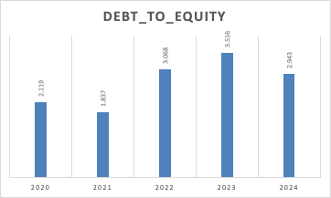
Figure 4: Debt to Equity Trends
(Source: Self-Developed)
The debt-to-equity ratio calculates the amount of debt used by a company to fund its operations, using debt relative to the equity of the shareholders. It is a significant indicator of the financial risk and stability of capital structure. The dependency of debt-to-equity ratio of BYD indicates a varying trend over the five-year period. This ratio declined in 2021 to 1.84, but followed by a massive growth to 3.07 in 2022 and 3.52 in 2023, and again decreased by a small margin to 2.94 in 2024 [Refer to Appendix D]. The rise of leverage shows that BYD was very dependent on external funds to fund its fast growth in the electric vehicle market.
The increased leverage ratio is more or less related to the company's investments in production plants, research and development, as well as the expansion of the global supply chain. The electric vehicle business involves heavy capital expenditure in the production and manufacture of batteries, the technology of manufacture, and the electrical charge infrastructure. Hence, most manufacturers of EVs rely on third-party funding to finance their development plans (Glova and Panko, 2025). Though an increased leverage may speed up the growth, the financial risks are increased as it increases interest payments and minimises financial flexibility. The slight decrease in the ratio in 2024 is an indication that BYD can be slowly bringing its capital structure into line and at the same time investing in long term growth.

2.6 Investment and Cash Flow Analysis
The cash flow analysis assists in determining the financial viability of a firm and its capacity to finance its business operations and investments. The operating cash flow of BYD improved considerably from CNY 45,392.7 million in 2020 to CNY 169,725.0 million in 2023 and then slightly decreased to CNY 133,453.9 million in 2024. This high growth in the operating cash flows is a pointer to higher revenue and high efficiency in operations. Nonetheless, there was still a negative investment of cash flows during the period as a result of high capital expenditures. In comparison, the capital expenditure rose between 2020 and 2024, taking the CNY 11,774 million to CNY 97,359 million, which shows that the company is investing significant capital in the manufacturing plants, battery production and development of technology. As per Gautam et al., (2025), the EV industry is characterised by high investment expenditure, as companies have to keep investing in innovation and infrastructure to stay in the business. In spite of the huge investments, their high operating cash flows indicate that BYD has the financial ability to sustain its growth.

2.7 Key Financial Strengths and Threats
The financial analysis shows that there are some strengths. These are good revenue growth of CNY 156,597.7 million in 2020 to CNY 777,102.5 million in 2024, enhanced profitability, better operating efficiency and high operating cash flows. Nevertheless, there are still some financial risks. The liquidity ratios have decreased with time, which points to the likelihood of financial stress in the short-term. Also, the high debt and capital requirements might also pose a risk to financial risks in case of a change in the markets. Thus, financial stability, along with preserving innovation and growth will be fundamental to the sustainability of BYD in the long term.

3. Working Capital Management Analysis

3.1 Working Capital Overview
As stated by Sogomi et al. (2022), working capital management is the management of short-term assets and liabilities of a company in order to provide efficiency in operations and adequate liquidity. It is essential to ensure smooth day-to-day running, especially in manufacturing companies where the production process needs constant investment in raw materials, stock and payment to suppliers. Within the electric vehicle market, working capital management is particularly crucial since production is associated with enormous investments into battery components, electronic devices, and advanced technologies of production. The financial account of BYD reveals that its working capital has been growing substantially over the last two years, between the year 2020 and 2024. The current assets of the company rose between 2020 and 2024 and surged to CNY 370,572.2 million in 2024. This is as compared to 2020, which was CNY 111,605.1 million. This expansion indicates how the scale of operation of the company is growing, and the need for electric cars and battery technologies is increasing. The growth in current assets is attributed by growth in inventory, accounts receivable, and cash balances (Enkel and Wintgens, 2025).
The time period led to a significant growth in cash reserves. The cash balance of BYD increased to CNY 102,730.2 million in 2024 compared to CNY 14,445.0 million in 2020, which will be helpful in terms of liquidity to fund operations and implement strategies used in the business. Increased cash reserves give the flexibility of finances and minimise the risk of liquidity crunch in the short term. In the same way, the accounts receivable grew to CNY 89,547.5 million in 2024 compared to CNY 57,726.4 million in 2020, which is the result of greater sales and credit transactions with the customers. Inventory also rose at great rates, since 2020, CNY 31,396.4 million increased to 2024 CNY 116,036.2 million, which shows an increase in the level of production and the increase in the level of demand. Nonetheless, the growth in the current assets was coupled with a higher growth of current liabilities. The current liabilities of BYD have grown to CNY 495,985.2 million in 2024 compared to CNY 106,430.7 million in 2020, and this is about 366 times higher. This growth signifies that the organisation as highly dependent on the short-term funding facilities, such as trade payables and short-term lending, to achieve the growth of its operations. Effective use of working capital is then necessary to maintain production and financial stability in the EV sector (El Gibran and Nainggolan, 2025) [Referred to Appendix B].

3.2 Cash Operating Cycle Analysis
The cash operating cycle, also referred to as the cash conversion cycle, is a measure of time that the business takes to convert its holdings in inventory and receivables to cash (Asman et al., 2022). It is an important measure of the efficiency of operations and management of liquidity. The cash operating cycle is usually calculated using the formula:
Cash Operating Cycle = Inventory Days + Receivable Days – Payable Days
In spite of the fact that the detailed data on the payable turnover is not available, the inventory turnover and receivables turnover ratios give an idea about the effectiveness of the operations of BYD. The 2024 inventory turnover ratio improved, which was 5.42 as compared to the 2020 ratio, which stands at 4.04. Increased inventory turnover implies that the company will sell goods faster, which will decrease the cost of storage and the threat of technological obsolescence, which is quite significant in the highly dynamic EV market. On the same note, the receivables turnover ratio also improved tremendously, as it stood at 2.71 in 2020 and had increased up to 8.68 in 2024, which is an indicator of better credit management practices and accelerated payments by customers. Modified receivables increase cash inflow and decrease the probability of late payments. According to Ersoy et al. (2025), comprehensively, the shifts in inventory and receivable turnover indicate a greater level of operational efficiency and shortening of the cash operating cycle, which enhances the liquidity status and lessens its dependence on outside funding.

3.3 Strategies to Improve Liquidity
Although there has been an increase in operational efficiency, the liquidity ratios are on the decline, indicating that BYD is likely to experience short-term liquidity pressure, caused by the increase in current liabilities. Good liquidity management practices are thus needed. Enhancing the effectiveness of the supply chains can minimise time wastage during the process of acquiring raw materials and ensure that the inventory is kept at a suitable level (Thrän et al., 2025). Other releases of additional working capital can be made through the reduction of inventory holding periods by enhancing forecasting and an inventory control system. The credit management policies should be reinforced to speed up the speed of collection process and minimise bad debt. Moreover, having sufficient reserves of cash will enable companies to use such funds to address any short-term liabilities without heavy borrowing. Murugan et al., (2025) added that the efficiency of the operations and liquidity can also be increased by technological advances in EV production and battery technology.

3.4 Short-Term vs Long-Term Financing
The decision of financing has a strong correlation with the management of working capital since companies have to finance both the short-run and long-run investments. Finance Daily operations, such as acquiring raw materials and inventory control, are funded through short-term financing like trade credit, overdraft facilities and short-term loans. Flexible as it is, overdependence on short-term finances might pose a liquidity problem because of frequent repayments. Long-term investments, including production facilities, battery development, and research work, are done using long-term financing that includes bonds, long-term loans, and equity. Electric vehicle producers frequently rely on long-term financing as infrastructure and technological innovation demand large amounts of capital to be invested (Qays et al., 2025). Balance financing is used to maintain a liquidity level and sustainable growth.

4. Strategic Financial Restructuring Plan

4.1 Need for Financial Restructuring
The EV market has grown tremendously with concerns about the environment, the favourable policy by governments, and technological advancement. Nevertheless, this expansion has also put a strain on EV manufacturers since substantial sums of money are needed to fund production facilities, battery research, and charging systems as well as research. Staying financially stable and growing production and technological invention are significant strategic issue to companies like BYD. By analysing its finances, it can be noted that BYD achieved great growth during the period of 2020-24. The revenue grew between CNY 156,597.7 million and CNY 777,102.5 million in the years 2020 and 2024, respectively [Refer to Appendix C]. On the other hand, total assets grew in the period between CNY 201, 017.3 million and CNY 783,355.9 million. Although this is a robust growth, the liabilities also rose considerably, as CNY 136,563.4 million in 2020 grew to CNY 584,667.7 million in 2024, which shows that it is becoming more dependent on external financing.
Concurrently, the liquidity ratios deteriorated since the current liabilities were increasing at a higher rate than the current assets, thus indicating that there is a risk to the financial position in case of further expansion of the company. There is a need to restructure its finances, therefore to make it more efficient in terms of capital, minimise financial risk, and facilitate sustainable growth (Cabeza-Ramírez et al., 2025). The EV manufacturers have to keep investing in battery technology, manufacturing industries and charging infrastructure to stay in the game. The need to integrate energy and large infrastructure investments will be necessary to facilitate the global deployment of electric vehicles (Güven et al., 2025). Good restructuring strategies can hence enable companies to have the ability to invest and at the same time, diversify financial risk.

4.2 Proposed Financial Strategies
In order to overcome the financial problem involved in high growth, it is possible to adopt several financial measures that would enhance the capital structure of BYD and the financial sustainability in the long term. Such strategies are aimed at mitigating the financial risks, enhancing efficiency in operations, and sustaining innovation in the EV sector. Equity financing is one of the strategies. Issuance of further equity may also contribute to minimising the dependence of the company on debt financing and decreasing the ratio of leverage. This will enhance the financial stability of the company since it will be able to boost the capital structure by increasing the shareholder equity. Equity financing will also be useful in supplying extra funds to cater to research and development, expansion of infrastructure and expansion into the international markets (Samawi et al., 2025). The other possible strategy is the establishment of strategic alliances with power firms and technology companies. Cooperation with renewable energy sources, battery technology manufacturers, and infrastructure creators could assist in lessening the financial burden of developing the network of charging and energy storage facilities. The strategic partnership is one where the companies cut the costs of investments and technological development, thus enhancing their work efficiency and minimising the financial risk.
The third approach includes the optimisation of assets and the sale of non-core businesses. As stated by Sogomi et al. (2022), organisations usually diversify into various business lines when they are experiencing a boom. Not every business activity is however, er equally helpful in the long-term profitability. Companies can release financial resources and concentrate on the core business processes through selling non-core or underperforming assets and investing in the core business processes, like the production of electric vehicles and the development of battery technologies. The use of government incentives and subsidies is also another significant strategy. Various governments offer financial aid, tax credits, and policy encouragement to encourage the creation of new vehicles with energy (Matkovic et al., 2025). These incentives have the ability to substantially lower the financial cost of research and development and investing in infrastructure. The policies of the government have contributed greatly to the rapid increase in the production of electric cars and technological development in China (Zeng et al., 2025). Along with finance restructuring strategies, companies ought to pay more attention to enhancing their operational efficiency as well as optimising their supply chain and technological innovation. Higher manufacturing technologies, electronic supply chains, and automation can assist in lowering production costs and enhancing profitability. Through restructuring its finances along with optimisation in its operations, BYD will be able to enhance its competitive edge in the fast-changing EV market.

4.3 Impact on Shareholder Value and Capital Structure
A strategic restructuring of its financial structure can have a profound effect on shareholder value as well as the capital structure of a company. The restructuring process aims at having the best debt and equity balance as a way of mitigating financial risk and maximising shareholder gains. Financing more through equity financing will reduce the debt-to-equity ratio, interest payable, and financial stability. As per the comment of Seo et al. (2025), it also means increased investor confidence and enables companies to obtain money more cheaply for long-term investment and growth as a result of a stronger capital structure. Another way financial restructuring can boost shareholder value is through the promotion of innovation and technological development. The battery technology, energy storage, and production efficiency can be invested in to enhance product performance and lower the cost of manufacturing (Wang et al., 2025). Moreover, the environmental, social, and governance (ESG) issues have a greater impact on investment choices. Businesses that have good sustainability behaviours usually attract more investors and get better valuations in the markets (Onomakpo, 2025). As such, the financial performance and competitiveness can be improved in the long run by redesigning strategies that focus on sustainable investment.

4.4 International and Ethical Considerations
The growth of the electric vehicle production process is associated with a number of international and ethical aspects that the companies in question need to consider to guarantee sustainable development and acceptance in the global market. Since EV manufacturers are going global, their operations are bound to adhere to various regulatory policies, environmental policies and sustainability policies. According to Al Shurideh et al. (2025), electric cars are very instrumental in improving the quality of air by reducing the emission of greenhouse gases through replacing the conventional internal combustion engine automobiles. Electric mobility is viewed as a significant measure to meet global climate targets and eliminate fossil reliance (Ndhlovu et al., 2025). Nevertheless, EV manufacturing also poses ethical issues of battery manufacturing and the procurement of raw materials. Lithium and cobalt are some of the minerals that are usually extracted in areas with different environmental and labour standards, and therefore, firms have to offer responsible sourcing and supply chain transparency. Also, the companies are to adhere to global emissions policies, recycling policies and sustainable policies (Alzoubi et al., 2025). The environmental effects can be mitigated by creating an environmentally supportive battery recycling system and incorporating renewable energy into the production process to enhance the corporate image and help in the development of sustainable transportation.

5. Investment Appraisal and Capital Budgeting

5.1 Introduction to Investment Appraisal
One of the tools of financial management that is of importance in determining the feasibility and profitability of a potential project before the investment of the financial resources into it is the investment appraisal. These methods enable managers to make comparisons of anticipated costs and benefits of the various investment options and to distribute funds effectively. According to Evensen et al. (2025), electric vehicle manufacturing is one of the key technological industries where the choice of investments becomes especially critical due to the high capital investments and time spent on the development of the project. EV organisations spend a lot of money on research and development, battery technology, manufacturing systems, and charging infrastructure. Investment appraisal techniques are those that assess projects on the basis of the projected cash flows and risk, as well as the time value of money. The most frequently used methods of common capital budgeting are payback period, accounting rate of return, net present value, internal rate of return, and profitability index. These procedures assist in arriving at a decision on whether projects will be able to produce enough amounts of finance (Yardim et al., 2025).

5.2 Payback Period (PBP) Analysis
Payback period is one of the most common investment appraisal techniques used to evaluate how soon the investment in a project can be paid back, as per cash inflows. It applies in unpredictable industries since it focuses on the rapid recovery of capital. The lifetime of payback is shorter, which means that the risk of investment is also less and the invested money is paid back more quickly.
- The payback period of project A is 4.5 years
- Project B will pay back after 4.55 years
- The payback period of project C is 3.6 years
The above results show that Project C is the one with the least payback period, i.e. it starts recovering its initial investment sooner as compared to the other two projects. Quick recovery of investment minimises financial risk since the company has the ability to reinvest recovered investment in other ventures or strategic projects. As per the view of Zhao et al. (2025), the payback period approach does possess a number of limitations. It fails to take into account the time value of money and does not take into consideration the cash flows that occur after the payback period. In spite of this shortcoming, the payback method is handy as a screening tool for investment decisions [Referred to Appendix E].

5.3 Accounting Rate of Return (ARR)
Another method of investment appraisal that is applied in determining the profitability of a project is the accounting rate of return (ARR). ARR is a percentage ratio of the annual profits of a project to the first investment. As compared to the payback period, which is concerned with the time taken to break even, ARR is concerned with the profitability of the project in general. The formula used to calculate the ARR is:
ARR = Average Annual Profit / Initial Investment × 100
The projections of the projects were performed in terms of financial operations by calculating the average annual cash inflows of the projects. Project A gives a generation of 10.8million, Project B 11 million, and Project C 13 million every year. These findings reveal that Project C has the largest average return, which means it is more profitable and manages the investment funds more efficiently. The ARR approach is practical as it provides an easy profitability tool that can be easily compared across projects (Serrato et al., 2025). Nevertheless, ARR fails to take into account the fact that the time value of money exists, and this can make it less reliable when making long-term investments.

5.4 Net Present Value (NPV)
One of the most popular methods of investment appraisal is the net present value (NPV) due to the fact that it takes the time value of money into consideration whenever it is used to evaluate investment decisions. The NPV method is used to determine the current value of cash inflows in the future at the cost of a project and the initial cost of the project. As long as the cash flows that are initially invested in a project have a present value that is less than the present value of future cash flows, the project will create a positive value to the company (Chiradeja et al., 2025). The NPV calculation involves the use of a discount rate, which represents the required rate of return or cost of capital of the company. This analysis was carried out at a discount rate of 10% in the evaluation of the three investment projects. The results of the NPV calculations are:
- Project A = –£8,675,823
- Project B = –£8,301,345
- Project C = –£19,838,434
The NPV of all three projects is negative at a discount rate of 10%, and this implies that the discounting of the future cash flows is less than the investment. Nevertheless, Project B is the least risky in terms of the negative NPV. The companies can still invest in case the projects have strategic value to them, like the development of technology and market growth [Referred to Appendix E].

5.5 Internal Rate of Return (IRR) and Profitability Index (PI)
Another useful capital budgeting method that is employed in the evaluation of investment opportunities is the internal rate of return (IRR). IRR is the discount rate at which the net present value of a project will be zero. That is, it represents the rate of the project generated through its cash flows. The IRR results calculated for the projects are:
- Project A = 2.72%
- Project B = 3.26%
- Project C = 8.59%
The project with the highest potential return in terms of its investment value against its cost of investment is project C, which shows the highest profitability on the basis of the internal rate of return. An increased IRR depicts an increased profitability and a more appealing investment. The index of profitability (PI) is also a measure of the value created on each unit of investment, by comparing the present value of the future cash flow with the amount of investment made. Going by the PI findings based on the NPV calculations, Project C will yield high returns at any given unit of investment, although it has a negative NPV at the selected discount rate.

5.6 Project Recommendation
The results of the investment appraisal give various opinions about the financial performance of the three projects. The payback period analysis indicates that Project C breaks even after 3.6 years, compared to 4.8 years in Project A and 6 years in Project B, meaning that there will be less risk of investment due to the speed of the capital payback period. It is also apparent in the analysis of accounting rate of return that Project C is the best in terms of average annual returns, which is at £13 million, whereas Projects A and B have average annual returns of 10.8 million and 11 million, respectively. On the same note, Project C is the most profitable within IRR of 8.59%. Nonetheless, it is shown that Project B has the least negative NPV at a 10% discount rate, showing that it has low financial risk. As such, investment decisions must be made in a way that gives a balanced approach on profitability and risk.

5.7 Capital Rationing Decision
Capital rationing is a situation where the availability of financial resources is limited to make investments, and the company is faced with a number of competing projects to invest in. The total investment budget that the company can make in such a case is up to 100 million pounds and the project start-up costs are 50 million pounds. This is a budget constraint that the company will only be able to make two out of three different available projects. In the process of considering the potential project combinations, managers have to take into account the financial outcome of the investment appraisal methods. The combinations are possible and are:
- Project A and Project B
- Project A and Project C
- Project B and Project C
Financial analysis indicates that the most appropriate combination of investments would be Project B and Project C. Project C offers the greatest profitability and the shortest period to break even on investment, whereas Project B offers the worst negative NPV. As inspired from the ideas of Eti et al., (2025), the choice of both projects will balance profitability and risk to enhance the investment efficiency and financial sustainability of the long-term capital-intensive EV industry.

6. Conclusion
Financial analysis reveals that BYD has recorded high levels of revenue growth, profitability and market growth over the years of 2020-2024. The profitability and efficiency ratios increased by a significant margin, which means that there was better operational performance. Nevertheless, the decrease in the liquidity ratios and the increase in leverage indicate the possible financial risks associated with the fast growth. There has been an increase in working capital management, especially on inventory and receivables. The results of the investment appraisal reveal that Project C provides the quickest payback time and the highest IRR, as Projects B and C combine to provide an optimal investment solution subject to capital rationing.

References
Akinsooto, O., Ogunnowo, E.O. and Ezeanochie, C.C., (2025). The future of electric vehicles: Technological innovations and market trends. Engineering and Technology Journal, 10(4), pp.4392-4405. https://www.researchgate.net/profile/Enoch-Ogunnowo/publication/390661749_The_Future_of_Electric_Vehicles_Technological_Innovations_and_Market_Trends/links/67f7b95391535861140da4a7/The-Future-of-Electric-Vehicles-Technological-Innovations-and-Market-Trends.pdf
Al Shurideh, M., Alzoubi, H.M., Al Kurdi, B., Hamadneh, S., Ahmed, G., Al-Sulaiti, K., Bataineh, A.Q., Alquqa, E.K. and Ozturk, I., (2025). Consumer and economic influences on electric vehicle adoption: The mediating role of attitudes and the moderating effect of demographics. International Journal of Energy Economics and Policy, 15. https://savearchive.zbw.eu/bitstream/11159/709423/1/1931392471_0.pdf
Alzoubi, H.M., Al Shurideh, M., Al-Gharaibeh, S.M., Al-Shyaab, K.O.M., Al Kurdi, B., Al-Sulaiti, I., Ahmed, G., Bataineh, A.Q. and Alquqa, E.K., (2025). Assessing Economic and Infrastructure Constraints on Electric Vehicle Purchase Decisions: A Demographic-Moderated Analysis in Emerging Markets. International Journal of Energy Economics and Policy, 15. https://savearchive.zbw.eu/bitstream/11159/710452/1/1932991840_0.pdf
Annual Report, (2025). BYD Balance Statement. Available at: https://in.investing.com/equities/byd-co.-balance-sheet [Accessed on: 02 March 2026].
Annual Report, (2025). BYD Cash Flow Statement. Available at: https://in.investing.com/equities/byd-co.-cash-flow [Accessed on: 02 March 2026].
Annual Report, (2025). BYD Income Statement. Available at: https://in.investing.com/equities/byd-co.-income-statement [Accessed on: 10 March 2026].
Asman, F.N., Fernandez, D., Jamaludin, N.A., Omar Zaki, H. and Ghazali, A.W., 2022. Cash conversion cycle and firm’s performance. International Journal of Academic Research in Business and Social Sciences, 12(11), pp.2682-2692. https://www.academia.edu/download/106769993/cash-conversion-cycle-and-firms-performance.pdf
BYD, (2025). About the Company. Available at: https://www.bydglobal.com/en/CompanyIntro.html [Accessed on: 08 March 2026].
Cabeza-Ramírez, L.J., Rosales-Tristancho, A., Sanchez-Canizares, S.M. and Palacios-Florencio, B., (2025). Rational and normative determinants in electric vehicle adoption: Willingness to pay and moderating variables. Technology in Society, 81, p.102842. https://www.sciencedirect.com/science/article/pii/S0160791X25000326
Chiradeja, P., Sottiyaphai, C., Ananwattanaporn, S. and Ngaopitakkul, A., (2025). Evaluating the financial dynamics of electric vehicle charging stations in thailand: implications of energy cost variability. IEEE Access. https://ieeexplore.ieee.org/abstract/document/10896644/
El Gibran, P.A. and Nainggolan, Y.A., (2025). Impact Of Financial Performance on The Innovation and Development of Research and Development in Electric Vehicle Industry. Economic Reviews Journal, 4(2), pp.534-552. http://www.mes-bogor.com/journal/index.php/mrj/article/view/688
Enkel, E. and Wintgens, S., (2025). Understanding mass-market electric vehicle adoption: Integrating diffusion of innovation theory with risk mitigation strategy in Germany. Technological Forecasting and Social Change, 220, p.124329. https://www.sciencedirect.com/science/article/pii/S0040162525003609
Ersoy, N., Mai, N.T. and Thinh, H.X., (2025). Applying MCDM methods for electric vehicle selection: a comparative study between CRADIS and PIV methods. Journal of Applied Engineering Science, 23(2), pp.345-358. https://aseestant.ceon.rs/index.php/jaes/article/view/56793
Eti, S., Dinçer, H., Yüksel, S. and Gökalp, Y., (2025). A new fuzzy decision-making model for enhancing electric vehicle charging infrastructure. Spectrum of decision making and applications, 2(1), pp.94-99. http://dmap-journal.org/index.php/dmap/article/view/13
Evensen, D., Uratani, J.M., Sovacool, B.K. and Griffiths, S., (2025). A novel model for barriers to electric vehicle adoption in the Middle East. Transportation Research Part D: Transport and Environment, 142, p.104714. https://www.sciencedirect.com/science/article/pii/S1361920925001245
Gautam, M., Wu, D., Chen, P. and Fang, H., (2025), January. Techno-economic assessments of second-life batteries for electric vehicle charging stations. In 2025 IEEE Electrical Energy Storage Applications and Technologies Conference (EESAT) (pp. 1-5). IEEE. https://ieeexplore.ieee.org/abstract/document/10891225/
Glova, J. and Panko, M., (2025). The effects of environmental, social, and governance factors on financial performance and market valuation in the European automotive industry. International Journal of Financial Studies, 13(2), p.82. https://www.mdpi.com/2227-7072/13/2/82
Güven, A.F., Ateş, N., Alotaibi, S., Alzahrani, T., Amsal, A.M. and Elsayed, S.K., (2025). Sustainable hybrid systems for electric vehicle charging infrastructures in regional applications. Scientific Reports, 15(1), p.4199. https://www.nature.com/articles/s41598-025-87985-7
Katterbauer, K., Yılmaz, S., Syed, H. and Özbay, R.D., (2025). Chinese Electric Vehicle (Ev) Financial Performance–Is The Market Supporting It?. Journal of Recycling Economy & Sustainability Policy, 4(2), pp.1-13. https://respjournal.com/index.php/pub/article/view/84
Matkovic, D., Pilski, T.M. and Capuder, T., (2025). Participation of electric vehicle charging station aggregators in the day-ahead energy market using demand forecasting and uncertainty-based pricing. Energy, 328, p.136299. https://www.sciencedirect.com/science/article/pii/S0360544225019413
Mishra, A.K., (2025). Discussion on the Impact of the Green Innovation Strategy on Corporate Financial Performance in The Automotive Sector. SAIM Journal of Social Science and Technology, 2(1), pp.1-5. https://nepjol.info/index.php/sjsst/article/view/83808
Murugan, M., Elumalai, P.V., Vijayakumar, K.C.K., Babu, M., Suresh Kumar, K., Ganesh, M., Kuang, L. and Prabhakar, S., (2025). A comprehensive review of thermal management methods and ideal system design for improved electric vehicle battery pack performance and safety. Energy Science & Engineering, 13(3), pp.1011-1036. https://scijournals.onlinelibrary.wiley.com/doi/abs/10.1002/ese3.2081
Nair, A. and Prajapati, N., (2025). FINANCIAL PERFORMANCE ANALYSIS OF SELECT LISTED ELECTRIC VEHICLE MANUFACTURERS IN INDIA. https://www.gapinterdisciplinarities.org/res/articles/(1-10)%20FINANCIAL%20PERFORMANCE%20ANALYSIS%20OF%20SELECT%20LISTED%20ELECTRIC%20VEHICLE%20MANUFACTURERS%20IN%20INDIA.pdf
Nasution, Y.A. and Yusleny, Y., (2023, February). Financial Performance Measurement Using Profitability Ratios And Liquidity Ratios. In Proceeding Medan International Conference on Economic and Business (Vol. 1, pp. 1730-1741). https://proceeding.umsu.ac.id/index.php/Miceb/article/download/282/303
Ndhlovu, E., Mhlanga, D. and Duri, B., (2025). Decarbonising urban transport: an overview of electric vehicles, public transport, and sustainable infrastructure in achieving net-zero emissions. Discover Global Society, 3(1), p.53. https://link.springer.com/article/10.1007/s44282-025-00201-9
Onomakpo, H.E.O., (2025). ESG risk ratings and stock performance in electric vehicle manufacturing: A panel regression analysis using the Fama-French five-factor model. Journal of Investment Banking and Finance, 3(1), p.12. https://www.academia.edu/download/122484032/esg_risk_ratings_and_stock_performance_in_electric_vehicle_manufacturing_a_panel_regression_analysis_using_the_famafrenc.pdf
Qays, M.O., Ahmad, I., Habibi, D. and Moses, P., (2025). Long-term techno-economic analysis considering system strength and reliability shortfalls of electric vehicle-to-grid-systems installations integrated with renewable energy generators using hybrid GRU-classical optimization method. Sustainable Energy Technologies and Assessments, 76, p.104294. https://www.sciencedirect.com/science/article/pii/S2213138825001250
Samawi, G.A., Bwaliez, O.M., Jreissat, M. and Kandas, A., (2025). Advancing sustainable development in Jordan: a business and economic analysis of electric vehicle adoption in the transportation sector. World Electric Vehicle Journal, 16(1), p.45. https://www.mdpi.com/2032-6653/16/1/45
Seo, J., Vijayagopal, R., Kim, N., Rousseau, A. and Stutenberg, K., (2025). Effects of ambient temperature on electric vehicle range considering battery Performance, powertrain Efficiency, and HVAC load. Energy Conversion and Management, 326, p.119493. https://www.sciencedirect.com/science/article/pii/S0196890425000160
Serrato, D.A., Tibaquirá, J.E., López, J.C., Castillo, J.C., Giraldo, M. and Quirama, L.F., (2025). Evaluating electric vehicle and emission standards improvement in a Latin American city. Green Energy and Intelligent Transportation, p.100284. https://www.sciencedirect.com/science/article/pii/S2773153725000349
Shamsuddoha, M. and Nasir, T., (2025). The road ahead for hybrid or electric vehicles in developing countries: market growth, infrastructure, and policy needs. World Electric Vehicle Journal, 16(3), p.180. https://www.mdpi.com/2032-6653/16/3/180
Sogomi, F.C., Patrick, M.K. and Kamau, C.G., (2022). Working capital management, liquidity and financial performance: Context of Kenyan SME’s. SSRN E-Journals. https://ijcsacademia.com/index.php/journal/article/download/178/176
Thrän, J., Mareček, J., Shorten, R.N. and Green, T.C., (2025). Reserve provision from electric vehicles: Aggregate boundaries and stochastic model predictive control. IEEE Transactions on Power Systems, 40(5), pp.4081-4092. https://ieeexplore.ieee.org/abstract/document/10878458/
Wang, Q., Huang, C., Wang, C., Li, K. and Shafie-khah, M., (2025). Risk-averse frequency regulation strategy of electric vehicle aggregator considering multiple uncertainties. Applied Energy, 382, p.125259. https://www.sciencedirect.com/science/article/pii/S0306261924026436
Yardım, M.F., Yüksel, S. and Dinçer, H., (2025). Development of optimal investment strategies for electric vehicle charging stations with a novel decision-making technique. Journal of Operations Intelligence, 3(1), pp.68-75. http://jopi-journal.org/index.php/jopi/article/view/34
Zeng, S., Ji, M. and Huang, X., (2025). An empirical study on the impact of tax incentives on the development of new energy vehicles: Case of China. Energy Policy, 198, p.114452. https://www.sciencedirect.com/science/article/pii/S0301421524004725
Zhao, K., Sanmugam, A. and Aravindan, K.L., (2025). Driving sustainability in the green entrepreneurial intentions among SMEs in the electric vehicle component industry. Discover Sustainability, 6(1), p.4. https://link.springer.com/article/10.1007/s43621-024-00667-8

Appendices

Appendix A: Income Statement of BYD
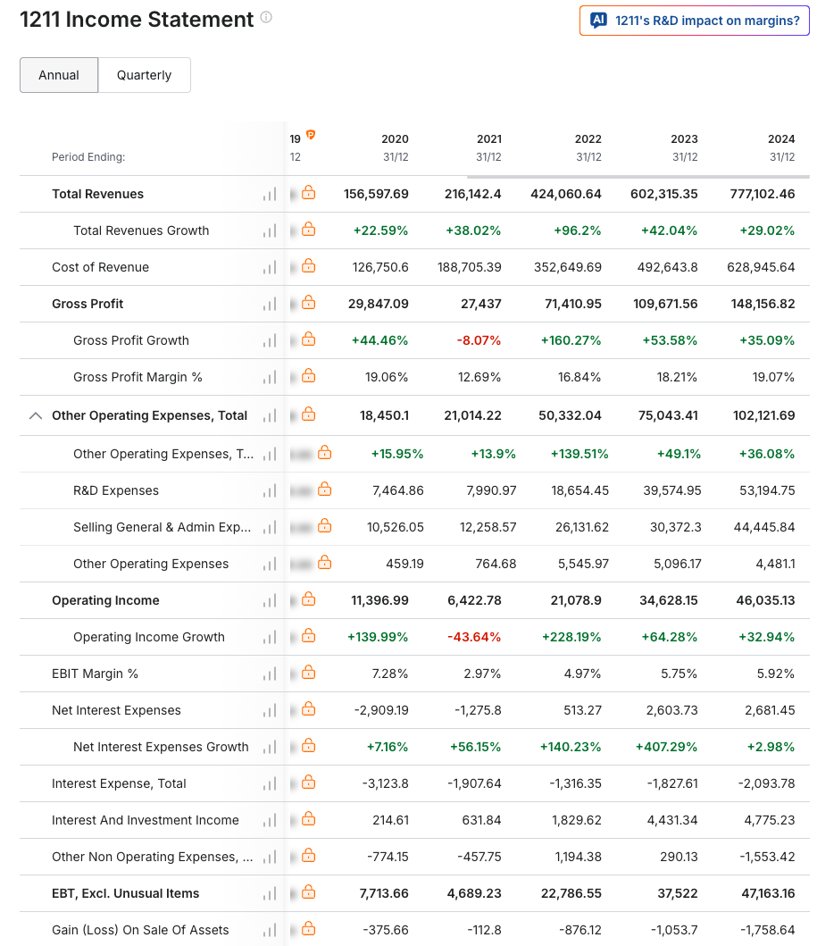
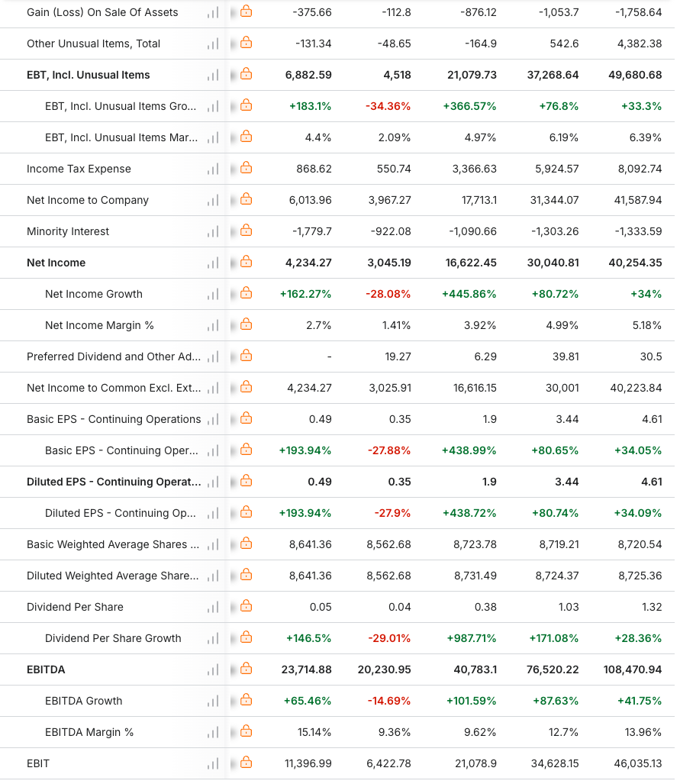
(Source: https://in.investing.com/equities/byd-co.-income-statement)

Appendix B: Balance Sheet of BYD
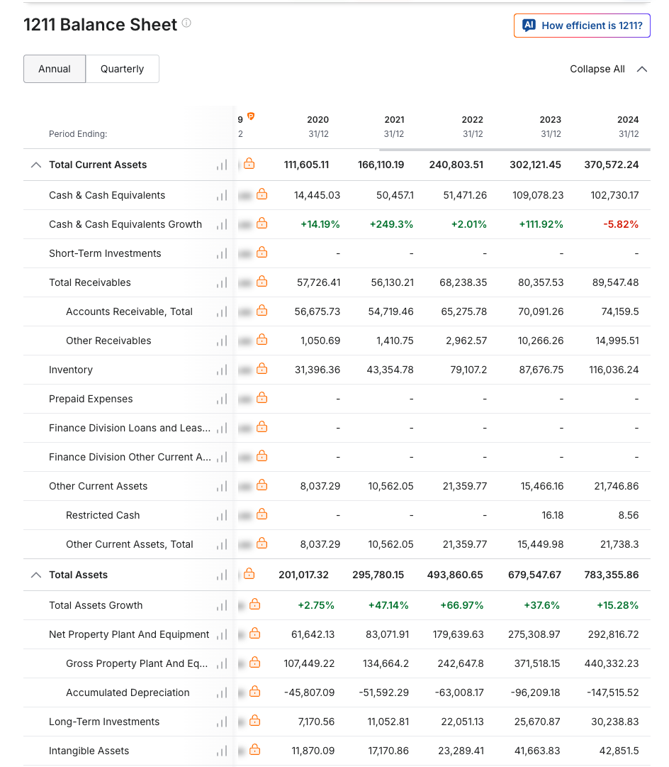
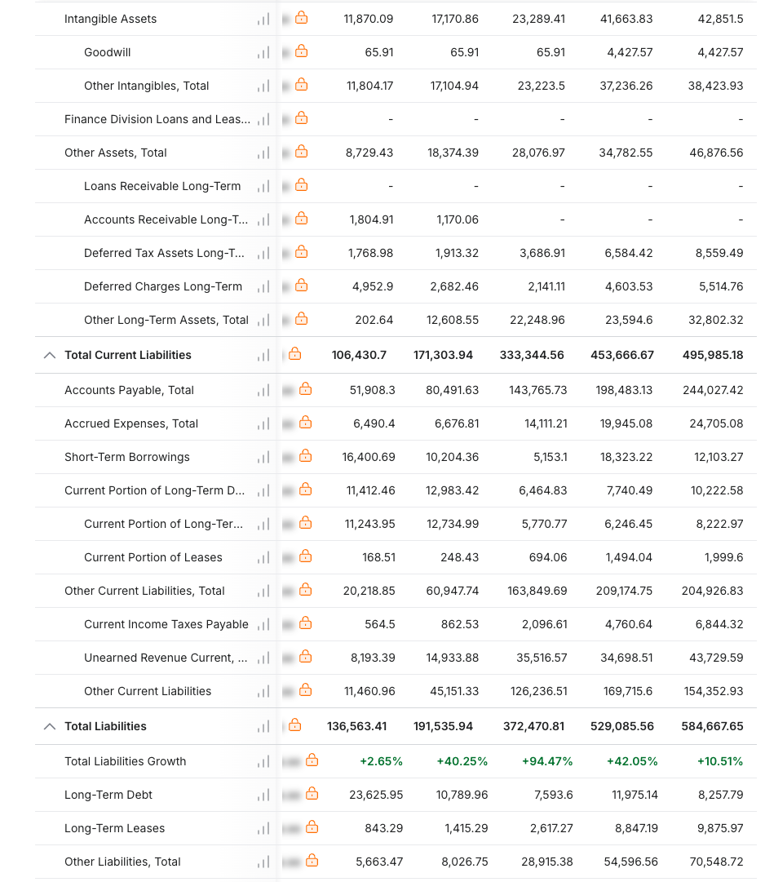
(Source: https://in.investing.com/equities/byd-co.-balance-sheet)

Appendix C: Cashflow Statement of BYD
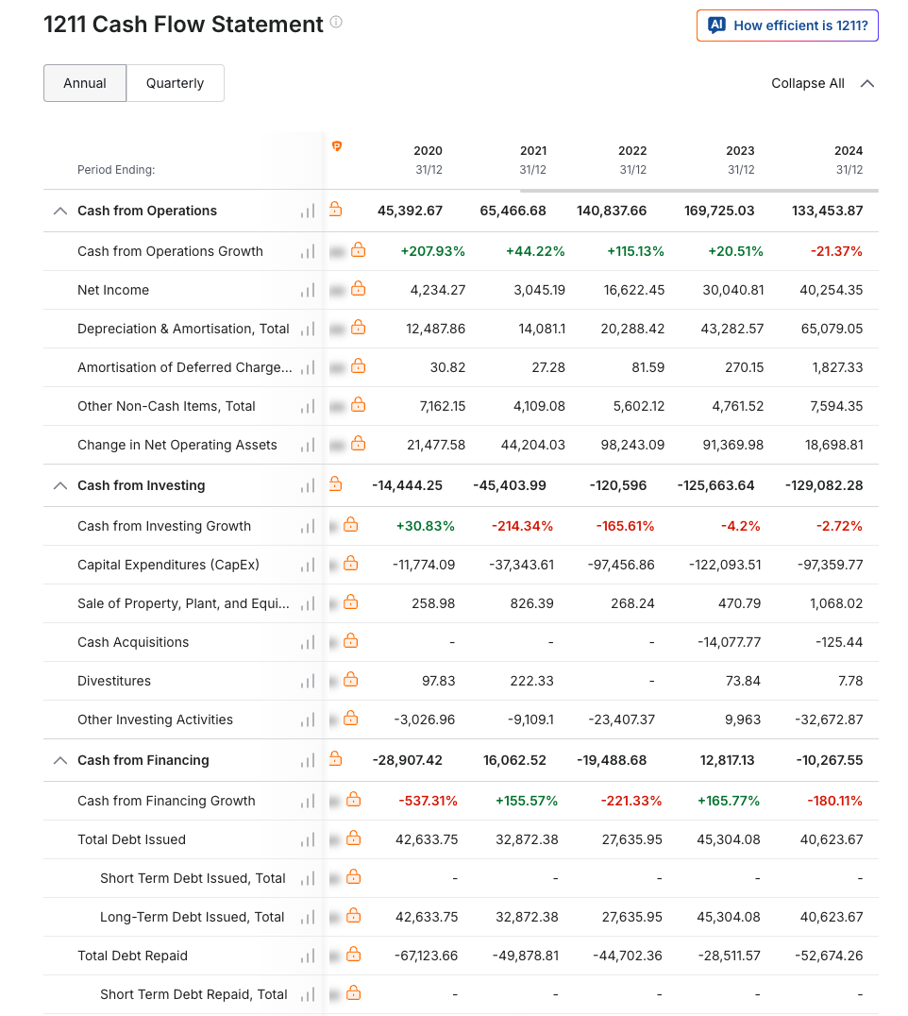
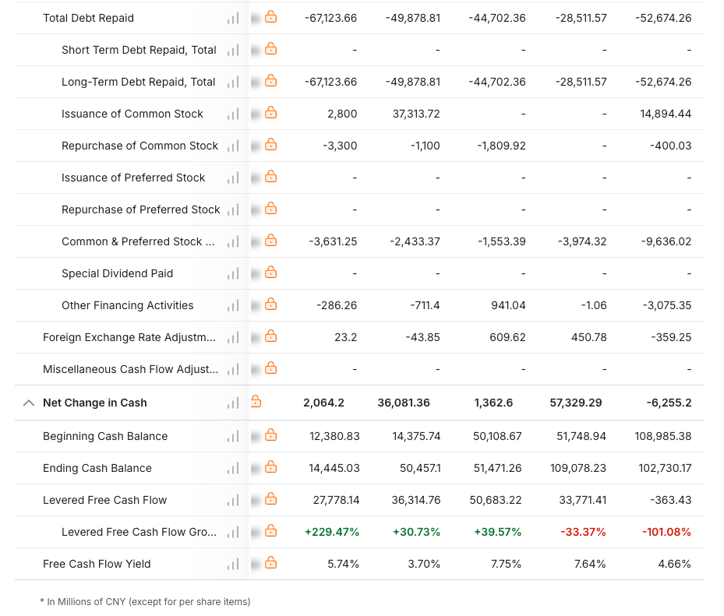
(Source: https://in.investing.com/equities/byd-co.-cash-flow)

Appendix D: Ratio Analysis
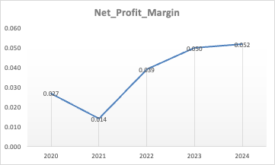
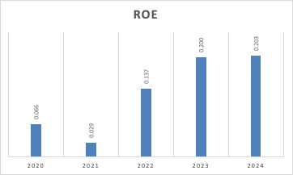
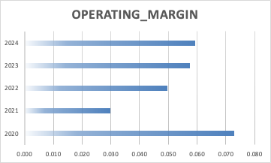
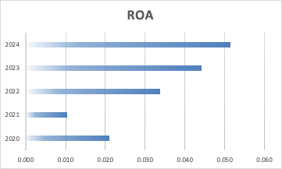
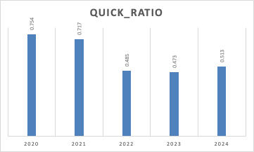
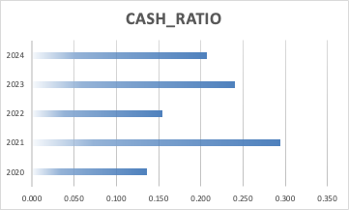
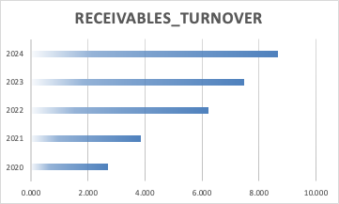
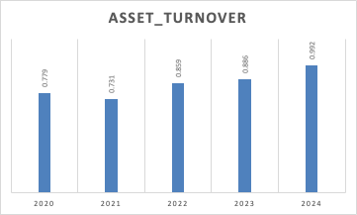
(Source: Excel)

Appendix E: Investment Appraisal
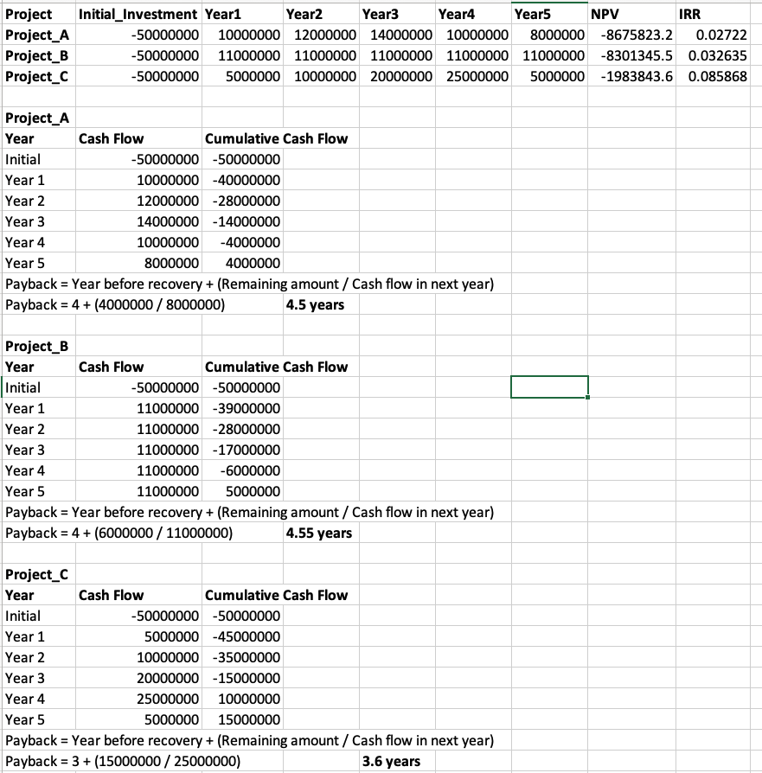
(Source: Excel)

