
Network Operating Systems and Services (ACCA5023_LON)
Darina Tsoneva 2324106

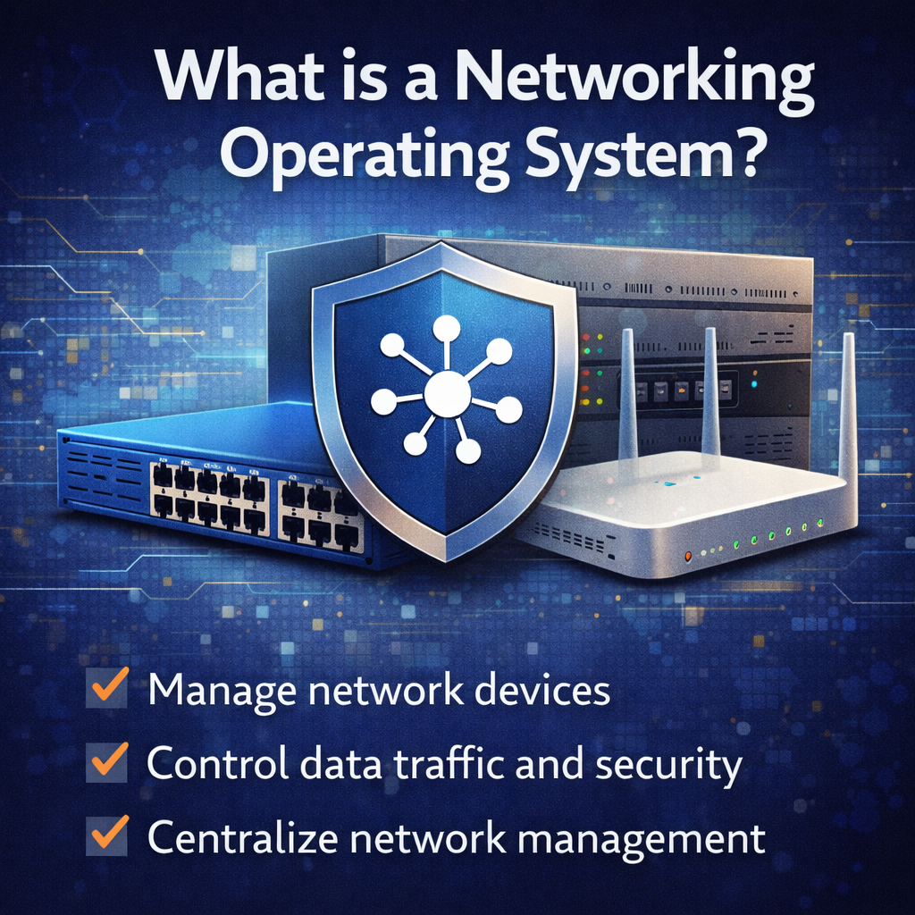
March 12, 2026
University of Wales Trinity Saint David
2324106

Contents
Introduction 1
Task 1 Research 1
Research on Hypervisors 1
Research on IP Addressing 1
Research on Routing 1
Research on Network Services 1
Task 2:Technical Documentation 1
Choice of Hypervisor 1
Download and Setup 2
Configure IP Addressing 10
Task 3: Reflection 12
Technical Reflection 12
Personal Reflection 12
References 13

Introduction
This report presents the research, design, and implementation of a virtualised enterprise network for the organisation University of Wales Trinity Saint David, which operates across two locations: Birmingham and London. The primary aim of this project is to critically analyse core networking technologies and apply this knowledge to develop a functional and scalable virtual network infrastructure using virtualisation techniques. The report begins by examining key theoretical concepts, including hypervisor architectures, IP addressing schemes, routing strategies, and essential network services such as Dynamic Host Configuration Protocol (DHCP), Virtual Private Networks (VPNs), Active Directory Domain Services (AD DS), and Certificate Authorities. Rather than providing purely descriptive explanations, the discussion focuses on evaluating how these technologies contribute to the performance, scalability, and security of enterprise network environments. Following the research component, the report documents the practical implementation of the proposed network using Oracle VirtualBox as the chosen hypervisor platform. The deployment involves the configuration of multiple virtual machines running Windows Server and Debian Linux operating systems, interconnected through logically segmented virtual networks. A structured IP addressing scheme is applied to ensure efficient communication within individual networks while maintaining controlled isolation between separate network segments. Finally, the report provides both a technical and personal reflection on the deployment process. This includes an evaluation of challenges encountered during configuration and testing, the troubleshooting methods applied to resolve these issues, and the key technical and professional skills developed throughout the project. Overall, the report demonstrates the integration of theoretical knowledge with practical implementation in designing a reliable virtualised network environment.

Task 1 Research

Research on Hypervisors
Virtualization has become a fundamental technology in modern computing environments because it allows multiple operating systems to run simultaneously on a single physical machine. This is achieved through a hypervisor, which acts as a layer between the hardware and the operating systems. Hypervisors are mainly categorized into Type 1 (bare-metal) and Type 2 (hosted) hypervisors based on their architecture and how they interact with system hardware. Type 1 hypervisors run directly on the physical hardware without requiring an underlying host operating system. Because they have direct access to hardware resources such as CPU, memory, and storage, they provide better performance, higher efficiency, and improved security compared to hosted solutions. Examples include VMware ESXi and Microsoft Hyper-V. These hypervisors are commonly used in enterprise data centres where high performance, scalability, and centralized management are essential (Stallings, 2020). In contrast, Type 2 hypervisors operate on top of an existing operating system and function similarly to other applications. The host operating system manages hardware access, while the hypervisor allocates resources to virtual machines. Popular Type 2 hypervisors include Oracle VM VirtualBox and VMware Workstation. Although Type 2 hypervisors introduce additional overhead due to the host operating system layer, they provide easier installation and greater flexibility for learning environments and testing scenarios (Nanda & Chiueh, 2005). Considering the topology required for this coursework, which includes Windows Server 2022 and Debian virtual machines within the BIRMINGHAM.ACCA domain environment, a Type 2 hypervisor such as VirtualBox is the most suitable choice. The main reason is that the topology is likely deployed on a personal computer rather than enterprise server hardware. VirtualBox supports multiple guest operating systems, including both Windows and Linux platforms, which makes it ideal for hosting domain services and Linux-based network components within a single environment. Additionally, VirtualBox offers useful features such as snapshots, virtual networking configurations, and easy resource allocation, which are important when testing network services. Security isolation between virtual machines also allows different network configurations to be tested without affecting the host system. Therefore, considering hardware limitations, compatibility with multiple operating systems, and ease of configuration, VirtualBox provides a practical and efficient solution for implementing the required network topology.

Research on IP Addressing
Communication between computers on the Internet relies on a structured system of addressing known as Internet Protocol (IP) addressing. Every device connected to a network must have a unique IP address so that data can be correctly delivered between devices. When information is transmitted across networks, it is divided into packets that contain both the source IP address and the destination IP address. These addresses enable routers to determine the correct path for delivering data packets across interconnected networks (Kurose & Ross, 2021). The most widely used addressing format is IPv4, which uses a 32-bit address represented in dotted-decimal notation. A typical IPv4 address appears as four numerical segments separated by periods, such as 192.168.1.1. Each segment represents 8 bits of the address, allowing a total of approximately 4.3 billion unique addresses. However, the rapid growth of the Internet led to the exhaustion of IPv4 addresses, which resulted in the development of IPv6. IPv6 uses 128-bit addresses represented in hexadecimal format. This significantly expands the number of available addresses and improves routing efficiency and security. An example IPv6 address is: Another important concept within IP addressing is subnetting, which divides a large network into smaller logical networks. Subnetting improves network efficiency by reducing broadcast traffic and enabling better control of address allocation. By using subnet masks, administrators can define network and host portions of an IP address. Routers and switches also play critical roles in the transmission of data. Switches operate within local networks by forwarding data frames based on MAC addresses, while routers operate at the network layer to route packets between different networks using IP addresses. Efficient IP addressing contributes significantly to network performance and scalability. Proper planning ensures that address spaces are used efficiently and prevents conflicts that could disrupt communication. In practical environments such as the given network topology, well-designed IP addressing schemes allow different network segments to communicate effectively while maintaining clear network boundaries.

Research on Routing
Routing is a fundamental networking process that determines how data packets travel between different networks. Routers use routing tables to identify the most appropriate path for forwarding packets from a source device to a destination device. These routing tables contain information about network addresses and the next hop that packets must follow in order to reach their destination. Routing approaches are typically classified as static routing or dynamic routing. Static routing requires network administrators to manually configure routes within a router’s routing table. Although this method requires manual updates whenever network changes occur, it offers predictable routing behaviour and minimal resource usage. Static routing is therefore commonly used in smaller networks where the topology is stable and changes are infrequent.Dynamic routing, on the other hand, relies on routing protocols that automatically exchange routing information between routers. Protocols such as RIP, OSPF, and BGP allow routers to dynamically update routing tables and determine optimal paths based on various metrics such as hop count, bandwidth, or latency (Peterson & Davie, 2022). For the topology used in this coursework, static routing is likely the most appropriate solution. The network structure appears relatively simple, consisting of a Windows server environment and Linux machines connected through different network segments. Implementing dynamic routing protocols in such a small environment would introduce unnecessary complexity.In this setup, the Debian server plays an important role as a DHCP relay that forwards DHCP requests between network segments. Meanwhile, the Windows server provides connectivity and domain services for client machines. Because the number of network paths is limited, manually defining routes ensures predictable communication between systems while simplifying network troubleshooting. Therefore, static routing offers sufficient control and reliability for this topology.

Research on Network Services
Modern network infrastructures rely on several critical services to support secure communication, device management, and centralized administration. Among the most essential services are Virtual Private Networks (VPNs), Dynamic Host Configuration Protocol (DHCP), Active Directory Domain Services (AD DS), and Certificate Authorities. A Virtual Private Network (VPN) enables secure communication between remote users and a private network through encrypted connections over the Internet. VPN technologies such as IPsec and OpenVPN create secure tunnels that protect sensitive data from interception during transmission. VPNs are widely used by organizations to allow employees to access internal network resources remotely while maintaining security.The Dynamic Host Configuration Protocol (DHCP) simplifies network management by automatically assigning IP addresses and other network configuration parameters to devices. Instead of manually configuring each device, a DHCP server distributes addresses from a predefined pool, ensuring efficient address allocation and reducing configuration errors.Another critical service is Active Directory Domain Services (AD DS), which is a directory service provided by Windows Server 2022. AD DS manages user accounts, computers, and network resources within a centralized domain environment. Through domain controllers and Group Policy management, administrators can enforce security policies and control access to resources across the entire organization.Certificate Authorities (CAs) are responsible for issuing digital certificates that verify the identity of users, systems, and services. These certificates support secure communication protocols such as SSL/TLS and ensure that encrypted connections can be trusted.Together, these services create a robust and secure network environment. DHCP simplifies device configuration, VPNs provide secure remote access, Active Directory centralizes identity management, and certificate authorities strengthen authentication and encryption mechanisms. When integrated effectively, these services contribute significantly to the stability, security, and scalability of enterprise networks.

Task 2:Technical Documentation

Choice of Hypervisor
The selected hypervisor for this project is Oracle VirtualBox (Type 2 hypervisor).
This choice is based on several practical and technical considerations. Firstly, VirtualBox is lightweight and does not require dedicated hardware, making it suitable for environments with limited resources. It supports multiple operating systems, including Windows Server 2022 and Debian Linux, ensuring compatibility with the given topology. Secondly, VirtualBox provides flexible networking options such as NAT, Host-Only, and Bridged networking. This is particularly important for creating isolated networks (NAT Network1 and NAT Network2) as required in the topology. From a security perspective, VirtualBox ensures isolation between virtual machines, which is sufficient for this domain-based setup. While Type 1 hypervisors offer better performance, they require more complex setup and hardware support, which is not necessary for this project. Additionally, VirtualBox is widely used in academic environments, making it easier to troubleshoot and manage. Therefore, VirtualBox is the most appropriate choice due to its ease of use, compatibility, flexibility, and suitability for small-scale enterprise simulations.

Download and Setup
Download VirtualBox from official website
https://www.virtualbox.org/
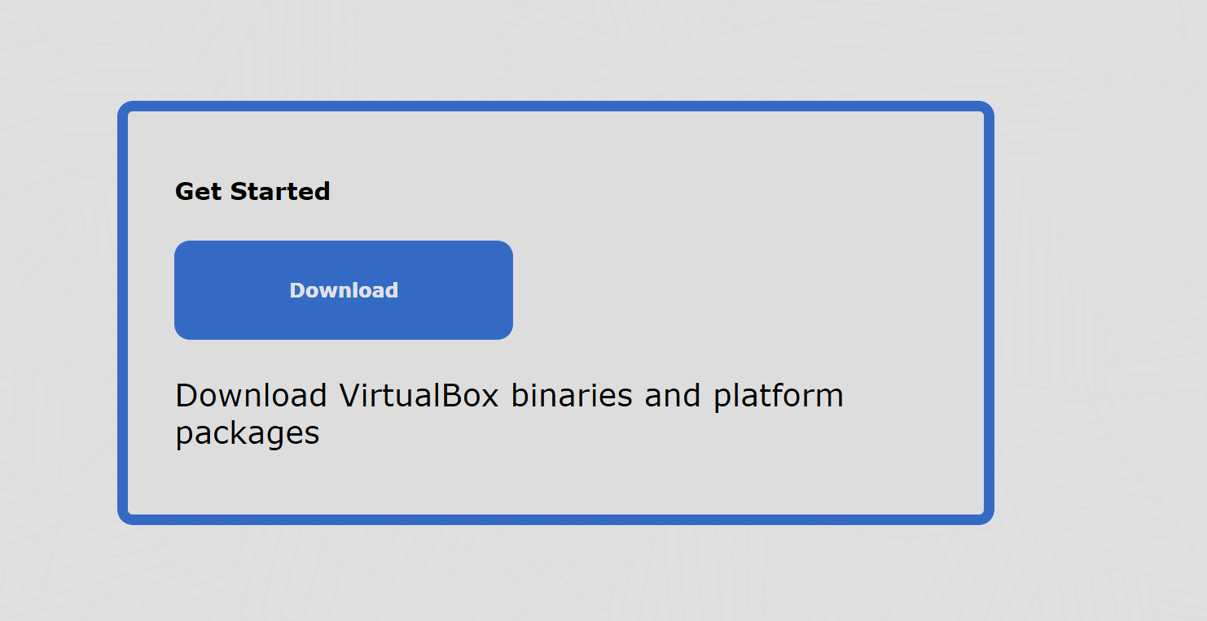
Download Windows Server 2019, Windows 10, Debian ISO files
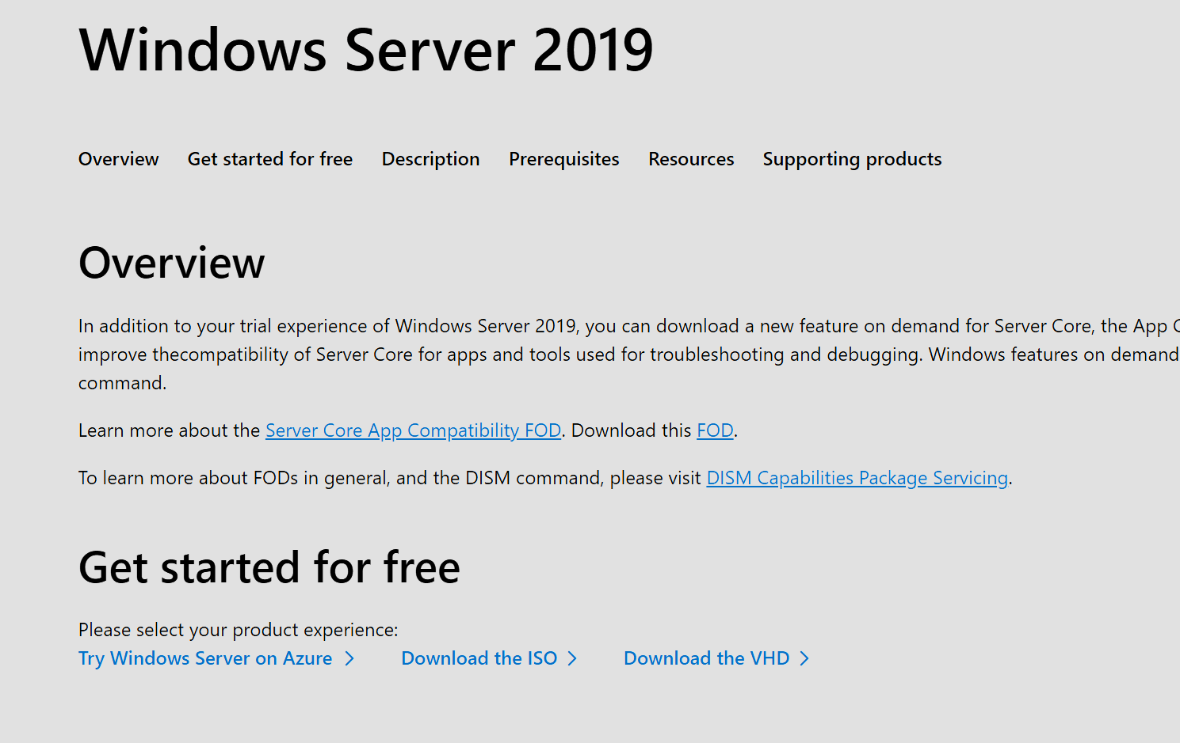
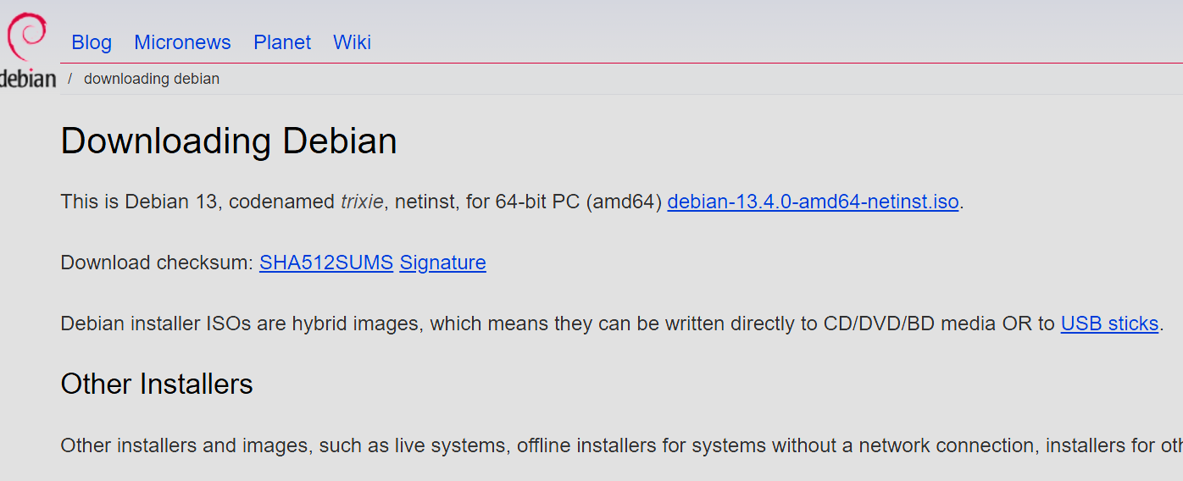

Create 4 Virtual Machines:
2 Windows Machines
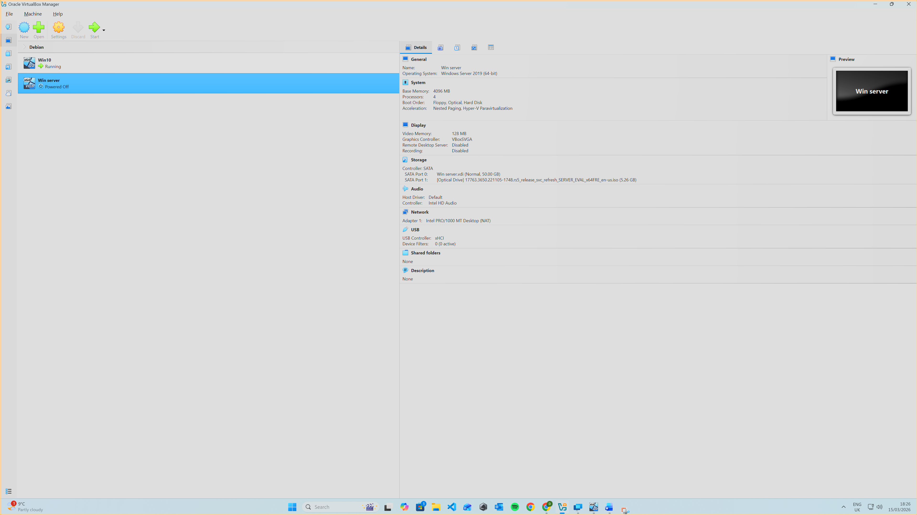
2 Debian Machines
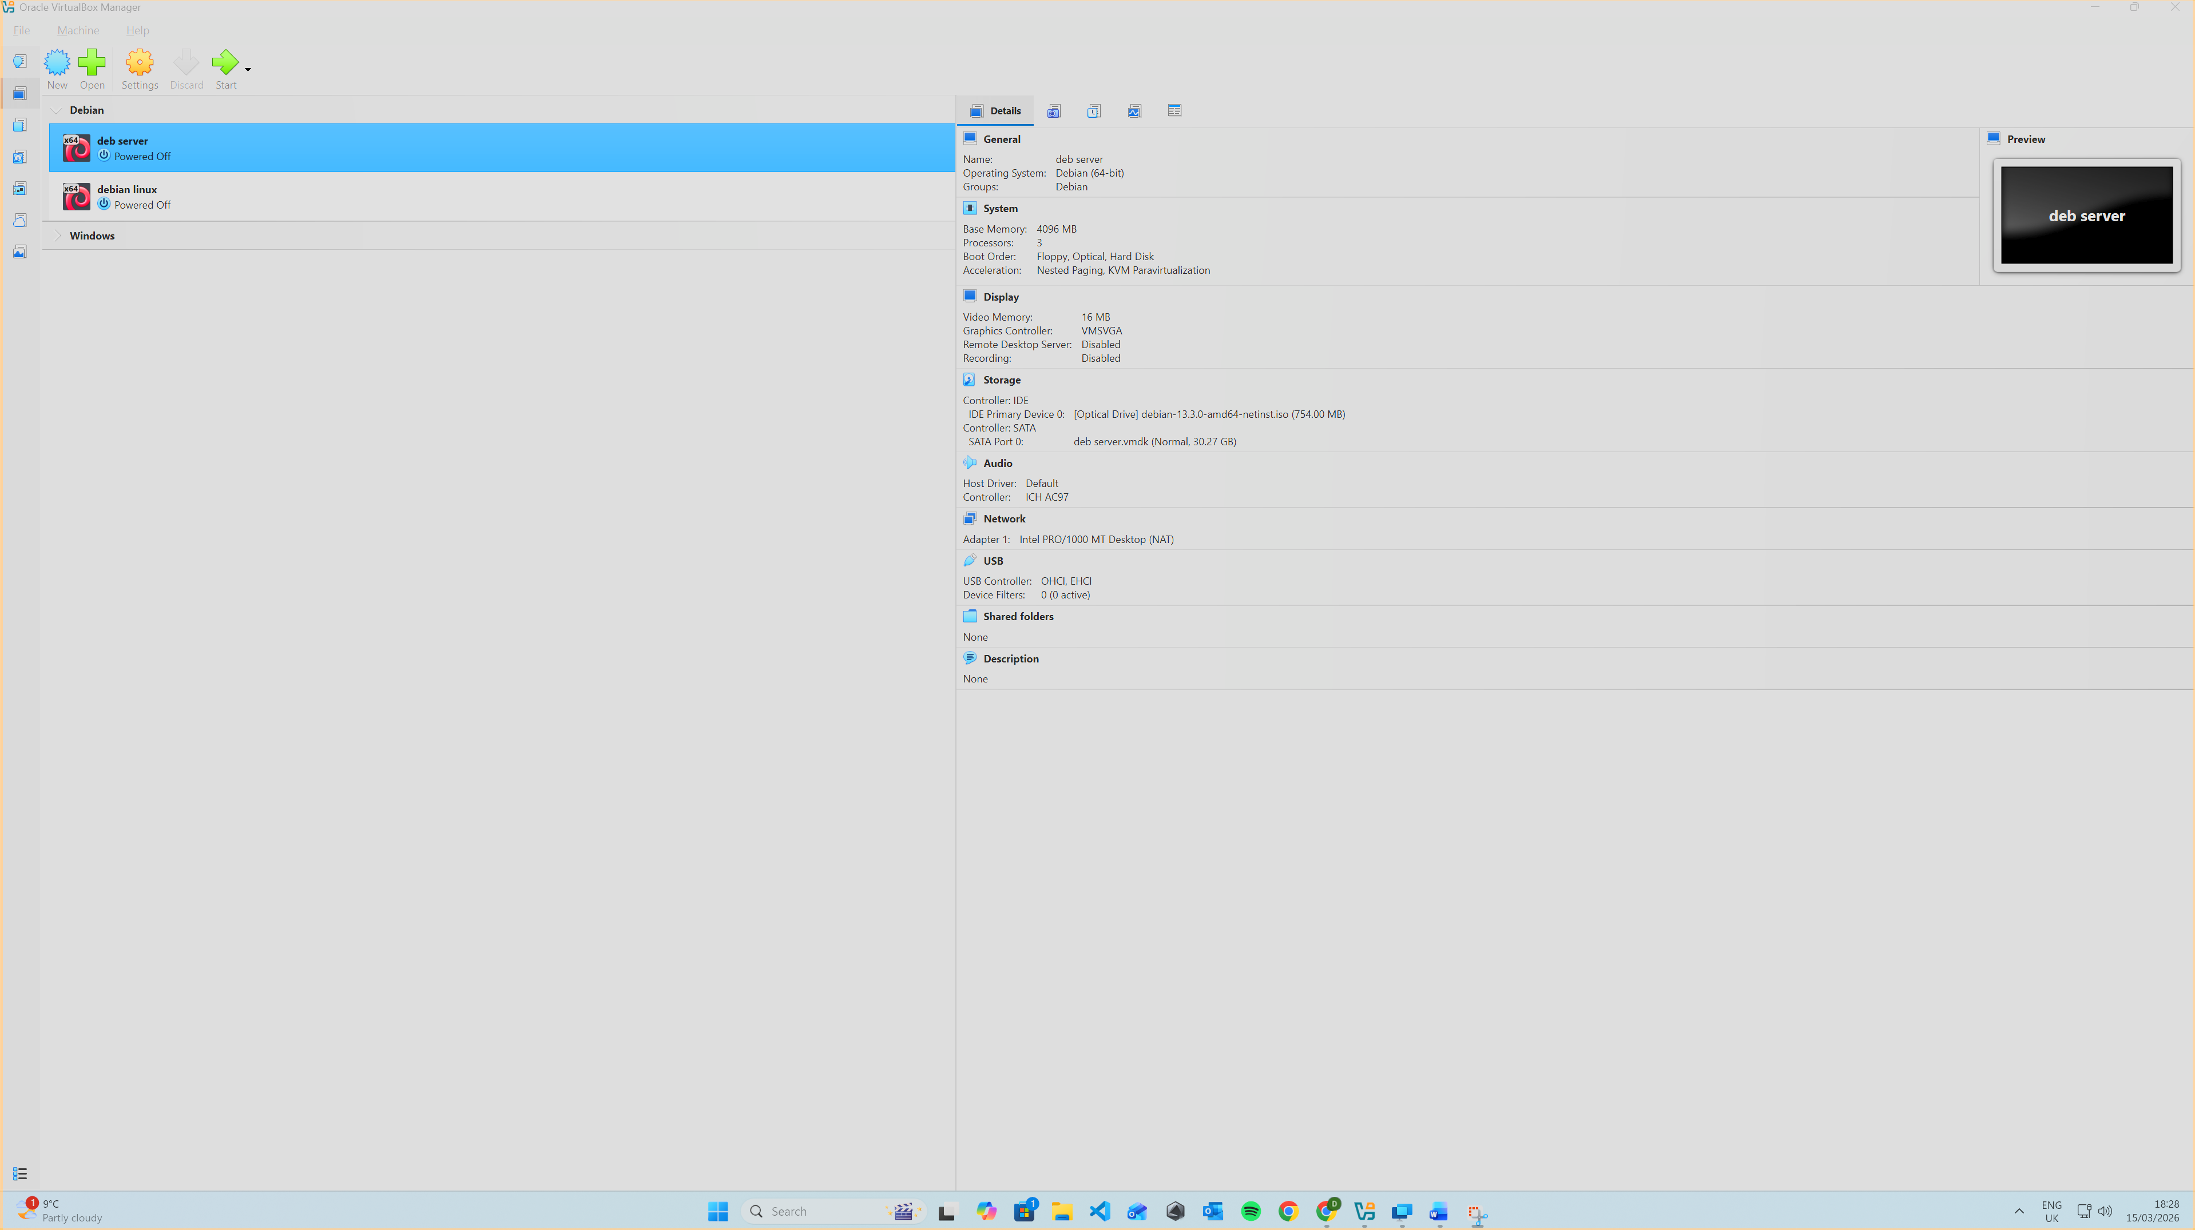
Install all machines
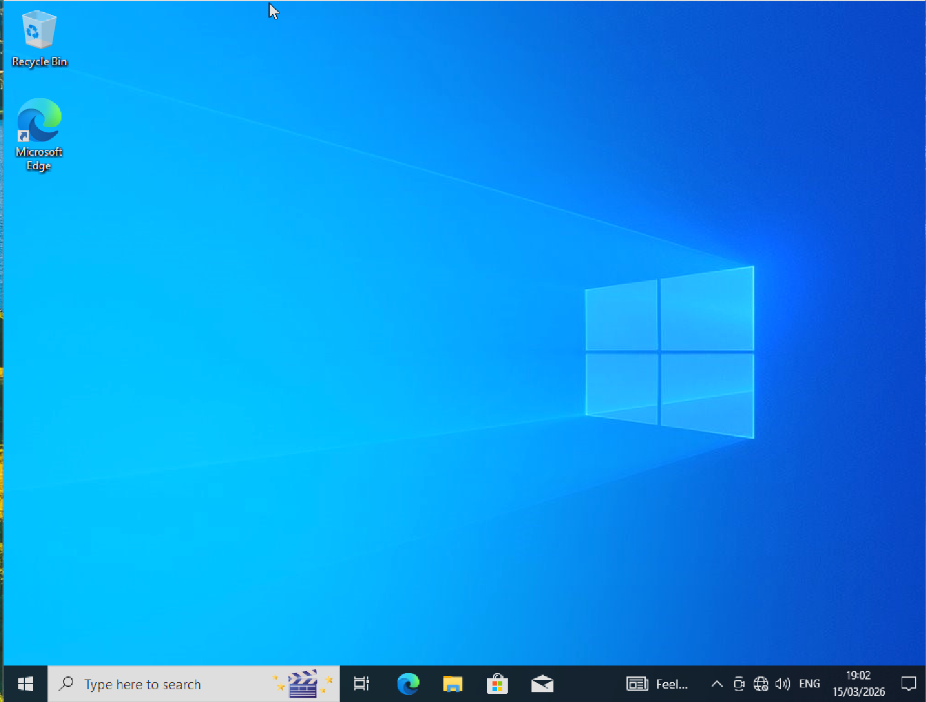
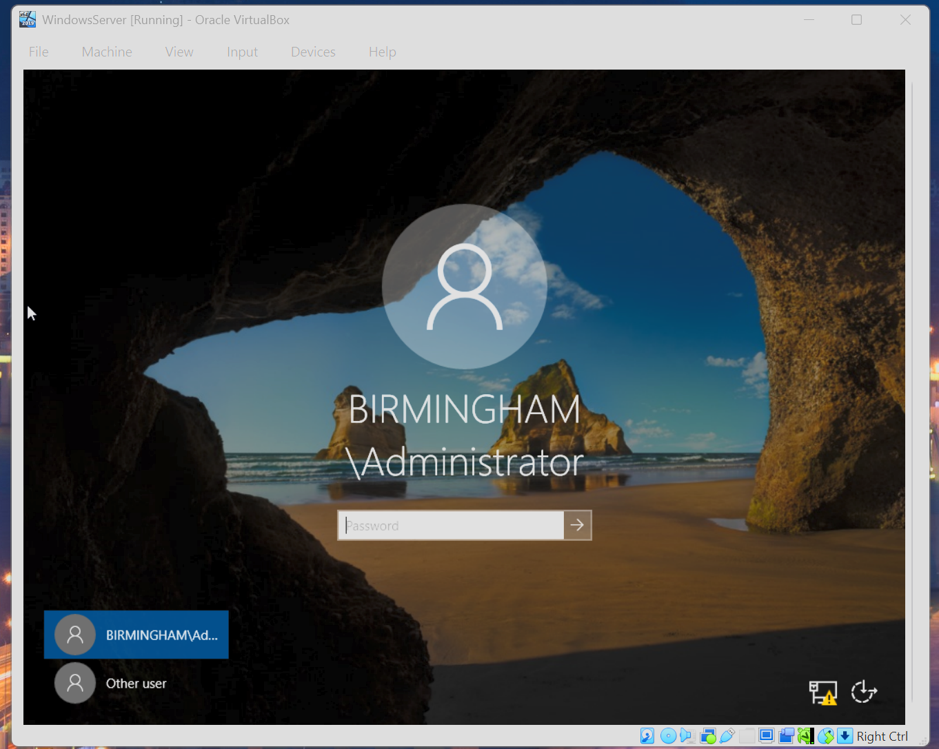
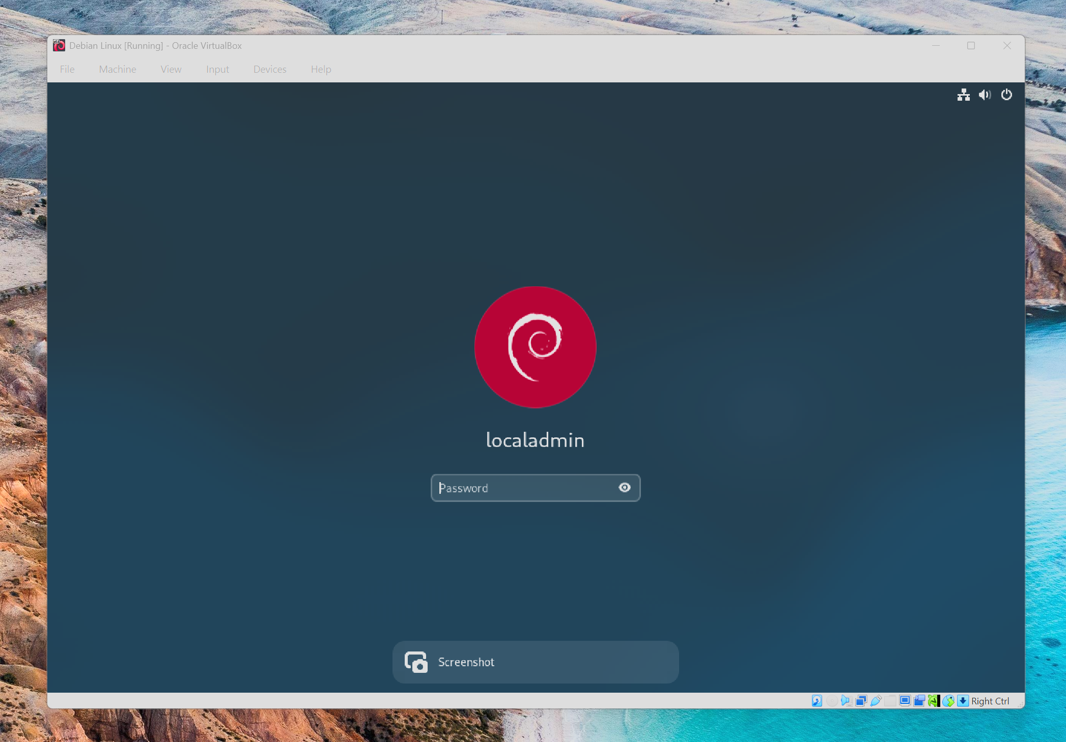
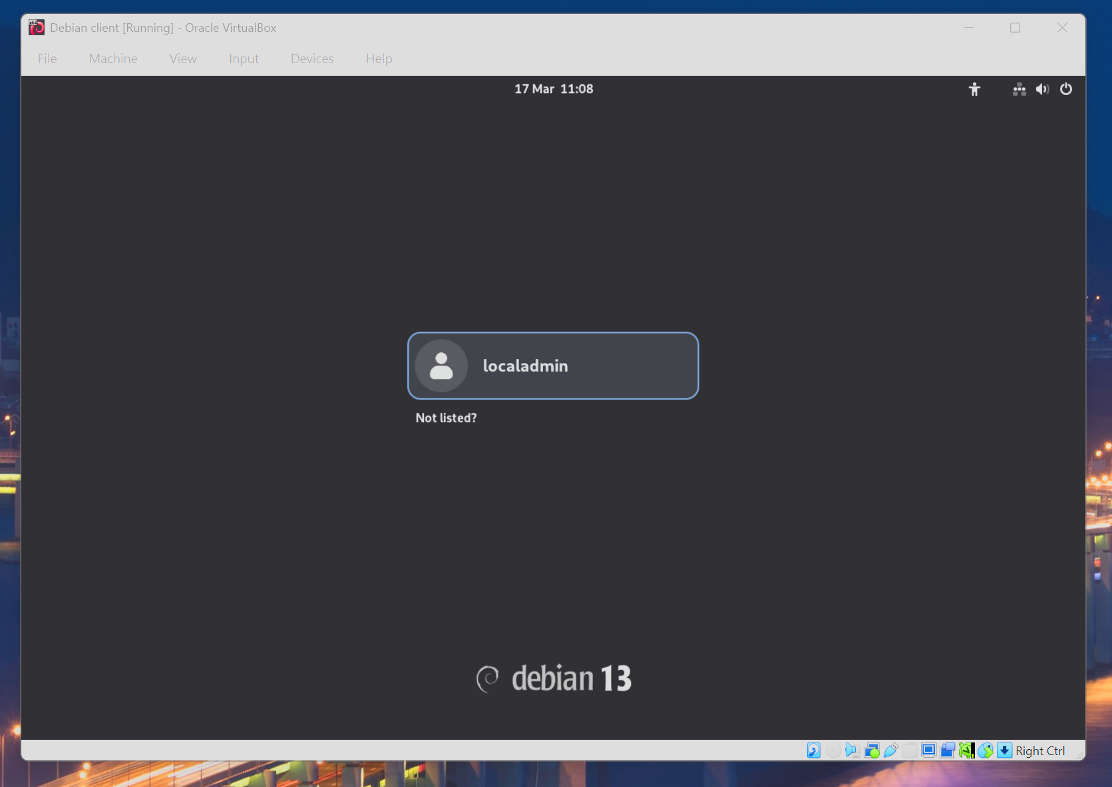
Creation of Network with NAT Network1 for windows
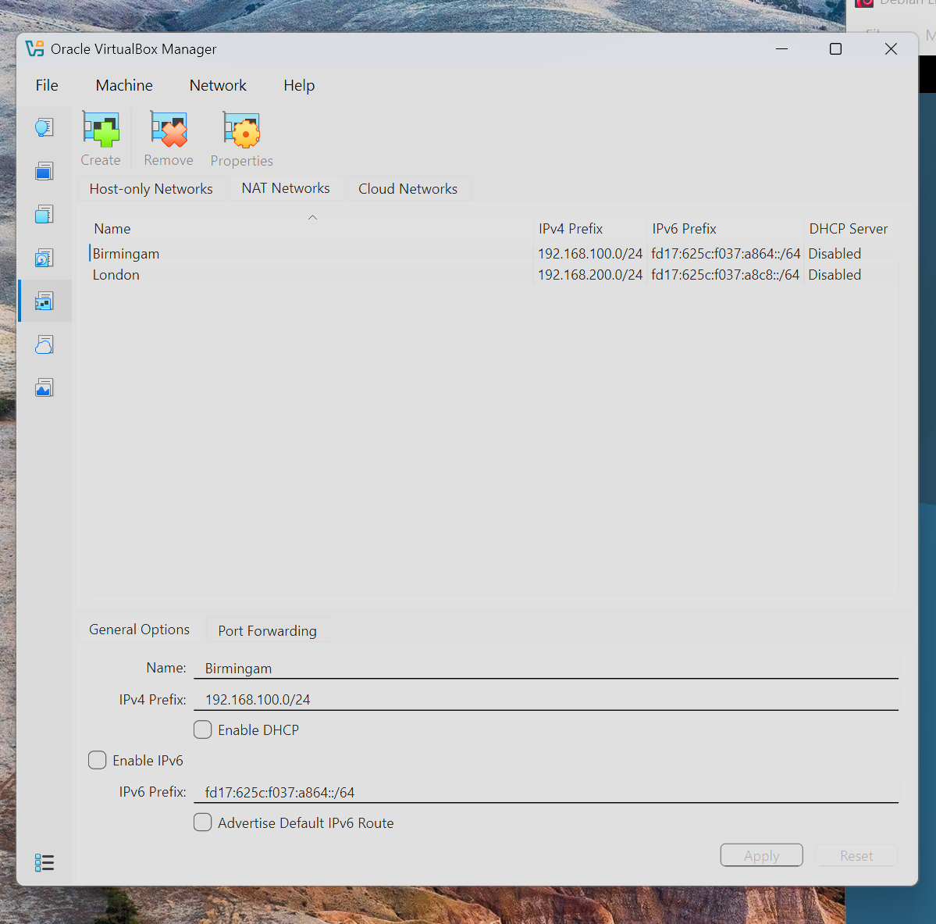
Creation of Network with NAT Network 2 for Linux 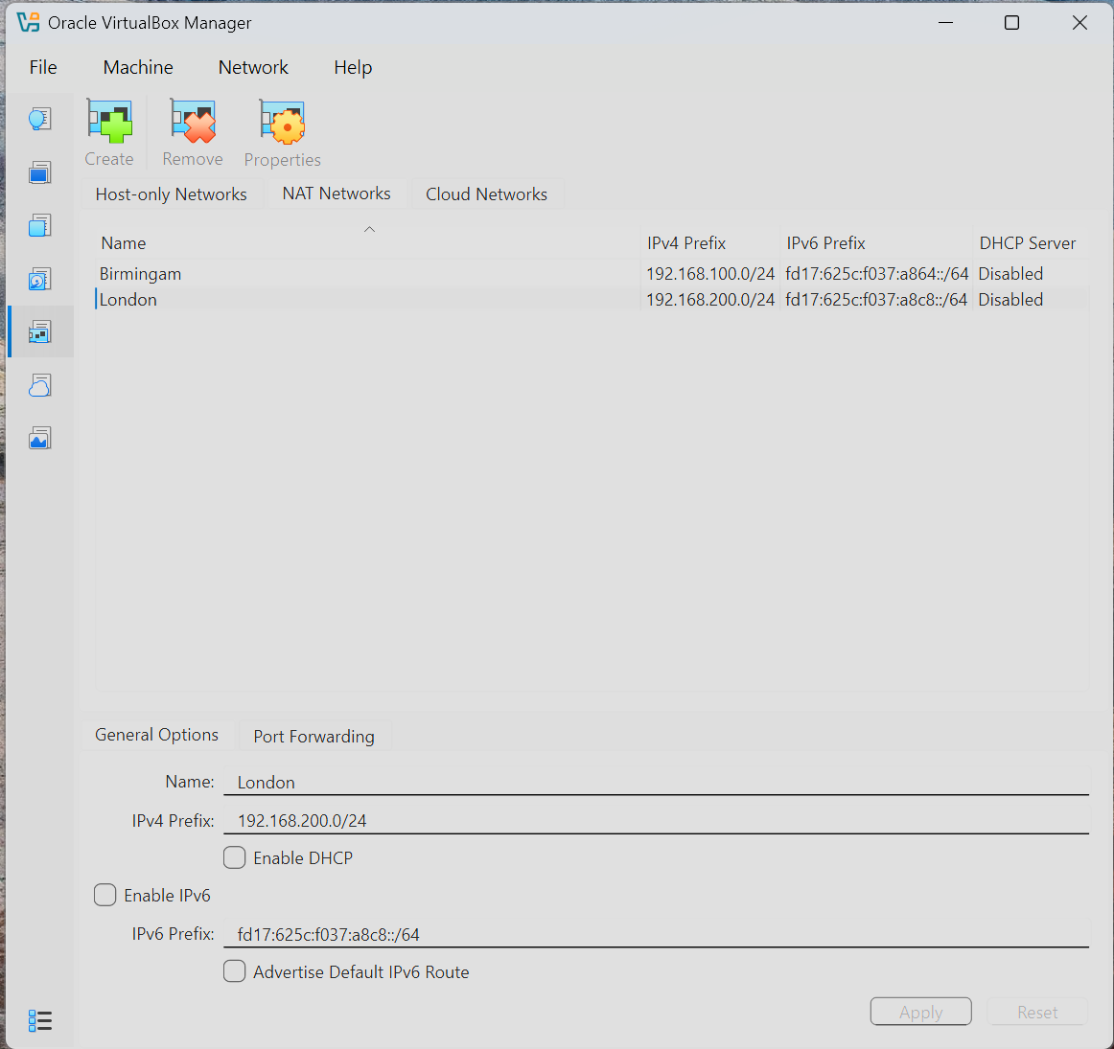
Evidence of 2 Windows PCs are connected with NAT Network1
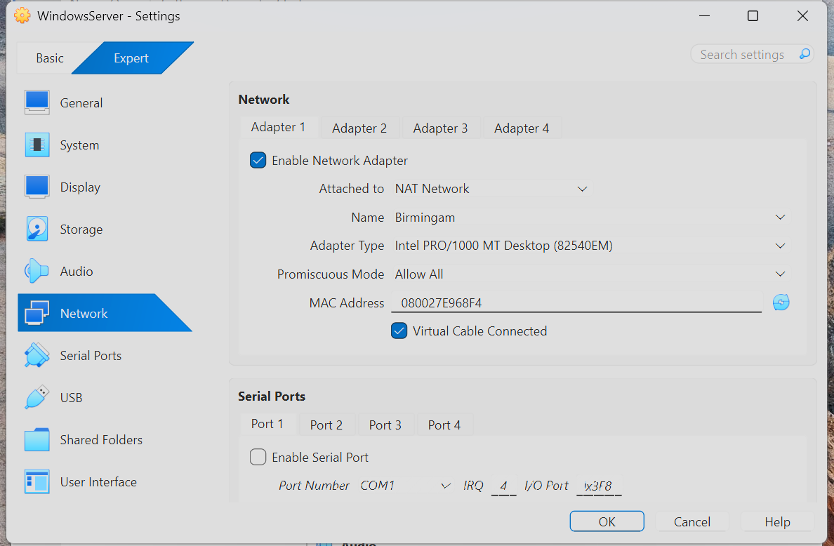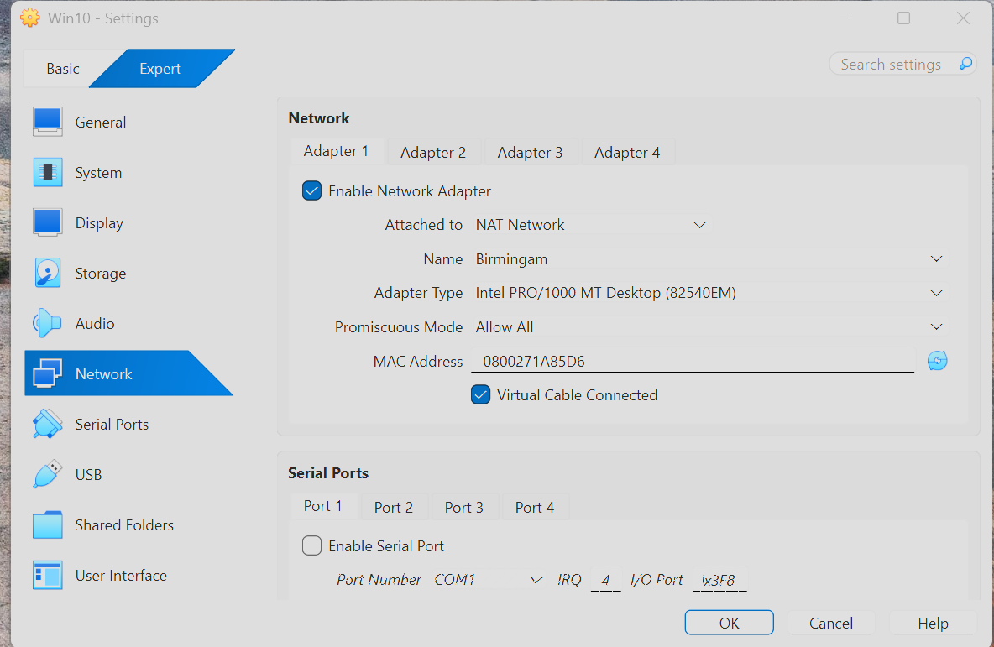
Evidence of 2 Linux PCs are connected with NAT Network2

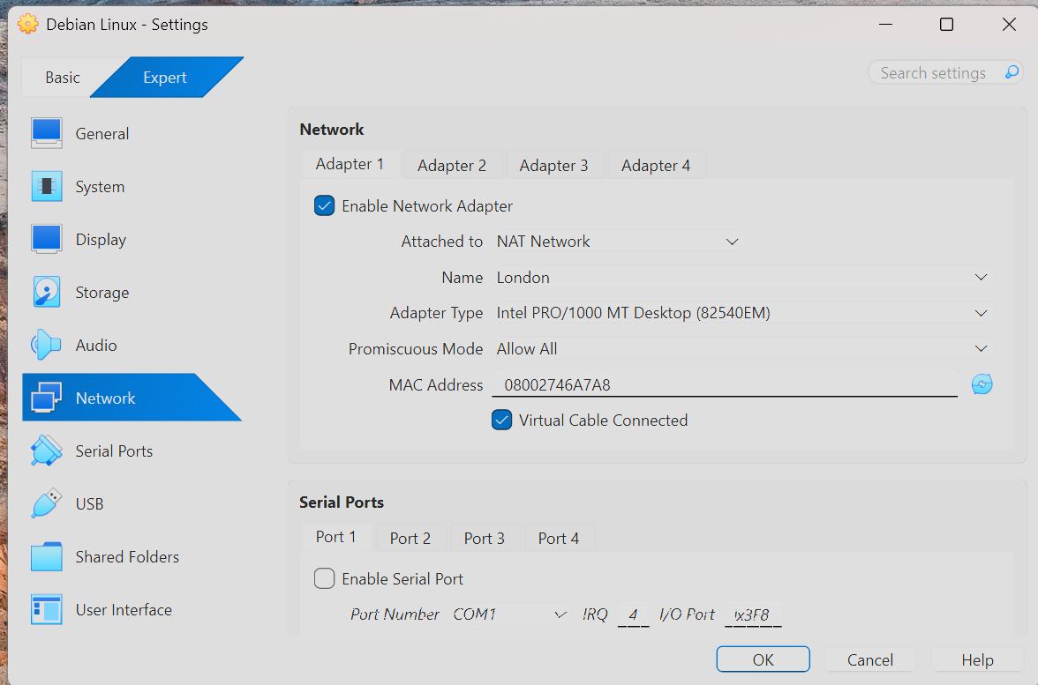
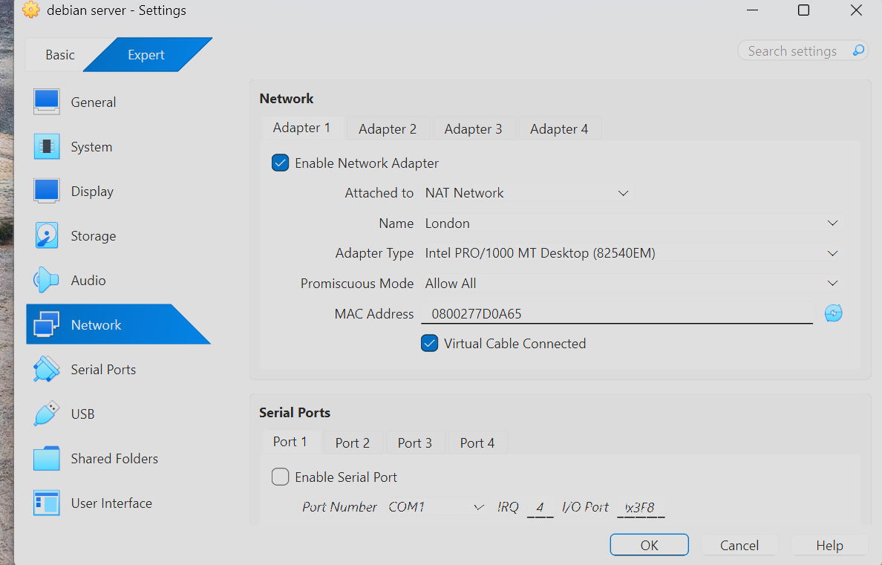

Configure IP Addressing
Custom IP addressing scheme:
Machine | OS | IP Address | Network
WindowsServer | Windows Server | 192.168.100.10 | Birmingham
WindowsClient | Windows 10 | 192.168.100.20 | Birmingham
DebianServer | Debian | 192.168.200.10 | London
DebianClient | Debian | 192.168.200.20 | London
Testing and Troubleshooting
Successful:
Windows ↔ Windows (Ping successful)
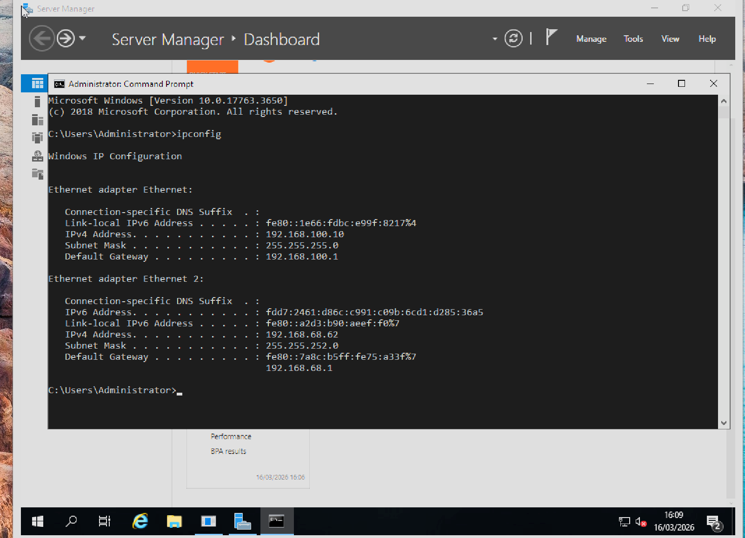
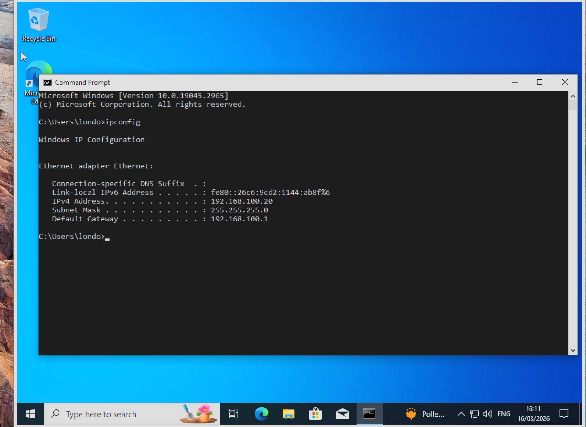
Linux ↔ Linux (Ping successful)
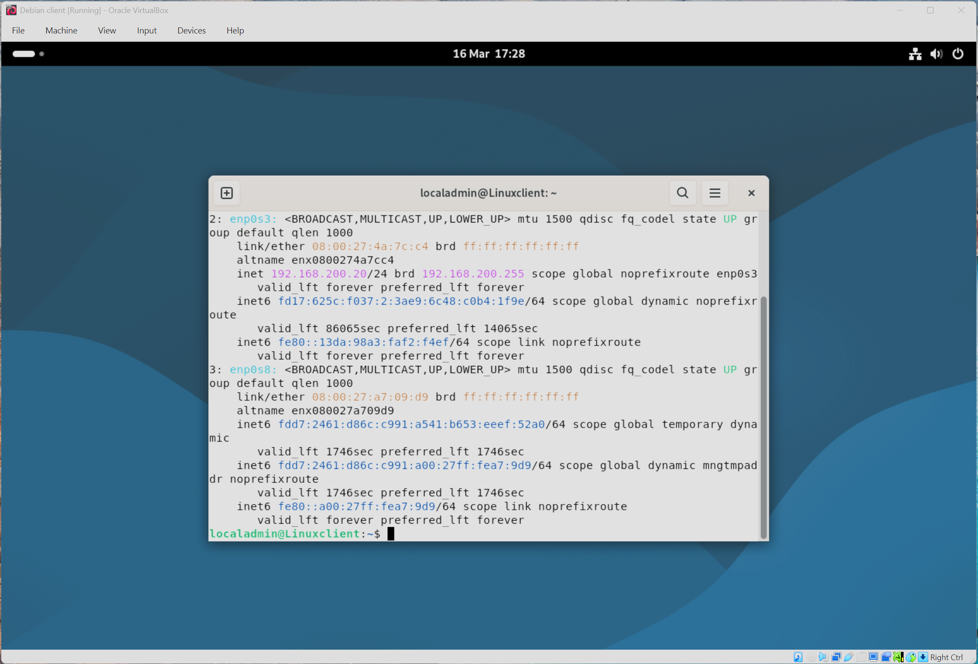
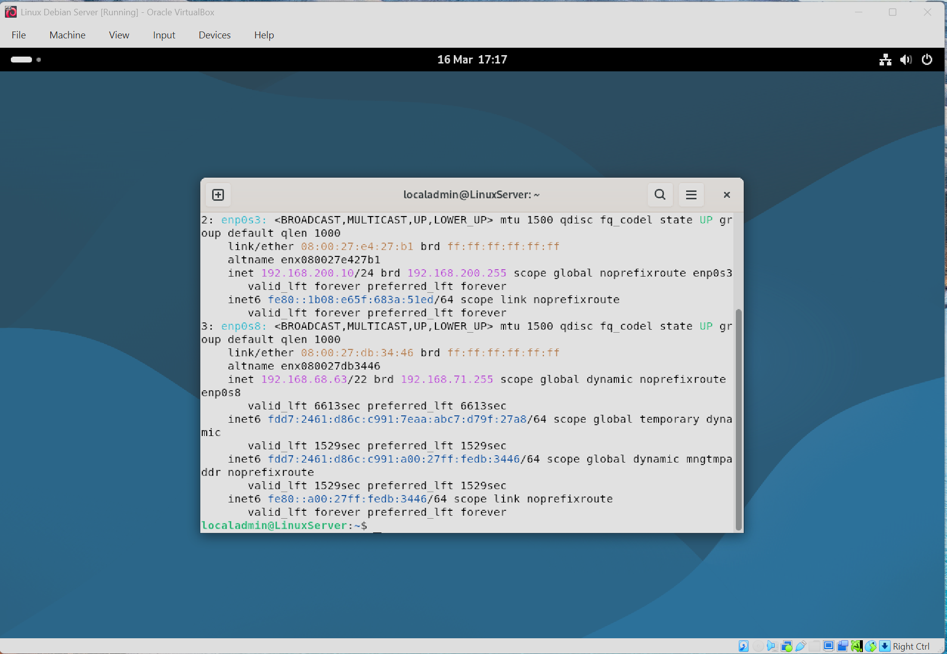

Task 3: Reflection

Technical Reflection
During deployment, several challenges were encountered. One major issue was incorrect IP configuration, which resulted in failed connectivity tests. This was resolved by verifying subnet masks and ensuring devices were within the same network range. Another issue involved firewall settings on Windows Server, which blocked ICMP requests. This was diagnosed using ping tests and resolved by enabling ICMP in firewall settings. DNS resolution was also initially misconfigured, preventing domain communication. This was fixed by correctly assigning DNS server addresses. The troubleshooting process involved systematic testing using ping, checking configurations, and isolating faults step by step.

Personal Reflection
This assignment enhanced my understanding of virtualisation and networking concepts. I developed practical skills in configuring virtual machines, assigning IP addresses, and troubleshooting network issues. I learned the importance of planning and testing configurations carefully. Time management was also crucial, as tasks required consistent effort rather than last-minute work. Overall, the project improved both my technical knowledge and problem-solving skills, preparing me for real-world networking scenarios.

References
[1]
D. Kuhn, C. Kim, and B. Lopuz, Chapter 12: VirtualBox for Oracle. in Linux and Solaris Recipes for Oracle DBAs. Springer, 2015, pp. 325–344.
[2]
M. Dye, R. McDonald, and A. Rufi, Network fundamentals, CCNA exploration companion guide. Cisco press, 2007.
[3]
T. ANDREW S and W. DAVID J, “COMPUTER NETWORKS FIFTH EDITION,” 2011.
[4]
C. E. C. Guide, “Network Fundamentals,” 2008.
[5]
B. Berger and R. Serre, Hyper-V 2016 Best Practices. Packt Publishing Ltd, 2016.
[6]
A. Syrewicze and R. Siddaway, “Pro Microsoft Hyper-V 2019”.
[7]
C. Neal, “No title,” 2013.
[8]
A. Tanenbaum, D. Wetherall, J. Kurose, and K. Ross, “Computer networks title: Computer networking: A top-down approach,” vol. 201901, 2019.

