The Psychology of Personal Adventure
Outdoor adventurous activities are a great way to boost mental wellbeing and physical health as well as many other benefits. In this assignment I will be looking at the psychological benefits as well as the potential risks one can have when taking part in adventure seeking activities. Adventure activities can be seen to be physically and mentally challenging with factors of risk which can also be life threatening. Popular outdoor sports such as traditional rock climbing requires competence when climbing at height. With proper equipment and experience the risk of this sport Is significantly lower however, human and equipment error is still be considered when taking part in trad. So, what still motivates climbers and other adventure seekers to take part in these thrilling sports. Self-determination theory is the ability to make choices and be in control of your decisions. This could be engaging in activities for the inherent reward of the behaviour itself whenever that is self-appreciation or independence this is also known as intrinsic motivation. Self determination theory is split into 3 goals. Autonomy, having control over choices in experience or activity. Relatedness, the feeling of having a sense of belonging or connection with others. Competence, the need to have the correct skills to compete an activity. (Cherry, 2022) In Competition Self-determination can motivate people to excel in outdoor sports. by increasing a person's level of mental toughness usually when doing something challenging or dangerous. By having a competence in a sport are driven to perform better. In Social Settings, outdoor sports such as climbing also has a great social area and community to help and make friends. Places like overhang, Carmarthen have an adult social night and a student night Monday and Friday where you can go and make friends whilst also taking part in the sport (Centre, 2020). Challenges in outdoor sports are usually confronted which can help improve one’s autonomy though good choices and hard work. Being capable of making good choices happen when you pursue things that are intrinsically motivated and with your goals. (Cherry, 2022) an example of this is when I went cold water swimming in Pembrokeshire. Before this was out of my comfort zone however I was capable of making the decision on whenever I wanted to or not get into the water. After going into the water for 10 minutes I felt extremely better, and I felt that I accomplished a new goal that I wouldn’t have done before because it was out of my comfort zone.
Being physical in the outdoor environment also has many psychological benefits that usually go beyond being active in the non-natural environment. a systematic review of the comparative effects participating in indoor and outdoor activity that confirms that sports including environment hiking, trekking, swimming in the natural environment, cycling, snowshoeing, cross-country skiing, canoeing, surfing, or climbing outdoor sports are associated with a better subjective overall health perception and a better physical quality of life. (Eigenschenk, 2019) Overall the study showed that green environments seem to have a positive effect that go beyond being physically active in a non-natural environment. Many adventure seekers look for a sensation of self-efficacy in their pursuits such as skydiving or coasteering. These types of sports will raise the individual’s excitement and stimulation. Outdoor adventure also has a lot of mental health benefits which include the lowering of anxiety levels. The state of anxiety is defined as an emotional response characterized by a subjective feeling of tension, apprehension, nervousness, and worry associated with an arousal of the autonomic nervous system. state anxiety happens when a person is exposed to a frightening or stressful situation which can trigger a response such as a rapid heartbeat, sweaty palms etc. Trait anxiety is more of a constant state where a person personality is affected. People with trait anxiety may feel more anxious in day-to-day situations. Outdoor adventure is also used as a form of therapy. Adventure therapy is a psychotherapeutic approach that uses outdoor adventure activities by using the natural environment to facilitate a change in clients that they may not have received in a indoor environment. A study, with students who reported to have anxiety and depression experienced participating in an innovative intervention that combined individual therapy with an adventurous
outdoor experience. The study showed that safe therapeutic space within which they could unveil their anxieties and achieve inner healing. (KYRIAKOPOULOS, 2011) A lot of outdoor programs use the environment to produce change in the participants whenever that is by creating fear. Which could improve their sense of achievement at the end of the activity. it is common for the participants personal growth to grow when they are put in an environment outside of their comfort zone. (priest & gass, 1997) The emotion that is called fear is controlled by the hippocampus located in our brains. The hippocampus is a big portion of the brain that is responsible for storing memory and knowledge. When an emotion such as fear is being controlled by the hippocampus, this can make learning more difficult as I disrupt the storage of memory. it can almost me impossible to function our learning ability as our brain gets sent into a fight or flight state of mind. (Ward, 2022) This can affect our adventure if we are not fully listening to instructions given by either an outdoor instructor. Even a competent outdoor adventure who has set their own instructions. When faced with fear we may make not make the best decisions, potentially leading to a mistake or even death. A study was developed to further understand the stages of adventure that participants can feel. The study states that to achieve a peak experience there needs to be a balance of risk along with a balance of competence. If there becomes an imbalance in either the participant can experience either peak adventure or misadventure. It is in the expertise for outdoor adventure leaders to help participants achieve their peak adventure. however there is always an exposer to risk which could turn the whole experience into a disaster. Outdoor adventure facilitator must find that balance between adventure and moderate fear without there being to much risk. (Ward, 2022) so, if done correctly. Outdoor adventures have also been proven to help boost self-esteem. Self esteem is what we evaluate the positive and negative judgment of ourselves are. How we feel of our self-confidence can change or ability to make good decisions and change our competence with certain skills. those with low self-esteem are more likely to have difficulty in forming and sustaining social relationships, show depression, become pregnant during their teenage years, have suicidal thoughts, experience unemployment male, and have eating disorders female (Leather, 2012).self-efficacy is what someone believes they can achieve with their capabilities to manage and executer a course of action. This is someone personal believe in their ability to complete a goal or succeed in a certain situation. If someone’s self-efficacy in outdoor skills and knowledge increase. So will their ability to continue their participation in outdoor adventures. If the person continues to participate in outdoor sports, they are considered to pursue more traits of leadership. The more someone participates the more likely there will be more opportunities for them to build a greater overall self-worth. (verywellmind, 2023) Outdoor adventure has been seen to improve character building in recent developments. (Leather, 2012)suggest that outdoor adventure has a great importance to education programs as it is seen as character building. The improvements that have been recognised form having an outdoor adventure experience in children are self-concept, locus of control, greater socialisation with others and are more likely to contribute to the process of healthy adolescent development. There are programmes such as forest schools that are created to develop these soft skills and raise self esteem and confidence. They do this by facilitating courses for children that make them perceive a situation of risk which is completely controlled by the organisation. (Leather, 2012) to conclude I believe that outdoor adventure is a beneficial experience that everyone should have to help develop their self-confidence, esteem, and efficacy. People need to be put out of their comfort zones to be able to feel achievement which can benefit personal growth. Self-determination they also suggest that we are naturally motivated to go and take part in these adventures. The major threat that is faced with taking part in outdoor adventure is the exposer to risk and what could happen if one is either to confident or to scared. I believe that is the outdoor adventure is well risk managed and facilitated by a competent outdoor leader then outdoor adventure experience should be promoted and taken part in more than it already does as the psychological benefits outweigh the risk.
CSAI-2 Completed 1 week prior to / morning of a downhill mountain bike competition.

To test the hypothesis that there will be no change to anxiety and self confidence levels throughout the build up to a competition. The samples were taken 1 week before downhill mountain biking competition and the morning of. In this test the cognitive anxiety, somatic anxiety, and self-confidence in 20 students were taken to find out if there was a significant difference.

The 20 students did 6 different assessments. This includes cognitive anxiety 1 week prior and morning of the event. Somatic anxiety 1 week prior and morning of the event and their self-confidence 1 week prior and morning of event.
See Table 1
The Cognitive anxiety measured the week prior (M=19.95, SD=2.78) and the measurement the morning of the event (M=26.95, SD=3.45) were recorded. Due to the nature of the statistics being dependent on each other, a paired t-test was performed.
See Table 2
The Null hypothesis of levels of cognitive anxiety being equal was rejected, t(19) = -9.554, p = <0.01. Therefore, showing the mean cognitive anxiety the morning of the event was statistically significantly higher than the mean anxiety recorded the week prior to the event.
See Table 3
The somatic anxiety the week prior (M=13.9, SD=2.48). and the measurement the morning of the event (M=24.75, SD=4.15) were recorded. Due to the nature of the statistics being dependent on each other, a paired t-test was performed.
See Table 2
Null hypothesis of somatic anxiety being equal was rejected due to the value of t (t(19) = -15.569) being less that the value of P (p = <0.01). therefore, showing that the mean somatic anxiety the morning of the event was statistically significantly higher than the mean anxiety recorded the week prior to the event.
See Table 3
The statistics measured for self-confidence the week prior to the event (M=19.55, SD=4.12) and the measurements the morning of the event (M=16.35, SD=4.81) lead to a different outcome than the previous two sets of data.
See Table 2
Although the null hypothesis is not rejected immediately as the t value (t(19) = 3.582) is greater than the value of P (P = <0.01).
This tells us that the mean self confidence in the participants is lower the morning of the biking competition than the week prior.

To summarise the t test. 1 week prior the biking event the cognitive anxiety and the somatic anxiety of those participants showed significantly lower than the morning of the event. However, the self-confidence showed higher.
The morning of the biking event the cognitive anxiety and the somatic anxiety of the participants showed significantly higher than 1 week prior to the event. However, the self-confidence showed lower.
See Table 3


Table 1
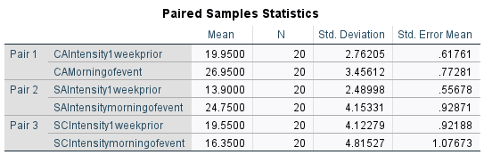
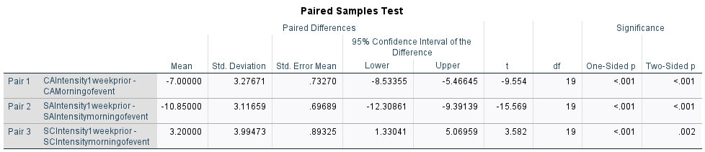
Table 3

Table 2

